**University of Aveiro**

**Master’s in Cybersecurity**

**Security in Communications Networks**

**School Year 2024/25**

**Second Project**

**Made in: 2025/06/02**

**Carlos Ferreira 108822**

**Tomás Bogalho 124224**

**Index**

1. Introduction iii

2. Analysis of Non-Anomalous Behavior iv

2.1. Identify Private Networks iv

2.2. Identify Internal Services/Servers v

2.3. Describe and Quantify Internal Traffic Exchanges vi

2.4. Describe and Quantify External Traffic Exchanges ix

2.5. Connection Timings ix

x

3. SIEM Rules xi

3.1. Internal BotNet, Data Exfiltration and C&C Activities xi

3.2. Anomalous External Destinations xiv

3.3. External Users using the corporate public services in an anomalous way xiv

4. Test of SIEM Rules and Identification of Devices xiv

5. Conclusion xiv

# Introduction

This report presents the configuration and validation of a rule-based SIEM detection system for identifying anomalous network behavior and compromised internal devices. The primary objective of this project is to define, implement, and evaluate detection rules capable of identifying security threats such as internal botnet activity, data exfiltration, remote command and control (C&C) communication, and anomalous external interactions with public corporate servers.

The analysis was conducted using Python on a dataset of network flow logs exported in Parquet format, simulating real-world enterprise environments. Data from normal and potentially compromised traffic were analyzed to establish baselines and detect deviations.

The network behavior was profiled based on source and destination IPs, protocols, traffic volume, and geolocation, enabling the formulation of SIEM rules grounded in empirical evidence. These rules were tested against known-safe and mixed-behavior datasets to validate their effectiveness in identifying malicious patterns without generating excessive false positives.

According to the value of our mecanographic values the datasets used were the **sixth**.

# Analysis of Non-Anomalous Behavior

## Identify Private Networks

In order to identify the internal private networks used by the corporate infrastructure, a script was developed to analyze the source IP addresses from the network flow logs in the data6.parquet file. The dataset contains non-anomalous traffic from a full day of operation, serving as a baseline for typical network behavior.

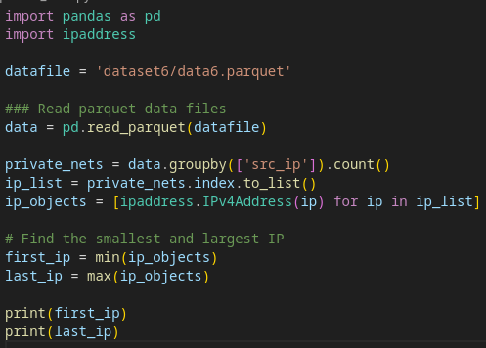Figure 1: get_private_nets Script

Using Python and the ipaddress library, the script extracts and processes all unique source IP addresses, which correspond to internal devices. These IPs are then converted to IPv4Address objects to determine their numeric range and identify the lowest and highest addresses in use.

The smallest and largest source IPs found in the dataset were: **192.168.106.11** and **192.168.106.210** respectively.

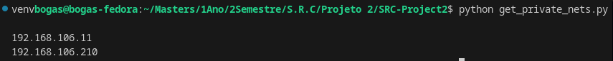Figure 2: Result of Script get_private_nets

## Identify Internal Services/Servers

To identify the internal servers and services operating within the private corporate network, two complementary analyses were performed based on the traffic flows present in the data and servers datasets.

First, using the data file which includes internal traffic only a grouping operation by destination port and transport protocol was executed. This allowed for the identification of commonly accessed ports and services used internally, such as web port 54 using UDP and port 443 using TCP.

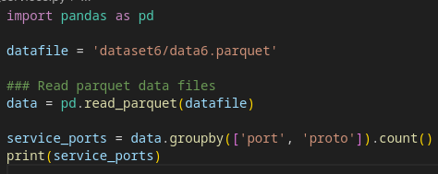Figure 3: get_services.py

Second, the servers file was analyzed to understand interactions with the **public-facing corporate servers** located in the 200.0.0.0/24 subnet. By aggregating up_bytes and down_bytes per destination IP, port, and protocol, the script calculates upload/download ratios to infer the role of each server.

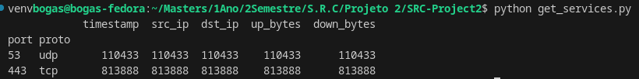Figure 4: Result of Script get_services

This script identified two servers: 200.0.0.11 and 200.0.0.12, both using TCP in port 443.

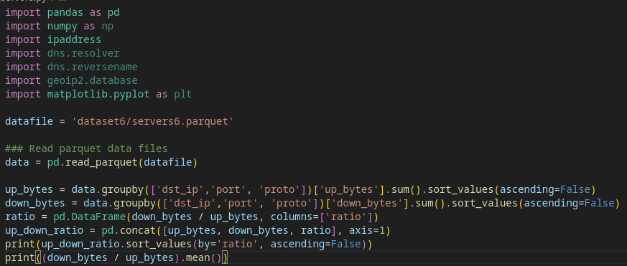Figure 5: get_servers Script

## Describe and Quantify Internal Traffic Exchanges

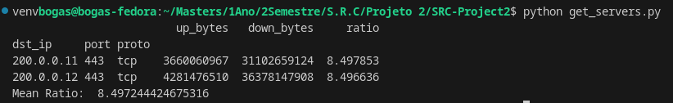Figure 6: Result of Script get_servers

To analyze internal network behavior and characterize data flows between internal devices and both internal and external servers, the dataset data was used.

Each internal IP (source address) was evaluated in terms of total uploaded and downloaded bytes. By grouping traffic by source IP and summing the up_bytes fields and down_bytes, the volume and directionality of data exchanges were quantified. Additionally, the download-to-upload ratio was calculated to assess usage behavior, distinguishing endpoints with typical client-like activity (high download) from potential servers or upload-heavy devices.

To identify interactions with external services, each destination IP address was geolocated using the GeoLite2 Country and ASN databases. The results revealed a set of distinct destination countries that internal devices communicated with, providing insights into the geographical spread of external dependencies.

The calculated metrics included:

* Total **upload** and **download** volume per internal IP
* **Download-to-upload ratio** per internal IP
* **Mean** and **standard deviation** of download/upload ratios across all devices

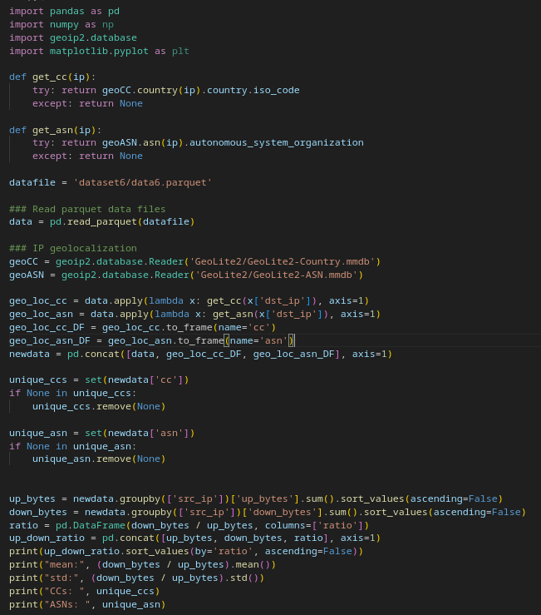Figure 7: get_stats Script

The **average download-to-upload ratio** across 198 internal devices was **9.23**, with a **standard deviation of 0.20**, indicating a relatively uniform pattern of usage.

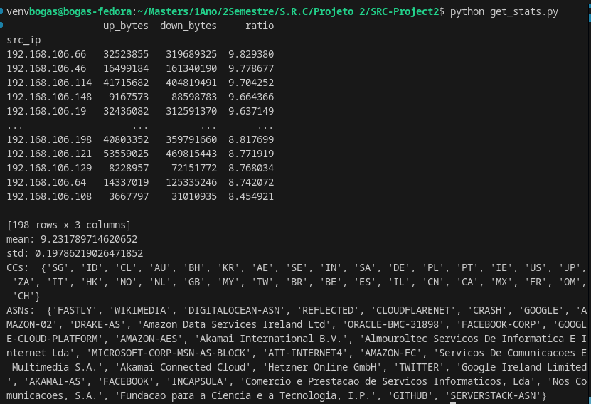Figure 8: Result of Script get_stats

The observed destination countries included:

* North America: **US, CA, MX**
* Europe: **DE, FR, NL, GB, PL, SE, CH, NO, IT, BE, PT, IE**
* Asia-Pacific: **JP, CN, IN, SG, KR, HK, TW, MY, ID, AU**
* Middle East: **AE, SA, OM, BH, IL**
* Africa: **ZA**
* South America: **BR, CL**

Notable ASNs included:

* Cloud Providers: GOOGLE, AMAZON-02, GOOGLE-CLOUD-PLATFORM, ORACLE-BMC-31898, MICROSOFT-CORP-MSN-AS-BLOCK, DIGITALOCEAN-ASN, SERVERSTACK-ASN
* CDNs: CLOUDFLARENET, AKAMAI-AS, Akamai Connected Cloud, INCAPSULA, FASTLY
* Content Platforms: FACEBOOK, TWITTER, WIKIMEDIA, GITHUB
* National/ISP Providers: Nos Comunicacoes, S.A., Fundacao para a Ciencia e a Tecnologia, I.P., Servicos De Comunicacoes E Multimedia S.A.
* Others: REFLECTED, ATT-INTERNET4, Hetzner Online GmbH, DRAKE-AS, Almouroltec Servicos De Informatica E Internet Lda

## Describe and Quantify External Traffic Exchanges

To understand how external clients interact with the corporate network, the servers6.parquet dataset was analyzed. This dataset contains traffic flows from external IPs to public-facing corporate servers located in the 200.0.0.0/24 network specifically 200.0.0.11 and 200.0.0.12 since they are the servers addresses.

For each external IP, the total uploaded and downloaded data was calculated. The download-to-upload ratio was computed to assess the nature of each connection — with higher ratios indicating data retrieval behavior, which is typical for external clients accessing web or API services.

* The average download-to-upload ratio was 8.49
* The standard deviation was 0.047, indicating very consistent behavior among all clients

To evaluate how frequently external clients accessed services, the average time between consecutive flows was calculated.

* Mean inter-flow timestamp: 842.58 (1/100 seconds, ≈ 8.4 seconds)
* Standard deviation: 337.06

These values indicate moderate variation, with some clients showing steady access patterns, while others exhibit more sporadic or burst-like behavior.

TERMINAR

## Connection Timings

Apart from the the points asked in the assignment the group also analyzed the connection timings, in order to obtain the base values, we first obtained the differences between timestamps for each source address and calculated the mean, standard deviation, maximum and minimum, then did the same for the servers data. These value values will later allow to define rules to identify anomalous addresses.

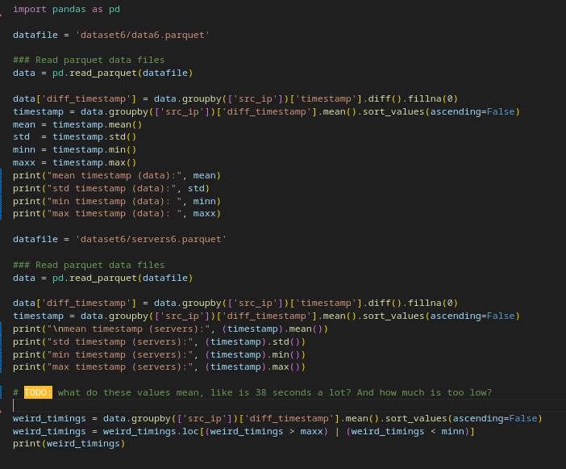Figure 9: conn_timings Script

## 

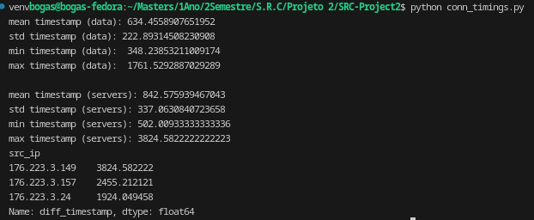Figure 10: Result of Script conn_timings

# SIEM Rules

## Internal BotNet, Data Exfiltration and C&C Activities

To detect potential internal botnet infections, data exfiltration via DNS, and command and control (C&C) activities, SIEM rules were formulated based on deviations from baseline traffic patterns established using the clean dataset data.

For the normal internal traffic, the following distribution of HTTPS-to-DNS connection ratios was observed across 198 internal IPs:

* Mean ratio: 7.36
* Standard deviation: 0.60
* Minimum: 5.74
* Maximum: 9.16

This profile reflects typical enterprise behavior, where HTTPS traffic dominates due to web access and secure services, with relatively fewer DNS queries.

Using the test dataset the same HTTPS/DNS ratio was calculated, with the following results:

* Mean ratio: 7.35
* Standard deviation: 1.11
* Minimum: 0.100
* Maximum: 9.47

By comparing the values we could conclude that the standard deviation and the minimum were the values that most diverge from the clean results. When analyzing the ratio, a low value means that a lot more data was consumed/obtained by external devices then by the servers, which could mean data extrafiltration, when the difference isn’t as high it could still represent C&C activities. These values are alarming since the client consumes more than what it sends.

Any internal host with a significantly lower ratio than the baseline minimum (5.74) was flagged for suspicious behavior. Such a pattern may indicate:

* Botnet command & control activity using frequent DNS queries
* DNS tunneling or data exfiltration (e.g., sensitive data hidden in DNS payloads)
* Suppressed web activity while maintaining background communications

So the resulting rules was:

* **Any value below the minimum obtained from the clean dataset is considered anomalous**, this was our decision since

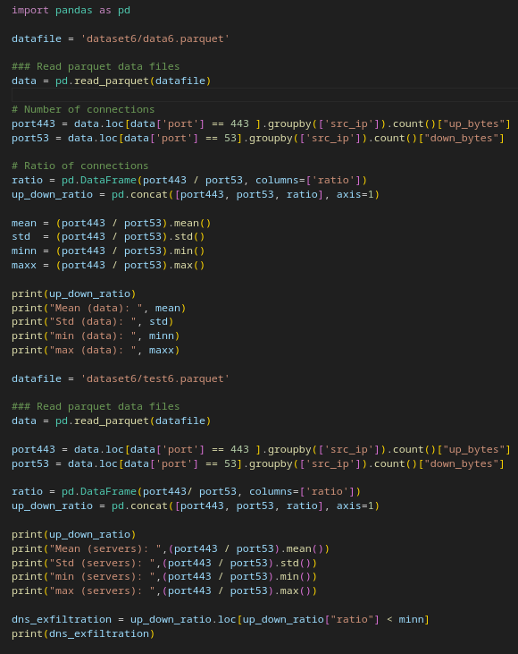Figure 11: http_dns_extrafiltration Script

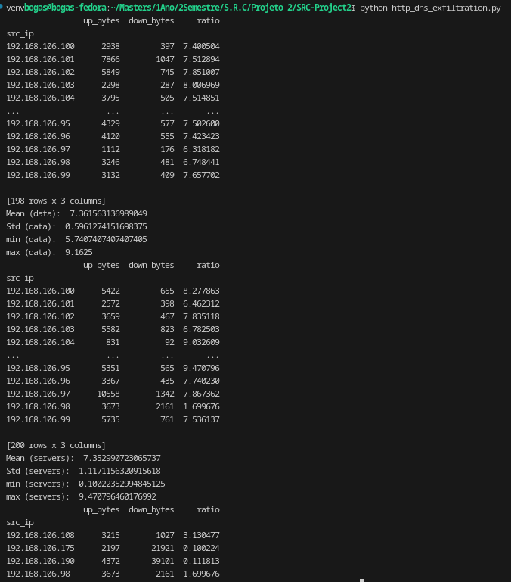Figure 12: Result of Script http_dns_extrafiltration

## Anomalous External Destinations

TODO

## External Users using the corporate public services in an anomalous way

# Test of SIEM Rules and Identification of Devices

# Conclusion