Recuritment Portal Code Review

SL NO | Date | Description | Amount
 | 23-06-2025 | From Office to Doit | 102
 | 23-06-2025 | From Doit to Office | 120
 | 27-06-2025 | From Office to Doit | 113
 | 27-06-2025 | Lunch | 158
 | 27-06-2025 | From Doit to Office | 102
Total = |  |  | 595

23-06-2025
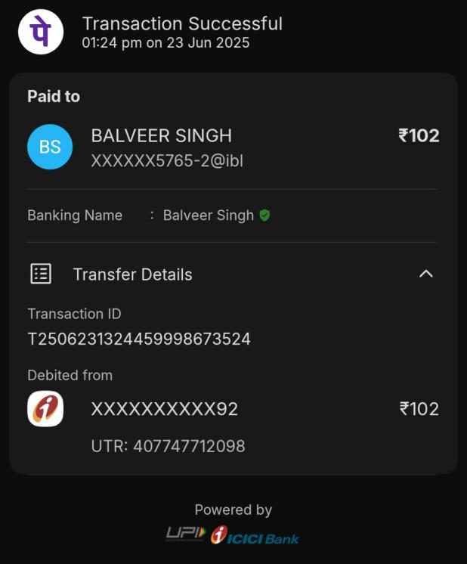 | 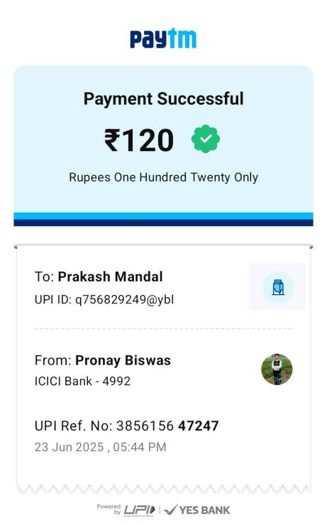
27-06-2025
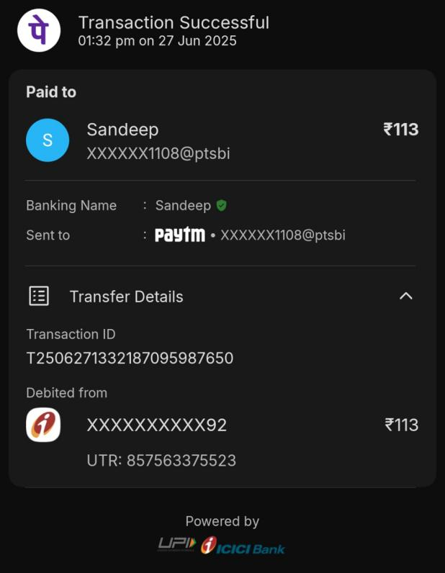 | 