Writeups
Local File Inclusion

Description: File Inclusion vulnerabilities are commonly found and exploited in various programming languages for web applications, such as PHP that are poorly written and implemented. The main issue of these vulnerabilities is the input validation, in which the user inputs are not sanitized or validated, and the user controls them. When the input is not validated, the user can pass any input to the function, causing the vulnerability.

Step to Reproduce:
- Visit the URL.
- Use Burp Suite to intercept and modify a request that fetches a product/image etc.
- Send the request to the Repeater.
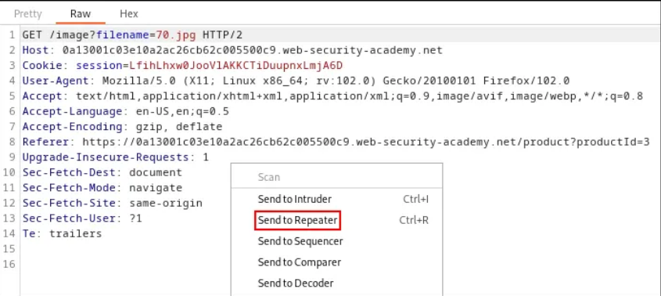
- Modify the filename parameter, giving it the value: ../../../etc/passwd
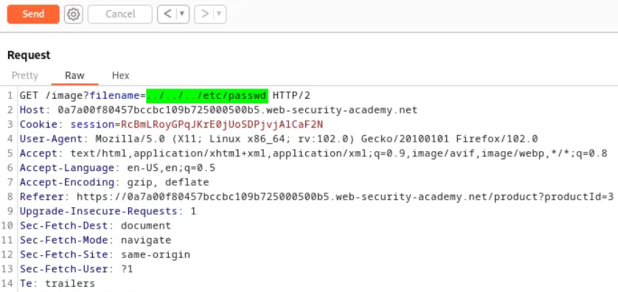
- The sequence ../ is valid within a file path, and means to step up one level in the directory structure.
- Observe that the response contains the contents of the /etc/passwd file.

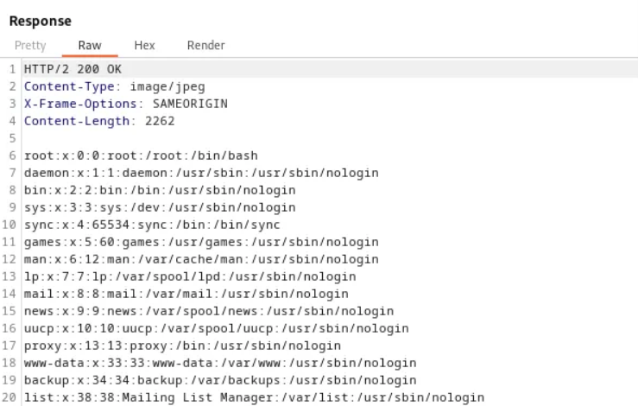

- If traversal sequences are blocked, an attacker might try using an absolute filesystem path (for example, filename=/etc/passwd) to reference a file directly from the root.

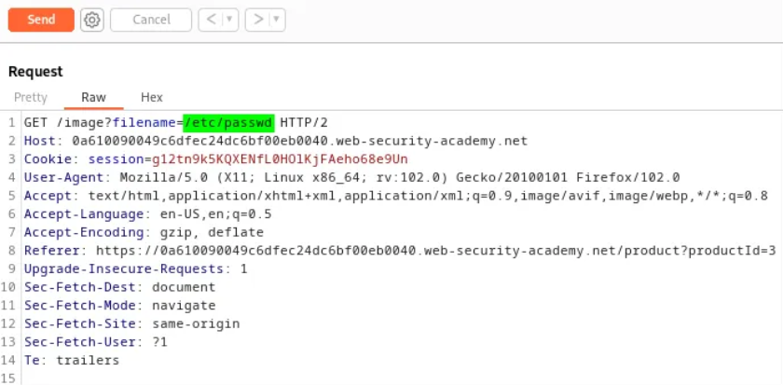

- Observe that the response contains the contents of the /etc/passwd file.
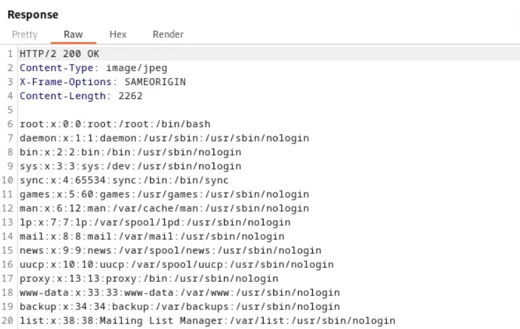

- If traversal sequences are stripped non-recursively, nested or obfuscated patterns (for example ....// or ..\/) can normalize to ../ and bypass the filter.
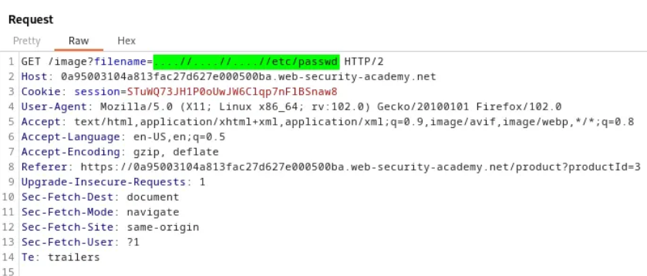
- Observe that the response contains the contents of the /etc/passwd file.
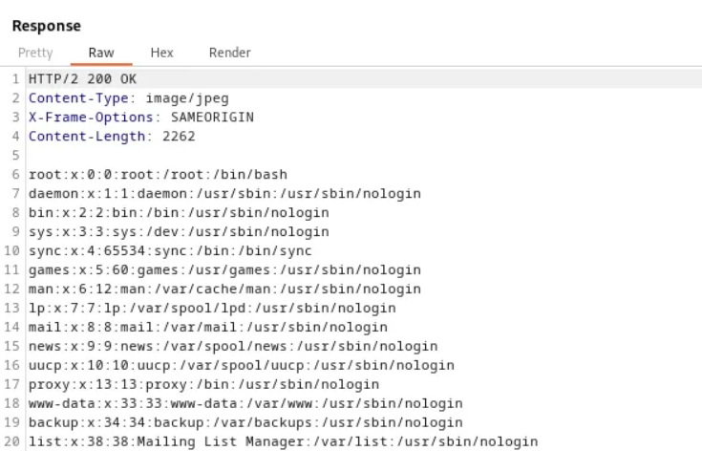

- If a server strips ../ sequences before handing input to the application, an attacker can sometimes bypass that filter by URL-encoding (e.g. %2e%2e%2f) or double-encoding (e.g. %252e%252e%252f) the traversal characters, which decode back during processing.

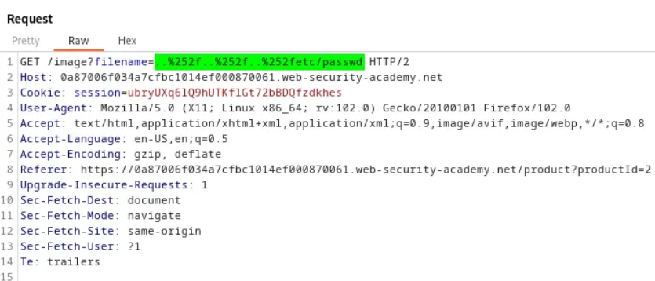

- Observe that the response contains the contents of the /etc/passwd file.

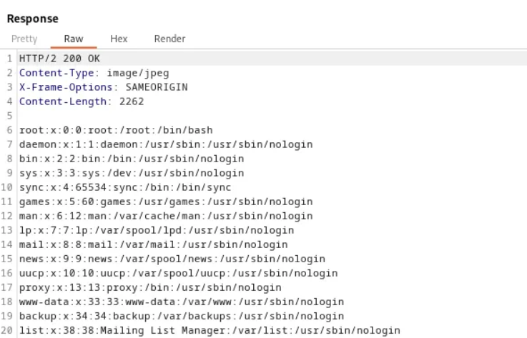

Remediation:

- Validate and sanitize all file/path inputs on the server side.
- Implement an allow-list for accessible filenames and reject inputs containing path traversal sequences.
- Run the application with least privilege and isolate file storage locations.

Open Redirection

An Open Redirection vulnerability occurs when a web application accepts untrusted input that determines the destination of a redirection without proper validation. Attackers exploit this flaw by crafting malicious URLs that appear legitimate but secretly redirect users to external, often harmful sites. This can be used for phishing, credential theft, or spreading malware while bypassing user suspicion.

The vulnerability is dangerous because users generally trust the original domain and are unaware of the redirection. If sensitive actions, such as login or payment, are involved, it increases the risk of exploitation. To prevent this, developers should enforce strict allow-lists, validate redirect targets, or avoid using user-controllable input for redirection altogether.

Step to Reproduce:
- Usually want to look out for are URL parameters that look like a path or a URL. Here are some examples of the types of parameters found open redirects in the wild:

https://site.com/login?ReturnURL=https%3A%2F%2Fsite.com%2Fmy-account
https://site.com/form-complete?return=%2Fcompleted
https://site.com/api/v2/redirect?url=https%3A%2F%2Fsite.com%2F404

- Try to find hidden parameter by fuzzing the parameters with a tool like ffuf or by crawl using BurpSuite.
- Now paste malicious URL after ReturnURL=, return=,Url=, U=, redirect= etc endpoint.
- It will redirect you the the malicious Website if exploited.

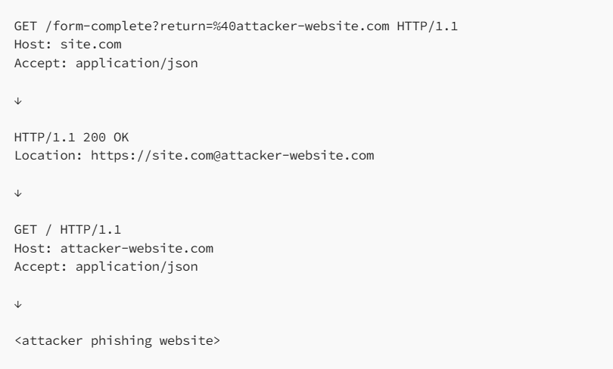

- Use encoding/double encoding url bypass firewall if required.

Remediation:
- Avoid using return/redirect parameters and use hardcoded URLs instead.

HTTP request smuggling

HTTP request smuggling occurs when an attacker crafts ambiguous or malformed HTTP requests that are interpreted differently by front-end proxies and the back-end server, allowing them to smuggle a hidden request past defenses. This can lead to cache poisoning, session hijacking, or bypassing security controls because the proxy and origin disagree on request boundaries. The vulnerability is subtle and high-impact since it exploits protocol parsing differences rather than application logic. Detection requires observing inconsistent behavior between intermediaries and the origin, often via logs or controlled test requests. Mitigation includes keeping proxies and servers patched, enforcing strict and consistent HTTP parsing/configuration across components, normalizing requests at the edge, and deploying web application firewalls that understand smuggling patterns.

Step to Reproduce:

- Visit the target URL and capture the request that returns a 403 Forbidden response.
- Forward that request to the Repeater for testing.
- Add a second Host header to the end of the request and resend, the 403 may be bypassed and the content returned.
- Insert an additional arbitrary header below the original headers and resend; this may also cause the 403 to be bypassed.
- Modify the value of the second Host header (e.g., to a different hostname); this change can likewise affect the response and bypass the 403.

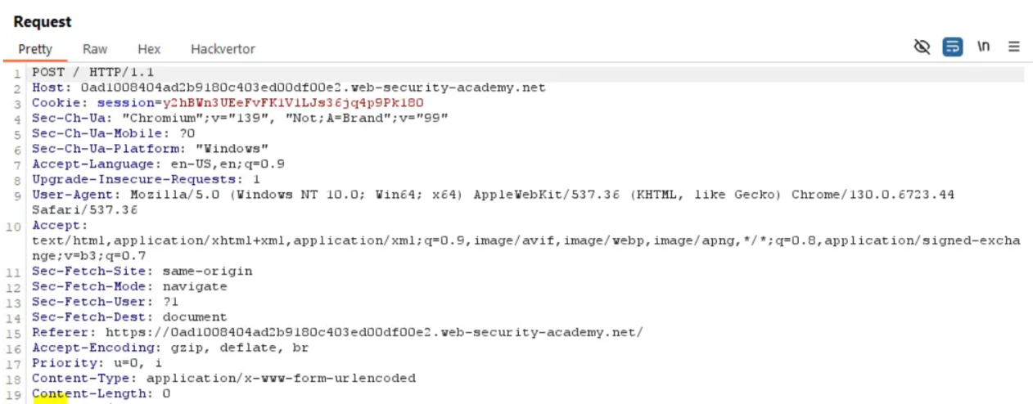

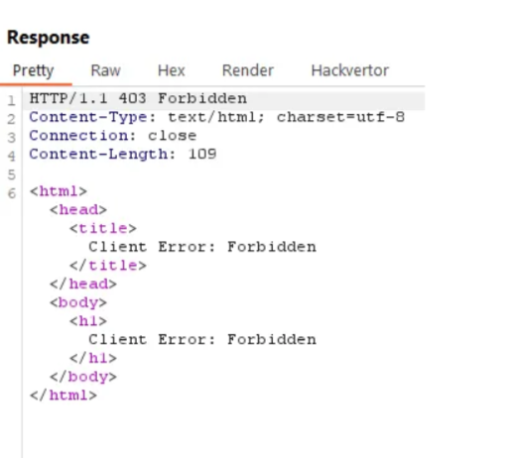

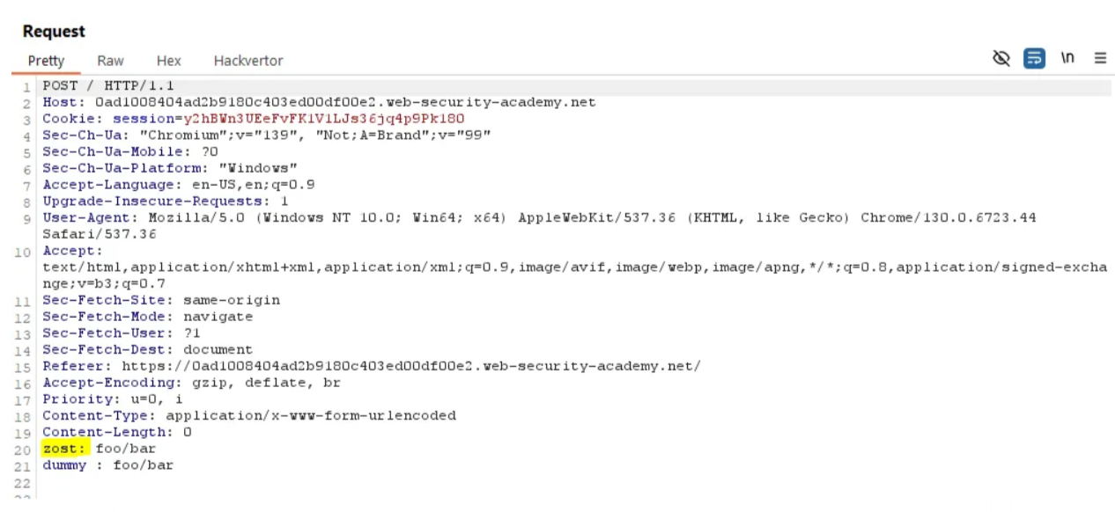

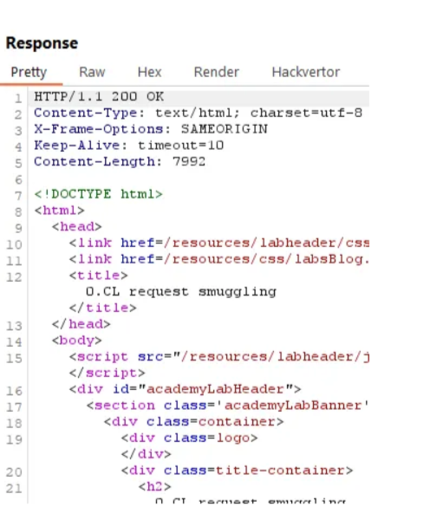

Remediation:

- Normalize and canonicalize incoming requests at the edge (load-balancer / CDN / WAF) before they reach the application. Reject requests after decoding/normalization if they contain traversal, encoded sequences, or unexpected characters.
- Enforce a single trusted Host value: reject requests with multiple Host headers or conflicting host values.
- Maintain an allow-list of valid hostnames and reject any request whose Host header is not on that list.

HTTP Verb Tampering

HTTP verb tampering happens when an attacker manipulates the HTTP verb in a request to the server. In order to specify what should be done with a resource, HTTP verbs are employed. The GET, POST, PUT, DELETE, and HEAD verbs make up the core of the HTTP language.

Step to Reproduce:
1.
