RajKishan Sathi Application Code Review

SL NO | Date | Description | Amount
 | 16-07-2025 | From Office to Pant Krishi Bhawan | 110
 | 16-07-2025 | Lunch | 80
 | 16-07-2025 | From Pant Krishi Bhawan to Office | 100
 | 22-07-2025 | From Office to Pant Krishi Bhawan | 165
 | 22-07-2025 | Lunch | 75
 | 22-07-2025 | From Pant Krishi Bhawan to Office | 145
Total = |  |  | 675

16-07-2025
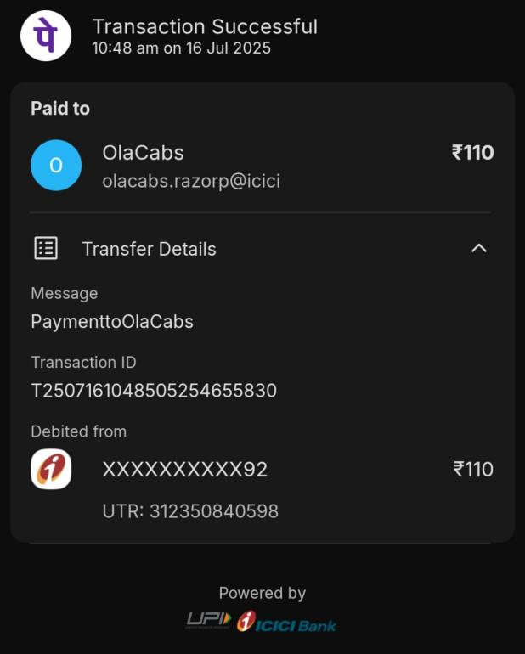 | 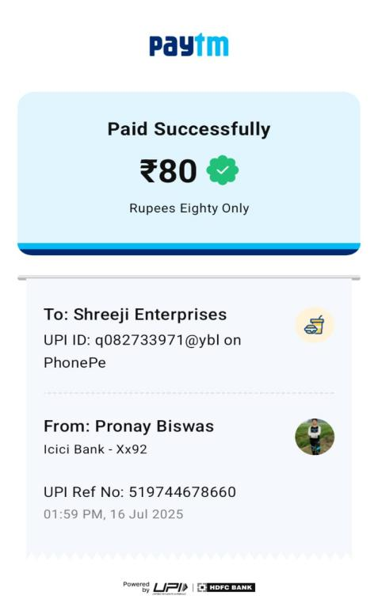
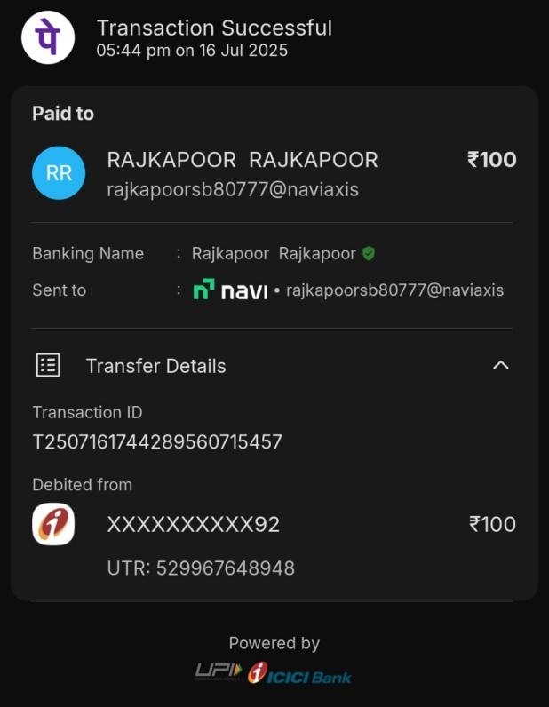
22-07-2025
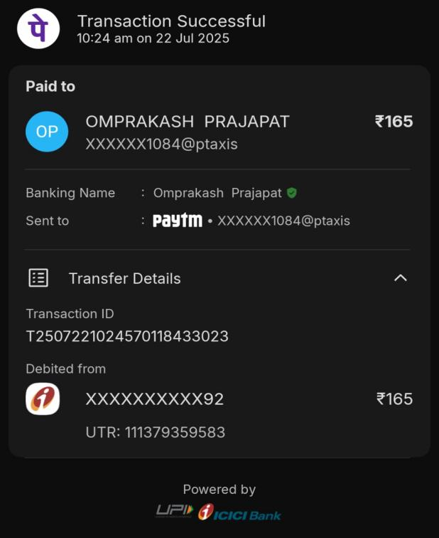 | 