SJVN IS Audit Bill

SL NO | Date | Description | Amount
 | 11-08-2025 | Jaipur to Chandigarh Train Ticket (Pronay) | 769.05
 | 11-08-2025 | Chandigarh to Jaipur Train Ticket (Cancel) | 1529.05
 | 11-08-2025 | Chandigarh to Delhi Train Ticket (Cancel) | 820
 | 11-08-2025 | Cancle Ticket (Sachin Sharma)
 | 23-08-2025 | Diary For Office | 190
 | 24-08-2025 | Room to Station | 167
 | 24-08-2025 | Watter Bottle | 30
 | 24-08-2025 | Dinner | 240
 | 24-08-2025 | PG to MG Metro (Cash) | 100
 | 24-08-2025 | MG Metro to Kashmiri Gate (Card) | 50
 | 24-08-2025 | Dinner | 210
 | 24-08-2025 | Delhi to Chandigarh | 712
 | 25-08-2025 | Chandigarh Bus Stand to Railway Station (Cash) | 150
 | 25-08-2025 | Tea + Snacks | 80
 | 25-08-2025 | Soap + Shampoo | 66
 | 25-08-2025 | Breakfast | 380
 | 25-08-2025 | Lunch | 420
 | 26-08-2025 | Lunch | 140
 | 26-08-2025 | Snacks | 60
 | 27-08-2025 | Lunch | 140
 | 27-08-2025 | Snacks | 70
 | 28-08-2025 | Lunch | 320
 | 28-08-2025 | Snacks | 70
 | 29-08-2025 | Lunch | 140
 | 29-08-2025 | Snacks | 50
 | 25-08-2025 to  30-08-2025 | Guest House Charges with food | 1500+1100
 | 30-08-2025 | Brakefast | 340
 | 30-08-2025 | Lunch | 460
 | 30-08-2025 | Guest House to Chandigarh Station | 12000
 | 30-08-2025 | Chandigarh to Jaipur Train Ticket | 769.05
 | 30-08-2025 | Chandigarh to Delhi Train Ticket | 1061
 | 30-08-2025 | Dinner | 241
 | 30-08-2025 | Station to Room | 165
 | 30-08-2025 | New Delhi Station to PG | 440
Total = |  |  | 24979.15

11-08-2025
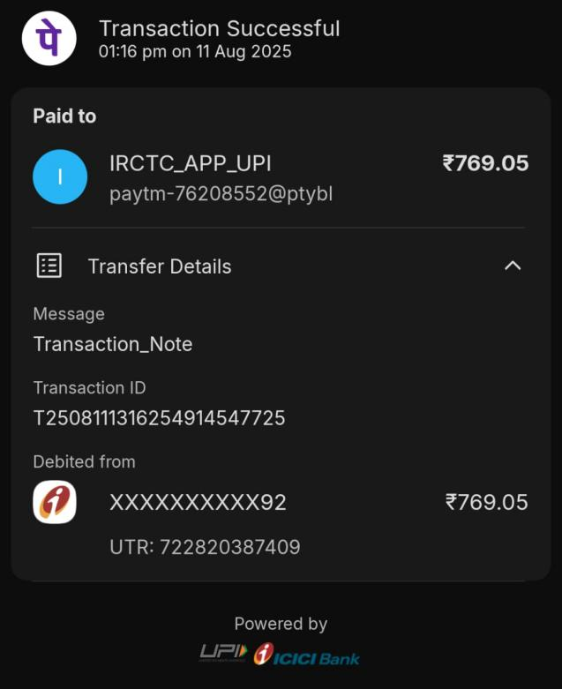 | 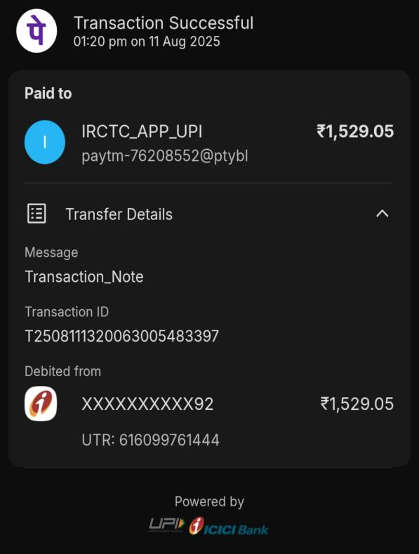
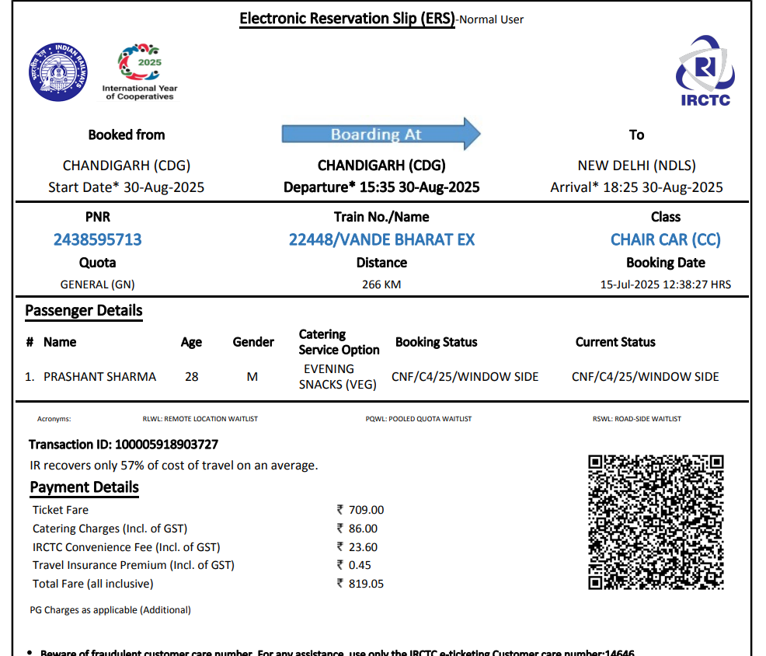
24-07-2025
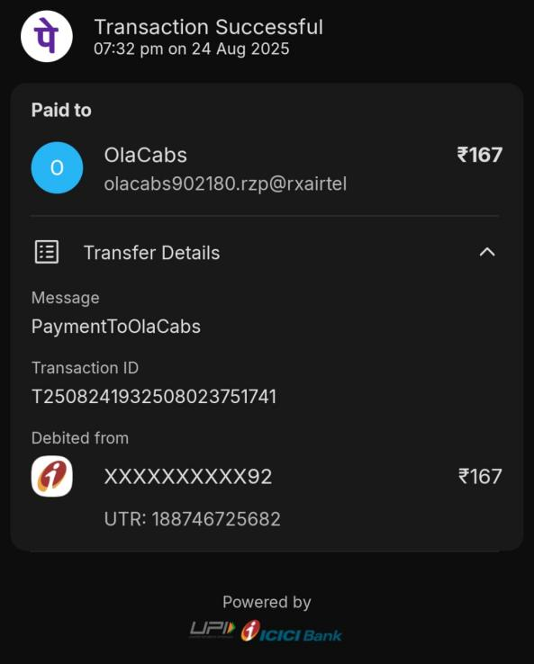 | 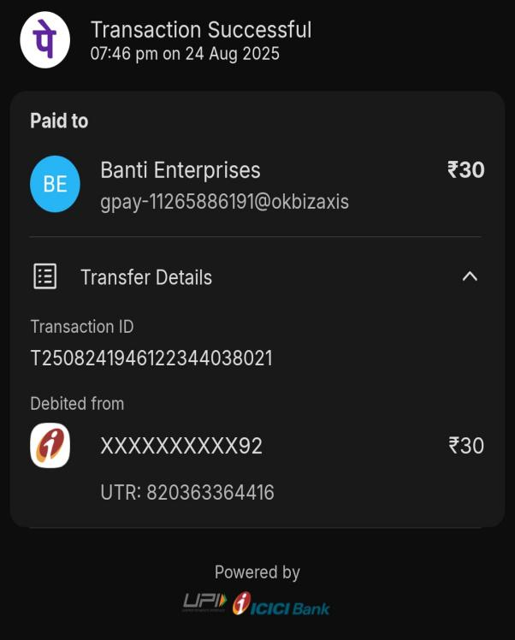
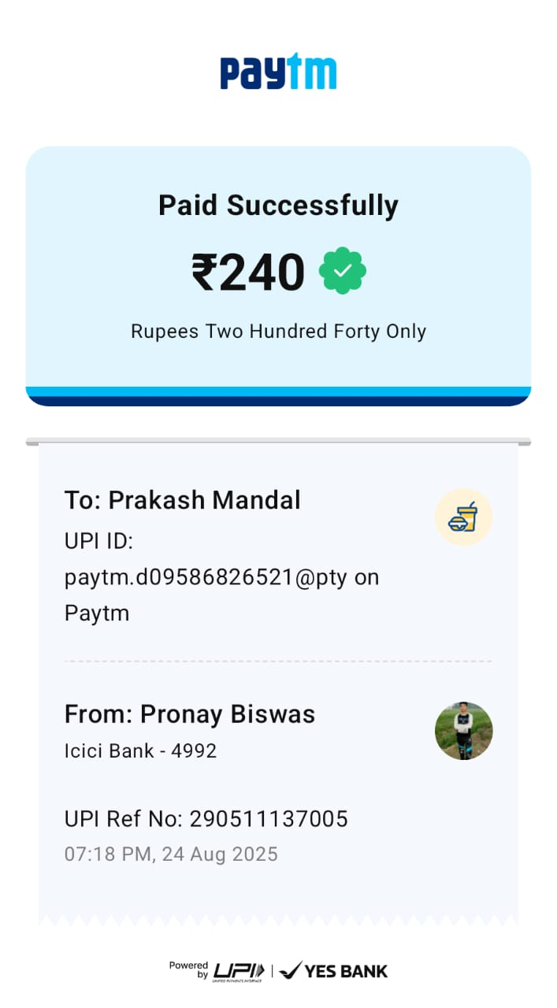 | 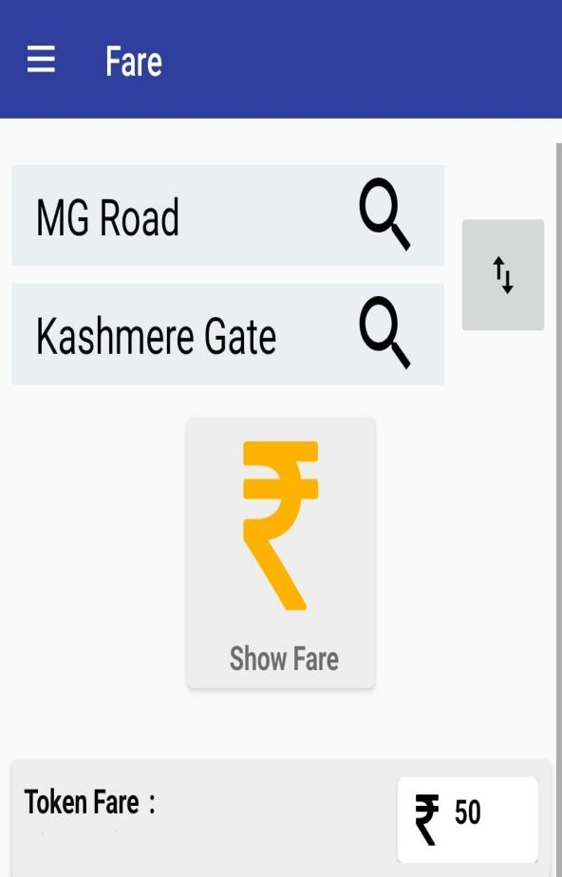
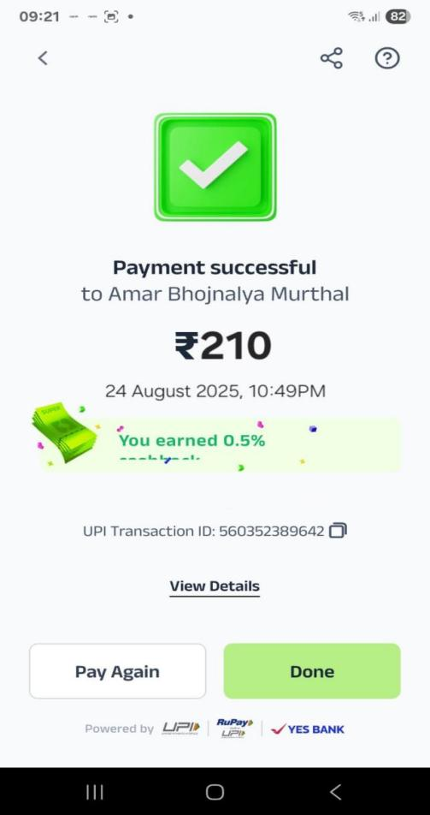 | 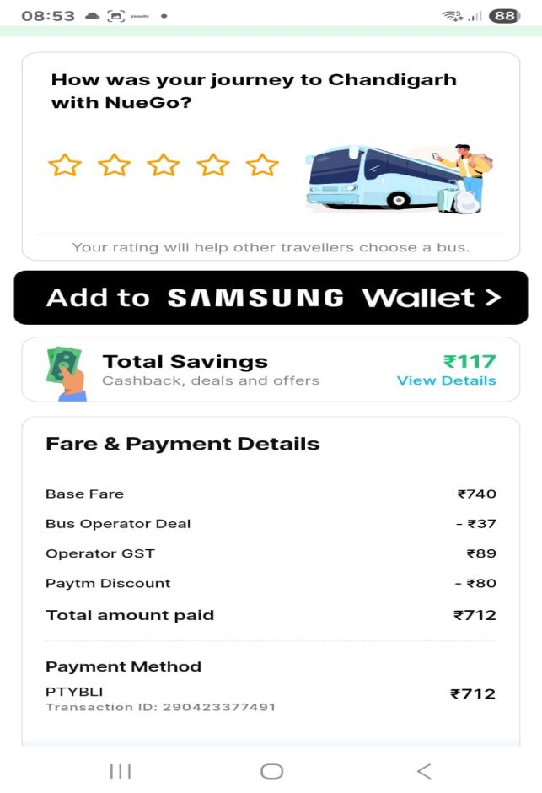
25-08-2025
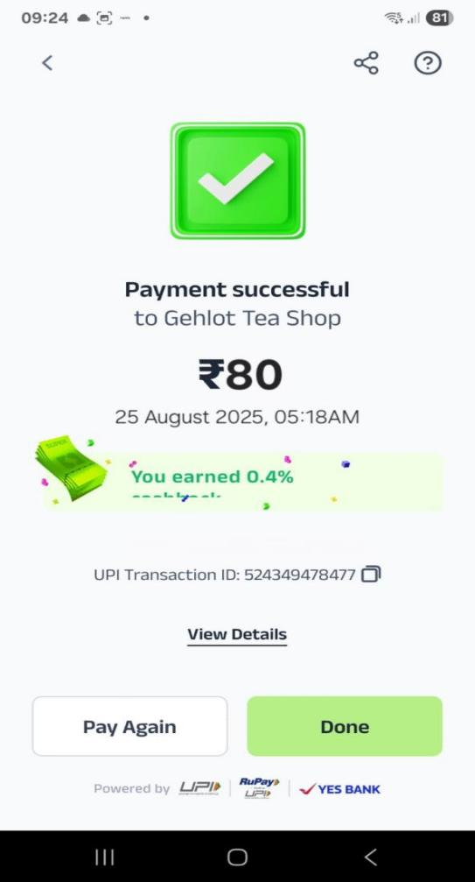 | 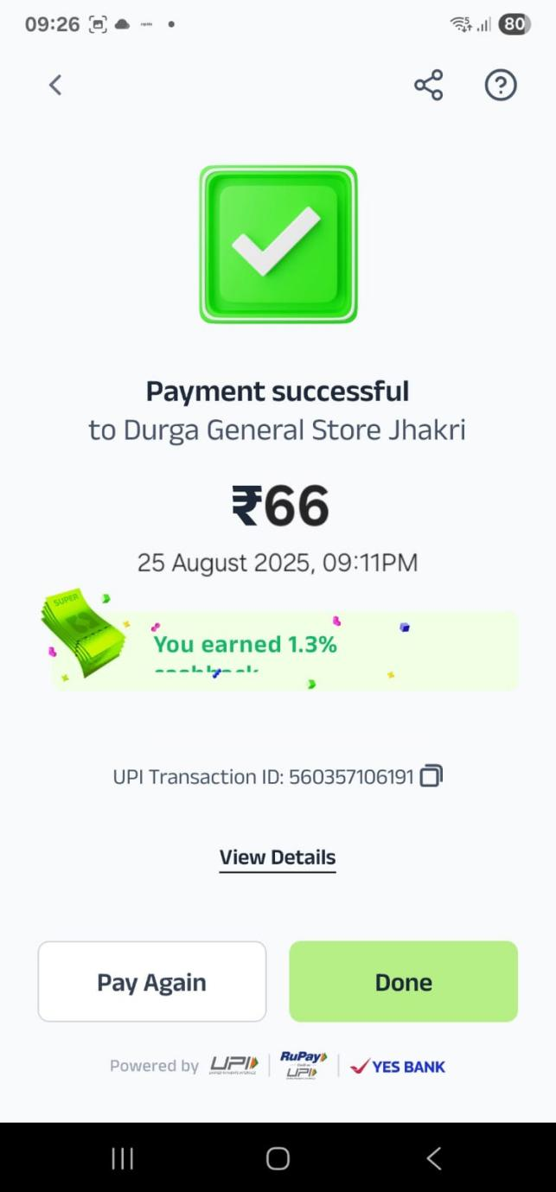
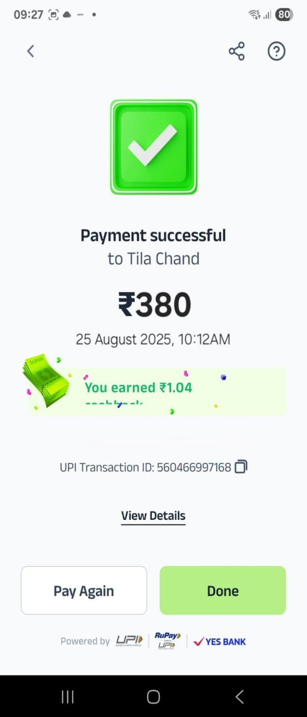 | 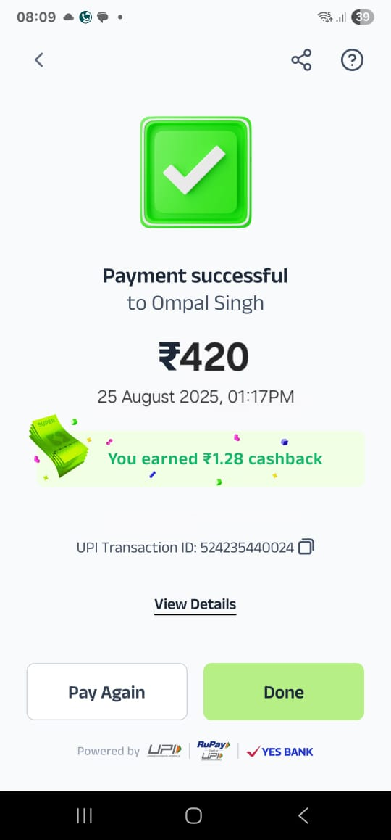
26-08-2025
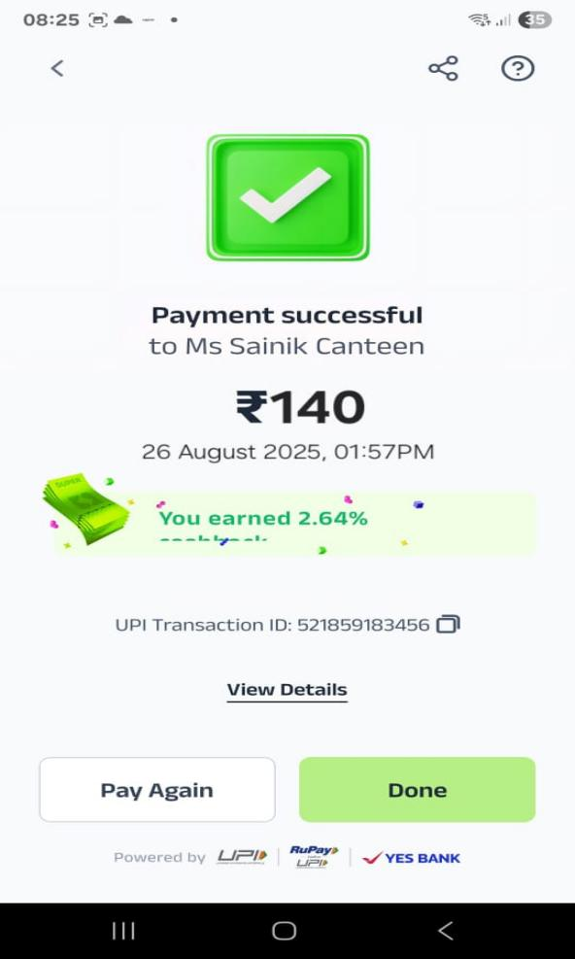 | 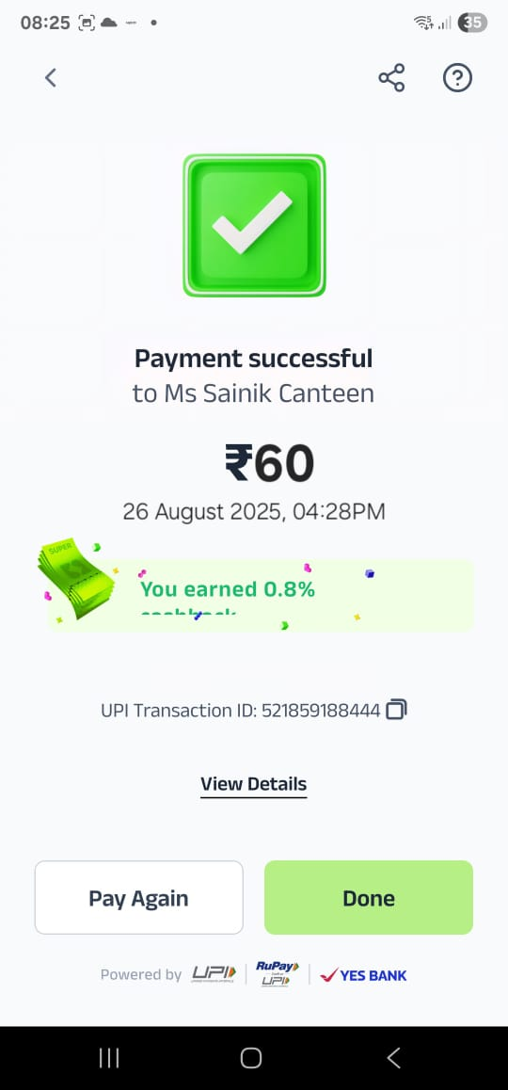
27-08-2025
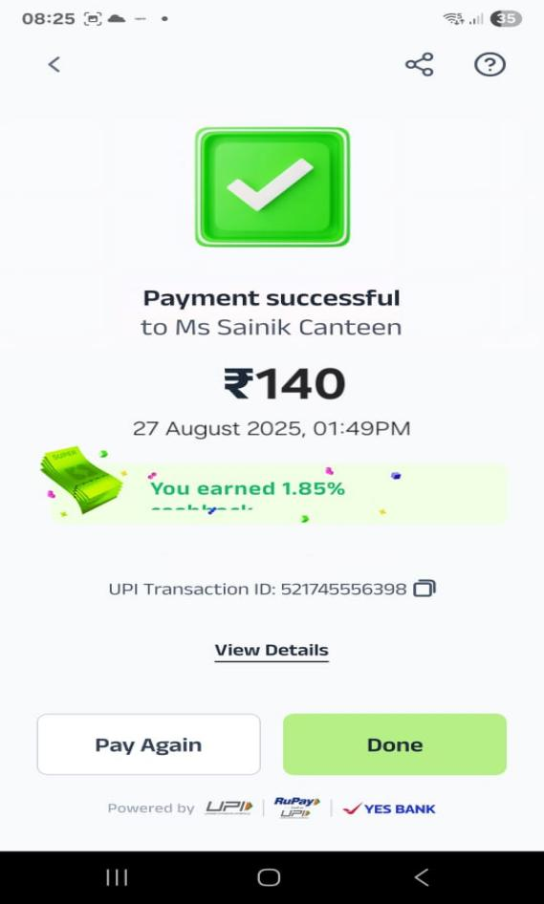 | 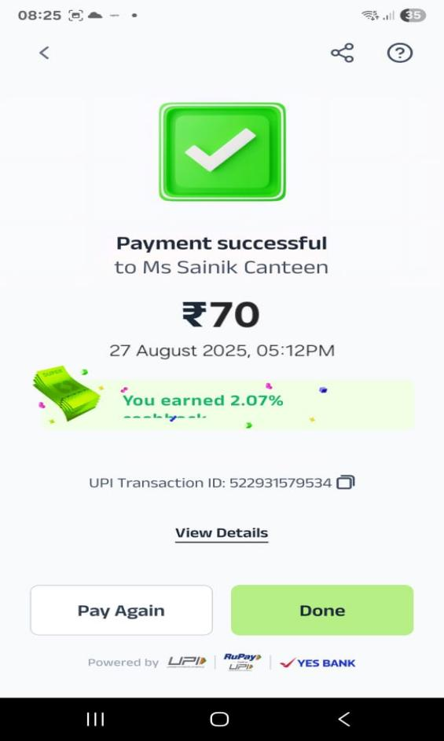
28-08-2025
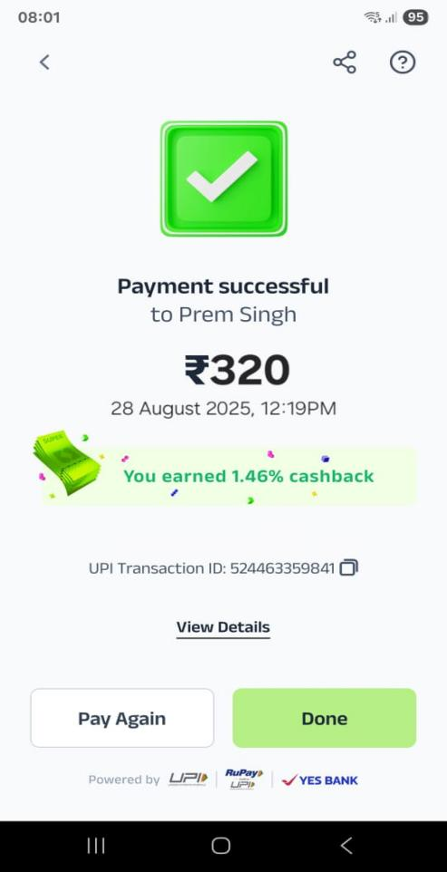 | 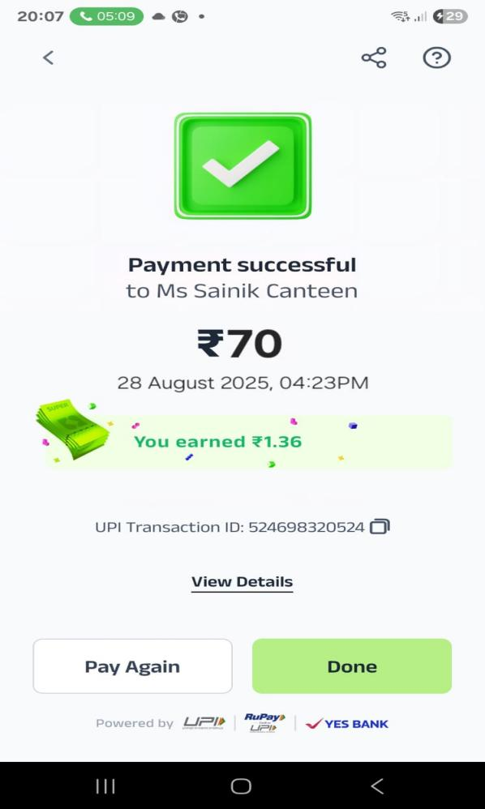
29-08-2025
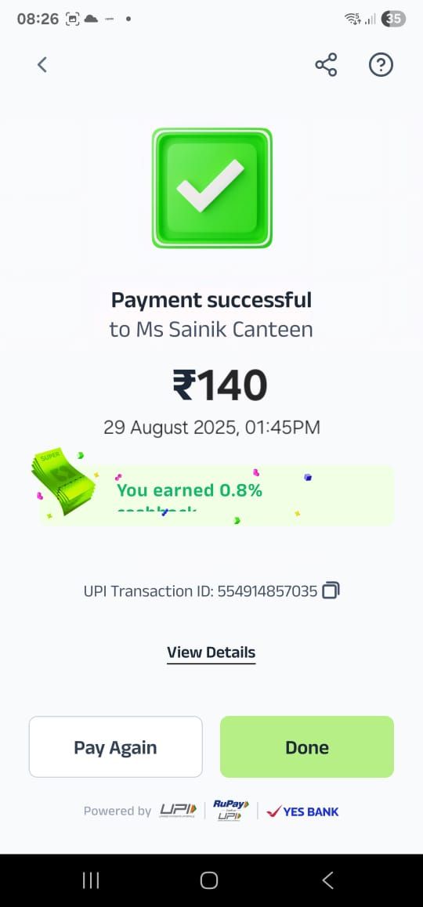 | 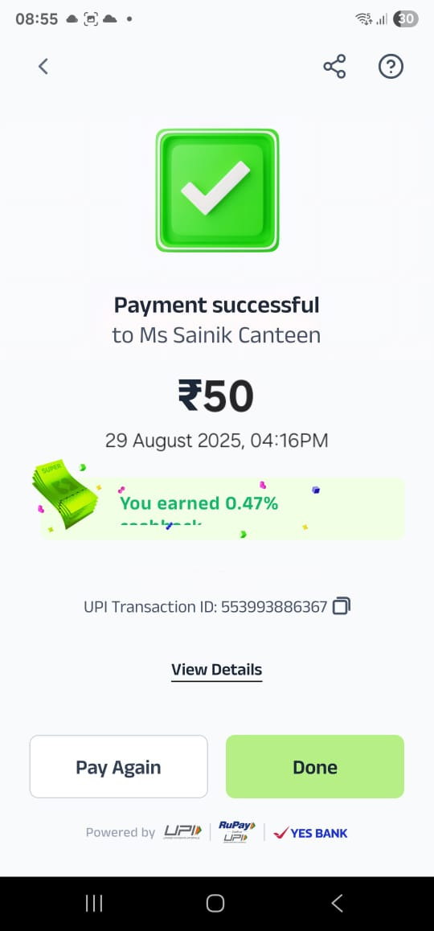
30-08-2025 (Guest House food Bill)
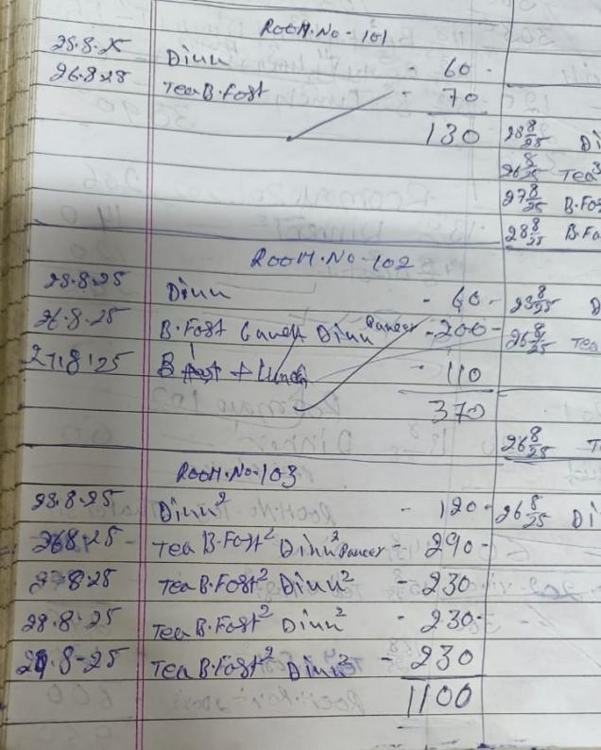 | 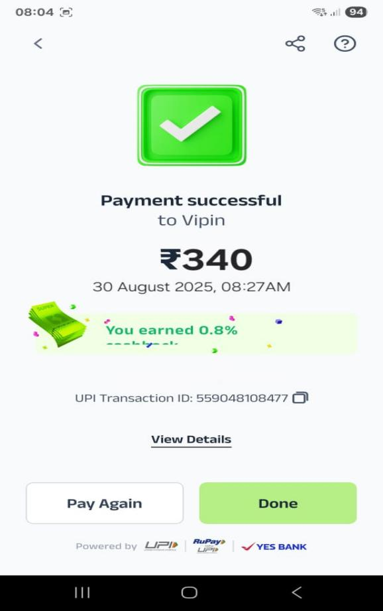
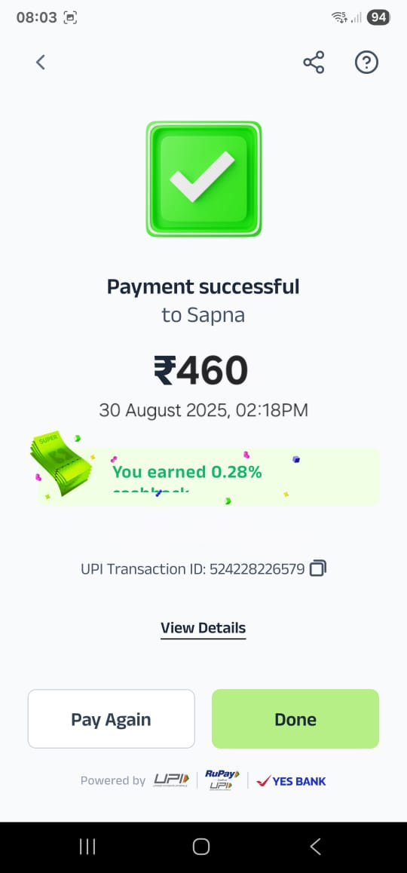 | 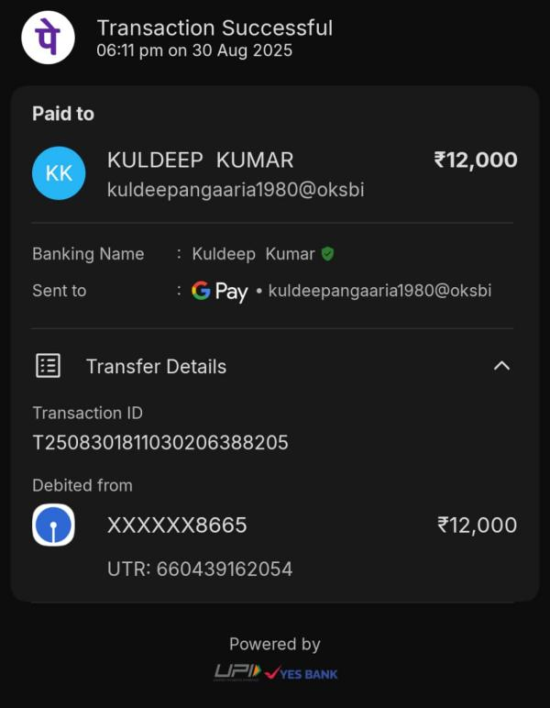
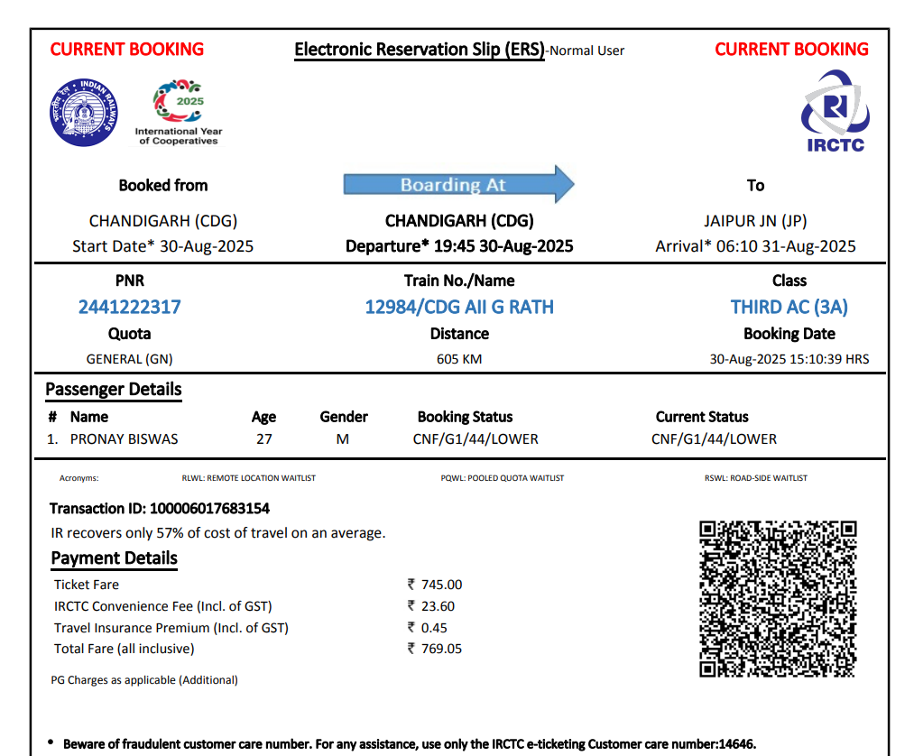
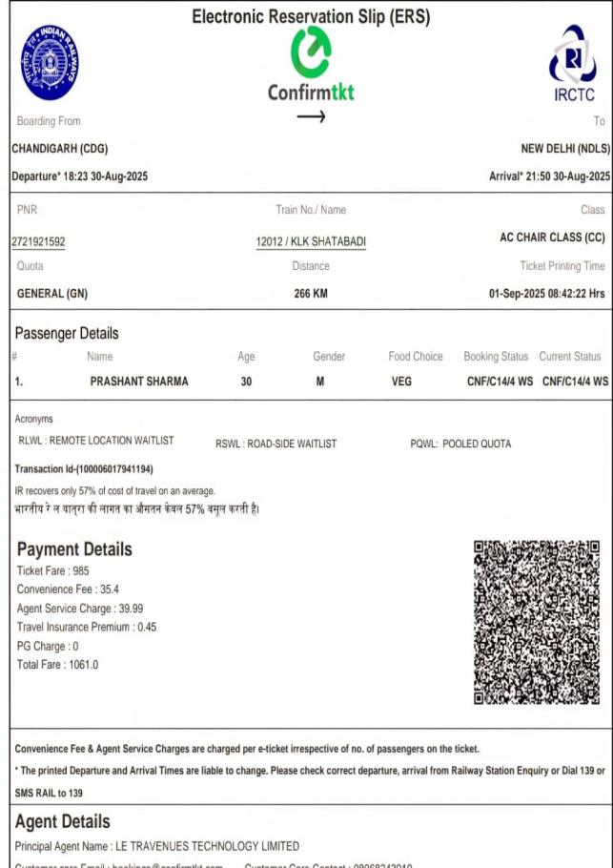
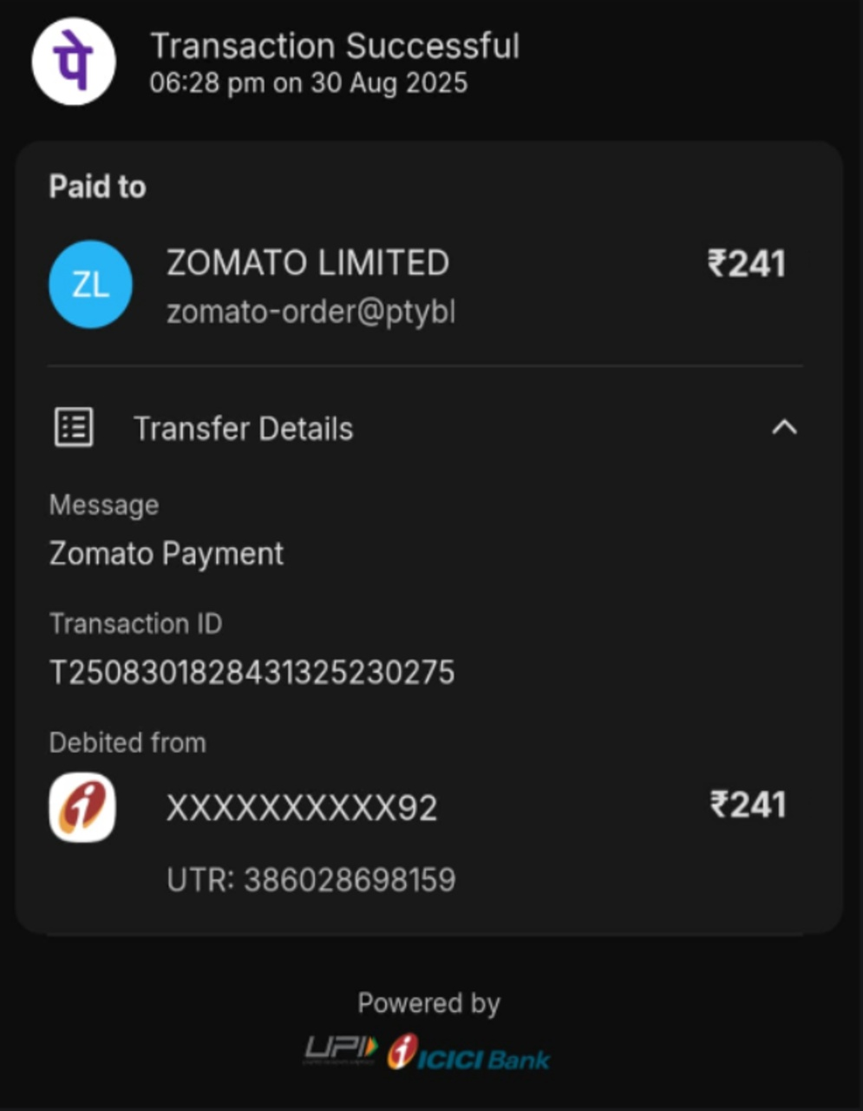
31-08-2025
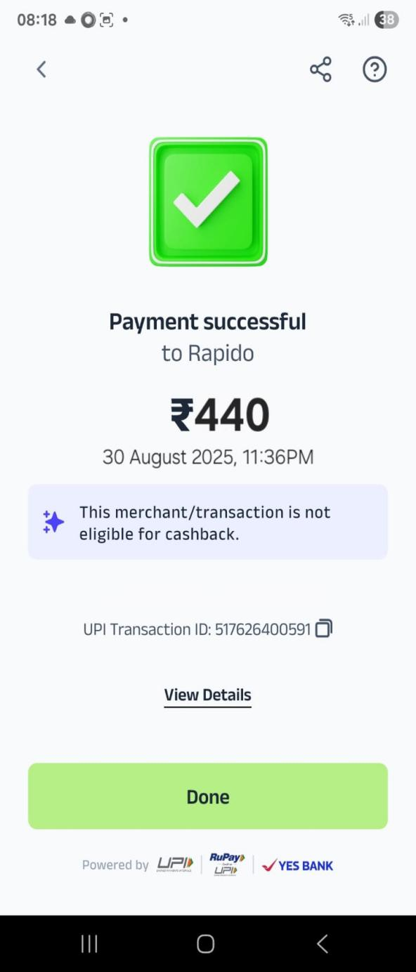 | 