**CSCI3310 Mobile Computing & Application Development**

Assignment 1

Classic Side Scroller Game

Due : Oct 9, 2015 11:55pm

Game app is the biggest constituent category in mobile application. Side scroller game in which the player slowly moving towards the right or up, define the first generation of arcade game. They are still being enjoyed by many people nowadays. In this assignment, we will implement a simple version of a classic side scroller game called “Moon Patrol”, using Corona. The purpose is to let you have some experience on using middleware such as Corona, and touch based UI programming and physics.

Moon Patrol is an early side-scrolling shooter introduced in 1982 and is widely credited for the introduction of parallax scrolling in side-scrolling video games. The objective is to eliminate a number of obstacles in the level by the colliding action of a ball. A screenshot is shown as below.

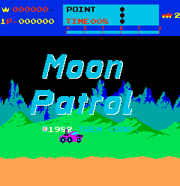

The player takes the role of a Luna City police officer assigned to Sector Nine, the home of the "toughest thugs in the galaxy". The player controls a moon buggy that travels over the moon's surface, viewing it from the side as it moves towards the right side of the screen. While driving it, obstacles such as craters and mines must be avoided, and various enemies such as UFOs from above and tanks on the ground must be shot down.

In this assignment, in order to limit the difficulty, you are only required to implement the basic requirement as stated below.

1. We use a screen resolution of **320 by 480**. This will keep the memory resources needed to a minimum.
2. The orientation of the device should be set at “**landscape**”.
3. When the game starts, our implementation is that the car will stay at about 40 pixels from left. The background will be slowly moving to the left, creating the impression of the car moving to right. The scrolling speed can be about 4 to 5 pixels per frame under frame rate of 30. You need not implement the move left and right in this assignment.
4. You should draw something in the background to differentiate the black background so as to create the impression of car moving to the right. We provide a sample background image for you. Obviously you are encouraged to draw your own background as well.
5. The player can make the car **jump** up to the air to avoid the craters. The air time can be from 1 to 3 seconds. The jump must be triggered by a **swipe** **gesture** **on** the car avatar.
6. We won’t have flying saucer enemies in this assignment. The danger to the player will only be the **craters** and **rocks** on the road.
7. Rocks can be eliminated by firing at it or jumping over it.
8. Craters can only avoided by jumping through it.
9. Tapping on any place on screen other than the car will **fire** a missile to the right. The missile upon hitting a rock will eliminate it.
10. The missile is having a speed of at least 2 times faster than the car travelling speed. It will disappear after 5 seconds travelling.
11. The car upon colliding with craters or rocks will die. “**Game over**” should be displayed at the center of the screen and the car image should be **removed**. The screen can either continue to scroll or stop.
12. There should be at least 2 craters and 2 rocks in your game during the patrol period.
13. When the scrolling is at the end, “**You win**” should be displayed at the center of the screen. The minimum scroll time in this assignment is **30 seconds**.
14. There is no need to implement the replay and next level control upon game over or finishing the patrol.

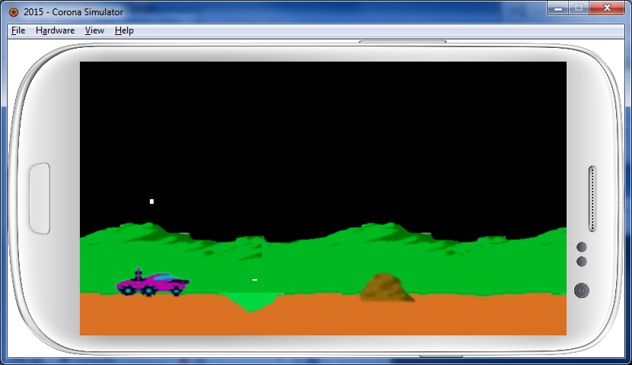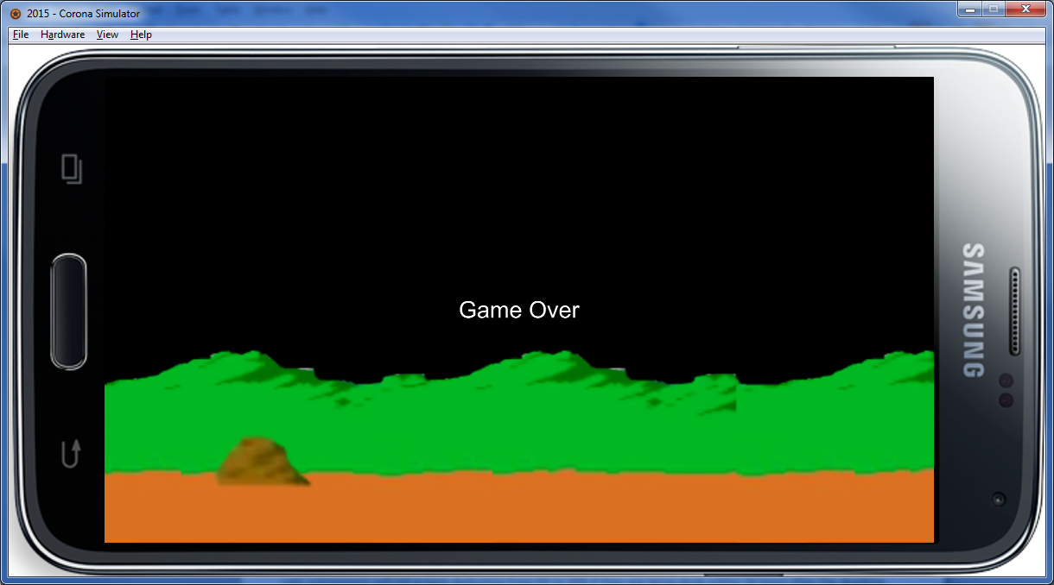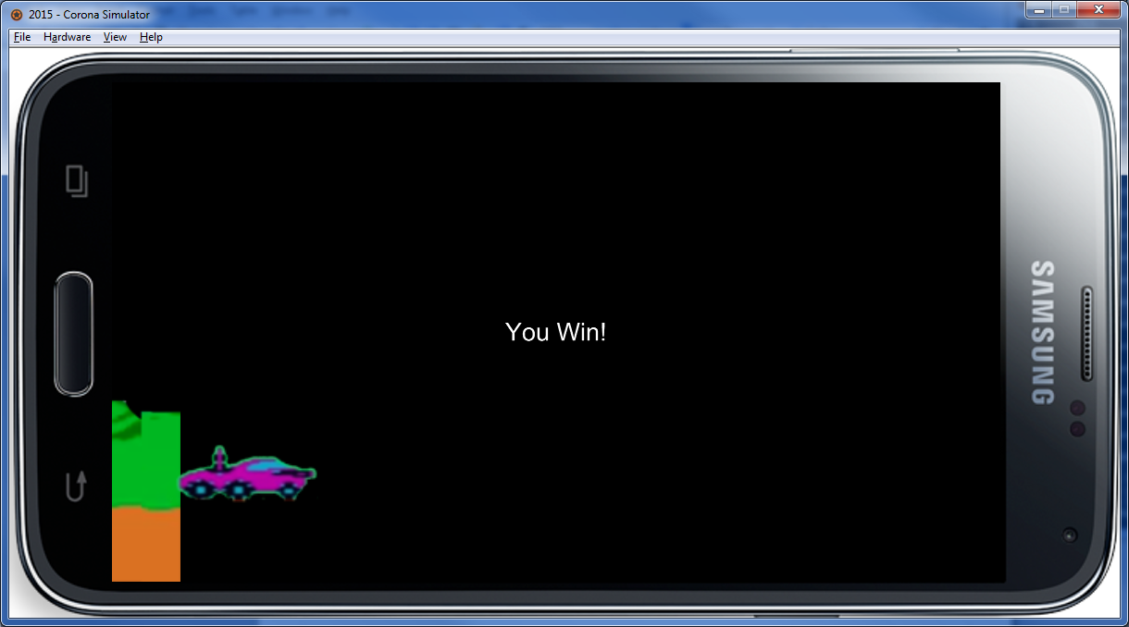

**Submission**

You should packed all your program and related files e.g. icon file, settings etc. into a folder named 3310_asg1, and zip the folder into the same named zip or rar file, and submitted it into our assignment collection slot in Blackboard system before the deadline, Oct 9, 2015 11:55pm.

Late submissions will risk a mark deduction from 5% to 30% if they are being done within 24 hours after the deadline. Submission later than Oct 12 11:55pm won’t be considered.

**Reference**

<https://en.wikipedia.org/wiki/Moon_Patrol>

A game play clip on youtube

<https://www.youtube.com/watch?v=HBOKWCpwGfM>