**CSCI3310 Mobile Computing & Application Development**

Assignment 3

Google Map with Traffic images

Due : Nov 30, 2015 (Mon) 11:59pm

In this assignment, you will implement the Google map feature into an app which helps users to know the timely traffic information.

Google Maps API provides enormous support to developers so that they can embed a map view in their app easily, but at the same time showing great map features to the user. Adding map view to your own program is in fact quite easy. But to do this, you need to go through several steps.

1. Register for your use of Map API in Google and obtain the key. You should follow the procedure listed here:  
   <https://developers.google.com/maps/documentation/android-api/start>
2. Adding the library use of Map, as well as permissions needed, which is both Internet, and location information in this assignment.

**Requirements**

It is recommended you open a new project to try the Google Map Android API v2 tutorial to understand the properties of Google map. Once you have the confident in working on the map, you may proceed to do the following.

1. You need to embed a map into your app. The map should show **one** of the images of the traffic snapshot at CCTV camera installed at various locations of major roads in Hong Kong. The map type can be either normal, satellite or hybrid as shown in the figure below.
2. Your map should display the traffic snapshot image as the marker icon centered on the map.
3. Your program should embed the description of the traffic image into the marker eg. “Tai Po Road near MTR Racecourse Station traffic snapshot images”. The description can be look up in [this](https://data.gov.hk/en-data/dataset/hk-td-tis-traffic-snapshot-images) link.
4. Your program should create a marker for one of the CCTV in Hong Kong(Tai Po Road near MTR Racecourse Station – link https://data.gov.hk/en-data/dataset/hk-td-tis-traffic-snapshot-images/resource/70c87bdb-2c75-4001-a103-4237a05dab1c) .
5. When the user tap on the marker(image), the program should **narrate i.e. speak** all the information i.e. description in the marker. In addition, the program should **update** the image by downloading a new snapshot and replace the current marker at the same position.  
     
   The link to the image can be found under the above link.

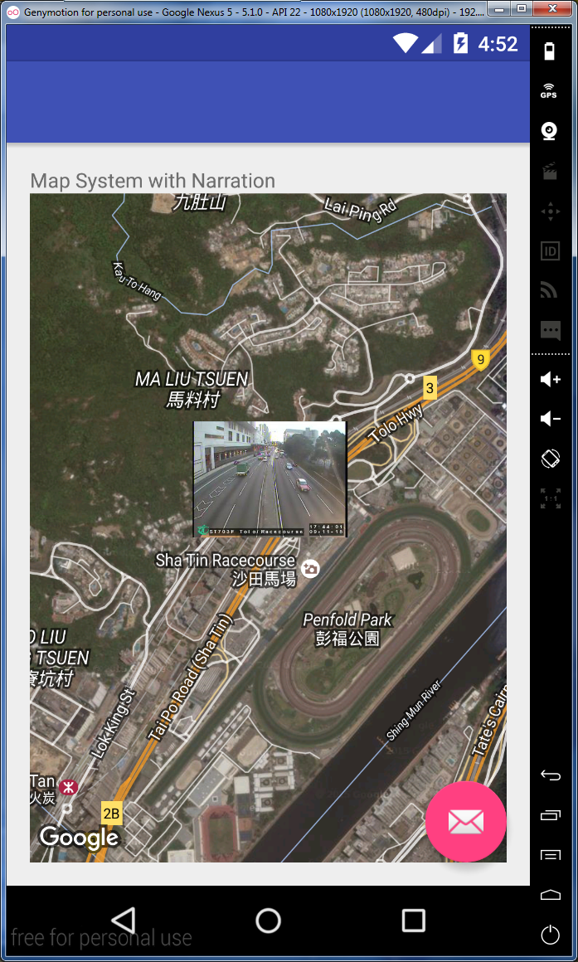

**Extension**

For those who find this assignment interesting can implement the additional feature below:

1. Our program at this point can return a traffic snapshot for selected cameras. You may consider to extend your program to incorporate ALL the 180 cameras installed and center the map view showing all of them.
2. Refresh of the traffic image is now done manually. You can consider to write a timer to update the images automatically

**Remarks:**

1. Platform for implementation  
   You may choose to implement the program on either Android 4.x or 5.x. But please be noted that the API to both map and speech is changed a bit among these two API levels.
2. There are some similar apps which are doing similar (but more features obviously) on the market:
3. <https://play.google.com/store/apps/details?id=mobi.coolapps.hkvisualtraffic>
4. <https://play.google.com/store/apps/details?id=com.roar.liveTraffic.liveTrafficHKFree>
5. <https://play.google.com/store/apps/details?id=com.rence.trafficSpotHK>
6. <https://play.google.com/store/apps/details?id=com.rwal.traffichk>

**Submission**

You should packed all your program and related files e.g. icon file, settings etc. into a folder named **3310_asg3**, and zip the folder into the same named zip or rar file, and submitted it into our assignment collection slot in Blackboard system before the deadline, Nov 30, 2015 11:59pm.

Late submissions will risk a mark deduction from 5% to 30% if they are being done within 24 hours after the deadline. Submission later than Dec 1 11:59pm won’t be considered.