## Connect to the farm, use your OneIT password

ssh [b17975@10.81.117.101](mailto:b17975@10.81.117.101)

## Another option to connect

ssh rhuath.am.freescale.net

## Open 4 terminals connected to rhuath

## Use console 1 for MC prints

## Use console 2 for AIOP prints

## Use console 3 for GPP prints

## Use console 4 for bft commands

## Use console 4 for the following commands

## Check if the board is free and try to reserve, our boards number are changing from day to day.   
## Please check the numbers before you reserve one.   
## Even if the board appears as free, you can’t take it unless it is assigned to SSI.  
## ls2qds-1 is one of the board names

bft query --board ls2085qds

bft reserve --claim ls2qds-1

bft reserve --claim ls2qds-1-MC

bft reserve --claim ls2qds-1-AIOP

## Use console 3 for the following commands

bft connect --console ls2qds-1

## Use console 1 for the following commands

bft connect --console ls2qds-1-MC

## Use console 2 for the following commands

bft connect --console ls2qds-1-AIOP

## Use console 4 in order to turn OFF and turn ON the board

bft power ls2qds-1  
bft power ls2qds-1

## ------------Look at console 3 to see the uboot----------------

## U-Boot 2015.01-02906-g0418018-dirty (Feb 02 2015 - 15:07:18) LS2085A-QDS

## fsl-mc: Booting Management Complex ...

## Polling mc_ccsr_regs->reg_gsr ...

## fsl-mc: timeout booting management complex firmware

## e1000: 68:05:ca:12:7d:70

## e1000#0

## Warning: e1000#0 using MAC address from net device

## Wait until “Hit any key to stop autoboot: n” and press ENTER

## If you get “ERROR: can't get kernel image!” ignore it.

## IMPORTANT: Do not do reset to board, use only power ON/OFF

## Now you’re in the Uboot prompt

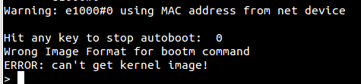

## Copy mc.itb into the farm  
## Use WinSCP and copy the image into /tftpboot/<username>, tftboot is above home directory.  
## Use the same IP as for rhuath

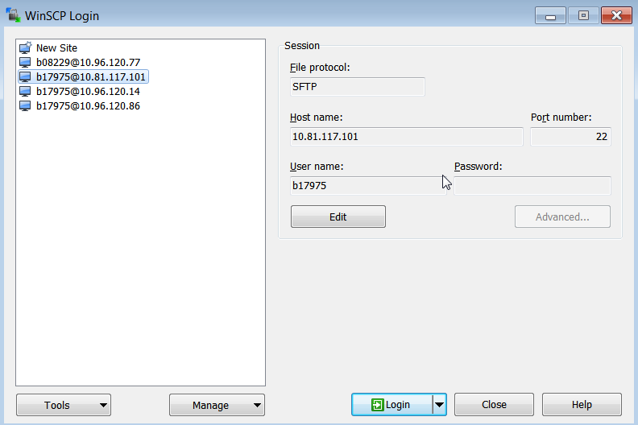

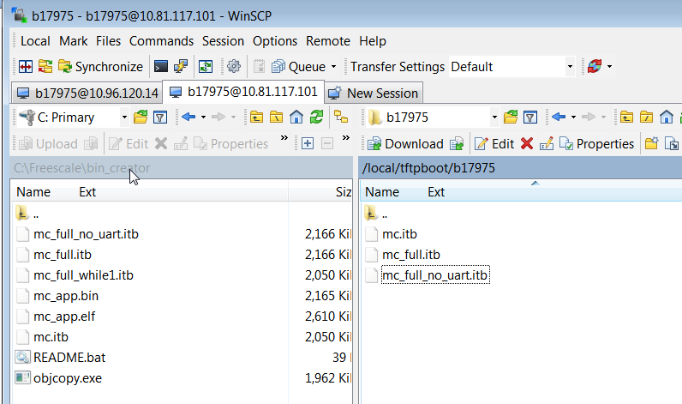

## Use console 3 in order to run the following commands  
## It will copy the images to the BOARD  
## You need to be in the Uboot prompt

setenv ipaddr 192.168.1.4;setenv serverip 192.168.1.1;setenv netmask 255.255.0.0; ping 192.168.1.1



tftp 0x80000000 <username>/mc.itb; erase 0x580300000 +0x300000; cp.b 0x80000000 0x580300000 $filesize

## If you need to use DPC and DPL copy them to the farm in the same way as we did for mc.itb and run:

tftp 0x80000000 <username>/dpl.dtb; erase 0x580700000 +$filesize; cp.b 0x80000000 0x580700000 $filesize

tftp 0x80000000 <username>/dpc.dtb; erase 0x580800000 +$filesize; cp.b 0x80000000 0x580800000 $filesize

## If you need to load AIOP and your uboot version supports autoloading of AIOP images from NOR flash:

tftp 0x80000000 <username>/aiop.elf; erase 0x580900000 +0x80000; cp.b 0x80000000 0x580900000 0x80000

## If you need to load AIOP and your uboot version DOESN’T supports autoloading of AIOP images from NOR flash, then pause MC before start_aiop(), load it to DDR using the command before and run MC.  
## As your AIOP image has been written to DDR directly there is no need to restart uboot in order to copy it from NOR FLASH.

tftp 0x83E7000000 <username>/aiop_app.elf;

## If you see this output, power OFF/ON and load the images again.

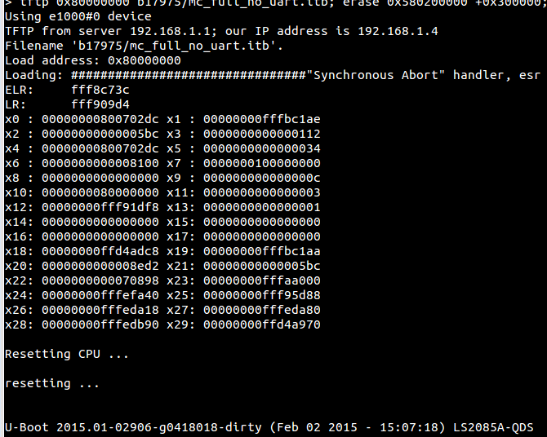

## Successful output of image loaded:

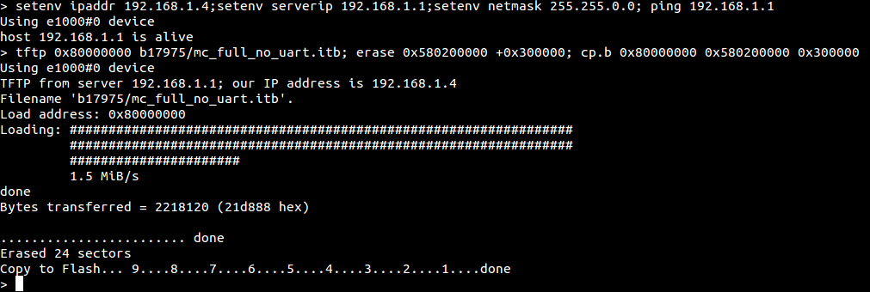

## Now go to console 4 and power Off/On the board.  
## This is done in order to restart the uboot that will copy the new images from NOR FLASH into DDR and will kick the new MC.  
bft power ls2qds-1  
bft power ls2qds-1

## Look at console 3 and see the Uboot which is loading now the new MC image.  
## Now you’re ready to attach using CW

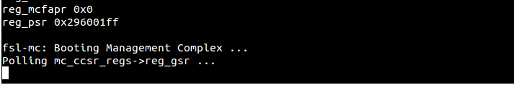

## CW launch file should look like this:  
## Use bft tap –i ls2qds-1 to get the CW TAP IP and set in inside HW connection as shown below:  
## If existing launch is not working, you may use CW File->New->Project in order to create good attach connection. You need to create 2 different attach connections 1 for AIOP and 1 for MC.

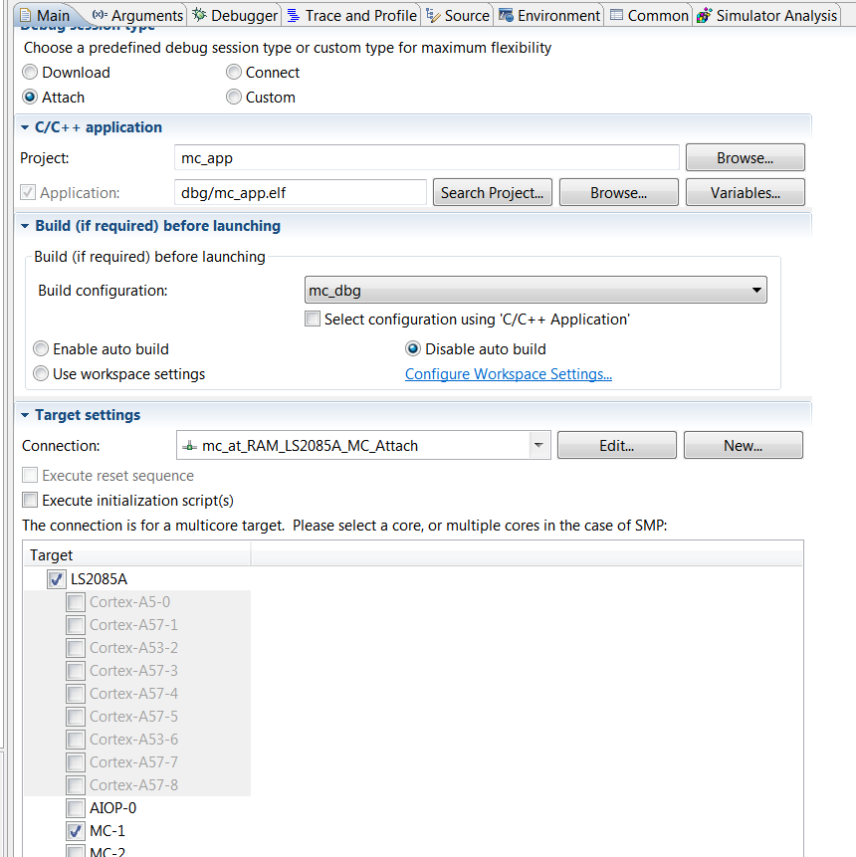

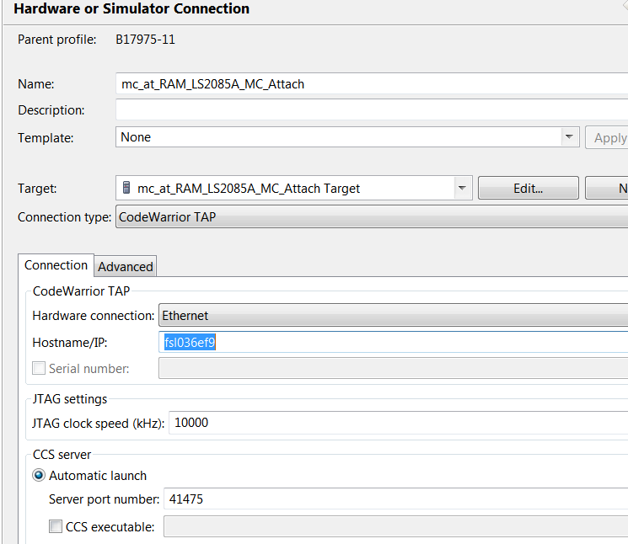

## AIOP connection will like this:

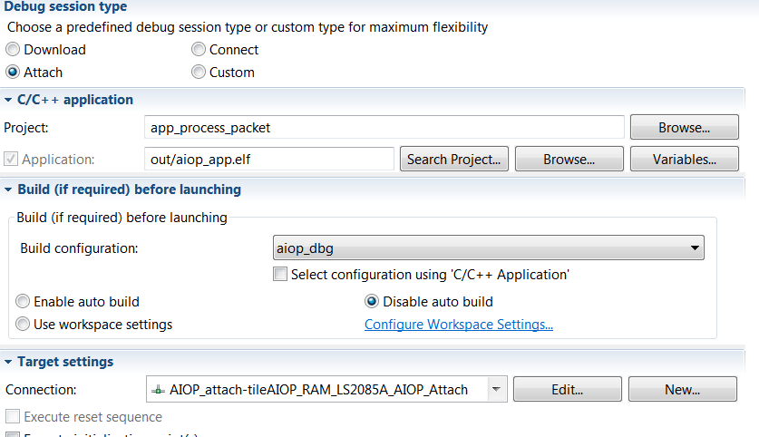

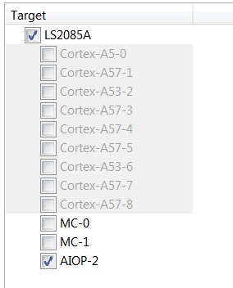

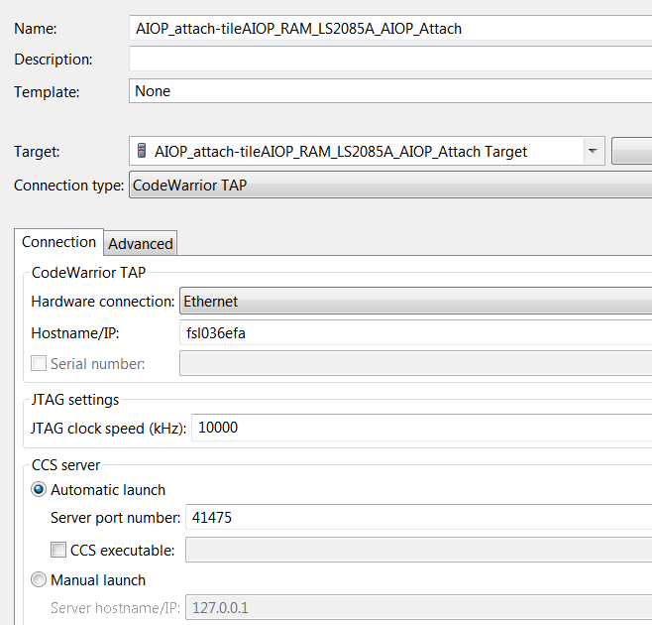

## Note the new image is not always loaded in a good way to DDR, you may see the SP is at 0x60 illegal instruction . If you see it do it again, power OFF/ON the board and reattach.

## Once you’re done please disconnect and free your board  
## Disconnect from console: CTRL + \ + C then ‘exit’ OR “bft connect --kill --force ls2qds-1”  
 ## Free the board,   
bft reserve --free ls2qds-1  
bft reserve --free ls2qds-1-AIOP  
bft reserve --free ls2qds-1-MC

## Use - -force to free the board that does not belong to you.   
bft reserve --free --force ls2qds-1  
bft reserve --free --force ls2qds-1-AIOP  
bft reserve --free --force ls2qds-1-MC  
  
## If you have difficulties to connect to board after you force freed it then connect to CW tap using IP and reset the CW TAP.  
## For CW TAP IP, do ping to output of ‘bft tap –i ls2qds-1’.  
telnet <CW TAP IP>  
> reset

To create MC ITB:

- Create mc_app.bin, can be done on Windows PC:

- > objcopy -O binary mc_app.elf mc_app.bin

- Copy mc/build/rel/mc.its and mc_app.bin into u-boot-devel/tools. Use WinSCP tool if you copy it from your Windows PC.

- > cd ./u-boot-devel/tools

- > ./mkimage -f mc.its mc.itb

Now copy mc.itb to your PC. Use WinSCP.