Ludo
Iteration 1 – System Report
Software Engineering and Quality Assurance in Information Systems, University of Haifa
Group Alligator
Nour Alden Mousa | 209431667
Lama Zbedat | 213970429
Aya Khalaila | 213764012
Sleeman Eketeh | 212017891
https://github.com/b14ckPanther/Ludo_Alligator
15/11/2026

1. What iteration 1 delivers
Iteration 1 is a full game of Ludo on the Easy board, from setting up the players to saving the result in the history file. It covers user stories US-1 to US-6 of our SDP. The Medium and Hard boards, question squares, the administrator area, surprises and computer players are planned for iterations 2 and 3.
Story | What the player can do | SRS IDs
US-1 | Set up a game: number of players, level, names and colors | P-SET-1 to 5
US-2 | See the board and whose turn it is | P-BRD-1, 4, 6, 7; P-DIC-1
US-3 | Roll and move pieces to the finish | P-DIC-2, 3, 5, 7, 8; P-MOV-1 to 4
US-4 | Capture other pieces | P-MOV-5
US-5 | See the results and save the game | P-END-1 to 5; DB-1, 3
US-6 | See old games | P-HIS-1; REL-2

2. How to run the system

2.1 What you need
- Java 17 or newer (check with java -version). Nothing else has to be installed.
- Windows 10 or newer, macOS 12 or newer, or Linux. A screen of at least 1280x720.

2.2 Starting the game
The ready-made jar is in the dist folder of the submitted zip and of the GitHub repository:
java -jar dist/Ludo_Alligator.jar
Or use the launch scripts in the main folder, which also build the jar if it is missing:
- Windows: double-click run.bat
- macOS / Linux: ./run.sh
On most computers a double-click on Ludo_Alligator.jar also works.

2.3 Building from the source code
- Windows: build.bat – macOS / Linux: ./build.sh (only a JDK 17+ is needed)
- With Maven: mvn package (the jar is written to target/Ludo_Alligator.jar)

2.4 Files the game makes
Finished games are saved in data/history.csv in a folder called data next to the jar. The folder is created the first time a game ends. The file follows the course template (see 4.5).

3. Inputs
Input | Valid values | If the value is wrong
Number of players | 2, 3 or 4 | Can only be chosen from the three options
Difficulty | Easy (Medium and Hard are shown but locked in this iteration) | Locked levels can't be selected
Player name | 1–16 characters after removing spaces at the ends; different from the other names (upper/lower case doesn't matter) | Game doesn't start, a message at the bottom, the name field gets a red border
Player color | Red, Green, Yellow or Blue, each color once | A color another player has is crossed out and can't be clicked
Roll | Roll the dice button, click on the die, Space or Enter | Ignored when it is not time to roll
Move | Click a glowing piece or press 1–4 | Clicking a piece that can't move does nothing

The game also reads data/history.csv when the History screen opens. Lines that can't be read are skipped.

4. What the player can do

4.1 Home screen
From the Home screen the player starts a new game (Play), opens the game history or closes the game.

Figure 1 – Home screen

4.2 Setting up a game
The player chooses the number of players and the difficulty, then a name and a color for every player. Taken colors are crossed out. When a value is wrong the game does not start and the field to fix is marked.
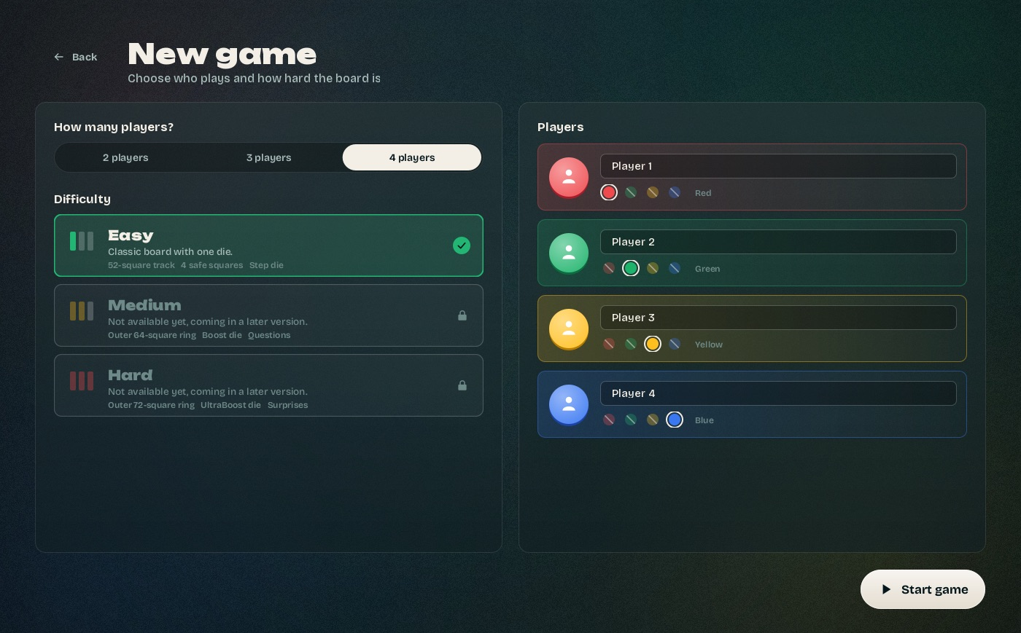
Figure 2 – Setup screen
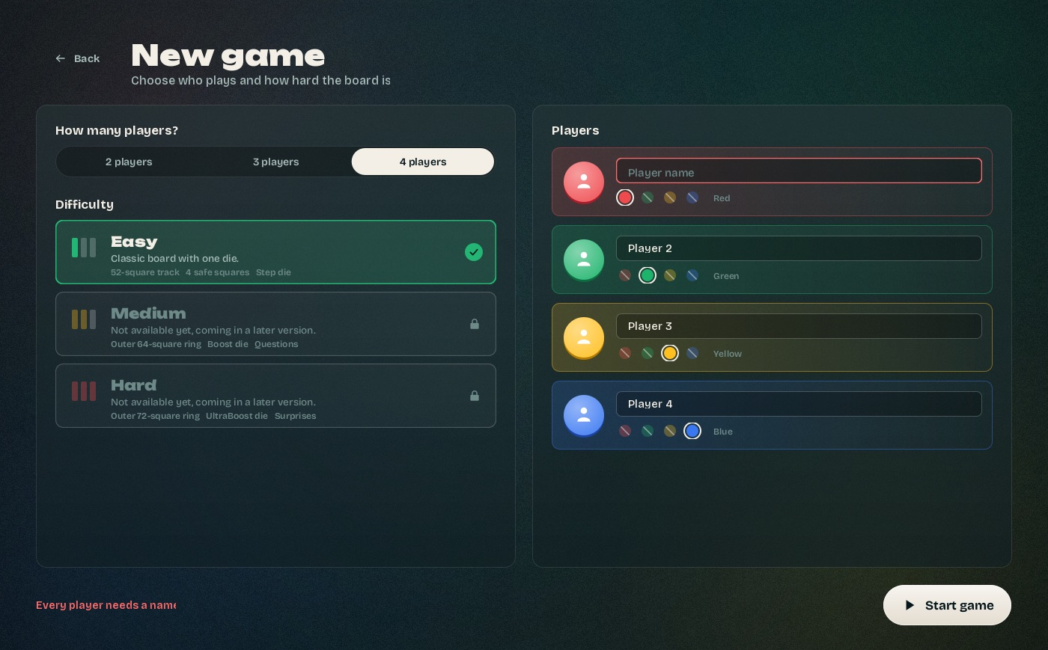
Figure 3 – An empty name is marked and the game does not start

4.3 Playing
The board shows the 52-square track, the four castles, the home columns and the finish. Start squares have #, safe squares a star and the arrow squares an arrow, so they can be told apart without colors. The side panel shows the game time, whose turn it is (name and color), the die, the players and a log of the last events.
- A piece leaves its castle only with a six, onto its start square. A six also gives another roll.
- After a roll the pieces that can move glow. Hovering one shows where it will land.
- Pieces move exactly the number rolled and need the exact number to reach the finish.
- If no piece can move, the log says why and the turn passes to the next player.
- Landing on a single opponent piece sends it back to its castle, except on start, safe and home squares.
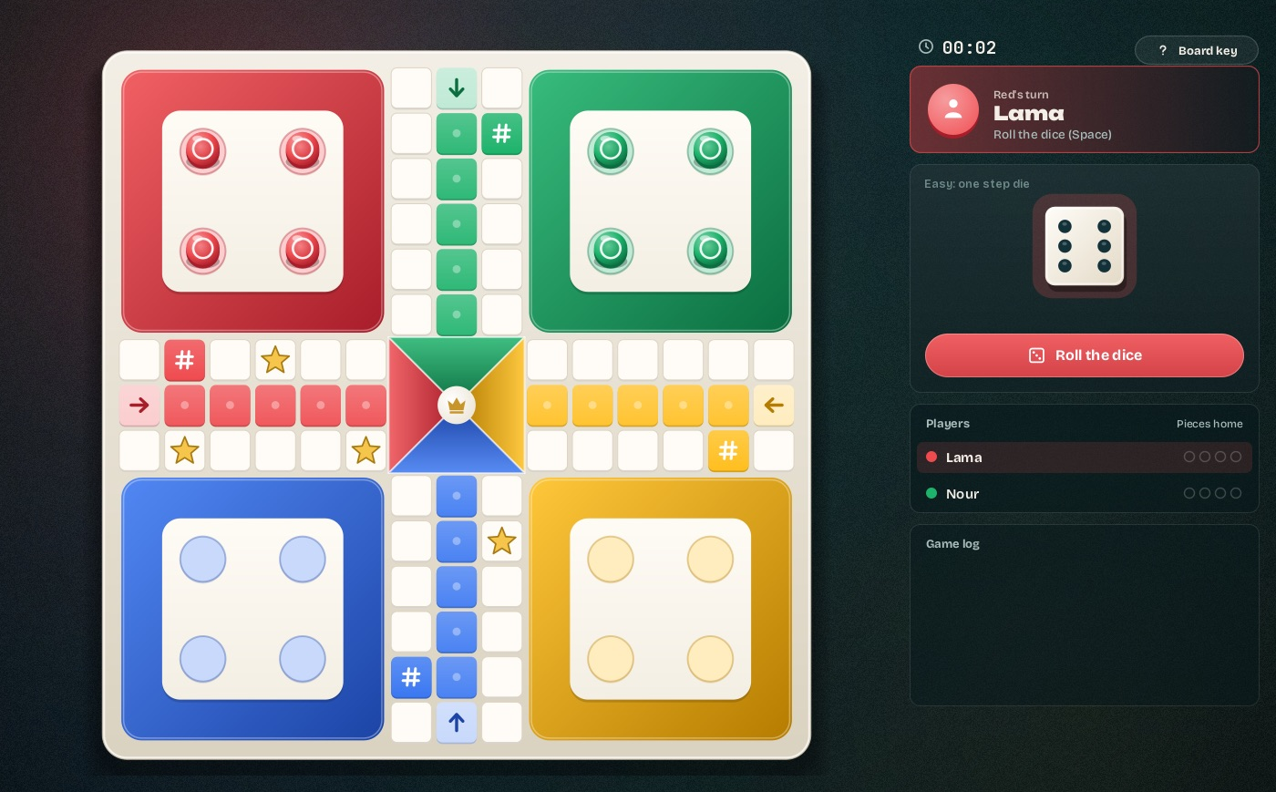
Figure 4 – The board at the start of a game
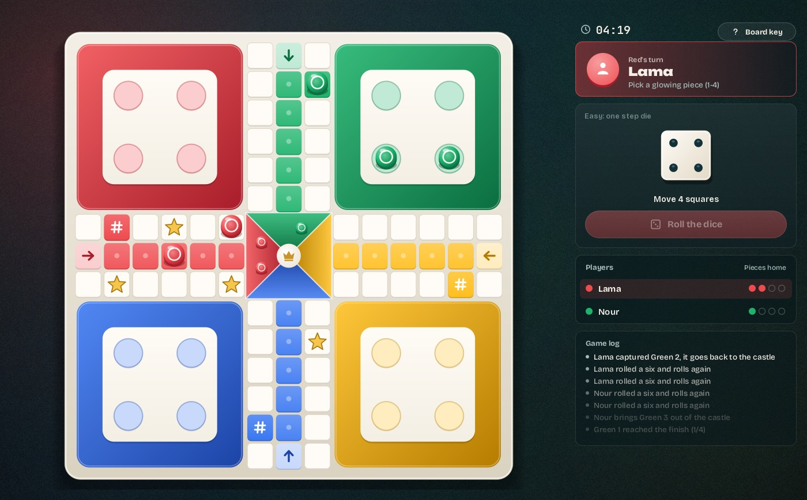
Figure 5 – During a game: Lama has two pieces home and just captured a green piece

4.4 Results
A player who brings all four pieces home takes the next place. When only one player is left the game ends and the Results screen shows every place, name and color and the game time, and whether the game was saved.
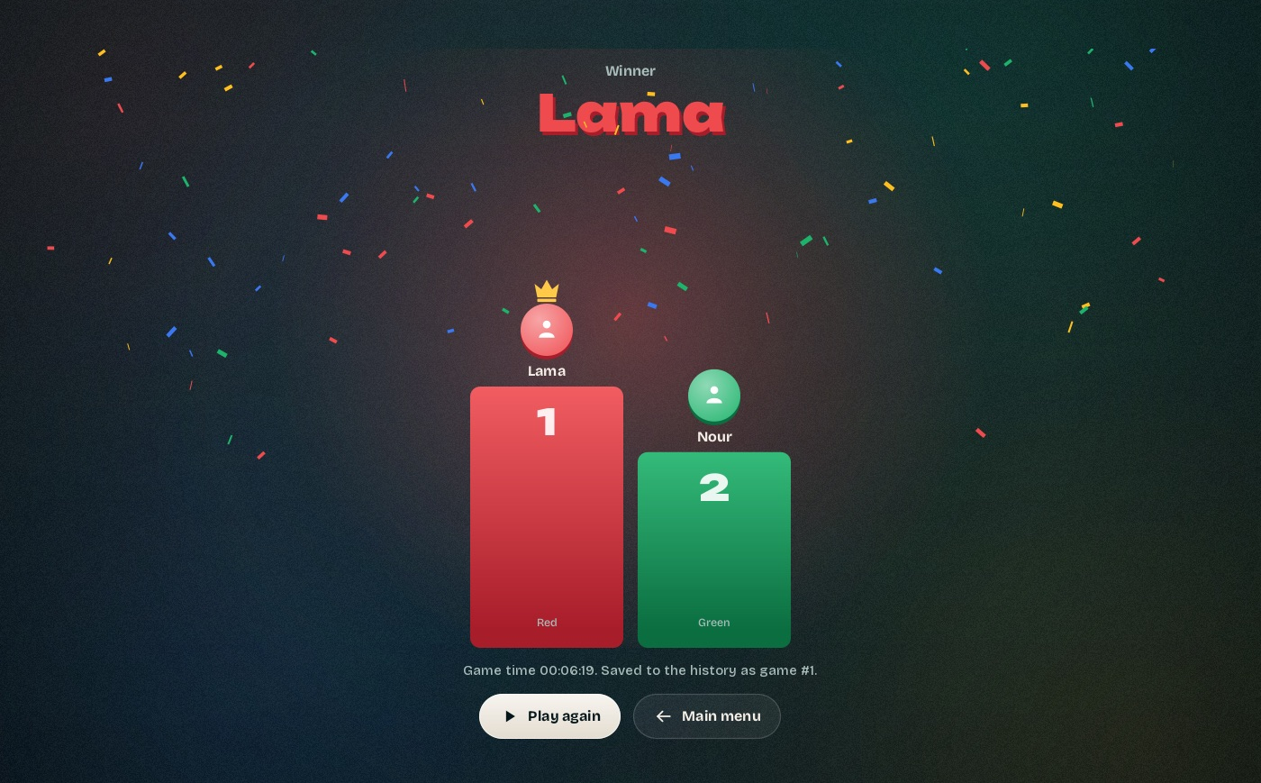
Figure 6 – Results screen

4.5 Game history
The History screen lists every saved game, newest first, with the date, difficulty, finishing order and duration. It can be filtered by difficulty.
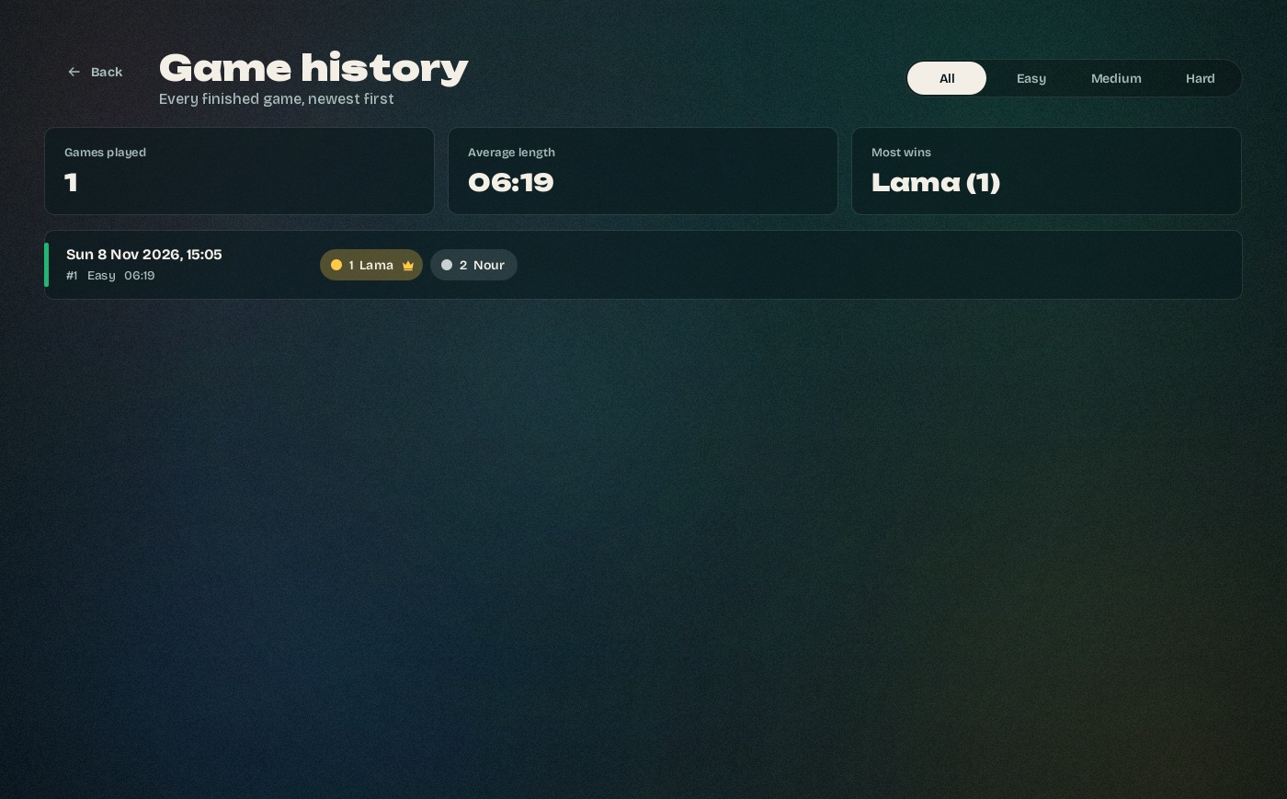
Figure 7 – History screen
The saved file uses the course template exactly. For example:
gameID,difficulty,timestamp(DD/MM/YYYY; HH:MM:SS),1st_place_name,2nd_place_name,3rd_place_name,4rd_place_name,game_duration(HH:MM:SS)
1,easy,08/11/2026;15:05:43,Lama,Nour,,,00:06:19

5. Expected results in different scenarios
Scenario | Expected result
Start with an empty name, a name over 16 characters or two equal names | The game doesn't start; the message says what to fix and the field is marked red
3 players: Blue, Green, Yellow | Green starts, then Yellow, then Blue (clockwise from the first color in play)
Roll 1–5 while all pieces are in the castle | Log: "<name> needs a six to leave the castle", the next player's turn
Roll 6 | A piece can come out (or a piece on the board can move 6), then the same player rolls again
Piece 3 squares before the finish, roll 5 | That piece can't move; if no other piece can, the turn passes
End a move on a single opponent piece on a plain square | The opponent piece goes back to its castle, the log shows the capture
End a move on an opponent on a star or start square | No capture, both pieces stay
A player gets all 4 pieces home | The player gets the next place (#1, #2…) and is skipped from then on
Only one player still has pieces out | The game ends, that player is last, the Results screen opens
Game ends normally | A new line is added to data/history.csv and the Results screen says "Saved to the history as game #N"
history.csv can't be written (for example read-only) | The Results screen is still shown, with the error in red
history.csv has a damaged line | The History screen skips that line and shows all other games
Space pressed twice quickly | Only one roll

6. How we tested the system
Unit tests with JUnit are planned for iteration 2 (MNT-2). In iteration 1 we tested as written in the quality control plan of our SDP (5.3.4):

6.1 Reviews of every task
Every task was done on its own branch (members other than the repository owner worked in their own fork) and merged with a pull request only after another member approved it. The depth of the review followed the SDP:
Tasks | Review | What was checked
T1.7, T1.9 | Deep: two members, test list | T1.7: 14 cases for P-MOV-1 to 4. T1.9: 12 cases for P-MOV-5 (protected squares, passing over, own pieces, two opponents). Both also ran 200 random 4-player games
T1.11 | Deep: compare with the course template | 17 checks: header byte for byte, CRLF line ends, 8 columns, empty places, RFC 4180 quoting, reading the template's own sample row, damaged rows, write errors, 10,000 games load in 36 ms
T1.1, T1.14 | Checklist: jar runs on Windows and macOS | See 6.3
T1.2, T1.4, T1.6, T1.10 | Normal: code review and test games | Setup checks, board and routes (57 squares per route), turns and dice (60,000 rolls, every face 9,813–10,165 times), game end (300 random games with 2–4 players all end with a full ranking)
T1.3, T1.5, T1.12 | Light: check by the PO | Screens checked by the PO
T1.8 | DoD only | Importance 2, view only

6.2 Acceptance test
The PO checked every user story against its SRS IDs (docs/iteration1/acceptance-test.md). A complete 2-player game was played on the jar with the keyboard only: 139 rolls, 123 moves, 24 sixes and a capture in 6:19. It ended on the Results screen and was saved as game #1. All six stories passed.

6.3 Jar on Windows and macOS
Our team works on Macs, so the jar is also tested on a Windows machine with GitHub Actions (workflow "Jar check"). On every push it takes the submitted jar, plays 50 games, opens the real window, saves a game and checks data/history.csv next to the jar, and then builds with build.bat / build.sh and starts the game with run.bat / run.sh. All checks pass on Windows Server 2025 and on macOS with Java 17.

6.4 Bugs found by testing
Bug | Fixed in
start() could announce the first player twice | T1.6
The board key button took the Space key away from rolling | T1.6
Roll text of the previous player stayed on screen | T1.6
Game time on the Results screen was cut off ("00:0") | T1.10
Last letter of some labels cut off ("editio") | T1.12
Home text cut off on Windows (found by the Windows test) | T1.14

7. GitHub repository
Repository: https://github.com/b14ckPanther/Ludo_Alligator
Main folders:
Folder | Content
src/main/java/Model | Game state and rules, no Swing code
src/main/java/View | The window and the screens
src/main/java/Controller | Main, AppController (screens) and GameController (one game)
dist/Ludo_Alligator.jar | The runnable jar
docs/iteration1 | Acceptance test, Windows/macOS test, class diagram, scrum report, questions
ci, .github/workflows | Jar test for Windows and macOS

Design patterns used in iteration 1: Observer (GameListener), Strategy (DiceStrategy), Factory (BoardFactory), Builder (GameConfig.Builder), Command (Move) and Repository (HistoryRepository). The class diagram (classDiagram_Alligator) shows them and the classes planned for the next iterations.

7.1 Who did what
Member | Role in iteration 1 | Tasks
Nour Alden Mousa | Scrum master + developer | T1.1 repository and jar build, T1.6 turns and dice, T1.9 capture, T1.14 Windows/macOS test, scrum report
Lama Zbedat | Product owner + developer | T1.8 movable pieces, T1.10 game end and Results screen, T1.13 acceptance test, README, this report
Aya Khalaila | Backend developer | T1.2 game and setup, T1.4 Easy board, T1.7 moving and finishing, T1.11 history file, class diagram
Sleeman Eketeh | Frontend developer | T1.3 Home and Setup, T1.5 Board screen, T1.12 History screen, questions file

8. Known limits of this version
- Only the Easy level can be played. Medium and Hard are shown on the Setup screen but locked.
- No question or surprise squares, Double Blocks, three-sixes rule, pause button or computer players yet (iterations 2 and 3).
- The history file has only the 8 columns of the course template; player colors are added as extra columns in iteration 3 (DB-2), so the History screen shows places in gold, silver and bronze.

