Visvesvaraya Technological University

BelgaVI-590014

A CG Mini-Project Report
On

“Snake Game 2D”

A Mini project report submitted in partial fulfillment of the requirements for the 6th semester of Bachelor of Engineering in Computer Science and Engineering
of Visvesvaraya Technological University, Belgavi

Submitted by:

AJAY DESHPANDE (1RN16CS005)

DHANUSH C (1RN16CS021)

Under the Guidance of:

Mrs. Sudhamani M J
Assistant Professor
Department of CSE



Department of Computer Science and Engineering
RNS Institute of Technology
Channasandra, Dr.Vishnuvardhan Road, Bengaluru-560 098
2018-2019

RNS Institute of Technology
Channasandra, Dr.Vishnuvardhan Road,
Bengaluru-560 098

Department of Computer Science & Engineering

CERTIFICATE
Certified that the mini project work entitled “SNAKE GAME 2D” has been successfully carried out by AJAY DESHPANDE bearing USN 1RN16CS005 and DHANUSH C bearing USN 1RN16CS021, bonafide students of RNS Institute of Technology in partial fulfillment of the requirements for the 6th semester of Bachelor of Engineering in Computer Science and Engineering of Visvesvaraya Technological University, Belgaum, during academic year 2018-2019. It is certified that all corrections/suggestions indicated for Internal Assessment have been incorporated in the report deposited in the departmental library. The project report has been approved as it satisfies the CG laboratory requirements of 6th semester BE, CSE.

Mrs. Sudhamani M J Dr. G T Raju
Assistant Professor Vice Principal and HOD
Dept. of CSE Dept of CSE

External Viva:
Name of the Examiners Signature with Date
1.

2.

ACKNOWLEDGMENT

Any achievement, be it scholastic or otherwise does not depend solely on the individual efforts but on the guidance, encouragement and cooperation of intellectuals, elders and friends. A number of personalities, in their own capacities have helped us in carrying out this project work. We would like to take this opportunity to thank them all.
We would like to thank Dr. H N Shivashankar, Director, RNSIT, Bangalore, for his moral support towards completing our project.
We are grateful to Dr. M K Venkatesha, Principal, RNSIT, Bangalore, for his support towards completing this mini project.
We would like to thank Dr. G T Raju,Vice Principal, Prof. and Head, Department of Computer Science & Engineering, RNSIT, Bangalore, for his valuable suggestions and expert advice.
We deeply express my sincere gratitude to all my guides Mrs. Sudhamani M J, Dr. Kiran P, Mrs. Sampada K S and Mrs. Rashmi M, Assistant Professors, Department of CSE, RNSIT, Bangalore, for their able guidance, regular source of encouragement and assistance throughout this project.
We would like to thank all the teaching and non-teaching staff of department of Computer Science & Engineering, RNSIT, Bengaluru for their constant support and encouragement.

Date : DHANUSH C
Place : Bangalore AJAY DESHPANDE

ABSTRACT

The Snake Game is a classic game from the 90’s. The project we have done is the snake game with certain developments in the animation regions and it is a simple version of the previous game.
The project has functionalities to detect collision of the snake head with outer boundaries and the snake body itself. The snake can grow by feeding over a circular food which appears at random co-ordinates. After certain intervals of time a big food like a bonus appears for sometime which can gain the player more points if consumed within a pre-defined duration.
We have used the openGL library for most functionalities. The keyboard function - a callback for the keyboard event, has been used to maneuver the snake to make it eat the food. Once the game has ended the score for the player appears on the screen clearing out the game background.

CONTENTS
Chapter | Page No
1.Introduction to computer graphics | 1-4
1.1 Overview of computer graphics | 1
1.2 History of computer graphics | 2
1.3 Applications of computer graphics | 3-4
2. OpenGL | 5-6
2.1 Introduction to OpenGL | 5
2.2 OpenGL libraries | 5
2.3 Graphics pipeline architecture | 6
2.4 OpenGL contributions | 6
2.5 Limitations | 6
3. Resource Requirements | 7
3.1 Hardware Requirements | 7
3.2 Software Requirements | 7
4. Function descriptions | 8-10
5. Implementation | 11-20
6. Testing  7. Results and snapshots | 21  22-24
8. Conclusion and Future enhancements | 25
References | 26

CHAPTER 1

INTRODUCTION

  - OVERVIEW OF COMPUTER GRAPHICS
The term computer graphics has been used in a broad sense to describe almost everything on computers that is not text or sound. Typically, the term computer graphics refers to several different things:
- The representation and manipulation of image data by a computer
- The various technologies used to create and manipulate images
- The images so produced, and
- The sub-field of computer science which studies methods for digitally synthesizing and manipulating visual content.
Today, computers and computer-generated images touch many aspects of daily life. Computer images is found on television, in newspapers, for example in weather reports, in all kinds of medical investigation and surgical procedures. A well-constructed graph can present complex statistics in a form that is easier to understand and interpret. In the media such graphs are used to illustrate papers, reports, thesis, and other presentation material.Many powerful tools have been developed to visualize data. Computer generated imagery can be categorized into several different types: 2D, 3D, 4D, 7D, and animated graphics.

As technology has improved, 3D computer graphics have become more common. Computer graphics has emerged as a sub-field of computer science which studies methods for digitally synthesizing and manipulating visual content. Over the past decade, other specialized fields have been developed like information visualization, and scientific visualization more concerned with the visualization of three dimensional phenomena (architectural, meteorological, medical, biological, etc.), where the emphasis is on realistic renderings of volumes, surfaces, illumination sources, and so forth, perhaps with a dynamic component.

  - HISTORY OF COMPUTER GRAPHICS
In 1959, the TX-2 computer was developed at MIT's Lincoln Laboratory. The TX-2 integrated a number of new man-machine interfaces. A light pen could be used to draw sketches on the computer using Ivan Sutherland's revolutionary Sketchpad software.^{[4]} Using a light pen, Sketchpad allowed one to draw simple shapes on the computer screen, save them and even recall them later. The light pen itself had a small photoelectric cell in its tip. This cell emitted an electronic pulse whenever it was placed in front of a computer screen and the screen's electron gun fired directly at it. By simply timing the electronic pulse with the current location of the electron gun, it was easy to pinpoint exactly where the pen was on the screen at any given moment. Once that was determined, the computer could then draw a cursor at that location. Also in 1961 another student at MIT, Steve Russell, created the first video game, E. E. Zajac, a scientist at Bell Telephone Laboratory (BTL), created a film called "Simulation of a two-giro gravity attitude control system" in 1963.
During 1970s, the first major advance in 3D computer graphics was created at UU by these early pioneers, the hidden-surface algorithm. In order to draw a representation of a 3D object on the screen, the computer must determine which surfaces are "behind" the object from the viewer's perspective, and thus should be "hidden" when the computer creates (or renders) the image.
In the 1980s, artists and graphic designers began to see the personal computer, particularly the Commodore Amiga and Macintosh, as a serious design tool, one that could save time and draw more accurately than other methods. In the late 1980s, SGI computers were used to create some of the first fully computer-generated short films at Pixar. The Macintosh remains a highly popular tool for computer graphics among graphic design studios and businesses. Modern computers, dating from the 1980s often use graphical user interfaces (GUI) to present data and information with symbols, icons and pictures, rather than text. Graphics are one of the five key elements of multimedia technology.
3D graphics became more popular in the 1990s in gaming, multimedia and animation. In 1996, Quake, one of the first fully 3D games, was released. In 1995, Toy Story, the first full-length computer-generated animation film, was released in cinemas worldwide. Since then, computer graphics have only become more detailed and realistic, due to more powerful graphics hardware and 3D modeling software.e

  - APPLICATIONS OF COMPUTER GRAPHICS
The applications of computer graphics can be divided into four major areas:
- Display of information
- Design
- Simulation and animation
- User interfaces

Display of information
Computer graphics has enabled architects, researchers and designers to pictorially interpret the vast quantity of data. Cartographers have developed maps to display the celestial and geographical information. Medical imaging technologies like Computerized Tomography (CT), Magnetic Resonance Imaging (MRI), Ultrasound, Positron Emission Tomography (PET) and many others make use of computer graphics.

Design
Professions such as engineering and architecture are concerned with design. They start with a set of specification; seek cost-effective solutions that satisfy the specification. Designing is an iterative process. Designer generates a possible design, tests it and then uses the results as the basis for exploring other solutions. The use of interactive graphical tools in Computer Aided Design (CAD) pervades the fields including architecture, mechanical engineering, and the design of very-large-scale integrated (VLSI) circuits and creation of characters for animation.

Simulation and animation
Once the graphics system evolved to be capable of generating sophisticated images in real time, engineers and researchers began to use them as simulators. Graphical flight simulators have proved to increase the safety and to reduce the training expenses. The field of virtual reality (VR) has opened many new horizons. A human viewer can be equipped with a display headset that allow him/her to see the images with left eye and right eye which gives the effect of stereoscopic vision. This has further led to motion pictures and interactive video games.

User interfaces
Computer graphics has led to the creation of graphical user interfaces (GUI) using which even naive users are able to interact with a computer. Interaction with the computer has been dominated by a visual paradigm that includes windows, icons, menus and a pointing device such as mouse. Millions of people are internet users; they access the internet through the graphical network browsers such as Microsoft internet explorer and Mozilla Firefox.

CHAPTER 2
OpenGL
2.1 Introduction to OpenGL
OpenGL (Open Graphics Library) is a standard specification defining a cross-language, cross-platform API for writing applications that produce 2D and 3D computer graphics. The interface consists of over 250 different function calls which can be used to draw complex three-dimensional scenes from simple primitives. OpenGL was developed by Silicon Graphics Inc. (SGI) in 1992 and is widely used in CAD, virtual reality, scientific visualization, information visualization, and flight simulation.
OpenGL provides a set of commands to render a three dimensional scene. That means you provide the data in an OpenGL-useable form and OpenGL will show this data on the screen (render it). It is developed by many companies and it is free to use. You can develop OpenGL-applications without licensing. OpenGL is a hardware- and system-independent interface. An OpenGL-application will work on every platform, as long as there is an installed implementation. Because it is system independent, there are no functions to create windows etc., but there are helper functions for each platform. A very useful thing is GLUT.

2.2 OpenGL LIBRARIES

Computer Graphics are created using OpenGL, which became a widely accepted standard software system for developing graphics applications. As a software interface for graphics hardware, OpenGL's main purpose is to render two- and three-dimensional objects into a frame buffer. These objects are described as sequences of vertices (which define geometric objects) or pixels (which define images). OpenGL performs several processing steps on this data to convert it to pixels to form the final desired image in the frame buffer.
OpenGL stands for ‘open graphics library’ graphics library is a collection of API’s (Applications Programming Interface). Graphics library functions are:
GL library (OpenGL in windows) – Main functions for windows.
GLU (OpenGL utility library) - Creating and viewing objects.
GLUT (OpenGL utility toolkit)- Functions that help in creating interface of windows OpenGL draws primitives—points, line segments, or polygons—subject to several selectable modes. You can control modes independently of each other; that is, setting one mode doesn't affect whether other modes are set (although many modes may interact to determine what eventually ends up in the frame buffer). Primitives are specified, modes are set, and other OpenGL operations are described by issuing commands in the form of function calls. These libraries are included in the application program using preprocessor directives
#include<GL/glut.h>
OpenGL User Interface Library (GLUI) is a C++ user interface library based on the OpenGL Utility Toolkit (GLUT) which provides controls such as buttons, checkboxes, radio buttons, and spinners to OpenGL applications. It is window and operating system independent, relying on GLUT to handle all system-dependent issues, such as window and mouse management.
The OpenGL Utility Library (GLU) is a computer graphics library. It consists of a number of functions that use the base OpenGL library to provide higher-level drawing routines from the more primitive routines that OpenGL provides. It is usually distributed with the base OpenGL package.
2.3 OpenGL CONTRIBUTIONS
It is very popular in the video games development industry where it competes with Direct3D (on Microsoft Windows).OpenGL is also used in CAD, virtual reality, and scientific visualization programs.OpenGL is very portable. It will run for nearly every platform in existence, and it will run well. It even runs on Windows NT 4.0 etc. The reason OpenGL runs for so many platforms is because of its Open Standard.
OpenGL has a wide range of features, both in its core and through extensions. Its extension feature allows it to stay immediately current with new hardware features, despite the mess it can cause.

2.4 LIMITATIONS
- OpenGL is case sensitive
- Line Color, Filled Faces and Fill Color not supported.
- Bump mapping is not supported.
- Shadow plane is not supported.

CHAPTER 3

RESOURCE REQUIREMENTS

3.1 HARDWARE REQUIREMENTS
The Hardware requirements are very minimal and the program can be run on most of the machines.
Processor | : | Intel Core i5 processor
Processor Speed | : | 2.50 GHz
RAM | : | 4 GB
Storage Space | : | 40 GB
Monitor Resolution | : | 1024*768 or 1336*768 or 1280*1024

3.2 SOFTWARE REQUIREMENTS

Operating System : elementary OS 0.4.1 Loki
IDE : Microsoft Visual Studio Code.
OpenGL libraries, Header Files which includes GL/glut.h, Object File Libraries, glu32.lib,opengl32.lib,glut32.lib,DLLfiles,glu32.dll,glut32.dll,opengl32.dll.

CHAPTER 4

SYSTEM DESIGN
The description of all the functions used in the program is given below:
- void glutInitDisplayMode (unsigned int mode) :- This function requests a display with the properties in mode. The value of mode is determined by the logical OR of options including the color model (GLUT_RGB, GLUT_INDEX) and buffering (GLUT_SINGLE, GLUT_DOUBLE).
- void glutInitWindowPosition (int x, int y) :- This specifies the initial position of top-left corner of the windows in pixels.
- void glutInitWindowSize (int width, int height) :- This function specifies the initial height and width of the window in pixels.
- void glutCreateWindow (char *title) :- This function creates a window on the display the string title can be used to label the window. The return value provides a reference to the window that can be used when there are multiple windows.
- void glutDisplayFunc (void (*func) (void)) :- This function registers the display func that is executed when the window needs to be redrawn.
- void glClearColor(GLclampfr,GLclampf g, GLclampfb,GLclampf a)
This sets the present RGBA clear colour used when clearing the colour buffer. Variables of type GLclampf are floating point numbers between 0.0 and 1.0.
- void glClear(GLbitfield mask) :- It clear buffers to present values. The value of mask is determined by the bitwise OR of options GL_COLOR_BUFFER_BIT, GL_DEPTH_BUFFER_BIT
- void glutPostRedisplay ()This function requests that the display callback be executed after the current callback returns.
- void glutReshapeFunc (void *f (int width, int height) :- This function registers the reshape callback function f. The callback function returns the height and width of the new window. The reshape callback invokes a display callback.
- void glViewport (int x, int y, GLsizei width, GLsizei height) :- This function specifies a width*height viewport in pixels whose lower left corner is at. (x, y) measured from the origin of the window.
- void glMatrixMode (GLenum mode) :- This function specifies which matrix will be affected by subsequent transformations. Mode can be GL_MODEL_VIEW, GL_PROJECTION, GL_TEXTURE.
- void glLoadIdentity () :- This function sets the current transformation matrix to an identity matrix.
- void gluOrtho2D(GLdoubleleft, GLdouble right, GLdouble bottom, GLdouble top) :- This function defines a two-dimensional viewing rectangle in the plane z=0.
- void glutMouseFunc (void *f (int button, int state, int x, int y) :- This function registers the mouse callback function f. The callback function return the button (GLUT_LEFT_BUTTON, GLUT_MIDDLE_BUTTON, GLUT_RIGHT_BUTTON), the state of the button after the event (GLUT_UP, GLUT_DOWN), and the position of the mouse relative to the top-left corner of the window.
- void glVertex3f(TYPE xcoordinate, TYPE ycoordinate, TYPE zcoordinate) OR void glVertex3fv(TYPE *coordinates) :- This specifies the position of a vertex in 3 dimensions. If v is present, the argument is a pointer to an array containing the coordinates.
- void glBegin(glEnum mode) This function initiates a new primitive of type mode and starts the collecion of vertices. Values of mode include GL_POINTS, GL_LINES and GL_POLYGON.
- void glEnd() :- This function terminates a list of vertices.
- void glutMainLoop() :- This function causes the program to enter an event processing loop. It should be the last statement in main.
- void glPushMatrix(void) :- Pushes all matrices in the current stack down one level. The current stack is determined by glMatrixMode(). The topmost matrix is copied, so its contents are duplicated in both the top and second-from-the-top matrix. If too many matrices are pushed, an error is generated.
- void glRotate{fd} (TYPE angle, TYPE x, TYPE y, TYPE z);
- void glTranslate{fd} (TYPE x, TYPE y, TYPE z);
- void glScale {fd} (TYPE x, TYPE y, TYPE z);
- void glPopMatrix (void);
- Pops the top matrix off the stack, destroying the contents of the popped matrix. What was the second-from-the-top matrix becomes the top matrix. The current stack is determined byglMatrixMode(). If the stack contains a single matrix, calling glPopMatrix() generates an error.
- glPopMatrix() : To destroy the matix on top of the stack and to make the second matrix on the stack become the current matrix
- glutMouseFunc(mousefcn) : Specify a mouse callback function that is to be invoked when a mouse button is pressed
- glutKeyboardFunc(keyboardfcn) : Specify a keyboard callback function that is to be invoked when a standard key is pressed
- void drawFood() : Displays the circular food a t random places.
- void drawBigFood() : Displays big food at random places after a particular duration of time.
- void detectCollision() : Checks if there is any collision of the snake head with the outer boundary or the snake’s body itself.
- void drawSnake() : Draws the snake with increased or initial size with updated co-ordinates in the direction of movement.

CHAPTER 5
IMPLEMENTATION
#include<stdio.h>
#include<stdlib.h>
#include<string.h>
#include<math.h>
#include<GL/glut.h>

#define COLUMNS 40
# define ROWS 40
// FPS -> frames per second
// here greater the FPS faster is the game speed
# define FPS 10

//this are the GLUT_KEY_UP values we can use these to compute snake direction
# define UP 101
# define DOWN 103
# define RIGHT 102
# define LEFT 100
# define MAX 60 //max size of the body of snake

int gridX, gridY; // for grid coordinates
int snake_length = 5; //initial snake body length
int snake_direction = RIGHT; // initial snake direction is right
int posX[60] = { 20, 20, 20, 20, 20}, posY[60] = { 20, 19, 18, 17, 16}; // initial position of snake

int gameOver = 0; //bool
int food = 1;
int bigFood = 0; //bool
int bigFoodCount = 0;
int foodX, foodY; // food position
int bigTimer = 0;
int bigX, bigY;
int score = 0;

void unit(int, int);
//sets maximum value of the grid to check boundary condition for collision
void initGrid(int x, int y) {
gridX = x;
gridY = y;
}

void unit(int x, int y) // for drawing each square block (grid) on the display
{
if (x == 0 || y == 0 || x == gridX - 1 || y == gridY - 1) {
glLineWidth(3.0);
glColor3f(1.0, 0.0, 0.0);
//drawing a square of length 1 unit
glBegin(GL_POLYGON); //outer wall solid
} else {
glLineWidth(1.0);
glColor3f(1.0, 1.0, 1.0);
glBegin(GL_LINE_LOOP);
}
glVertex2f(x, y);
glVertex2f(x + 1, y);
glVertex2f(x + 1, y + 1);
glVertex2f(x, y + 1);
glEnd();
}
// for drawing square grids
void drawGrid() {
for (int x = 0; x < gridX; x++) {
for (int y = 0; y < gridY; y++) {
unit(x, y);
}
}
}

//

int bodyCollision() {
// it is used to detect body collision of snake

for (int i = snake_length - 1; i > 0; i--) {
if (posX[i] == posX[0] && posY[i] == posY[0])
return 1;
//if head position matches(coincides) with any of body position then GAMEOVER!
}
return 0;

}

void drawSnake() {
/*
draw snake with updated values
to move the body of the snake we just have to shift all the body parts from back to front except head
head will goto a new position based on the key pressed.
So just by changing heads position rest of the body will just follow head
to move the body of the snake we just have to shift all the body parts from back to front except head
head will goto a new position based on the key pressed.
So just by changing heads position rest of the body will just follow head
*/

//starting with the last part of body towards head
for (int i = snake_length - 1; i > 0; i--) {
posX[i] = posX[i - 1];
posY[i] = posY[i - 1];
}

if (snake_direction == UP)
posY[0]++; //increment posY ,posX remains same
else if (snake_direction == DOWN)
posY[0]--; //decrement posY ,posX remains same
else if (snake_direction == RIGHT)
posX[0]++; //increment posX ,posY remains same
else if (snake_direction == LEFT)
posX[0]--; //decrement posX ,posY remains same

//values of the snake body are changed now drawing it actually
for (int i = 0; i < snake_length; i++) {
if (i == 0)
//green color for head of the snake
glColor3f(0.0, 1.0, 0.0);
else
glColor3f(0.0, 0.0, 1.0);
//to draw a solid rectangle for each block of snake body
glRectd(posX[i], posY[i], posX[i] + 1, posY[i] + 1);
}
glColor3f(1.0, 0.0, 0.0);
if (posX[0] == 0 || posX[0] == gridX - 1 || posY[0] == 0 || posY[0] == gridY - 1 || bodyCollision()) {
// it snake head touches the border of the window or touches itself then GAMEOVER!!
gameOver = 1;
} else if (posX[0] == foodX && posY[0] == foodY) {
// checking if newly generated food location is same as the snake location
score++;
snake_length++;
/*
body size is increased now so the last block we used to overwrite will be written to this new block at the tail of snake and rest all works same
*/
//if snake length is greater than this it will hard to play so we wont increase size of the body
if (snake_length > MAX)
snake_length = MAX;
food = 1; //generate new food

//we set this value because every time frame is rendered drawfood is called even if snake
//hasnt eaten the food
} else if (posX[0] == bigX && posY[0] == bigY) {
// else if(posX[0] >= bigX && posY[0] >= bigY && posX[0] <= bigX+2 && posY[0] <= bigY+2) {
score += 4;
snake_length += 2;
if (snake_length > MAX)
snake_length = MAX;
food = 1; //generate new food
bigFoodCount = 0;
bigFood = 0;
bigTimer = 0;
}
//to display tongue right before snake eats it
else if (posX[0] == foodX - 2 && posY[0] == foodY) {
glRectd(posX[0] + 1, posY[0], posX[0] + 2, posY[0] + 1);
} else if (posX[0] == foodX + 2 && posY[0] == foodY) {
glRectd(posX[0] - 1, posY[0], posX[0] - 2, posY[0] + 1);
} else if (posY[0] == foodY - 2 && posX[0] == foodX) {
glRectd(posX[0], posY[0] + 1, posX[0] + 1, posY[0] + 2);
} else if (posY[0] == foodY + 2 && posX[0] == foodX) {
glRectd(posX[0], posY[0] - 1, posX[0] + 1, posY[0] - 2);
}
}

int findElement(int * a, int length, int ele) {
//Search starts from the 0th location
int i = 0;
while (i < length && ele != a[i]) {
i++;
}
if (i < length)
return 1;
return 0;
}

void drawFood() {
if (food) {
// generating food position
// random(foodX, foodY);
//inbetween the walls
printf("food = %d bigFood = %d bigFoodCount = %d \n", food, bigFood, bigFoodCount);
int maxX = gridX - 2, maxY = gridY - 2;
int min = 1;
while (1) {
foodX = min + rand() % (maxX - min);
foodY = min + rand() % (maxY - min);
int statusX = findElement(posX, snake_length, foodX);
int statusY = findElement(posY, snake_length, foodY);
//to make sure generated food isnt on the body of snake
if (!statusX || !statusY)
break;
}
bigFoodCount++;
if (bigFoodCount == 5) {
bigFood = 1;
food = 0;
return;
}
}

food = 0; //dont generate a new food until its eaten
glColor3f(1.0, 1.0, 1.0);
glRectf(foodX, foodY, foodX + 1, foodY + 1); // drawing food
}
void drawBigFood() {
if (bigFood) {
int maxX = gridX - 4, maxY = gridY - 4;
int min = 1;

bigX = min + rand() % (maxX - min);
bigY = min + rand() % (maxY - min);

}
bigFood = 0;
printf("%d\n", bigTimer);
//how long should the big food be there
if (bigTimer++ < 30) {

glColor3f(1.0, 0.0, 0.0);
if (bigTimer % 3 == 0)
glRectf(bigX, bigY, bigX + 1, bigY + 1);
} else {
bigTimer = 0;
bigFood = 0;
bigFoodCount = 0;
food = 1;
}
}

void display_callback() {
glClear(GL_COLOR_BUFFER_BIT);

drawGrid(); //draws grid lines every frame
drawSnake(); //draws the snake body in its new/current state for every frame
if (bigFoodCount != 5)
drawFood(); //generates a food at a random position
else
drawBigFood();

glutSwapBuffers(); //swaps content from back buffer to front for display

if (gameOver) { //game over end the program by displaying score
glClearColor(0.0 f, 0.0 f, 0.0 f, 1.0 f);
glClear(GL_COLOR_BUFFER_BIT | GL_DEPTH_BUFFER_BIT);
glColor3f(0.0, 1.0, 0.0);
char str_score[50];
sprintf(str_score, "Your score is %d", score);

glRasterPos3f(17.0 f, 25.0 f, 0.0 f);
for (int i = 0; str_score[i] != '\0'; i++)
glutBitmapCharacter(GLUT_BITMAP_HELVETICA_18, str_score[i]);

glutSwapBuffers();
glFlush();
for (int i = 0; i < 1000000000; i++);
exit(0);
}
}

void reshape_callback(int w, int h) {
glViewport(0, 0, w, h);
/*
glViewport(x,y,w,h)
x,y - lower left corner of the viewport rectangle
w,h - takes value from the current dimensions of window
so when u resize the window it automatically sets dimensions
*/

glMatrixMode(GL_PROJECTION);

glLoadIdentity(); //loads identity matrix
glOrtho(0.0, COLUMNS, 0.0, ROWS, -1.0, 1.0);
glMatrixMode(GL_MODELVIEW);
}

void init() {
glClearColor(0.0, 0.0, 0.0, 1.0);
initGrid(COLUMNS, ROWS); // sets grid values
}

void keyboard(int key, int x, int y) {
//printf("%d \n",key);
switch (key) {

case GLUT_KEY_UP:
//if snake is moving down then going up directly is impossible

if (snake_direction != DOWN)
snake_direction = key;
break;

case GLUT_KEY_DOWN:
//if snake is moving up then going down directly is impossible
if (snake_direction != UP)
snake_direction = key;
break;

case GLUT_KEY_RIGHT:
//if snake is moving left then going right directly is impossible
if (snake_direction != LEFT)
snake_direction = key;
break;

case GLUT_KEY_LEFT:
//if snake is moving right then going left directly is impossible
if (snake_direction != RIGHT)
snake_direction = key;
break;
}
}

void timer_callback(int a) {
glutPostRedisplay();
glutTimerFunc(1000 / FPS, timer_callback, 0);
}

int main(int argc, char ** argv) {
glutInit( & argc, argv);
glutInitDisplayMode(GLUT_RGB | GLUT_DOUBLE);
glutInitWindowPosition(100, 100);
glutInitWindowSize(600, 600);
glutCreateWindow("Snake 2D");
init();
glutDisplayFunc(display_callback);
glutReshapeFunc(reshape_callback);
glutSpecialFunc(keyboard); //void glutSpecialFunc(void (*func)(int key, int x, int y));
glutTimerFunc(0, timer_callback, 0);

glutMainLoop();
return 0;
}

CHAPTER 6

TESTING

In unit testing, the program modules that make up the system are tested individually. Unit testing focuses to locate errors in the working modules that are independent to each other. This enables to detect errors in coding and the logic within the module alone. This testing is also used to ensure the integrity of the data stored. The various routines were checked by passing the inputs and the corresponding output is tested. Test cases used in the project as follows:

Serial  No | Metric | Description | Observation
1 | Keyboard  Function | The arrow keys for changing the direction of snake movement. | Results obtained as expected
2 | Display  Function | The grid, outer boundary, snake and the food are displayed. | Results obtained as expected
3 | Animation  Effect | The movement of snake and showing the tongue when snake eats food. | Results obtained as expected

CHAPTER7
RESULTS AND SNAPSHOTS
- Initial
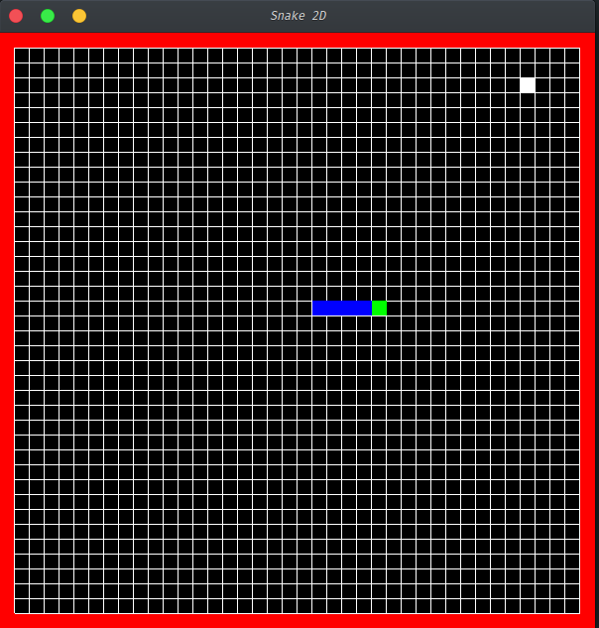

- Food

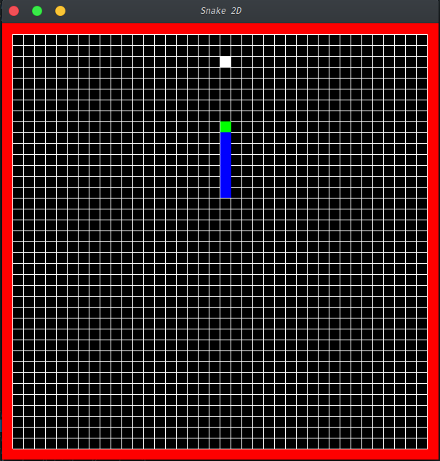

- Big Food

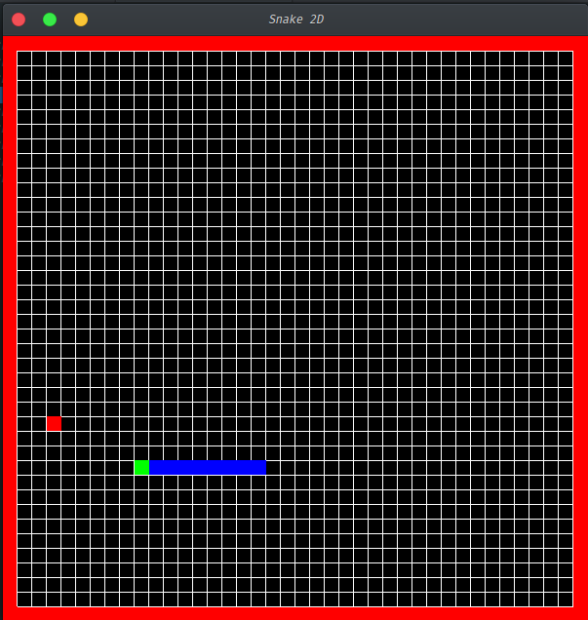

CHAPTER 8
CONCLUSION AND FUTURE ENHANCEMENTS

- The gaming experience from this game is exciting and has the nostalgic feel for this generation
- Improve UX by incorporating textures
- Add maze structures as obstacles
- Add levels
- Make it a 3D visualisation

REFERENCES

- Edward Angel, “Interactive Computer Graphics A Top-Down Approach with OpenGL” 5th Edition, Addison-Wesley, 2008.

- F.S. Hill, Jr., “Computer Graphics Using OpenGL”, 2nd Edition, Pearson Education, 2001.

- JamesD.Foley, AndriesVan Dam, StevenK.Feiner, JohnF.Hughes, ”Computer Graphics”, Second Edition, Addison-Wesley Proffesional, August 14,1995

- www.opengl.org.

- https://www.khronos.org/opengl/

- https://www.stackoverflow.com

- https://www.github.org

- https://www.stackexchange.org

Snake Game

