
Kathmandu
Bernhardt College
Bafal, Kathmandu

Lab report of: …………..

Submitted by: Submitted to:
Name:………… Department of CSIT
Semester: …….
Signature

Lab 1
Problems:
Write SQL statements for the following queries:
- Create a database named Bernhardt.
CREATE DATABASE Bernhardt;
- Select the database Bernhardt.
USE Bernhardt;
- Create table named EMPLOYEE under database Bernhardt with following data columns and datatypes:
EMPNO | ENAME | DESIGNATION | HIREDATE | SALARY | COMM | DEPTNO
INT(4) | VARCHAR(20) | VARCHAR(25) | DATE | INT(10) | DECIMAL(10,2) | INT(4)
CREATE TABLE EMPLOYEE (
EMPNO INT(4),
ENAME VARCHAR(20),
DESIGNATION VARCHAR(25),
HIREDATE DATE,
SALARY INT(10),
COMM DECIMAL(10,2),
DEPTNO INT(4)
);
- Show description of table employee.
DESCRIBE EMPLOYEE;
- Delete the column named COMM
ALTER TABLE EMPLOYEE
DROP COLUMN COMM;
- Rename the column name Deptno as Dpno.
ALTER TABLE EMPLOYEE
RENAME COLUMN DEPTNO TO Dpno;
- Add new column with name phone with datatype bigint.
ALTER TABLE EMPLOYEE
ADD COLUMN phone BIGINT;
- Change datatype of EMPNO to varchar(5).
ALTER TABLE EMPLOYEE
MODIFY COLUMN EMPNO VARCHAR(5);
- Delete the table EMPLOYEE.
DROP TABLE EMPLOYEE;
- Delete the database Bernhardt.
DROP DATABASE Bernhardt;

Lab 2
Problems:
Insert the following data in table EMPLOYEE.
Empno | Ename | Designation | Hiredate | Salary | Comm | Deptno
1011 | Ram | Manager | 1995-01-01 | 20000 | 800 | 100
1021 | Hari | Accountant | 1999-04-04 | 15000 | 650 | 200
1456 | Shyam | Clerk | 1995-07-03 | 12000 | 500 | 300
1045 | Sita | Analyst | 1998-10-06 | 18000 | 700 | 400
1099 | Ramesh | Clerk | 1996-01-01 | 10000 | 400 | 300
1060 | Hari | Clerk | 1997-10-25 | 10000 | 400 | 300

INSERT INTO EMPLOYEE VALUES (1011, 'Ram', 'Manager', '1995-01-01', 20000, 800, 100);
INSERT INTO EMPLOYEE VALUES (1021, 'Hari', 'Accountant', '1999-04-04', 15000, 650, 200);
INSERT INTO EMPLOYEE VALUES (1456, 'Shyam', 'Clerk', '1995-07-03', 12000, 500, 300);
INSERT INTO EMPLOYEE VALUES (1045, 'Sita', 'Analyst', '1998-10-06', 18000, 700, 400);
INSERT INTO EMPLOYEE VALUES (1099, 'Ramesh', 'Clerk', '1996-01-01', 10000, 400, 300);
INSERT INTO EMPLOYEE VALUES (1060, 'Hari', 'Clerk', '1997-10-25', 10000, 400, 300);
- Find all the information about the employee.
SELECT * FROM EMPLOYEE;
- Find name, designation and salary of all the employee.
SELECT ENAME, DESIGNATION, SALARY FROM EMPLOYEE;
- Find the names of all employees who work as a clerk
SELECT ENAME FROM EMPLOYEE WHERE DESIGNATION = 'Clerk';
- Find the information of all clerks working in department number 300.
SELECT * FROM EMPLOYEE WHERE DESIGNATION = 'Clerk' AND DEPTNO = 300;
- Find name, employee number and designation of the employee who works as manager or analyst.
SELECT ENAME, EMPNO, DESIGNATION FROM EMPLOYEE WHERE DESIGNATION = 'Manager' OR DESIGNATION = 'Analyst';
- Find the records of all the employees except those whose designation is either Director or receptionist.
SELECT * FROM EMPLOYEE WHERE DESIGNATION NOT IN ('Director', 'Receptionist');
- Find the records of all the employees whose designation is either Director or receptionist.
SELECT * FROM EMPLOYEE WHERE DESIGNATION IN ('Director', 'Receptionist');
- Find employee name, salary of all the employee whose salary is between 12000 and 20000.
SELECT ENAME, SALARY FROM EMPLOYEE WHERE SALARY BETWEEN 12000 AND 20000;
- Find employee name, salary who earns less than 10000 or more than 15000.
SELECT ENAME, SALARY FROM EMPLOYEE WHERE SALARY < 10000 OR SALARY > 15000;
- Find the distinct designation of the employees.
SELECT DISTINCT DESIGNATION FROM EMPLOYEE;
- Find the names of employees whose name starts with the alphabet 'R.
SELECT ENAME FROM EMPLOYEE WHERE ENAME LIKE 'R%';
- Find the employee number and names whose names end in 'm'.
SELECT EMPNO, ENAME FROM EMPLOYEE WHERE ENAME LIKE '%m';
- Find the employee name whose name starts with 'H' and ends in I.
SELECT ENAME FROM EMPLOYEE WHERE ENAME LIKE 'H%i';
- Find the employee name and number whose name starts with 'R' and has two more characters after R.
SELECT EMPNO, ENAME FROM EMPLOYEE WHERE ENAME LIKE 'R__';
- Find the names of the employees in ascending, descending order.
SELECT ENAME FROM EMPLOYEE ORDER BY ENAME ASC;
SELECT ENAME FROM EMPLOYEE ORDER BY ENAME DESC;
- Display the names and salaries of all the employees after increasing the salary by 20%.
SELECT ENAME, SALARY * 1.20 AS NEW_SALARY FROM EMPLOYEE;
- Display the names and commission of all the employees after incrementing the commission by 20%.
SELECT ENAME, COMM * 1.20 AS NEW_COMM FROM EMPLOYEE;
- Display the name and total salary (Salary + Commission) of all the employees.
SELECT ENAME, (SALARY + COMM) AS TOTAL_SALARY FROM EMPLOYEE;
- Find the records of all the employees who work as manager or earns more than 12000.
SELECT * FROM EMPLOYEE WHERE DESIGNATION = 'Manager' OR SALARY > 12000;
- Find the total salary paid to all the employees.
SELECT SUM(SALARY) AS TOTAL_SALARY FROM EMPLOYEE;
- Find the total number of record of all the employees.
SELECT COUNT(*) AS TOTAL_RECORDS FROM EMPLOYEE;
- Find the total number of departments.
SELECT COUNT(DISTINCT DEPTNO) AS TOTAL_DEPARTMENTS FROM EMPLOYEE;
- Find the maximum salary of each department.
SELECT DEPTNO, MAX(SALARY) AS MAX_SALARY FROM EMPLOYEE GROUP BY DEPTNO;
- Find all the records of employee who has highest salary.
SELECT * FROM EMPLOYEE WHERE SALARY = (SELECT MAX(SALARY) FROM EMPLOYEE);
- Find the department number of the employee who gets salary more than the average salary.
SELECT DEPTNO FROM EMPLOYEE WHERE SALARY > (SELECT AVG(SALARY) FROM EMPLOYEE);
- Find the department number that pays salary more than 12000.
SELECT DISTINCT DEPTNO FROM EMPLOYEE WHERE SALARY > 12000;

Lab 3
Problem:
1) Create a database named customers_db
2) Create a table named customers with following columns adding constraints following constraints
Customer_id: Primary key
Name: not null
customer_id | Name | Email | Age | Address
INT | VARCHAR(30) | VARCHAR(30) | INT | VARCHAR(30)

3) We have already added two constraints (PRIMARY KEY and NULL) while creating table customers. We can add constraints after creating table as well.
Now add the following constraint to the above table named customers
• Email must be unique of each customer
• Age must be greater than 18
• The default value of address must be bhaktapur
4) Now insert records of customer with and without violating constraints.
PRIMARY KEY
insert into customers values(1,'ram','ram@gmail.com',22,'kathmandu');
insert into customers values(2,'sita','sita@gmail.com',25,'pokhara');
insert into customers values(2,'gita','gita@gmail.com',26,'butwal');
NOT NULL
insert into customers(customer_id,email,age,address)
values (3,'gita@gmail.com',26,'butwal');
select * from customers;
CHECK
insert into customers values (4,'hari','hari@gmail.com',27,'lalitpur');
insert into customers values (11,'ganesh','ganesh@gmail.com',15,'dolkha');
UNIQUE
insert into customers values (16,'ramesh','ram@gmail.com',24,'chitwan');
DEFAULT
insert into customers(customer_id,name,email,age)
values(5,'gopal','gopal@gmail.com',20);
select * from customers;
FOREIGN KEY
We have already created table customers. Now we have to create table orders with following columns.
order_id is primary key and customer_id as foreign key for customer
create table orders(order_id int, product_name varchar(30), price int, customer_id int,
primary key(order_id), foreign key (customer_id) references customers(customer_id));
Now let update customer table,
update customers set name='gita' where customer_id=3;
Again insert some rows in orders table
insert into orders values(1,'iron',1200,1);
insert into orders values(2,'guitar',4500,2);
insert into orders values (3,'phone',57000,1);
insert into orders values(4,'printer',88000,3);
insert into orders values(5,'drone',125000,2);
insert into orders values(6,'smartwatch',7500,4);
insert into orders values(7,'oven',14500,5);
Try to insert customer_id in orders table that does not exist in customers table
insert into orders values(8,'Laptop',158000,6);
SQL Syntax
CREATE DATABASE customeers_db;
USE customeers_db;

CREATE TABLE customers (
customer_id INT PRIMARY KEY,
name VARCHAR(30) NOT NULL,
email VARCHAR(30),
age INT,
address VARCHAR(30)
);
ALTER TABLE customers
ADD UNIQUE (email);

ALTER TABLE customers
ADD CONSTRAINT age_check CHECK (age > 18);

ALTER TABLE customers
ALTER address SET DEFAULT 'bhaktapur';

INSERT INTO customers VALUES (1, 'Ram', 'ram@gmail.com', 22, 'Kathmandu');
INSERT INTO customers VALUES (2, 'Sita', 'sita@gmail.com', 25, 'Pokhara');

INSERT INTO customers VALUES (2, 'Gita', 'gita@gmail.com', 26, 'Butwal');
// This cannot inserted because customer_id is primary key which should be unique and not null.

INSERT INTO customers(customer_id, email, age, address)
VALUES (9, 'rita@gmail.com', 26, 'Butwal');
SELECT * FROM customers;

INSERT INTO customers VALUES (4, 'Hari', 'hari@gmail.com', 17, 'Butwal');
INSERT INTO customers VALUES (16, 'Ramesh', 'ram@gmail.com', 28, 'Kathmandu');
//This won’t works because age must be greater than 18

INSERT INTO customers (customer_id, name, email, age)
VALUES (5, 'Gobal', 'gobal@gmail.com', 29);
//Although there is no address inserted, default address has been set to ‘bhaktapur’

CREATE TABLE orders (
order_id INT PRIMARY KEY,
product_name VARCHAR(30),
price INT,
customer_id INT,
FOREIGN KEY (customer_id) REFERENCES customers(customer_id)
);
UPDATE customers SET name = 'Gita'
WHERE customer_id = 3;

INSERT INTO orders VALUES (1, 'Iron', 1200, 1);
INSERT INTO orders VALUES (2, 'Guitar', 4500, 2);
INSERT INTO orders VALUES (3, 'Phone', 57000, 1);
INSERT INTO orders VALUES (4, 'Printer', 88000, 3);
INSERT INTO orders VALUES (5, 'Drone', 125000, 2);
INSERT INTO orders VALUES (6, 'Smartwatch', 7500, 4);
INSERT INTO orders VALUES (7, 'Oven', 14500, 5);
INSERT INTO orders VALUES (8, 'Oven', 14500, 6);

Discussion
A customers table was created with different SQL constraints such as PRIMARY KEY, NOT NULL, UNIQUE, CHECK, and DEFAULT. These constraints were tested by inserting both valid and invalid records. An orders table with a FOREIGN KEY was also created to establish a relationship with the customers table. The results showed that the constraints successfully prevented invalid and inconsistent data from being inserted.

Conclusion
This lab demonstrated how database constraints improve the reliability and consistency of stored data. The constraints successfully enforced the required rules and prevented invalid data from being stored. It also showed how relationships between tables are maintained using foreign keys. Overall, it provided a clear understanding of how SQL constraints are used to ensure data integrity.
Lab 4:
Problem 1
1. Create any database name
2. Create two table name Employee and Department with following columns using appropriate data types and insert the following data in table.
Employee
emp_id | emp_name | Position | Salary | Dept_id
1 | Anish | Manager | 25000 | 1
2 | Ram | Secretary | 20000 | 2
3 | Sam | Analyst | 15000 | 5
4 | Hari | Manager | 25000 | 3

Department
Dept_id | Dept_name | HOD
1 | Sales | Bob
2 | Marketing | Alice
3 | Finance | Gita
4 | Operations | Shyam

SQL Syntax
CREATE DATABASE joindb;
USE joindb;

CREATE TABLE Employee (
emp_id INT,
emp_name VARCHAR(20),
position VARCHAR(25),
salary INT(10),
dept_id INT
);

CREATE TABLE Department (
dept_id INT,
dept_name VARCHAR(20),
HOD VARCHAR(20)
);
INSERT INTO Employee
VALUES (1, "Anish", "Manager", 25000, 1),
(2, "Ram", "Secretary", 25000, 2),
(3, "Sam", "Analyst", 15000, 5),
(4, "Hari", "Manager", 25000, 3);

INSERT INTO Department VALUES (1, "Sales", "Bob"),
(2, "Marketing", "Alice"),
(3, "Finance", "Gita"),
(4, "Operations", "Shyam");

3. Now perform the following Join Operations.

a. Inner Join
SELECT * FROM Employee INNER JOIN Department
ON Employee.dept_id = Department.dept_id;
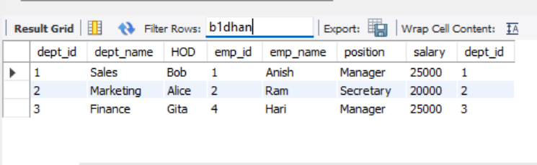

b. Outer Join
i. Left Outer Join
SELECT * FROM Employee LEFT JOIN Department
ON Employee.dept_id = Department.dept_id;
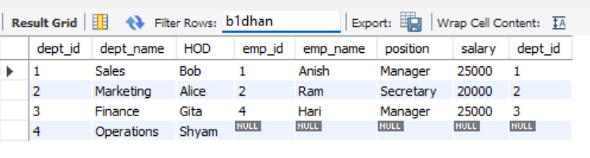
ii. Right Outer Join
SELECT * FROM Employee RIGHT JOIN Department
ON Employee.dept_id = Department.dept_id;
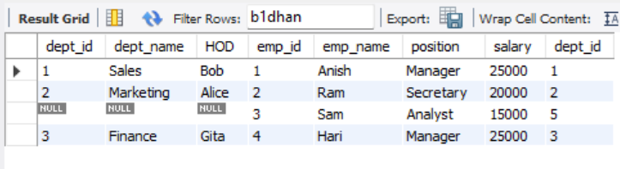
iii. Full Join
SELECT * FROM Employee RIGHT JOIN Department
ON Employee.dept_id = Department.dept_id
UNION
SELECT * FROM Employee LEFT JOIN Department
ON Employee.dept_id = Department.dept_id;
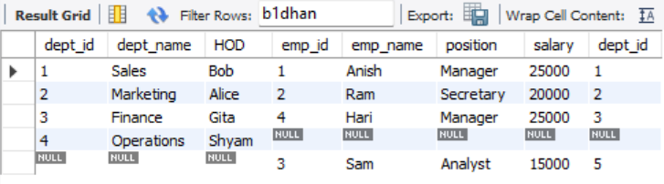
c. Natural Join
SELECT * FROM Employee NATURAL JOIN Department;
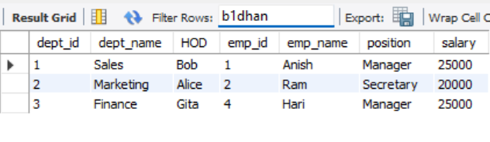
d. Cross Join
SELECT * FROM Employee
CROSS JOIN Department;
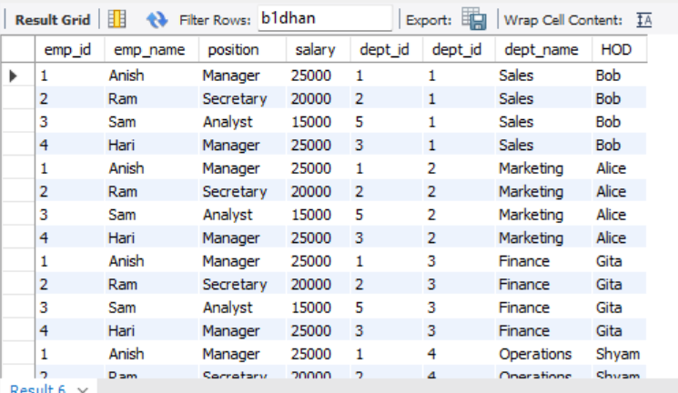
4. Write SQL queries to
i. Find Employee names with their department.
SELECT Employee.emp_name, Department.dept_name FROM Employee
JOIN Department
ON Employee.dept_id = Department.dept_id;
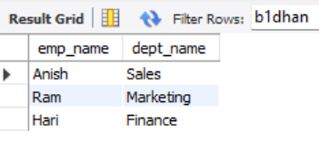
ii. Find emp_name, position, salary of employee who work in finance department.
SELECT Employee.emp_name, Employee.position, Employee.salary FROM
Employee JOIN Department
ON Employee.dept_id = Department.dept_id
WHERE Department.dept_name = "Finance";
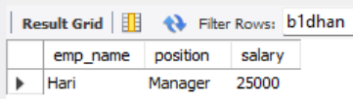
iii. Find emp_name of employee who works in sales department.
SELECT Employee.emp_name FROM Employee
JOIN Department
ON Employee.dept_id = Department.dept_id
WHERE Department.dept_name = "Sales";
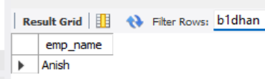
iv. Find the information of employee who works in marketing department.
SELECT Employee.* FROM Employee
JOIN Department
ON Employee.dept_id = Department.dept_id
WHERE Department.dept_name = "Marketing";
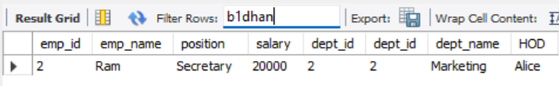
v. Find the HOD of Hari.
SELECT Department.HOD FROM Department
JOIN Employee
ON Employee.dept_id = Department.dept_id
WHERE Employee.emp_name = "Hari";
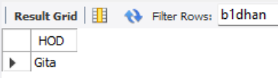
Problem 2:
1. Create two table named emp_computerdept and emp_csitdept with following columns with appropriate data types and insert the following data in table.
Emp_computerdept
Emp_id | Emp_name | Address
1 | Aarush | Biratnagar
2 | Aaryan | Dharan
3 | Aashik | Kathmandu
4 | Aditi | Surkhet
5 | Amit | Dhangadi
Emp_csitdept
Emp_id | Emp_name | Address
1 | Anjali | Butwal
2 | Ansila | Bajhang
3 | Benjamin | Kathmandu
4 | Bhairab | Surkhet
5 | Arati | Dhangadi

SQL Syntax
CREATE TABLE emp_computerdept (
emp_id INT,
emp_name VARCHAR(20),
address VARCHAR(20)
);

CREATE TABLE emp_csitdept (
emp_id INT,
emp_name VARCHAR(20),
address VARCHAR(20)
);

INSERT INTO emp_computerdept VALUES(1,'Aarush','Biratnagar');
INSERT INTO emp_computerdept VALUES(2,'Aaryan','Dharan');
INSERT INTO emp_computerdept VALUES(3,'Aashik','Kathmandu');
INSERT INTO emp_computerdept VALUES(4,'Aditi','Surkhet');
INSERT INTO emp_computerdept VALUES(5,'Amit','Dhangadi');

INSERT INTO emp_csitdept VALUES(1,'Anjali','Butwal');
INSERT INTO emp_csitdept VALUES(2,'Ansila','Bajhang');
INSERT INTO emp_csitdept VALUES(3,'Benjamin','Kathmandu');
INSERT INTO emp_csitdept VALUES(4,'Bhairab','Surkhet');
INSERT INTO emp_csitdept VALUES(5,'Arati','Dhangadi');

2. Perform the following set operations.
i.UNION
SELECT * FROM emp_computerdept
UNION
SELECT * FROM emp_csitdept;
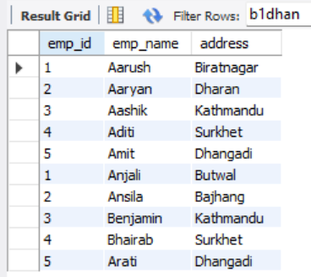

ii.UNION ALL
SELECT * FROM emp_computerdept
UNION ALL
SELECT * FROM emp_csitdept;
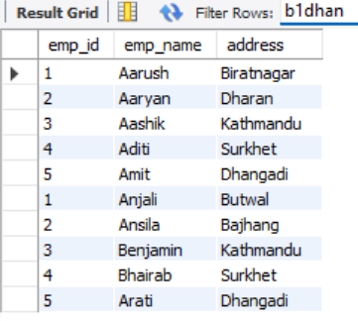
iii. INTERSECT
SELECT DISTINCT c.address
FROM emp_computerdept c
INNER JOIN emp_csitdept s
ON c.address = s.address;
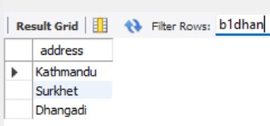
iv. Except
SELECT address
FROM emp_computerdept
WHERE address NOT IN (
SELECT address FROM emp_csitdept );
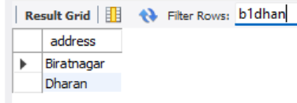

3. Write SQL queries for the following:
i. Find the name of employee who works either computer or csit department.
SELECT emp_name
FROM emp_computerdept
UNION
SELECT emp_name
FROM emp_csitdept;
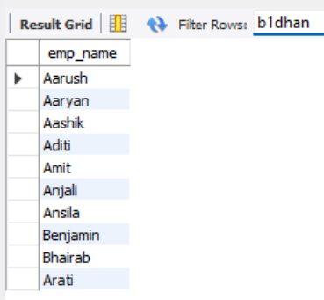

ii. Find the name of employee who works in both computer and csit .
SELECT c.emp_name
FROM emp_computerdept c
INNER JOIN emp_csitdept s
ON c.emp_id = s.emp_id;
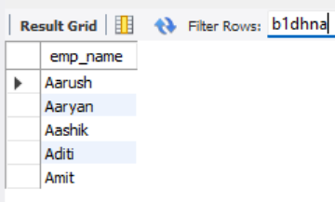

iii. Find the name of employee who works in csit department but not in computer department.
SELECT emp_name
FROM emp_csitdept
WHERE emp_name NOT IN (
SELECT emp_name
FROM emp_computerdept );
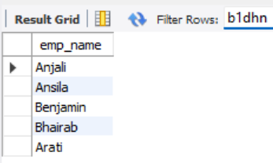
iv. Find the common address of where both computer and csit department employee lives in.
SELECT DISTINCT c.address
FROM emp_computerdept c
INNER JOIN emp_csitdept s
ON c.address = s.address;

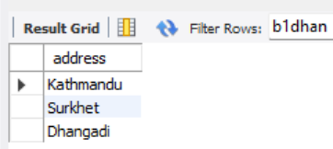

Discussion
In this assignment, two tables (emp_computerdept and emp_csitdept) were created using appropriate data types, and employee records were inserted successfully. SQL set operations such as UNION and UNION ALL were performed to combine data from both tables. Since MySQL does not support INTERSECT and EXCEPT directly, equivalent queries using INNER JOIN and NOT IN were used to achieve the same results.

Conclusion
This assignment improved the understanding of SQL table creation, data insertion, and retrieval using set operations. The difference between UNION and UNION ALL and how to find common and unique records between tables using MySQL-compatible queries were known.

