

American International University- Bangladesh

CSC 4181: Advanced Database Management Systems

Midterm Report
Fall 22-23

Project Title: Renting-Borrowing Service
Section: A

Student Name | Student Id
Sudarshan Saha Bishal | 20-42915-1

Table of Contents

System Summary | :................................................................................ | 03
ERD Diagram | :................................................................................ | 04
Class Diagram | :................................................................................ | 05
Use Case Diagram | :................................................................................ | 06
Activity Diagram | :................................................................................ | 07-08
Schema Diagram | :................................................................................ | 09
Creating Tables | :................................................................................ | 10-15
Tables with Data | :................................................................................ | 16-21
Task | :................................................................................ | 22-23
User Interface | :................................................................................ | 24

System Summary:

People occasionally want different items in day-to-day life to fulfill their temporary needs. These items can be a camera, cycle, book, or any kind of item. Since the need is temporal, a person decides to buy the item it will not be beneficial in long term. Thus it can be counted as waste. Therefore, what the person can do instead of buying, he/she can borrow from others who already own those items.
There are four types of user categories -
i. Admin ii. Customer Support iii. Owner iv. Borrower
Admin and Customer Support entities are very important to this system. They are responsible to maintain the platform properly.
Like any modern system, any user can create an account, sign in to the system, and use different functionalities. There is also the option to update your account information and password. Users can also have their unique username. The user interface is easy to navigate.

ERD Diagram:
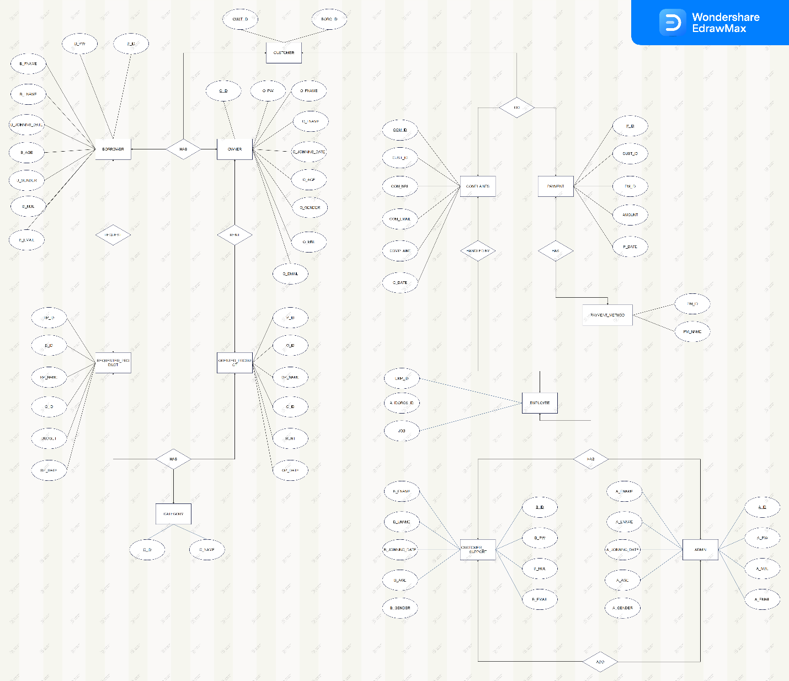
Class Diagram:
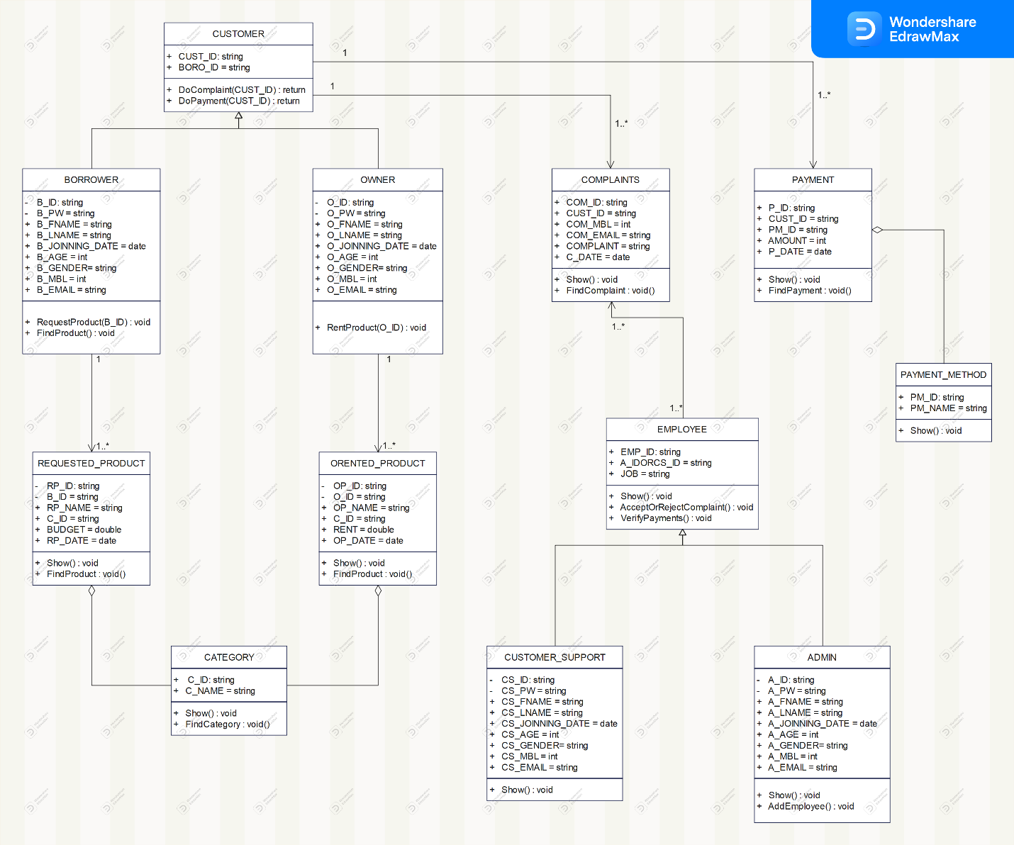

Use Case Diagram:

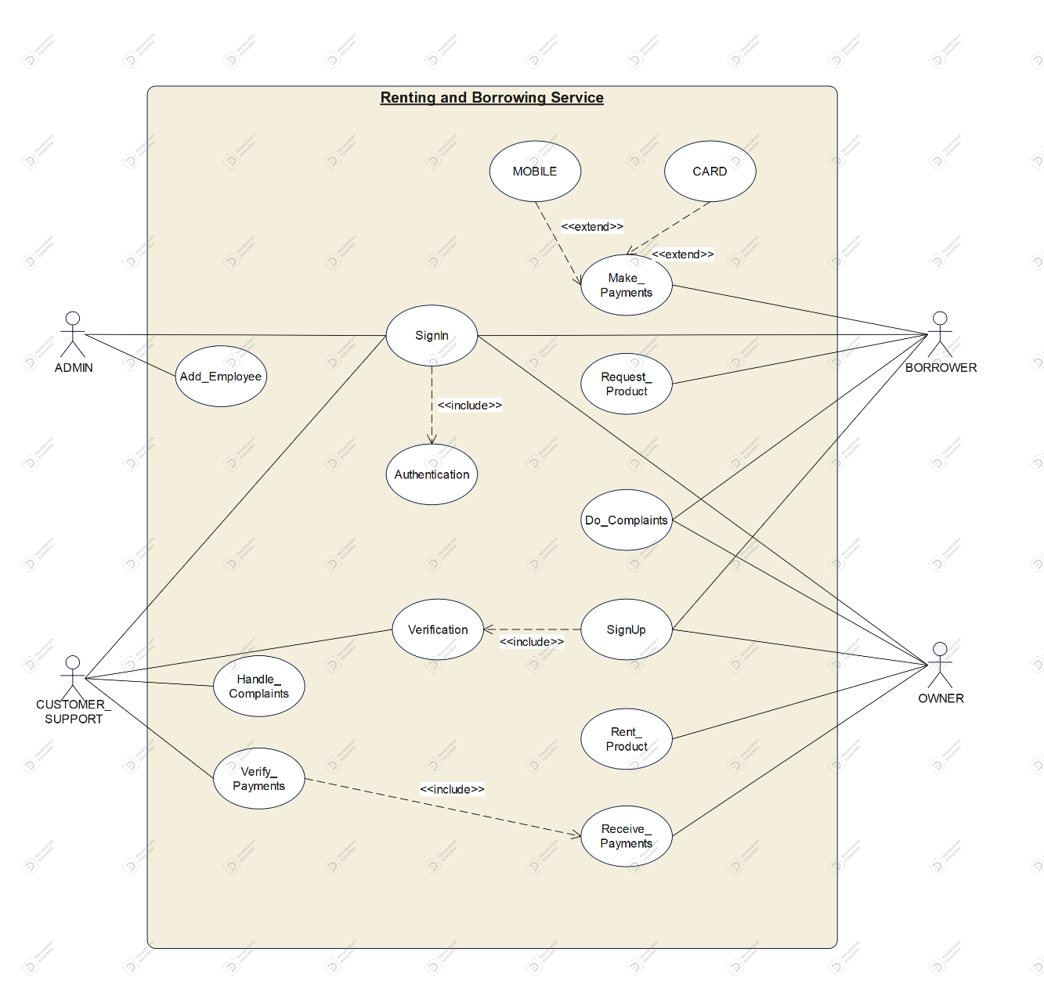
Activity Diagram:
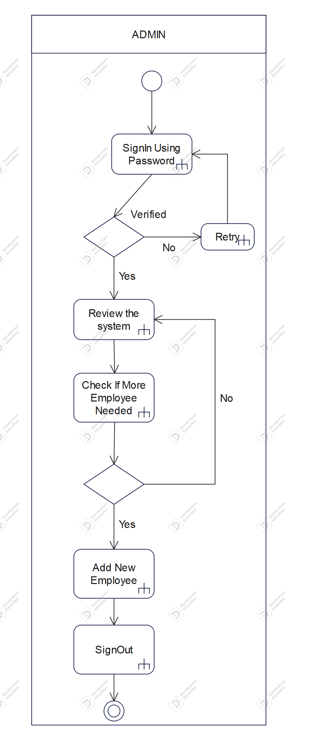 | 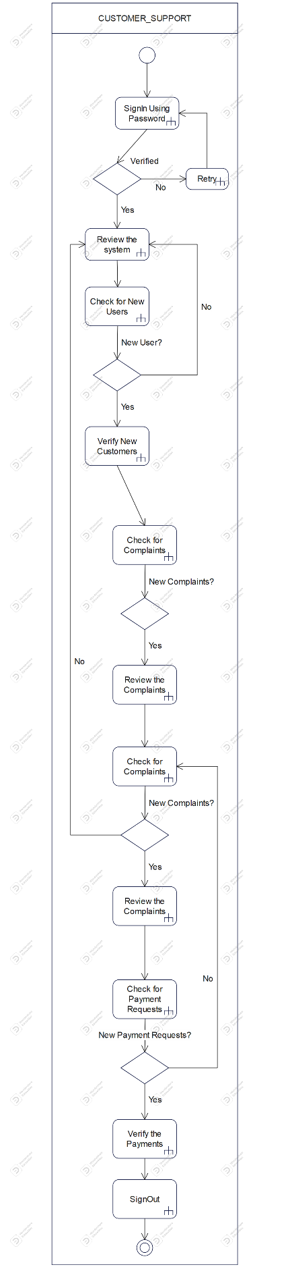
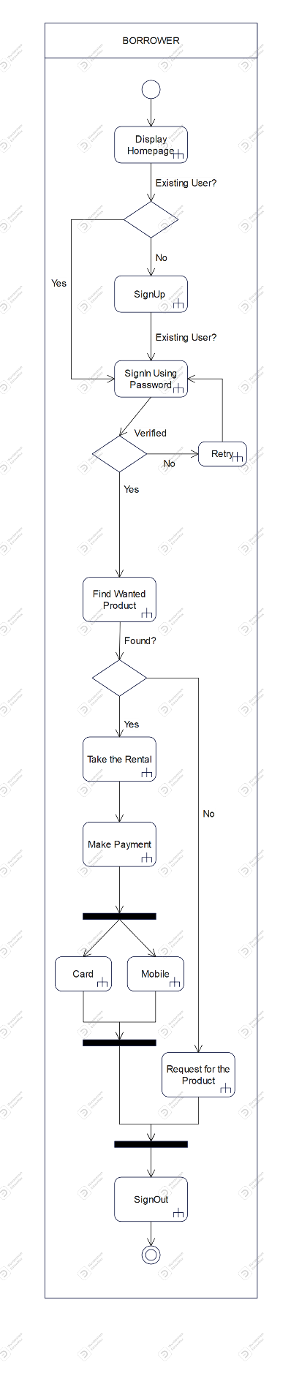 | 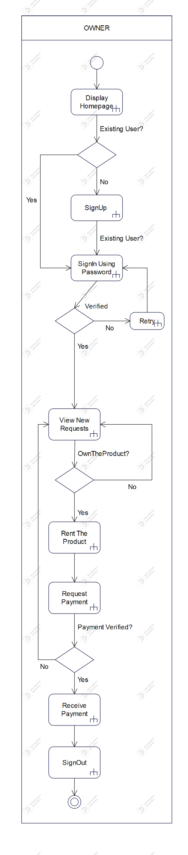
Schema Diagram:

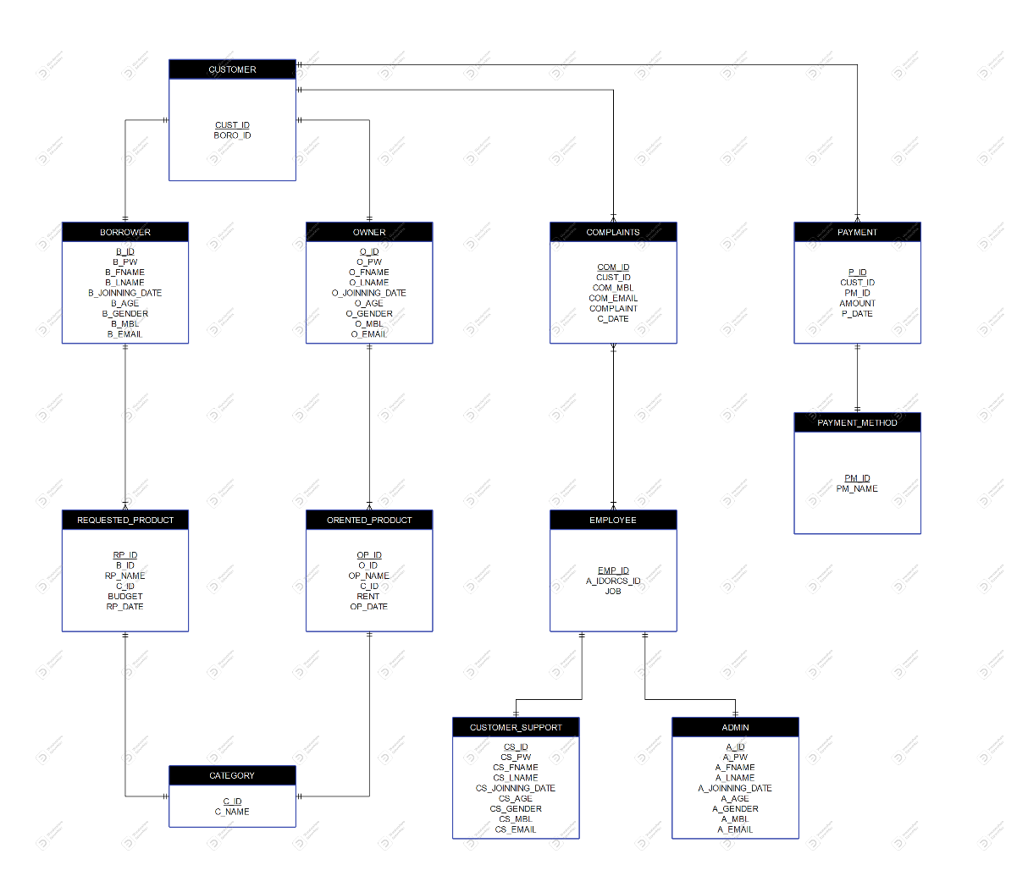

Creating Tables:
ADMIN-
CREATE TABLE ADMIN(
A_ID varchar(30) not null,
A_PW varchar(20) not null,
A_FNAME varchar(40) not null,
A_LNAME varchar(40) not null,
A_JOINNING_DATE date not null,
A_AGE number(3) not null,
A_GENDER varchar(10) not null,
A_MBL varchar(15) not null,
A_EMAIL varchar(30) not null,
PRIMARY KEY (A_ID )
);
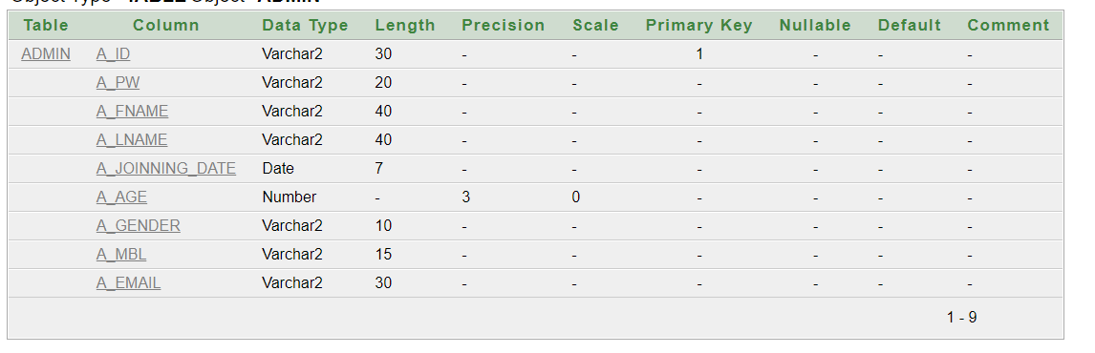

CUSTOMER_SUPPORT-
CREATE TABLE CUSTOMER_SUPPORT(
CS_ID varchar(30) not null,
CS_PW varchar(20) not null,
CS_FNAME varchar(40) not null,
CS_LNAME varchar(40) not null,
CS_JOINNING_DATE date not null,
CS_AGE number(3) not null,
CS_GENDER varchar(10) not null,
CS_MBL varchar(15) not null,
CS_EMAIL varchar(30) not null,
PRIMARY KEY (CS_ID )
);
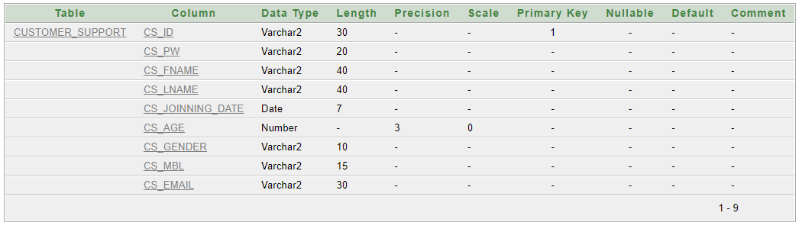
BORROWER-
CREATE TABLE BORROWER(
B_ID varchar(30) not null,
B_PW varchar(20) not null,
B_FNAME varchar(40) not null,
B_LNAME varchar(40) not null,
B_JOINNING_DATE date not null,
B_AGE number(3) not null,
B_GENDER varchar(10) not null,
B_MBL varchar(15) not null,
B_EMAIL varchar(30) not null,
PRIMARY KEY (B_ID )
);
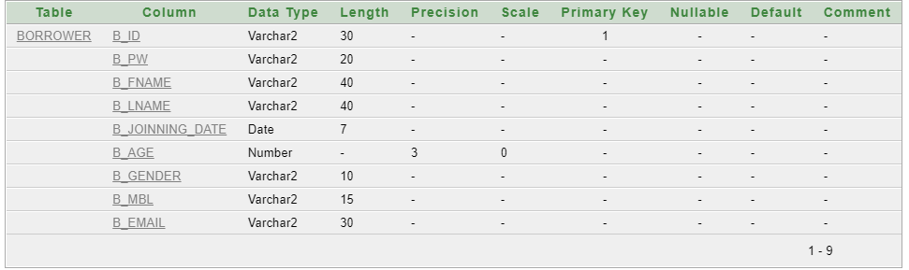

OWNER-
CREATE TABLE OWNER(
O_ID varchar(30) not null,
O_PW varchar(20) not null,
O_FNAME varchar(40) not null,
O_LNAME varchar(40) not null,
O_JOINNING_DATE date not null,
O_AGE number(3) not null,
O_GENDER varchar(10) not null,
O_MBL varchar(15) not null,
O_EMAIL varchar(30) not null,
PRIMARY KEY (O_ID )
);
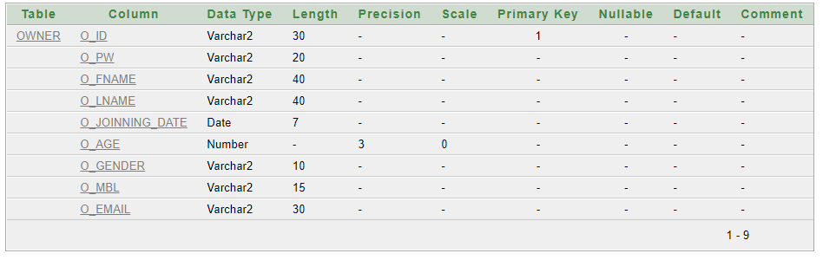
CATEGORY-
CREATE TABLE CATEGORY(
C_ID varchar(20) not null,
C_NAME varchar(30) not null,
PRIMARY KEY (C_ID )
);

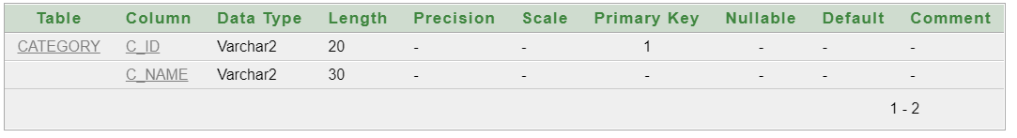
CUSTOMER-
CREATE TABLE CUSTOMER(
CUST_ID varchar(20) not null,
BORO_ID varchar(30) not null,
PRIMARY KEY (CUST_ID )
);
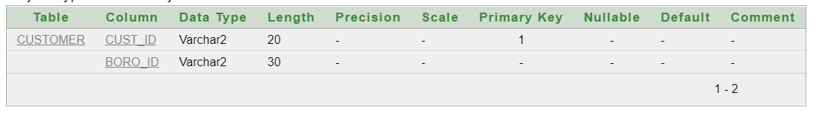
PAYMENT_METHOD-
CREATE TABLE PAYMENT_METHOD(
PM_ID varchar(20) not null,
PM_NAME varchar(30) not null,
PRIMARY KEY (PM_ID )
);
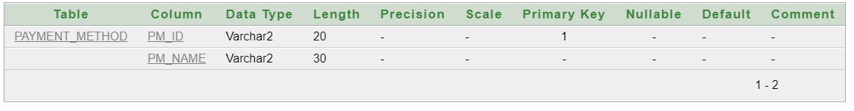

EMPLOYEE -
CREATE TABLE EMPLOYEE(
EMP_ID varchar(20) not null,
AD_OR_CS_ID varchar(30) not null,
JOB varchar(20) not null,
PRIMARY KEY (EMP_ID )
);
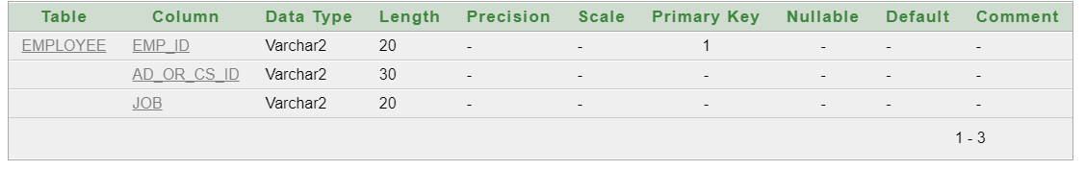

COMPLAINTS -
CREATE TABLE COMPLAINTS(
COM_ID varchar(20) not null,
CUST_ID varchar(20) not null,
COM_MBL varchar(15) not null,
COM_EMAIL varchar(30) not null,
COMPLAINT long not null,
C_DATE date not null,
PRIMARY KEY (COM_ID ),
FOREIGN KEY(CUST_ID) REFERENCES CUSTOMER(CUST_ID)
);

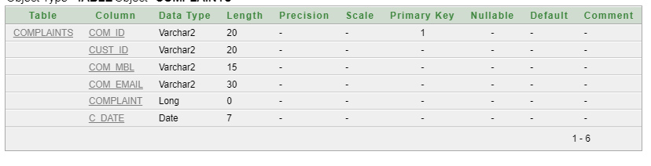

REQUESTED_PRODUCT -
CREATE TABLE REQUESTED_PRODUCT(
RP_ID varchar(20) not null,
B_ID varchar(30) not null,
RP_NAME varchar(50) not null,
C_ID varchar(20) not null,
BUDGET float(10) not null,
RP_DATE date not null,
PRIMARY KEY (RP_ID),
FOREIGN KEY(B_ID) REFERENCES BORROWER(B_ID),
FOREIGN KEY(C_ID) REFERENCES CATEGORY(C_ID)
);
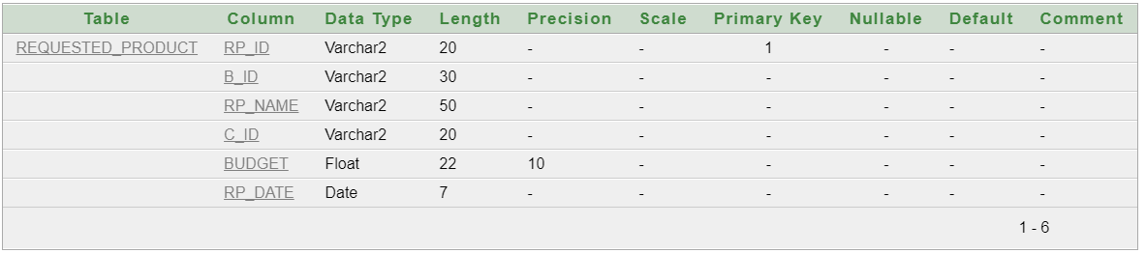

ORENTED_PRODUCT -
CREATE TABLE ORENTED_PRODUCT(
OP_ID varchar(20) not null,
O_ID varchar(30) not null,
OP_NAME varchar(50) not null,
C_ID varchar(20) not null,
RENT float(10) not null,
OP_DATE date not null,
PRIMARY KEY (OP_ID ),
FOREIGN KEY(O_ID ) REFERENCES OWNER(O_ID ),
FOREIGN KEY(C_ID) REFERENCES CATEGORY(C_ID)
);
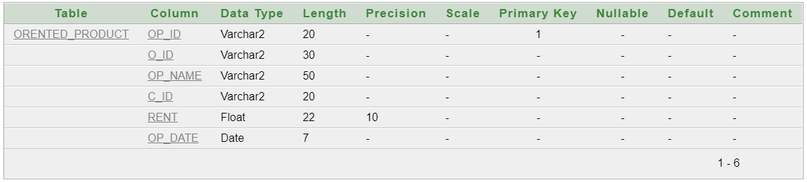

PAYMENT -
CREATE TABLE PAYMENT(
P_ID varchar(20) not null,
CUST_ID varchar(20) not null,
PM_ID varchar(20) not null,
AMOUNT float(10) not null,
P_DATE date not null,
PRIMARY KEY (P_ID ),
FOREIGN KEY(CUST_ID) REFERENCES CUSTOMER(CUST_ID),
FOREIGN KEY(PM_ID) REFERENCES PAYMENT_METHOD(PM_ID)
);
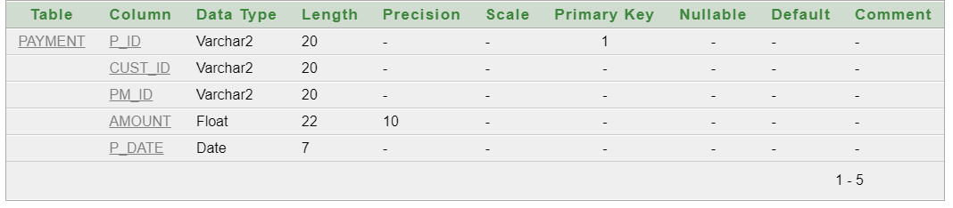

Tables with Data:
- ADMIN-

INSERT INTO ADMIN
(A_ID, A_PW, A_FNAME, A_LNAME, A_JOINNING_DATE, A_AGE, A_GENDER, A_MBL, A_EMAIL)
VALUES('AD001','AD001','BRUCE','WAYNE', TO_DATE('2020/01/01', 'yyyy/mm/dd'), 32, 'M', '01451254120', 'brucewayne@gmail.com');

INSERT INTO ADMIN
(A_ID, A_PW, A_FNAME, A_LNAME, A_JOINNING_DATE, A_AGE, A_GENDER, A_MBL, A_EMAIL)
VALUES('AD002','AD002','CLARK','KENT', TO_DATE('2020/01/03', 'yyyy/mm/dd'), 30, 'M', '01230232011', 'clarkkent@gmail.com');

INSERT INTO ADMIN
(A_ID, A_PW, A_FNAME, A_LNAME, A_JOINNING_DATE, A_AGE, A_GENDER, A_MBL, A_EMAIL)
VALUES('AD003','AD003','ARTHUR','MORGAN', TO_DATE('2020/02/01', 'yyyy/mm/dd'), 36, 'M', '01230254632', 'arthurm@gmail.com');

INSERT INTO ADMIN
(A_ID, A_PW, A_FNAME, A_LNAME, A_JOINNING_DATE, A_AGE, A_GENDER, A_MBL, A_EMAIL)
VALUES('AD004','AD004','JAMES','WAYNE', TO_DATE('2020/01/05', 'yyyy/mm/dd'), 33, 'M', '01236521456', 'jameswayne@gmail.com');

INSERT INTO ADMIN
(A_ID, A_PW, A_FNAME, A_LNAME, A_JOINNING_DATE, A_AGE, A_GENDER, A_MBL, A_EMAIL)
VALUES('AD005','AD005','GERALT','RIVIA', TO_DATE('2020/01/03', 'yyyy/mm/dd'), 37, 'M', '01232021256', 'geraltrivia@gmail.com');

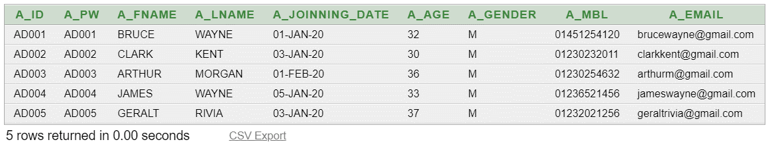

- CUSTOMER_SUPPORT-

INSERT INTO CUSTOMER_SUPPORT(CS_ID, CS_PW, CS_FNAME, CS_LNAME, CS_JOINNING_DATE, CS_AGE, CS_GENDER, CS_MBL, CS_EMAIL) VALUES('CS001','CS001','ALFRED','PENNYWORTH', TO_DATE('2020/04/01', 'yyyy/mm/dd'), 25, 'M', '01230232549', 'alfredpenny@gmail.com');

INSERT INTO CUSTOMER_SUPPORT(CS_ID, CS_PW, CS_FNAME, CS_LNAME, CS_JOINNING_DATE, CS_AGE, CS_GENDER, CS_MBL, CS_EMAIL) VALUES('CS002','CS002','JACK','SPRING', TO_DATE('2021/01/01', 'yyyy/mm/dd'), 24, 'M', '01232125478', 'jacks@gmail.com');

INSERT INTO CUSTOMER_SUPPORT(CS_ID, CS_PW, CS_FNAME, CS_LNAME, CS_JOINNING_DATE, CS_AGE, CS_GENDER, CS_MBL, CS_EMAIL) VALUES('CS003','CS003','JOHN','HALO', TO_DATE('2021/03/04', 'yyyy/mm/dd'), 26, 'M', '01232125469', 'johnhalo002@gmail.com');

INSERT INTO CUSTOMER_SUPPORT(CS_ID, CS_PW, CS_FNAME, CS_LNAME, CS_JOINNING_DATE, CS_AGE, CS_GENDER, CS_MBL, CS_EMAIL) VALUES('CS004','CS004','EDWARD','KENWAY', TO_DATE('2021/03/04', 'yyyy/mm/dd'), 26, 'M', '02312547896', 'kenwayed23@gmail.com');

INSERT INTO CUSTOMER_SUPPORT(CS_ID, CS_PW, CS_FNAME, CS_LNAME, CS_JOINNING_DATE, CS_AGE, CS_GENDER, CS_MBL, CS_EMAIL) VALUES('CS005','CS005','HOLY LANG','PENNYWORTH', TO_DATE('2022/01/01', 'yyyy/mm/dd'), 24, 'F', '01546321203', 'langholy456@yahoo.com');

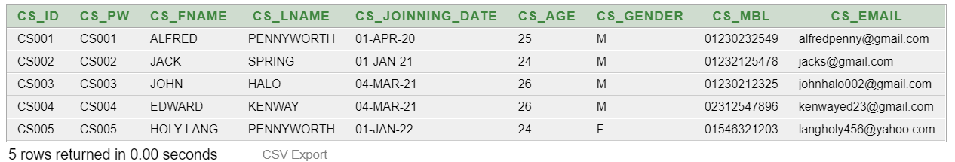

- BORROWER-

INSERT INTO BORROWER(B_ID, B_PW, B_FNAME, B_LNAME, B_JOINNING_DATE, B_AGE, B_GENDER, B_MBL, B_EMAIL) VALUES('BO001','BO001','KEN','KANEKI', TO_DATE('2020/06/03', 'yyyy/mm/dd'), 19, 'M', '01236545897', 'kaneki887@gmail.com');

INSERT INTO BORROWER(B_ID, B_PW, B_FNAME, B_LNAME, B_JOINNING_DATE, B_AGE, B_GENDER, B_MBL, B_EMAIL) VALUES('BO002','BO002','SAUL','GOODMAN', TO_DATE('2020/06/04', 'yyyy/mm/dd'), 31, 'M', '01456321564', 'sgoodman002@gmail.com');

INSERT INTO BORROWER(B_ID, B_PW, B_FNAME, B_LNAME, B_JOINNING_DATE, B_AGE, B_GENDER, B_MBL, B_EMAIL) VALUES('BO003','BO003','JIMMY','MCGIL', TO_DATE('2020/06/04', 'yyyy/mm/dd'), 31, 'M', '01325648563', 'jimc002@gmail.com');

INSERT INTO BORROWER(B_ID, B_PW, B_FNAME, B_LNAME, B_JOINNING_DATE, B_AGE, B_GENDER, B_MBL, B_EMAIL) VALUES('BO004','BO004','CHUCK','MCGIL', TO_DATE('2020/08/26', 'yyyy/mm/dd'), 39, 'M', '01230254789', 'chuckmcgil2135@gmail.com');

INSERT INTO BORROWER(B_ID, B_PW, B_FNAME, B_LNAME, B_JOINNING_DATE, B_AGE, B_GENDER, B_MBL, B_EMAIL) VALUES('BO005','BO005','MIKE','ERHMENTRAUT', TO_DATE('2020/06/03', 'yyyy/mm/dd'), 48, 'M', '01459875462', 'mikey@gmail.com');
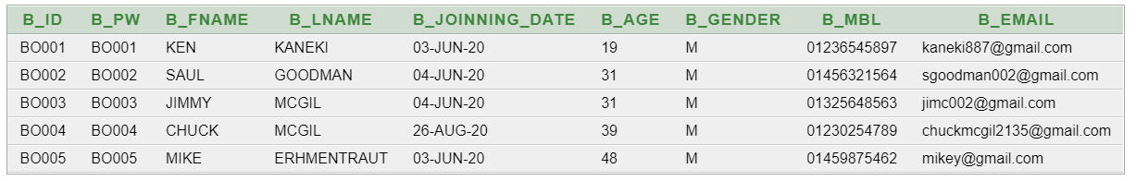

- OWNER-

INSERT INTO OWNER(O_ID, O_PW, O_FNAME, O_LNAME, O_JOINNING_DATE, O_AGE, O_GENDER, O_MBL, O_EMAIL) VALUES('OW001','OW001','BRIAN','KRANSTON', TO_DATE('2020/06/01', 'yyyy/mm/dd'), 48, 'M', '01325463215', 'bkrans236@gmail.com');

INSERT INTO OWNER(O_ID, O_PW, O_FNAME, O_LNAME, O_JOINNING_DATE, O_AGE, O_GENDER, O_MBL, O_EMAIL) VALUES('OW002','OW002','ANNA','GUNN', TO_DATE('2020/06/02', 'yyyy/mm/dd'), 39, 'F', '01326547896', 'gunnanna47896@gmail.com');

INSERT INTO OWNER(O_ID, O_PW, O_FNAME, O_LNAME, O_JOINNING_DATE, O_AGE, O_GENDER, O_MBL, O_EMAIL) VALUES('OW003','OW003','GUSTAVO','FRING', TO_DATE('2020/07/03', 'yyyy/mm/dd'), 52, 'M', '01854632102', 'gusfring@gmail.com');

INSERT INTO OWNER(O_ID, O_PW, O_FNAME, O_LNAME, O_JOINNING_DATE, O_AGE, O_GENDER, O_MBL, O_EMAIL) VALUES('OW004','OW004','JESSE','PINKMAN', TO_DATE('2020/07/03', 'yyyy/mm/dd'), 27, 'M', '01654123065', 'jessepink00000@gmail.com');

INSERT INTO OWNER(O_ID, O_PW, O_FNAME, O_LNAME, O_JOINNING_DATE, O_AGE, O_GENDER, O_MBL, O_EMAIL) VALUES('OW005','OW005','BOB','ODENKIRK', TO_DATE('2020/06/01', 'yyyy/mm/dd'), 36, 'M', '01878965425', 'bobbyod879@gmail.com');

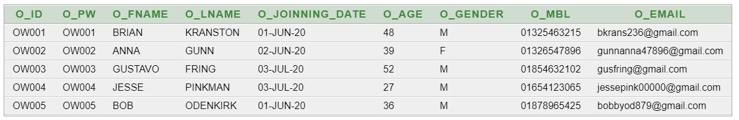

- CATEGORY-
INSERT INTO CATEGORY(C_ID, C_NAME) VALUES('CA001','FURNITURES');
INSERT INTO CATEGORY(C_ID, C_NAME) VALUES('CA002','CLOTHING');
INSERT INTO CATEGORY(C_ID, C_NAME) VALUES('CA003','SPORTS');
INSERT INTO CATEGORY(C_ID, C_NAME) VALUES('CA004','ELECTRONICS');
INSERT INTO CATEGORY(C_ID, C_NAME) VALUES('CA005','KITCHEN');
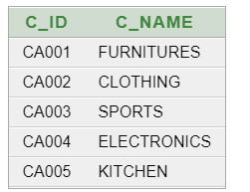

- CUSTOMER-
INSERT INTO CUSTOMER(CUST_ID, BORO_ID) VALUES('CUST001','BO002');
INSERT INTO CUSTOMER(CUST_ID, BORO_ID) VALUES('CUST002','OW001');
INSERT INTO CUSTOMER(CUST_ID, BORO_ID) VALUES('CUST003','BO005');
INSERT INTO CUSTOMER(CUST_ID, BORO_ID) VALUES('CUST004','OW002');
INSERT INTO CUSTOMER(CUST_ID, BORO_ID) VALUES('CUST005','OW004');
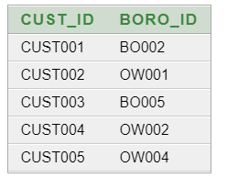

- PAYMENT_METHOD-
INSERT INTO PAYMENT_METHOD(PM_ID, PM_NAME) VALUES('PM001','BKASH');
INSERT INTO PAYMENT_METHOD(PM_ID, PM_NAME) VALUES('PM002','NAGAD');
INSERT INTO PAYMENT_METHOD(PM_ID, PM_NAME) VALUES('PM003','ROCKET');
INSERT INTO PAYMENT_METHOD(PM_ID, PM_NAME) VALUES('PM004','VISA');
INSERT INTO PAYMENT_METHOD(PM_ID, PM_NAME) VALUES('PM005','AMERICAN EXPRESS');
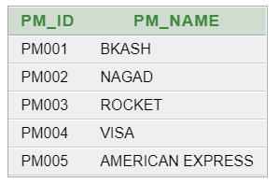
- EMPLOYEE-
INSERT INTO EMPLOYEE(EMP_ID, AD_OR_CS_ID, JOB) VALUES('EMP001','AD001','ADMIN');
INSERT INTO EMPLOYEE(EMP_ID, AD_OR_CS_ID, JOB) VALUES('EMP002','AD003','ADMIN');
INSERT INTO EMPLOYEE(EMP_ID, AD_OR_CS_ID, JOB) VALUES('EMP003','AD004','ADMIN');
INSERT INTO EMPLOYEE(EMP_ID, AD_OR_CS_ID, JOB) VALUES('EMP004','CS002','CUSTOMER SUPPORT');
INSERT INTO EMPLOYEE(EMP_ID, AD_OR_CS_ID, JOB) VALUES('EMP005','CS005','CUSTOMER SUPPORT');
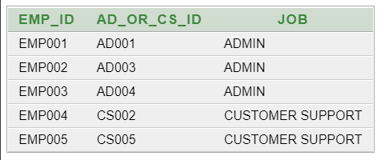

- COMPLAINTS-

INSERT INTO COMPLAINTS(COM_ID, CUST_ID, COM_MBL, COM_EMAIL, COMPLAINT, C_DATE) VALUES('COM001', 'CUST002', '01325463215', 'bkrans236@gmail.com', 'I did not get the requested product.', TO_DATE('2020-06-08', 'yyyy/mm/dd'));
INSERT INTO COMPLAINTS(COM_ID, CUST_ID, COM_MBL, COM_EMAIL, COMPLAINT, C_DATE) VALUES('COM002', 'CUST002', '01325463215', 'bkrans236@gmail.com', 'The customer support was not able to help.', TO_DATE('2020-06-09', 'yyyy/mm/dd'));
INSERT INTO COMPLAINTS(COM_ID, CUST_ID, COM_MBL, COM_EMAIL, COMPLAINT, C_DATE) VALUES('COM003', 'CUST001', '01456321564', 'sgoodman002@gmail.com', 'I was charged more than the shown amount.', TO_DATE('2020-07-10', 'yyyy/mm/dd'));
INSERT INTO COMPLAINTS(COM_ID, CUST_ID, COM_MBL, COM_EMAIL, COMPLAINT, C_DATE) VALUES('COM004', 'CUST003', '01459875462', 'mikey@gmail.com', 'I received a faulty product.', TO_DATE('2020-07-11', 'yyyy/mm/dd'));
INSERT INTO COMPLAINTS(COM_ID, CUST_ID, COM_MBL, COM_EMAIL, COMPLAINT, C_DATE) VALUES('COM005', 'CUST005', '01654123065', 'jessepink00000@gmail.com', 'I was charged more than the shown amount.', TO_DATE('2020-07-11', 'yyyy/mm/dd'));

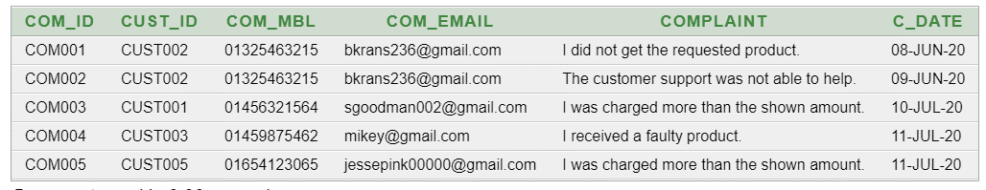

- REQUESTED_PRODUCT -
INSERT INTO REQUESTED_PRODUCT(RP_ID, B_ID, RP_NAME, C_ID, BUDGET, RP_DATE) VALUES('RP001', 'BO002', 'SONY CYBER-SHOT W800 20MP', 'CA004', 2500, TO_DATE('2020-11-06', 'yyyy/mm/dd'));
INSERT INTO REQUESTED_PRODUCT(RP_ID, B_ID, RP_NAME, C_ID, BUDGET, RP_DATE) VALUES('RP002', 'BO001', 'WOODEN ARM CHAIR', 'CA001', 150, TO_DATE('2020-11-06', 'yyyy/mm/dd'));
INSERT INTO REQUESTED_PRODUCT(RP_ID, B_ID, RP_NAME, C_ID, BUDGET, RP_DATE) VALUES('RP003', 'BO002', 'Apple MacBook Air 13.3-Inch', 'CA004', 4000, TO_DATE('2020-11-07', 'yyyy/mm/dd'));
INSERT INTO REQUESTED_PRODUCT(RP_ID, B_ID, RP_NAME, C_ID, BUDGET, RP_DATE) VALUES('RP004', 'BO005', '5 Way Manual Treadmill', 'CA003', 1000, TO_DATE('2020-11-08', 'yyyy/mm/dd'));
INSERT INTO REQUESTED_PRODUCT(RP_ID, B_ID, RP_NAME, C_ID, BUDGET, RP_DATE) VALUES('RP005', 'BO003', 'Apple Studio Display 27"', 'CA004', 2500, TO_DATE('2020-11-10', 'yyyy/mm/dd'));

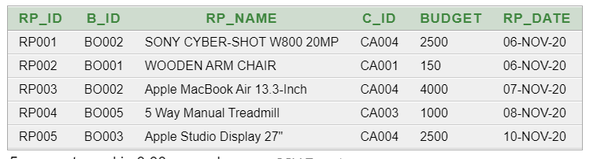

- ORENTED_PRODUCT -
INSERT INTO ORENTED_PRODUCT (OP_ID, O_ID, OP_NAME, C_ID, RENT, OP_DATE) VALUES('OP001', 'OW003', 'SONY CYBER-SHOT W800 20MP', 'CA004', 2500, TO_DATE('2020-11-06', 'yyyy/mm/dd'));
INSERT INTO ORENTED_PRODUCT (OP_ID, O_ID, OP_NAME, C_ID, RENT, OP_DATE) VALUES('OP002', 'OW005', 'Curren 9065 Quartz Watch ', 'CA002', 500, TO_DATE('2020-11-07', 'yyyy/mm/dd'));
INSERT INTO ORENTED_PRODUCT (OP_ID, O_ID, OP_NAME, C_ID, RENT, OP_DATE) VALUES('OP003', 'OW001', 'WOODEN ARM CHAIR', 'CA001', 150, TO_DATE('2020-11-08', 'yyyy/mm/dd'));
INSERT INTO ORENTED_PRODUCT (OP_ID, O_ID, OP_NAME, C_ID, RENT, OP_DATE) VALUES('OP004', 'OW002', 'SONY CYBER-SHOT W800 20MP', 'CA004', 2000, TO_DATE('2020-11-08', 'yyyy/mm/dd'));
INSERT INTO ORENTED_PRODUCT (OP_ID, O_ID, OP_NAME, C_ID, RENT, OP_DATE) VALUES('OP005', 'OW004', 'NVIDIA Quadro P1000 4GB', 'CA004', 800, TO_DATE('2020-11-09', 'yyyy/mm/dd'));

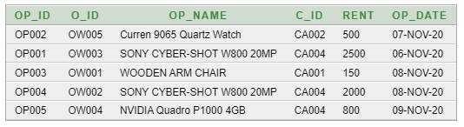

- PAYMENT -
INSERT INTO PAYMENT(P_ID, CUST_ID, PM_ID, AMOUNT, P_DATE) VALUES('PA001', 'CUST005', 'PM001', 2000, TO_DATE('2020-11-06', 'yyyy/mm/dd'));
INSERT INTO PAYMENT(P_ID, CUST_ID, PM_ID, AMOUNT, P_DATE) VALUES('PA002', 'CUST002', 'PM004', 150, TO_DATE('2020-11-07', 'yyyy/mm/dd'));
INSERT INTO PAYMENT(P_ID, CUST_ID, PM_ID, AMOUNT, P_DATE) VALUES('PA003', 'CUST005', 'PM005', 800, TO_DATE('2020-11-08', 'yyyy/mm/dd'));
INSERT INTO PAYMENT(P_ID, CUST_ID, PM_ID, AMOUNT, P_DATE) VALUES('PA004', 'CUST001', 'PM001', 1200, TO_DATE('2020-11-09', 'yyyy/mm/dd'));
INSERT INTO PAYMENT(P_ID, CUST_ID, PM_ID, AMOUNT, P_DATE) VALUES('PA005', 'CUST003', 'PM002', 200, TO_DATE('2020-11-09', 'yyyy/mm/dd'));

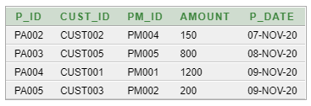

Tasks:
- Find employees who joined after year 2019.
- SELECT EMP_ID, JOB FROM EMPLOYEE WHERE AD_OR_CS_ID IN (SELECT A_ID FROM ADMIN WHERE A_JOINNING_DATE > to_date('31 Dec 2019','DD MON YYYY')) OR AD_OR_CS_ID IN (SELECT CS_ID FROM CUSTOMER_SUPPORT WHERE CS_JOINNING_DATE > to_date('31 Dec 2019','DD MON YYYY'))

- Find the requested and rented products which have same budget.
- select requested_product.*, orented_product.* from requested_product, orented_product where BUDGET=RENT

- Find the borrowers who paid with BKASH.
- SELECT * FROM BORROWER WHERE B_ID IN (SELECT BORO_ID FROM CUSTOMER WHERE CUST_ID IN (SELECT CUST_ID FROM PAYMENT WHERE PM_ID=(SELECT PM_ID FROM PAYMENT_METHOD WHERE PM_NAME='BKASH')))

- Find the product category that are requested most.
- SELECT C_NAME FROM CATEGORY WHERE C_ID=(SELECT C_ID FROM requested_product GROUP BY C_ID HAVING COUNT(C_ID)=(select MAX(COUNT(C_ID)) from requested_product GROUP BY C_ID))

- Find out the product of second highest price.
- select p.* from requested_product p where p.BUDGET in(select max(BUDGET) from requested_product where BUDGET<(select max(BUDGET) from requested_product ));

- Find out the month in which maximum number of admin joined.
- SELECT to_char(A_JOINNING_DATE, 'YYYY-MM') FROM ADMIN GROUP BY to_char(A_JOINNING_DATE, 'YYYY-MM') HAVING COUNT(to_char(A_JOINNING_DATE, 'YYYY-MM')) = (select MAX(COUNT(to_char(A_JOINNING_DATE, 'YYYY-MM'))) from ADMIN group by to_char(A_JOINNING_DATE, 'YYYY-MM'))

- Find out the category and the requested date of requested product 4.
- SELECT C_NAME, RP_DATE FROM requested_product, CATEGORY WHERE requested_product.C_ID=CATEGORY.C_ID AND RP_ID='RP004'

- Find out the joinning date of most junior customer support executive.
- Find out the rented product and its category with least price.
- Find out the customer with oldest complaint.

User Interface:
Registration-
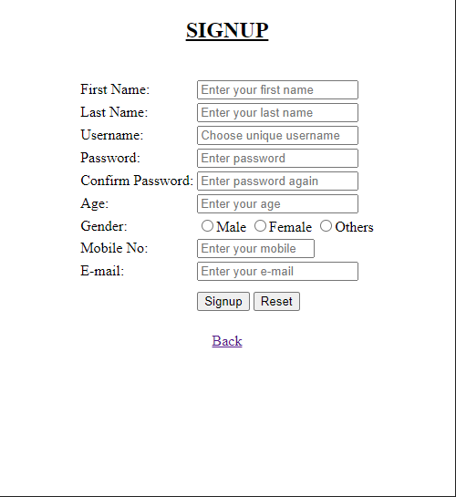

LOGIN-
