

American International University- Bangladesh

CSC 4181: Advanced Database Management Systems

Final Term Report
Fall 22-23

Project Title: Renting-Borrowing Service
Section: A

Student Name | Student Id
Sudarshan Saha Bishal | 20-42915-1

Table of Contents

Database | :............................................ | 03-06
Admin Panel | :............................................ | 07-08
User Interface | :............................................ | 08-09
Searching & Advance Searching | :............................................ | 10
Sequence | :............................................ | 11
View | :............................................ | 12-13
Procedures & Functions | :............................................ | 13-16
Triggers | :............................................ | 17-18

Database:

Tables | Views
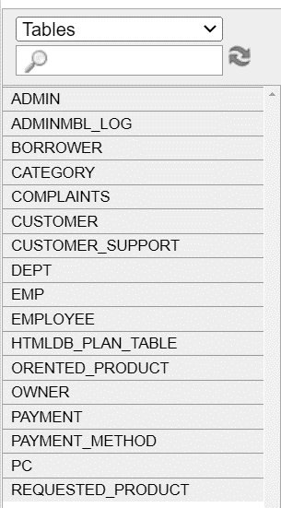 | 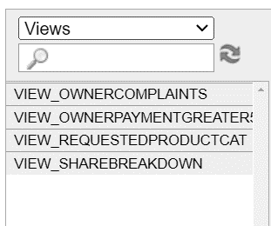
Sequences | Triggers
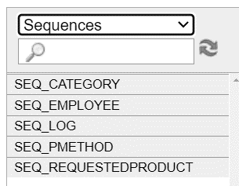 | 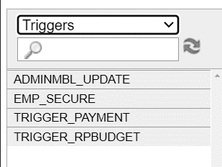
Procedures
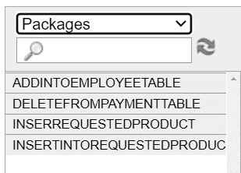

Tables:
- ADMIN-

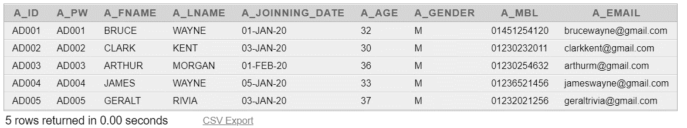

- CUSTOMER_SUPPORT-

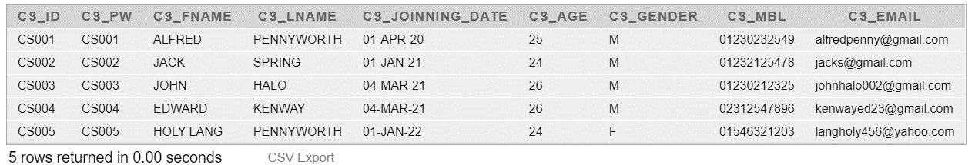

- BORROWER-

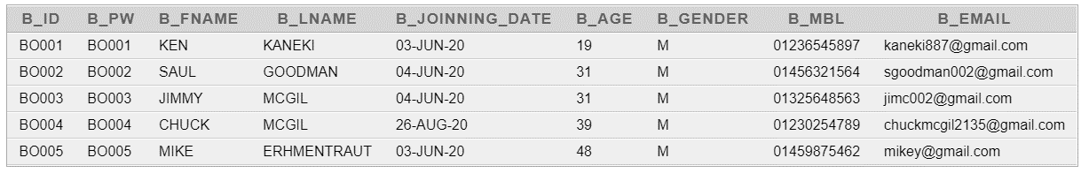

- OWNER-

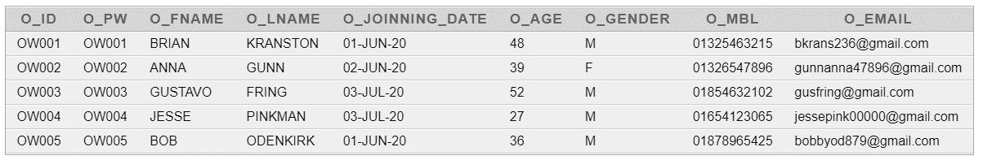

- CATEGORY-
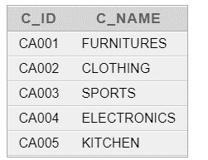

- CUSTOMER-
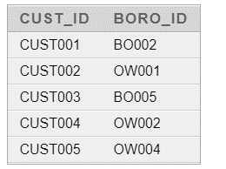

- PAYMENT_METHOD-
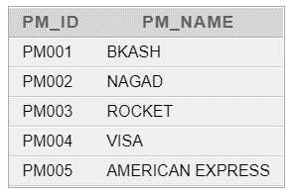
- EMPLOYEE-
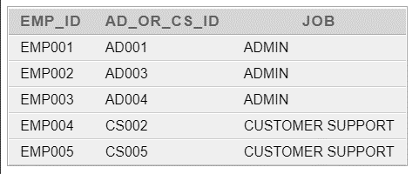

- COMPLAINTS-
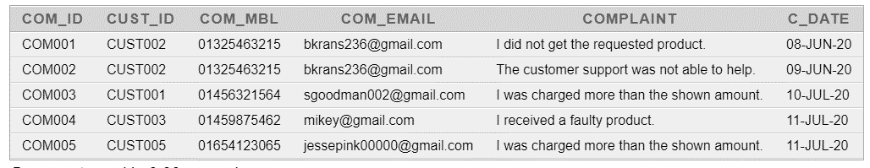

- REQUESTED_PRODUCT -
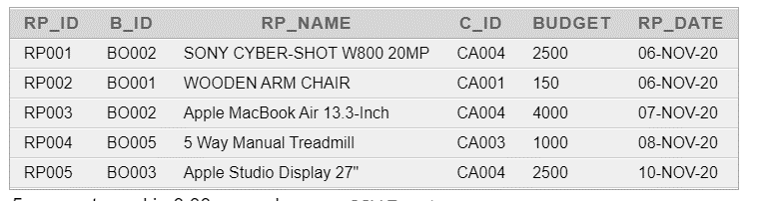

- ORENTED_PRODUCT -
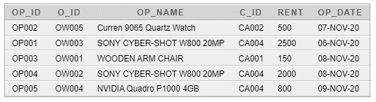

- PAYMENT -
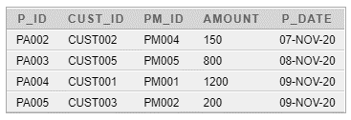

Admin Panel:

SignIn Page-
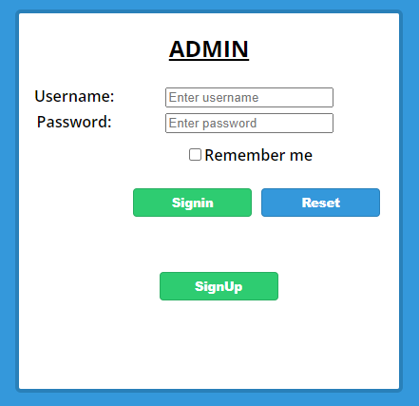

SignUp Page-
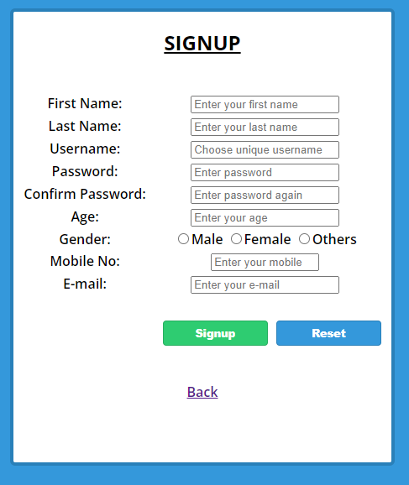

Admin Dashboard-
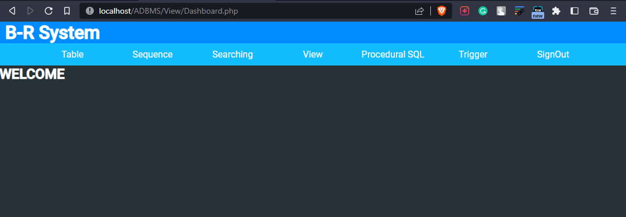

User Interface:

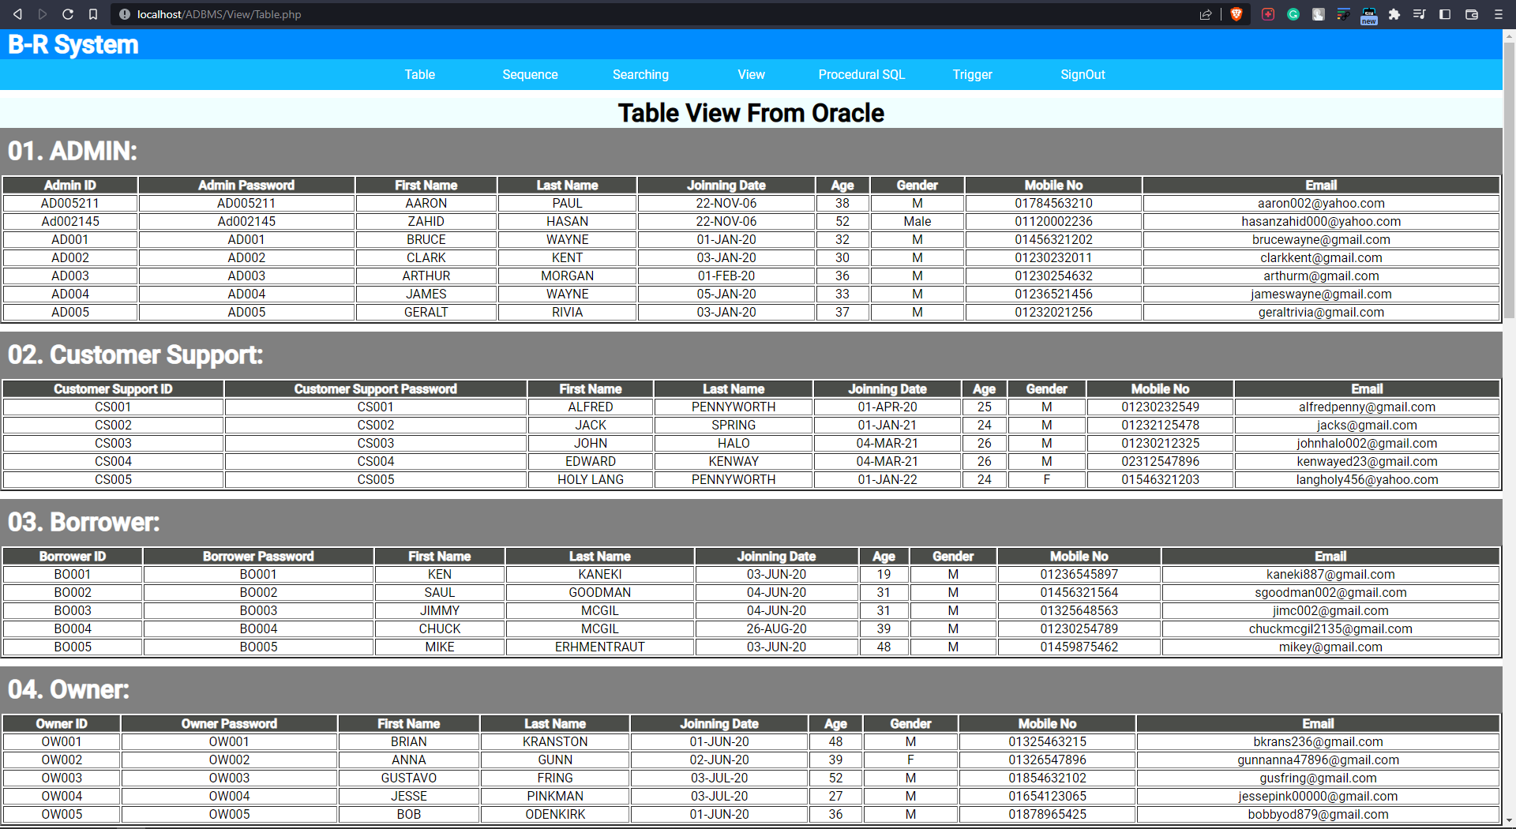
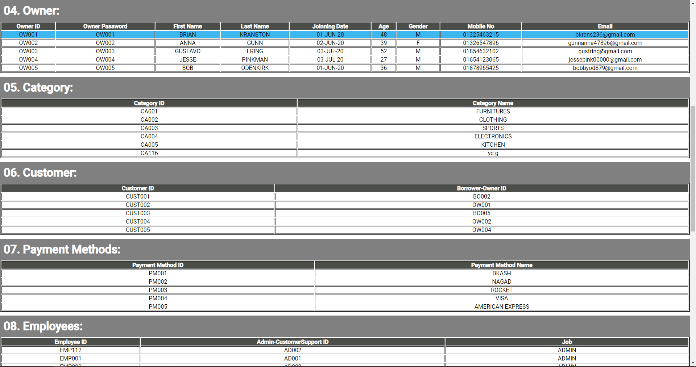
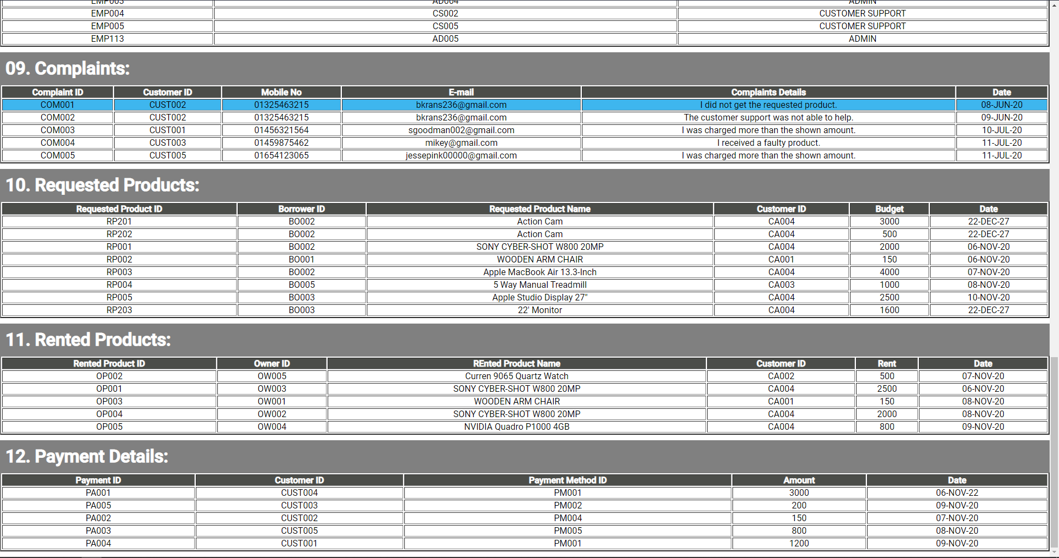

Searching & Advance Searching:

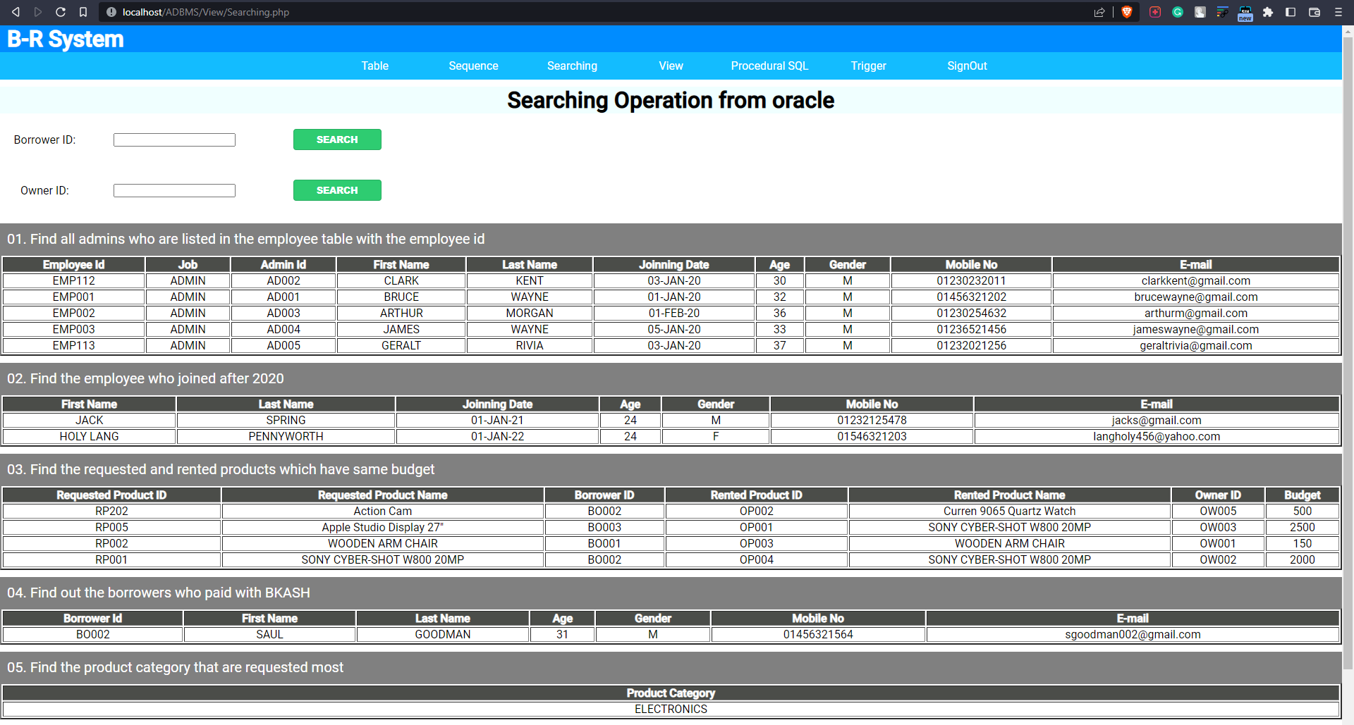

Sequence:
CREATE SEQUENCE seq_category
MINVALUE 100
MAXVALUE 999999999999999999
START WITH 111
INCREMENT BY 1
CACHE 10;

CREATE SEQUENCE seq_pMethod
MINVALUE 100
MAXVALUE 999999999999999999
START WITH 555
INCREMENT BY 2
CACHE 10;

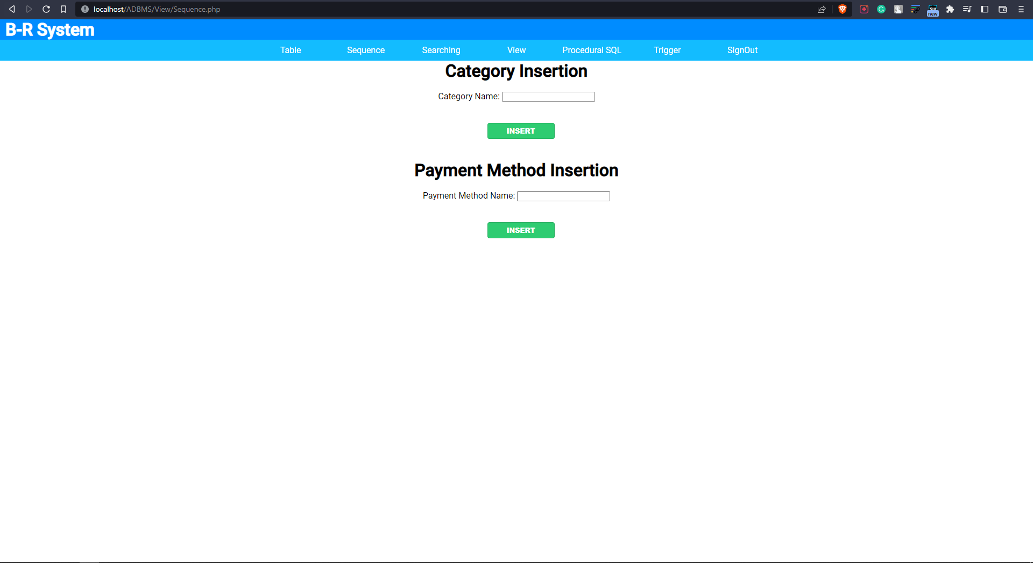

View:

      - Requested Products with the category name:
CREATE VIEW view_requestedProductCat AS select REQUESTED_PRODUCT.RP_ID, REQUESTED_PRODUCT.RP_NAME, CATEGORY.C_NAME, REQUESTED_PRODUCT.BUDGET from REQUESTED_PRODUCT, CATEGORY where REQUESTED_PRODUCT.C_ID=CATEGORY.C_ID

select * from view_requestedProductCat

      - Owner who rented products amount of more than 500:
CREATE VIEW view_ownerPaymentGreater500 AS
select CUSTOMER.BORO_ID, OWNER.O_FNAME, OWNER.O_LNAME, OWNER.O_AGE, OWNER.O_GENDER, OWNER.O_MBL, OWNER.O_EMAIL, PAYMENT.AMOUNT, PAYMENT.P_DATE FROM PAYMENT, CUSTOMER, OWNER WHERE AMOUNT>500 AND CUSTOMER.CUST_ID=PAYMENT.CUST_ID AND OWNER.O_ID=CUSTOMER.BORO_ID

select * from view_ownerPaymentGreater500

      - Company taking 15% profit share breakdown:
CREATE VIEW view_shareBreakdown AS
select ORENTED_PRODUCT.OP_ID, ORENTED_PRODUCT.O_ID, ORENTED_PRODUCT.OP_NAME, ORENTED_PRODUCT.RENT, ROUND(ORENTED_PRODUCT.RENT*0.15) AS COMPANY_SHARE, ROUND(ORENTED_PRODUCT.RENT-(ORENTED_PRODUCT.RENT*0.15)) AS CUSTOMER_PROFIT from ORENTED_PRODUCT

select * from view_shareBreakdown

      - View only owner customers’ complaints
CREATE VIEW view_ownerComplaints AS
select customer.boro_id ,complaints.* from complaints, customer where complaints.cust_id=customer.cust_id and customer.boro_id like 'OW%'

select * from view_ownerComplaints

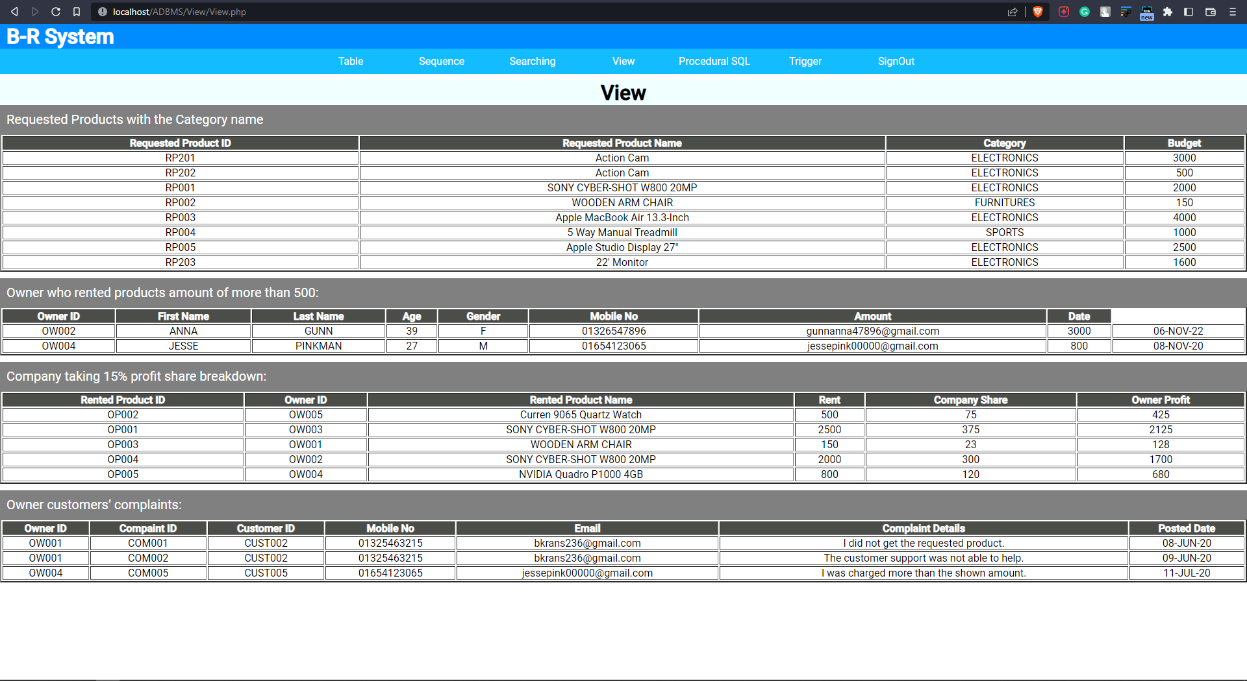

Procedures and Functions:

Porcedure-01: Adding existing admin or customer support into employee table
create or replace package addIntoEmployeeTable as
procedure add_emp(acs_no employee.AD_OR_CS_ID%type, job_title employee.job%type);
end addIntoEmployeeTable;

create or replace package body addIntoEmployeeTable as
function validAcsId(acs_no employee.AD_OR_CS_ID%type)
return boolean
is
acsno_count number(3);
begin
select count(*) into acsno_count from employee where AD_OR_CS_ID=acs_no;
if acsno_count=0 then
return true;
else return false;
end if;
end validAcsId;

procedure add_emp(acs_no employee.AD_OR_CS_ID%type, job_title employee.job%type)
is
inval_emp exception;
begin
if validAcsId(acs_no) then
INSERT INTO EMPLOYEE(EMP_ID, AD_OR_CS_ID, JOB) VALUES('EMP'||seq_employee.nextval, acs_no, job_title);
else
raise inval_emp;
end if;
exception
when inval_emp then
raise_application_error(-42915,'Employee already exists!');
when others then
raise_application_error(-42915,'Something went wrong');
end add_emp;
end addIntoEmployeeTable;

Porcedure-02: Delete a payment detail entering the payment id

create or replace package deleteFromPaymentTable as
procedure del_payment(pno payment.P_ID%type);
end deleteFromPaymentTable ;

create or replace package body deleteFromPaymentTable as
function validPayment(pno payment.P_ID%type)
return boolean
is
payment_count number(3);
begin
select count(*) into payment_count from payment where P_ID=pno;
if payment_count=0 then
return false;
else return true;
end if;
end validPayment;

procedure del_payment(pno payment.P_ID%type)
is
inval_del exception;
begin
if validPayment(pno) then
delete from payment where p_id=pno;
else
raise inval_del ;
end if;
exception
when inval_del then
raise_application_error(-42916,'Payment does not exist!');
when others then
raise_application_error(-42920,'Something went wrong');
end del_payment;
end deleteFromPaymentTable;

Porcedure-03: Inserting product details in the requested product table

CREATE OR REPLACE FUNCTION CheckValidCategory(cat_id CATEGORY.C_ID%type)
return varchar2 IS
c number(3);
BEGIN
select count(*) into c from CATEGORY where C_ID=cat_id;
if c=1 then
return 'TRUE';
else
return 'FALSE';
end if;
END;

CREATE OR REPLACE FUNCTION CheckValidBorrower(bno REQUESTED_PRODUCT.B_ID%type)
return varchar2 IS
c number(3);
BEGIN
select count(*) into c from BORROWER where B_ID=bno;
if c=1 then
return 'TRUE';
else
return 'FALSE';
end if;
END;

CREATE OR REPLACE PROCEDURE Insert_ReqProduct(bno REQUESTED_PRODUCT.B_ID%type, pname REQUESTED_PRODUCT.RP_NAME%type, cat_id CATEGORY.C_ID%type, budg REQUESTED_PRODUCT.BUDGET%type)
IS
ret_ValidBorrower varchar2(10);
ret_ValidCategory varchar2(10);
inval_request exception;
BEGIN
if budg>=10 then
ret_ValidBorrower := CheckValidBorrower(bno);
if ret_ValidBorrower = 'TRUE' then
ret_ValidCategory := CheckValidCategory(cat_id);
if ret_ValidCategory='TRUE' then
INSERT INTO REQUESTED_PRODUCT(RP_ID, B_ID, RP_NAME, C_ID, BUDGET, RP_DATE) VALUES('RP'||seq_requestedProduct.nextval,
bno, pname, cat_id, budg, TO_DATE(sysdate, 'yyyy/mm/dd'));
else
raise inval_request;
end if;
else
raise inval_request;
end if;
else
raise inval_request;
end if;
exception
when inval_request then
raise_application_error(-42914,'Not a valid category OR invalid user OR does not meet minimum budget!');
when others then
raise_application_error(-42917,'Something went wrong');
END;

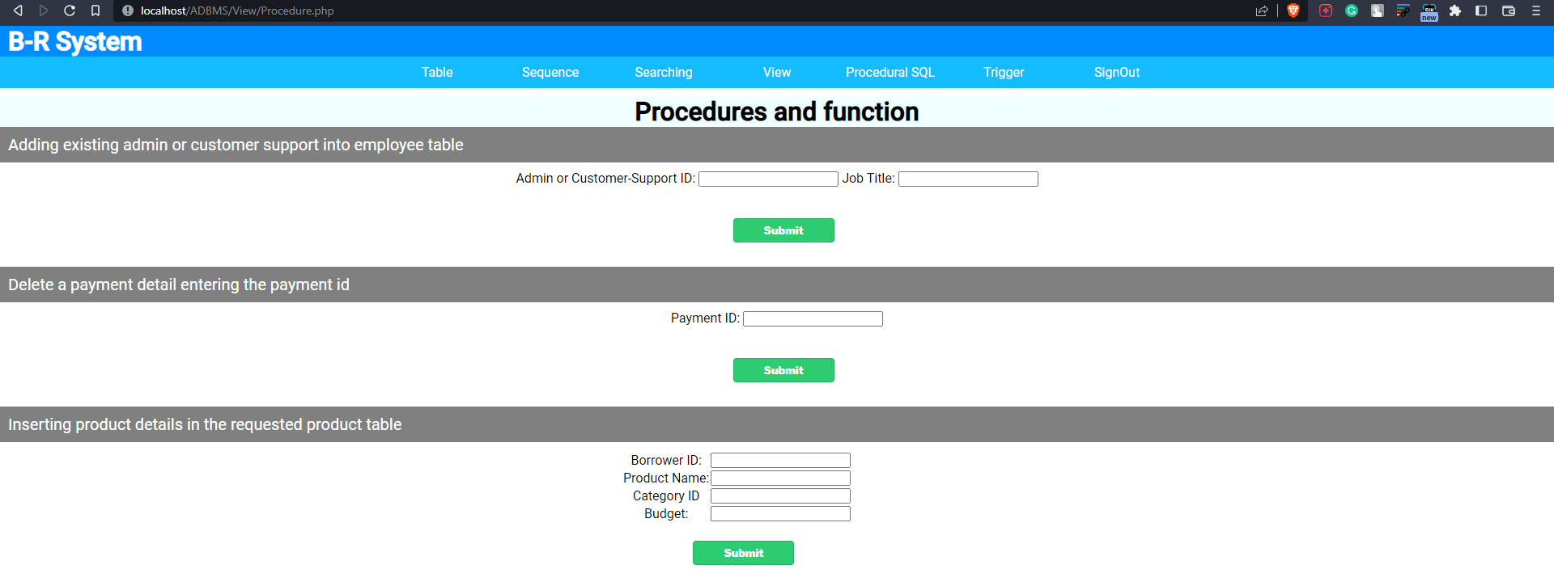

Triggers:

Trigger-01: Inserting a negative value in the budget column will call this trigger

create or replace trigger trigger_rpBudget
before insert or update of BUDGET on REQUESTED_PRODUCT
for each row
begin
if :new.BUDGET<0
then raise_application_error(-2056321,'Budget cannot be a negative value');
end if;
end;

Trigger-02: Updating admins’ mobile no will be kept in a log table by this trigger

CREATE SEQUENCE seq_log
MINVALUE 100
MAXVALUE 999999999999999999999999999
START WITH 100
INCREMENT BY 1
CACHE 10;

create table adminMBL_log(
adno number not null,
old_mbl varchar(20) not null,
new_mbl varchar(20) not null,
u_date date not null);
create or replace trigger adminMBL_update
after update of A_MBL on admin
for each row
Begin
insert into adminMBL_log values(seq_log.nextval,:old.A_MBL ,:new.A_MBL ,sysdate);
end;

Trigger-03: Performing insert, update, or delete operation not in the working period

create or replace trigger trigger_payment
before insert or update or delete on payment
begin
if to_char(sysdate,'DY') in ('SAT','FRI')
or to_char(sysdate,'HH24') not between '08' and '21' then
raise_application_error(-42587, 'Try later!');
end if;
end;

