

American International University-Bangladesh

**SOFTWARE ENGINEERING**

**Section:** A

**Group No:** 01

**Semester:** Spring [21-22]

**Restaurant Digital Marketing Solution**

|  |  |
| --- | --- |
| **Group Members** | **Student ID** |
| 1. Fabiha Tasnim | 20-43426-1 |
| 1. Sudarshan Saha Bishal | 20-42915-1 |
| 1. Md. Sadik Hossain Chowdhury | 20-43427-1 |
| 1. Md. Apon Riaz Talukder | 20-42905-1 |

Use Case Diagram of Restaurant Digital Marketing Solution:

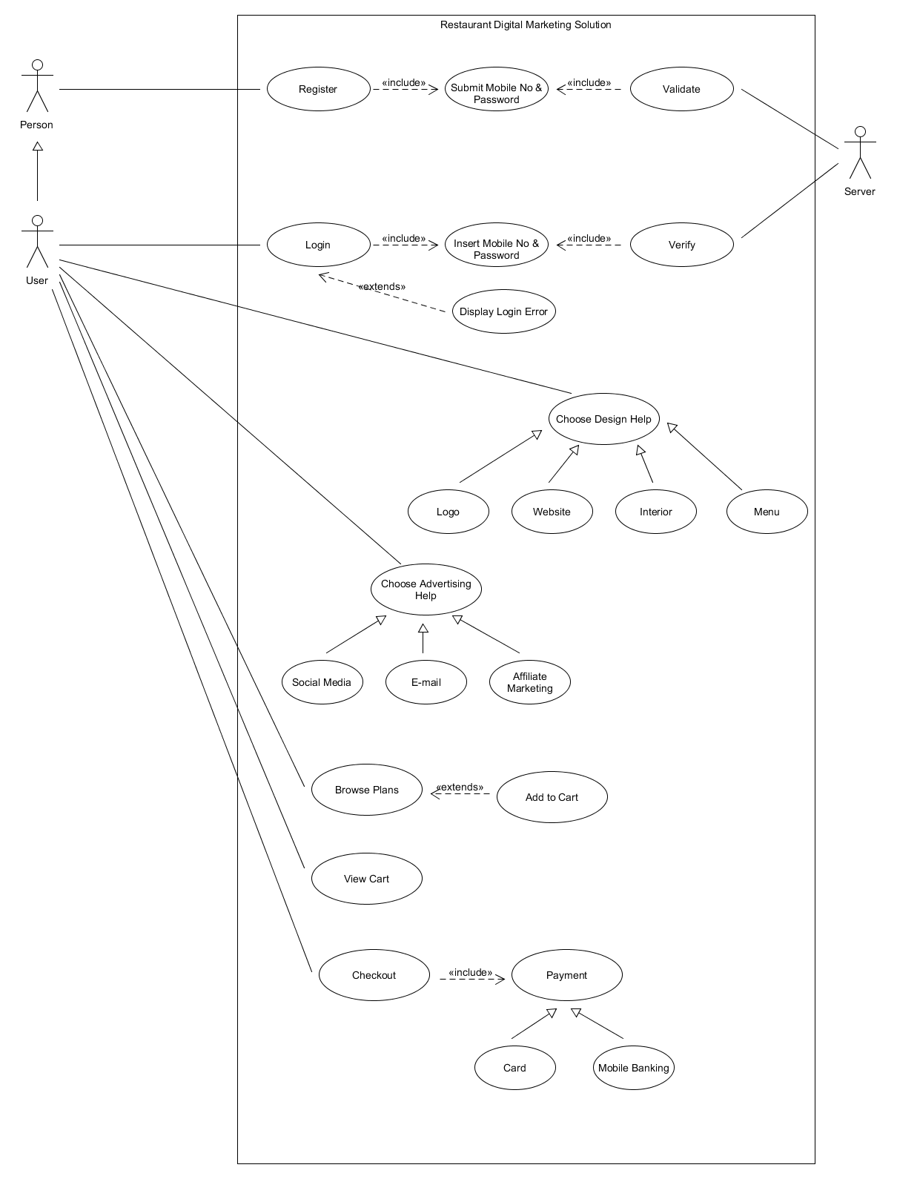

|  |  |
| --- | --- |
| **Actors** | **Use Case** |
| Person | Register |
| Server | Validate, Verify |
| User | Login, Browse Plans, Choose Design Help, Choose Advertising Help, View Cart, Checkout |