NavTech

CodingAssessment

* Creating a User ie.(Signing Up)
* Authorizing a created User (Logging)
* Creating the orders
* Viewing the orders based on page index and page size

The user tries to create order without signing up

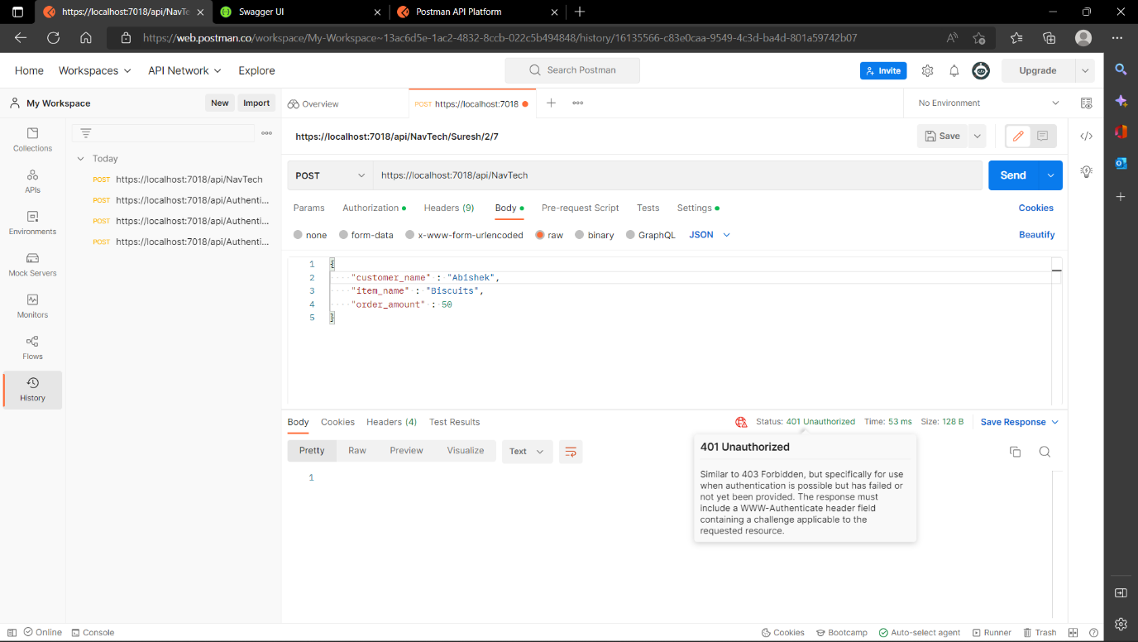

User registers himself successfully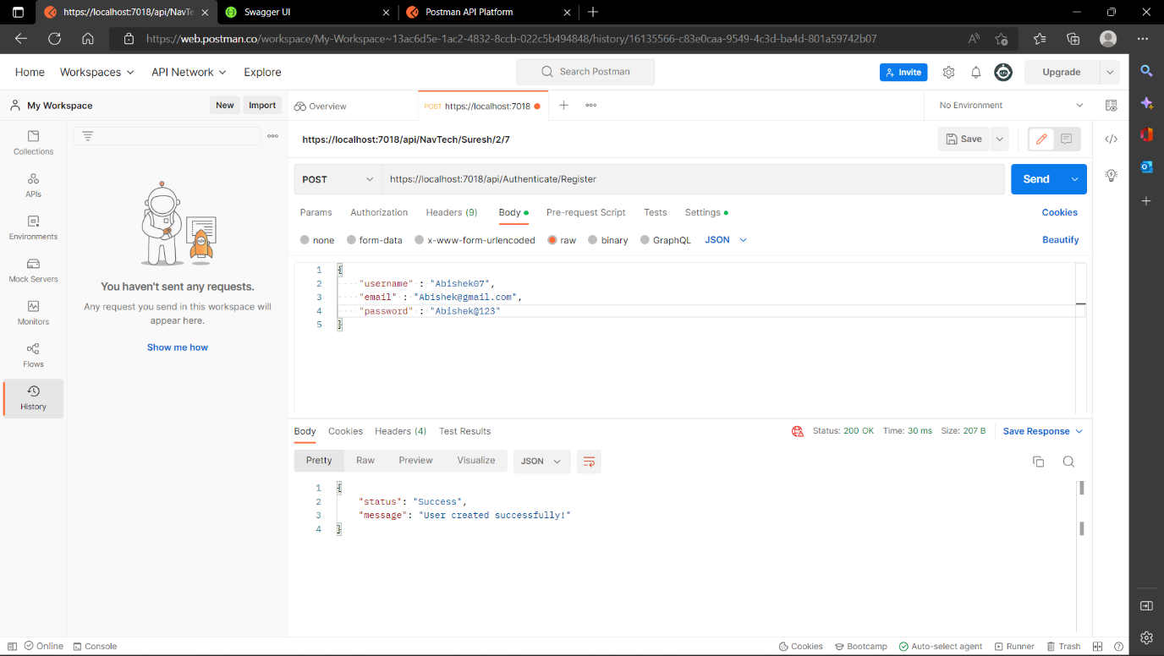

User already exists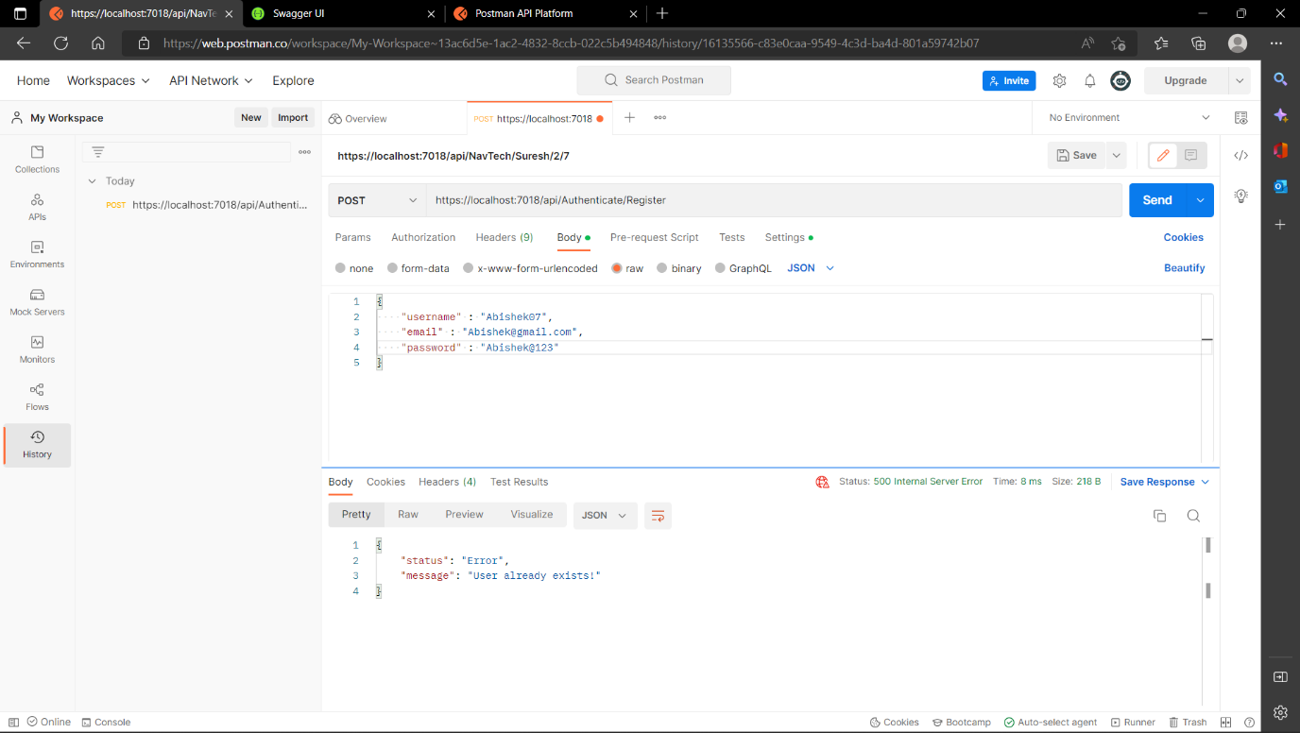

Logging in without registering

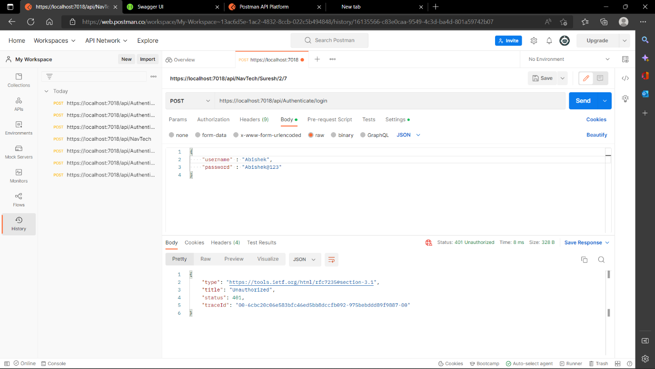

Log in Successful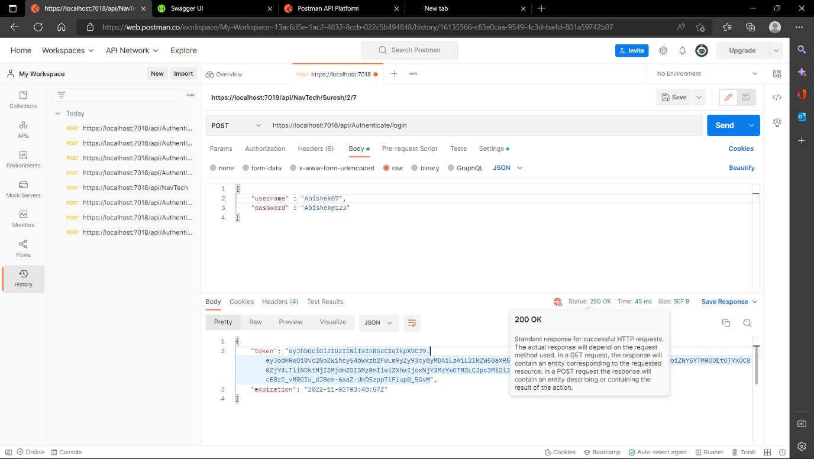

Now user creates order successfully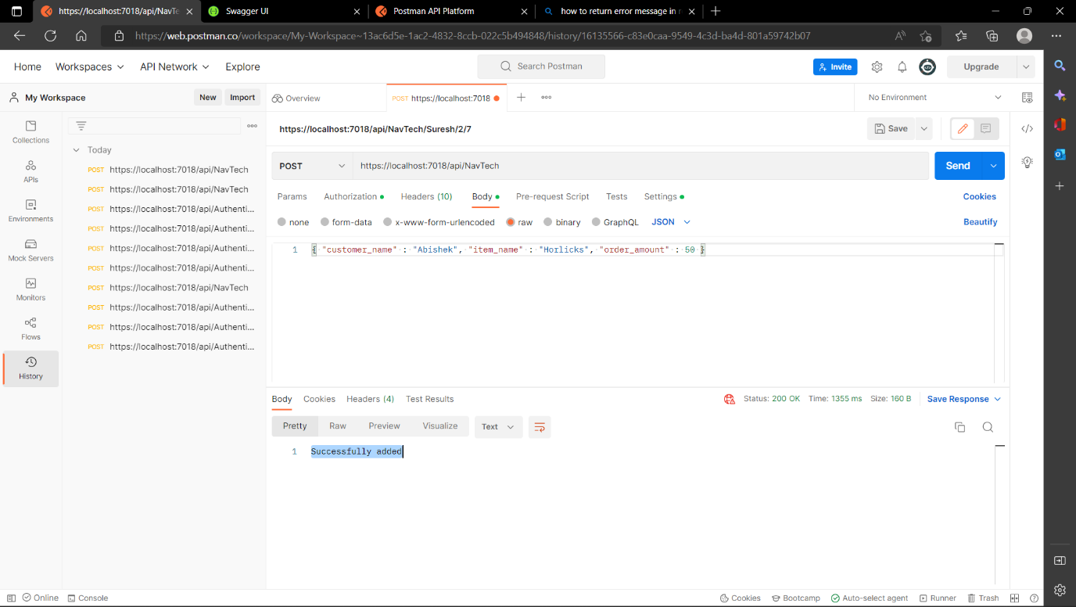

View data based on page no. and page size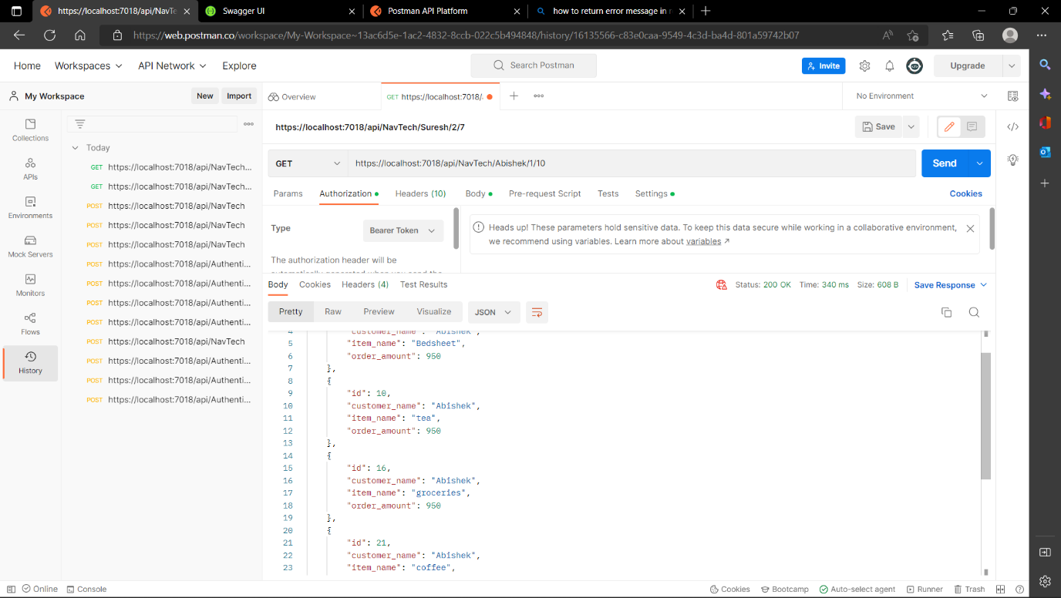

If page no. doesn’t have any content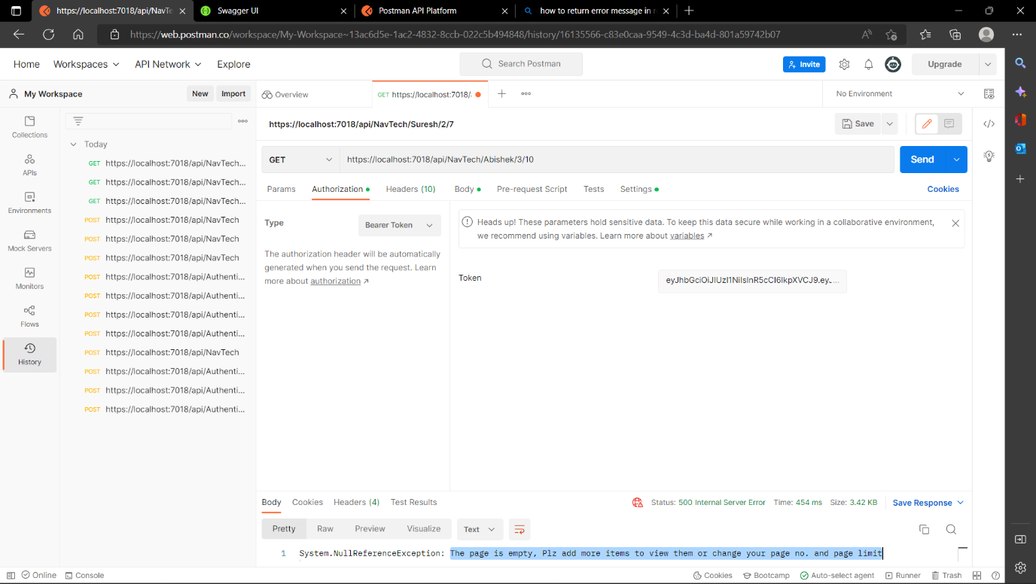

Order database 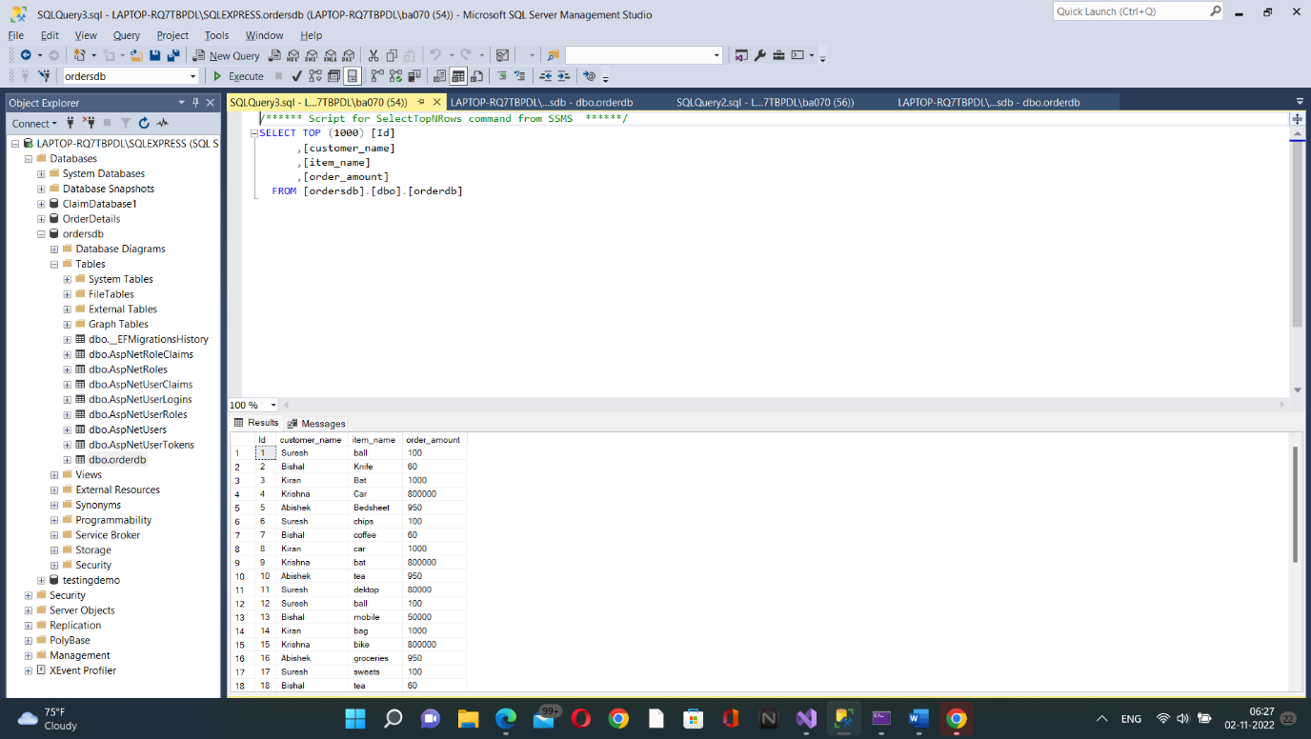

Customer database