ФЕДЕРАЛЬНОЕ АГЕНТСТВО СВЯЗИ

Федеральное государственное образовательное бюджетное учреждение

высшего профессионального образования

«Санкт-Петербургский государственный университет телекоммуникаций

им. проф. М.А. Бонч-Бруевича»

Факультет Информационных технологий и программной инженерии

Кафедра Программной инженерии и вычислительной техники

КУРСОВАЯ РАБОТА

по дисциплине:

**«Программирование»**

тема: Анализ сигнала на выходе электрической цепи

Передаточная характеристика – 16 вариант

Входной сигнал – 4 вариант

Выполнил студент(ка):

Мандрыкин Никита Алексеевич, 44

*(Ф.И.О., № группы)*

_____________

*(подпись)*

Дата выполнения:

«______» ______________________2025г

Проверил:

Дятлов Денис Алексеевич _____________

*(Ф.И.О.) (подпись)*

Санкт-Петербург

2025

Содержание

1 Постановка задачи 3

1.1 Ход работы 3

1.2 Задание для варианта №16 3

2 Контрольный расчет 5

3 Таблица идентификаторов 15

4 Блок-схемы 17

5 Текст программы 24

5.1 Главный модуль программы 24

5.1.1 Файл: signal_analysis.c 24

5.2 Модуль формирования данных 25

5.2.1 Файл: forming.h 25

5.2.2 Файл: forming.c 25

5.3 Модуль расчёта параметров сигнала 26

5.3.1 Файл: parameter.h 26

5.3.2 Файл: parameter.c 27

5.4 Модуль ввода данных 28

5.4.1 Файл: input.h 28

5.4.2 Файл: input.c 28

5.5 Модуль вывода и сохранения данных 30

5.5.1 Файл: output.h 30

5.5.2 Файл: input.c 30

6 Графики (обработка полученных результатов) 32

Заключение 42

Список использованных источников 43

# Постановка задачи

В курсовой работе необходимо для заданной электрической цепи по известному входному сигналу определить выходной сигнал для N равностоящих моментов времени, а затем определить некоторые его характеристики с погрешностью не более 1%.

## Ход работы

* Произвести расчет входного и выходного сигнала в контрольных точках, используя при этом математический пакет wxMaxima;
* Написать текст программы на языке Си;
* Произвести запись полученных результатов в файлы данных;
* Используя математический пакет wxMaxima или LibreOffice Calc (электронные таблицы), построить графики зависимости напряжений входных и выходных сигналов от времени.
* Оформить пояснительную записку (doc-файл) по ГОСТ 19.402-78. ЕСПД. Описание программы. Плюс «Заключение» с личными выводами по работе.
* Объединить программу на Си и Wxmaxima (LibreOffice Calc), вызов отчета с помощью скрипта на Bash.
* Защитить работу преподавателю.

## Задание для варианта №16

1. Сигнал на входе:
2. Передаточная характеристика:
3. Расчетный параметр:

Найти длительность переднего фронта импульса сигнала для Uвых.

# Контрольный расчет

В данном разделе представлена реализация контрольных расчётов, выполненная в среде wxMaxima. Программа рассчитывает значения функций Uvx и Uvix на интервале, указанном в постановке задачи, с шагом, обеспечивающим вычисление на 500 точках. Такой подход позволяет достичь оптимальной точности при вычислительном эксперименте.

(%i238) /* Определение начальных условий для Uvx(t) */  
 fpprintprec:5;  
 tnach:5; t1:10; t2:15; t3:45; tkon:50;  
 a:20;b:0.5;c:17;  
   
 /* Определение функции Uvx(t) */  
 Uvx(t):=if t <= t1 then 0  
 else if t1 < t and t <= t2 then a*(t-t1)  
 else if t2 < t and t <= t3 then a*(t2-t1)-b*(t-t2)  
 else a*(t2-t1) - b*(t3-t1) - c*(t-t3);  
   
 /* Формирование массива времени */  
 N:1500; /* Количество точек */  
 dt:(tkon-tnach)/(N-1), numer;  
 time_array:makelist(tnach + i*dt, i, 0, N-1);  
   
 /* Вычисление значений Uvx(t) для массива времени */  
 Uvx_values:map(Uvx, time_array);  
   
 /* Определение начальных условий для Uvix */  
 d:2; e:-5;  
 Uvx1:20;  
   
 /* Определение функции Uvix */  
 Uvix(t):=if Uvx(t) <= Uvx1 then d*Uvx(t) + e  
 else d*Uvx1 + e;  
   
 /* Вычисление значений Uvix для массива времени */  
 Uvix_values:map(Uvix, time_array);  
   
 /* Построение графика Uvx(t) */  
 wxplot2d([discrete, time_array, Uvx_values], [gnuplot_preamble, "set grid;"]);  
 wxplot2d([discrete, time_array, Uvix_values], [gnuplot_preamble, "set grid;"]);  
(fpprintprec) 5  
  
(tnach) 5  
  
(t1) 10  
  
(t2) 15  
  
(t3) 45  
  
(tkon) 50  
  
(a) 20  
  
(b) 0.5  
  
(c) 17  
  
(%o227) Uvx(t):=if t<=t1 then 0 else if t1<t and t<=t2 then a*(t-t1) else if t2<t and t<=t3 then a*(t2-t1)-b*(t-t2) else a*(t2-t1)-b*(t3-t1)+-c*(t-t3)  
(N) 1500  
  
(dt) 0.03002  
  
(time_array) [5,5.03,5.06,5.0901,5.1201,5.1501,5.1801,5.2101,5.2402,5.2702,5.3002,5.3302,5.3602,5.3903,5.4203,5.4503,5.4803,5.5103,5.5404,5.5704,5.6004,5.6304,5.6604,5.6905,5.7205,5.7505,5.7805,5.8105,  
5.8406,5.8706,5.9006,5.9306,5.9606,5.9907,6.0207,6.0507,6.0807,6.1107,6.1408,6.1708,6.2008,6.2308,6.2608,6.2909,6.3209,6.3509,6.3809,6.4109,6.441,6.471,6.501,6.531,6.561,6.5911,6.6211,6.6511,  
6.6811,6.7111,6.7412,6.7712,6.8012,6.8312,6.8612,6.8913,6.9213,6.9513,6.9813,7.0113,7.0414,7.0714,7.1014,7.1314,7.1614,7.1915,7.2215,7.2515,7.2815,7.3115,7.3416,7.3716,7.4016,7.4316,7.4616,  
7.4917,7.5217,7.5517,7.5817,7.6117,7.6418,7.6718,7.7018,7.7318,7.7618,7.7919,7.8219,7.8519,7.8819,7.9119,7.942,7.972,8.002,8.032,8.062,8.0921,8.1221,8.1521,8.1821,8.2121,8.2422,8.2722,8.3022,  
8.3322,8.3622,8.3923,8.4223,8.4523,8.4823,8.5123,8.5424,8.5724,8.6024,8.6324,8.6624,8.6925,8.7225,8.7525,8.7825,8.8125,8.8426,8.8726,8.9026,8.9326,8.9626,8.9927,9.0227,9.0527,9.0827,9.1127,  
9.1428,9.1728,9.2028,9.2328,9.2628,9.2929,9.3229,9.3529,9.3829,9.4129,9.443,9.473,9.503,9.533,9.563,9.5931,9.6231,9.6531,9.6831,9.7131,9.7432,9.7732,9.8032,9.8332,9.8632,9.8933,9.9233,9.9533,  
9.9833,10.013,10.043,10.073,10.103,10.133,10.163,10.193,10.223,10.254,10.284,10.314,10.344,10.374,10.404,10.434,10.464,10.494,10.524,10.554,10.584,10.614,10.644,10.674,10.704,10.734,10.764,  
10.794,10.824,10.854,10.884,10.914,10.944,10.974,11.004,11.034,11.064,11.094,11.124,11.154,11.184,11.214,11.244,11.274,11.304,11.334,11.364,11.394,11.424,11.454,11.484,11.514,11.544,11.574,  
11.604,11.634,11.664,11.694,11.724,11.755,11.785,11.815,11.845,11.875,11.905,11.935,11.965,11.995,12.025,12.055,12.085,12.115,12.145,12.175,12.205,12.235,12.265,12.295,12.325,12.355,12.385,  
12.415,12.445,12.475,12.505,12.535,12.565,12.595,12.625,12.655,12.685,12.715,12.745,12.775,12.805,12.835,12.865,12.895,12.925,12.955,12.985,13.015,13.045,13.075,13.105,13.135,13.165,13.195,  
13.225,13.256,13.286,13.316,13.346,13.376,13.406,13.436,13.466,13.496,13.526,13.556,13.586,13.616,13.646,13.676,13.706,13.736,13.766,13.796,13.826,13.856,13.886,13.916,13.946,13.976,14.006,  
14.036,14.066,14.096,14.126,14.156,14.186,14.216,14.246,14.276,14.306,14.336,14.366,14.396,14.426,14.456,14.486,14.516,14.546,14.576,14.606,14.636,14.666,14.696,14.726,14.757,14.787,14.817,  
14.847,14.877,14.907,14.937,14.967,14.997,15.027,15.057,15.087,15.117,15.147,15.177,15.207,15.237,15.267,15.297,15.327,15.357,15.387,15.417,15.447,15.477,15.507,15.537,15.567,15.597,15.627,  
15.657,15.687,15.717,15.747,15.777,15.807,15.837,15.867,15.897,15.927,15.957,15.987,16.017,16.047,16.077,16.107,16.137,16.167,16.197,16.227,16.258,16.288,16.318,16.348,16.378,16.408,16.438,  
16.468,16.498,16.528,16.558,16.588,16.618,16.648,16.678,16.708,16.738,16.768,16.798,16.828,16.858,16.888,16.918,16.948,16.978,17.008,17.038,17.068,17.098,17.128,17.158,17.188,17.218,17.248,  
17.278,17.308,17.338,17.368,17.398,17.428,17.458,17.488,17.518,17.548,17.578,17.608,17.638,17.668,17.698,17.728,17.759,17.789,17.819,17.849,17.879,17.909,17.939,17.969,17.999,18.029,18.059,  
18.089,18.119,18.149,18.179,18.209,18.239,18.269,18.299,18.329,18.359,18.389,18.419,18.449,18.479,18.509,18.539,18.569,18.599,18.629,18.659,18.689,18.719,18.749,18.779,18.809,18.839,18.869,  
18.899,18.929,18.959,18.989,19.019,19.049,19.079,19.109,19.139,19.169,19.199,19.229,19.26,19.29,19.32,19.35,19.38,19.41,19.44,19.47,19.5,19.53,19.56,19.59,19.62,19.65,19.68,19.71,19.74,19.77,  
19.8,19.83,19.86,19.89,19.92,19.95,19.98,20.01,20.04,20.07,20.1,20.13,20.16,20.19,20.22,20.25,20.28,20.31,20.34,20.37,20.4,20.43,20.46,20.49,20.52,20.55,20.58,20.61,20.64,20.67,20.7,20.73,20.761,  
20.791,20.821,20.851,20.881,20.911,20.941,20.971,21.001,21.031,21.061,21.091,21.121,21.151,21.181,21.211,21.241,21.271,21.301,21.331,21.361,21.391,21.421,21.451,21.481,21.511,21.541,21.571,  
21.601,21.631,21.661,21.691,21.721,21.751,21.781,21.811,21.841,21.871,21.901,21.931,21.961,21.991,22.021,22.051,22.081,22.111,22.141,22.171,22.201,22.231,22.262,22.292,22.322,22.352,22.382,  
22.412,22.442,22.472,22.502,22.532,22.562,22.592,22.622,22.652,22.682,22.712,22.742,22.772,22.802,22.832,22.862,22.892,22.922,22.952,22.982,23.012,23.042,23.072,23.102,23.132,23.162,23.192,  
23.222,23.252,23.282,23.312,23.342,23.372,23.402,23.432,23.462,23.492,23.522,23.552,23.582,23.612,23.642,23.672,23.702,23.732,23.763,23.793,23.823,23.853,23.883,23.913,23.943,23.973,24.003,  
24.033,24.063,24.093,24.123,24.153,24.183,24.213,24.243,24.273,24.303,24.333,24.363,24.393,24.423,24.453,24.483,24.513,24.543,24.573,24.603,24.633,24.663,24.693,24.723,24.753,24.783,24.813,  
24.843,24.873,24.903,24.933,24.963,24.993,25.023,25.053,25.083,25.113,25.143,25.173,25.203,25.233,25.264,25.294,25.324,25.354,25.384,25.414,25.444,25.474,25.504,25.534,25.564,25.594,25.624,  
25.654,25.684,25.714,25.744,25.774,25.804,25.834,25.864,25.894,25.924,25.954,25.984,26.014,26.044,26.074,26.104,26.134,26.164,26.194,26.224,26.254,26.284,26.314,26.344,26.374,26.404,26.434,  
26.464,26.494,26.524,26.554,26.584,26.614,26.644,26.674,26.704,26.734,26.765,26.795,26.825,26.855,26.885,26.915,26.945,26.975,27.005,27.035,27.065,27.095,27.125,27.155,27.185,27.215,27.245,  
27.275,27.305,27.335,27.365,27.395,27.425,27.455,27.485,27.515,27.545,27.575,27.605,27.635,27.665,27.695,27.725,27.755,27.785,27.815,27.845,27.875,27.905,27.935,27.965,27.995,28.025,28.055,  
28.085,28.115,28.145,28.175,28.205,28.235,28.266,28.296,28.326,28.356,28.386,28.416,28.446,28.476,28.506,28.536,28.566,28.596,28.626,28.656,28.686,28.716,28.746,28.776,28.806,28.836,28.866,  
28.896,28.926,28.956,28.986,29.016,29.046,29.076,29.106,29.136,29.166,29.196,29.226,29.256,29.286,29.316,29.346,29.376,29.406,29.436,29.466,29.496,29.526,29.556,29.586,29.616,29.646,29.676,  
29.706,29.736,29.767,29.797,29.827,29.857,29.887,29.917,29.947,29.977,30.007,30.037,30.067,30.097,30.127,30.157,30.187,30.217,30.247,30.277,30.307,30.337,30.367,30.397,30.427,30.457,30.487,  
30.517,30.547,30.577,30.607,30.637,30.667,30.697,30.727,30.757,30.787,30.817,30.847,30.877,30.907,30.937,30.967,30.997,31.027,31.057,31.087,31.117,31.147,31.177,31.207,31.237,31.268,31.298,  
31.328,31.358,31.388,31.418,31.448,31.478,31.508,31.538,31.568,31.598,31.628,31.658,31.688,31.718,31.748,31.778,31.808,31.838,31.868,31.898,31.928,31.958,31.988,32.018,32.048,32.078,32.108,  
32.138,32.168,32.198,32.228,32.258,32.288,32.318,32.348,32.378,32.408,32.438,32.468,32.498,32.528,32.558,32.588,32.618,32.648,32.678,32.708,32.738,32.769,32.799,32.829,32.859,32.889,32.919,  
32.949,32.979,33.009,33.039,33.069,33.099,33.129,33.159,33.189,33.219,33.249,33.279,33.309,33.339,33.369,33.399,33.429,33.459,33.489,33.519,33.549,33.579,33.609,33.639,33.669,33.699,33.729,  
33.759,33.789,33.819,33.849,33.879,33.909,33.939,33.969,33.999,34.029,34.059,34.089,34.119,34.149,34.179,34.209,34.239,34.27,34.3,34.33,34.36,34.39,34.42,34.45,34.48,34.51,34.54,34.57,34.6,  
34.63,34.66,34.69,34.72,34.75,34.78,34.81,34.84,34.87,34.9,34.93,34.96,34.99,35.02,35.05,35.08,35.11,35.14,35.17,35.2,35.23,35.26,35.29,35.32,35.35,35.38,35.41,35.44,35.47,35.5,35.53,35.56,35.59,  
35.62,35.65,35.68,35.71,35.74,35.771,35.801,35.831,35.861,35.891,35.921,35.951,35.981,36.011,36.041,36.071,36.101,36.131,36.161,36.191,36.221,36.251,36.281,36.311,36.341,36.371,36.401,36.431,  
36.461,36.491,36.521,36.551,36.581,36.611,36.641,36.671,36.701,36.731,36.761,36.791,36.821,36.851,36.881,36.911,36.941,36.971,37.001,37.031,37.061,37.091,37.121,37.151,37.181,37.211,37.241,  
37.272,37.302,37.332,37.362,37.392,37.422,37.452,37.482,37.512,37.542,37.572,37.602,37.632,37.662,37.692,37.722,37.752,37.782,37.812,37.842,37.872,37.902,37.932,37.962,37.992,38.022,38.052,  
38.082,38.112,38.142,38.172,38.202,38.232,38.262,38.292,38.322,38.352,38.382,38.412,38.442,38.472,38.502,38.532,38.562,38.592,38.622,38.652,38.682,38.712,38.742,38.773,38.803,38.833,38.863,  
38.893,38.923,38.953,38.983,39.013,39.043,39.073,39.103,39.133,39.163,39.193,39.223,39.253,39.283,39.313,39.343,39.373,39.403,39.433,39.463,39.493,39.523,39.553,39.583,39.613,39.643,39.673,  
39.703,39.733,39.763,39.793,39.823,39.853,39.883,39.913,39.943,39.973,40.003,40.033,40.063,40.093,40.123,40.153,40.183,40.213,40.243,40.274,40.304,40.334,40.364,40.394,40.424,40.454,40.484,  
40.514,40.544,40.574,40.604,40.634,40.664,40.694,40.724,40.754,40.784,40.814,40.844,40.874,40.904,40.934,40.964,40.994,41.024,41.054,41.084,41.114,41.144,41.174,41.204,41.234,41.264,41.294,  
41.324,41.354,41.384,41.414,41.444,41.474,41.504,41.534,41.564,41.594,41.624,41.654,41.684,41.714,41.744,41.775,41.805,41.835,41.865,41.895,41.925,41.955,41.985,42.015,42.045,42.075,42.105,  
42.135,42.165,42.195,42.225,42.255,42.285,42.315,42.345,42.375,42.405,42.435,42.465,42.495,42.525,42.555,42.585,42.615,42.645,42.675,42.705,42.735,42.765,42.795,42.825,42.855,42.885,42.915,  
42.945,42.975,43.005,43.035,43.065,43.095,43.125,43.155,43.185,43.215,43.245,43.276,43.306,43.336,43.366,43.396,43.426,43.456,43.486,43.516,43.546,43.576,43.606,43.636,43.666,43.696,43.726,  
43.756,43.786,43.816,43.846,43.876,43.906,43.936,43.966,43.996,44.026,44.056,44.086,44.116,44.146,44.176,44.206,44.236,44.266,44.296,44.326,44.356,44.386,44.416,44.446,44.476,44.506,44.536,  
44.566,44.596,44.626,44.656,44.686,44.716,44.746,44.777,44.807,44.837,44.867,44.897,44.927,44.957,44.987,45.017,45.047,45.077,45.107,45.137,45.167,45.197,45.227,45.257,45.287,45.317,45.347,  
45.377,45.407,45.437,45.467,45.497,45.527,45.557,45.587,45.617,45.647,45.677,45.707,45.737,45.767,45.797,45.827,45.857,45.887,45.917,45.947,45.977,46.007,46.037,46.067,46.097,46.127,46.157,  
46.187,46.217,46.247,46.278,46.308,46.338,46.368,46.398,46.428,46.458,46.488,46.518,46.548,46.578,46.608,46.638,46.668,46.698,46.728,46.758,46.788,46.818,46.848,46.878,46.908,46.938,46.968,  
46.998,47.028,47.058,47.088,47.118,47.148,47.178,47.208,47.238,47.268,47.298,47.328,47.358,47.388,47.418,47.448,47.478,47.508,47.538,47.568,47.598,47.628,47.658,47.688,47.718,47.748,47.779,  
47.809,47.839,47.869,47.899,47.929,47.959,47.989,48.019,48.049,48.079,48.109,48.139,48.169,48.199,48.229,48.259,48.289,48.319,48.349,48.379,48.409,48.439,48.469,48.499,48.529,48.559,48.589,  
48.619,48.649,48.679,48.709,48.739,48.769,48.799,48.829,48.859,48.889,48.919,48.949,48.979,49.009,49.039,49.069,49.099,49.129,49.159,49.189,49.219,49.249,49.28,49.31,49.34,49.37,49.4,49.43,  
49.46,49.49,49.52,49.55,49.58,49.61,49.64,49.67,49.7,49.73,49.76,49.79,49.82,49.85,49.88,49.91,49.94,49.97,50.0]  
(Uvx_values) [0,0,0,0,0,0,0,0,0,0,0,0,0,0,0,0,0,0,0,0,0,0,0,0,0,0,0,0,0,0,0,0,0,0,0,0,0,0,0,0,0,0,0,0,0,0,0,0,0,0,0,0,0,0,0,0,0,0,0,0,0,0,0,0,0,0,0,0,0,0,0,0,0,0,0,0,0,0,0,0,0,0,0,0,0,0,0,0,0,0  
,0,0,0,0,0,0,0,0,0,0,0,0,0,0,0,0,0,0,0,0,0,0,0,0,0,0,0,0,0,0,0,0,0,0,0,0,0,0,0,0,0,0,0,0,0,0,0,0,0,0,0,0,0,0,0,0,0,0,0,0,0,0,0,0,0,0,0,0,0,0,0,0,0,0,0,0,0,0.26684,0.86724,1.4676,2.068,  
2.6684,3.2688,3.8692,4.4696,5.07,5.6704,6.2708,6.8712,7.4716,8.072,8.6724,9.2728,9.8732,10.474,11.074,11.674,12.275,12.875,13.476,14.076,14.676,15.277,15.877,16.478,17.078,17.678,18.279,  
18.879,19.48,20.08,20.68,21.281,21.881,22.482,23.082,23.682,24.283,24.883,25.484,26.084,26.684,27.285,27.885,28.486,29.086,29.686,30.287,30.887,31.488,32.088,32.688,33.289,33.889,34.49,35.09,  
35.69,36.291,36.891,37.492,38.092,38.692,39.293,39.893,40.494,41.094,41.694,42.295,42.895,43.496,44.096,44.696,45.297,45.897,46.498,47.098,47.698,48.299,48.899,49.5,50.1,50.7,51.301,51.901,  
52.502,53.102,53.702,54.303,54.903,55.504,56.104,56.704,57.305,57.905,58.506,59.106,59.706,60.307,60.907,61.508,62.108,62.708,63.309,63.909,64.51,65.11,65.71,66.311,66.911,67.512,68.112,  
68.712,69.313,69.913,70.514,71.114,71.714,72.315,72.915,73.516,74.116,74.716,75.317,75.917,76.518,77.118,77.718,78.319,78.919,79.52,80.12,80.72,81.321,81.921,82.522,83.122,83.722,84.323,  
84.923,85.524,86.124,86.724,87.325,87.925,88.526,89.126,89.726,90.327,90.927,91.528,92.128,92.728,93.329,93.929,94.53,95.13,95.73,96.331,96.931,97.532,98.132,98.732,99.333,99.933,99.987,  
99.972,99.957,99.942,99.927,99.912,99.897,99.882,99.867,99.852,99.837,99.822,99.807,99.792,99.777,99.762,99.746,99.731,99.716,99.701,99.686,99.671,99.656,99.641,99.626,99.611,99.596,99.581,  
99.566,99.551,99.536,99.521,99.506,99.491,99.476,99.461,99.446,99.431,99.416,99.401,99.386,99.371,99.356,99.341,99.326,99.311,99.296,99.281,99.266,99.251,99.236,99.221,99.206,99.191,99.176,  
99.161,99.146,99.131,99.116,99.101,99.086,99.071,99.056,99.041,99.026,99.011,98.996,98.981,98.966,98.951,98.936,98.921,98.906,98.891,98.876,98.861,98.846,98.831,98.816,98.801,98.786,98.771,  
98.756,98.741,98.726,98.711,98.696,98.681,98.666,98.651,98.636,98.621,98.606,98.591,98.576,98.561,98.546,98.531,98.516,98.501,98.486,98.471,98.456,98.441,98.426,98.411,98.396,98.381,98.366,  
98.351,98.336,98.321,98.306,98.291,98.276,98.261,98.245,98.23,98.215,98.2,98.185,98.17,98.155,98.14,98.125,98.11,98.095,98.08,98.065,98.05,98.035,98.02,98.005,97.99,97.975,97.96,97.945,97.93,  
97.915,97.9,97.885,97.87,97.855,97.84,97.825,97.81,97.795,97.78,97.765,97.75,97.735,97.72,97.705,97.69,97.675,97.66,97.645,97.63,97.615,97.6,97.585,97.57,97.555,97.54,97.525,97.51,97.495,97.48,  
97.465,97.45,97.435,97.42,97.405,97.39,97.375,97.36,97.345,97.33,97.315,97.3,97.285,97.27,97.255,97.24,97.225,97.21,97.195,97.18,97.165,97.15,97.135,97.12,97.105,97.09,97.075,97.06,97.045,97.03  
,97.015,97.0,96.985,96.97,96.955,96.94,96.925,96.91,96.895,96.88,96.865,96.85,96.835,96.82,96.805,96.79,96.775,96.76,96.744,96.729,96.714,96.699,96.684,96.669,96.654,96.639,96.624,96.609,  
96.594,96.579,96.564,96.549,96.534,96.519,96.504,96.489,96.474,96.459,96.444,96.429,96.414,96.399,96.384,96.369,96.354,96.339,96.324,96.309,96.294,96.279,96.264,96.249,96.234,96.219,96.204,  
96.189,96.174,96.159,96.144,96.129,96.114,96.099,96.084,96.069,96.054,96.039,96.024,96.009,95.994,95.979,95.964,95.949,95.934,95.919,95.904,95.889,95.874,95.859,95.844,95.829,95.814,95.799,  
95.784,95.769,95.754,95.739,95.724,95.709,95.694,95.679,95.664,95.649,95.634,95.619,95.604,95.589,95.574,95.559,95.544,95.529,95.514,95.499,95.484,95.469,95.454,95.439,95.424,95.409,95.394,  
95.379,95.364,95.349,95.334,95.319,95.304,95.289,95.274,95.259,95.243,95.228,95.213,95.198,95.183,95.168,95.153,95.138,95.123,95.108,95.093,95.078,95.063,95.048,95.033,95.018,95.003,94.988,  
94.973,94.958,94.943,94.928,94.913,94.898,94.883,94.868,94.853,94.838,94.823,94.808,94.793,94.778,94.763,94.748,94.733,94.718,94.703,94.688,94.673,94.658,94.643,94.628,94.613,94.598,94.583,  
94.568,94.553,94.538,94.523,94.508,94.493,94.478,94.463,94.448,94.433,94.418,94.403,94.388,94.373,94.358,94.343,94.328,94.313,94.298,94.283,94.268,94.253,94.238,94.223,94.208,94.193,94.178,  
94.163,94.148,94.133,94.118,94.103,94.088,94.073,94.058,94.043,94.028,94.013,93.998,93.983,93.968,93.953,93.938,93.923,93.908,93.893,93.878,93.863,93.848,93.833,93.818,93.803,93.788,93.773,  
93.758,93.742,93.727,93.712,93.697,93.682,93.667,93.652,93.637,93.622,93.607,93.592,93.577,93.562,93.547,93.532,93.517,93.502,93.487,93.472,93.457,93.442,93.427,93.412,93.397,93.382,93.367,  
93.352,93.337,93.322,93.307,93.292,93.277,93.262,93.247,93.232,93.217,93.202,93.187,93.172,93.157,93.142,93.127,93.112,93.097,93.082,93.067,93.052,93.037,93.022,93.007,92.992,92.977,92.962,  
92.947,92.932,92.917,92.902,92.887,92.872,92.857,92.842,92.827,92.812,92.797,92.782,92.767,92.752,92.737,92.722,92.707,92.692,92.677,92.662,92.647,92.632,92.617,92.602,92.587,92.572,92.557,  
92.542,92.527,92.512,92.497,92.482,92.467,92.452,92.437,92.422,92.407,92.392,92.377,92.362,92.347,92.332,92.317,92.302,92.287,92.272,92.257,92.241,92.226,92.211,92.196,92.181,92.166,92.151,  
92.136,92.121,92.106,92.091,92.076,92.061,92.046,92.031,92.016,92.001,91.986,91.971,91.956,91.941,91.926,91.911,91.896,91.881,91.866,91.851,91.836,91.821,91.806,91.791,91.776,91.761,91.746,  
91.731,91.716,91.701,91.686,91.671,91.656,91.641,91.626,91.611,91.596,91.581,91.566,91.551,91.536,91.521,91.506,91.491,91.476,91.461,91.446,91.431,91.416,91.401,91.386,91.371,91.356,91.341,  
91.326,91.311,91.296,91.281,91.266,91.251,91.236,91.221,91.206,91.191,91.176,91.161,91.146,91.131,91.116,91.101,91.086,91.071,91.056,91.041,91.026,91.011,90.996,90.981,90.966,90.951,90.936,  
90.921,90.906,90.891,90.876,90.861,90.846,90.831,90.816,90.801,90.786,90.771,90.756,90.74,90.725,90.71,90.695,90.68,90.665,90.65,90.635,90.62,90.605,90.59,90.575,90.56,90.545,90.53,90.515,90.5  
,90.485,90.47,90.455,90.44,90.425,90.41,90.395,90.38,90.365,90.35,90.335,90.32,90.305,90.29,90.275,90.26,90.245,90.23,90.215,90.2,90.185,90.17,90.155,90.14,90.125,90.11,90.095,90.08,90.065,  
90.05,90.035,90.02,90.005,89.99,89.975,89.96,89.945,89.93,89.915,89.9,89.885,89.87,89.855,89.84,89.825,89.81,89.795,89.78,89.765,89.75,89.735,89.72,89.705,89.69,89.675,89.66,89.645,89.63,89.615  
,89.6,89.585,89.57,89.555,89.54,89.525,89.51,89.495,89.48,89.465,89.45,89.435,89.42,89.405,89.39,89.375,89.36,89.345,89.33,89.315,89.3,89.285,89.27,89.255,89.239,89.224,89.209,89.194,89.179,  
89.164,89.149,89.134,89.119,89.104,89.089,89.074,89.059,89.044,89.029,89.014,88.999,88.984,88.969,88.954,88.939,88.924,88.909,88.894,88.879,88.864,88.849,88.834,88.819,88.804,88.789,88.774,  
88.759,88.744,88.729,88.714,88.699,88.684,88.669,88.654,88.639,88.624,88.609,88.594,88.579,88.564,88.549,88.534,88.519,88.504,88.489,88.474,88.459,88.444,88.429,88.414,88.399,88.384,88.369,  
88.354,88.339,88.324,88.309,88.294,88.279,88.264,88.249,88.234,88.219,88.204,88.189,88.174,88.159,88.144,88.129,88.114,88.099,88.084,88.069,88.054,88.039,88.024,88.009,87.994,87.979,87.964,  
87.949,87.934,87.919,87.904,87.889,87.874,87.859,87.844,87.829,87.814,87.799,87.784,87.769,87.754,87.738,87.723,87.708,87.693,87.678,87.663,87.648,87.633,87.618,87.603,87.588,87.573,87.558,  
87.543,87.528,87.513,87.498,87.483,87.468,87.453,87.438,87.423,87.408,87.393,87.378,87.363,87.348,87.333,87.318,87.303,87.288,87.273,87.258,87.243,87.228,87.213,87.198,87.183,87.168,87.153,  
87.138,87.123,87.108,87.093,87.078,87.063,87.048,87.033,87.018,87.003,86.988,86.973,86.958,86.943,86.928,86.913,86.898,86.883,86.868,86.853,86.838,86.823,86.808,86.793,86.778,86.763,86.748,  
86.733,86.718,86.703,86.688,86.673,86.658,86.643,86.628,86.613,86.598,86.583,86.568,86.553,86.538,86.523,86.508,86.493,86.478,86.463,86.448,86.433,86.418,86.403,86.388,86.373,86.358,86.343,  
86.328,86.313,86.298,86.283,86.268,86.253,86.237,86.222,86.207,86.192,86.177,86.162,86.147,86.132,86.117,86.102,86.087,86.072,86.057,86.042,86.027,86.012,85.997,85.982,85.967,85.952,85.937,  
85.922,85.907,85.892,85.877,85.862,85.847,85.832,85.817,85.802,85.787,85.772,85.757,85.742,85.727,85.712,85.697,85.682,85.667,85.652,85.637,85.622,85.607,85.592,85.577,85.562,85.547,85.532,  
85.517,85.502,85.487,85.472,85.457,85.442,85.427,85.412,85.397,85.382,85.367,85.352,85.337,85.322,85.307,85.292,85.277,85.262,85.247,85.232,85.217,85.202,85.187,85.172,85.157,85.142,85.127,  
85.112,85.097,85.082,85.067,85.052,85.037,85.022,85.007,82.216,81.706,81.196,80.685,80.175,79.665,79.154,78.644,78.134,77.623,77.113,76.603,76.092,75.582,75.072,74.561,74.051,73.541,73.03,  
72.52,72.01,71.499,70.989,70.479,69.968,69.458,68.948,68.437,67.927,67.417,66.906,66.396,65.886,65.375,64.865,64.355,63.844,63.334,62.824,62.313,61.803,61.293,60.782,60.272,59.762,59.251,  
58.741,58.23,57.72,57.21,56.699,56.189,55.679,55.168,54.658,54.148,53.637,53.127,52.617,52.106,51.596,51.086,50.575,50.065,49.555,49.044,48.534,48.024,47.513,47.003,46.493,45.982,45.472,  
44.962,44.451,43.941,43.431,42.92,42.41,41.9,41.389,40.879,40.369,39.858,39.348,38.838,38.327,37.817,37.307,36.796,36.286,35.776,35.265,34.755,34.244,33.734,33.224,32.713,32.203,31.693,31.182,  
30.672,30.162,29.651,29.141,28.631,28.12,27.61,27.1,26.589,26.079,25.569,25.058,24.548,24.038,23.527,23.017,22.507,21.996,21.486,20.976,20.465,19.955,19.445,18.934,18.424,17.914,17.403,16.893,  
16.383,15.872,15.362,14.852,14.341,13.831,13.321,12.81,12.3,11.79,11.279,10.769,10.259,9.7482,9.2378,8.7275,8.2171,7.7068,7.1965,6.6861,6.1758,5.6654,5.1551,4.6448,4.1344,3.6241,3.1137,2.6034,  
2.0931,1.5827,1.0724,0.56204,0.051701,-0.45864,-0.96898,-1.4793,-1.9897,-2.5]  
(d) 2  
  
(e) -5  
  
(Uvx1) 20  
  
(%o235) Uvix(t):=if Uvx(t)<=Uvx1 then d*Uvx(t)+e else d*Uvx1+e  
  
(Uvix_values) [-5,-5,-5,-5,-5,-5,-5,-5,-5,-5,-5,-5,-5,-5,-5,-5,-5,-5,-5,-5,-5,-5,-5,-5,-5,-5,-5,-5,-5,-5,-5,-5,-5,-5,-5,-5,-5,-5,-5,-5,-5,-5,-5,-5,-5,-5,-5,-5,-5,-5,-5,-5,-5,-5,  
-5,-5,-5,-5,-5,-5,-5,-5,-5,-5,-5,-5,-5,-5,-5,-5,-5,-5,-5,-5,-5,-5,-5,-5,-5,-5,-5,-5,-5,-5,-5,-5,-5,-5,-5,-5,-5,-5,-5,-5,-5,-5,-5,-5,-5,-5,-5,-5,-5,-5,-5,-5,-5,-5,-5,-  
5,-5,-5,-5,-5,-5,-5,-5,-5,-5,-5,-5,-5,-5,-5,-5,-5,-5,-5,-5,-5,-5,-5,-5,-5,-5,-5,-5,-5,-5,-5,-5,-5,-5,-5,-5,-5,-5,-5,-5,-5,-5,-5,-5,-5,-5,-5,-5,-5,-5,-5,-5,-5,-5,-5,-5,  
-5,-5,-4.4663,-3.2655,-2.0647,-0.86391,0.33689,1.5377,2.7385,3.9393,5.1401,6.3409,7.5417,8.7425,9.9433,11.144,12.345,13.546,14.746,15.947,17.148,18.349,19.55,20.751,21.951,23.152,24.353,  
25.554,26.755,27.955,29.156,30.357,31.558,32.759,33.959,35,35,35,35,35,35,35,35,35,35,35,35,35,35,35,35,35,35,35,35,35,35,35,35,35,35,35,35,35,35,35,35,35,35,35,35,35,35,35,35,35,35,  
35,35,35,35,35,35,35,35,35,35,35,35,35,35,35,35,35,35,35,35,35,35,35,35,35,35,35,35,35,35,35,35,35,35,35,35,35,35,35,35,35,35,35,35,35,35,35,35,35,35,35,35,35,35,35,35,35,35,35,35,  
35,35,35,35,35,35,35,35,35,35,35,35,35,35,35,35,35,35,35,35,35,35,35,35,35,35,35,35,35,35,35,35,35,35,35,35,35,35,35,35,35,35,35,35,35,35,35,35,35,35,35,35,35,35,35,35,35,35,35,35,  
35,35,35,35,35,35,35,35,35,35,35,35,35,35,35,35,35,35,35,35,35,35,35,35,35,35,35,35,35,35,35,35,35,35,35,35,35,35,35,35,35,35,35,35,35,35,35,35,35,35,35,35,35,35,35,35,35,35,35,35,  
35,35,35,35,35,35,35,35,35,35,35,35,35,35,35,35,35,35,35,35,35,35,35,35,35,35,35,35,35,35,35,35,35,35,35,35,35,35,35,35,35,35,35,35,35,35,35,35,35,35,35,35,35,35,35,35,35,35,35,35,  
35,35,35,35,35,35,35,35,35,35,35,35,35,35,35,35,35,35,35,35,35,35,35,35,35,35,35,35,35,35,35,35,35,35,35,35,35,35,35,35,35,35,35,35,35,35,35,35,35,35,35,35,35,35,35,35,35,35,35,35,  
35,35,35,35,35,35,35,35,35,35,35,35,35,35,35,35,35,35,35,35,35,35,35,35,35,35,35,35,35,35,35,35,35,35,35,35,35,35,35,35,35,35,35,35,35,35,35,35,35,35,35,35,35,35,35,35,35,35,35,35,  
35,35,35,35,35,35,35,35,35,35,35,35,35,35,35,35,35,35,35,35,35,35,35,35,35,35,35,35,35,35,35,35,35,35,35,35,35,35,35,35,35,35,35,35,35,35,35,35,35,35,35,35,35,35,35,35,35,35,35,35,  
35,35,35,35,35,35,35,35,35,35,35,35,35,35,35,35,35,35,35,35,35,35,35,35,35,35,35,35,35,35,35,35,35,35,35,35,35,35,35,35,35,35,35,35,35,35,35,35,35,35,35,35,35,35,35,35,35,35,35,35,  
35,35,35,35,35,35,35,35,35,35,35,35,35,35,35,35,35,35,35,35,35,35,35,35,35,35,35,35,35,35,35,35,35,35,35,35,35,35,35,35,35,35,35,35,35,35,35,35,35,35,35,35,35,35,35,35,35,35,35,35,  
35,35,35,35,35,35,35,35,35,35,35,35,35,35,35,35,35,35,35,35,35,35,35,35,35,35,35,35,35,35,35,35,35,35,35,35,35,35,35,35,35,35,35,35,35,35,35,35,35,35,35,35,35,35,35,35,35,35,35,35,  
35,35,35,35,35,35,35,35,35,35,35,35,35,35,35,35,35,35,35,35,35,35,35,35,35,35,35,35,35,35,35,35,35,35,35,35,35,35,35,35,35,35,35,35,35,35,35,35,35,35,35,35,35,35,35,35,35,35,35,35,  
35,35,35,35,35,35,35,35,35,35,35,35,35,35,35,35,35,35,35,35,35,35,35,35,35,35,35,35,35,35,35,35,35,35,35,35,35,35,35,35,35,35,35,35,35,35,35,35,35,35,35,35,35,35,35,35,35,35,35,35,  
35,35,35,35,35,35,35,35,35,35,35,35,35,35,35,35,35,35,35,35,35,35,35,35,35,35,35,35,35,35,35,35,35,35,35,35,35,35,35,35,35,35,35,35,35,35,35,35,35,35,35,35,35,35,35,35,35,35,35,35,  
35,35,35,35,35,35,35,35,35,35,35,35,35,35,35,35,35,35,35,35,35,35,35,35,35,35,35,35,35,35,35,35,35,35,35,35,35,35,35,35,35,35,35,35,35,35,35,35,35,35,35,35,35,35,35,35,35,35,35,35,  
35,35,35,35,35,35,35,35,35,35,35,35,35,35,35,35,35,35,35,35,35,35,35,35,35,35,35,35,35,35,35,35,35,35,35,35,35,35,35,35,35,35,35,35,35,35,35,35,35,35,35,35,35,35,35,35,35,35,35,35,  
35,35,35,35,35,35,35,35,35,35,35,35,35,35,35,35,35,35,35,35,35,35,35,35,35,35,35,35,35,35,35,35,35,35,35,35,35,35,35,35,35,35,35,35,35,35,35,35,35,35,35,35,35,35,35,35,35,35,35,35,  
35,35,35,35,35,35,35,35,35,35,35,35,35,35,35,35,35,35,35,35,35,35,35,35,35,35,35,35,35,35,35,35,35,35,35,35,35,35,35,35,35,35,35,35,35,35,35,35,35,35,35,35,35,35,35,35,35,35,35,35,  
35,35,35,35,35,35,35,35,35,35,35,35,35,35,35,35,35,35,35,35,35,35,35,35,35,35,35,35,35,35,35,35,35,35,35,35,35,35,35,35,35,35,35,35,35,35,35,35,35,35,35,35,35,35,35,35,35,35,35,35,  
35,35,35,35,35,35,35,35,35,35,35,35,35,35,35,35,35,35,35,35,35,35,35,35,35,35,35,35,35,35,35,35,35,35,35,35,35,35,35,35,35,35,35,35,35,35,35,35,35,35,35,35,35,35,35,35,35,35,35,35,  
35,35,35,35,35,35,35,35,35,35,35,35,35,35,35,35,35,35,35,35,35,35,35,35,35,35,35,35,35,35,35,35,35,35,35,35,35,35,35,35,35,35,35,35,35,35,35,35,35,35,35,35,35,35,35,35,35,35,35,35,  
35,35,35,35,35,35,35,35,35,35,35,35,35,34.91,33.889,32.869,31.848,30.827,29.807,28.786,27.765,26.744,25.724,24.703,23.682,22.662,21.641,20.62,19.6,18.579,17.558,16.538,15.517,14.496,13.476,  
12.455,11.434,10.414,9.3929,8.3722,7.3516,6.3309,5.3102,4.2895,3.2688,2.2482,1.2275,0.2068,-0.81388,-1.8346,-2.8552,-3.8759,-4.8966,-5.9173,-6.938,-7.9586,-8.9793,-10.0]  
(%t237) 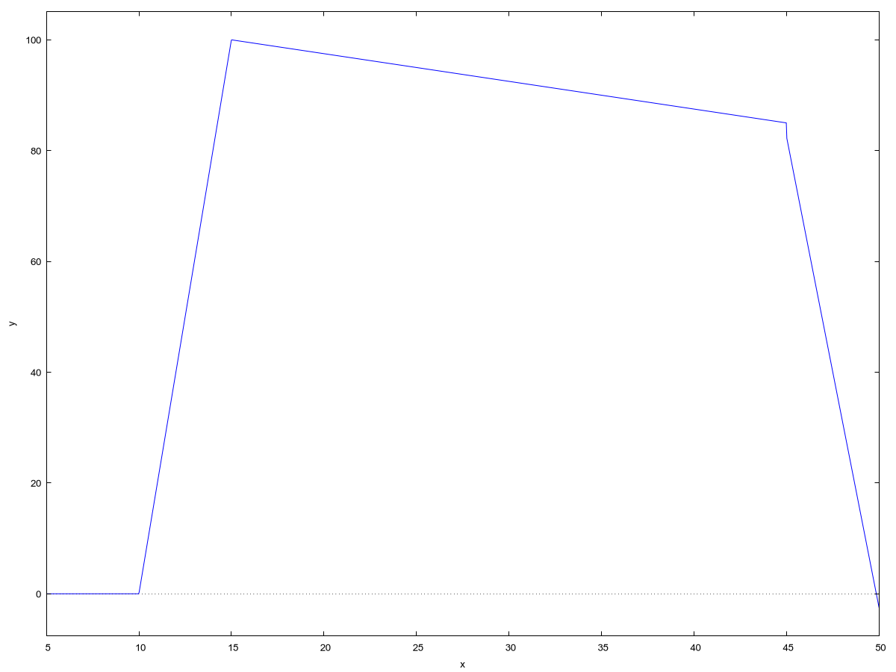

Рисунок 1 – График входного напряжения

(%o237)   
  
(%t238) 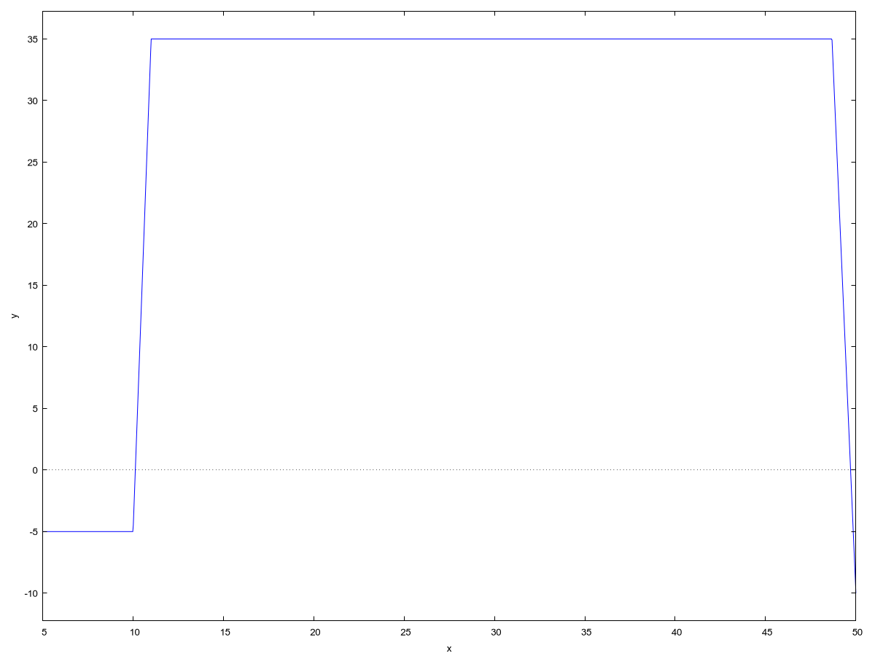

Рисунок 2 – График выходного напряжения

(%o238)

# Таблица идентификаторов

|  |  |  |
| --- | --- | --- |
| Идентификатор | Тип | Назначение / Описание |
| **Константы/Макросы** | | |
| N | int (макрос) | Максимальный размер массивов данных (t, Uvx, Uvix). |
| INPUT_SIZE | int (макрос) | Максимальный размер буфера для строкового ввода (input). |
| **Переменные и Массивы** | | |
| t | float[] | Массив значений времени. |
| Uvx | float[] | Массив значений входного напряжения Uвх(t). |
| Uvix | float[] | Массив значений выходного напряжения Uвых(t). |
| n | int | Количество точек данных (размер массивов); параметр функций или локальная переменная. |
| dt | float | Шаг дискретизации по времени; параметр или локальная переменная. |
| choice | int | Переменная для хранения выбора пользователя в меню (main). |
| continueProgram | bool | Флаг продолжения работы основного цикла программы (main). |
| epsilon | float | Заданная точность для итерационного расчета (calculate_with_precision). |
| current_precision | float | Текущая рассчитанная погрешность (calculate_with_precision). |
| current_parameter | float | Текущее рассчитанное значение параметра (calculate_with_precision). |
| prev_parameter | float | Значение параметра на предыдущей итерации (calculate_with_precision). |
| duration | float | Рассчитанная длительность фронта (calc_leading_edge). |
| Umax, Umin | float | Максимальное/минимальное значение сигнала (calc_leading_edge). |
| U1, U2 | float | Пороговые уровни для расчета фронта (calc_leading_edge). |
| fp, f1, f2, f3 | FILE* | Указатели на файлы. |
| line | char[] | Буфер для чтения строки из файла (print_banner). |
| input | char[] | Буфер для строкового ввода пользователя (ask_user_continue). |
| **Пользовательские Функции** | | |
| main | int() | Главная функция, точка входа, основной цикл программы. |
| forming_time | void() | Формирование массива времени t. |
| forming_Uvx | void() | Формирование массива входного напряжения Uvx. |
| forming_Uvix | void() | Формирование массива выходного напряжения Uvix. |
| input_n | int() | Ввод целочисленного значения n пользователем. |
| to_lower_str | void() | Преобразование строки к нижнему регистру. |
| ask_user_continue | bool() | Запрос у пользователя на продолжение работы программы. |
| print_banner | void() | Вывод заставки программы из файла zast.txt. |
| forming_table | void() | Формирование и вывод таблицы результатов в консоль. |
| output_in_file | void() | Запись массивов данных t, Uvx, Uvix в файлы. |
| calc_leading_edge | float() | Расчет длительности переднего фронта сигнала. |
| calculate_with_precision | void() | Итерационный расчет параметра с заданной точностью. |

# Блок-схемы

В разделе представлены схемы алгоритмов ключевых функций программы. Для наглядного представления логики использованы диаграммы активностей стандарта UML, сгенерированные средствами PlantUML и являющиеся функциональным эквивалентом блок-схем по ГОСТ 19.701-90.

Для иллюстрации работы программы выбраны шесть наиболее репрезентативных функций, охватывающих общую структуру (main), основные вычислительные алгоритмы (calculate_with_precision, calc_leading_edge), формирование данных (forming_Uvx) и вывод/сохранение результатов (forming_table, output_in_file). Диаграммы для этих функций представлены ниже.

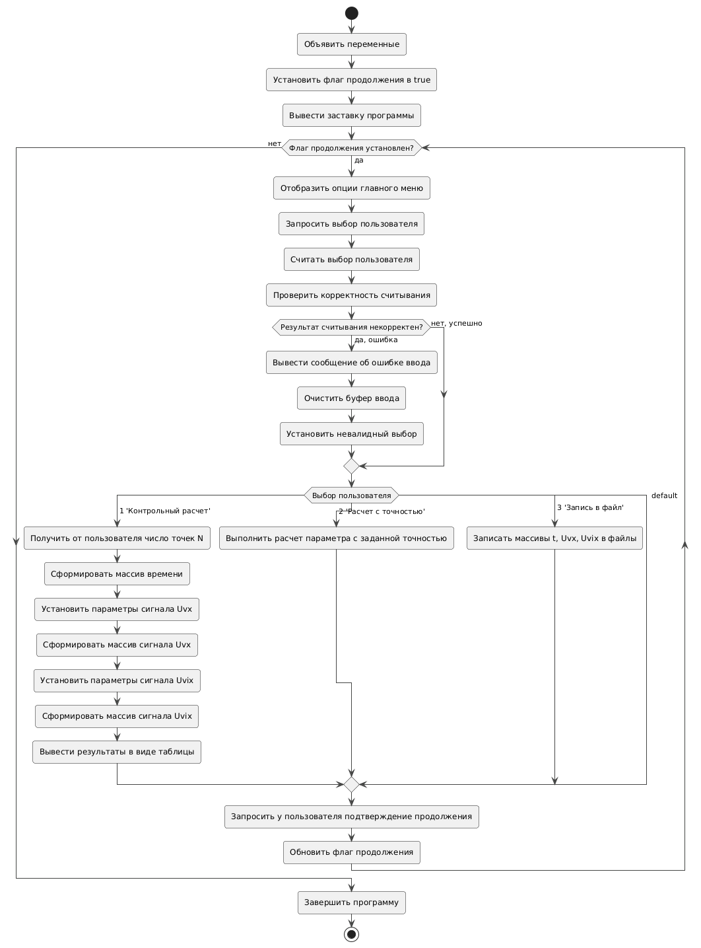

Рисунок 3 - Диаграмма активностей функции main

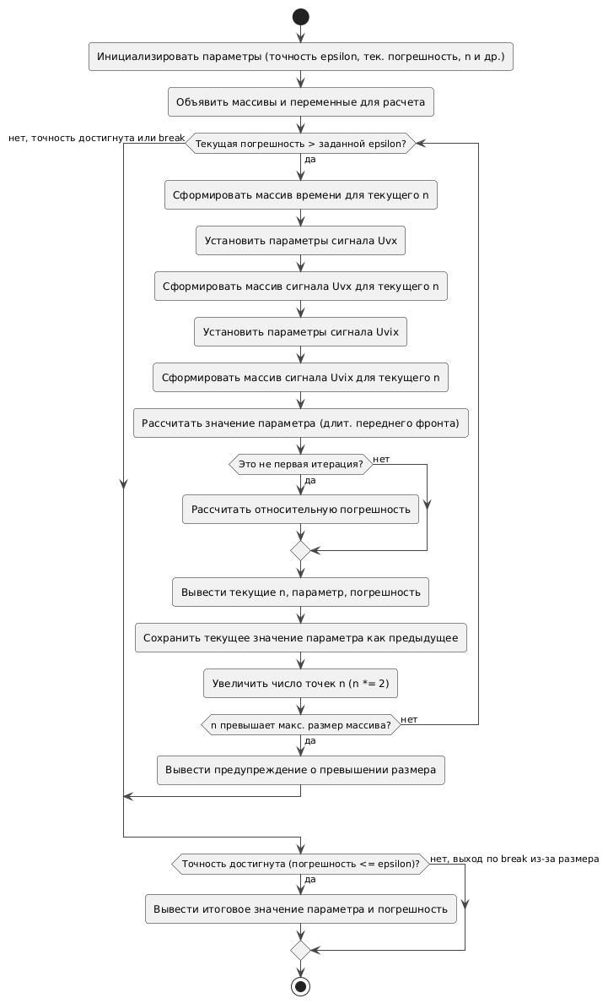

Рисунок 4 - Диаграмма активностей функции calculate_with_precision

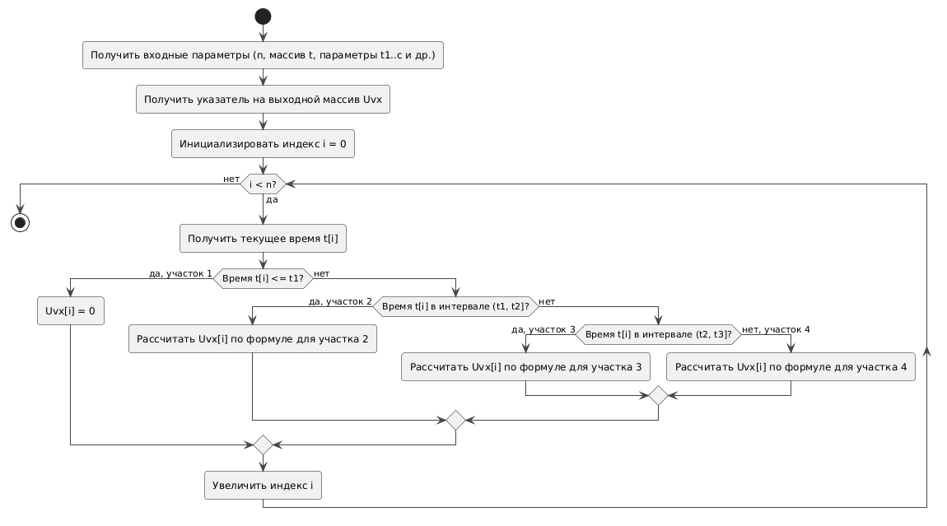

Рисунок 5 - Диаграмма активностей функции forming_Uvx

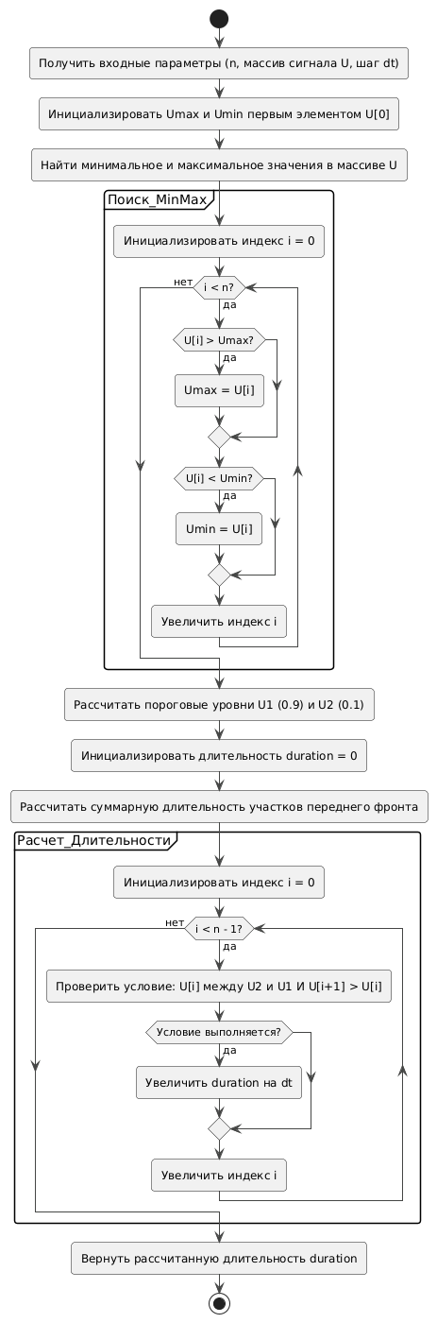

Рисунок 6 - Диаграмма активностей функции calc_leading_edge

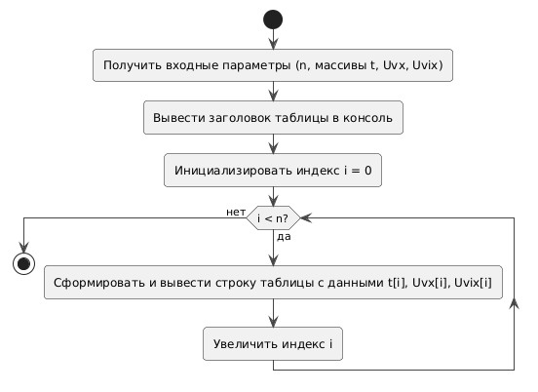

Рисунок 7 - Диаграмма активностей функции forming_table

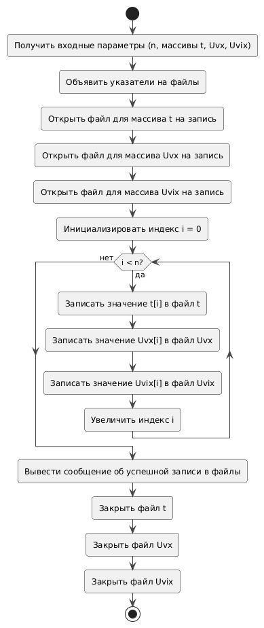

Рисунок 8 - Диаграмма активностей функции output_in_file

# Текст программы

## Главный модуль программы

### Файл: signal_analysis.c

Назначение: Организация основного цикла работы, взаимодействие с пользователем, вызов основных функций расчёта, вывода и сохранения данных.

#include <stdio.h>  
#include <stdbool.h>  
#include <math.h>  
  
#include "input.h"  
#include "output.h"  
#include "forming.h"  
#include "parameter.h"  
  
#define N 1500  
  
int main() {  
 float t[N], Uvx[N], Uvix[N], dt;  
 int n, choice;  
 bool continueProgram = true;  
  
 print_banner();  
  
 while (continueProgram) {  
 printf("\nМеню:\n");  
 printf("1. Контрольный расчет для n точек\n");  
 printf("2. Расчет параметра с заданной точностью\n");  
 printf("3. Запись данных в файл\n");  
 printf("Выберите опцию: ");  
  
 int scanf_result = scanf(" %d", &choice); // Сохраняем результат scanf  
  
 if (scanf_result != 1) { // Проверяем, прочитала ли scanf ровно одно целое число  
 printf("Ошибка ввода. Пожалуйста, введите целое число.\n");  
 // Очистка буфера ввода  
 int c;  
 while ((c = getchar()) != '\n' && c != EOF) {  
 // Просто читаем и выбрасываем символы до конца строки или файла  
 }  
 choice = -1; // Присваиваем 'choice' недопустимое значение, чтобы избежать случайного выхода (если было 0)  
 // или повторного выполнения предыдущего case. -1 попадет в default.  
 }  
  
 switch (choice) {  
 case 1:  
 n = input_n();  
  
 forming_time(n, t, &dt);  
  
 float t1 = 10, t2 = 15, t3 = 45, a = 20, b = 0.5, c = 17;  
 forming_Uvx(n, t, Uvx, t1, t2, t3, a, b, c);  
  
 float Uvx1 = 20, d = 2, e = -5;  
 forming_Uvix(n, Uvx, Uvix, Uvx1, d, e);  
  
 forming_table(n, t, Uvx, Uvix);  
  
 break;  
 case 2:  
 calculate_with_precision();  
 break;  
 case 3:  
 output_in_file(n, t, Uvx, Uvix);  
 break;  
 }  
  
 continueProgram = ask_user_continue();  
 }  
   
 return 0;  
}

## Модуль формирования данных

### Файл: forming.h

Назначение: Заголовочный файл, объявляющий функции формирования временного массива и сигналов.

#ifndef FORMING_H  
#define FORMING_H  
  
void forming_time(int n, float *t, float *dt);  
void forming_Uvx(int n, float *t, float *Uvx, float t1, float t2, float t3, float a, float b, float c);  
void forming_Uvix(int n, float *Uvx, float *Uvix, float Uvx1, float a, float b);  
  
#endif // FORMING_H

### Файл: forming.c

Назначение: Реализация функций формирования временного массива и сигналов.

#include <stdio.h>  
#include "forming.h"  
  
// Функция формирования массива времени  
void forming_time(int n, float *t, float *dt) {  
 float tn = 5, tk = 50;  
  
 *dt = (tk - tn) / (n - 1);  
 for (int i = 0; i < n; i++) {  
 t[i] = tn + i * (*dt);  
 }  
}  
  
// Функция формирования массива Uvx  
void forming_Uvx(int n, float *t, float *Uvx, float t1, float t2, float t3, float a, float b, float c) {  
 for (int i = 0; i < n; i++) {  
 if (t[i] <= t1) {  
 Uvx[i] = 0;  
 } else if (t1 < t[i] && t[i] <= t2) {  
 Uvx[i] = a * (t[i] - t1);  
 } else if (t2 < t[i] && t[i] <= t3) {  
 Uvx[i] = a * (t2 - t1) - b * (t[i] - t2);  
 } else {  
 Uvx[i] = a * (t2 - t1) - b * (t3 - t1) - c * (t[i] - t3);  
 }  
 }  
}  
  
// Функция формирования массива Uvix  
void forming_Uvix(int n, float *Uvx, float *Uvix, float Uvx1, float a, float b) {  
 for (int i = 0; i < n; i++) {  
 if (Uvx[i] <= Uvx1) {  
 Uvix[i] = a * Uvx[i] + b;  
 } else {  
 Uvix[i] = a * Uvx1 + b;  
 }  
 }  
}

## Модуль расчёта параметров сигнала

### Файл: parameter.h

Назначение: Заголовочный файл, объявляющий функции анализа параметров сигнала.

#ifndef PARAMETER_H  
#define PARAMETER_H  
  
float calc_leading_edge(int n, float *U, float dt);  
void calculate_with_precision();  
  
#endif // PARAMETER_H

### Файл: parameter.c

Назначение: Реализация функций анализа параметров сигнала, включая вычисление длительности переднего фронта и итерационный расчёт с заданной точностью.

#include <stdio.h>  
#include <math.h>  
  
#include "parameter.h"  
#include "forming.h"  
  
#define N 1500  
  
// Функция расчета длительности переднего фронта импульса  
float calc_leading_edge(int n, float *U, float dt) {  
 // Находим максимальное и минимальное значения  
 float Umax = U[0], Umin = U[0];  
 for (int i = 0; i < n; i++) {  
 if (U[i] > Umax) Umax = U[i];  
 if (U[i] < Umin) Umin = U[i];  
 }  
  
 // Рассчитываем пороговые уровни  
 float U1 = Umin + 0.9 * (Umax - Umin);  
 float U2 = Umin + 0.1 * (Umax - Umin);  
  
 // Считаем длительность заднего фронта  
 float duration = 0;  
 for (int i = 0; i < n - 1; i++) {  
 if (U[i] < U1 && U[i] > U2 && U[i + 1] > U[i]) duration += dt;  
 }  
  
 return duration;  
}  
  
// Функция расчета параметра с заданной точностью  
void calculate_with_precision() {  
 float epsilon = 0.01; // Требуемая точность (1%)  
 float current_precision = 1.0; // Текущая погрешность  
 float prev_parameter = 1e10; // Начальное (очень большое) значение   
 int n = 11; // Начальное количество точек  
  
 float current_parameter, t[N], Uvx[N], Uvix[N], dt;  
  
 while (current_precision > epsilon) {  
 // Формирование массивов  
 forming_time(n, t, &dt);  
   
 float t1 = 10, t2 = 15, t3 = 45, a = 20, b = 0.5, c = 17;  
 forming_Uvx(n, t, Uvx, t1, t2, t3, a, b, c);  
 float Uvx1 = 20, d = 2, e = -5;  
 forming_Uvix(n, Uvx, Uvix, Uvx1, d, e);  
  
 // Расчет параметра  
 current_parameter = calc_leading_edge(n, Uvix, dt);  
  
 // Расчет погрешности  
 if (prev_parameter != 1e10) {  
 current_precision = fabs(prev_parameter - current_parameter) / current_parameter;  
 }  
  
 printf("n = %d, параметр = %f, погрешность = %f\n", n, current_parameter, current_precision);  
  
 // Обновление значений для следующей итерации  
 prev_parameter = current_parameter;  
 n *= 2;  
 }  
  
 if (n >= N) {  
 printf("Предупреждение: достигнут максимальный размер массива без достижения требуемой точности\n");  
 } else {  
 printf("Итоговое значение параметра: %f (точность: %f)\n", current_parameter, current_precision);  
 }  
}

## Модуль ввода данных

### Файл: input.h

Назначение: Заголовочный файл, объявляющий функции для ввода данных и обработки пользовательского ввода.

#ifndef INPUT_H  
#define INPUT_H  
  
int input_n();  
void to_lower_str(char *str);  
bool ask_user_continue(void);  
  
#endif // INPUT_H

### Файл: input.c

Назначение: Реализация функций для ввода количества точек, преобразования строки к нижнему регистру и запроса на продолжение работы.

#include <stdio.h>  
#include <string.h>  
#include <ctype.h>  
#include <stdbool.h>  
#include "input.h"  
  
#define INPUT_SIZE 10  
  
// Функция для ввода n  
int input_n() {  
 int value;  
 int result;  
   
 while (1) {  
 printf("Введите целое число: ");  
 result = scanf("%d", &value);  
 if (result == 1) {  
 break; // Ввод успешно прочитан  
 } else {  
 printf("Ошибка ввода. Попробуйте еще раз.\n");  
 // Очистка буфера ввода до символа новой строки  
 while(getchar() != '\n');  
 }  
 }  
 return value;  
}  
  
// Функция для преобразования строки к нижнему регистру  
void to_lower_str(char *str) {  
 for (int i = 0; str[i]; i++) {  
 str[i] = tolower((unsigned char)str[i]);  
 }  
}  
  
// Функция для запроса пользователя на продолжение работы  
bool ask_user_continue(void) {  
 char input[INPUT_SIZE];  
 bool valid = false;  
  
 do {  
 printf("Хотите продолжить? (да/нет): ");  
 // Считываем строку ввода  
 if (scanf("%9s", input) != 1) {  
 // Если произошла ошибка ввода, очищаем буфер  
 while(getchar() != '\n');  
 continue;  
 }  
  
 // Преобразуем строку в нижний регистр для корректного сравнения  
 to_lower_str(input);  
  
 // Сравниваем введённое значение с допустимыми  
 if (strcmp(input, "да") == 0) {  
 return true;  
 } else if (strcmp(input, "нет") == 0) {  
 return false;  
 } else {  
 printf("Некорректный ввод. Пожалуйста, введите 'да' или 'нет'.\n");  
 valid = false;  
 }  
 } while (!valid);  
  
 return false;  
}

## Модуль вывода и сохранения данных

### Файл: output.h

Назначение: Заголовочный файл, объявляющий функции для вывода и сохранения результатов.

#ifndef OUTPUT_H  
#define OUTPUT_H  
  
void print_banner();  
void forming_table(int n, float *t, float *Uvx, float *Uvix);  
void output_in_file(int n, float *t, float *Uvx, float *Uvix);  
  
#endif // BANNER_H

### Файл: input.c

Назначение: Реализация функций для вывода заставки, вывода таблицы данных и сохранения массивов в файлы.

#include <stdio.h>  
#include "output.h"  
  
// Функция вывода заставки из файла  
void print_banner() {  
 FILE *fp = fopen("data/zast.txt", "r");  
 if (!fp) {  
 perror("Не удалось открыть файл заставки");  
 return;  
 }  
 char line[256];  
 while (fgets(line, sizeof(line), fp)) {  
 printf("%s", line);  
 }  
 fclose(fp);  
}  
  
// Функция вывода данных в виде таблицы  
void forming_table(int n, float *t, float *Uvx, float *Uvix) {  
 printf("\n № t Uvx Uvix\n");  
 for (int i = 0; i < n; i++) {  
 printf(" %3d %6.3f %6.3f %6.3f\n", i, t[i], Uvx[i], Uvix[i]);  
 }  
}  
  
// Функция для записи данных в файл  
void output_in_file(int n, float *t, float *Uvx, float *Uvix) {  
 FILE *f1, *f2, *f3;  
 f1 = fopen("data/array_t.txt", "w");  
 f2 = fopen("data/array_Uvx.txt", "w");  
 f3 = fopen("data/array_Uvix.txt", "w");  
 for (int i = 0; i < n; i++) {  
 fprintf(f1, "\n %6.3f", t[i]);  
 fprintf(f2, "\n %6.3f", Uvx[i]);  
 fprintf(f3, "\n %6.3f", Uvix[i]);  
 }  
 printf("Запись данных в файлы произведена успешно\n");  
 fclose(f1);  
 fclose(f2);  
 fclose(f3);  
}

# Графики (обработка полученных результатов)

Графики, полученные в результате обработки данных, представлены ниже. Первый график отображает входной сигнал, второй — выходной сигнал. Оба графика построены на основе данных, рассчитанных программой на языке C. Форма графиков соответствует ожидаемой: входной сигнал имеет трапецеидальную форму, выходной сигнал — прямоугольную с плато. Полученные результаты подтверждают корректность работы программы и соответствие расчетов теоретическим ожиданиям.

--> /* Считывание данных из файлов, записанных программой, написанной на C */  
 t:read_list("../data/array_t.txt");  
 Uvx:read_list("../data/array_Uvx.txt");  
 Uvix:read_list("../data/array_Uvix.txt");  
   
 /* Построение по этим данным графиков функций */  
 wxplot2d([['discrete, t, Uvx]], [gnuplot_preamble, "set grid;"]);  
 wxplot2d([['discrete, t, Uvix]], [gnuplot_preamble, "set grid;"]);  
(t) [5.0,5.03,5.06,5.09,5.12,5.15,5.18,5.21,5.24,5.27,5.3,5.33,5.36,5.39,5.42,5.45,5.48,5.51,5.54,5.57,5.6,5.63,5.66,5.69,5.72,5.751,5.781,5.811,5.841,5.871,5.901,5.931,5.961,5.991,6.021,6.051,6.081,6.111,6.141,6.171,6.201,6.231,6.261,6.291,6.321,6.351,6.381,6.411,6.441,6.471,6.501,6.531,6.561,6.591,6.621,6.651,6.681,  
6.711,6.741,6.771,6.801,6.831,6.861,6.891,6.921,6.951,6.981,7.011,7.041,7.071,7.101,7.131,7.161,7.191,7.221,7.252,7.282,7.312,7.342,7.372,7.402,7.432,7.462,7.492,7.522,7.552,7.582,7.612,7.642,7.672,7.702,7.732,7.762,7.792,7.822,7.852,7.882,7.912,7.942,7.972,8.002,8.032,8.062,8.092,8.122,8.152,8.182,8.212,8.242,  
8.272,8.302,8.332,8.362,8.392,8.422,8.452,8.482,8.512,8.542,8.572,8.602,8.632,8.662,8.692,8.722,8.753,8.783,8.813,8.843,8.873,8.903,8.933,8.963,8.993,9.023,9.053,9.083,9.113,9.143,9.173,9.203,9.233,9.263,9.293,9.323,9.353,9.383,9.413,9.443,9.473,9.503,9.533,9.563,9.593,9.623,9.653,9.683,9.713,9.743,9.773,9.803,  
9.833,9.863,9.893,9.923,9.953,9.983,10.013,10.043,10.073,10.103,10.133,10.163,10.193,10.223,10.254,10.284,10.314,10.344,10.374,10.404,10.434,10.464,10.494,10.524,10.554,10.584,10.614,10.644,10.674,10.704,10.734,10.764,10.794,10.824,10.854,10.884,10.914,10.944,10.974,11.004,11.034,11.064,11.094,11.124,11.154,  
11.184,11.214,11.244,11.274,11.304,11.334,11.364,11.394,11.424,11.454,11.484,11.514,11.544,11.574,11.604,11.634,11.664,11.694,11.724,11.755,11.785,11.815,11.845,11.875,11.905,11.935,11.965,11.995,12.025,12.055,12.085,12.115,12.145,12.175,12.205,12.235,12.265,12.295,12.325,12.355,12.385,12.415,12.445,12.475,  
12.505,12.535,12.565,12.595,12.625,12.655,12.685,12.715,12.745,12.775,12.805,12.835,12.865,12.895,12.925,12.955,12.985,13.015,13.045,13.075,13.105,13.135,13.165,13.195,13.225,13.256,13.286,13.316,13.346,13.376,13.406,13.436,13.466,13.496,13.526,13.556,13.586,13.616,13.646,13.676,13.706,13.736,13.766,13.796,  
13.826,13.856,13.886,13.916,13.946,13.976,14.006,14.036,14.066,14.096,14.126,14.156,14.186,14.216,14.246,14.276,14.306,14.336,14.366,14.396,14.426,14.456,14.486,14.516,14.546,14.576,14.606,14.636,14.666,14.696,14.726,14.757,14.787,14.817,14.847,14.877,14.907,14.937,14.967,14.997,15.027,15.057,15.087,15.117,  
15.147,15.177,15.207,15.237,15.267,15.297,15.327,15.357,15.387,15.417,15.447,15.477,15.507,15.537,15.567,15.597,15.627,15.657,15.687,15.717,15.747,15.777,15.807,15.837,15.867,15.897,15.927,15.957,15.987,16.017,16.047,16.077,16.107,16.137,16.167,16.197,16.227,16.258,16.288,16.318,16.348,16.378,16.408,16.438,  
16.468,16.498,16.528,16.558,16.588,16.618,16.648,16.678,16.708,16.738,16.768,16.798,16.828,16.858,16.888,16.918,16.948,16.978,17.008,17.038,17.068,17.098,17.128,17.158,17.188,17.218,17.248,17.278,17.308,17.338,17.368,17.398,17.428,17.458,17.488,17.518,17.548,17.578,17.608,17.638,17.668,17.698,17.728,17.759,  
17.789,17.819,17.849,17.879,17.909,17.939,17.969,17.999,18.029,18.059,18.089,18.119,18.149,18.179,18.209,18.239,18.269,18.299,18.329,18.359,18.389,18.419,18.449,18.479,18.509,18.539,18.569,18.599,18.629,18.659,18.689,18.719,18.749,18.779,18.809,18.839,18.869,18.899,18.929,18.959,18.989,19.019,19.049,19.079,  
19.109,19.139,19.169,19.199,19.229,19.26,19.29,19.32,19.35,19.38,19.41,19.44,19.47,19.5,19.53,19.56,19.59,19.62,19.65,19.68,19.71,19.74,19.77,19.8,19.83,19.86,19.89,19.92,19.95,19.98,20.01,20.04,20.07,20.1,20.13,20.16,20.19,20.22,20.25,20.28,20.31,20.34,20.37,20.4,20.43,20.46,20.49,20.52,20.55,20.58,20.61,20.64,  
20.67,20.7,20.73,20.761,20.791,20.821,20.851,20.881,20.911,20.941,20.971,21.001,21.031,21.061,21.091,21.121,21.151,21.181,21.211,21.241,21.271,21.301,21.331,21.361,21.391,21.421,21.451,21.481,21.511,21.541,21.571,21.601,21.631,21.661,21.691,21.721,21.751,21.781,21.811,21.841,21.871,21.901,21.931,21.961,  
21.991,22.021,22.051,22.081,22.111,22.141,22.171,22.201,22.231,22.262,22.292,22.322,22.352,22.382,22.412,22.442,22.472,22.502,22.532,22.562,22.592,22.622,22.652,22.682,22.712,22.742,22.772,22.802,22.832,22.862,22.892,22.922,22.952,22.982,23.012,23.042,23.072,23.102,23.132,23.162,23.192,23.222,23.252,23.282,  
23.312,23.342,23.372,23.402,23.432,23.462,23.492,23.522,23.552,23.582,23.612,23.642,23.672,23.702,23.732,23.763,23.793,23.823,23.853,23.883,23.913,23.943,23.973,24.003,24.033,24.063,24.093,24.123,24.153,24.183,24.213,24.243,24.273,24.303,24.333,24.363,24.393,24.423,24.453,24.483,24.513,24.543,24.573,24.603,  
24.633,24.663,24.693,24.723,24.753,24.783,24.813,24.843,24.873,24.903,24.933,24.963,24.993,25.023,25.053,25.083,25.113,25.143,25.173,25.203,25.233,25.264,25.294,25.324,25.354,25.384,25.414,25.444,25.474,25.504,25.534,25.564,25.594,25.624,25.654,25.684,25.714,25.744,25.774,25.804,25.834,25.864,25.894,25.924,  
25.954,25.984,26.014,26.044,26.074,26.104,26.134,26.164,26.194,26.224,26.254,26.284,26.314,26.344,26.374,26.404,26.434,26.464,26.494,26.524,26.554,26.584,26.614,26.644,26.674,26.704,26.734,26.765,26.795,26.825,26.855,26.885,26.915,26.945,26.975,27.005,27.035,27.065,27.095,27.125,27.155,27.185,27.215,27.245,  
27.275,27.305,27.335,27.365,27.395,27.425,27.455,27.485,27.515,27.545,27.575,27.605,27.635,27.665,27.695,27.725,27.755,27.785,27.815,27.845,27.875,27.905,27.935,27.965,27.995,28.025,28.055,28.085,28.115,28.145,28.175,28.205,28.235,28.266,28.296,28.326,28.356,28.386,28.416,28.446,28.476,28.506,28.536,28.566,  
28.596,28.626,28.656,28.686,28.716,28.746,28.776,28.806,28.836,28.866,28.896,28.926,28.956,28.986,29.016,29.046,29.076,29.106,29.136,29.166,29.196,29.226,29.256,29.286,29.316,29.346,29.376,29.406,29.436,29.466,29.496,29.526,29.556,29.586,29.616,29.646,29.676,29.706,29.736,29.767,29.797,29.827,29.857,29.887,  
29.917,29.947,29.977,30.007,30.037,30.067,30.097,30.127,30.157,30.187,30.217,30.247,30.277,30.307,30.337,30.367,30.397,30.427,30.457,30.487,30.517,30.547,30.577,30.607,30.637,30.667,30.697,30.727,30.757,30.787,30.817,30.847,30.877,30.907,30.937,30.967,30.997,31.027,31.057,31.087,31.117,31.147,31.177,31.207,  
31.237,31.268,31.298,31.328,31.358,31.388,31.418,31.448,31.478,31.508,31.538,31.568,31.598,31.628,31.658,31.688,31.718,31.748,31.778,31.808,31.838,31.868,31.898,31.928,31.958,31.988,32.018,32.048,32.078,32.108,32.138,32.168,32.198,32.228,32.258,32.288,32.318,32.348,32.378,32.408,32.438,32.468,32.498,32.528,  
32.558,32.588,32.618,32.648,32.678,32.708,32.738,32.769,32.799,32.829,32.859,32.889,32.919,32.949,32.979,33.009,33.039,33.069,33.099,33.129,33.159,33.189,33.219,33.249,33.279,33.309,33.339,33.369,33.399,33.429,33.459,33.489,33.519,33.549,33.579,33.609,33.639,33.669,33.699,33.729,33.759,33.789,33.819,33.849,  
33.879,33.909,33.939,33.969,33.999,34.029,34.059,34.089,34.119,34.149,34.179,34.209,34.239,34.27,34.3,34.33,34.36,34.39,34.42,34.45,34.48,34.51,34.54,34.57,34.6,34.63,34.66,34.69,34.72,34.75,34.78,34.81,34.84,34.87,34.9,34.93,34.96,34.99,35.02,35.05,35.08,35.11,35.14,35.17,35.2,35.23,35.26,35.29,35.32,35.35,  
35.38,35.41,35.44,35.47,35.5,35.53,35.56,35.59,35.62,35.65,35.68,35.71,35.74,35.771,35.801,35.831,35.861,35.891,35.921,35.951,35.981,36.011,36.041,36.071,36.101,36.131,36.161,36.191,36.221,36.251,36.281,36.311,36.341,36.371,36.401,36.431,36.461,36.491,36.521,36.551,36.581,36.611,36.641,36.671,36.701,36.731,  
36.761,36.791,36.821,36.851,36.881,36.911,36.941,36.971,37.001,37.031,37.061,37.091,37.121,37.151,37.181,37.211,37.241,37.272,37.302,37.332,37.362,37.392,37.422,37.452,37.482,37.512,37.542,37.572,37.602,37.632,37.662,37.692,37.722,37.752,37.782,37.812,37.842,37.872,37.902,37.932,37.962,37.992,38.022,38.052,  
38.082,38.112,38.142,38.172,38.202,38.232,38.262,38.292,38.322,38.352,38.382,38.412,38.442,38.472,38.502,38.532,38.562,38.592,38.622,38.652,38.682,38.712,38.742,38.773,38.803,38.833,38.863,38.893,38.923,38.953,38.983,39.013,39.043,39.073,39.103,39.133,39.163,39.193,39.223,39.253,39.283,39.313,39.343,39.373,  
39.403,39.433,39.463,39.493,39.523,39.553,39.583,39.613,39.643,39.673,39.703,39.733,39.763,39.793,39.823,39.853,39.883,39.913,39.943,39.973,40.003,40.033,40.063,40.093,40.123,40.153,40.183,40.213,40.243,40.274,40.304,40.334,40.364,40.394,40.424,40.454,40.484,40.514,40.544,40.574,40.604,40.634,40.664,40.694,  
40.724,40.754,40.784,40.814,40.844,40.874,40.904,40.934,40.964,40.994,41.024,41.054,41.084,41.114,41.144,41.174,41.204,41.234,41.264,41.294,41.324,41.354,41.384,41.414,41.444,41.474,41.504,41.534,41.564,41.594,41.624,41.654,41.684,41.714,41.744,41.775,41.805,41.835,41.865,41.895,41.925,41.955,41.985,42.015,  
42.045,42.075,42.105,42.135,42.165,42.195,42.225,42.255,42.285,42.315,42.345,42.375,42.405,42.435,42.465,42.495,42.525,42.555,42.585,42.615,42.645,42.675,42.705,42.735,42.765,42.795,42.825,42.855,42.885,42.915,42.945,42.975,43.005,43.035,43.065,43.095,43.125,43.155,43.185,43.215,43.245,43.276,43.306,43.336,  
43.366,43.396,43.426,43.456,43.486,43.516,43.546,43.576,43.606,43.636,43.666,43.696,43.726,43.756,43.786,43.816,43.846,43.876,43.906,43.936,43.966,43.996,44.026,44.056,44.086,44.116,44.146,44.176,44.206,44.236,44.266,44.296,44.326,44.356,44.386,44.416,44.446,44.476,44.506,44.536,44.566,44.596,44.626,44.656,  
44.686,44.716,44.746,44.777,44.807,44.837,44.867,44.897,44.927,44.957,44.987,45.017,45.047,45.077,45.107,45.137,45.167,45.197,45.227,45.257,45.287,45.317,45.347,45.377,45.407,45.437,45.467,45.497,45.527,45.557,45.587,45.617,45.647,45.677,45.707,45.737,45.767,45.797,45.827,45.857,45.887,45.917,45.947,45.977,  
46.007,46.037,46.067,46.097,46.127,46.157,46.187,46.217,46.247,46.278,46.308,46.338,46.368,46.398,46.428,46.458,46.488,46.518,46.548,46.578,46.608,46.638,46.668,46.698,46.728,46.758,46.788,46.818,46.848,46.878,46.908,46.938,46.968,46.998,47.028,47.058,47.088,47.118,47.148,47.178,47.208,47.238,47.268,47.298,  
47.328,47.358,47.388,47.418,47.448,47.478,47.508,47.538,47.568,47.598,47.628,47.658,47.688,47.718,47.749,47.779,47.809,47.839,47.869,47.899,47.929,47.959,47.989,48.019,48.049,48.079,48.109,48.139,48.169,48.199,48.229,48.259,48.289,48.319,48.349,48.379,48.409,48.439,48.469,48.499,48.529,48.559,48.589,48.619,  
48.649,48.679,48.709,48.739,48.769,48.799,48.829,48.859,48.889,48.919,48.949,48.979,49.009,49.039,49.069,49.099,49.129,49.159,49.189,49.219,49.25,49.28,49.31,49.34,49.37,49.4,49.43,49.46,49.49,49.52,49.55,49.58,49.61,49.64,49.67,49.7,49.73,49.76,49.79,49.82,49.85,49.88,49.91,49.94,49.97,50.0]  
(Uvx) [0.0,0.0,0.0,0.0,0.0,0.0,0.0,0.0,0.0,0.0,0.0,0.0,0.0,0.0,0.0,0.0,0.0,0.0,0.0,0.0,0.0,0.0,0.0,0.0,0.0,0.0,0.0,0.0,0.0,0.0,0.0,0.0,0.0,0.0,0.0,0.0,0.0,0.0,0.0,0.0,0.0,0.0,0.0,0.0,0.0,0.0,0.0,0.0,0.0,0.0,0.0,0.0,0.0,0.0,0.0,0.0,0.0,0.0,0.0,0.0,0.0,0.0,0.0,0.0,0.0,0.0,0.0,0.0,0.0,0.0,0.0,0.0,0.0,0.0,0.0,0.0,0.0,0.0,0.0,0.0,0.0,0.0,0.0,0.0  
,0.0,0.0,0.0,0.0,0.0,0.0,0.0,0.0,0.0,0.0,0.0,0.0,0.0,0.0,0.0,0.0,0.0,0.0,0.0,0.0,0.0,0.0,0.0,0.0,0.0,0.0,0.0,0.0,0.0,0.0,0.0,0.0,0.0,0.0,0.0,0.0,0.0,0.0,0.0,0.0,0.0,0.0,0.0,0.0,0.0,0.0,0.0,0.0,0.0,0.0,0.0,0.0,0.0,0.0,0.0,0.0,0.0,0.0,0.0,0.0,0.0,0.0,0.0,0.0,0.0,0.0,0.0,0.0,0.0,0.0,0.0,0.0,0.0,0.0,0.0,0.0,0.0,0.0,0.0,0.0,0.0,0.0,0.0,  
0.267,0.867,1.468,2.068,2.668,3.269,3.869,4.47,5.07,5.67,6.271,6.871,7.472,8.072,8.672,9.273,9.873,10.474,11.074,11.674,12.275,12.875,13.476,14.076,14.676,15.277,15.877,16.478,17.078,17.678,18.279,18.879,19.48,20.08,20.68,21.281,21.881,22.482,23.082,23.682,24.283,24.883,25.484,26.084,26.684,27.285,27.885,  
28.486,29.086,29.686,30.287,30.887,31.488,32.088,32.688,33.289,33.889,34.49,35.09,35.69,36.291,36.891,37.492,38.092,38.692,39.293,39.893,40.494,41.094,41.694,42.295,42.895,43.496,44.096,44.696,45.297,45.897,46.498,47.098,47.698,48.299,48.899,49.5,50.1,50.7,51.301,51.901,52.502,53.102,53.702,54.303,54.903,  
55.504,56.104,56.704,57.305,57.905,58.506,59.106,59.706,60.307,60.907,61.508,62.108,62.708,63.309,63.909,64.51,65.11,65.71,66.311,66.911,67.512,68.112,68.712,69.313,69.913,70.514,71.114,71.714,72.315,72.915,73.516,74.116,74.716,75.317,75.917,76.518,77.118,77.718,78.319,78.919,79.52,80.12,80.72,81.321,81.921,  
82.522,83.122,83.722,84.323,84.923,85.524,86.124,86.724,87.325,87.925,88.526,89.126,89.726,90.327,90.927,91.528,92.128,92.728,93.329,93.929,94.53,95.13,95.73,96.331,96.931,97.532,98.132,98.732,99.333,99.933,99.987,99.972,99.957,99.942,99.927,99.912,99.897,99.882,99.867,99.852,99.837,99.822,99.807,99.792,  
99.777,99.762,99.746,99.731,99.716,99.701,99.686,99.671,99.656,99.641,99.626,99.611,99.596,99.581,99.566,99.551,99.536,99.521,99.506,99.491,99.476,99.461,99.446,99.431,99.416,99.401,99.386,99.371,99.356,99.341,99.326,99.311,99.296,99.281,99.266,99.251,99.236,99.221,99.206,99.191,99.176,99.161,99.146,99.131,  
99.116,99.101,99.086,99.071,99.056,99.041,99.026,99.011,98.996,98.981,98.966,98.951,98.936,98.921,98.906,98.891,98.876,98.861,98.846,98.831,98.816,98.801,98.786,98.771,98.756,98.741,98.726,98.711,98.696,98.681,98.666,98.651,98.636,98.621,98.606,98.591,98.576,98.561,98.546,98.531,98.516,98.501,98.486,98.471,  
98.456,98.441,98.426,98.411,98.396,98.381,98.366,98.351,98.336,98.321,98.306,98.291,98.276,98.261,98.245,98.23,98.215,98.2,98.185,98.17,98.155,98.14,98.125,98.11,98.095,98.08,98.065,98.05,98.035,98.02,98.005,97.99,97.975,97.96,97.945,97.93,97.915,97.9,97.885,97.87,97.855,97.84,97.825,97.81,97.795,97.78,97.765,  
97.75,97.735,97.72,97.705,97.69,97.675,97.66,97.645,97.63,97.615,97.6,97.585,97.57,97.555,97.54,97.525,97.51,97.495,97.48,97.465,97.45,97.435,97.42,97.405,97.39,97.375,97.36,97.345,97.33,97.315,97.3,97.285,97.27,97.255,97.24,97.225,97.21,97.195,97.18,97.165,97.15,97.135,97.12,97.105,97.09,97.075,97.06,97.045,  
97.03,97.015,97.0,96.985,96.97,96.955,96.94,96.925,96.91,96.895,96.88,96.865,96.85,96.835,96.82,96.805,96.79,96.775,96.76,96.744,96.729,96.714,96.699,96.684,96.669,96.654,96.639,96.624,96.609,96.594,96.579,96.564,96.549,96.534,96.519,96.504,96.489,96.474,96.459,96.444,96.429,96.414,96.399,96.384,96.369,96.354  
,96.339,96.324,96.309,96.294,96.279,96.264,96.249,96.234,96.219,96.204,96.189,96.174,96.159,96.144,96.129,96.114,96.099,96.084,96.069,96.054,96.039,96.024,96.009,95.994,95.979,95.964,95.949,95.934,95.919,95.904,95.889,95.874,95.859,95.844,95.829,95.814,95.799,95.784,95.769,95.754,95.739,95.724,95.709,95.694,  
95.679,95.664,95.649,95.634,95.619,95.604,95.589,95.574,95.559,95.544,95.529,95.514,95.499,95.484,95.469,95.454,95.439,95.424,95.409,95.394,95.379,95.364,95.349,95.334,95.319,95.304,95.289,95.274,95.259,95.243,95.228,95.213,95.198,95.183,95.168,95.153,95.138,95.123,95.108,95.093,95.078,95.063,95.048,95.033,  
95.018,95.003,94.988,94.973,94.958,94.943,94.928,94.913,94.898,94.883,94.868,94.853,94.838,94.823,94.808,94.793,94.778,94.763,94.748,94.733,94.718,94.703,94.688,94.673,94.658,94.643,94.628,94.613,94.598,94.583,94.568,94.553,94.538,94.523,94.508,94.493,94.478,94.463,94.448,94.433,94.418,94.403,94.388,94.373,  
94.358,94.343,94.328,94.313,94.298,94.283,94.268,94.253,94.238,94.223,94.208,94.193,94.178,94.163,94.148,94.133,94.118,94.103,94.088,94.073,94.058,94.043,94.028,94.013,93.998,93.983,93.968,93.953,93.938,93.923,93.908,93.893,93.878,93.863,93.848,93.833,93.818,93.803,93.788,93.773,93.758,93.742,93.727,93.712,  
93.697,93.682,93.667,93.652,93.637,93.622,93.607,93.592,93.577,93.562,93.547,93.532,93.517,93.502,93.487,93.472,93.457,93.442,93.427,93.412,93.397,93.382,93.367,93.352,93.337,93.322,93.307,93.292,93.277,93.262,93.247,93.232,93.217,93.202,93.187,93.172,93.157,93.142,93.127,93.112,93.097,93.082,93.067,93.052,  
93.037,93.022,93.007,92.992,92.977,92.962,92.947,92.932,92.917,92.902,92.887,92.872,92.857,92.842,92.827,92.812,92.797,92.782,92.767,92.752,92.737,92.722,92.707,92.692,92.677,92.662,92.647,92.632,92.617,92.602,92.587,92.572,92.557,92.542,92.527,92.512,92.497,92.482,92.467,92.452,92.437,92.422,92.407,92.392,  
92.377,92.362,92.347,92.332,92.317,92.302,92.287,92.272,92.257,92.241,92.226,92.211,92.196,92.181,92.166,92.151,92.136,92.121,92.106,92.091,92.076,92.061,92.046,92.031,92.016,92.001,91.986,91.971,91.956,91.941,91.926,91.911,91.896,91.881,91.866,91.851,91.836,91.821,91.806,91.791,91.776,91.761,91.746,91.731,  
91.716,91.701,91.686,91.671,91.656,91.641,91.626,91.611,91.596,91.581,91.566,91.551,91.536,91.521,91.506,91.491,91.476,91.461,91.446,91.431,91.416,91.401,91.386,91.371,91.356,91.341,91.326,91.311,91.296,91.281,91.266,91.251,91.236,91.221,91.206,91.191,91.176,91.161,91.146,91.131,91.116,91.101,91.086,91.071,  
91.056,91.041,91.026,91.011,90.996,90.981,90.966,90.951,90.936,90.921,90.906,90.891,90.876,90.861,90.846,90.831,90.816,90.801,90.786,90.771,90.756,90.74,90.725,90.71,90.695,90.68,90.665,90.65,90.635,90.62,90.605,90.59,90.575,90.56,90.545,90.53,90.515,90.5,90.485,90.47,90.455,90.44,90.425,90.41,90.395,90.38,  
90.365,90.35,90.335,90.32,90.305,90.29,90.275,90.26,90.245,90.23,90.215,90.2,90.185,90.17,90.155,90.14,90.125,90.11,90.095,90.08,90.065,90.05,90.035,90.02,90.005,89.99,89.975,89.96,89.945,89.93,89.915,89.9,89.885,89.87,89.855,89.84,89.825,89.81,89.795,89.78,89.765,89.75,89.735,89.72,89.705,89.69,89.675,89.66,  
89.645,89.63,89.615,89.6,89.585,89.57,89.555,89.54,89.525,89.51,89.495,89.48,89.465,89.45,89.435,89.42,89.405,89.39,89.375,89.36,89.345,89.33,89.315,89.3,89.285,89.27,89.255,89.239,89.224,89.209,89.194,89.179,89.164,89.149,89.134,89.119,89.104,89.089,89.074,89.059,89.044,89.029,89.014,88.999,88.984,88.969,  
88.954,88.939,88.924,88.909,88.894,88.879,88.864,88.849,88.834,88.819,88.804,88.789,88.774,88.759,88.744,88.729,88.714,88.699,88.684,88.669,88.654,88.639,88.624,88.609,88.594,88.579,88.564,88.549,88.534,88.519,88.504,88.489,88.474,88.459,88.444,88.429,88.414,88.399,88.384,88.369,88.354,88.339,88.324,88.309,  
88.294,88.279,88.264,88.249,88.234,88.219,88.204,88.189,88.174,88.159,88.144,88.129,88.114,88.099,88.084,88.069,88.054,88.039,88.024,88.009,87.994,87.979,87.964,87.949,87.934,87.919,87.904,87.889,87.874,87.859,87.844,87.829,87.814,87.799,87.784,87.769,87.754,87.738,87.723,87.708,87.693,87.678,87.663,87.648,  
87.633,87.618,87.603,87.588,87.573,87.558,87.543,87.528,87.513,87.498,87.483,87.468,87.453,87.438,87.423,87.408,87.393,87.378,87.363,87.348,87.333,87.318,87.303,87.288,87.273,87.258,87.243,87.228,87.213,87.198,87.183,87.168,87.153,87.138,87.123,87.108,87.093,87.078,87.063,87.048,87.033,87.018,87.003,86.988,  
86.973,86.958,86.943,86.928,86.913,86.898,86.883,86.868,86.853,86.838,86.823,86.808,86.793,86.778,86.763,86.748,86.733,86.718,86.703,86.688,86.673,86.658,86.643,86.628,86.613,86.598,86.583,86.568,86.553,86.538,86.523,86.508,86.493,86.478,86.463,86.448,86.433,86.418,86.403,86.388,86.373,86.358,86.343,86.328,  
86.313,86.298,86.283,86.268,86.253,86.237,86.222,86.207,86.192,86.177,86.162,86.147,86.132,86.117,86.102,86.087,86.072,86.057,86.042,86.027,86.012,85.997,85.982,85.967,85.952,85.937,85.922,85.907,85.892,85.877,85.862,85.847,85.832,85.817,85.802,85.787,85.772,85.757,85.742,85.727,85.712,85.697,85.682,85.667,  
85.652,85.637,85.622,85.607,85.592,85.577,85.562,85.547,85.532,85.517,85.502,85.487,85.472,85.457,85.442,85.427,85.412,85.397,85.382,85.367,85.352,85.337,85.322,85.307,85.292,85.277,85.262,85.247,85.232,85.217,85.202,85.187,85.172,85.157,85.142,85.127,85.112,85.097,85.082,85.067,85.052,85.037,85.022,85.007,  
82.216,81.706,81.196,80.685,80.175,79.665,79.154,78.644,78.134,77.623,77.113,76.603,76.092,75.582,75.072,74.561,74.051,73.541,73.03,72.52,72.01,71.499,70.989,70.479,69.968,69.458,68.948,68.437,67.927,67.417,66.906,66.396,65.886,65.375,64.865,64.355,63.844,63.334,62.824,62.313,61.803,61.293,60.782,60.272,  
59.762,59.251,58.741,58.23,57.72,57.21,56.699,56.189,55.679,55.168,54.658,54.148,53.637,53.127,52.617,52.106,51.596,51.086,50.575,50.065,49.555,49.044,48.534,48.024,47.513,47.003,46.493,45.982,45.472,44.962,44.451,43.941,43.431,42.92,42.41,41.9,41.389,40.879,40.369,39.858,39.348,38.838,38.327,37.817,37.307,  
36.796,36.286,35.775,35.265,34.755,34.245,33.734,33.224,32.713,32.203,31.693,31.182,30.672,30.162,29.651,29.141,28.631,28.12,27.61,27.1,26.589,26.079,25.569,25.058,24.548,24.038,23.527,23.017,22.507,21.996,21.486,20.976,20.465,19.955,19.445,18.934,18.424,17.914,17.403,16.893,16.383,15.872,15.362,14.852,  
14.341,13.831,13.321,12.81,12.3,11.79,11.279,10.769,10.258,9.748,9.238,8.727,8.217,7.707,7.196,6.686,6.176,5.665,5.155,4.645,4.134,3.624,3.114,2.603,2.093,1.583,1.072,0.562,0.052,-0.459,-0.969,-1.479,-1.99,-2.5]  
(Uvix) [-5.0,-5.0,-5.0,-5.0,-5.0,-5.0,-5.0,-5.0,-5.0,-5.0,-5.0,-5.0,-5.0,-5.0,-5.0,-5.0,-5.0,-5.0,-5.0,-5.0,-5.0,-5.0,-5.0,-5.0,-5.0,-5.0,-5.0,-5.0,-5.0,-5.0,-5.0,-5.0,-5.0,-5.0,-5.0,-5.0,-5.0,-5.0,-5.0,-5.0,-5.0,-5.0,-5.0,-5.0,-5.0,-5.0,-5.0,-5.0,-5.0,-5.0,-5.0,-5.0,-5.0,-5.0,-5.0,-5.0,-5.0,-5.0,-5.0,-5.0,-5.0,-  
5.0,-5.0,-5.0,-5.0,-5.0,-5.0,-5.0,-5.0,-5.0,-5.0,-5.0,-5.0,-5.0,-5.0,-5.0,-5.0,-5.0,-5.0,-5.0,-5.0,-5.0,-5.0,-5.0,-5.0,-5.0,-5.0,-5.0,-5.0,-5.0,-5.0,-5.0,-5.0,-5.0,-5.0,-5.0,-5.0,-5.0,-5.0,-5.0,-5.0,-5.0,-5.0,-5.0,-5.0,-5.0,-5.0,-5.0,-5.0,-5.0,-5.0,-5.0,-5.0,-5.0,-5.0,-5.0,-5.0,-5.0,-5.0,-5.0,-5.0,-5.0,-  
5.0,-5.0,-5.0,-5.0,-5.0,-5.0,-5.0,-5.0,-5.0,-5.0,-5.0,-5.0,-5.0,-5.0,-5.0,-5.0,-5.0,-5.0,-5.0,-5.0,-5.0,-5.0,-5.0,-5.0,-5.0,-5.0,-5.0,-5.0,-5.0,-5.0,-5.0,-5.0,-5.0,-5.0,-5.0,-5.0,-5.0,-5.0,-5.0,-5.0,-5.0,-5.0,-5.0,-5.0,-5.0,-4.466,-3.266,-2.065,-0.864,0.337,1.538,2.738,3.939,5.14,6.341,7.542,8.743,9.943,  
11.144,12.345,13.546,14.746,15.947,17.148,18.349,19.55,20.751,21.951,23.152,24.353,25.554,26.755,27.955,29.156,30.357,31.558,32.758,33.959,35.0,35.0,35.0,35.0,35.0,35.0,35.0,35.0,35.0,35.0,35.0,35.0,35.0,35.0,35.0,35.0,35.0,35.0,35.0,35.0,35.0,35.0,35.0,35.0,35.0,35.0,35.0,35.0,35.0,35.0,35.0,35.0,35.0,35.0,35.0,  
35.0,35.0,35.0,35.0,35.0,35.0,35.0,35.0,35.0,35.0,35.0,35.0,35.0,35.0,35.0,35.0,35.0,35.0,35.0,35.0,35.0,35.0,35.0,35.0,35.0,35.0,35.0,35.0,35.0,35.0,35.0,35.0,35.0,35.0,35.0,35.0,35.0,35.0,35.0,35.0,35.0,35.0,35.0,35.0,35.0,35.0,35.0,35.0,35.0,35.0,35.0,35.0,35.0,35.0,35.0,35.0,35.0,35.0,35.0,35.0,35.0,35.0,35.0,35.0,  
35.0,35.0,35.0,35.0,35.0,35.0,35.0,35.0,35.0,35.0,35.0,35.0,35.0,35.0,35.0,35.0,35.0,35.0,35.0,35.0,35.0,35.0,35.0,35.0,35.0,35.0,35.0,35.0,35.0,35.0,35.0,35.0,35.0,35.0,35.0,35.0,35.0,35.0,35.0,35.0,35.0,35.0,35.0,35.0,35.0,35.0,35.0,35.0,35.0,35.0,35.0,35.0,35.0,35.0,35.0,35.0,35.0,35.0,35.0,35.0,35.0,35.0,35.0,35.0,  
35.0,35.0,35.0,35.0,35.0,35.0,35.0,35.0,35.0,35.0,35.0,35.0,35.0,35.0,35.0,35.0,35.0,35.0,35.0,35.0,35.0,35.0,35.0,35.0,35.0,35.0,35.0,35.0,35.0,35.0,35.0,35.0,35.0,35.0,35.0,35.0,35.0,35.0,35.0,35.0,35.0,35.0,35.0,35.0,35.0,35.0,35.0,35.0,35.0,35.0,35.0,35.0,35.0,35.0,35.0,35.0,35.0,35.0,35.0,35.0,35.0,35.0,35.0,35.0,  
35.0,35.0,35.0,35.0,35.0,35.0,35.0,35.0,35.0,35.0,35.0,35.0,35.0,35.0,35.0,35.0,35.0,35.0,35.0,35.0,35.0,35.0,35.0,35.0,35.0,35.0,35.0,35.0,35.0,35.0,35.0,35.0,35.0,35.0,35.0,35.0,35.0,35.0,35.0,35.0,35.0,35.0,35.0,35.0,35.0,35.0,35.0,35.0,35.0,35.0,35.0,35.0,35.0,35.0,35.0,35.0,35.0,35.0,35.0,35.0,35.0,35.0,35.0,35.0,  
35.0,35.0,35.0,35.0,35.0,35.0,35.0,35.0,35.0,35.0,35.0,35.0,35.0,35.0,35.0,35.0,35.0,35.0,35.0,35.0,35.0,35.0,35.0,35.0,35.0,35.0,35.0,35.0,35.0,35.0,35.0,35.0,35.0,35.0,35.0,35.0,35.0,35.0,35.0,35.0,35.0,35.0,35.0,35.0,35.0,35.0,35.0,35.0,35.0,35.0,35.0,35.0,35.0,35.0,35.0,35.0,35.0,35.0,35.0,35.0,35.0,35.0,35.0,35.0,  
35.0,35.0,35.0,35.0,35.0,35.0,35.0,35.0,35.0,35.0,35.0,35.0,35.0,35.0,35.0,35.0,35.0,35.0,35.0,35.0,35.0,35.0,35.0,35.0,35.0,35.0,35.0,35.0,35.0,35.0,35.0,35.0,35.0,35.0,35.0,35.0,35.0,35.0,35.0,35.0,35.0,35.0,35.0,35.0,35.0,35.0,35.0,35.0,35.0,35.0,35.0,35.0,35.0,35.0,35.0,35.0,35.0,35.0,35.0,35.0,35.0,35.0,35.0,35.0,  
35.0,35.0,35.0,35.0,35.0,35.0,35.0,35.0,35.0,35.0,35.0,35.0,35.0,35.0,35.0,35.0,35.0,35.0,35.0,35.0,35.0,35.0,35.0,35.0,35.0,35.0,35.0,35.0,35.0,35.0,35.0,35.0,35.0,35.0,35.0,35.0,35.0,35.0,35.0,35.0,35.0,35.0,35.0,35.0,35.0,35.0,35.0,35.0,35.0,35.0,35.0,35.0,35.0,35.0,35.0,35.0,35.0,35.0,35.0,35.0,35.0,35.0,35.0,35.0,  
35.0,35.0,35.0,35.0,35.0,35.0,35.0,35.0,35.0,35.0,35.0,35.0,35.0,35.0,35.0,35.0,35.0,35.0,35.0,35.0,35.0,35.0,35.0,35.0,35.0,35.0,35.0,35.0,35.0,35.0,35.0,35.0,35.0,35.0,35.0,35.0,35.0,35.0,35.0,35.0,35.0,35.0,35.0,35.0,35.0,35.0,35.0,35.0,35.0,35.0,35.0,35.0,35.0,35.0,35.0,35.0,35.0,35.0,35.0,35.0,35.0,35.0,35.0,35.0,  
35.0,35.0,35.0,35.0,35.0,35.0,35.0,35.0,35.0,35.0,35.0,35.0,35.0,35.0,35.0,35.0,35.0,35.0,35.0,35.0,35.0,35.0,35.0,35.0,35.0,35.0,35.0,35.0,35.0,35.0,35.0,35.0,35.0,35.0,35.0,35.0,35.0,35.0,35.0,35.0,35.0,35.0,35.0,35.0,35.0,35.0,35.0,35.0,35.0,35.0,35.0,35.0,35.0,35.0,35.0,35.0,35.0,35.0,35.0,35.0,35.0,35.0,35.0,35.0,  
35.0,35.0,35.0,35.0,35.0,35.0,35.0,35.0,35.0,35.0,35.0,35.0,35.0,35.0,35.0,35.0,35.0,35.0,35.0,35.0,35.0,35.0,35.0,35.0,35.0,35.0,35.0,35.0,35.0,35.0,35.0,35.0,35.0,35.0,35.0,35.0,35.0,35.0,35.0,35.0,35.0,35.0,35.0,35.0,35.0,35.0,35.0,35.0,35.0,35.0,35.0,35.0,35.0,35.0,35.0,35.0,35.0,35.0,35.0,35.0,35.0,35.0,35.0,35.0,  
35.0,35.0,35.0,35.0,35.0,35.0,35.0,35.0,35.0,35.0,35.0,35.0,35.0,35.0,35.0,35.0,35.0,35.0,35.0,35.0,35.0,35.0,35.0,35.0,35.0,35.0,35.0,35.0,35.0,35.0,35.0,35.0,35.0,35.0,35.0,35.0,35.0,35.0,35.0,35.0,35.0,35.0,35.0,35.0,35.0,35.0,35.0,35.0,35.0,35.0,35.0,35.0,35.0,35.0,35.0,35.0,35.0,35.0,35.0,35.0,35.0,35.0,35.0,35.0,  
35.0,35.0,35.0,35.0,35.0,35.0,35.0,35.0,35.0,35.0,35.0,35.0,35.0,35.0,35.0,35.0,35.0,35.0,35.0,35.0,35.0,35.0,35.0,35.0,35.0,35.0,35.0,35.0,35.0,35.0,35.0,35.0,35.0,35.0,35.0,35.0,35.0,35.0,35.0,35.0,35.0,35.0,35.0,35.0,35.0,35.0,35.0,35.0,35.0,35.0,35.0,35.0,35.0,35.0,35.0,35.0,35.0,35.0,35.0,35.0,35.0,35.0,35.0,35.0,  
35.0,35.0,35.0,35.0,35.0,35.0,35.0,35.0,35.0,35.0,35.0,35.0,35.0,35.0,35.0,35.0,35.0,35.0,35.0,35.0,35.0,35.0,35.0,35.0,35.0,35.0,35.0,35.0,35.0,35.0,35.0,35.0,35.0,35.0,35.0,35.0,35.0,35.0,35.0,35.0,35.0,35.0,35.0,35.0,35.0,35.0,35.0,35.0,35.0,35.0,35.0,35.0,35.0,35.0,35.0,35.0,35.0,35.0,35.0,35.0,35.0,35.0,35.0,35.0,  
35.0,35.0,35.0,35.0,35.0,35.0,35.0,35.0,35.0,35.0,35.0,35.0,35.0,35.0,35.0,35.0,35.0,35.0,35.0,35.0,35.0,35.0,35.0,35.0,35.0,35.0,35.0,35.0,35.0,35.0,35.0,35.0,35.0,35.0,35.0,35.0,35.0,35.0,35.0,35.0,35.0,35.0,35.0,35.0,35.0,35.0,35.0,35.0,35.0,35.0,35.0,35.0,35.0,35.0,35.0,35.0,35.0,35.0,35.0,35.0,35.0,35.0,35.0,35.0,  
35.0,35.0,35.0,35.0,35.0,35.0,35.0,35.0,35.0,35.0,35.0,35.0,35.0,35.0,35.0,35.0,35.0,35.0,35.0,35.0,35.0,35.0,35.0,35.0,35.0,35.0,35.0,35.0,35.0,35.0,35.0,35.0,35.0,35.0,35.0,35.0,35.0,35.0,35.0,35.0,35.0,35.0,35.0,35.0,35.0,35.0,35.0,35.0,35.0,35.0,35.0,35.0,35.0,35.0,35.0,35.0,35.0,35.0,35.0,35.0,35.0,35.0,35.0,35.0,  
35.0,35.0,35.0,35.0,35.0,35.0,35.0,35.0,35.0,35.0,35.0,35.0,35.0,35.0,35.0,35.0,35.0,35.0,35.0,35.0,35.0,35.0,35.0,35.0,35.0,35.0,35.0,35.0,35.0,35.0,35.0,35.0,35.0,35.0,35.0,35.0,35.0,35.0,35.0,35.0,35.0,35.0,35.0,35.0,35.0,35.0,35.0,35.0,35.0,35.0,35.0,35.0,35.0,35.0,35.0,35.0,35.0,35.0,35.0,35.0,35.0,35.0,35.0,35.0,  
35.0,35.0,35.0,35.0,35.0,35.0,35.0,35.0,35.0,35.0,35.0,35.0,35.0,35.0,35.0,35.0,35.0,35.0,35.0,35.0,35.0,35.0,35.0,35.0,35.0,35.0,35.0,35.0,35.0,35.0,35.0,35.0,35.0,35.0,35.0,35.0,35.0,35.0,35.0,35.0,35.0,35.0,35.0,35.0,35.0,35.0,35.0,35.0,35.0,35.0,35.0,35.0,35.0,35.0,35.0,35.0,35.0,35.0,35.0,35.0,35.0,35.0,35.0,35.0,  
35.0,35.0,35.0,35.0,35.0,35.0,35.0,35.0,35.0,35.0,35.0,35.0,35.0,35.0,35.0,35.0,35.0,35.0,35.0,35.0,35.0,35.0,35.0,35.0,35.0,35.0,35.0,35.0,35.0,35.0,35.0,35.0,35.0,35.0,35.0,35.0,35.0,35.0,35.0,35.0,35.0,35.0,35.0,35.0,35.0,35.0,35.0,35.0,35.0,35.0,35.0,35.0,35.0,35.0,35.0,35.0,35.0,35.0,35.0,35.0,35.0,35.0,35.0,35.0,  
35.0,35.0,35.0,35.0,35.0,35.0,35.0,35.0,35.0,35.0,35.0,35.0,35.0,35.0,35.0,35.0,35.0,35.0,35.0,35.0,35.0,35.0,35.0,35.0,35.0,35.0,35.0,35.0,35.0,35.0,35.0,35.0,35.0,35.0,35.0,35.0,35.0,35.0,35.0,35.0,35.0,35.0,35.0,35.0,35.0,35.0,35.0,35.0,35.0,35.0,35.0,35.0,35.0,35.0,35.0,35.0,35.0,35.0,35.0,35.0,35.0,35.0,35.0,35.0,  
35.0,35.0,35.0,35.0,34.91,33.889,32.869,31.848,30.827,29.807,28.786,27.765,26.744,25.724,24.703,23.682,22.662,21.641,20.62,19.6,18.579,17.558,16.538,15.517,14.496,13.476,12.455,11.434,10.414,9.393,8.372,7.352,6.331,5.31,4.29,3.269,2.248,1.227,0.207,-0.814,-1.835,-2.855,-3.876,-4.897,-5.917,-6.938,-7.959,-  
8.979,-10.0]  
(%t4) 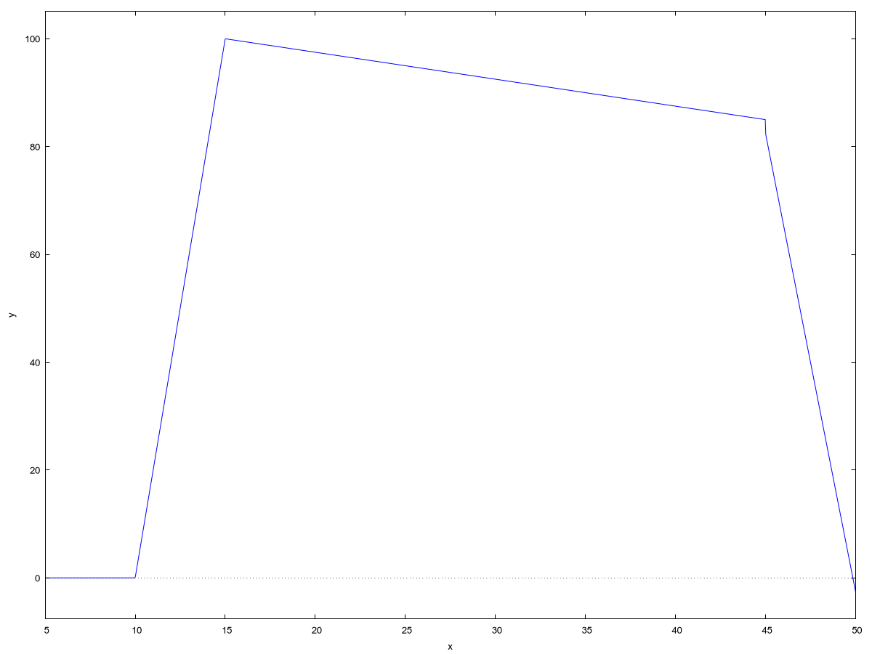

Рисунок 9 – График входного напряжения

(%o4)   
  
(%t5) 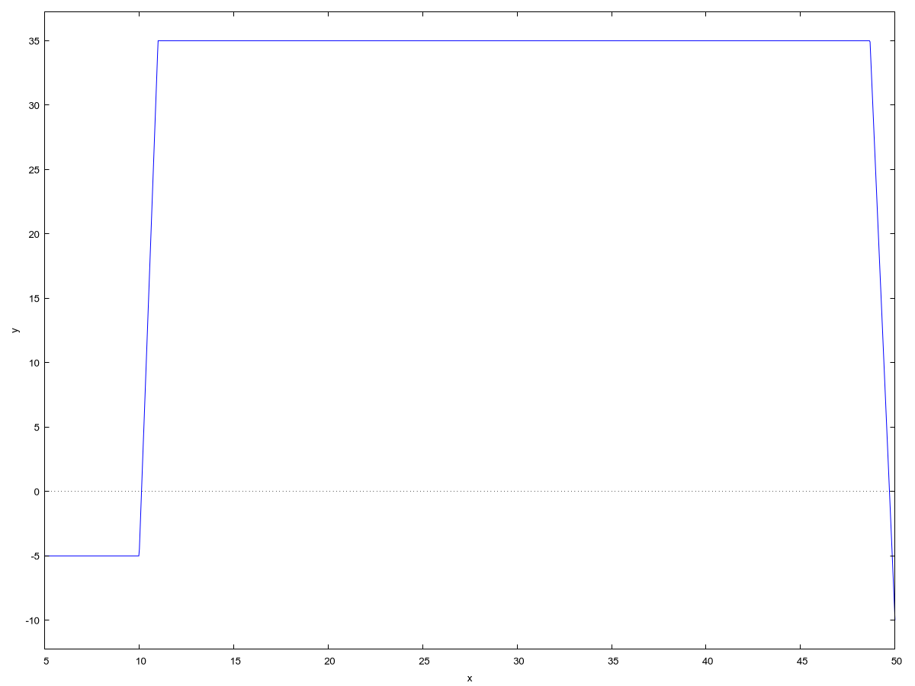

Рисунок 10 – График выходного напряжения

(%o5)

Заключение

В рамках данной курсовой работы была успешно решена задача анализа сигнала на выходе электрической цепи. Была разработана программа на языке Си, моделирующая прохождение входного сигнала (вариант 16) через цепь с заданной передаточной характеристикой (реализованной в коде) и вычисляющая выходной сигнал (Uvix).

Ключевой задачей являлся расчет длительности переднего фронта выходного сигнала с погрешностью не более 1%. Эта задача была выполнена с использованием итерационного алгоритма. Итоговое значение параметра составило с точностью , что соответствует требованиям задания.

Программа также реализует сохранение результатов расчета в файлы и предоставляет пользователю текстовое меню. Управление проектом осуществляется с помощью скрипта на Bash.

Работа позволила закрепить навыки программирования на языке Си (реализация численных методов, работа с файлами), использования математического пакета wxMaxima для контрольных расчетов и визуализации данных, а также применения скриптового языка Bash для автоматизации задач и организации проекта. Поставленные задачи выполнены успешно.

Список использованных источников

1. Анализ сигнала на выходе электрической цепи : методические указания к курсовой работе. – [Б. м.], 2022. – 24 с. – Текст : электронный.
2. ГОСТ 19.402-78. Единая система программной документации. Описание программы : [Текст]. – Введ. 1980-01-01. – Москва : Изд-во стандартов, 1979. – 6 с.
3. ГОСТ 19.701-90 (ИСО 5807-85). Единая система программной документации. Схемы алгоритмов, программ, данных и систем. Обозначения условные и правила выполнения : [Текст]. – Переиздание. – Москва : Стандартинформ, 2010. – 23 с.
4. Керниган, Б. У. Язык программирования C : [Текст] / Б. У. Керниган, Д. М. Ритчи ; пер. с англ. – 2-е изд. – Москва : Вильямс, 2015. – 304 с. – ISBN 978-5-8459-1975-5.
5. Конспекты лекций по программированию : [Электронный ресурс]. – URL: http://docs.basted.ru/ (дата обращения: 14.04.2025). – Текст : электронный.