

Compiler Lab
Lab Report-5
Course Title : Compiler Lab
Course Code : CSE0613322

Submitted to:
Teacher’s Name | Designation
Sonia Afroz | Lecturer
Tasneen Tanvir | Lecturer

Submitted by:
Student Name : Gaus Saraf Murady
Student ID : 0432410005101088
Semester : Autumn 2026
Batch : 55
Department : CSE

Date of Submission: 05.09.26
Experiment No. : 5
Experiment Name: Pattern Matching Problems

Given Test Cases :
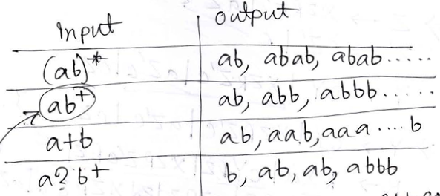
Code:
#include <bits/stdc++.h>
using namespace std;

int main()
{
string n;
cin >> n;
cout << endl << endl;

int ns = n.size();
string temp;

// (ab)*
if(n[0] == '(' && n[ns-2] == ')' && n[ns-1] == '*')
{

cout << "[ (ab)* ]" << endl << endl;
cout << "epsilon , ";
temp += n[1];
temp += n[2];
for(int i = 0; i<3; i++)
{
cout << temp << " , ";
temp += temp;
}
cout << " ... ";

}
// a?b+

else if(n[1] == '?' && n[ns-1] =='+')
{
cout << "[ a?b+ ]" << endl << endl;
cout << n[2] << " , ";
temp += n[ns-2];
for(int i = 0; i<3; i++)
{
cout << n[0] << temp << " , ";
temp += n[ns-2];
}
cout << " ... ";

}

//ab+

else if(n[ns-1] == '+')
{
cout << "[ ab+ ]" << endl << endl;
temp += n[0];
temp += n[1];
for(int i = 0; i<3; i++)
{
cout << temp << " , ";
temp += n[1];
}
cout << " ... ";

}

// a+b

else if(n[1] == '+')
{
cout << "[ a+b ]" << endl << endl;
temp += n[0];
for(int i = 0; i<3; i++)
{
cout << temp << n[2] << " , ";
temp += temp;
}
cout << " ... ";

}

cout << endl << endl;

return 0;
}

Input | Output
(ab)* | 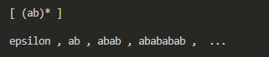
ab+ | 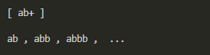
a+b | 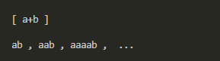
a?b+ | 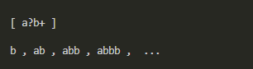

Discussion:

Through this assignment, I learned how to identify and show output by the corresponding input string. Here are 2 of my observations and learnings:
- I particularly struggled with the case a?b+ since it contained the ending + which overlapped with ab+ case, showing the wrong result when input was given a?b+. The fix to which was to put the else if block for a?b+ before the else if block for ab+. Hence when input matched both n[1] == '?' && n[ns-1] =='+' and not just ending n[ns-1] == '+', the code would correctly get into the else if blocks for both ab+ and a?b+ blocks.
- I used strings as character arrays string n; cin >> n; which helped me control the pattern matching using for loops.

Conclusion:

I was able to complete the assignment successfully.

