

Compiler Lab
Lab Report 2
Course Title : Compiler Lab
Course Code : CSE0613322

Submitted to:
Teacher’s Name | Designation
Sonia Afroz | Lecturer
Tasneen Tanvir | Lecturer

Submitted by:
Student Name : Gaus Saraf Murady
Student ID : 0432410005101088
Semester : Autumn 2026
Batch : 55
Department : CSE

Date of Submission: 15.08.26
Experiment No. : 2
Experiment Name : C++ Program for recognizing types of comments and finding number of lines in comments

1. Write a program to recognize the types of comments.
Input :
#include <bits/stdc++.h>
using namespace std;

int main() {

string text;
// cin >> text;
getline(cin, text);
cout << "Text Size is " << text.size() << endl;
cout << text[text.size() - 1] << endl;
if (text[0] == '/' && text[1] == '/') {
cout << text << " is a Single Line Comment" << endl;
} else if (text[0] == '/' && text[1] == '*' && text[text.size() - 2] == '*' &&
text[text.size() - 1] == '/') {
cout << text << " is a Multiple Line Comment" << endl;
} else {
cout << text << " is Not Comment" << endl;
}

return 0;
}

Output :
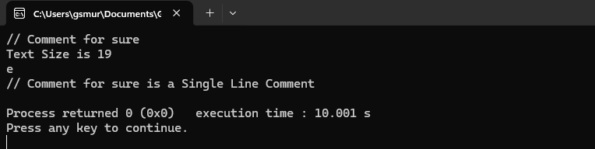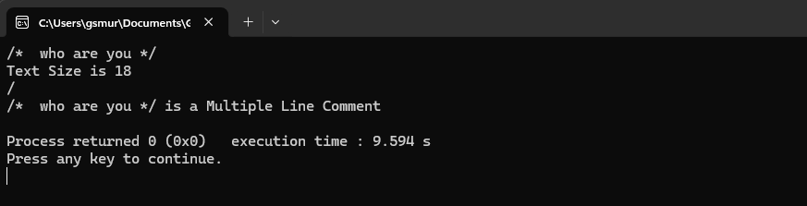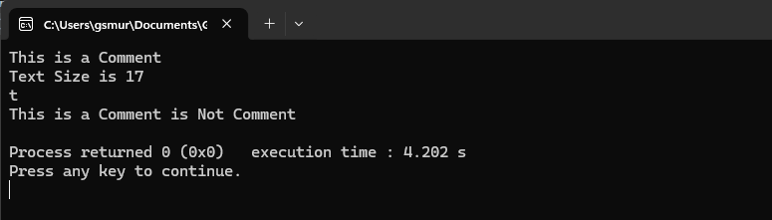

2. Write a program to find the number of lines where the comments are written.
Input :

#include <bits/stdc++.h>
using namespace std;

int main() {

int n;
cout << "How many lines to consider?\n>> ";
cin >> n;
cin.ignore(); // clears input buffer that ignores text[0] input
cout << endl << "Input each line and press Enter / add Newline:\n>>\n";

string text[n];

int cmt_cnt = 0;

for (int i = 0; i < n; i++) {
getline(cin, text[i]);
if (text[i][0] == '/' && text[i][1] == '/') {
cmt_cnt++;
}
}

cout << endl << "Total Comments: " << cmt_cnt << endl;

return 0;
}

Output :
