

Microprocessors, Microcontrollers and Assembly Language Lab
Lab Report - 2
Course Title : Microprocessors, Microcontrollers and Assembly
Language Lab
Course Code : CSE0611324

Submitted to:
Teacher’s Name | Designation
Tahmina Yeasmin Lima | Lecturer
Abrar Mahbub Tanim | Lecturer

Submitted by:
Student Name : Gaus Saraf Murady
Student ID : 0432410005101088
Semester : Autumn 2026
Batch : 55
Department : CSE

Date of Submission: 16.08.2026

Experiment No: 2

Experiment Name: Arithmetic operation of two one digit values in assembly language

Introduction:
In this lab, we learnt about programming with Assembly Language by performing some arithmetic operations. We operated on 2 single digit inputs and performed Addition, Subtraction, Multiplication, and Division using them.

Code:

.model small
.stack 100h

.data
num1 db ?
num2 db ?
sum db ?
subt db ?
multi db ?
divi db ?

quot db ?
rem db ?

.code

main proc
mov ax, @data
mov ds, ax

mov ah, 1
int 21h
sub al, 48 ; subtracting to convert from ASCII to Number values for operation
mov num1, al ; similar to storing to `bh`

; ////////////////////
mov ah, 2
mov dl, 32
int 21h
; ////////////////////

mov ah, 1
int 21h
sub al, 48
mov num2, al

; ////////////////////
mov ah, 2
mov dl, 32
int 21h
; ////////////////////

; SUM

mov al, num1 ; can use `ADD num1, num2` but we will lose the value of `num1`
add al, num2
add al, 48
mov sum,al ; summation for converting Number value back to ASCII for Output

mov ah, 2
mov dl, sum
int 21h

; ////////////////////
mov ah, 2
mov dl, 32
int 21h
; ////////////////////

; SUB

mov al, num1
sub al, num2
add al, 48
mov subt,al

mov ah, 2
mov dl, subt
int 21h

; ////////////////////
mov ah, 2
mov dl, 32
int 21h
; ////////////////////

; MUL

mov al, num1
mul num2 ; AL is automatically multiplied by num2
add al, 48
mov multi,al

; // ALT
; mov al, num1
; mov bl, num2
; mul bl
; mov multi,al
; add multi, 30h

mov ah, 2
mov dl, multi
int 21h

; ////////////////////
mov ah, 2
mov dl, 32
int 21h
; ////////////////////

; DIV

mov al, num1
div num2
add al, 48
add ah, 48
mov divi,al
mov rem,ah

mov ah, 2
mov dl, divi
int 21h

; ////////////////////
mov ah, 2
mov dl, 32
int 21h
; ////////////////////

mov ah, 2
mov dl, rem
int 21h

; // ALT
; mov al, num1
; mov bl, num2
; div bl
; mov quot,al
; mov rem,ah
; add quot, 30h
; add rem, 30h

main endp
end main

Output:
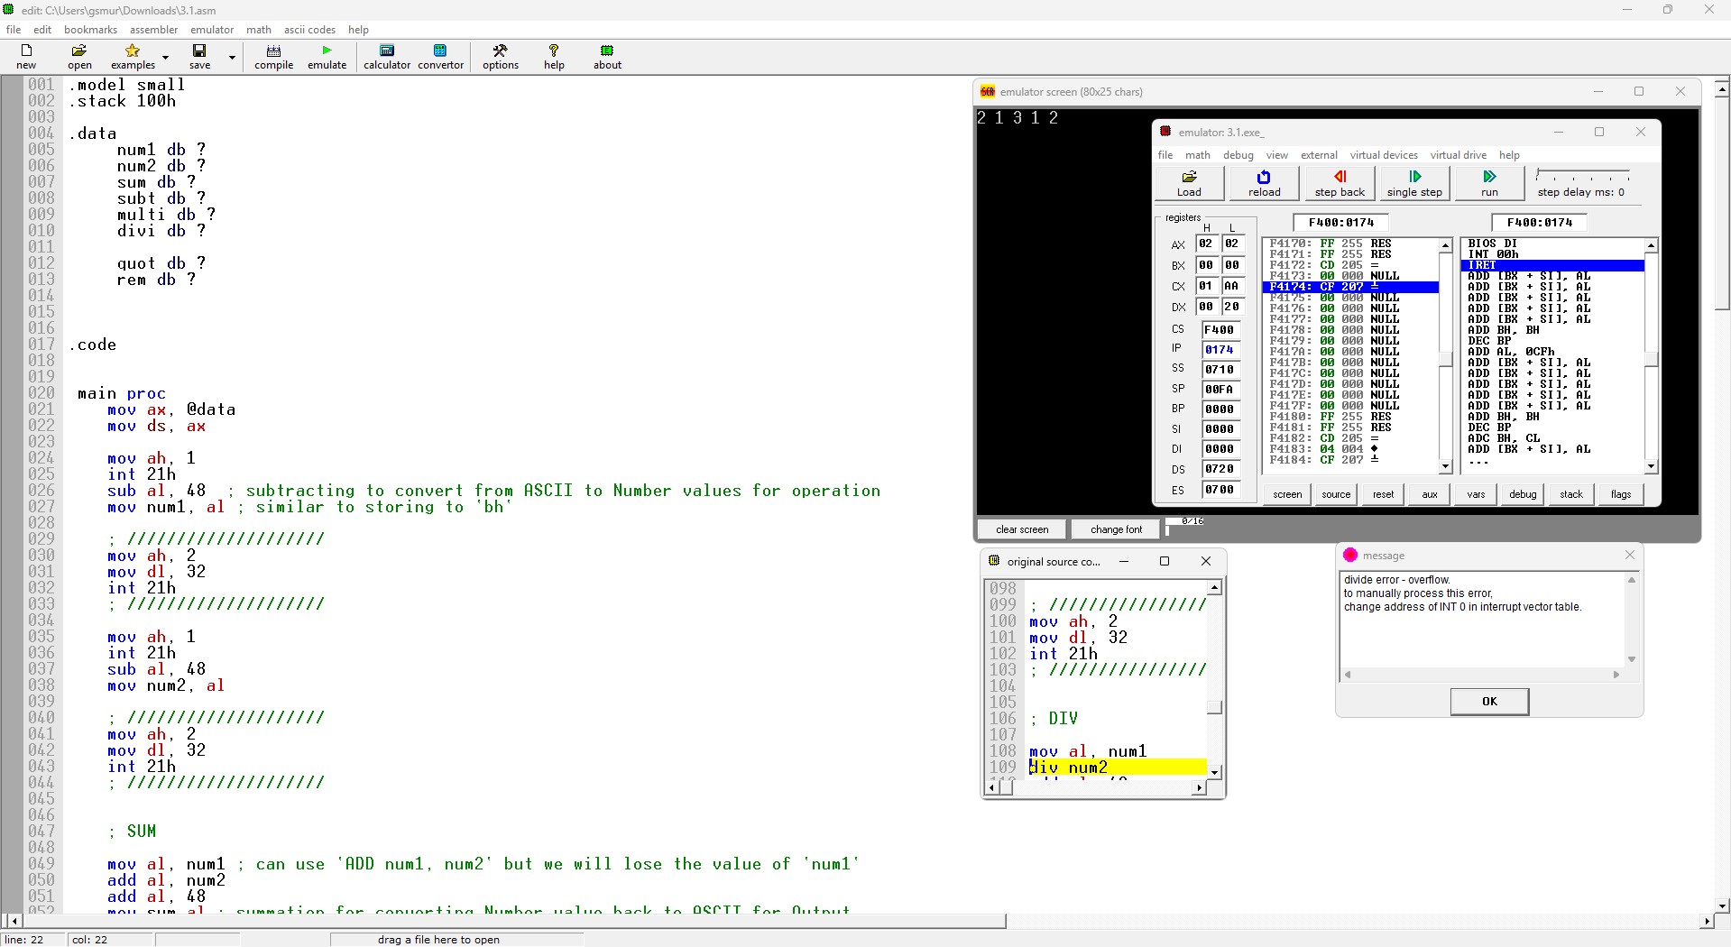

Conclusion:
We successfully showed the expected outputs of the respective operations. The MUL and DIV operations were a bit special since they require only a single parameter to operate. Also, the handling of double digit output of the operations using DIV was interesting, even though we could not implement it correctly during the lab hours.

