

Microprocessors, Microcontrollers and Assembly Language Lab
Lab Report - 4
Course Title : Microprocessors, Microcontrollers and Assembly
Language Lab
Course Code : CSE0611324

Submitted to:
Teacher’s Name | Designation
Tahmina Yeasmin Lima | Lecturer
Abrar Mahbub Tanim | Lecturer

Submitted by:
Student Name : Gaus Saraf Murady
Student ID : 0432410005101088
Semester : Autumn 2026
Batch : 55
Department : CSE

Date of Submission: 06.09.26
Experiment No : 4
Experiment Name: Conversion of lowercase letter to uppercase letter and vise versa

Introduction:
In this lab, we worked with Alphabets to convert Small Letter inputs to Capital Letter counterparts. The core logic is the conversion of ASCII values sub al, 20h or sub al, 32 so the output comes out as the Capital Letter.
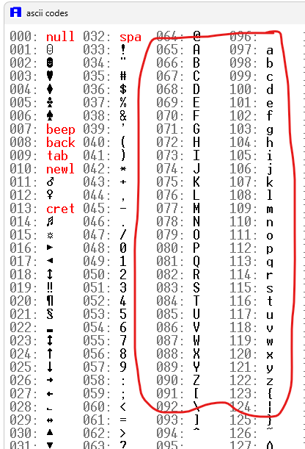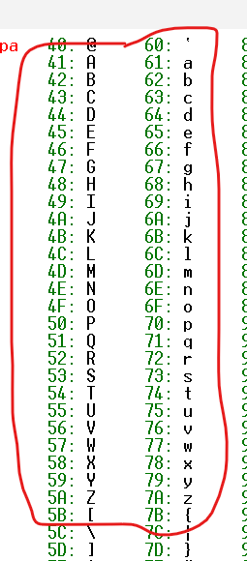
For our assignment, in addition to the core logic, we had to use the reverse logic (Capital→Small conversion) with JBE and CMP commands (If-Else equivalent of Programming Languages).

Code:

.model small
.stack 100h

.data
msg1 db "Input: $"
msg2 db "Output : $"

char db ?

.code

main proc

mov ax, @data
mov ds,ax

; INPUT

mov dx, offset msg1
mov ah, 09h
int 21h

mov ah, 01h
int 21h
; sub al, 20h ; WILL BE ADD / SUM only after determining Capital / Small
mov char, al

; /////////
mov ah, 02h
mov dl,10
int 21h
mov ah, 02h
mov dl, 13
int 21h
; /////////

; OUTPUT

mov dx, offset msg2
mov ah, 09h
int 21h

; IF BLOCK (if Capital, make Small)

mov al, char ; storing `char` value to AL to compare with 61h
cmp al, 60h ; comparing with the character before 'a' (" ' ")
jbe to_SMALL

; ELSE BLOCK (if Small, make Capital)

sub al, 20h

jmp to_Output

to_SMALL:
add al, 20h

to_Output:

mov char, al

mov ah, 02h
mov dl, char
int 21h

exit:
mov ah, 4ch
int 21h

main endp

end main

Output:
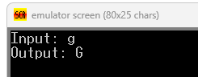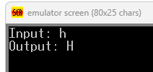
Discussions:
The relevant notes have been documented at: Microprocessor_Assembly_Lab/doc/Assignments/Learning/A_4-theory.md at main · b1tranger/Microprocessor_Assembly_Lab

Also see: (From which I learned that we are working with flags instead of actual value changes (If-Else checks).
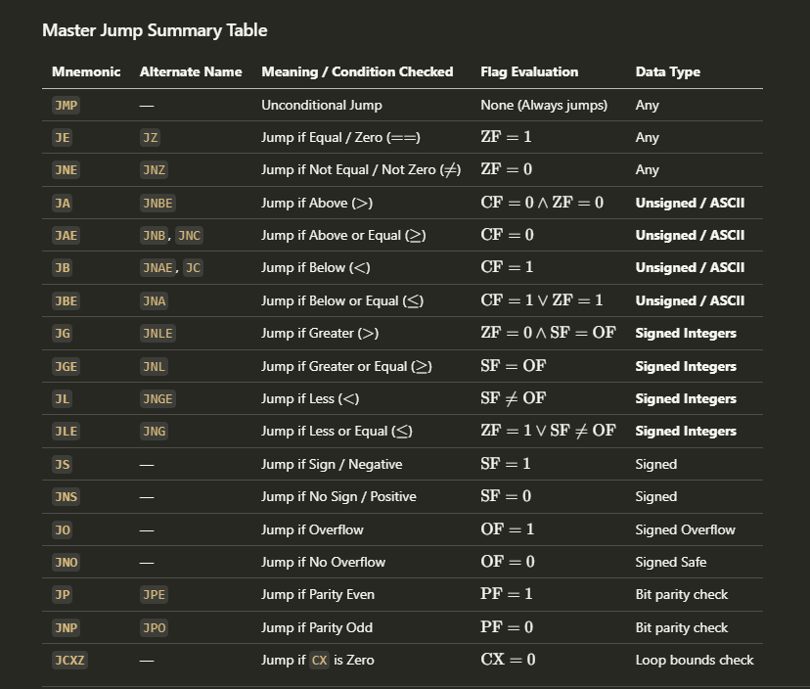

Conclusion:
I have successfully completed the assignment. While working on it, I had to study the Procedure Calling and Level Jumping to decide which one to use for this assignment.

