

Microprocessors, Microcontrollers and Assembly Language Lab
Lab Report - 5
Course Title : Microprocessors, Microcontrollers and Assembly
Language Lab
Course Code : CSE0611324

Submitted to:
Teacher’s Name | Designation
Tahmina Yeasmin Lima | Lecturer
Abrar Mahbub Tanim | Lecturer

Submitted by:
Student Name : Gaus Saraf Murady
Student ID : 0432410005101088
Semester : Autumn 2026
Batch : 55
Department : CSE

Date of Submission: 10.09.26
Experiment No : 5
Experiment Name: Find the biggest number among 3 numbers

Introduction:
In this lab, we worked with comparing numbers to find the largest among them. In the lab, we worked with 2 numbers and for the assignment, we were tasked with finding the largest among 3 numbers.
For my report, I have implemented only the “largest among 3 numbers” case, with a noticeable edge case of equal comparisons. I have addressed this by concluding that the first layer comparison check implies that I can jump to any of the 2 subsequent comparisons to make a decision on the final number’s state (largest / equal). Hence, I chose je b_is_big (I could choose je a_is_big as well; resulting in the same)

Implemented code:
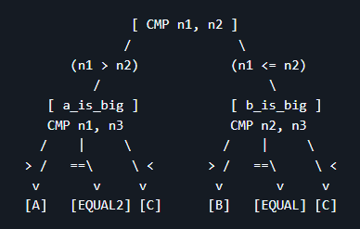

Code:

.model small
.stack 100h

.data ;data segment
a_input db 'Enter the value of A: $'
b_input db 10, 13, 'Enter the value of B: $'
c_input db 10, 13, 'Enter the value of C: $'

a db 10, 13, ' A is largest!$'
b db 10, 13, ' B is largest!$'
c db 10, 13, ' C is largest!$'

equal db 10, 13, ' Equal values!$'

n1 db ?
n2 db ?
n3 db ?

.code
main proc
mov ax,@data ;move the data segment in ax
mov ds, ax

mov ah, 9
lea dx, a_input
int 21h
mov ah, 1
int 21h
mov n1, al

mov ah, 9
lea dx, b_input
int 21h
mov ah, 1
int 21h
mov n2, al

mov ah, 9
lea dx, c_input
int 21h
mov ah, 1
int 21h
mov n3, al

;cmp bl, bh ; compare
mov al, n1
mov ah, n2
cmp al, ah
jg a_is_big ; if bl bigger than bh then jg flag on
jl b_is_big ; if bh bigger than bl then jl flag on
je b_is_big ; in case of equal case we can compare any one with the 3rd

a_is_big:
; bl is big so print variable a

mov al, n1
mov ah, n3

cmp al, ah
jg a_is_big2
jl c_is_big
je both_are_equal2

b_is_big:

mov al, n2
mov ah, n3

cmp al, ah
jg b_is_big2
jl c_is_big
je both_are_equal

b_is_big2:
mov ah, 9
lea dx, b
int 21h
jmp exit

both_are_equal:

mov ah, 9
lea dx, equal
int 21h
jmp exit

a_is_big2:
mov ah, 9
lea dx, a
int 21h
jmp exit

c_is_big:
mov ah, 9
lea dx, c
int 21h
jmp exit

both_are_equal2:
mov ah, 9
lea dx, equal
int 21h

jmp exit

exit:
mov ah, 4ch

main endp
end main

Output:
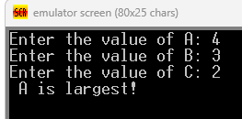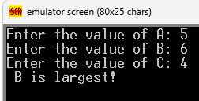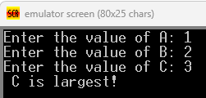
(Equal Cases)
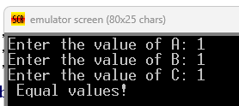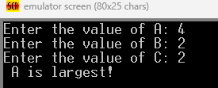
Discussions:
The relevant notes have been documented at:
- Microprocessor_Assembly_Lab/LabCodes/Learning/9.1-theory.md at main · b1tranger/Microprocessor_Assembly_Lab
- Microprocessor_Assembly_Lab/LabCodes/Learning/9.2_assignment-theory.md at main · b1tranger/Microprocessor_Assembly_Lab
- Microprocessor_Assembly_Lab/LabCodes/Learning/9.3_alt_assignment-theory.md at main · b1tranger/Microprocessor_Assembly_Lab

Conclusion:
I have successfully completed the assignment. Although I have addressed the Equal Numbers Case, and I have sufficiently addressed the requirements for this assignment.

