So here is a summary of what we talked about today:
Requirements:
1) AVR so mini or pro, what ever you think will work best
2) must have USB port for plug and play/programming with arduino
3) Need to dedicate a pin for each of the following:
- LEDs (one pin) for ws2812b RGB LEDS
- Sound (one pin to piezo)
- One pin with voltage divider for monitoring battery
- 6 buttons, one pin, with a series of resisters to analog read to determine button pushed
Header Pins for normal UNO for shields (8&6 and 8&10)
- 10 pin header socket for flight control board
- 10 pin header socket for LCD
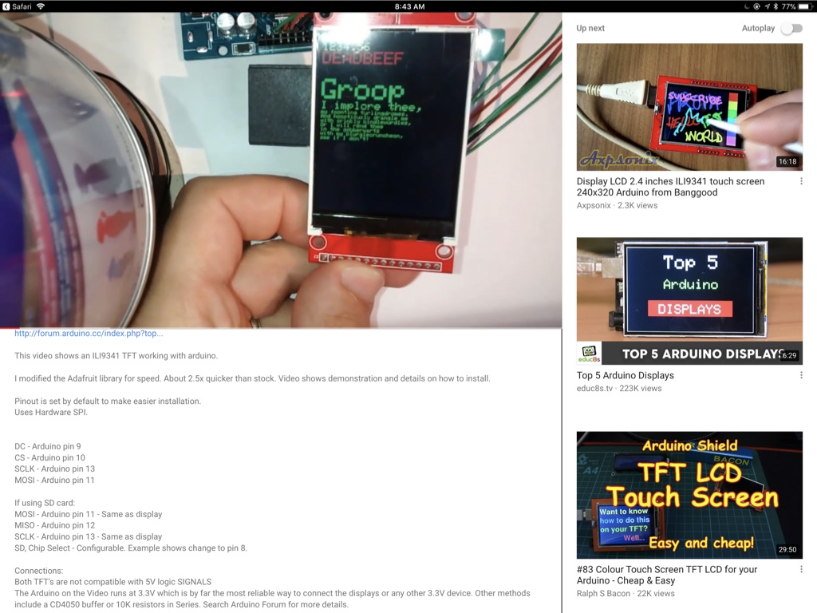
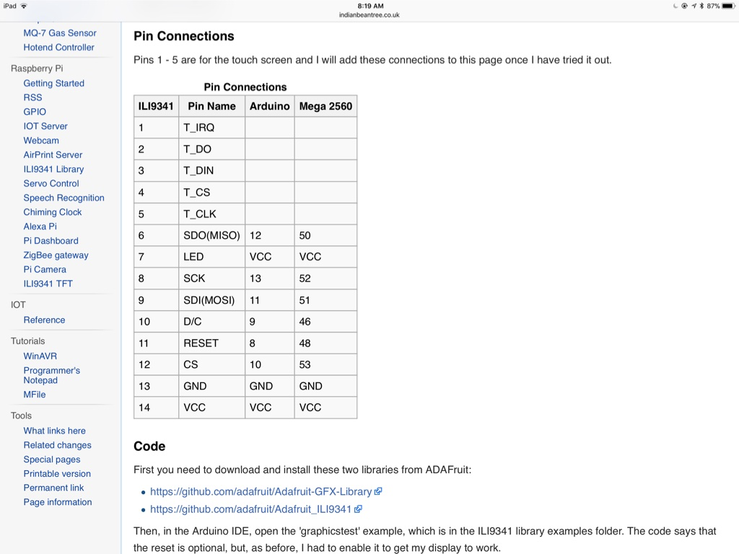
I will be swapping pins on LCD to the front side for mounting from behind on the skull badge, so we need to pay special attention to the pin order
battery will be a 2S LIPO so approx 8.5 v
switch to turn off Vin to badge, but NOT to the flight control header pins (so the user can turn off the lights and sound, but still fly; Vin should split and go to the switch to the voltage regulators and Vin header socket for flight control)
************************************************************

for information on the RGB LEDS see the sheet from this years attempt of mine at redoing the badge, will have sheets on them and the sound
as well as the flight control sockets
the LCD socket is new

Arduino socket libs: https://github.com/Alarm-Siren/arduino-kicad-library

