Assessment of knowledge, Attitude and Practice regarding Periodontal health among IT Professionals in Bangalore City- a cross sectional questionnaire survey
This report keeps Bangalore at the center of the analysis without discarding the outside-Bangalore respondents who also contributed useful signal.

Executive bullets
- Bangalore drives the dataset, but the city is not a single cluster.
- Named Bangalore localities differ more in behavior than in awareness.
- Ulsoor stands out as a small pocket where knowledge is not turning into routine practice.
- The weakest knowledge area is not advanced care; it is the basic cause of gum disease.
- Daily routines weaken most on interdental cleaning and dentist follow-up.

Sample profile and survey footing
The report stays Bangalore-first because most respondents are from Bangalore, but it keeps the outside-Bangalore sample visible throughout the analysis.
- 146 respondents are from Bangalore and 105 are outside Bangalore.
- The sample skews toward 20-30 years (61.8%) and full-time workers (78.1%).
- 20.7% report a previous treatment history.

Bangalore versus outside Bangalore
Bangalore contributes 58.2% of the full sample.
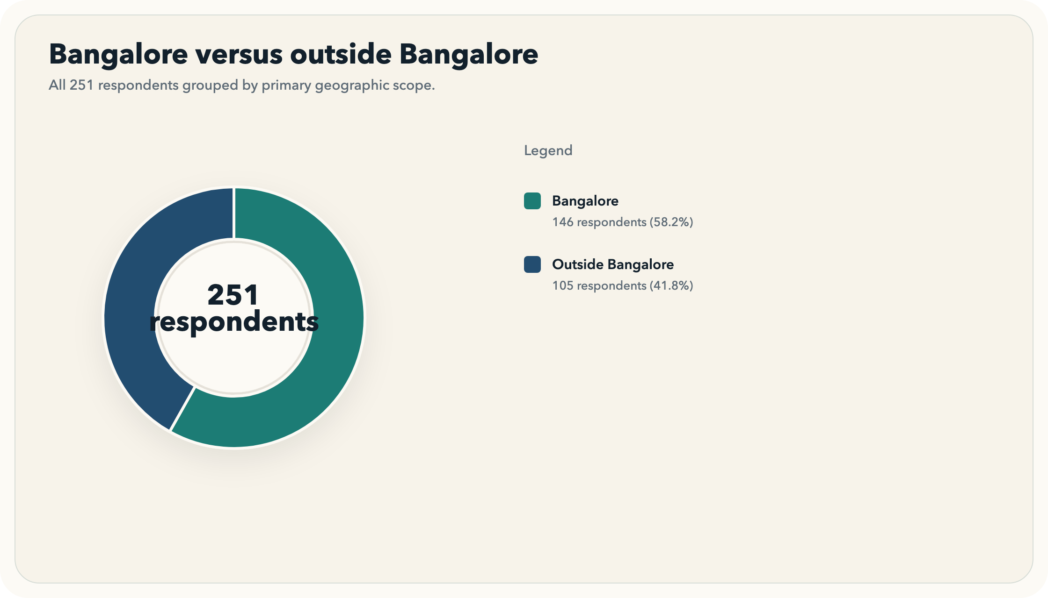

Gender mix
Male respondents account for 67.7% of the sample.
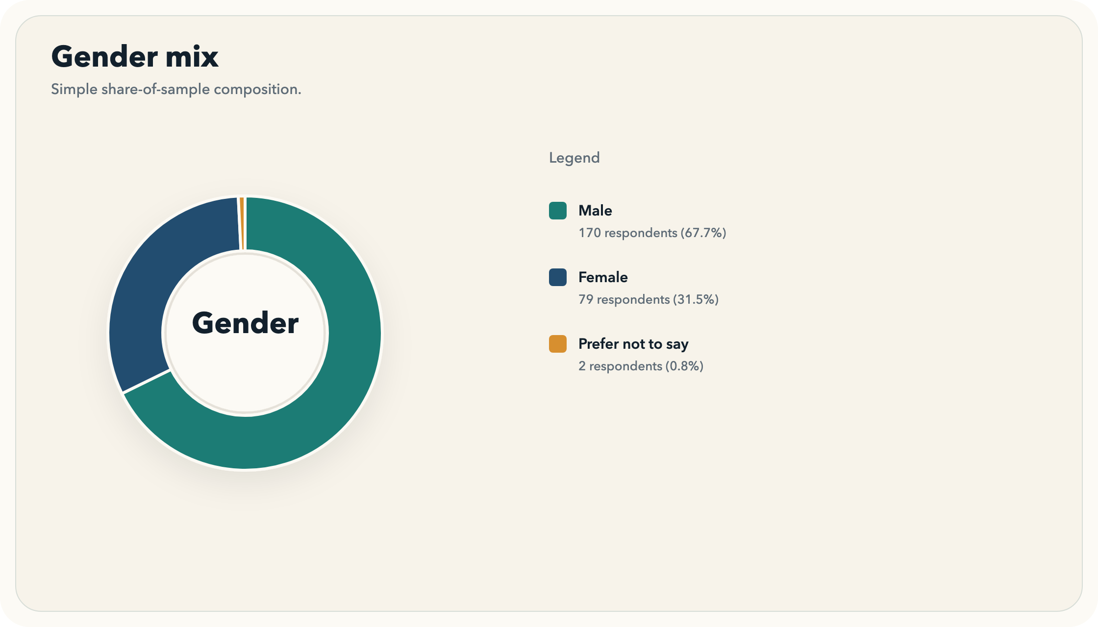

Age range distribution
The 20-30 years band makes up 61.8% of respondents.
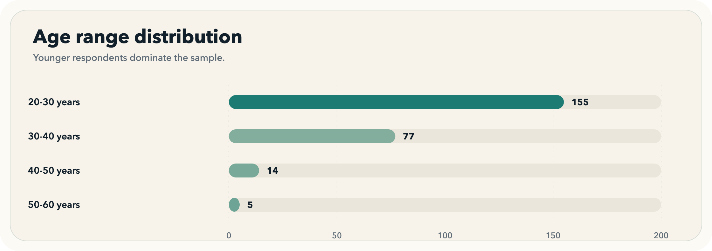

Work mode
Full-time work is the dominant mode at 78.1%.
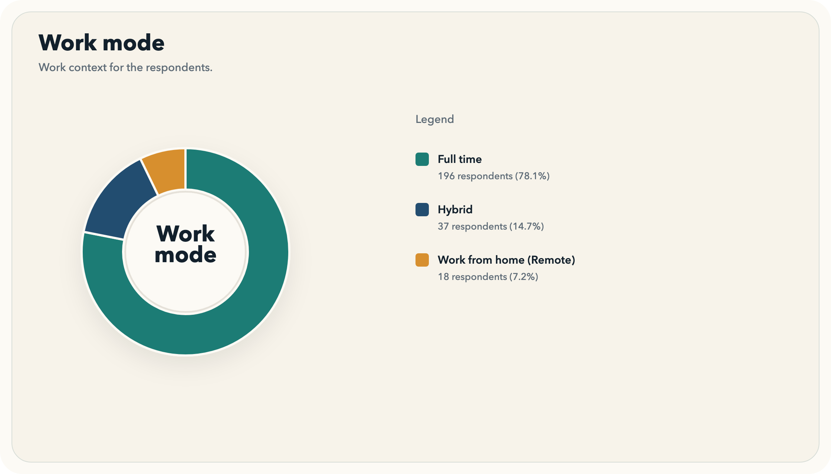

Bangalore is the core geography, but outside-Bangalore responses matter too.
Geography is shown in two layers: a whole-sample view that keeps outside-Bangalore responses visible, and a Bangalore-locality view that does not flatten the city into one bucket.
- Bangalore contributes 146 responses, but 105 respondents are still outside Bangalore.
- JP Nagar is the largest named Bangalore locality, while Chennai anchors the outside-Bangalore sample.

Top city or location clusters
Bangalore is the dominant location cluster, followed by Chennai at 30 respondents.
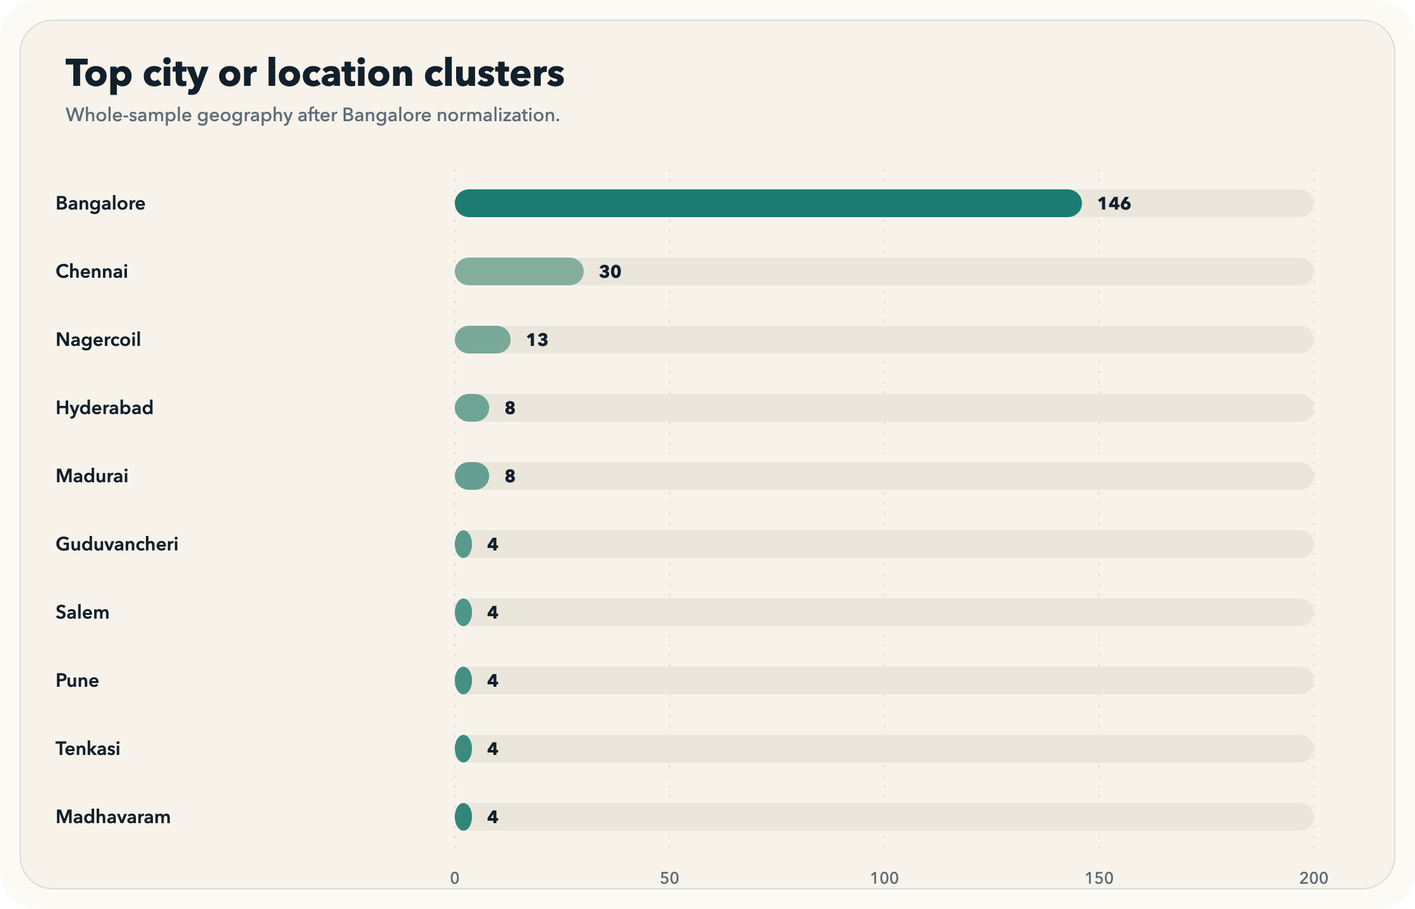

Bangalore locality distribution
JP Nagar is the largest named Bangalore locality in the sample.
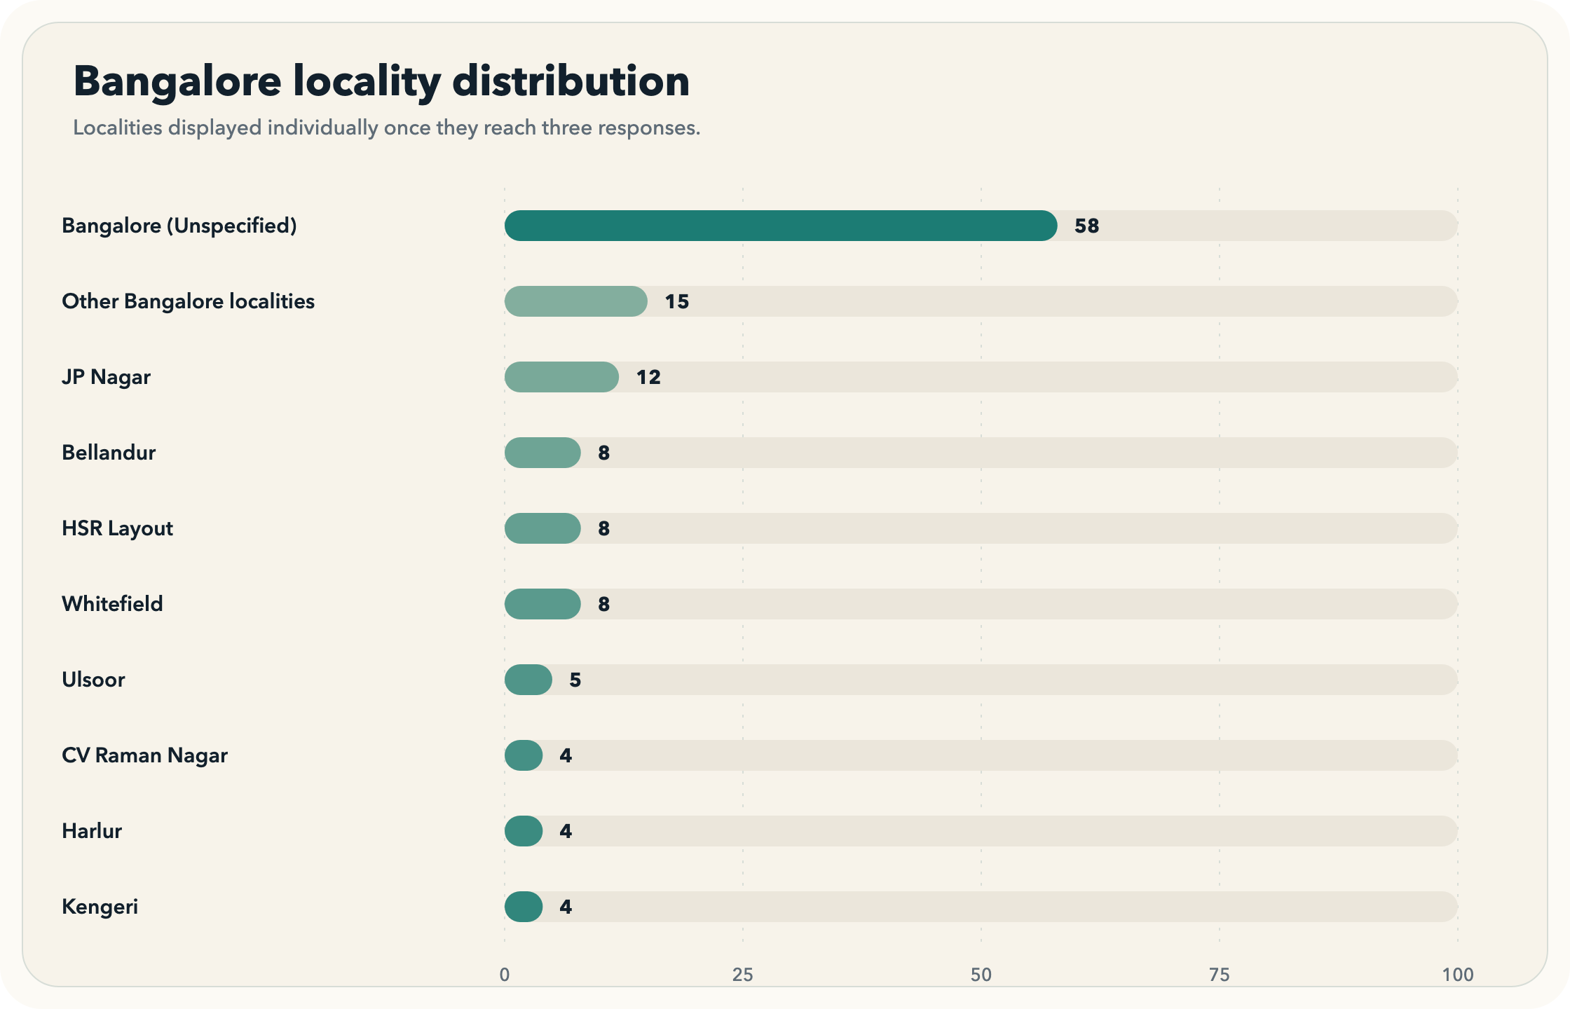

Top outside-Bangalore locations
Chennai leads the outside-Bangalore sample with 30 respondents.
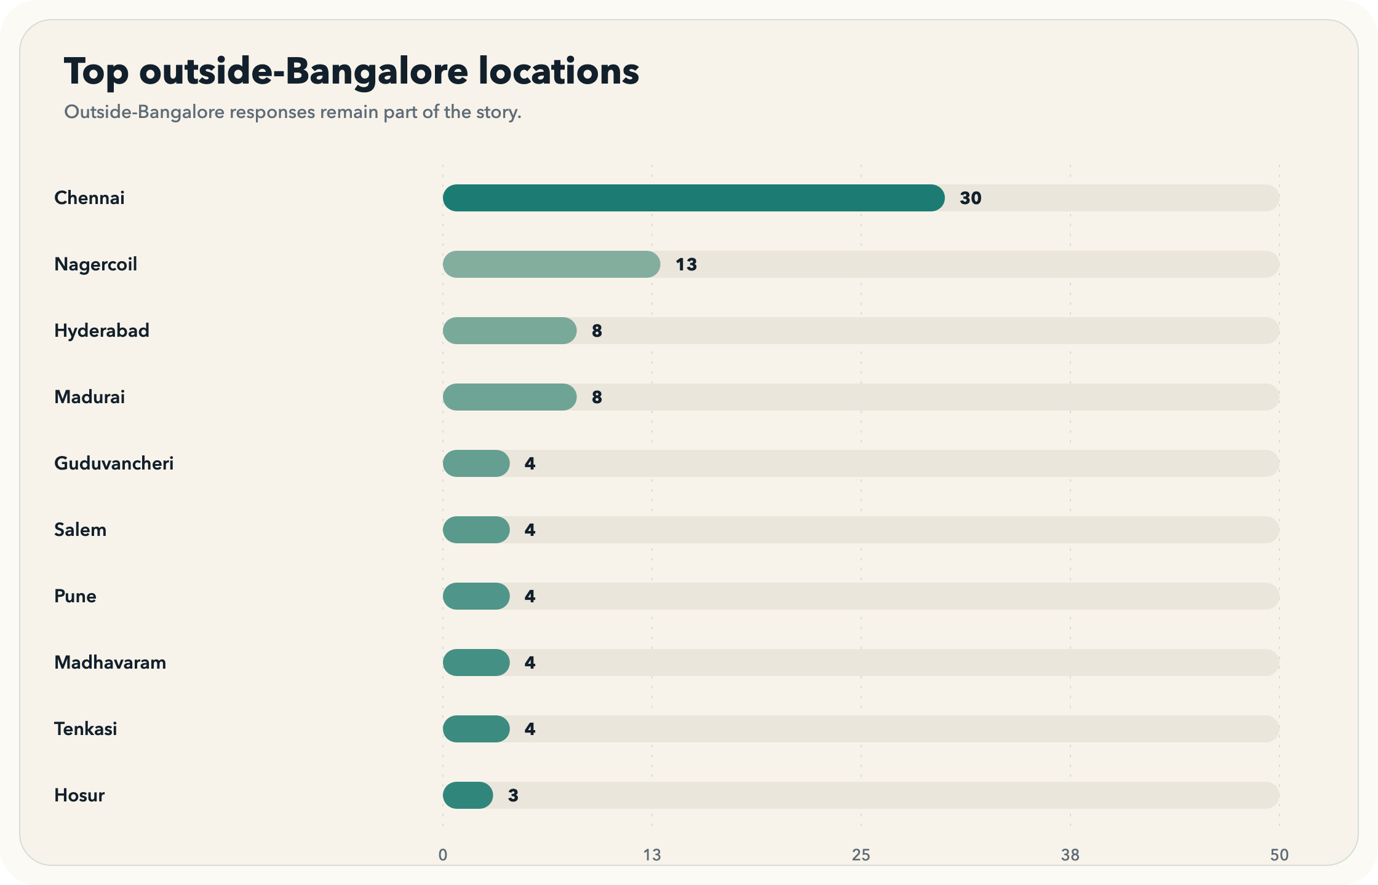

Named Bangalore localities do not all behave the same way.
The Bangalore locality section keeps the city-specific focus honest by showing where behavior is stronger, where knowledge leads action, and where small local pockets need caution.
- Use this section for Bangalore-specific commentary rather than citywide generalization.
- Locality comparisons are descriptive unless a locality reaches at least five respondents.

KAP by Bangalore locality
Practice varies more than knowledge across the claimable Bangalore localities.
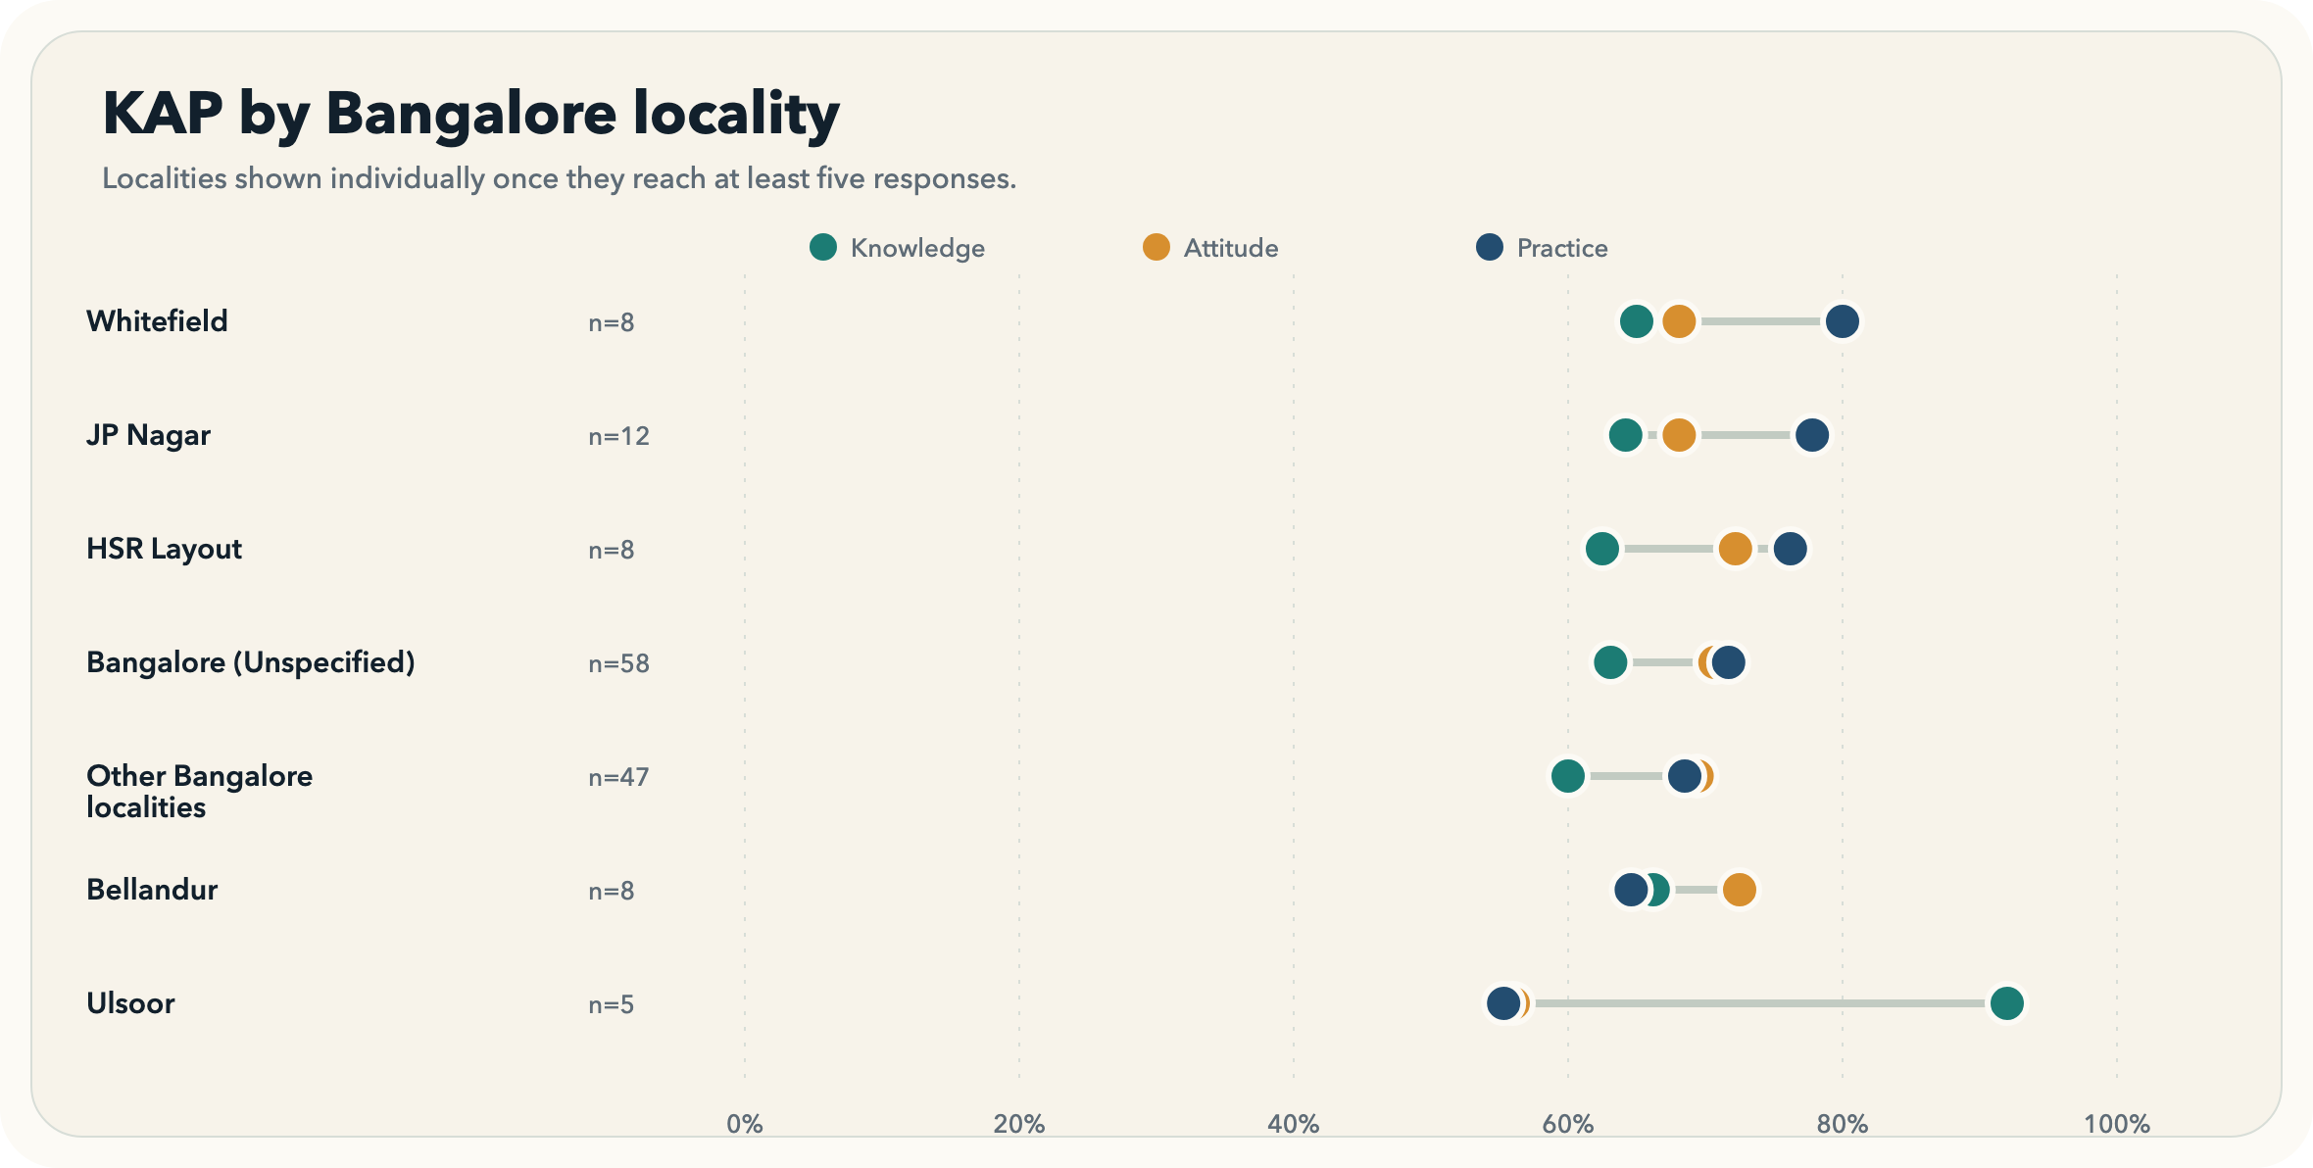

Knowledge vs practice in Bangalore localities
The sharpest locality gap appears in Ulsoor.
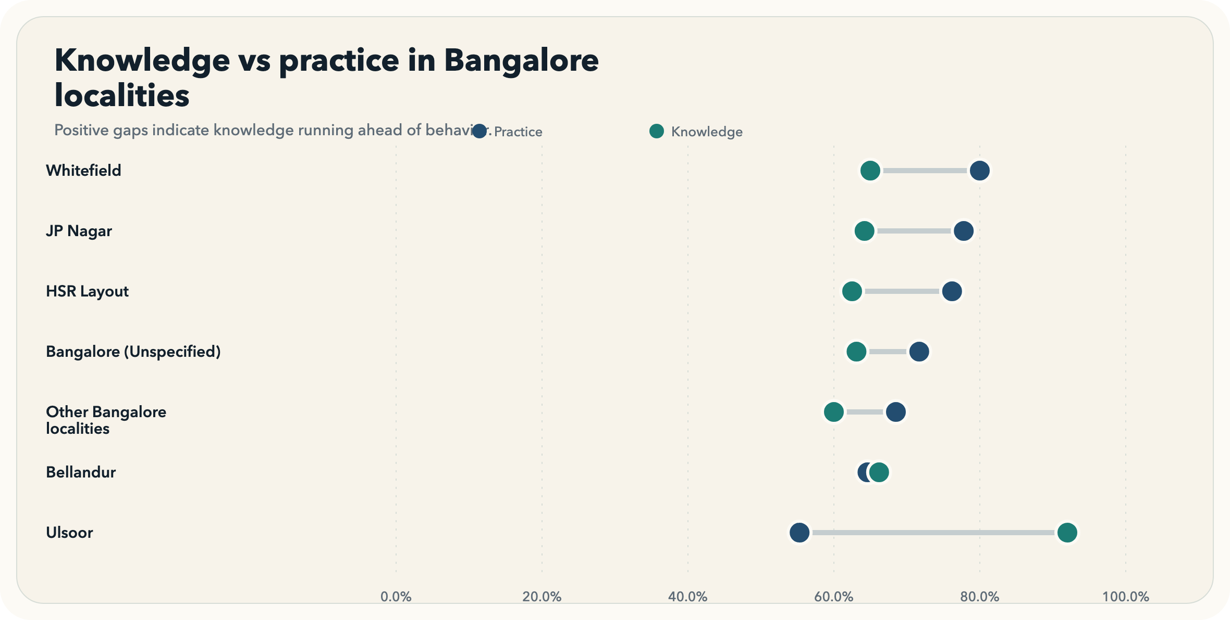

The knowledge story is about basic gum disease understanding, not specialist detail.
The lowest-scoring knowledge items concern the primary cause of gum disease and the definitions of plaque and tartar.
- Cause is the weakest knowledge item at 37.5% correct.
- The next weakest items are Plaque and Calculus.

Knowledge items ranked by percent correct
The cause-of-disease item is lowest at 37.5% correct.
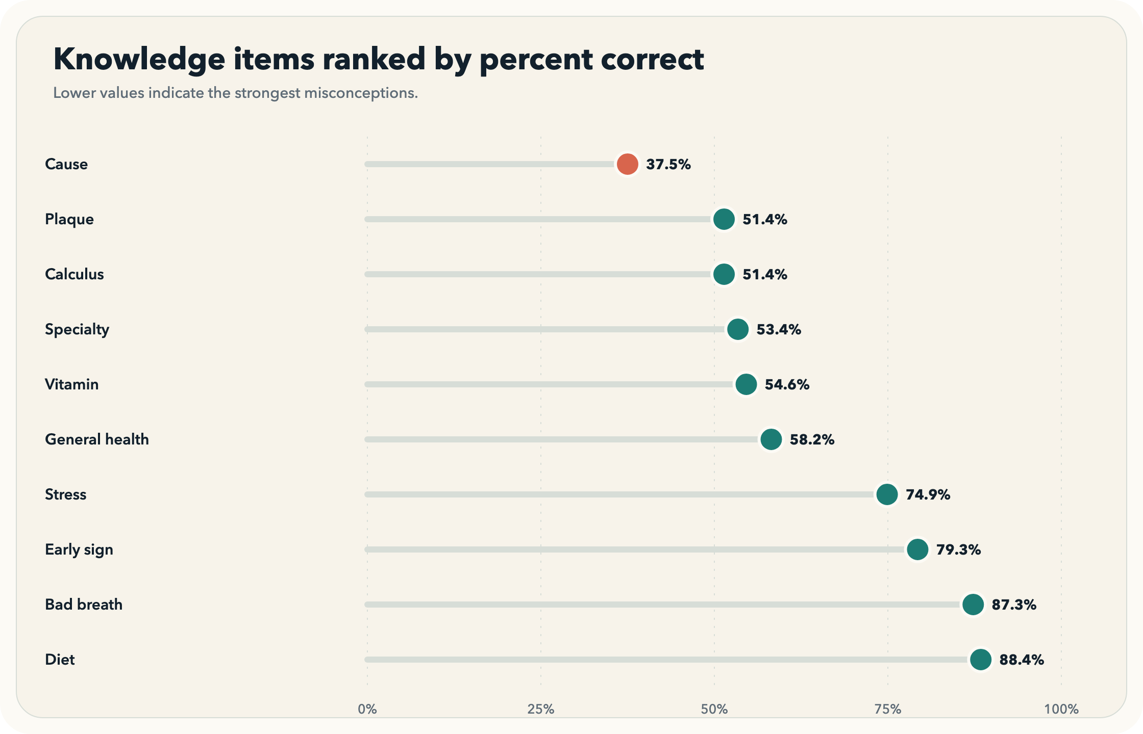

Attitudes are generally favorable, but a few items show friction.
The diverging view makes it easy to see which statements generate strong agreement and which still face skepticism or convenience-based resistance.
- The pain-only dentist-visit statement is the least favorable attitude item after reverse coding.
- Time and effort concerns remain visible even when oral-health attitudes are broadly positive.

Attitude toward periodontal health
The weakest net favorability appears on the statement 'Visiting a dentist is necessary only when I have pain or discomfort.'.
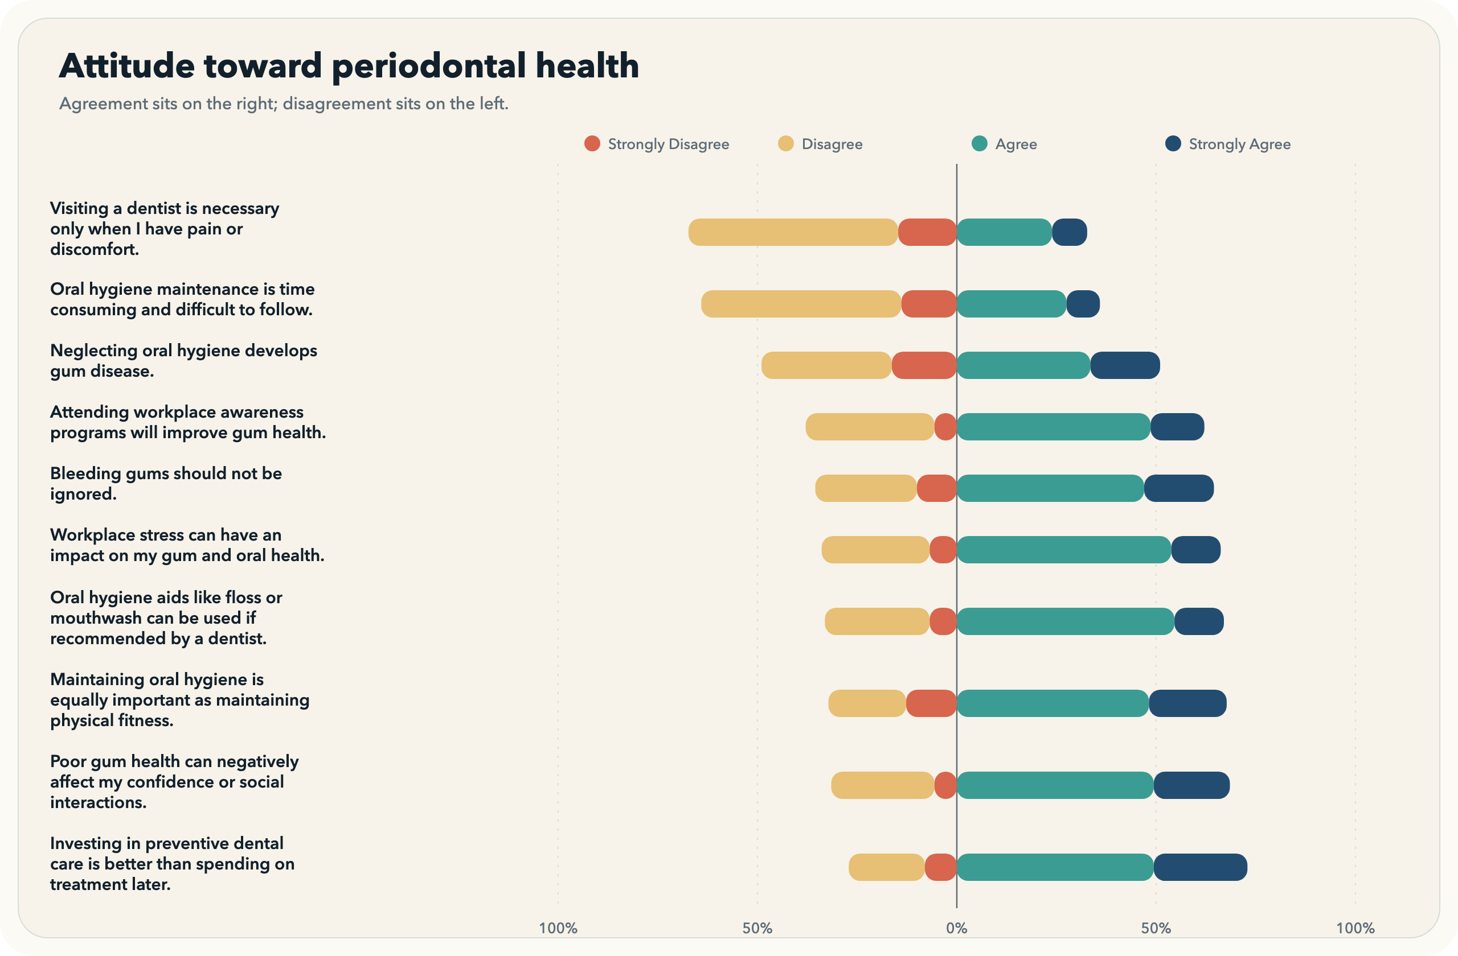

Reported behavior is strongest on some daily basics and weakest on follow-through routines.
The practice view separates broad adherence from the specific routines that still lag, especially cleaning aids and regular dentist visits.
- Only 12.0% report best-practice use of cleaning aids.
- Dentist visit recency reaches just 39.0% in the top band.

Practice response quality mix
Cleaning aids is the weakest practice area, with only 12.0% in the best-practice band.
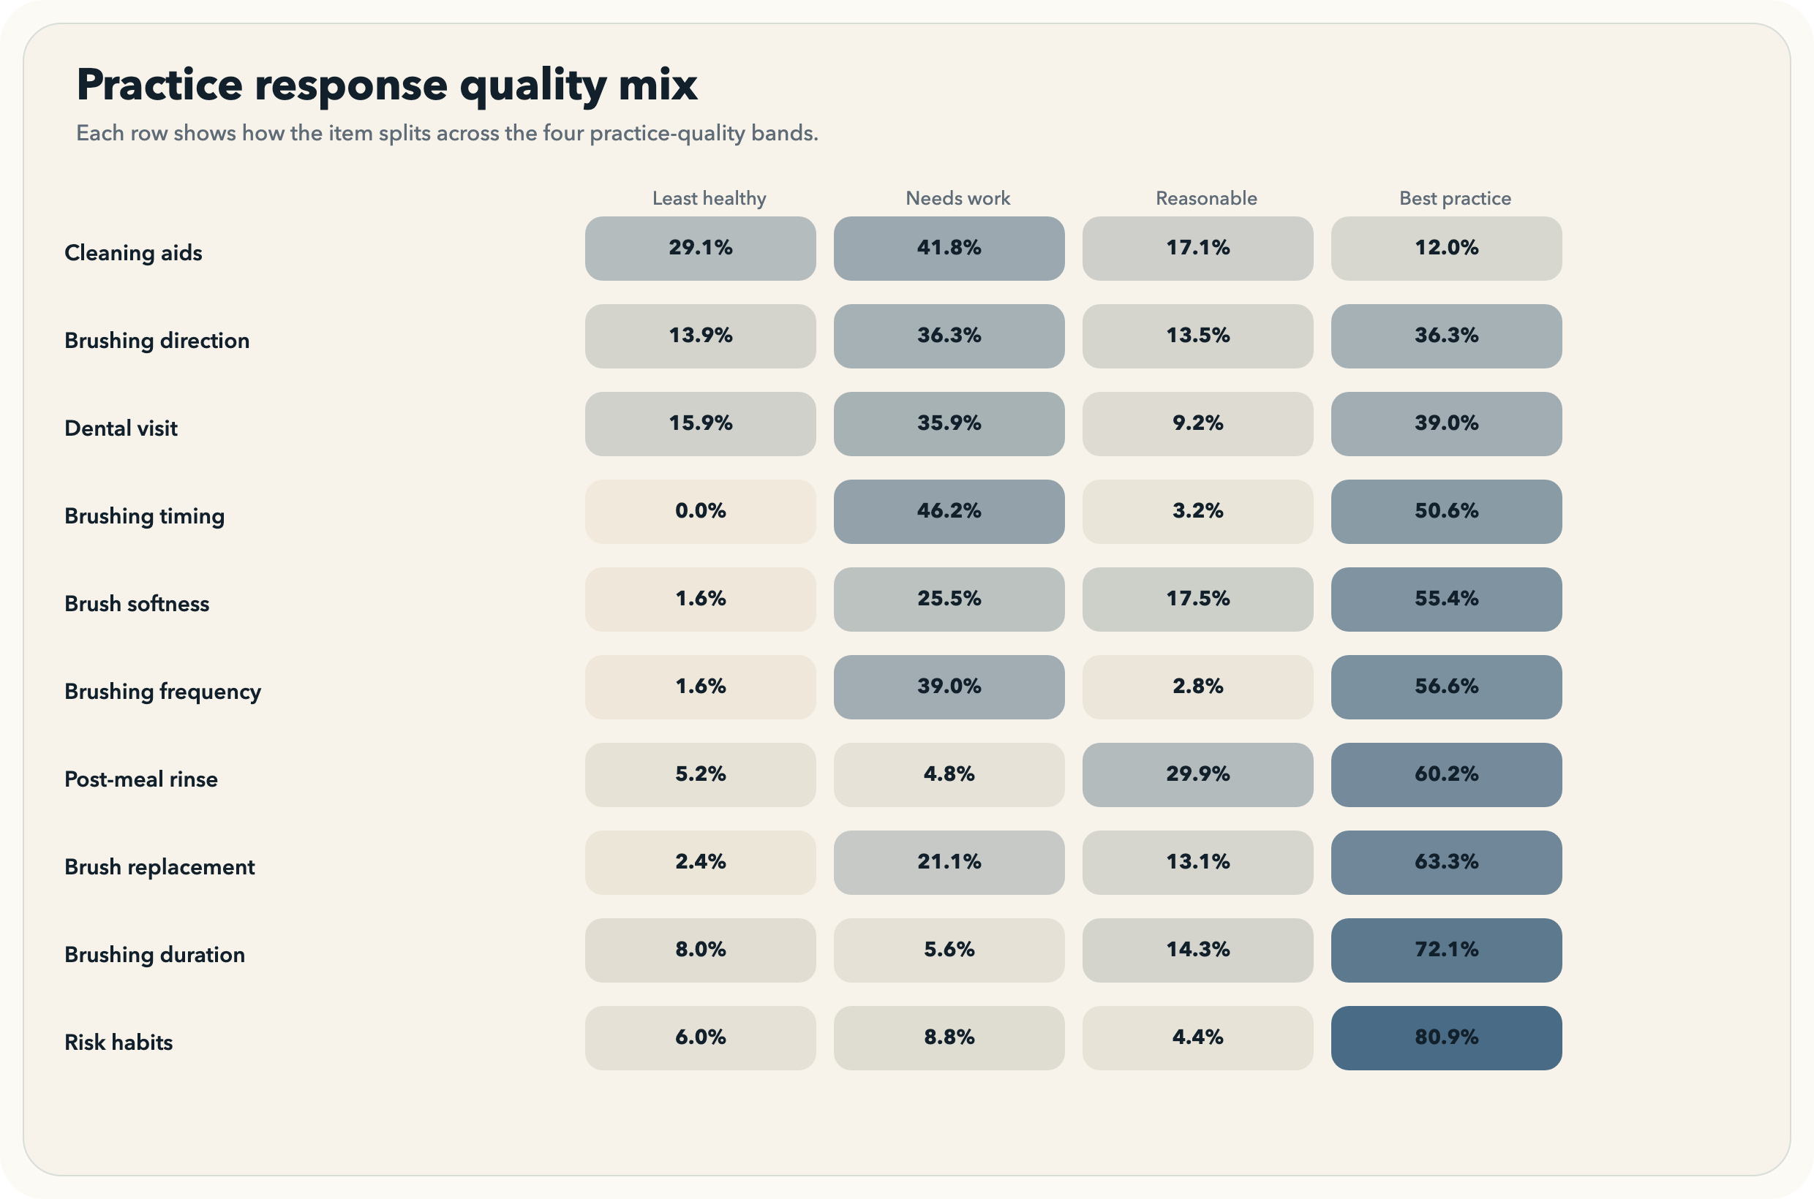

Lowest best-practice adherence
Cleaning aids and dentist visits are the two main behavior bottlenecks.
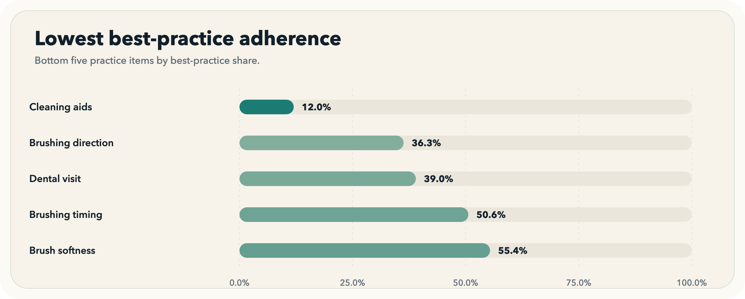

The cross-domain view shows how knowledge, attitude, and practice move together and where subgroup differences are large enough to notice.
Knowledge, attitude, and practice should be read as connected but not interchangeable domains; the charts below show both their overall score ranges and their subgroup differences.
- Knowledge and practice move together most closely at rho=0.381.
- The clearest geo-scope difference is in attitude, where Bangalore is higher by 3.5 points.

Composite score distributions
Practice has the highest average standardized score at 69.8%.
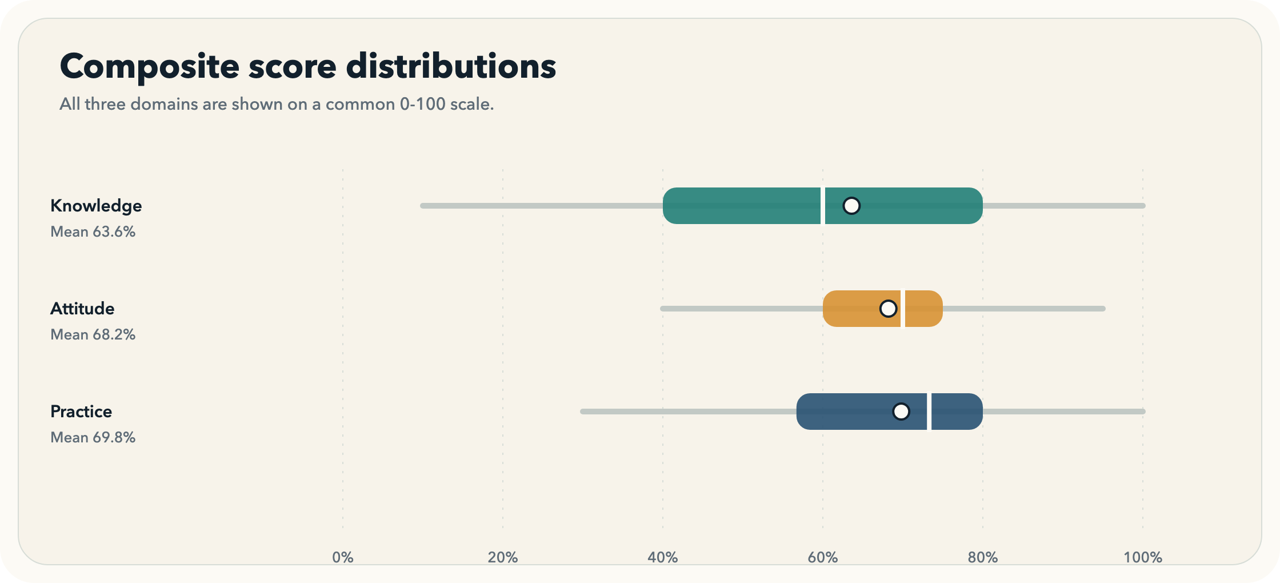

Subgroup score profile
Remote workers and 10-15 year professionals sit near the bottom of the practice distribution.
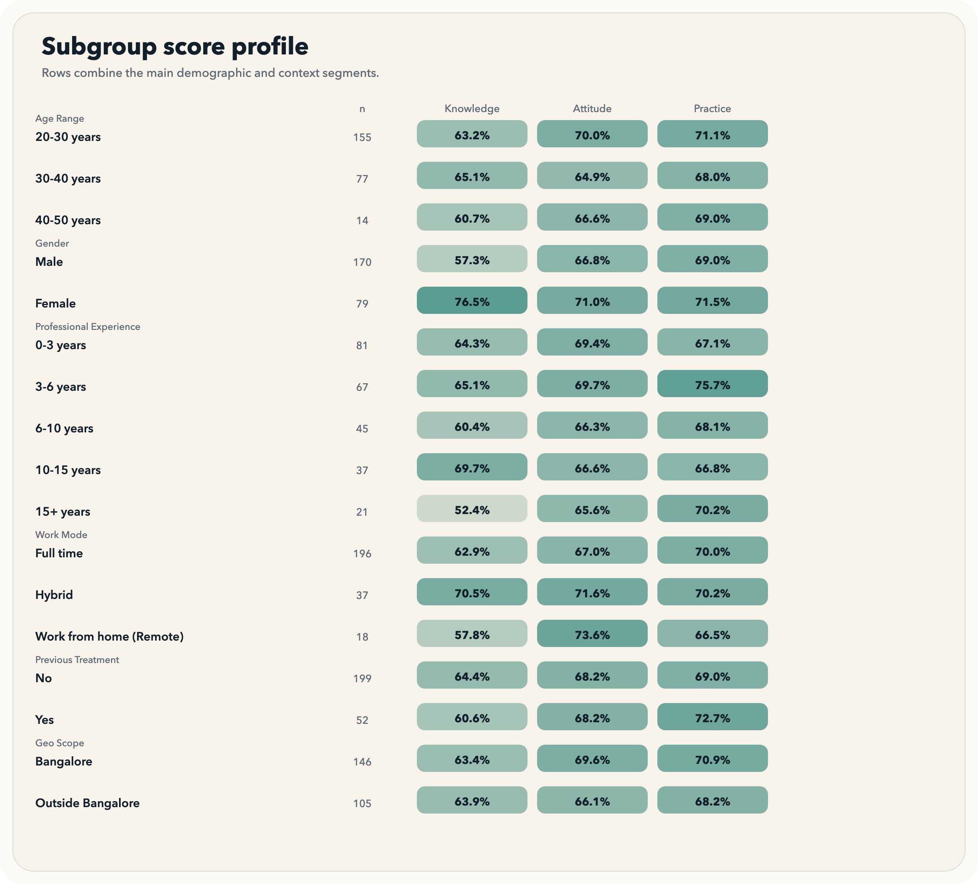

Bangalore versus outside Bangalore
Attitude is the clearest Bangalore-versus-outside difference at 3.5 points.
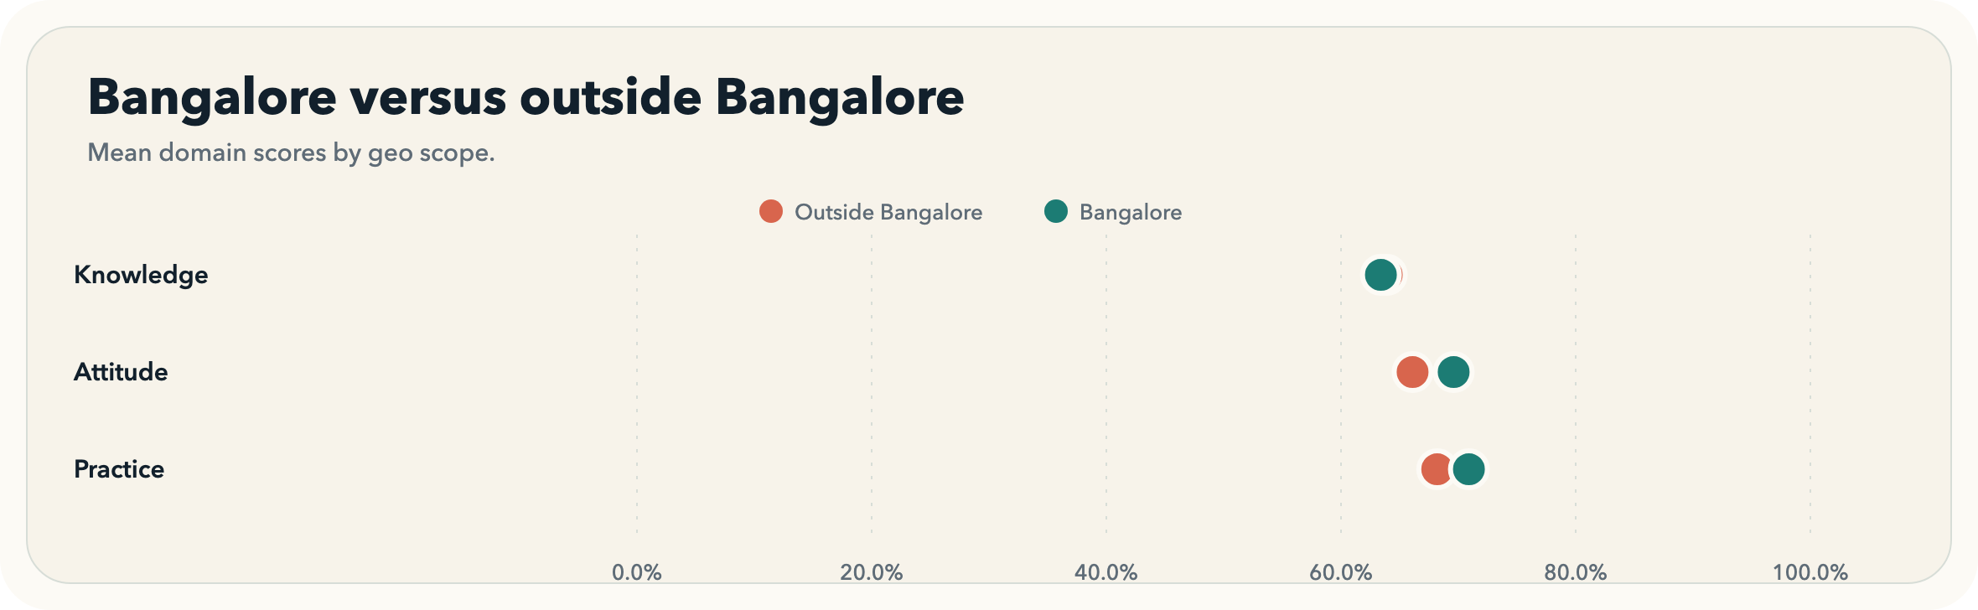

KAP relationship map
Knowledge vs Practice is the strongest pair with rho=0.381.
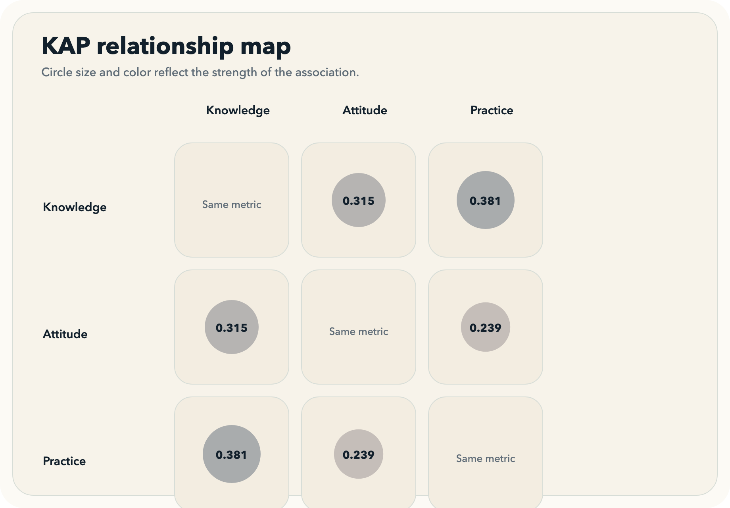

Insights
[Bangalore] Bangalore drives the dataset, but the city is not a single cluster.
The report should treat Bangalore as the main lens while still showing that responses come from several visible Bengaluru pockets.
- Bangalore contributes 146 of 251 responses (58.2%).
- JP Nagar is the largest named Bangalore locality with 12 responses.
- Bellandur, Whitefield, and HSR Layout each contribute meaningful local pockets of responses.
Why this matters: Presentation should not talk about Bangalore as if it were one homogeneous block; locality cuts are needed for a credible city-specific story.
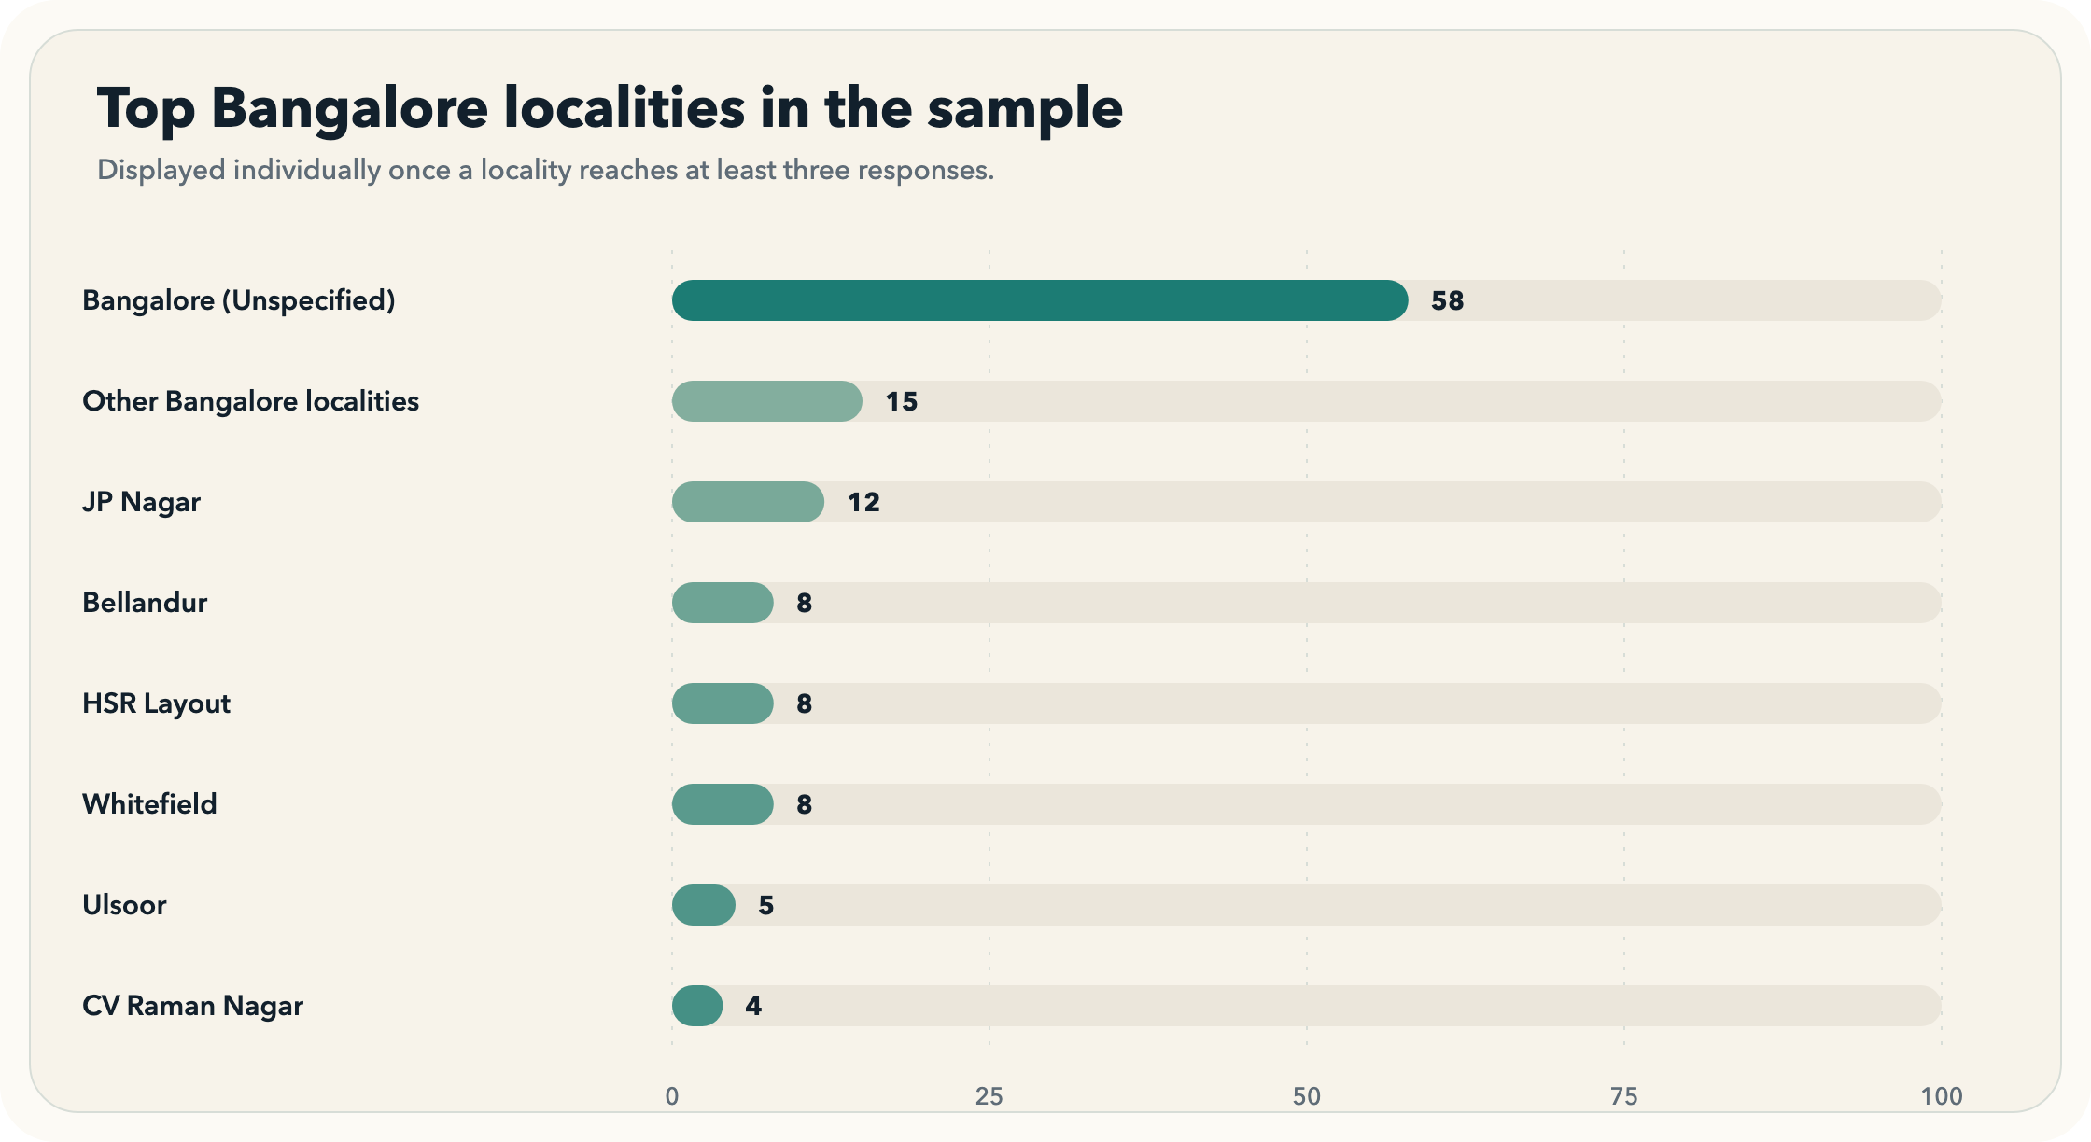
Bangalore accounts for 58.2% of the full sample, with JP Nagar leading the named localities.
[Bangalore] Named Bangalore localities differ more in behavior than in awareness.
Practice is strongest in a few named Bangalore pockets even when knowledge stays closer to the city average.
- Whitefield posts the highest reported practice score among claimable Bangalore localities at 80.0%.
- JP Nagar and HSR Layout also clear 75% on practice.
- The Bangalore-wide practice mean is 70.9%.
Why this matters: Locality messaging can highlight where good routines already exist and use those pockets as proof that stronger behavior is achievable inside the same city context.

Whitefield leads the claimable Bangalore localities on practice, not on knowledge alone.
[Bangalore] Ulsoor stands out as a small pocket where knowledge is not turning into routine practice.
The biggest knowledge-to-behavior mismatch inside Bangalore appears in a locality-sized pocket, not in the city average.
- Ulsoor records 92.0% on knowledge and 55.3% on practice.
- That creates a 36.7-point knowledge-practice gap.
- This comparison is based on 5 respondents, so it should be presented as a directional pocket rather than a citywide conclusion.
Why this matters: This is the clearest example that awareness alone does not guarantee daily action, which points toward behavior-focused interventions rather than awareness messaging alone.
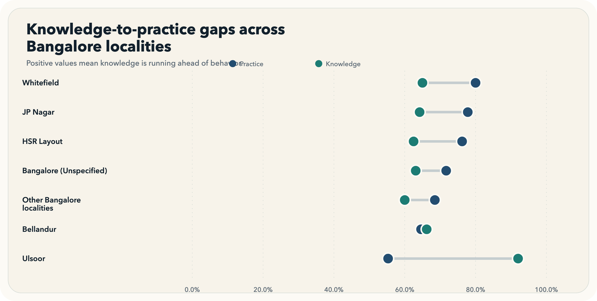
Ulsoor has the largest knowledge-practice gap among localities with at least five respondents.
[Overall] The weakest knowledge area is not advanced care; it is the basic cause of gum disease.
The biggest misconception sits at the foundation of periodontal understanding, which makes it especially important for public messaging.
- Only 37.5% answered the early gum disease cause question correctly.
- Plaque and tartar questions also stay near the halfway mark at 51.4% and 51.4%.
- The overall knowledge average is 63.6%.
Why this matters: If the basics are still unclear, communication should start with plain explanations of plaque, tartar, and disease causation before moving to treatment messaging.
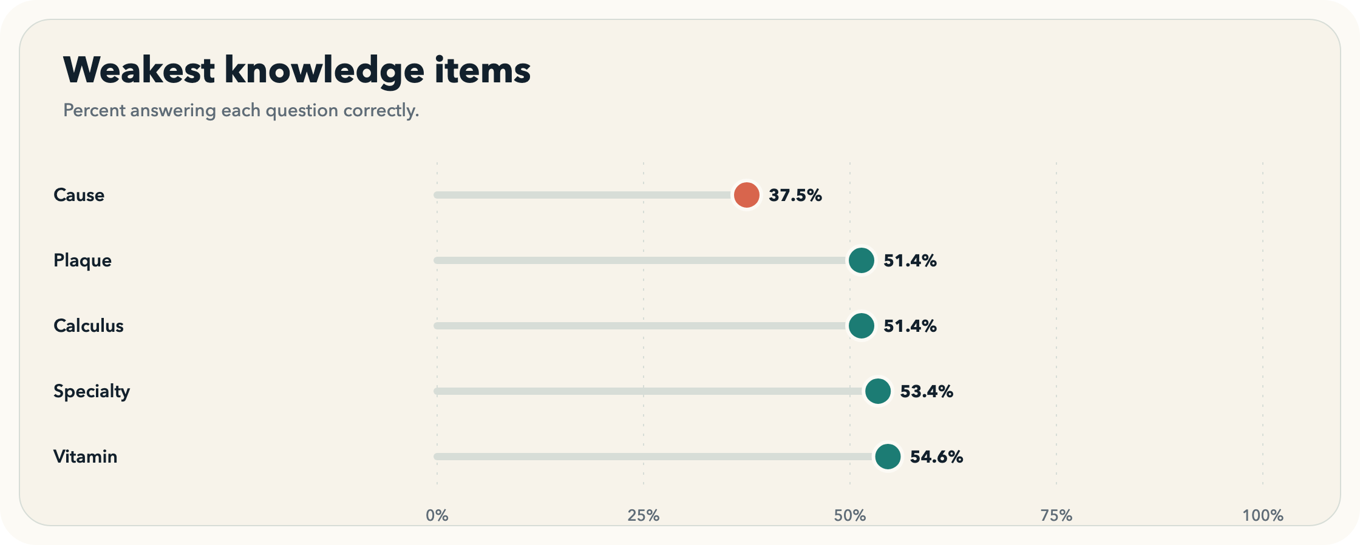
The disease-cause question is the lowest-scoring knowledge item at 37.5% correct.
[Overall] Daily routines weaken most on interdental cleaning and dentist follow-up.
The weakest behaviors are not brushing basics alone; they are the routines people skip once a toothbrush is no longer enough.
- Only 12.0% land in the best-practice band for cleaning aids.
- Dental visit recency reaches only 39.0% best-practice adherence.
- Half or more of respondents remain in the low-quality bands for brushing direction and dentist visits.
Why this matters: This points to a concrete behavior agenda: move beyond brushing frequency and focus on interdental cleaning and regular dental follow-up.
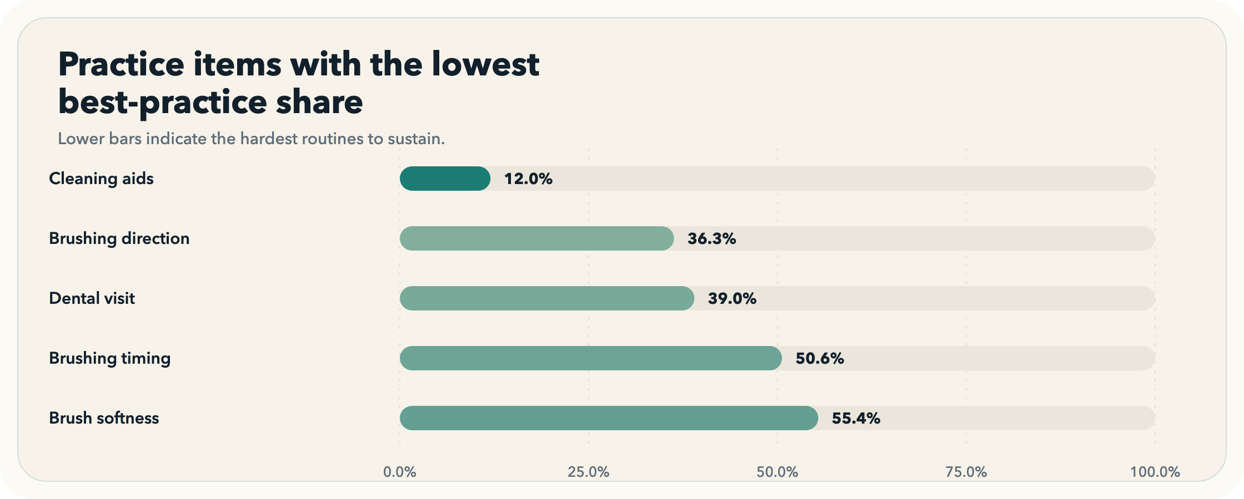
Cleaning aids is the weakest behavior area, with only 12.0% in the best-practice band.
[Outside Bangalore] Bangalore respondents are more attitude-positive, but knowledge and behavior look broadly similar to the outside-Bangalore sample.
The geography story is more about attitude tone than about a dramatic difference in knowledge or practice.
- Bangalore averages 69.6% on attitude versus 66.1% outside Bangalore.
- The attitude gap is 3.5 points with a small effect size of 0.190.
- Knowledge and practice differences are directionally smaller than the attitude split.
Why this matters: Outside-Bangalore respondents still belong in the story because the differences are not large enough to dismiss them as a separate population.
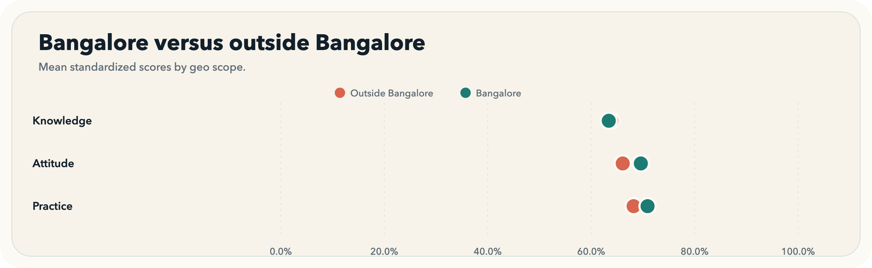
Attitude shows the clearest Bangalore-versus-outside contrast, while knowledge and practice stay closer together.
[Overall] Knowledge aligns most strongly with practice, more than with attitude alone.
Among the three composite domains, the cleanest statistical relationship is between knowing more and reporting better routines.
- Knowledge vs Practice has the strongest Spearman rho at 0.381.
- The 95% bootstrap interval runs from 0.264 to 0.491.
- Attitude also matters, but the practice link is weaker when attitude is paired with practice directly.
Why this matters: This connects awareness-building with behavior change, while still acknowledging that knowledge alone is not sufficient in every locality or segment.
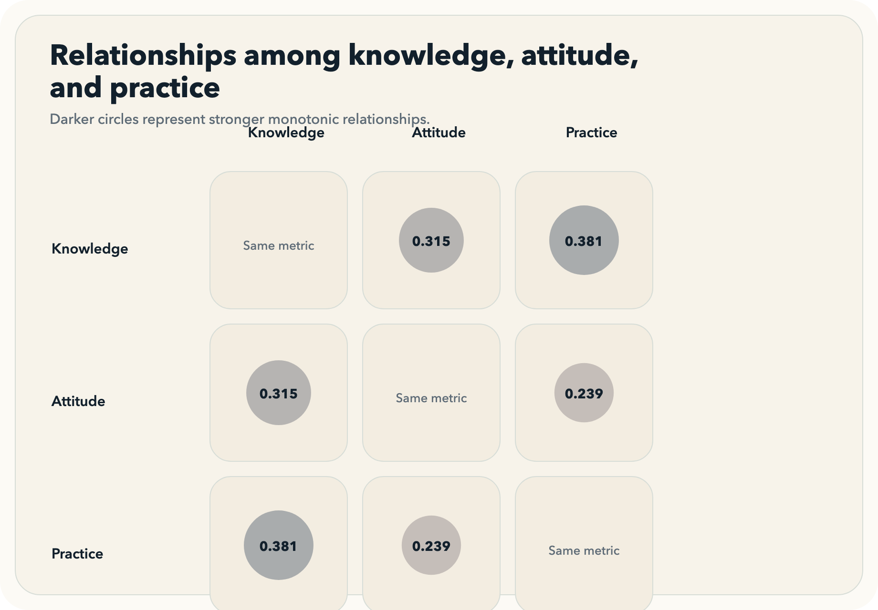
Knowledge shows its strongest alignment with practice at rho=0.381.
[Overall] The weakest reported practice is concentrated in a few work and career segments, not across the whole sample.
Behavior challenges are concentrated enough to support more targeted messaging instead of a single blanket intervention.
- Work from home (Remote) has the lowest practice score among segments with at least 10 respondents at 66.5%.
- 10-15 years follows close behind at 66.8%.
- 0-3 years rounds out the bottom three practice segments.
Why this matters: This makes the case for segment-aware outreach, especially when presenting recommendations to workplace or community stakeholders.
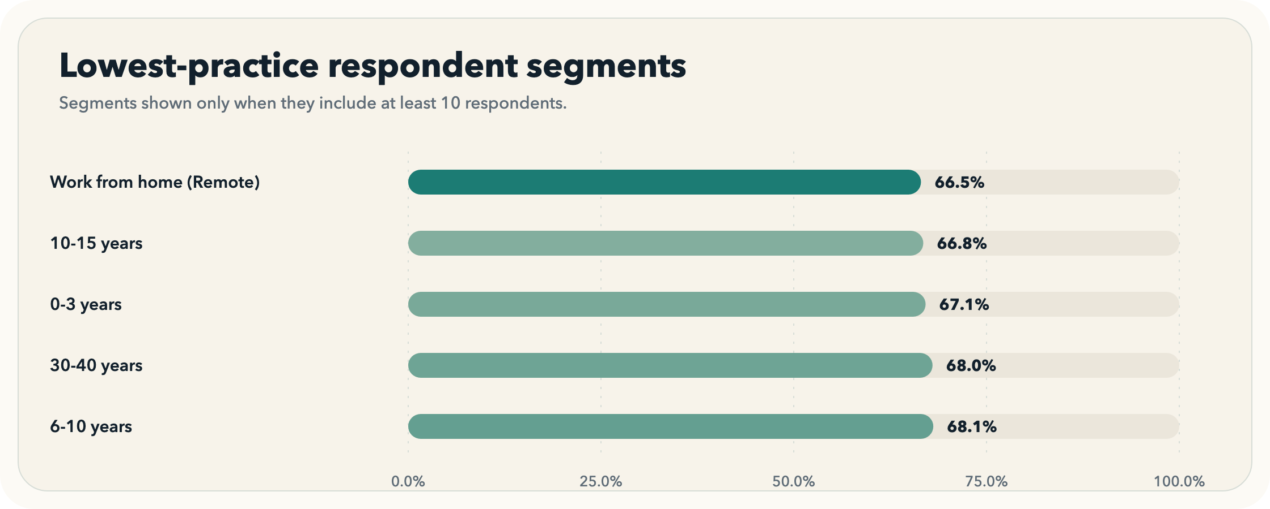
Work from home (Remote) is the lowest-practice segment in the dataset.

Method note and appendix
- Knowledge, attitude, and practice scores are recomputed directly from the raw item responses in the source CSV.
- Bangalore-specific locality analysis preserves named Bengaluru localities whenever a locality reaches at least three responses; smaller pockets roll into Other Bangalore localities.
- Locality-level claims are only elevated when a Bangalore locality reaches at least five responses.
- Subgroup comparisons use non-parametric tests, and the regression appendix is included only as a supporting validation layer.

Most notable subgroup tests
Knowledge | Gender | Kruskal-Wallis | p=0.0000 | epsilon-squared=0.155
Attitude | Work Mode | Kruskal-Wallis | p=0.0028 | epsilon-squared=0.039
Attitude | Geo Scope | Mann-Whitney U | p=0.0100 | Cliff's delta=0.19
Practice | Professional Experience | Kruskal-Wallis | p=0.0011 | epsilon-squared=0.058

Regression highlights
knowledge_model | Gender: Female vs Male | coef=21.080 | p=0.0000
knowledge_model | Gender: Prefer not to say vs Male | coef=38.270 | p=0.0020
knowledge_model | Age Range: 50-60 years vs 20-30 years | coef=28.626 | p=0.0028
knowledge_model | Gender: Other vs Male | coef=0.000 | p=0.0344
knowledge_model | Age Range: 40-50 years vs 20-30 years | coef=15.216 | p=0.0391
attitude_model | Knowledge Pct | coef=0.156 | p=0.0000
attitude_model | Work Mode: Work from home (Remote) vs Full time | coef=7.460 | p=0.0002
attitude_model | Gender: Other vs Male | coef=0.000 | p=0.0036
attitude_model | Geo Scope: Outside Bangalore vs Bangalore | coef=-3.970 | p=0.0039
attitude_model | Age Range: 30-40 years vs 20-30 years | coef=-7.227 | p=0.0071

