SIMATS ENGINEERING
ASSESSMENT TOOL 3 – Assignment 2

COURSE NAME: STATISTICS WITH R PROGRAMMING COURSE CODE: ITA04

COURSE OUTCOME COVERED

CO3: Construct and manipulate data frames using reshaping, merging, and file I/O operations in R to prepare structured datasets for analysis. (BL3, BL5)

Assessment Tool Weightage: 20%

QUESTIONS: 5 Total Marks: 100

Annexure

Assignment 2

Code of Conduct:

I BHAVYA BHUMIREDDY(192311324) (Name / Reg No) certify that this submission is my original work and that I have adhered to the guidelines specified for this assessment.
I understand that any violation of academic integrity rules will result in disciplinary action.

Signature of the student: BHAVYA.B

Assignment 2:
- Generate 5 Questions for your Capstone Project module
- Apply the formulae and use the relevant graph to visualize it
- Upload the file in Github link
- Save the 5 Questions and Gihub link in the Excell sheet

Question 1 – Accident Frequency Share per Blackspot Zone
Question
Aggregate the 20,000 accident records by blackspot zone and calculate the percentage share of each zone. Which zone carries the largest share of accidents, and visualise the result with a donut chart.
Formula
Share (%) = (Accidents in zone ÷ Total accidents) × 100, e.g. Kathipara = 7,235 ÷ 20,000 × 100 = 36.18 %
R Code
zones <- data.frame(
zone = c("Kathipara","Koyambedu","OMR IT Exp.","Tambaram","Poonamallee","Marina"),
count = c(7235,3140,3458,3026,1756,1385))
q1 <- zones %>% mutate(share = round(count / sum(count) * 100, 2))
ggplot(q1, aes(x = 2, y = count, fill = zone)) + geom_col(width = 1, colour = "white") +
coord_polar(theta = "y") + xlim(0.5, 2.5) + theme_void()

Output
Zone | Accidents | Share (%)
Kathipara Grade Separator Hub | 7,235 | 36.18
Koyambedu CMBT Junction | 3,140 | 15.70
OMR IT Expressway Corridor | 3,458 | 17.29
Tambaram GST Highway Junction | 3,026 | 15.13
Poonamallee Bypass Intersect | 1,756 | 8.78
Central Railway – Marina Stretch | 1,385 | 6.93
Total | 20,000 | 100.00

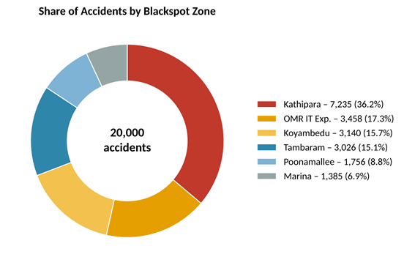
Figure 1: Donut chart – share of accidents by zone

Interpretation
Kathipara alone accounts for 36.18 % of all recorded accidents – more than twice the share of any other zone – so it is the primary hotspot. The remaining five zones each hold between 6.93 % and 17.29 %.

Question 2 – Cumulative Concentration of Accidents (Pareto Analysis)
Question
Sort the zones by accident count in descending order and compute the cumulative percentage. How many zones are needed to cover at least 80 % of all accidents? Present the result as a Pareto chart.
Formula
Cumulative % (k) = (Σ of the k largest zone counts ÷ Total accidents) × 100
R Code
q2 <- zones %>% arrange(desc(count)) %>%
mutate(cum_pct = round(cumsum(count) / sum(count) * 100, 2))
q2$zone<-factor(q2$zone, levels = q2$zone)
ggplot(q2, aes(zone, count)) + geom_col(fill = "#2E86AB") +
geom_line(aes(y = cum_pct / 100 * max(count), group = 1), colour = "#C0392B") +
scale_y_continuous(sec.axis = sec_axis(~ . / max(q2$count) * 100, name = "Cumulative %"))

Output
Rank | Zone | Accidents | Cumulative (%)
1 | Kathipara | 7235 | 36.18
2 | OMR IT Exp. | 3,458 | 53.46
3 | Koyambedu | 3,140 | 69.16
4 | Tambaram | 3,026 | 84.30
5 | Poonamallee | 1,756 | 93.08
6 | Marina | 1,385 | 100.00

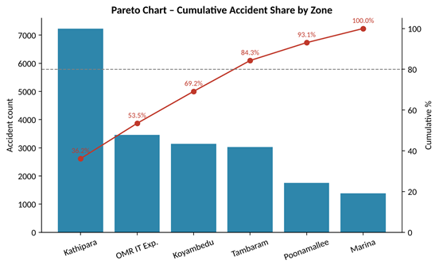
Figure 2: Pareto chart – accident counts with cumulative percentage
Interpretation
The top four zones (Kathipara, OMR, Koyambedu, Tambaram) cover 84.30 % of accidents, crossing the 80 % mark; the top three reach 69.16 %. Road-safety measures concentrated on four of the six corridors would therefore address most of the accident volume.

Question 3 – Decomposing the Composite Zone Risk Score
Question
Merge the zone score table with a volume index, then split each zone's Composite Risk Score into the part explained by volume and the part explained by severity factors (High-Risk % and Casualty Rate). Reshape the result from wide to long format and plot it as a stacked bar chart.
Formula
Composite Score = 0.40·V + 0.35·H + 0.25·C
Volume index V = (zone count ÷ highest zone count) × 100
Volume part = 0.40 × V; Severity part = Score − Volume part
Note: the volume index above is assumed to be scaled against the busiest zone (Kathipara = 100). Check this against the scaling used in 04_clustering.R; if your script scales volume differently, only the split of the bars changes, not the total scores.
R Code
vol <- zones %>% transmute(zone, vol_index = count / max(count) * 100)
q3 <- merge(zones, vol, by = "zone") %>%
mutate(volume_part = 0.40 * vol_index, severity_part = score - volume_part)
q3_long <- q3 %>% pivot_longer(c(volume_part, severity_part),
names_to = "component", values_to = "points")
ggplot(q3_long, aes(reorder(zone, score), points, fill = component)) +
geom_col() + coord_flip()

Output
Zone | Volume idx | Volume part | Severity part | Score | Class
Kathipara | 100.0 | 40.00 | 33.60 | 73.6 | High
Koyambedu | 43.4 | 17.36 | 31.94 | 49.3 | Medium
OMR IT Exp. | 47.8 | 19.12 | 29.28 | 48.4 | Medium
Tambaram | 41.8 | 16.73 | 31.07 | 47.8 | Medium
Poonamallee | 24.3 | 9.71 | 27.89 | 37.6 | Low
Marina | 19.1 | 7.66 | 29.74 | 37.4 | Low

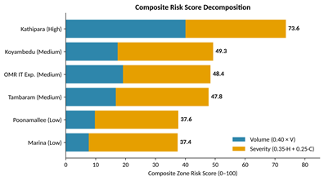
Figure 3: Stacked bar – volume vs severity contribution to the risk score
Interpretation
Kathipara is classed High Risk because it scores highest on both parts: it has the maximum volume contribution (40 points) and also the highest severity contribution (33.6 points). The other zones have similar severity parts (about 28–32 points), so their ranking is driven mainly by accident volume.

Question 4 – Relationship Between Accident Volume and Risk Score
Question
Calculate the Pearson correlation coefficient between accident count and Composite Risk Score across the six zones, fit a linear trend, and visualise the relationship with a scatter plot coloured by risk class.
Formula
r = Σ(xᵢ − x̄)(yᵢ − ȳ) ÷ √[Σ(xᵢ − x̄)² · Σ(yᵢ − ȳ)²], R² = r²
Trend line: Score = a + b × Count
R Code
r <- cor(zones$count,zones$score)
fit <- lm(score ~ count, data = zones)
ggplot(zones, aes(count, score, colour = class)) + geom_point(size = 4) +
geom_smooth(aes(group = 1), method = "lm", se = FALSE, linetype = "dashed")

Output
Statistic | Value
Pearson r | 0.9958
R² | 0.9916
Slope (b) | 0.00632 points per accident
Intercept (a) | 27.96

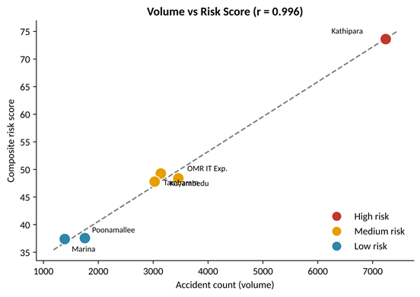
Figure 4: Scatter plot of accident count vs risk score with linear trend
Interpretation
The correlation of 0.996 is very strong and positive: about 99 % of the variation in the zone score is explained by accident volume. Each additional 1,000 accidents adds roughly 6.3 points to the score. With only six zones this is a descriptive result and should not be read as a general law.

Question 5 – Comparing the ML Models Used for Risk-Level Detection
Question
Module 3 applies Logistic Regression, Decision Tree and Random Forest to classify risk as Low, Medium or High. Store the 5-fold cross-validation metrics in a data frame, write them to a CSV file, read them back, reshape them to long format, and compare the models with a grouped bar chart. By how many percentage points does the best model beat the others in accuracy?
Formula
Accuracy = (Correct predictions ÷ Total predictions) × 100
F1 = 2 × Precision × Recall ÷ (Precision + Recall); Macro F1 = mean of the F1 scores of Low, Medium and High
Accuracy gain = Accuracy(RF) − Accuracy(other model)
R Code
models <- data.frame(model = c("Random Forest","Decision Tree","Logistic Reg."),
Accuracy = c(70.87,69.94,69.92), ROC_AUC = c(84.09,80.86,83.13),
Macro_F1 = c(69.57,68.02,68.11))
write.csv(models, "outputs/model_comparison.csv", row.names = FALSE)
m <- read.csv("outputs/model_comparison.csv")
m_long <- m %>% pivot_longer(-model, names_to = "metric", values_to = "value")
ggplot(m_long, aes(model, value, fill = metric)) + geom_col(position = "dodge")

Output
Model | Accuracy (%) | ROC-AUC (%) | Macro F1 (%)
Random Forest | 70.87 | 84.09 | 69.57
Decision Tree | 69.94 | 80.86 | 68.02
Logistic Regression | 69.92 | 83.13 | 68.11

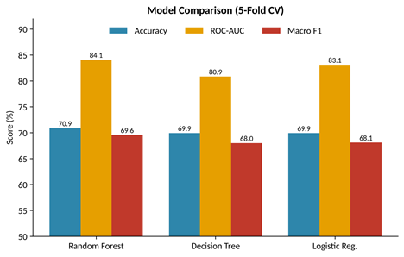
Figure 5: Grouped bar chart – accuracy, ROC-AUC and macro F1 by model
Interpretation
Random Forest leads on all three metrics. Its accuracy is 0.93 points above the Decision Tree and 0.95 points above Logistic Regression (70.87 − 69.94 and 70.87 − 69.92). The gap is small in accuracy but larger in ROC-AUC (about 3.2 points over the Decision Tree), so Random Forest was chosen as the champion model for the risk-prediction engine.

