EXPERIMENT 1: Introduction to R Programming

Aim
To become familiar with the R environment and execute basic R commands such as displaying a message, checking the R version, finding the working directory, and opening help for a function.

Algorithm
- Start the RStudio application.
- Display a welcome message using print().
- Display the installed R version using R.version.string.
- Display the current working directory using getwd().
- Open the help page for the mean() function using help() or ?.

Program
print("Welcome to R Programming")
R.version.string
getwd()
help(mean)
?mean

Output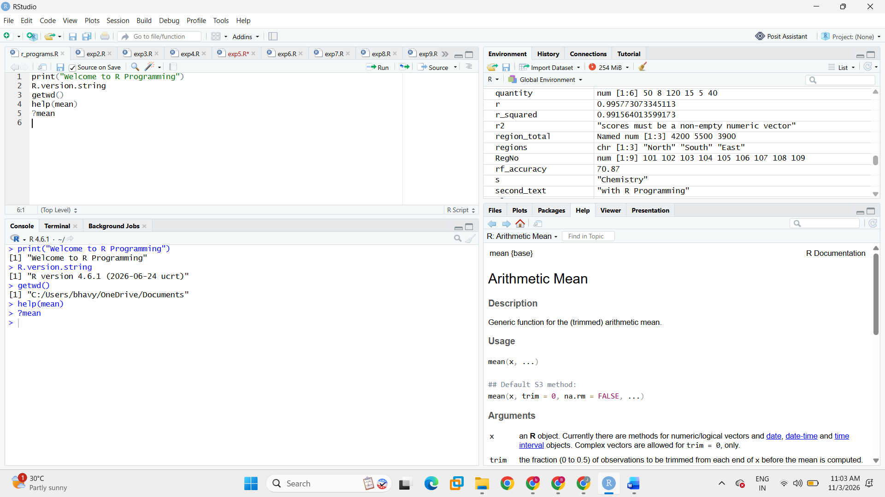

Result
Basic R commands were executed successfully and the R environment information and function help were displayed.

EXPERIMENT 2: Arithmetic Operations

Aim
To perform basic arithmetic operations such as addition, subtraction, multiplication, ordinary division, integer division, and modulus in R.

Algorithm
- Assign values to two variables a and b.
- Use arithmetic operators to perform the required calculations.
- Display each result using cat().

Program
a <- 20
b <- 6

cat("First number:", a, "\n")
cat("Second number:", b, "\n")
cat("Addition:", a + b, "\n")
cat("Subtraction:", a - b, "\n")
cat("Multiplication:", a * b, "\n")
cat("Ordinary division:", a / b, "\n")
cat("Integer division:", a %/% b, "\n")
cat("Modulus (remainder):", a %% b, "\n")

Output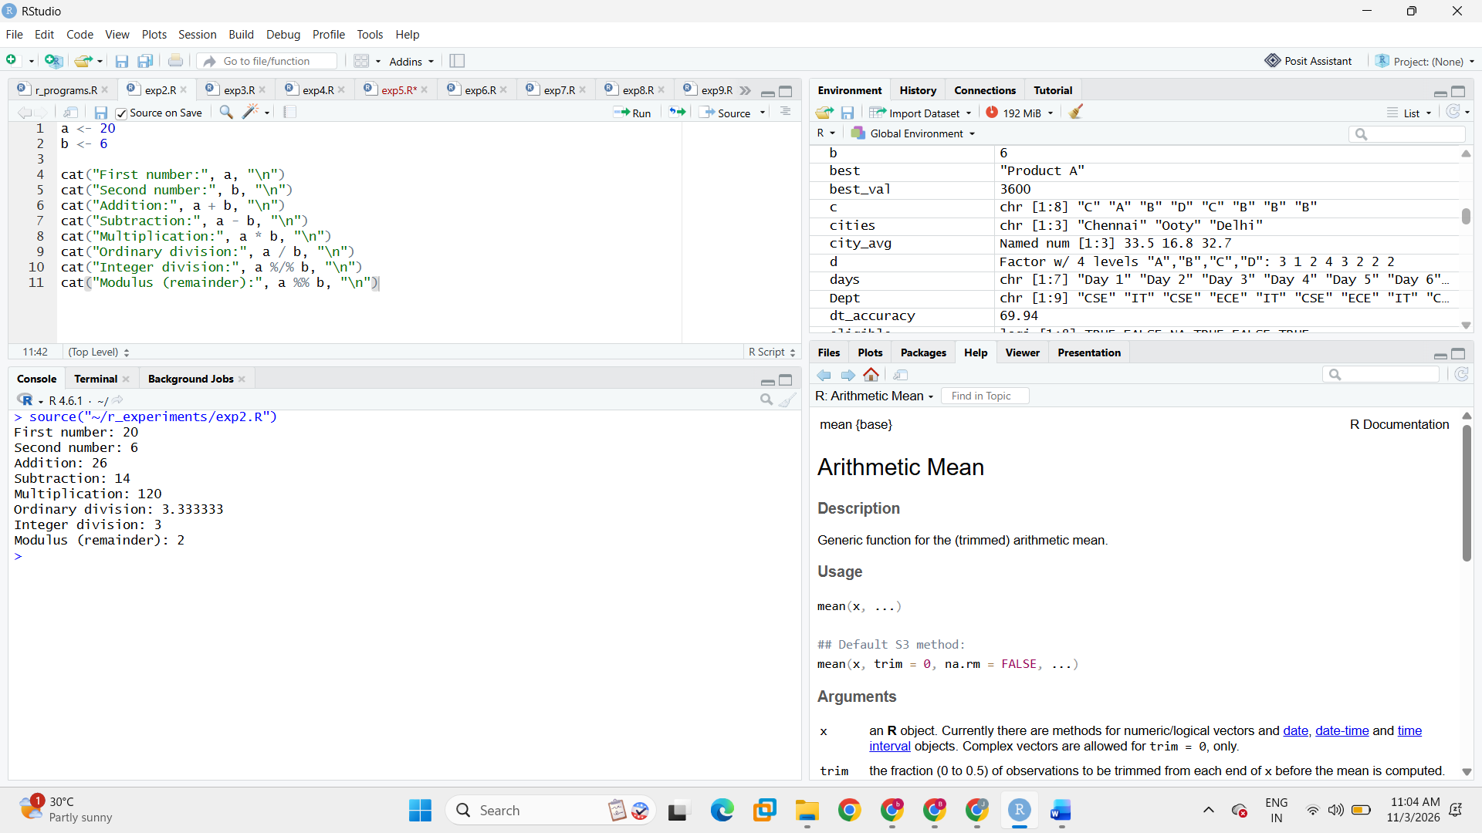

Result
All basic arithmetic operations were performed successfully using R operators.

EXPERIMENT 3: Assignment Operators

Aim
To assign values to variables using the leftward assignment operator (<-), equals operator (=), and rightward assignment operator (->) in R.

Algorithm
- Create variables using the three assignment operators.
- Display the value stored in each variable using cat().

Program
x <- 10
y = 20
30 -> z

cat("Value assigned using <- :", x, "\n")
cat("Value assigned using = :", y, "\n")
cat("Value assigned using -> :", z, "\n")

Output
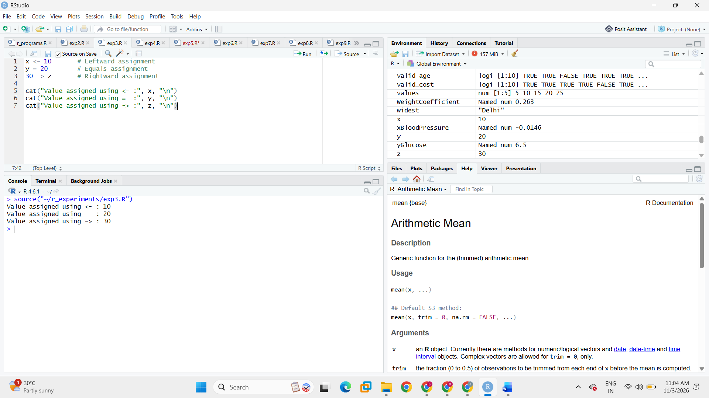

Result
Values were assigned and displayed successfully using all three assignment operators.

EXPERIMENT 4: Data Types in R

Aim
To create variables of different data types in R and examine their values, classes, and storage types.

Algorithm
- Create numeric, integer, character, logical, and complex variables.
- Display each variable's value.
- Use class() and typeof() to identify its class and storage type.

Program
num_var <- 25.5
int_var <- 25L
char_var <- "R Programming"
logical_var <- TRUE
complex_var <- 3 + 4i

show_details <- function(name, value) {
cat("Variable:", name, "\n")
cat("Value:", value, "\n")
cat("Class:", class(value), "\n")
cat("Storage type:", typeof(value), "\n\n")
}
show_details("Numeric", num_var)
show_details("Integer", int_var)
show_details("Character", char_var)
show_details("Logical", logical_var)
show_details("Complex", complex_var)

Output
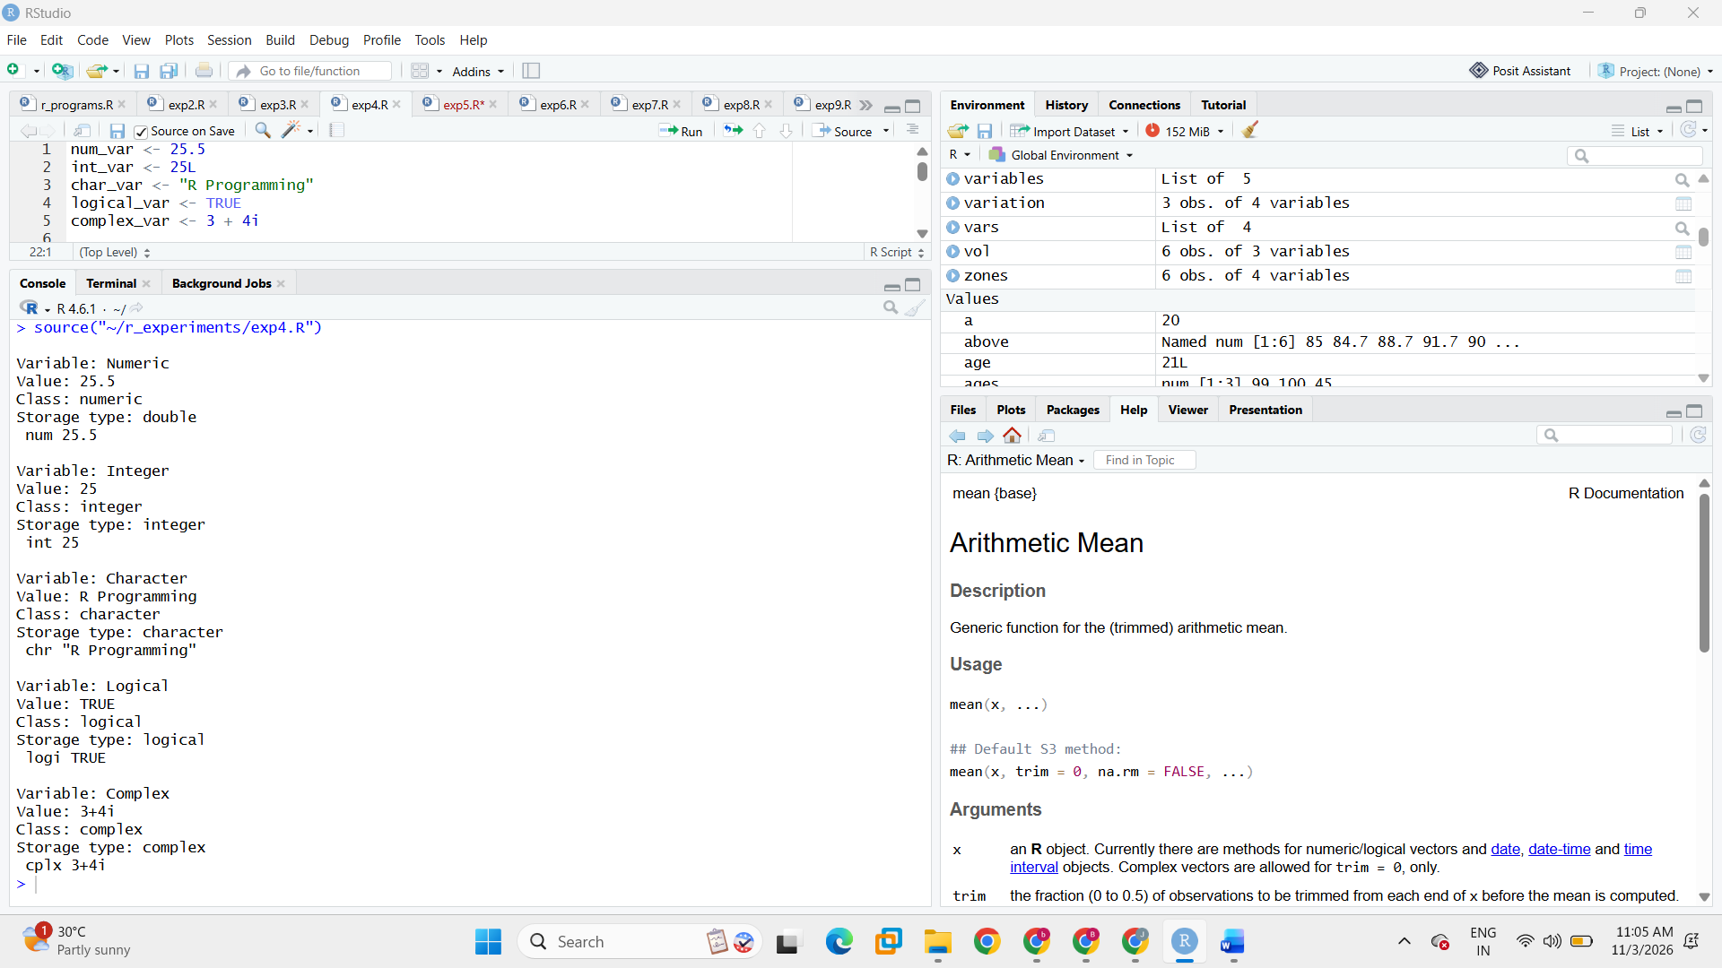

Result
Different R data types were created and their classes and storage types were identified.
EXPERIMENT 5: Type Conversion in R

Aim
To convert values from one data type to another using R conversion functions and identify invalid conversions.

Algorithm
- Create a character vector containing numeric strings and one invalid string.
- Convert the character vector to numeric using as.numeric().
- Identify missing values using is.na() and which().
- Demonstrate other conversion functions.

Program
text_values <- c("10", "25.5", "40", "hello", "100")
numeric_values <- as.numeric(text_values)
cat("Original character vector:\n")
print(text_values)
cat("After numeric conversion:\n")
print(numeric_values)
cat("Missing-value positions:\n")
print(which(is.na(numeric_values)))
number <- 1
number_as_character <- as.character(number)
number_as_logical <- as.logical(number)
logical_as_numeric <- as.numeric(c(TRUE, FALSE))
cat("Numeric to character:", number_as_character, "\n")
cat("Numeric to logical:", number_as_logical, "\n")
cat("Logical to numeric:", logical_as_numeric, "\n")

Output
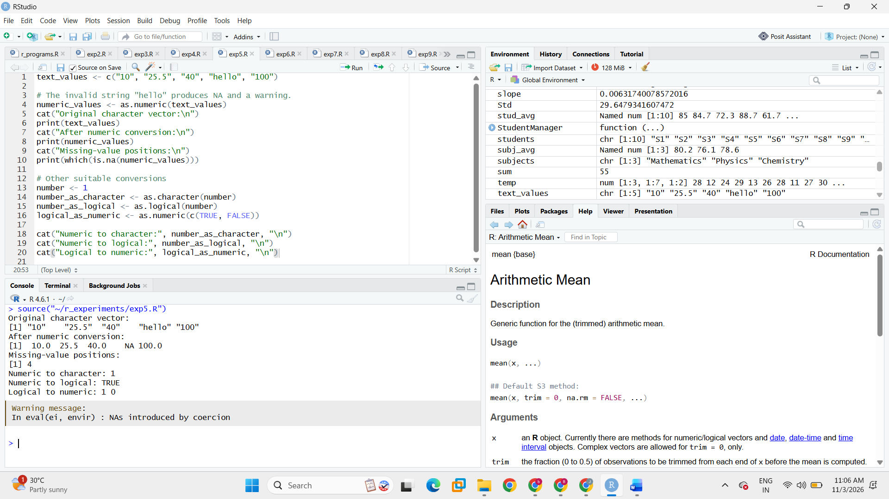

Result
Type conversion was demonstrated successfully. The invalid string was converted to NA and its position was identified.
EXPERIMENT 6: Relational and Logical Operators

Aim
To use relational and logical operators in R to compare values and combine or reverse logical conditions.

Algorithm
- Create a numeric vector.
- Apply greater than, less than, equal to, and not-equal-to operators.
- Use AND (&), OR (|), and NOT (!) operators.
- Display the logical results.

Program
values <- c(5, 10, 15, 20, 25)
cat("Values:\n")
print(values)
cat("Greater than 10:\n")
print(values > 10)
cat("Less than 20:\n")
print(values < 20)
cat("Equal to 15:\n")
print(values == 15)
cat("Not equal to 10:\n")
print(values != 10)
cat("Between 10 and 20 (inclusive):\n")
print(values >= 10 & values <= 20)
cat("Less than 10 OR greater than 20:\n")
print(values < 10 | values > 20)
cat("NOT greater than 15:\n")
print(!(values > 15))

Output
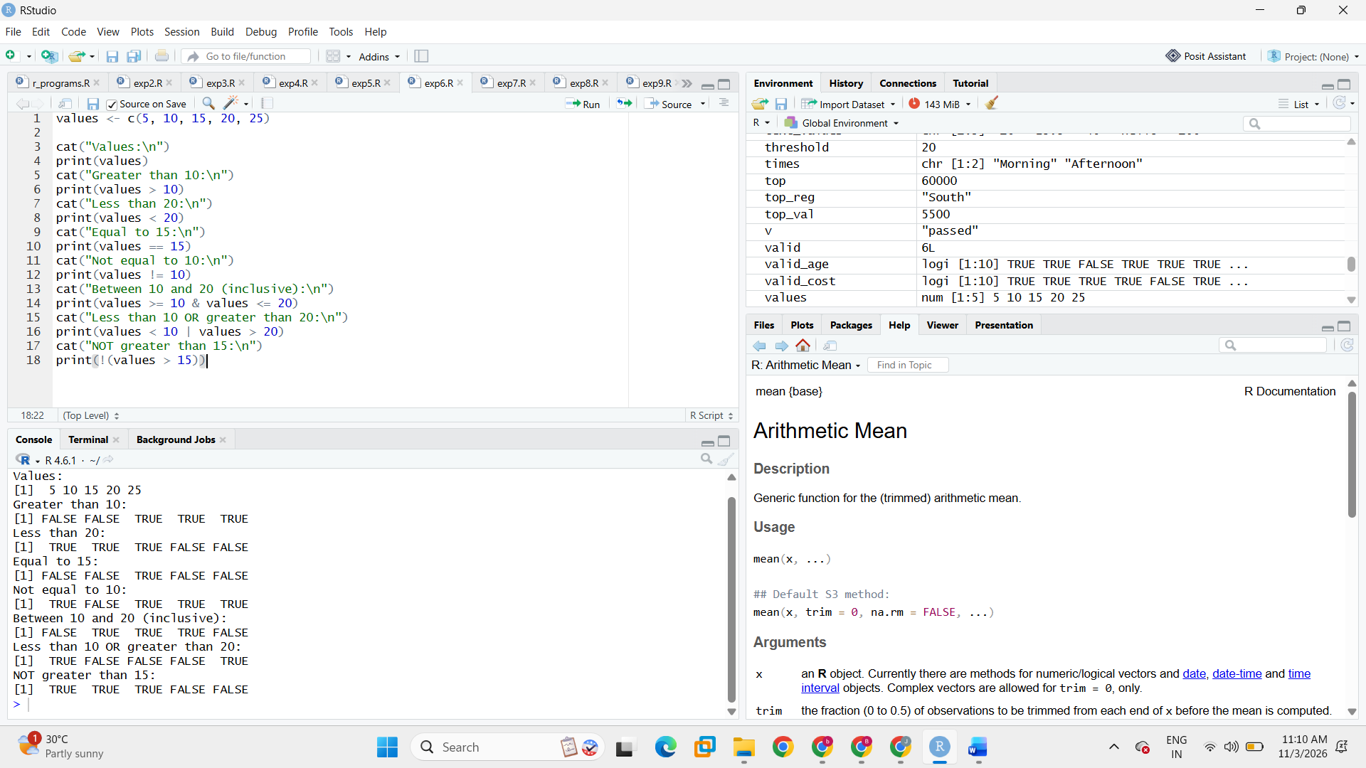

Result
Relational and logical operators were applied successfully to obtain the required logical conditions.

EXPERIMENT 7: Mathematical Functions

Aim
To perform mathematical calculations in R using functions such as abs(), sqrt(), round(), ceiling(), floor(), log(), and exp().

Algorithm
- Create a numeric vector.
- Apply the absolute value, square root, rounding, ceiling, floor, logarithm, and exponential functions.
- Print the results.

Program
x <- c(4, 9, 16, 2.7)
cat("Original values:\n")
print(x)
cat("Absolute value of -15:", abs(-15), "\n")
cat("Square root:\n")
print(sqrt(x))
cat("Rounded values:\n")
print(round(x))
cat("Ceiling values:\n")
print(ceiling(x))
cat("Floor values:\n")
print(floor(x))
cat("Natural logarithm of values:\n")
print(log(x))
cat("Exponential of values:\n")
print(exp(x))

Output
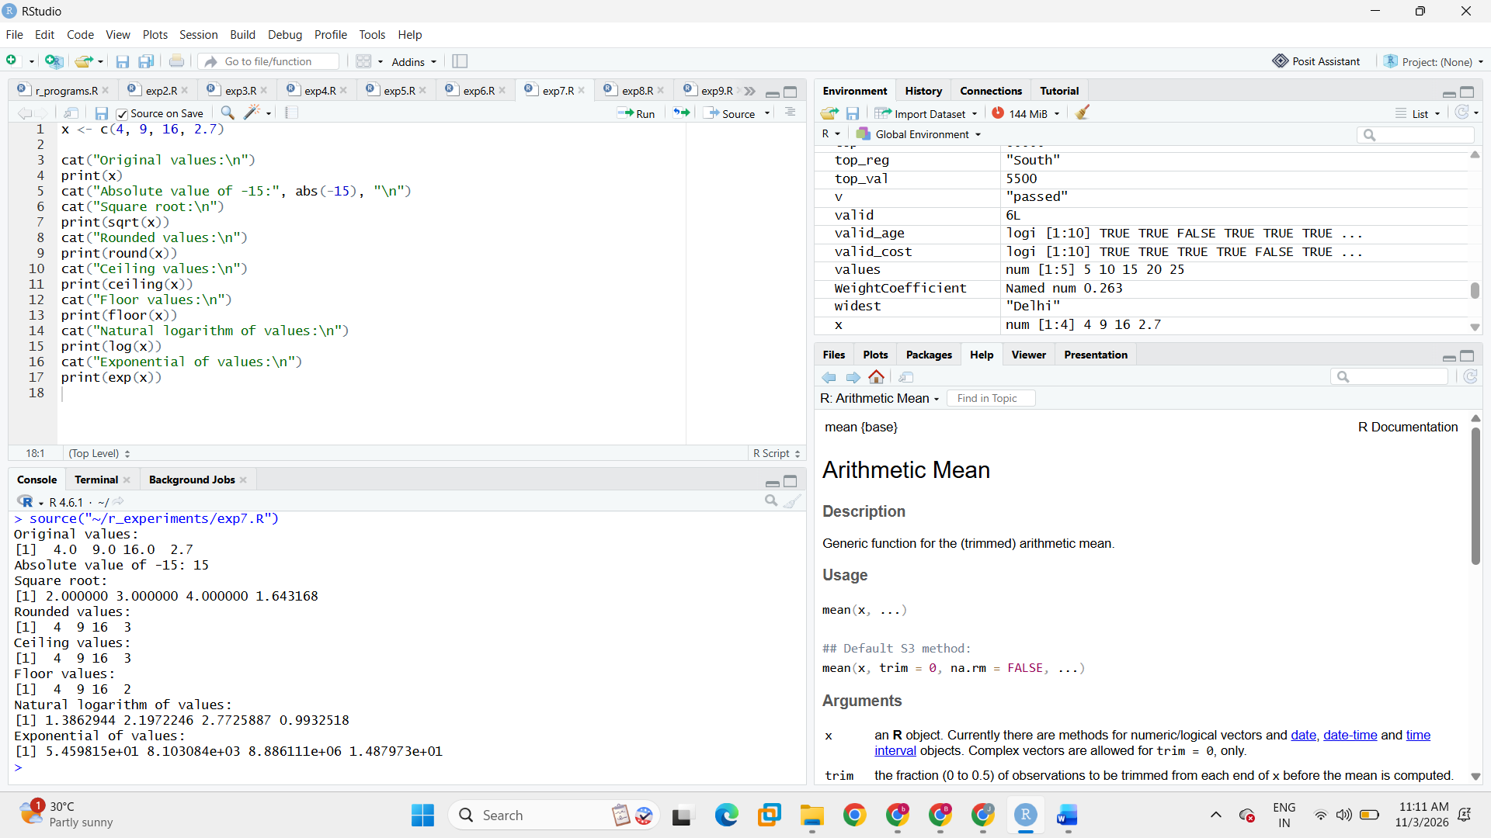

Result
Mathematical functions were executed successfully on the given numeric values.
EXPERIMENT 8: Vector Indexing

Aim
To access elements of a vector in R using positive indexing, negative indexing, and logical indexing.

Algorithm
- Create a numeric vector.
- Select specific positions using positive indexing.
- Exclude positions using negative indexing.
- Select values satisfying a logical condition.

Program
numbers <- c(10, 20, 30, 40, 50, 60)
cat("Original vector:\n")
print(numbers)
cat("Positive indexing (positions 1, 3, 5):\n")
print(numbers[c(1, 3, 5)])
cat("Negative indexing (exclude positions 2 and 4):\n")
print(numbers[-c(2, 4)])
cat("Logical indexing (values greater than 30):\n")
print(numbers[numbers > 30])

Output

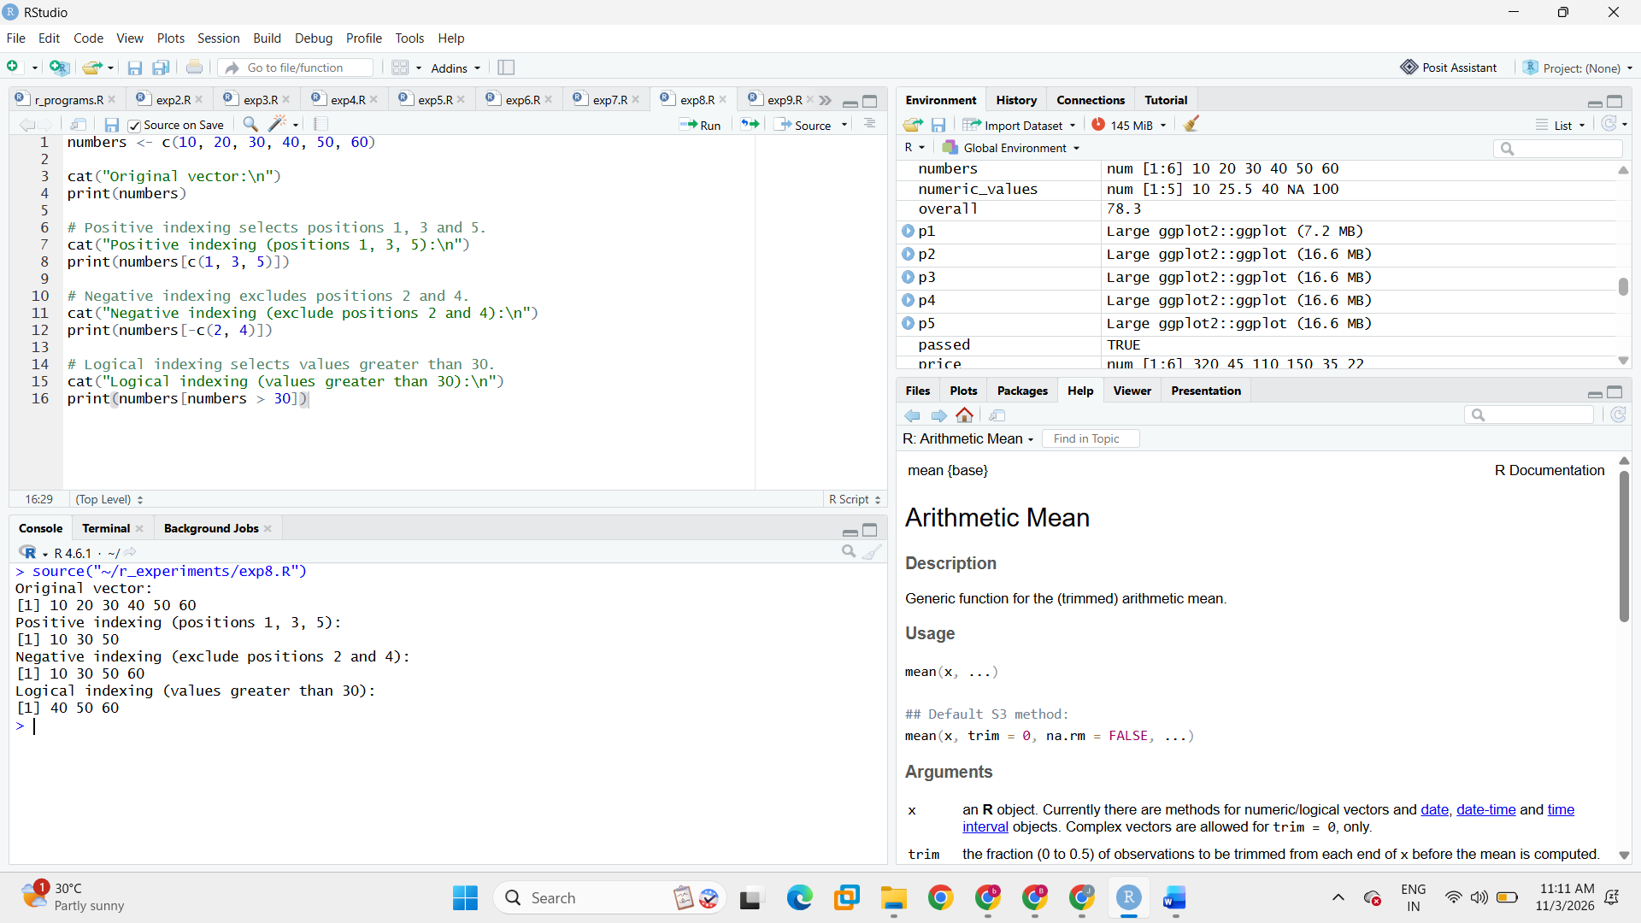

Result
Vector elements were selected and excluded successfully using the three indexing methods.

EXPERIMENT 9: Sequence and Repetition Functions

Aim
To generate sequences and repeat values or vectors using the seq() and rep() functions in R.

Algorithm
- Generate a sequence from 2 to 20 with an increment of 3 using seq().
- Repeat the value 5 four times.
- Repeat a vector two times.
- Repeat each element of a vector two times.

Program
sequence_values <- seq(from = 2, to = 20, by = 3)
repeat_each <- rep(5, times = 4)
repeat_vector <- rep(c(1, 2, 3), times = 2)
repeat_each_value <- rep(c(1, 2, 3), each = 2)

cat("Sequence generated using seq():\n")
print(sequence_values)
cat("Repeat value 5 four times:\n")
print(repeat_each)
cat("Repeat vector two times:\n")
print(repeat_vector)
cat("Repeat each element two times:\n")
print(repeat_each_value)

Output
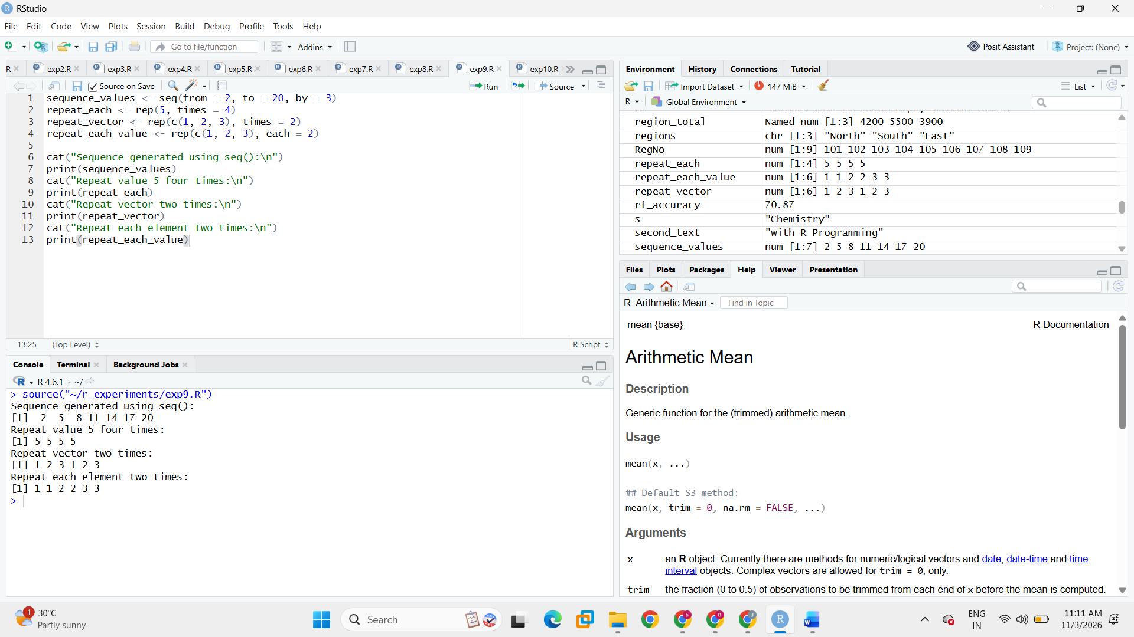

Result
Sequences and repeated values were generated successfully using seq() and rep().

EXPERIMENT 10: Vector Arithmetic and Recycling

Aim
To perform arithmetic and comparison operations on vectors and understand R's recycling rule when vectors have different lengths.

Algorithm
- Create two numeric vectors.
- Perform addition, subtraction, multiplication, division, and comparison.
- Add vectors of compatible and incompatible lengths to observe recycling.

Program
v1 <- c(10, 20, 30, 40)
v2 <- c(2, 4, 5, 8)

cat("Vector 1:\n")
print(v1)
cat("Vector 2:\n")
print(v2)
cat("Addition:\n")
print(v1 + v2)
cat("Subtraction:\n")
print(v1 - v2)
cat("Multiplication:\n")
print(v1 * v2)
cat("Division:\n")
print(v1 / v2)
cat("Comparison (v1 > v2):\n")
print(v1 > v2)

cat("Recycling with compatible lengths (4 and 2):\n")
print(c(10, 20, 30, 40) + c(1, 2))
cat("Recycling with incompatible lengths (5 and 2):\n")
print(c(10, 20, 30, 40, 50) + c(1, 2))

Output
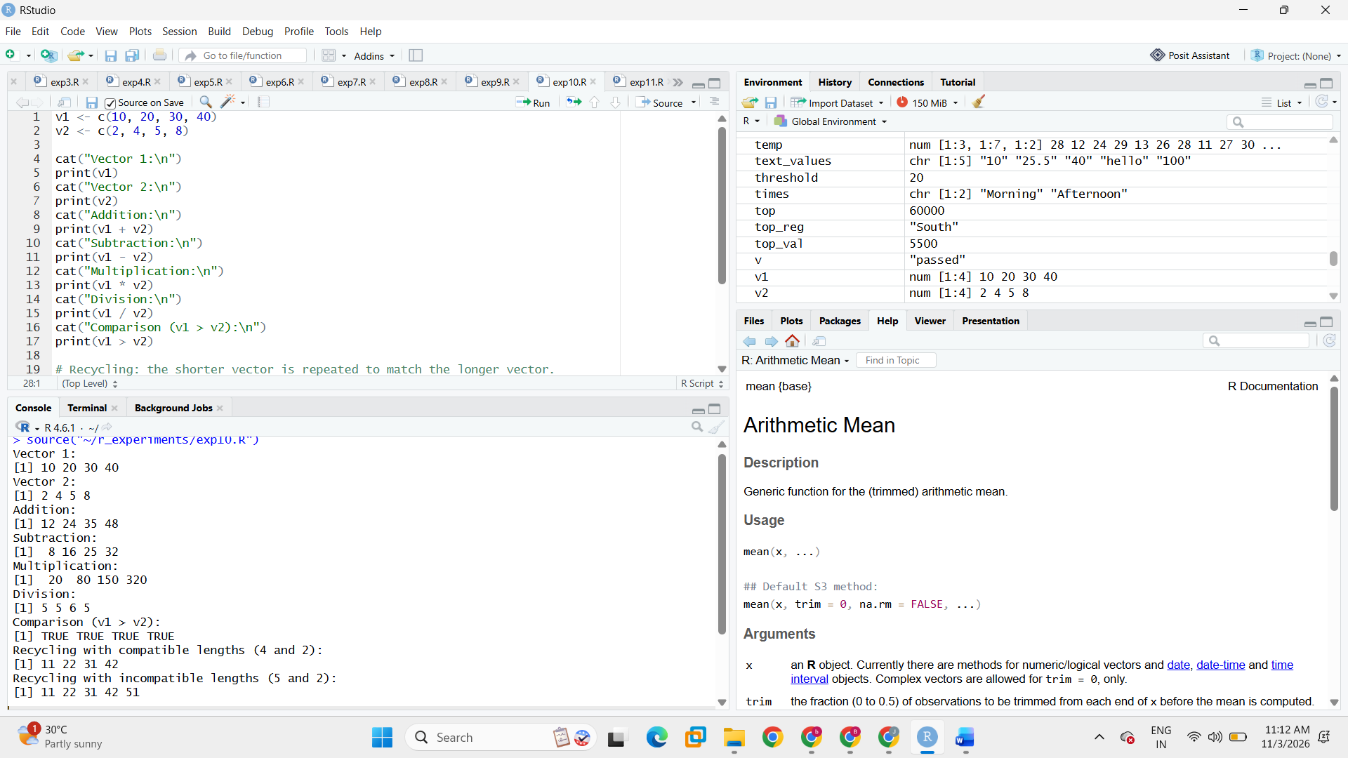

Result
Vector arithmetic and recycling were demonstrated successfully.

EXPERIMENT 11: Statistical Functions

Aim
To calculate basic statistical measures such as sum, mean, median, length, minimum, maximum, and range using R.

Algorithm
- Create a vector containing marks.
- Apply sum(), mean(), median(), and length().
- Find the minimum, maximum, and range.
- Display all calculated values.

Program
marks <- c(70, 80, 90, 80, 60, 100, 80)

cat("Marks:\n")
print(marks)
cat("Sum:", sum(marks), "\n")
cat("Mean:", mean(marks), "\n")
cat("Median:", median(marks), "\n")
cat("Length:", length(marks), "\n")
cat("Minimum:", min(marks), "\n")
cat("Maximum:", max(marks), "\n")
cat("Range:\n")
print(range(marks))

Output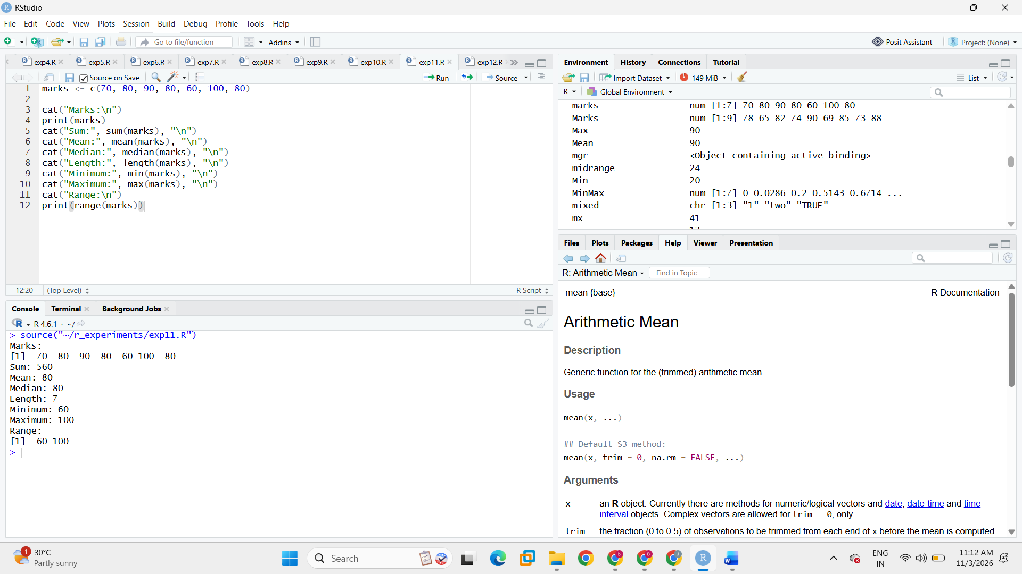

Result
Basic statistical measures were calculated successfully for the marks vector.

EXPERIMENT 12: Sorting, Unique Values and Frequency Table

Aim
To sort vector elements, identify unique values, detect duplicated elements, and generate a frequency table in R.

Algorithm
- Create a numeric vector containing repeated values.
- Sort the vector using sort().
- Extract unique values using unique().
- Identify repeated positions using duplicated().
- Generate a frequency table using table().

Program
data_values <- c(5, 2, 8, 5, 3, 2, 9, 5, 3)

cat("Original vector:\n")
print(data_values)
cat("Sorted values:\n")
print(sort(data_values))
cat("Unique values:\n")
print(unique(data_values))
cat("Duplicated positions (TRUE means already appeared):\n")
print(duplicated(data_values))
cat("Frequency table:\n")
print(table(data_values))

Output
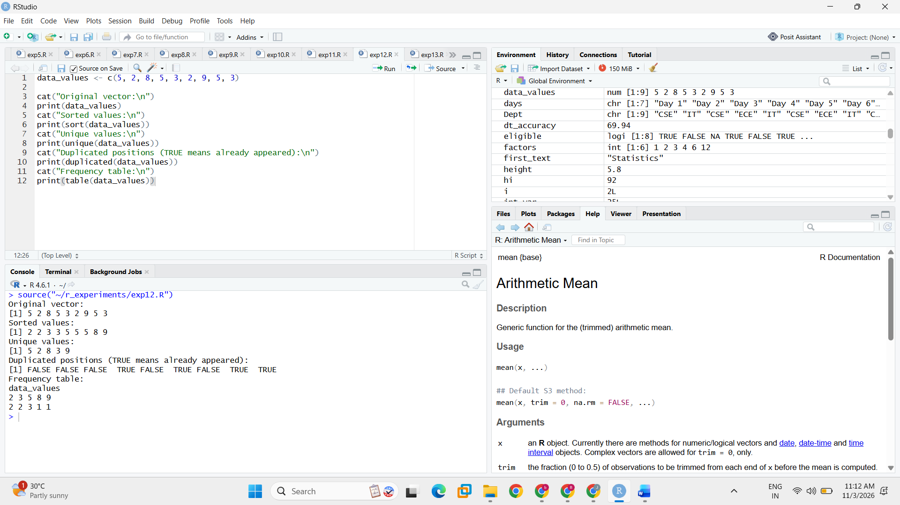

Result
Sorting, unique-value extraction, duplicate detection, and frequency counting were performed successfully.

EXPERIMENT 13: List Creation and Accessing Elements

Aim
To create a list in R containing different types of student information and access or update its elements.

Algorithm
- Create a list with student name, age, marks, and pass status.
- Display the complete list.
- Access elements by position and by name.
- Update the student's age and display the updated list.

Program
student <- list(
name = "Bhavya",
age = 20,
marks = c(85, 90, 88),
pass_status = TRUE
)

cat("Complete list:\n")
print(student)
cat("Name by position:\n")
print(student[[1]])
cat("Age by name:\n")
print(student$age)
cat("Marks vector:\n")
print(student$marks)

student$age <- 21
cat("Updated list:\n")
print(student)

Output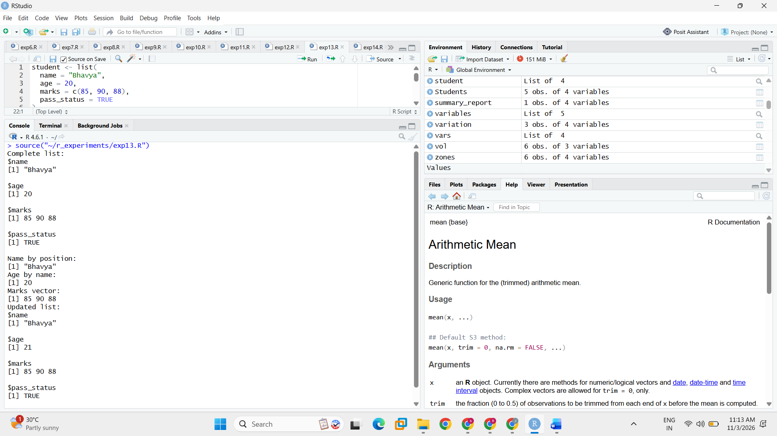

Result
A list containing different student details was created, accessed, and updated successfully.

EXPERIMENT 14: Matrix Creation and Indexing

Aim
To create a matrix in R and access a particular row, column, and individual element using matrix indexing.

Algorithm
- Create a 3 × 3 matrix using matrix().
- Display the complete matrix.
- Access the second row and third column.
- Access the element at row 2 and column 3.

Program
mat <- matrix(1:9, nrow = 3, ncol = 3)

cat("3 x 3 matrix:\n")
print(mat)
cat("Second row:\n")
print(mat[2, ])
cat("Third column:\n")
print(mat[, 3])
cat("Element in row 2, column 3:\n")
print(mat[2, 3])

Output
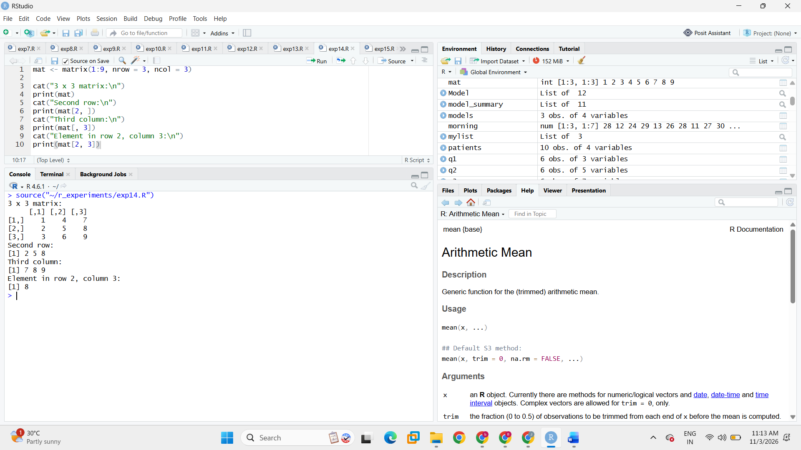

Result
A 3 × 3 matrix was created and its required rows, columns, and element were accessed successfully.

EXPERIMENT 15: Matrix Operations

Aim
To perform basic matrix operations such as addition, subtraction, and transpose on two matrices in R.

Algorithm
- Create two matrices A and B of the same dimensions.
- Display both matrices.
- Perform matrix addition and subtraction.
- Find the transpose of matrix A using t().

Program
A <- matrix(c(1, 2, 3, 4), nrow = 2)
B <- matrix(c(5, 6, 7, 8), nrow = 2)

cat("Matrix A:\n")
print(A)
cat("Matrix B:\n")
print(B)
cat("Matrix addition (A + B):\n")
print(A + B)
cat("Matrix subtraction (A - B):\n")
print(A - B)
cat("Transpose of A:\n")
print(t(A))

Output
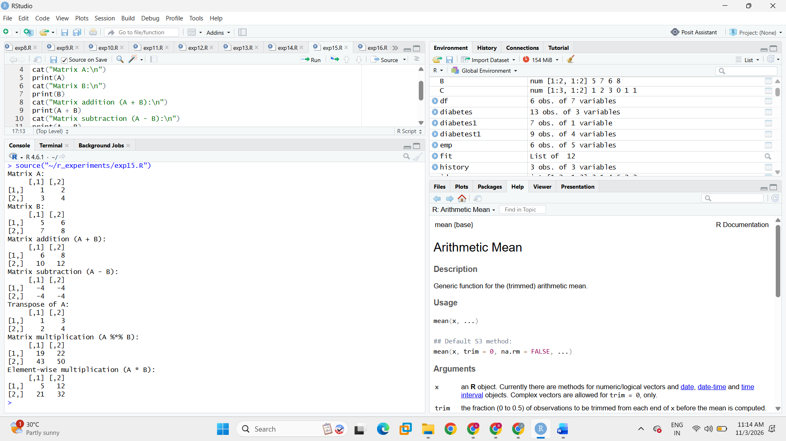

Result
Matrix addition, subtraction, and transpose operations were performed successfully.

EXPERIMENT 16: Three-Dimensional Array

Aim
To create a three-dimensional array in R and access its dimensions and a particular element.

Algorithm
- Create an array containing values 1 to 24.
- Specify its dimensions as 3 rows, 4 columns, and 2 slices.
- Display the array and its dimensions.
- Access the element at row 2, column 3, slice 1.

Program
arr <- array(1:24, dim = c(3, 4, 2))

cat("Three-dimensional array:\n")
print(arr)
cat("Dimensions:\n")
print(dim(arr))
cat("Element at row 2, column 3, slice 1:\n")
print(arr[2, 3, 1])

Output
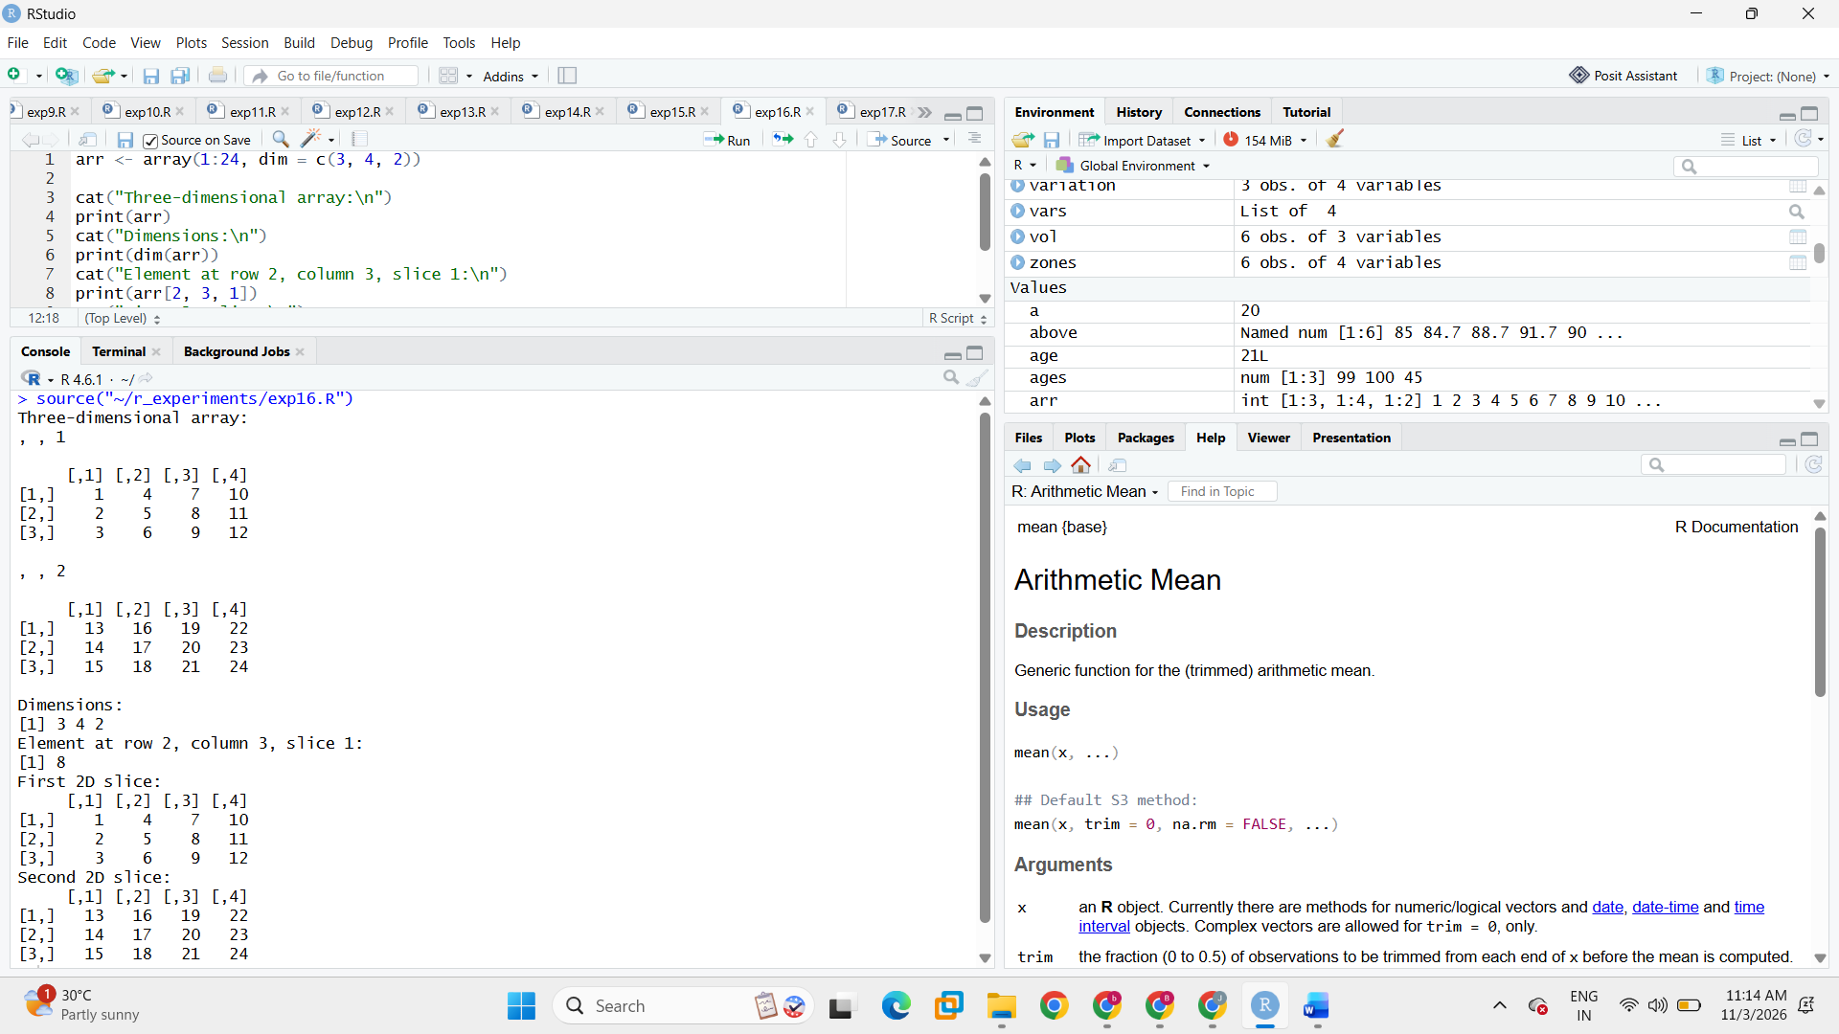

Result
A three-dimensional array was created, its dimensions were displayed, and the specified element was accessed.

EXPERIMENT 17: Ordered Factors

Aim
To create an ordered factor in R, define its levels, display category frequencies, and compare ordered categories.

Algorithm
- Create a character vector of performance categories.
- Convert it into an ordered factor with levels Low, Medium, and High.
- Display the factor and its levels.
- Display category frequencies.
- Compare High and Low as ordered categories.

Program
performance <- c("Medium", "Low", "High", "Medium",
"Low", "High", "High", "Medium")

performance_factor <- factor(
performance,
levels = c("Low", "Medium", "High"),
ordered = TRUE
)

cat("Ordered factor:\n")
print(performance_factor)
cat("Factor levels:\n")
print(levels(performance_factor))
cat("Category frequencies:\n")
print(table(performance_factor))
cat("Is High greater than Low?\n")
print(
factor("High", levels = levels(performance_factor), ordered = TRUE) >
factor("Low", levels = levels(performance_factor), ordered = TRUE)
)

Output
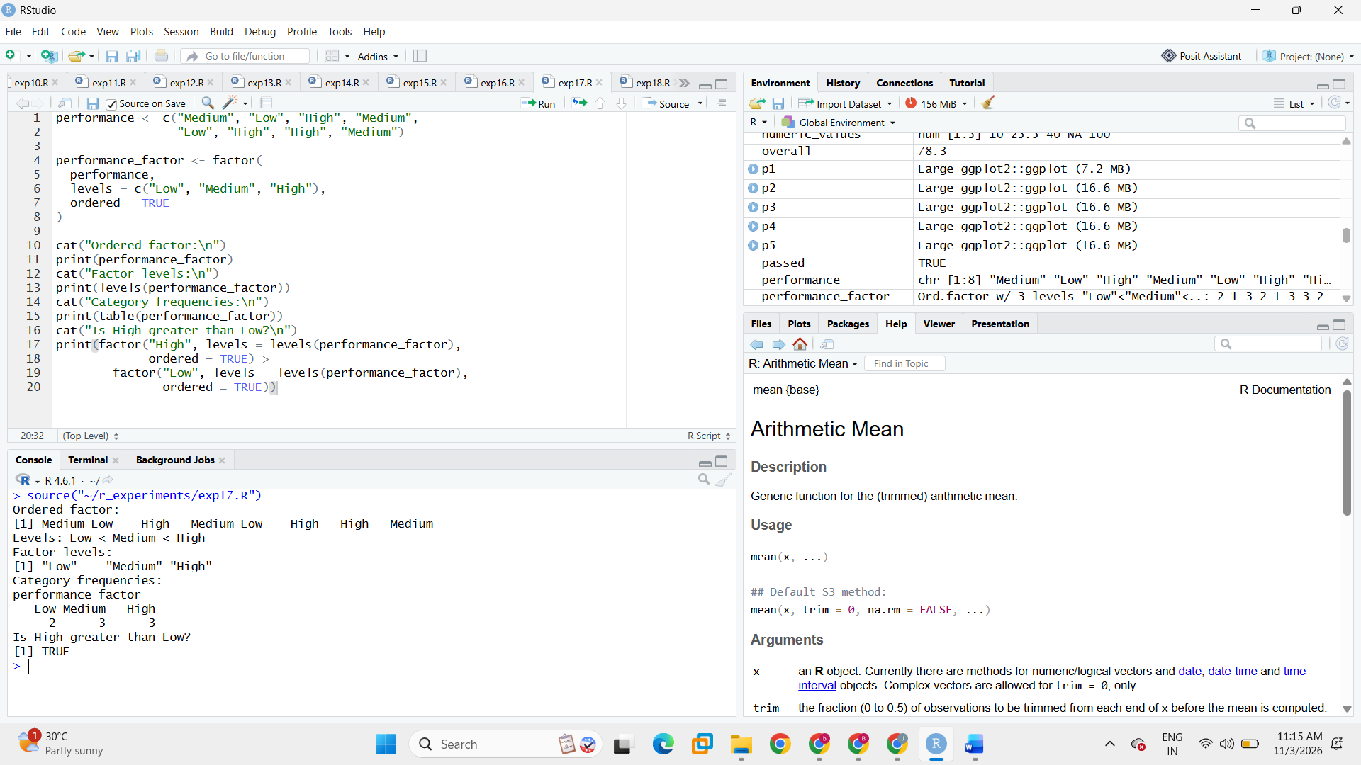

Result
An ordered factor was created and its levels, frequencies, and category comparison were displayed successfully.

EXPERIMENT 18: String Operations

Aim
To perform common string operations in R, including counting characters, extracting a substring, concatenating strings, and changing letter case.

Algorithm
- Create two character strings.
- Display the first string and count its characters using nchar().
- Extract characters 1 to 5 using substr().
- Join the strings using paste().
- Convert strings to uppercase and lowercase.

Program
first_text <- "statistics"
second_text <- "with R Programming"
cat("First string:", first_text, "\n")
cat("Number of characters:\n")
print(nchar(first_text))
cat("Substring (characters 1 to 5):\n")
print(substr(first_text, 1, 5))
cat("Concatenated strings:\n")
print(paste(first_text, second_text))
cat("Uppercase:\n")
print(toupper(second_text))
cat("Lowercase:\n")
print(tolower("R PROGRAMMING"))

Output
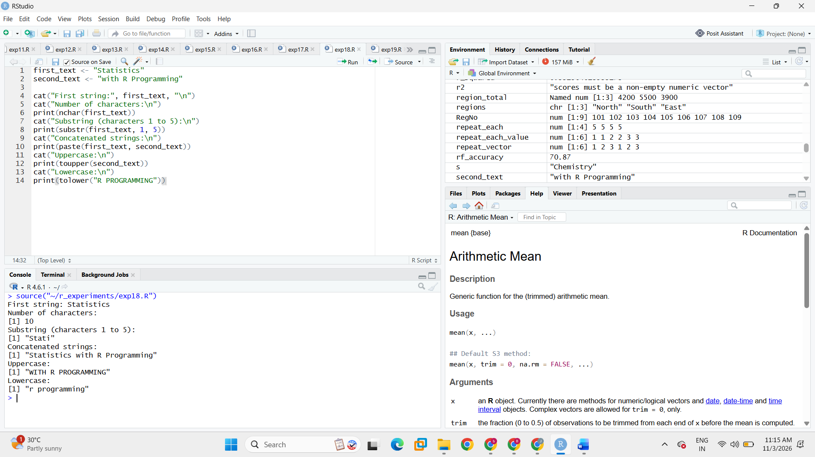

Result
String length, substring extraction, concatenation, and case-conversion operations were performed successfully.
EXPERIMENT 19: Date Operations

Aim
To create and manipulate date values in R and calculate the difference between dates and dates before or after a given date.

Algorithm
- Create two date values using as.Date().
- Display the dates as character strings.
- Subtract the dates to calculate the difference in days.
- Add ten days to the first date.
- Subtract seven days from the second date.

Program
date1 <- as.Date("2026-01-15", format = "%Y-%m-%d")
date2 <- as.Date("2026-02-10", format = "%Y-%m-%d")

cat("First date:", as.character(date1), "\n")
cat("Second date:", as.character(date2), "\n")
cat("Difference in days (date2 - date1):\n")
print(date2 - date1)
cat("Ten days after the first date:\n")
print(date1 + 10)
cat("Seven days before the second date:\n")
print(date2 - 7)

Output
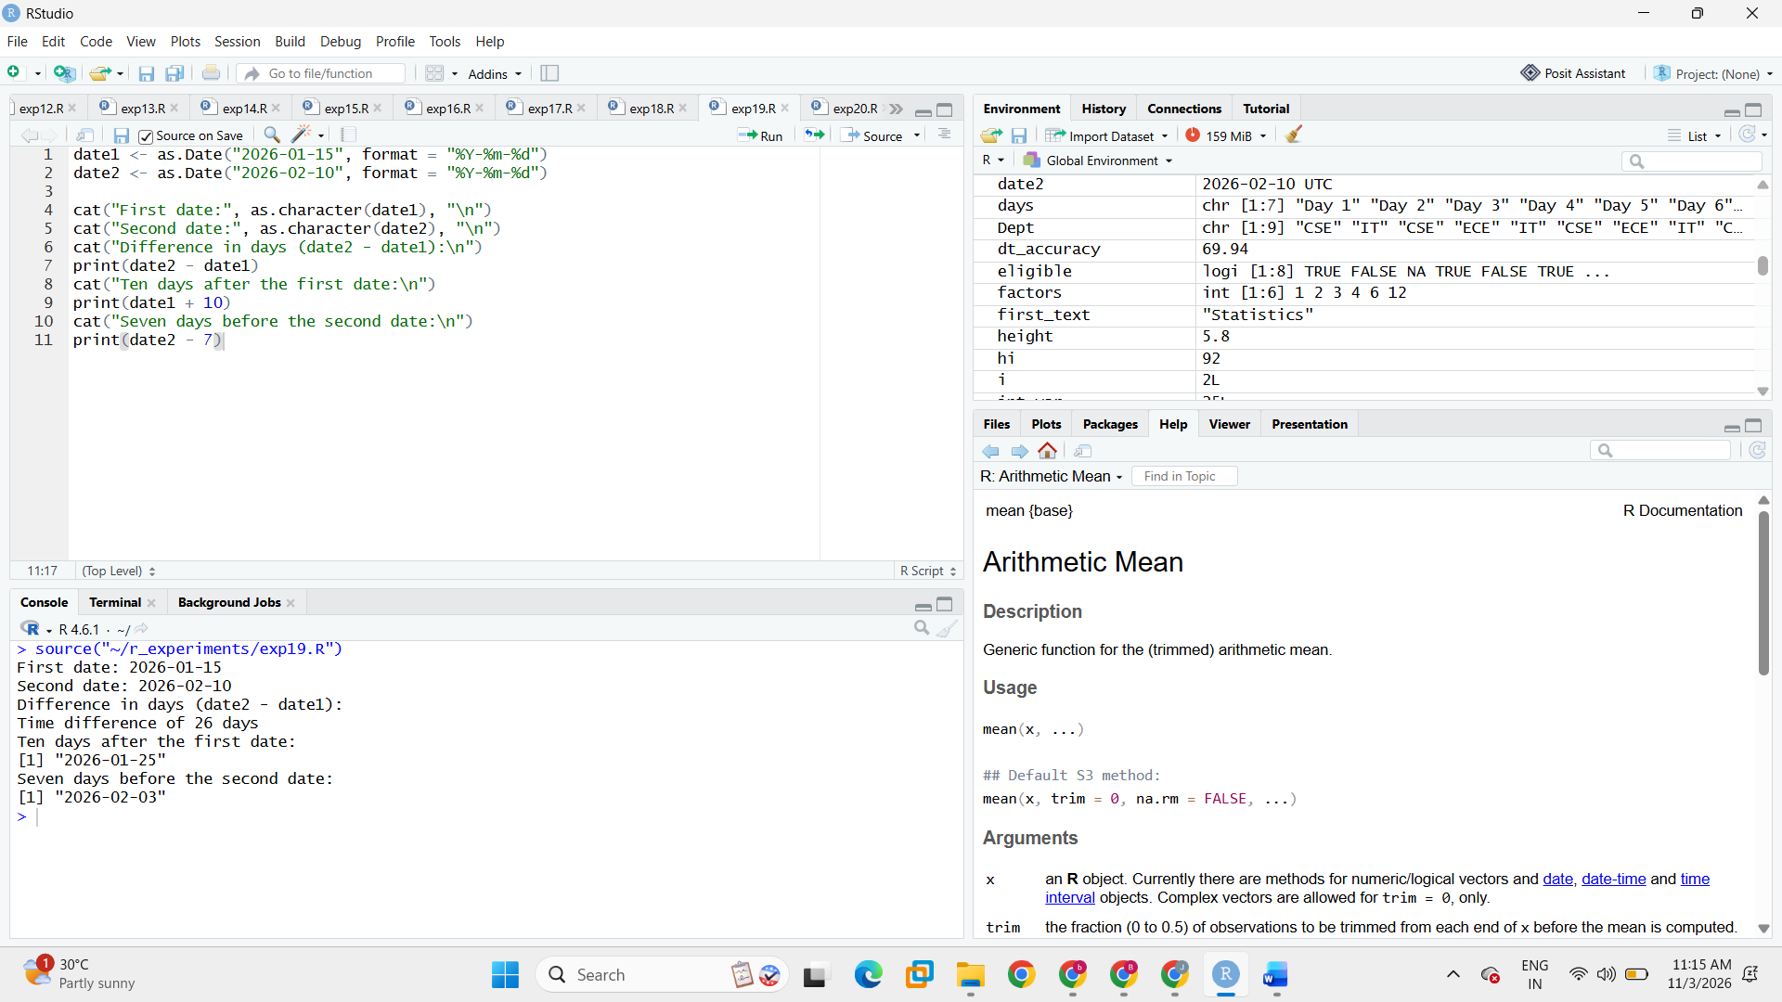

Result
Date values were created and date arithmetic was performed successfully.

EXPERIMENT 20: Student Marks Using Vectors and Matrices

Aim
To represent student marks using a vector and a matrix in R, with student names and subject names as labels.

Algorithm
- Create a vector containing marks for one subject.
- Create a character vector containing student names.
- Create a matrix containing marks for three subjects for four students.
- Assign row names and column names to the matrix.
- Display the vector and matrix.

Program
student_names <- c("Anu", "Bala", "Charan", "Divya")
subject_marks <- c(85, 78, 92, 88)

cat("Marks vector:\n")
print(subject_marks)

marks_matrix <- matrix(
c(85, 78, 92,
80, 82, 75,
92, 90, 95,
88, 86, 91),
nrow = 4,
byrow = TRUE,
dimnames = list(
student_names,
c("Subject1", "Subject2", "Subject3")
)
)

cat("Student marks matrix:\n")
print(marks_matrix)

Output

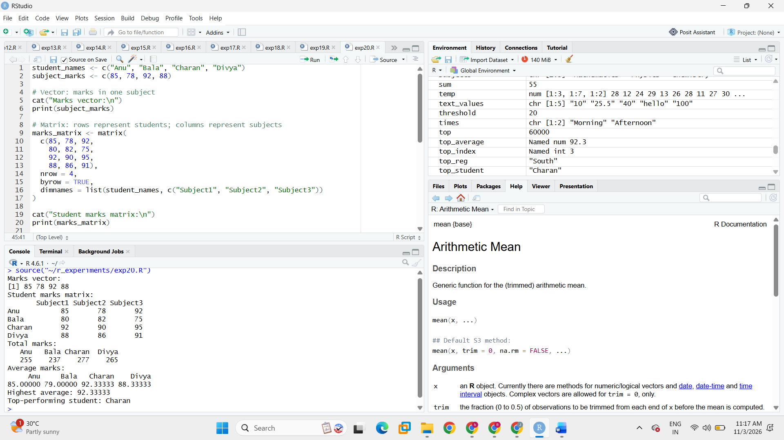

Result
Student marks were represented successfully using a vector and a labelled matrix.

