System-Wide Requirements Specification – Appendix B – GUI Prototypes

1. **Login Window**

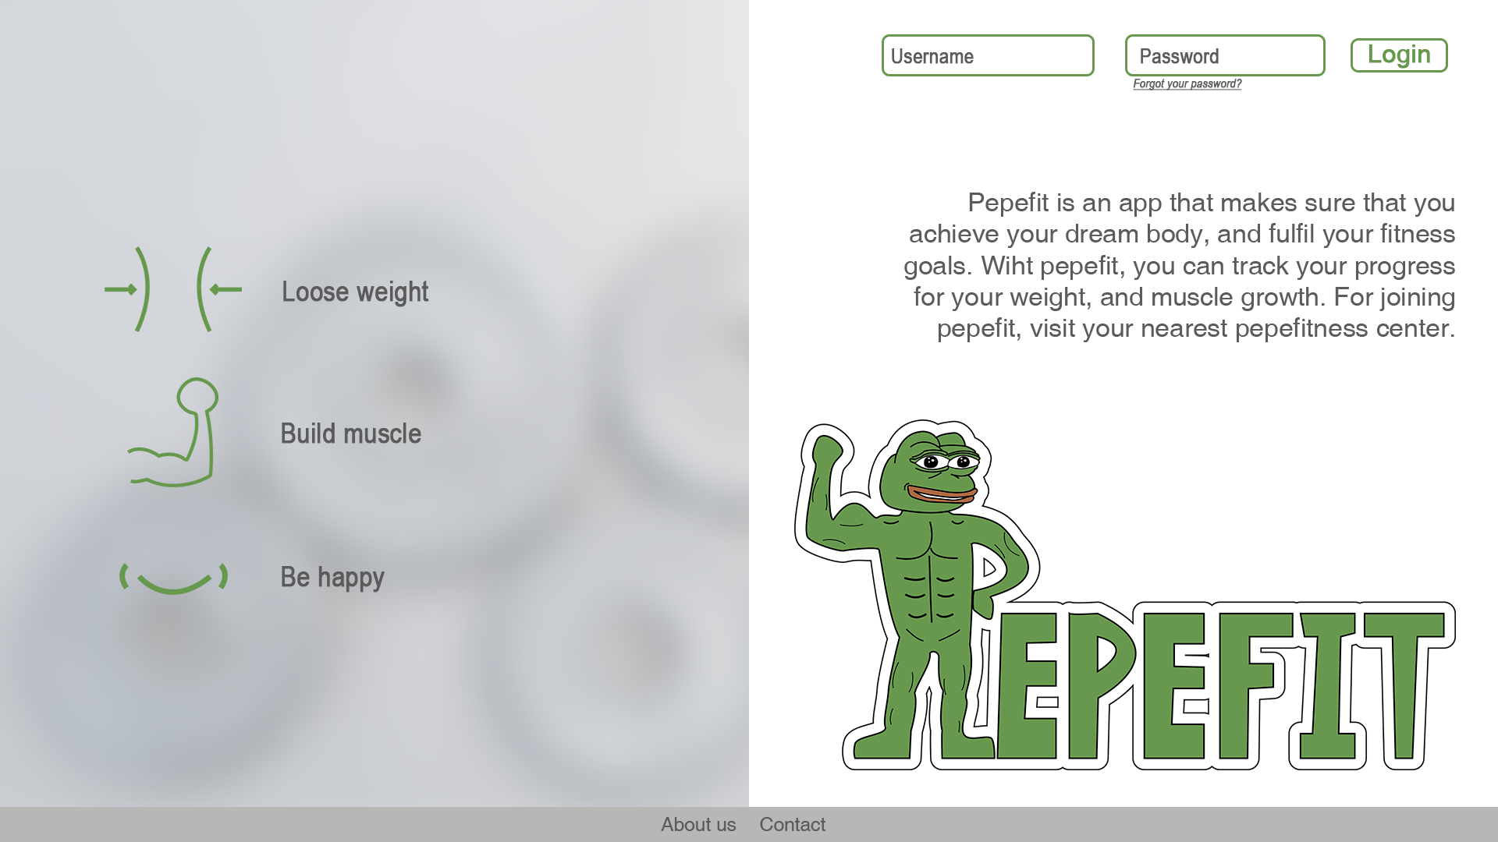

Related Use Cases:

* Use Case X: Login

1. **Logout Window**