PepeFit

Vision

# Introduction

PepeFit is a Sports Center Membership System that aims to best fulfill the needs of customers. The most important part of this application is that it being user friendly. And it also makes fitness more fun thanks to its achievement system.

# Positioning

## Problem Statement

|  |  |
| --- | --- |
| The problem of | Customers not being able to manage their schedules well, losing track of their progress, losing their motivation to continue their training |
| affects | Customers, PepeFit |
| the impact of which is | Customers will stop training. |
| a successful solution would be | Customers will be able to update and view their profile and track their progress easily. Coaches will keep their profiles updated so customers won’t miss courses and coaches will be able to track the customer progress and be able to train them more efficiently. |

## Product Position Statement

|  |  |
| --- | --- |
| For | Customers and coaches |
| Who | Customers and coaches |
| The (product name) | PepeFit |
| That | Will motivate customers and keep them motivated and always in touch. |
| Unlike | MacFit |
| Our product | Has an achievement and rewarding system. |

# Stakeholder Descriptions

## Stakeholder Summary

| **Name** | **Description** | **Responsibilities** |
| --- | --- | --- |
| User: Customer | Customer is the user that can view & edit their profile, follow group course schedule and contact their coach. | Keep their profile up-to-date, train. |

| **Name** | **Description** | **Responsibilities** |
| --- | --- | --- |
| User: Coach | Coach is the user that confirms the changes customers have made and opens new group courses and private lessons. | Oversees the changes customers have made and prevents misuse. Is excepted to regularly make new courses |

| **Name** | **Description** | **Responsibilities** |
| --- | --- | --- |
| User: Admin | Admin is the super-user. | They resolve the disagreements between customers and their coaches and oversee coaches in general. |

| **Name** | **Description** | **Responsibilities** |
| --- | --- | --- |
| Developer Team: Manager | Manages the project process, its people and product. | Planning activity schedules, risks etc. Setting project goals, budget allocation and monitoring. |

| **Name** | **Description** | **Responsibilities** |
| --- | --- | --- |
| Developer Team: Architect | Architect makes high-level design choices and dictates technical standards. | Design, develop and execute software solutions. Evaluate and recommend tools, technologies and processes. |

| **Name** | **Description** | **Responsibilities** |
| --- | --- | --- |
| Developer Team: Analyst | Analyst studies the software application domain, prepares requirements and documents. | Performing complex analysis to ensure project to meet its requirements. Analyzing and developing modifications to the existing system. |

| **Name** | **Description** | **Responsibilities** |
| --- | --- | --- |
| Developer Team: Configuration Manager | Configuration Manager manages the changes made on the project. | Helping in identifying individual elements and configurations, tracking changes, version selection, control and baselining. |

| **Name** | **Description** | **Responsibilities** |
| --- | --- | --- |
| Developer Team: Tester | Tester tests the software for bugs, errors and defects. | Setting up tests. Logging outcomes. Identifying the most appropriate implementation. Analyzing and recovering from errors. |

## User Environment

There are 3 users in the system: Customer (gym-goer), coach and admin.

Each one of them has different permissions and can supervise others in Admin > Coach > Customer order.

The system will use MySQL for database, Linux as environment and will be built for the web platform. The private data will be encrypted and will be hidden from PepeFit owners as well as other users.

**Context Diagram:**

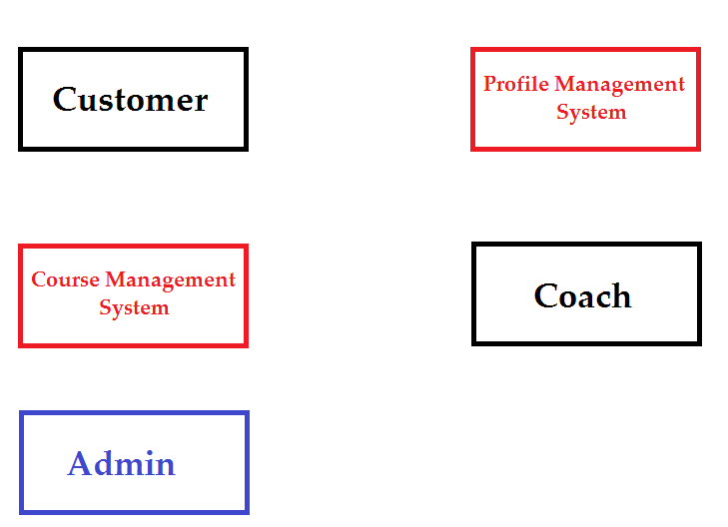

Checks courses

Maintenance of the system

Opens courses

Manages recommendations

Tracks customer progress

Updates profile

Shows progress

Recommends courses

# 

# Product Overview

## Needs and Features

|  |  |  |  |
| --- | --- | --- | --- |
| **Need** | **Priority** | **Features** | **Planned Release** |
| Log in | 1 | Users will have an account to track their progress easily. | Protoype 1 |
| Log out | 1 | Log out option will help customers protect their account privacy. | Protoype 3 |
| Profile Management | 1 | Users will update their profile and see their progress. | Protoype 1 |
| Course Management | 1 | Users will see course list and choose to attend them. | Protoype 2 |
| Achievement System | 1 | Users will earn achievements based on their progress. | Protoype 2 |

# Other Product Requirements

|  |  |  |  |
| --- | --- | --- | --- |
| **Requirement** | **Priority** | **Features** | **Planned Release** |
| A database for user and course data | 1 | It shall be secure. | Protoype 1 |
| Hardware | 1 | The system will be on a virtual machine | Protoype 2 |
| Environment | 1 | The system will be use Linux as environment | Protoype 2 |