Readably

**Coding Standards**

# Introduction

This document consists of a set of guidelines, best practices, programming styles and conventions that developers adhere to when writing source code for the project.

# Description

There are series of procedures that can be defined for a particular programming language specifying a program style, the methods and different procedures. These procedures can be for various aspects of the program written in that language. They can be considered as essential attributes of software development.

A coding standard makes sure that all the developers working on the project are following certain specified guidelines. The code can be easily understood and a proper consistency is maintained.

Consistency has a positive impact on the quality of the program and one should maintain it while coding. Also, it should be considered that the guidelines are homogeneously followed across different levels of the system and they do not contradict each other. The finished program code should look like it has been written by a single developer, in a single session.

# Coding Standards Specifications

1. Naming Standards
   1. Readably uses descriptive function and variable names.
   2. Function names are verbs and start with lowercase letters.
   3. Attribute and variable names are nouns and start with lowercase letters.
   4. Class names are nouns and start with uppercase letters.
   5. Use camel notation with function names.
   6. Use underscore notation with class attribute names and variable names.
   7. Use camel notation with class names.
   8. Avoid using abbreviations.
   9. Declare all member variables at the top of a class, with static variables at the very top.
   10. Do not use names that begin with a numeric character.
   11. Do not use single character variables names.
   12. File names should match with class name.
2. File Organization  
   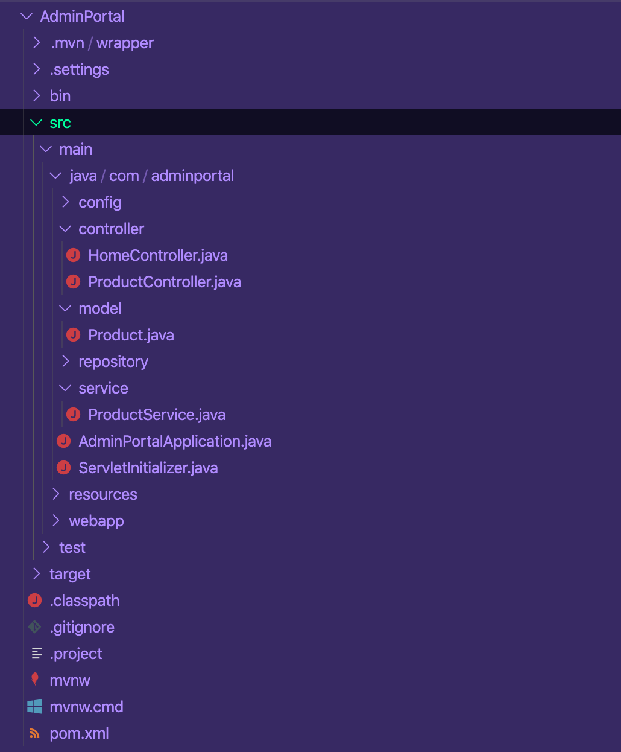
3. Comment Standards
   1. Do not write comments for every line of code and every variable declared.
   2. Write clean, readable code in such a way that it does not need any comments to understand it.
   3. Do a spell check on comments and also make sure that proper grammar and punctuation are used.
   4. Use one-line comment symbol. Avoid using multiple-line.
   5. Begin comment text with an uppercase letter.
   6. End comment text with a period.
   7. Place the comment on a separate line if it gets too long.
4. Coding Conventions
   1. Follow general Java coding standards.
   2. Maximize the number of individual groups of code for the sake of modularity and object-oriented design.
   3. Minimize the number of nested logic block for the sake of simplicity.
   4. Avoid long lines of code.
   5. Start a new line after each semicolon.
5. White Space
   1. Use indentation for every block.
   2. There should be one blank line between each pair of functions.
   3. In formulas and notations, use single whitespace if necessary.
   4. Avoid using unnecessary whitespaces.
   5. Do not use a space after the parenthesis and function arguments.
   6. Use a single space after a comma between function arguments.
   7. Use a single space before and after comparison operators, flow control statements.