**Readably**

**Software Design Description**

1. **Revision History**

|  |  |  |  |
| --- | --- | --- | --- |
| ***Version*** | ***Date*** | ***Author*** | ***Change Description*** |
| 1.0 | 18.05.2020 | F. Çiğdem Tosun | Initial edit. |
| 1.0 |  | Remzi Çiçek | Admin Portal |
| 1.0 |  | Kerem Üremez | Spring boot with readably template |
| 1.0 |  | Neşe Gamze Uyanık | Readably Payment |
| 1.0 |  | Kaan Nuri Beyhan | Readably Login page |

1. **INTRODUCTION**
   1. **Purpose and Scope**

SDD describes the goal of the project and describes the solutions of the problems. Also specifies the detailed structure of the components to satisfy the requirements in SRS.

* 1. **Document Overview**

In this document, you can find the general overview of the system such as definitions, design constraints and decisions. Also there is a detailed version of the software description in the following sections. These include software components, software behaviour, data model (E-R diagrams) and user interface design.

* 1. **System Overview**

[Give a general description of the complete system here; preferably in form of a commented drawing.]

* 1. **Definitions, Acronyms, and Abbreviations**

1. **Design Constraints and Decisions**

* Main programming language is Java.
* Readably will be able to run in every OS.
* MySQL is the database.
* Readably will be a stand-alone web application that requires a database connection.
* MVC is the architectural pattern of Readably.
* The system will be distributed over Github, documentations will also be on Github.
* The system will provide functionality and user friendly GUI.
* Only admin can edit the website.
* The performance of the system should not decrease under multiple users logged in.

1. **Design Details**
   1. **Software Components-Class Diagram**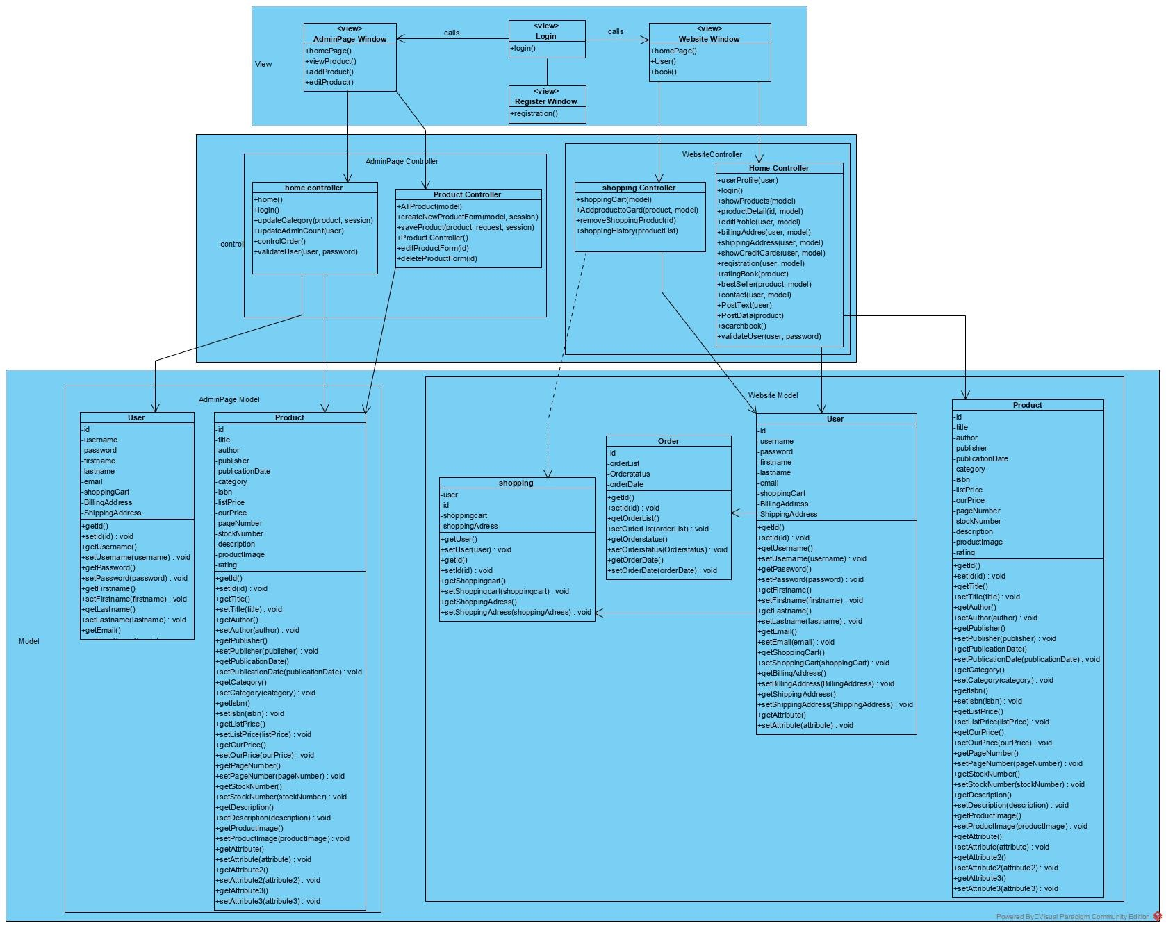
   2. **Software Behavior**

**State Diagram**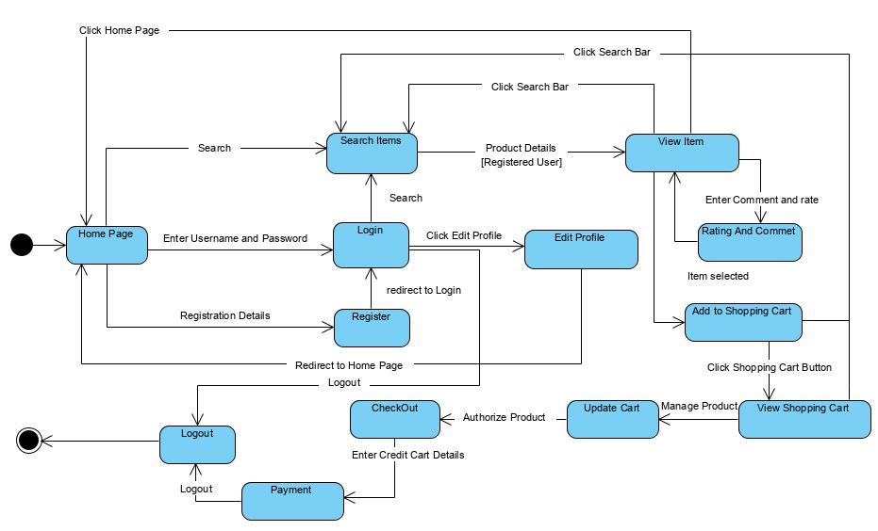

**Sequence Diagrams**

**1-Logout**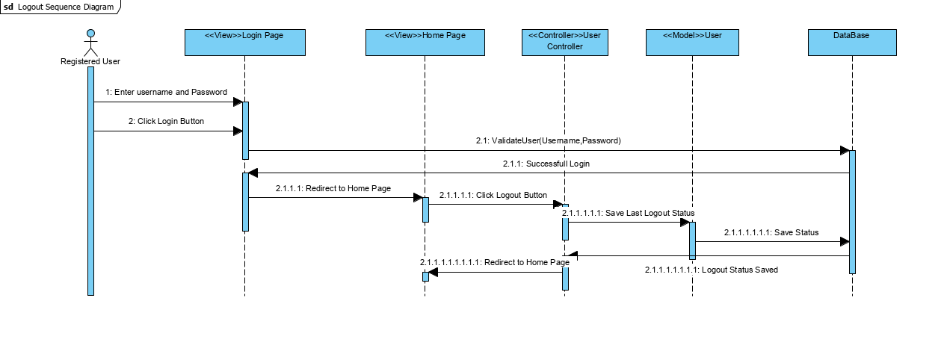

**2-Login**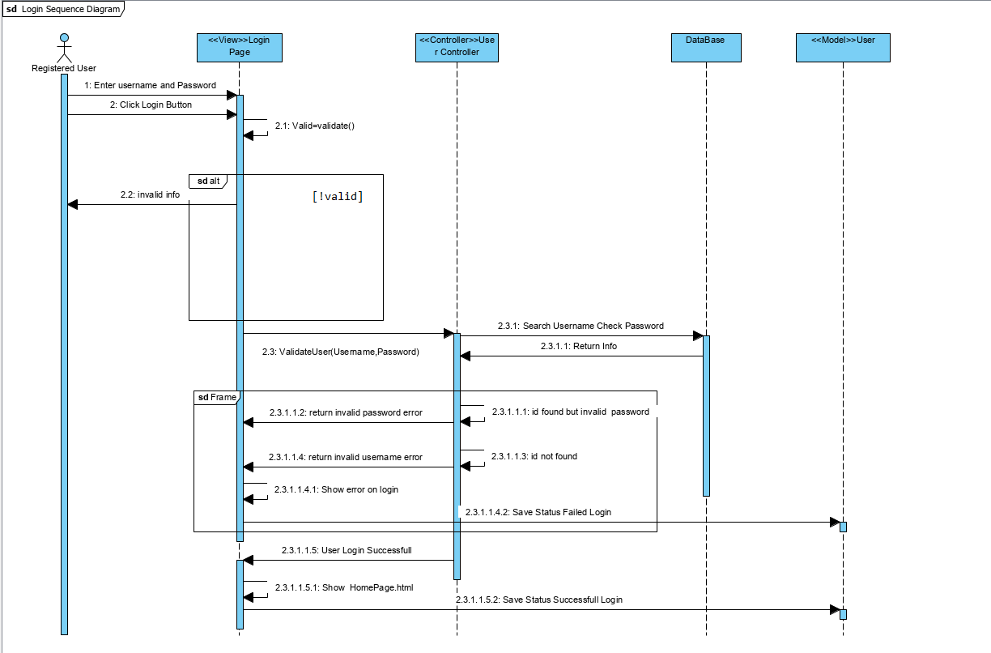

**3-Update Profile**

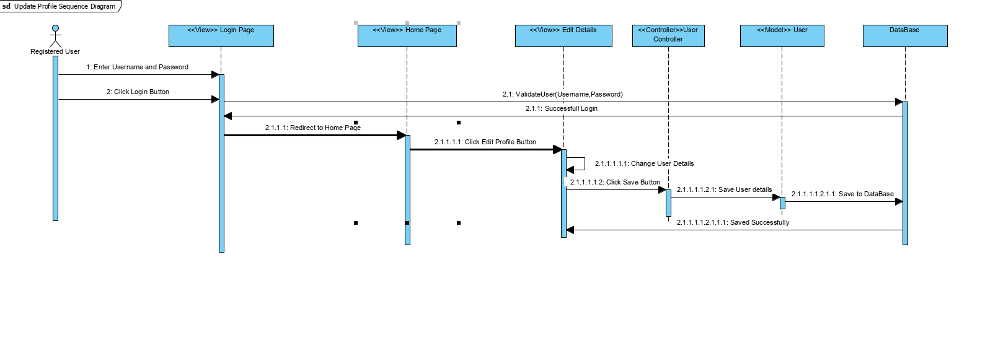

**4-Registration**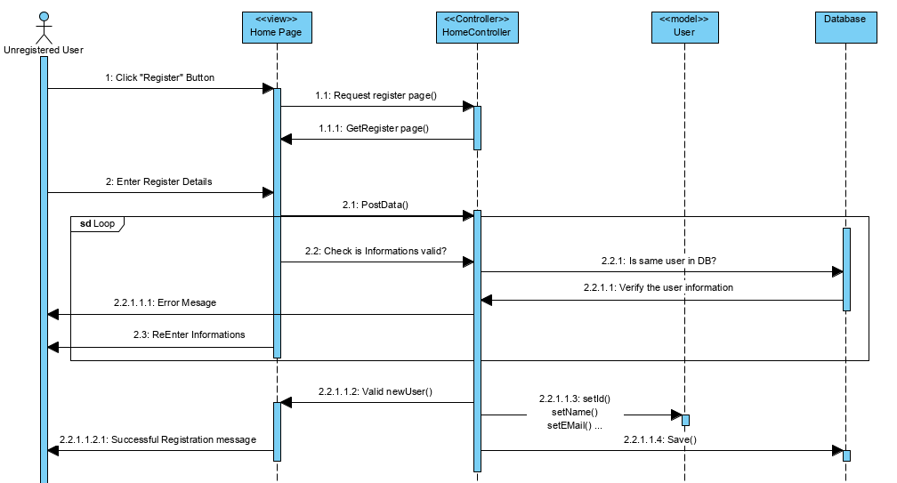

**5-Shopping Cart**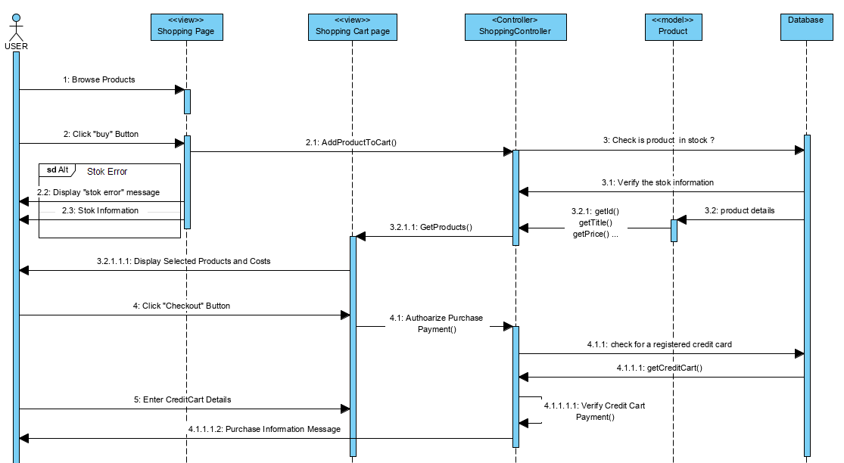

**6-Campaign**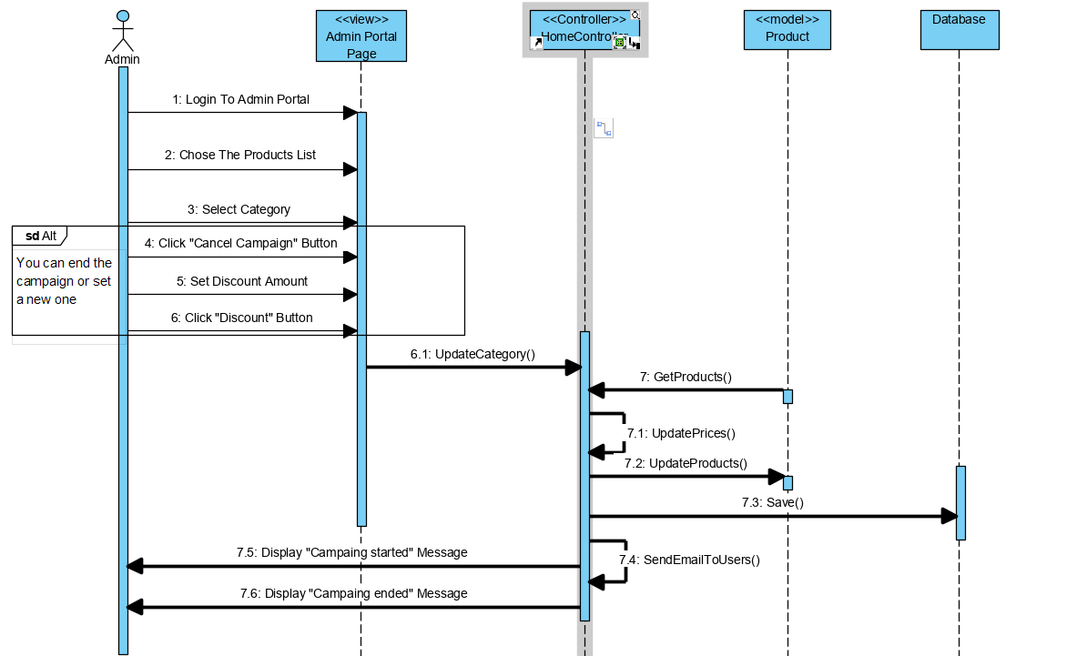

**7-Best Sellers**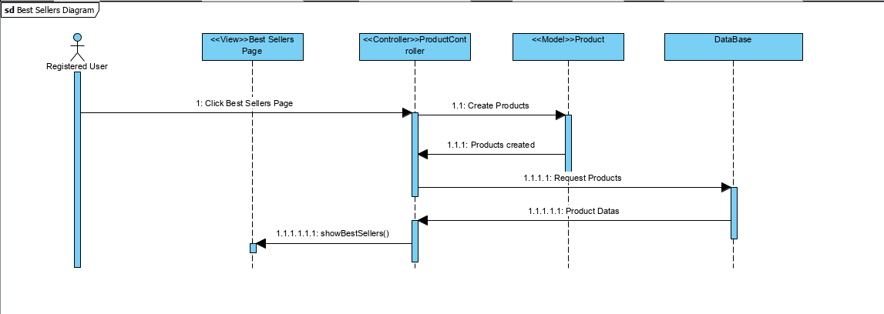

**8-Contact**

**9-Rating a Book**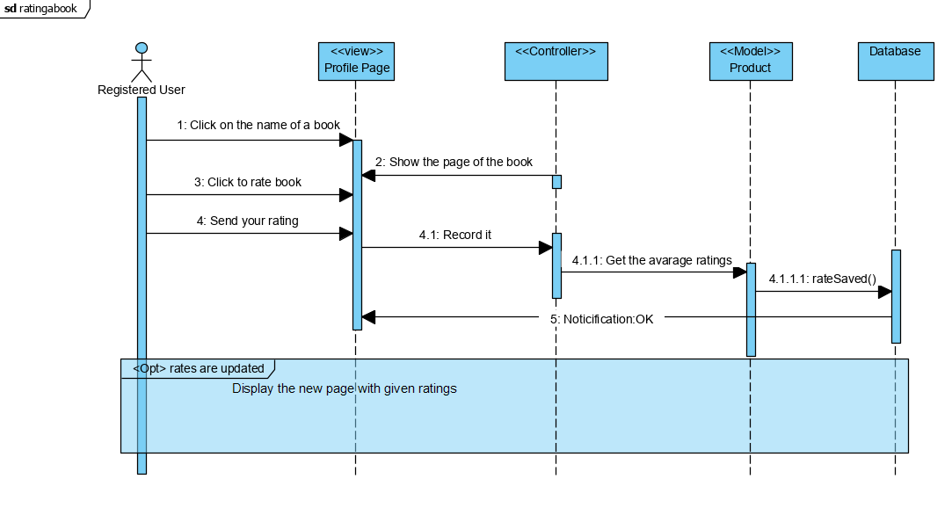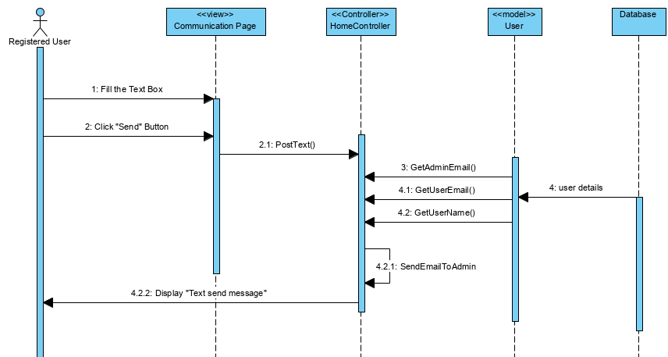

**10-Add/Delete Member**

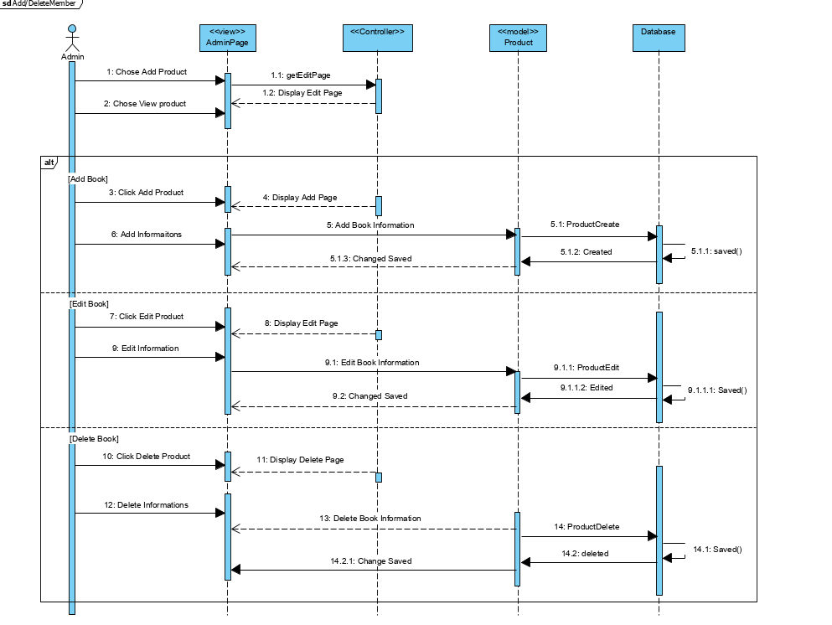

**11-Shopping History**

**12-Search Book**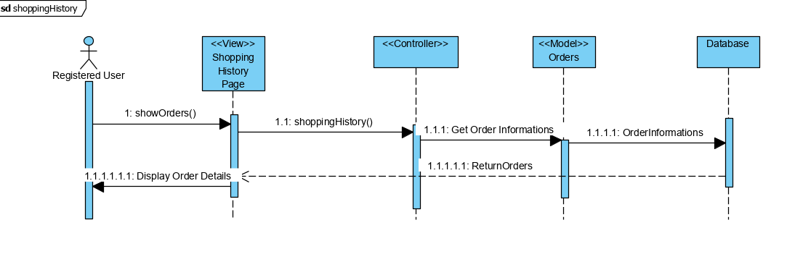

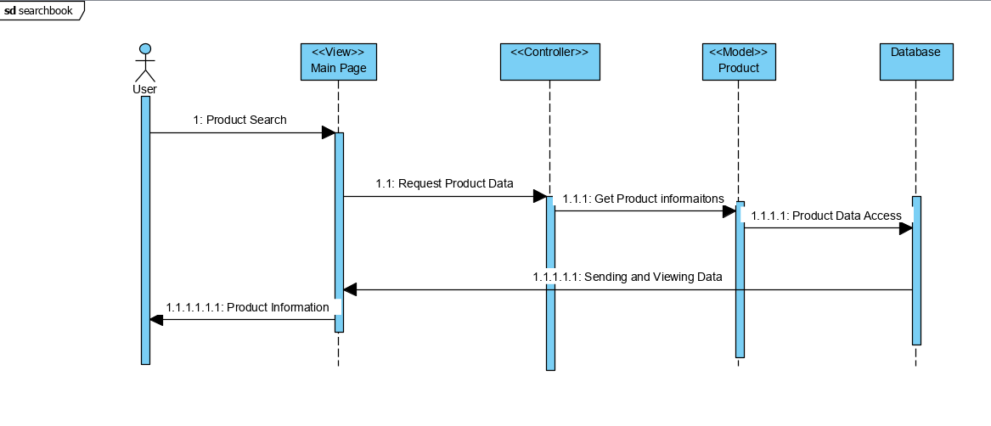

* 1. **Data Model (E-R Diagram)**

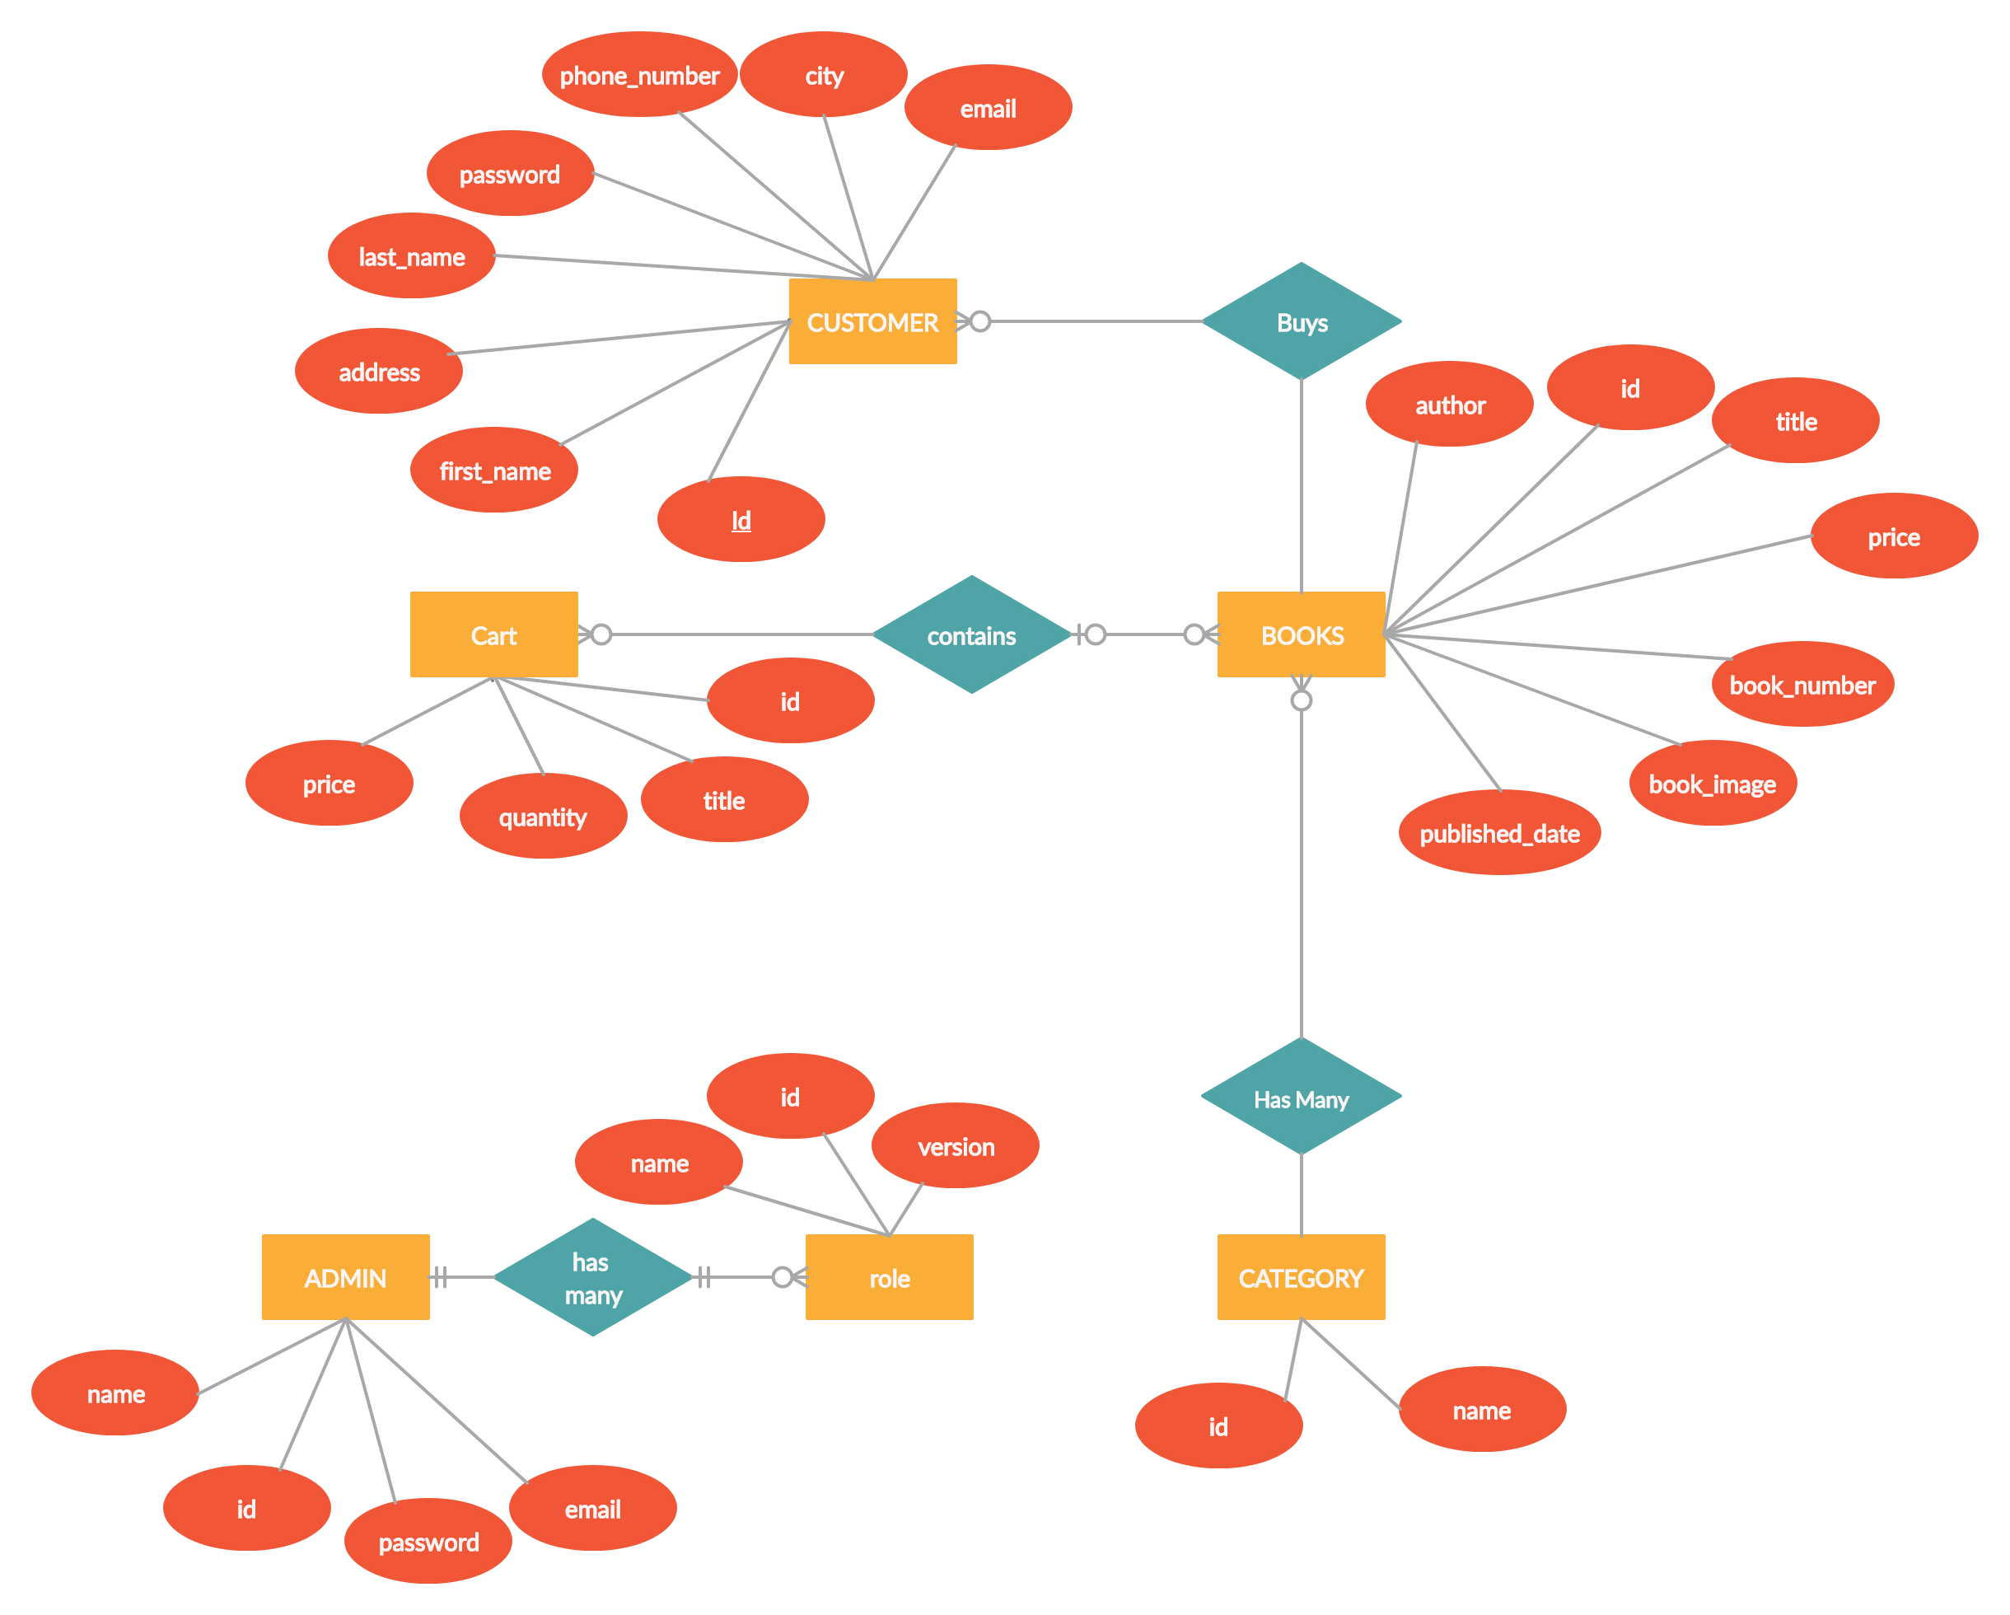

* 1. **User Interface Design**

User interface design is done with the strong consideration of user-friendliness and minimalism.



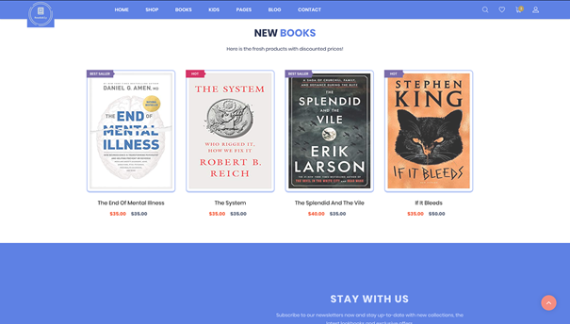

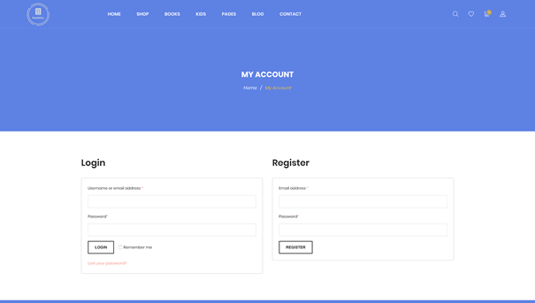

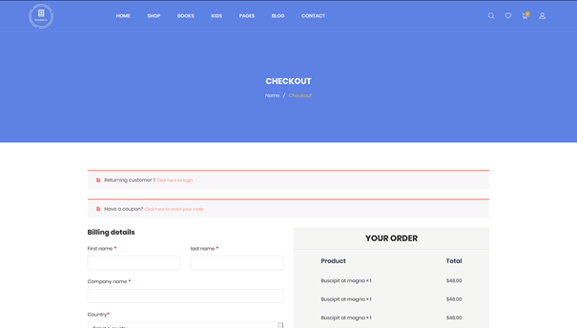

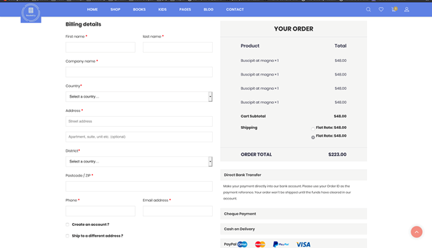

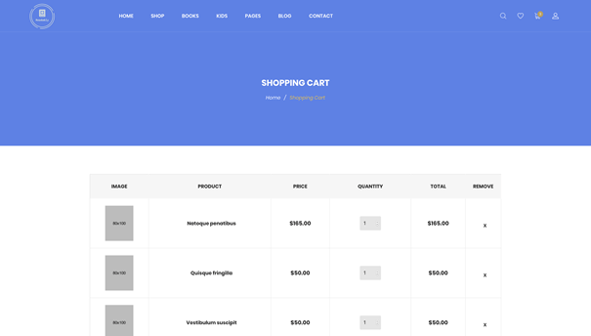

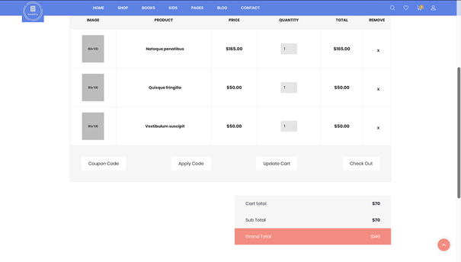

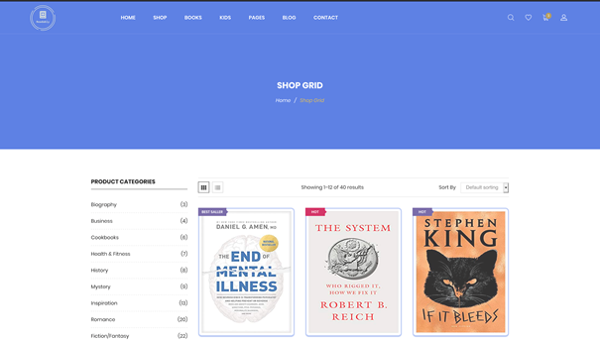

1. **Requirements Traceability**

