1.

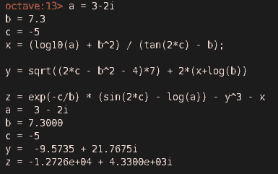

A= x = (log10(a) + b^2) / (tan(2*c) - b);

B= y = sqrt((2*c - b^2 - 4)*7) + 2*(x+log(b));

C= z = exp(-c/b) * (sin(2*c) - log(a)) - y^3 – x

2.

array = zeros(5,5)

for i = 1:5

for j = 1:5

if (i<j)

array(i,j) = (79 - i)/j;

elseif (i>j)

array(i,j) = (79-j) * i;

else

array(i,j) = 0

endif

endfor

endfor

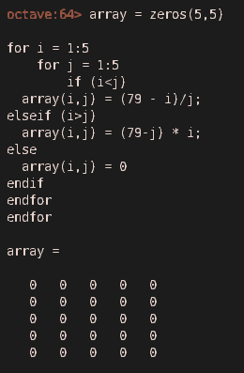

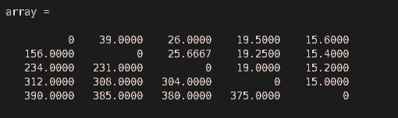

3.

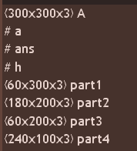

A = imread('arabaa.jpg')

part1 = A(1:300/5, 1:300, 1:3)

part2 = A(61:300*4/5, 1:300*2/3, 1:3)

part3 = A(241:300, 1:300*2/3, 1:3)

part4 = A(61:300, 201:300, 1:3)

part1 = *magenta*

*part2 = cyan*

*part3 = yellow*

*part4 = red*

4.

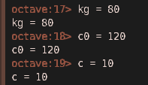



Konstrasyon 10’a eşit oldugunda zaman = 6.5264. dakikada,

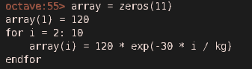

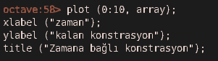

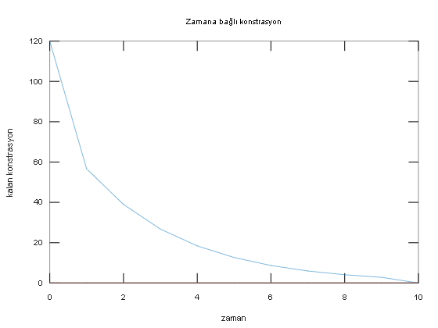

6.

function final = hacim_hesapla (r, a, h)

prizma_hacim = a^2 * h;

silindir_hacim = pi * (r/2)^2 * h;

final = prizma_hacim – silindir_hacim;

end

