Task 7 — Wireless Sensor Diagnostics
Protocol choice and system architecture for real-time sensor fault finding
Answer: we use Wi-Fi: the ESP32 creates its own access point, and the robot streams sensor frames to a laptop as UDP packets. It is the only option with comfortable bandwidth to send every reading from every channel at the full control-loop rate. An intermittent fault from a bump may last only a few milliseconds, and down-sampled data would hide it.
Scenario: the maze surface has small bumps, and one or more IR sensors give intermittent readings while the robot runs. We must identify the faulty sensor(s) in real time, without stopping the robot or touching the hardware.

1. Protocol selection
 | Wi-Fi (UDP, ESP32 soft-AP) | Classic Bluetooth (SPP) | BLE
Bandwidth | Several Mbit/s in practice: far more than we need | A few hundred kbit/s at best: marginal for full-rate data | Default packets carry only 20 bytes; useful throughput needs packet-size tuning
Latency | A few ms over the air; we batch every 20 ms | Tens of ms, varies with buffering | Tied to the connection interval (7.5 ms minimum)
Power (ESP32) | Highest: receive 95–100 mA, transmit peaks 240 mA (Espressif via JLCPCB) | Lower than Wi-Fi | Lowest
Ease on ESP32 Arduino | WiFi.softAP() + WiFiUDP: a few lines | BluetoothSerial: a few lines | Needs a custom GATT service and characteristics
Receiver | Any laptop; Python socket + live plot | Phone terminal app or laptop serial port | Phone app or BLE library on a laptop
Hardware conflict | ADC2 pins stop working while Wi-Fi is on (Espressif) | None | None

Why Wi-Fi for this job
- Bandwidth for full-rate data. 8 channels in a 37-byte frame at 1 kHz is about 37 kB/s (≈ 300 kbit/s). Wi-Fi carries this with large headroom; Classic Bluetooth would be close to its limit, and BLE would need tuning. Sending every sample matters because a bump-induced glitch can last just 1–5 control loops.
- Latency is good enough for a human watching a plot. Batching 20 ms of frames per packet keeps the end-to-end delay to roughly 20–50 ms, which looks instantaneous on a live graph.
- Power is not a constraint. Wi-Fi adds roughly 25 mA on average (Task 5): about 4% of the robot's 0.6 A running current, on practice runs only.
- Easiest analysis. UDP arrives in an ordinary Python script, where plotting, logging to CSV and running the fault rule are simple.
The one catch, handled: Wi-Fi disables the ESP32's ADC2 pins. Our robot's Pololu QTRX-MD-08RC sensors are read by timing on digital pins, not by the ADC, so Wi-Fi cannot affect them. On the Appendix A mock hardware, sensor S5 is on GPIO 25 (ADC2). It would have to move to an ADC1 pin (GPIO 36 or 39), or we would use Classic Bluetooth instead.
Competition rule: Meshmerize requires other Wi-Fi and Bluetooth devices to be switched off near the arena (PS p. 6). This system is for the practice track only: one #define compiles Wi-Fi out of the competition firmware. For the event itself, the robot can keep the same frames in a RAM ring buffer and send them over USB after the run.

2. System architecture
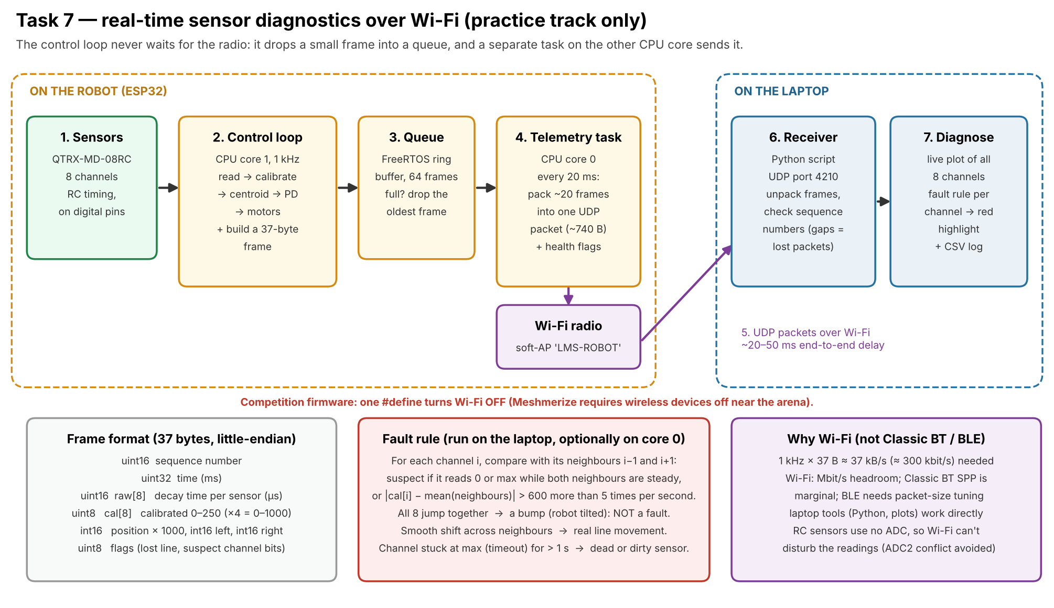
Figure 1: data flow from sensor read to the laptop plot.

Stage by stage
- Sensors. The 8 QTRX channels are read in parallel: each pin is charged, then the ESP32 times how long it takes to discharge (white: microseconds; black: up to about 1 ms).
- Control loop (CPU core 1, 1 kHz). Calibrates the readings to 0–1000, computes the line position and PD output, drives the motors, then packs a 37-byte frame. It never waits for the radio.
- Queue. A FreeRTOS queue of 64 frames passes data between the two cores. If it ever fills, the oldest frame is dropped, so the control loop is never blocked.
- Telemetry task (CPU core 0). Every 20 ms it takes about 20 frames from the queue, packs them into one UDP packet of about 740 bytes, and sends it. It can also set per-channel "suspect" flags using the rule in section 3.
- Wi-Fi link. The ESP32 runs as an access point ("LMS-ROBOT"), so no router is needed at the practice track. The laptop joins it and listens on UDP port 4210.
- Receiver (laptop). A Python script unpacks the frames. It checks the sequence numbers, so lost packets show up as gaps rather than going unnoticed.
- Diagnose. A live plot shows all 8 channels with the line position underneath. A channel the fault rule marks as suspect turns red, and everything is logged to CSV for later analysis.

Frame contents (37 bytes)
Field | Bytes | Purpose
Sequence number | 2 | Detect lost packets
Time (ms) | 4 | Align data with what the robot was doing
Raw decay time × 8 | 16 | Raw sensor data in microseconds: shows stuck-at-zero or stuck-at-timeout faults
Calibrated value × 8 | 8 | 0–250 (× 4 = 0–1000), what the control loop actually used
Position, left, right | 6 | Line position × 1000 and both motor commands: shows the effect of a bad sensor
Flags | 1 | Line lost, plus suspect-channel bits set on the robot

3. Telling a faulty sensor from a bump or a real line change
Event | What the 8 channels do | Classified as
Line moves sideways | Values shift smoothly across neighbours (S3 → S4 → S5) | Normal
Bump: robot tilts for a moment | All 8 channels jump together for a few ms | Normal (ignore)
Intermittent sensor or loose wire | One channel drops to 0 or jumps to maximum while both neighbours stay steady | Suspect channel
Dead or dirty sensor | One channel stuck at the timeout (always "black") or at minimum for more than 1 s | Faulty channel

Rule used (starting thresholds, tuned from recorded logs). For each channel i, compare its calibrated value with the average of its neighbours i − 1 and i + 1, using a single neighbour at the ends. Flag channel i as suspect if the difference exceeds 600 (out of 1000) more than 5 times per second while those neighbours change by less than 150. Ignore any frame where 6 or more channels change by over 400 at once: that is a bump. Flag a channel as faulty if it stays at its minimum or maximum for over 1 s while the robot is following the line.
This works without stopping the robot, because the data is analysed on the laptop (or on the robot's spare core) while the control loop carries on.

4. Risks and how the design handles them
Risk | Mitigation
Wi-Fi activity disturbs the control loop's timing | Control loop pinned to core 1, Wi-Fi on core 0; the queue decouples them. Compare loop timing with Wi-Fi on and off.
Packets lost | Sequence numbers make gaps visible; a lost packet costs 20 ms of plot, never the robot's control.
Diagnostics left on at the competition | Compile-time switch; the competition build is tested on its own before the event.

Sources: Espressif ESP32 GPIO & ADC notes; ESP32 current figures (Espressif data, via JLCPCB); Meshmerize 2026–27 problem statement, p. 6.

