Task 8 — Maze-Solving Algorithms
DFS vs wall-following, a worked example with a loop, and pseudocode
Answer: for an unknown maze we use depth-first search (DFS) on a graph, in its Trémaux form, with a left-first preference. It explores every path and copes with loops. The map it builds lets the replay take the true shortest route. In the example maze below, which has one loop, the left-hand rule followed by turn-string reduction replays a 240 cm route; DFS plus a shortest-path search on its map replays 120 cm.
Every number in this document comes from the simulation in src/maze_sim/example_maze.py, which runs both methods on the example maze.

1. DFS vs a wall-preference rule
 | Left-hand (or right-hand) rule | DFS on a graph (Trémaux)
How it decides | At every junction take the left-most exit (else straight, else right, else turn back) | Take an exit not yet explored (left-most first); when none is left, backtrack the way you first came
Memory needed | Only the turn string (L, S, R, B) | A map: every junction, its exits, which are explored, and edge lengths
Mazes with loops | Can circle a loop or follow its long side; dead-end reduction can't remove a loop detour | Recognises a revisited junction, turns back, and records the loop in the map
Guarantee | Reaches the end only if the end can be reached by keeping one hand on the outer boundary | Visits every reachable edge, so it always finds the end and the full map
Replay | Reduced turn string; shortest only in loop-free mazes | Shortest-path search (Dijkstra/BFS) on the map: always the shortest explored route
Hardware needs | Junction detection only | Junction detection + a way to tell junctions apart (position from heading and distance)
Effort | Very simple | More code (graph + search), still small for about 40 junctions

Which we use, and why
- The Meshmerize arena has loops. Modelling the sample arena (PS Fig. 1) as a graph gives 38 junctions and 42 edges, so 42 − 38 + 1 = 5 independent loops. The Pololu maze method that the README teaches assumes a loop-free maze.
- The score depends on the shortest path. The actual-run bonus S (30 points) and the time score T (up to 150) are awarded only on the shortest path. On the sample arena the right-hand rule's best replay is 715 cm against a true shortest 654 cm, which would lose both.
- DFS is complete. It cannot get stuck circling, and its map makes the shortest route a calculation instead of a hope.
Honest limitation: DFS must recognise when it has returned to a known junction. That needs the robot's position, worked out from its heading (always a multiple of 90°) and the distance driven. With our current no-encoder robot, distance comes from timing (±10–15%), which may not be reliable enough. Our practical fallback is the left-hand rule with turn-string reduction, with wheel encoders as the first upgrade.

2. Example maze: junctions → nodes, paths → edges
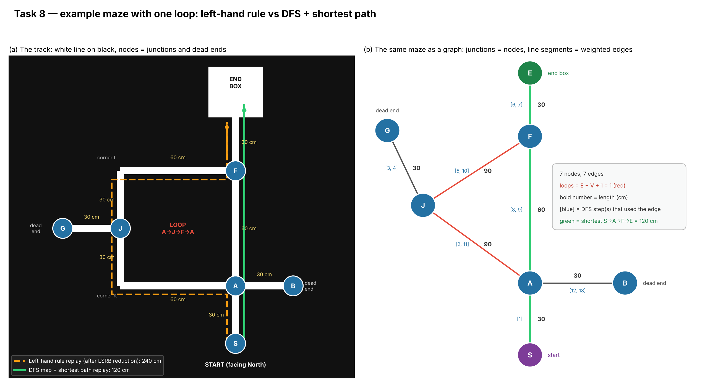
Figure 1: the example maze as a track (a) and as a graph (b). Lengths in cm.
How the track becomes a graph. Every place where the robot must decide (a junction), every dead end, the start and the end box become nodes. The line between two nodes, including any corners, becomes one edge, weighted by its length. Corners K and L are not nodes, because there is no choice to make there.
Node | Type | Exits (direction → neighbour, length)
S | Start | N → A, 30 cm
A | Cross-type junction | S → S 30 · E → B 30 · N → F 60 · W → J 90 (via corner K)
B | Dead end | W → A 30
J | T-junction | S → A 90 (via K) · W → G 30 · N → F 90 (via corner L)
G | Dead end | E → J 30
F | T-junction | S → A 60 · W → J 90 (via L) · N → E 30
E | End box | S → F 30

7 nodes and 7 edges, so 7 − 7 + 1 = 1 loop (A → J → F → A). The shortest route is S → A → F → E = 30 + 60 + 30 = 120 cm.

3. Worked traversal

3a. Left-hand rule (for comparison)
Step | What happens
Decisions recorded | A: L (into the long side of the loop) · J: L (to dead end G) · G: B · J: L · F: L (into the end box)
Turn string | L L B L L (exploration distance 300 cm)
Reduction | L·B·L → S, so L L B L L → L S L
Replay | S → A (L) → J (S) → F (L) → E = 30 + 90 + 90 + 30 = 240 cm

The reduction removed the dead end at G correctly, but it cannot see that A → F is a 60 cm shortcut. That edge was never driven, because the left-hand rule went round the long side of the loop. The replay is twice as long as necessary.

3b. DFS (Trémaux), left-first, exploring the whole maze
# | At | Facing | Turn | To | Reason
1 | S | N | S (only exit) | A | Start
2 | A | N | L | J | New junction; unexplored exits L, S, R: take L
3 | J | N | L | G | New junction; unexplored L, S: take L
4 | G | W | B | J | Dead end: turn back
5 | J | E | L | F | Back at J; only unexplored exit is L
6 | F | E | L | E | New junction; unexplored L, R: take L
7 | E | N | B | F | END BOX found: record it, turn back and keep mapping
8 | F | S | S | A | Back at F; take the last unexplored exit
9 | A | S | B | F | A was already visited and we arrived by a NEW edge: loop closed, turn back
10 | F | N | L | J | Every exit of F explored: backtrack the way we first came
11 | J | S | S | A | Every exit of J explored: backtrack
12 | A | E | S | B | A still has one unexplored exit (east): take it
13 | B | E | B | A | Dead end: turn back
14 | A | W | L | S | Every exit of A explored: backtrack to the start
15 | S | S | — | — | Back at start with every edge explored: map complete

3c. Shortest path on the finished map
The map now holds all 7 edges with their lengths. Dijkstra's algorithm from S gives S → A → F → E = 120 cm, compared with 240 cm for the left-hand replay. As turns, from the start facing North: A: straight, F: straight, then into the end box.

4. Exploration vs replay
Exploration (dry run) works in an unknown maze. At each junction it must detect the exits, choose one, record what it found, recognise loops and backtrack. It has to drive slowly enough to detect every junction reliably.
Replay (actual run) works on a known map, so it is much simpler:
- The route is computed once, before the run, as a fixed list of turns, such as "straight, straight, end".
- At each junction the robot just executes the next turn on the list. There is no decision-making, backtracking or map building.
- Because segment lengths are known (in an upgraded robot with encoders), it can speed up on long straights and brake just before each junction.
- If a junction is missed, the turn list falls out of step. Junction detection must therefore be as reliable in the replay as in exploration.

5. Pseudocode

Exploration: DFS / Trémaux with left preference
map = empty graph; visited = {start}; arrivedBy = edge(start -> first junction)
while true:
node = detectJunction() // exits seen on the left, straight and right
map.addNode(node, position, exits) // position from heading + distance
if node is END_BOX:
map.goal = node; turnBack(); continue // keep mapping
if node already visited and arrivedBy was a new edge:
turnBack(); continue // loop closed
unexplored = exits of node not yet driven, ordered Left, Straight, Right
if node is a dead end:
turnBack()
else if unexplored not empty:
take(unexplored[0])
else if node == START:
break // every edge explored
else:
take(edge by which we FIRST reached node) // backtrack
record edge length when the next junction is reached

Planning the replay: Dijkstra on the map
dist[start] = 0; queue = {start}
while queue not empty:
u = node in queue with smallest dist; remove u
for each edge (u, v, length) in map:
if dist[u] + length < dist[v]:
dist[v] = dist[u] + length; prev[v] = u; add v to queue
route = follow prev[] back from goal to start, then reverse
turns = for each junction on route: turn from incoming heading to outgoing heading

Replay
i = 0
followLine()
on every junction: execute(turns[i]); i = i + 1
on END_BOX: stop(); ledOn()

Fallback: turn-string reduction (loop-free mazes only)
Each rule removes a dead-end detour "X, B, Y" using turn angles L = 270°, S = 0°, R = 90°, B = 180° and keeping the sum modulo 360°.
Pattern | Becomes | Check (sum of angles mod 360°)
L B R | B | 270 + 180 + 90 = 540 → 180 = B (the README lists S, which is wrong)
L B S | R | 270 + 180 + 0 = 450 → 90 = R
L B L | S | 270 + 180 + 270 = 720 → 0 = S
S B L | R | 0 + 180 + 270 = 450 → 90 = R
S B S | B | 0 + 180 + 0 = 180 = B
R B L | B | 90 + 180 + 270 = 540 → 180 = B

6. Notes for the real competition
- If the dry run must end the moment the robot reaches the end box (to be confirmed with the organisers), DFS cannot finish mapping first. It then replays the shortest route on the part of the maze it has explored.
- On the PS sample arena, a left-first preference happens to explore the edges of the true shortest route (654 cm), while right-first does not (715 cm). The altered competition arena may differ, so the preference order is not a substitute for a map.
- Simulation code for the example: src/maze_sim/example_maze.py. Reference for wall-following and turn-string reduction: Pololu 3pi maze-solving guide.

