**New England Institute of Technology**

Video Game Development & Design

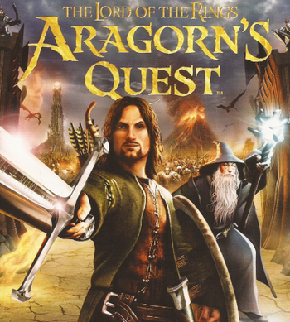

**Level 1: Quest 1 –**

Who are you?

**GDS 114: Introduction to Game Development**

Instructor:

Bill Culbertson, Professor

Introduction

Welcome to your first Quest. You find yourself on an 18-month journey, seeking knowledge in the **World of Games**. Gather, comprehend and employ that knowledge successfully and you will earn the title of **Game Maker.** Continue this quest successfully for an additional 18- months andyou will become the **Master Game Maker.**

Complete the questions below to begin your journey. You will not be judged by the content of your answers, rather by your willingness and commitment to answer them fully and truthfully. You are not alone on this journey, there are other players seeking the title and there are Wizards to teach and help you. There will be many challenges to meet and overcome. To gain the title, a candidate for **Game Maker** must be passionate and true to ways of the **World of Games**.

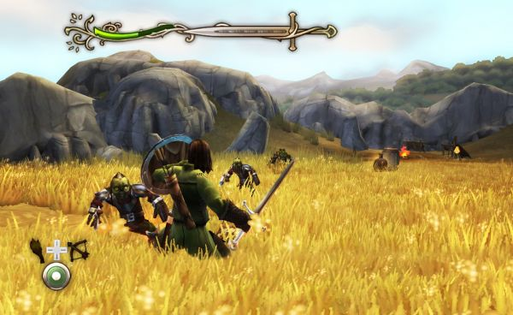

Section 1:

Who are you?

1) Why do you seek the title of **Game Master** and what is your career

goal?

I seek this title because I have been passionate about playing games through out my life. I also wish to be able to create, or help create, something that will mean something to many people.

2) Are you a video game player? What genre of games do you play?

What is your prime passion game - the game you live to play?

Of course I play video games, across several genres, but I would say that my favorite genre is JRPG’s. My favorite game of all time is Persona 5: Royal, but I consistently play Destiny 2.

3) On average, how many hours a week do you play the games?

I usually play games for an average of 20 to 30 hours a week.

4) Are you a board game player? If so, what games do you play?

I do not play a lot of board games, however I do play in, as well as run a Dungeons and Dragons campaign.

5) Are you interested in sports and if so, what teams are you loyal to?

I am not too interested in sports, but I usually end up watching the Super Bowl.

6) Are you an eSport fan? Are you an eSport player? Are you interested

in playing on the NEIT eSport team?

I do not really care for eSports, and I do not play eSports because I am terrible at most games when I have to compete against other people.

8) Do you like to cheat while playing games?  **No, I would never...**

9) Do you like to change the rules of games?  **Choose an item.**

10) Do you bet or gamble as part of games you play  **Choose an item.**

### Old Paper Background For Microsoft Word | Vintage paper background, Paper background, Old paper11) Rate your skill level playing these platforms:

### Platform:

### Xbox - 1- Noobish

### PS3/4 - 3 - A player

### PC - 3 - A player

### Wii/Wii U - 2- Can hold my own

### Mobile Apps - 2- Can hold my own

Other - Click or tap here to enter text.

### Games:

D&D - **5- Master of the house**

### Lord of the Rings - 3 - A player

Skyrim - **3 - A player**

Overwatch - **1- Noobish**

Fortnite - **1- Noobish**

Minecraft - **1- Noobish**

DotA 2 - **1- Noobish**

Counter-Strike - **1- Noobish**

Battlegrounds - **1- Noobish**

Call of Duty - **1- Noobish**

NBA 2K20 - **1- Noobish**

Madden NFL - **1- Noobish**

Borderlands - **4- Better than most**

Mortal Kombat - **1- Noobish**

Super Smash Bros - **4- Better than most**

Legend of Zelda - **4- Better than most**

League of Legends - **1- Noobish**

Rocket League - **2- Can hold my own**

Grand Theft Auto - **2- Can hold my own**

Super Mario - **2- Can hold my own**

Other - Click or tap here to enter text.

12) What factors about our program made you decide to come to NEIT for your education in Video Game development?

Not only did I choose NEIT’s Video Game Development program because of the knowledgeable and experienced staff, but also because of the reputation the program has. The shorter time to get a degree was certainly appealing as well.

Section 2:

Can you reason in the World of Games?

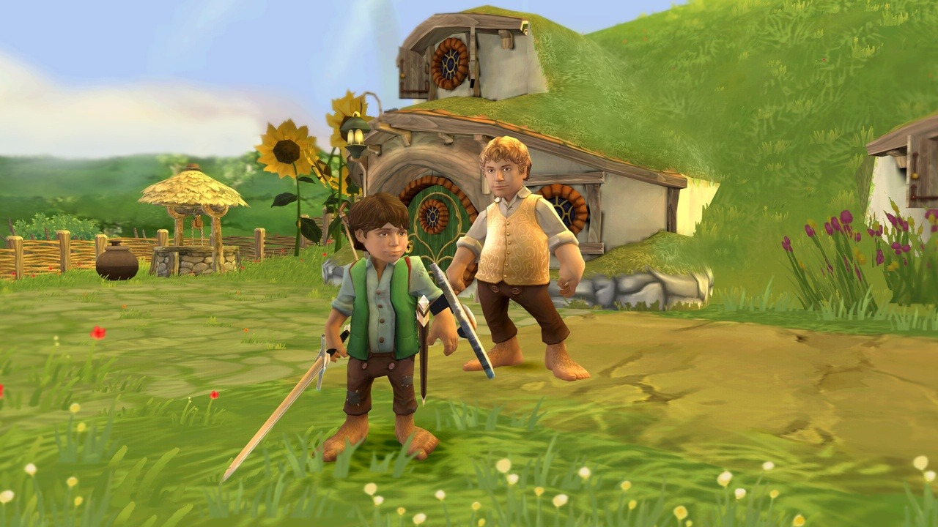In this part of Quest 1, you must prove your mind can function in the World of Games. You can not just play the games, you must know the games, know how they play, know how they succeed and know how they fail. Only by reason will you start the long journey to become **Game Maker**.

1) In your mind, select a video game that has had multiple versions or sequels

that you have played (Example: Zelda). What video game did you choose?

I selected the first Dark Souls game.

2) Close your eyes… think of playing the game you selected. See the game…

List at least 5 elements of the game that you liked and explain why:

The first thing that came to mind is the world design. Each level is interconnected, with many paths to many other levels, and can feel like navigating a large, 3d labyrinth. The second thing that comes to mind is the boss fights. All the fights are hard, but are also fair. Thirdly, the player has great freedom in how they fight. Heavy great swords are as viable as rapiers and magic. Next, the world building and story is told in a unique way. The player is only explicitly told the bare minimum and needs to go searching through item descriptions to piece together the rest of the story. Finally, the game does a great job of making the player not feel alone. The NPC’s scattered through out the world, and the shades of other players make the player feel some solace on a usually solo journey.

3) Not all is good. List at least 3 elements of the game that you disliked or would

 Improve in the game:

The combat can feel clunky, especially the doge roll. While locked on to an enemy, the player can only roll directly towards, away from, or the either side. No diagonal rolls can be performed while locked on to an enemy. Secondly, the game suffers from poor pacing in the second half. After obtaining a key item, the four main bosses are available to the player, and may be tackled in any order. These bosses do not scale to the player’s level, so the first one is extremely difficult, but that difficulty never rises. Finally, one of these four bosses is single handedly the worst part of this game. The Bed of Chaos breaks all the conventions set in the rest of the game. It is unfairly difficult, with random attacks coming out of nowhere that can instantly kill the player.

4) You know this game. You played this game. You played the different versions of

the game. How did the game evolve from the first version to the second… to

the third, etc.? Briefly describe how the game evolved in each incarnation

(story, appearance, etc.)

The second game in the series fixed the issuses with rolling in combat, but suffers due to having too many bosses (32 compared to the first game’s 22) at a much lower quality than the first game’s bosses. It also suffers due to a similar pacing issue as the first game, that is mitigated slightly by the fact that while some areas are open, they are much more difficult than others.

The third game in the series fixed all the issues with combat, but got rid of the interconnected world design. However, none of the bosses are as bad as some of the second game’s, which is an improvement.

5) In the World of Games, we must have order. We must have structure…

everything in its place. What genre does this game belong to? List the genre

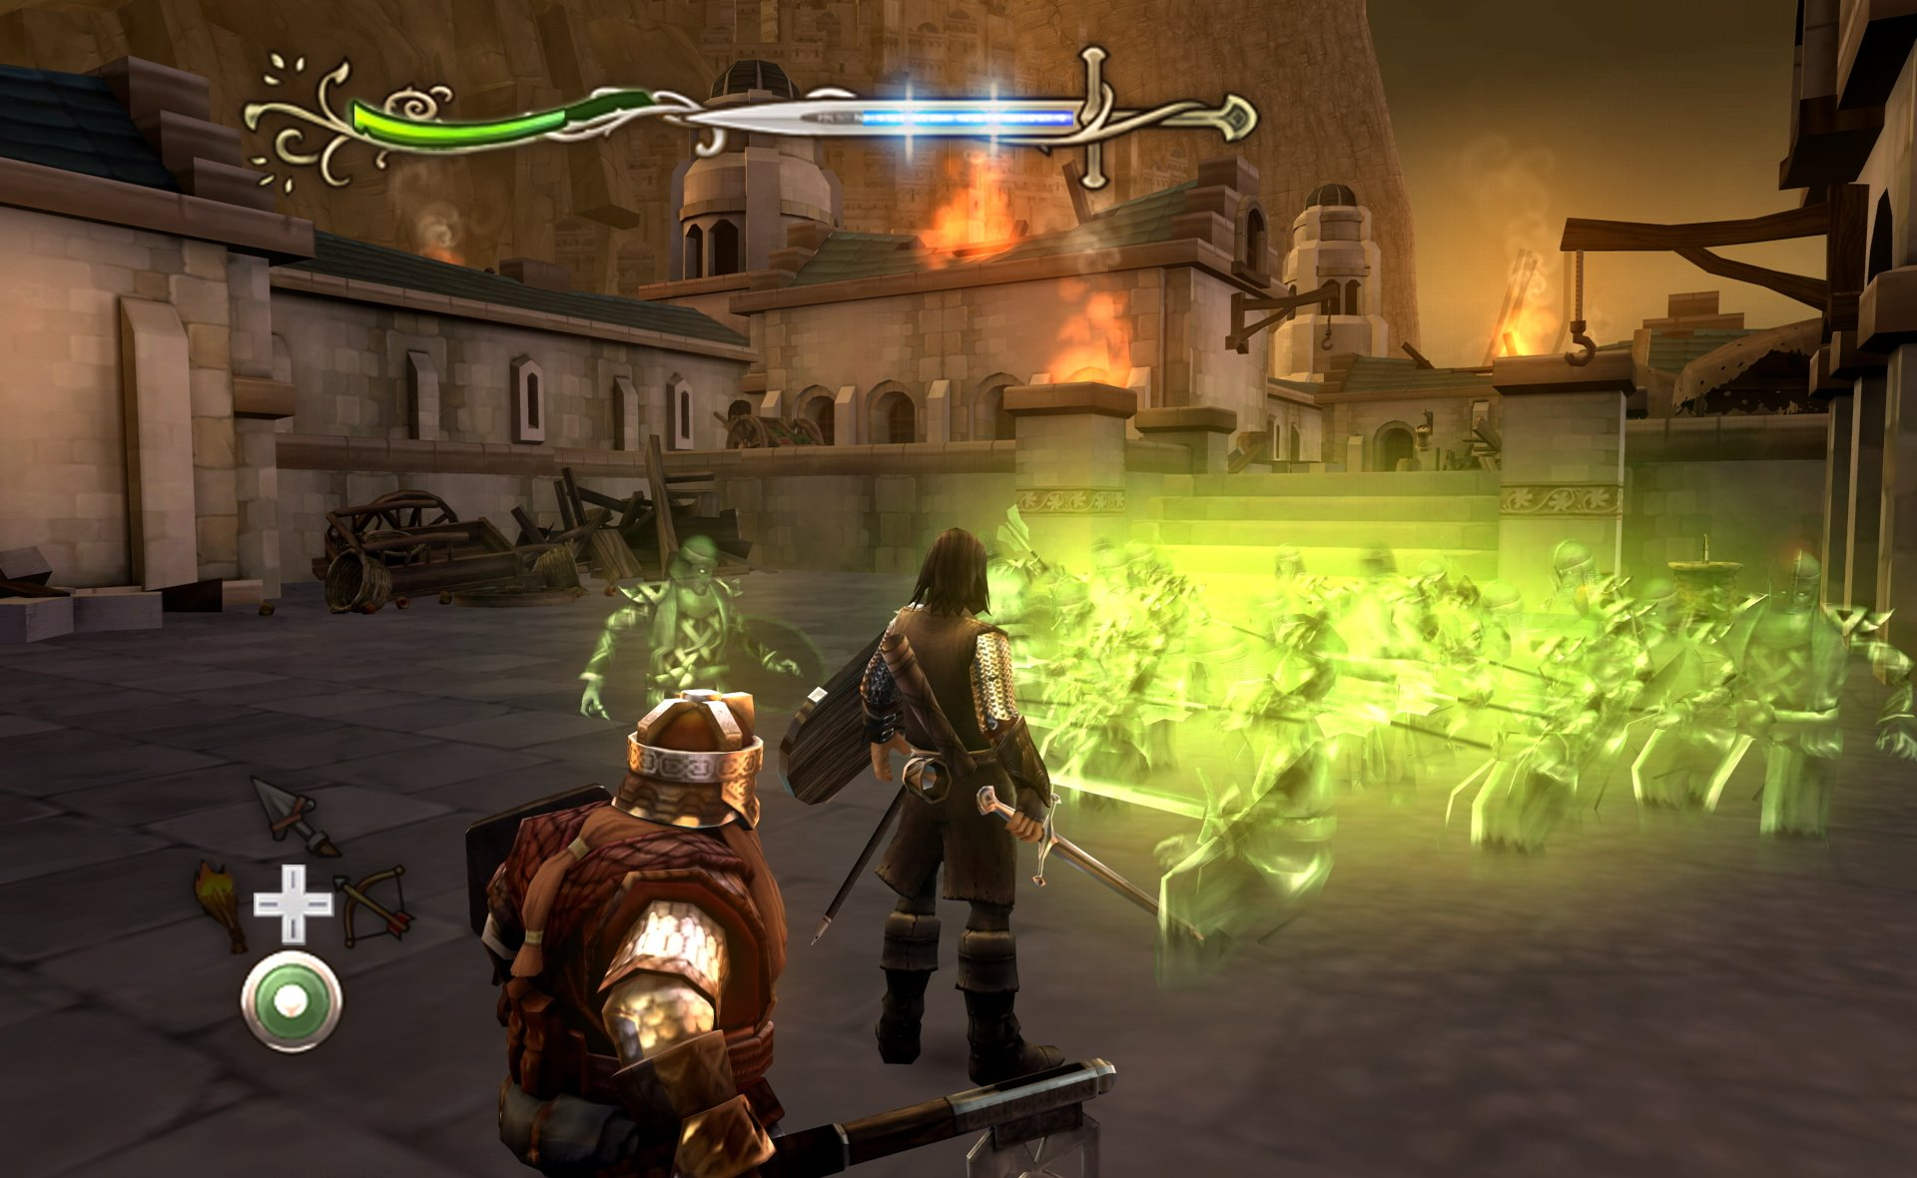 and the versions of the game:

While these games are technically JRPG’s, they are much closer to Western Action RPG’s.

This Quest has meaning.



Remember, you are in college. When we award a graduating student a diploma,

it means something. We do not just hand them out, you need to earn it.

Completing this Quest –

Due before class, Week 2

Submitting you Quest Document to Canvas.

* Save the file using the SaveAs option. Re-name the file using this filename

format convention: Lastname_114-xx_Quest1.docx

* Replace “Lastname” with your actual last name.
* Replace the xx with your class section number
* Failure to name your file correctly will result in a 10-point deduction.
* Submit to Canvas in the Submissions area of Week 1

(“Quest 1 Submission Area”)

* Make sure you submit it to the correct location, 10-points deduction if you submit it in the wrong place.

• If you submit the document more than once (you updated it), the last

submitted version will be the one graded.

• Late submissions will not be graded, they will receive a zero grade.

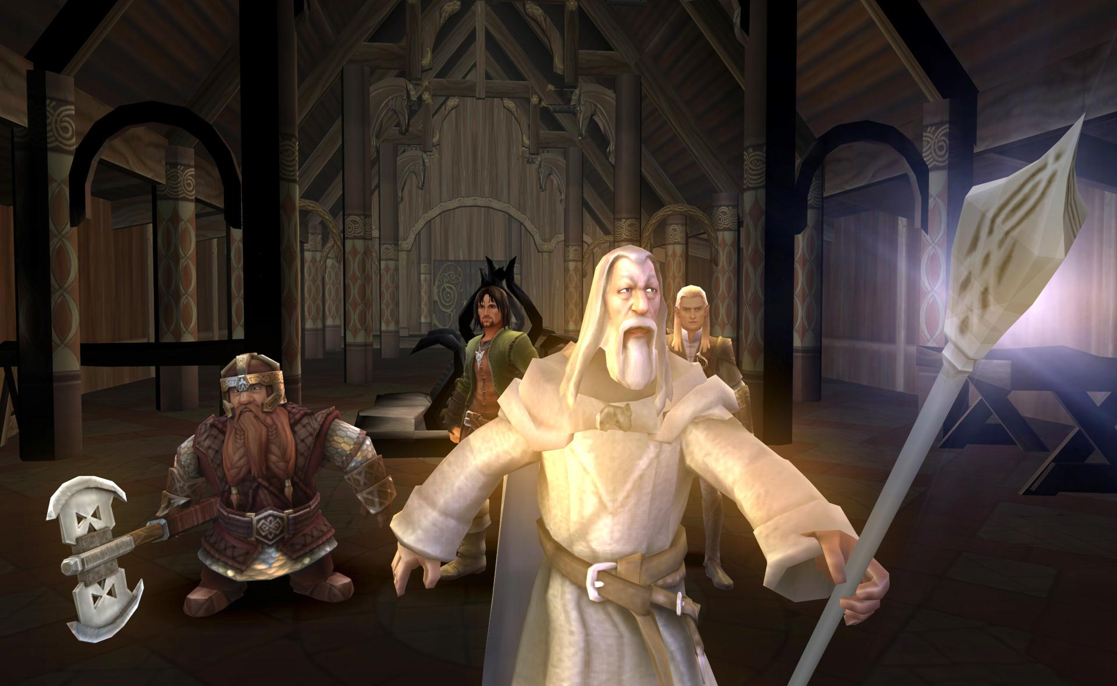Tips From A Wizard for written submissions in the Video Game Program:

1) You are in college. You are expected to write as a college student.

2) When reading instructions or documents… READ them carefully!

3) When asked to discuss or explain, write an answer that addresses

the request. Elaborate and explain your answer.

4) The format and layout you use is as important as the content.

Present your work in a professional manner. This is college.

5) Always use proper grammar and sentence structure.

6) Check for typos and misspellings: Use spell-checker!



7) Do not submit sloppy of half-hearted work. You will not be fooling

anyone here and will be graded accordingly or not graded at all.

8) Take time to review and proof-read your work.

9) No IM-style writing: convert to plain English.

10) No slang or profanity – anywhere!

11) Observe the instructed parameters for a submission. The

parameters are there for a reason, do not create your own format.

12) Take advantage of the school’s Academic Skills Center for help in

completing assignments or creating good study habits.

13) Do your work sooner than later. Last minute work typically will not

be your best work.

14) When you finish an assignment, set it aside and let it sit. Later, re-

read and assess the completed assignment for changes and

corrections.

15) Re-read the instructions before submitting the assignment. Did you do what was actually required or what you thought was required?

Lastly, be passionate about your education. Everything you do during this time should be the very best you can do. What you do not will determine who you will become. Be a **Game Make**r!