Typescript
NodeJS Install
npm -version
6.14.13
D:\CGI-UI-Development\08-Typescript>npm -version
6.14.13
>npm install -g typescript
D:\CGI-UI-Development\08-Typescript>tsc --init
file with :
TS1-App.ts
console.log("My Typescript First Program");
-- Compile TS file
D:\CGI-UI-Development\08-Typescript>tsc TS1-App.ts
Run Js file
D:\CGI-UI-Development\08-Typescript>node TS1-App.js
My Typescript First Program

Angular

Introduction to Angular
- Angular is a platform and Framework for building single-page client applications using and Typescript
- Angular is write in TypeScript.
- The Basic Building blocks of Angular framework are Angular components that are organized into NgModules.
Angular 7 Environment Setup
- NodeJs
- Npm
- Angular CLI
- IDE for Writing Code

Angular 7 CLI (Command Line Interface)
- Angular CLI makes it easy to start with any Angular Project
- Angular CLI comes with commands that help us create and, on our project, very fast(Create a project , a Component and Service , Routing ,Change the port etc..)
- To work with Angular CLI , We need to have installed NodeJS
Link :
After Install check versions

D:\CGI-UI-Development\09-Angular7>npm --version
6.14.13

D:\CGI-UI-Development\09-Angular7>node --version
v14.17.0
D:\CGI-UI-Development\09-Angular7>npm install –g @angular/cli

We can create new project and we can run the project using:
- ng new <projectname>
- cd projectname
Create New Angular Project
D:\CGI-UI-Development\09-Angular7>ng new A1-First-App
D:\CGI-UI-Development\09-Angular7>cd A1-First-App
Run Angular Project
D:\CGI-UI-Development\09-Angular7\ A1-First-App>ng serve
ng serve: will compile and we can see the ouput of our project in the browser
http://localhost:4200
4200 is the default port used when a new project is created
We will get by default Page of Angular : Page
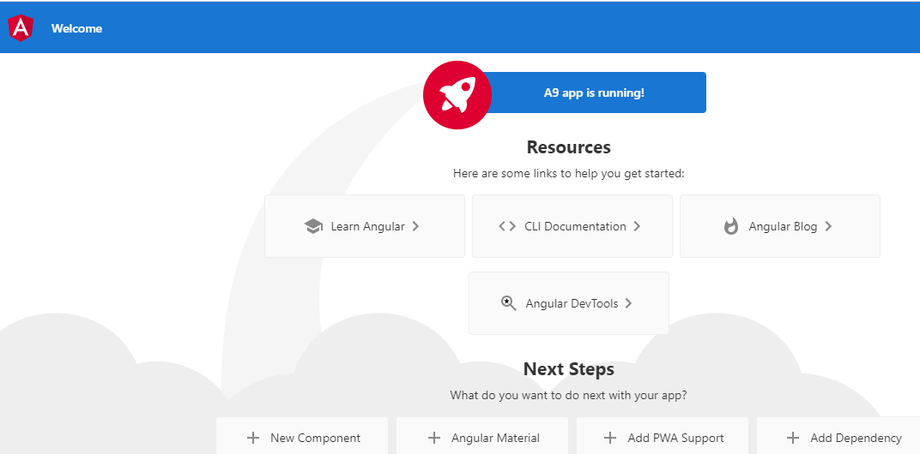

How to change PORT no:
>ng serve –port 4211
Below files are created by Angular (location : src/app)
- app.component.css
- app.component.html (root html)
2. app.component.ts (root component)
1. module.ts (root module)

How can we develop angular application :
changes in the files are :

- app.component.html
- app.componenet.ts
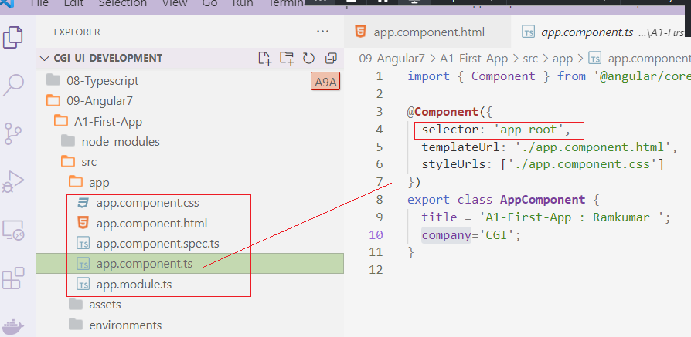

What is Interpolation ?.
Interpolation is used display a component
property in the respective view template with
double curly braces syntax
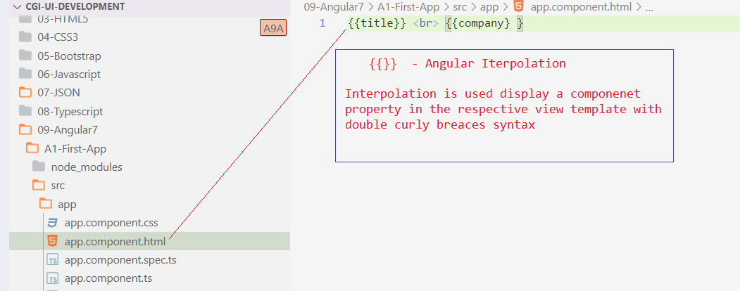

inline template:
An inline HTML template for a component is defined using template config in @Component decorator

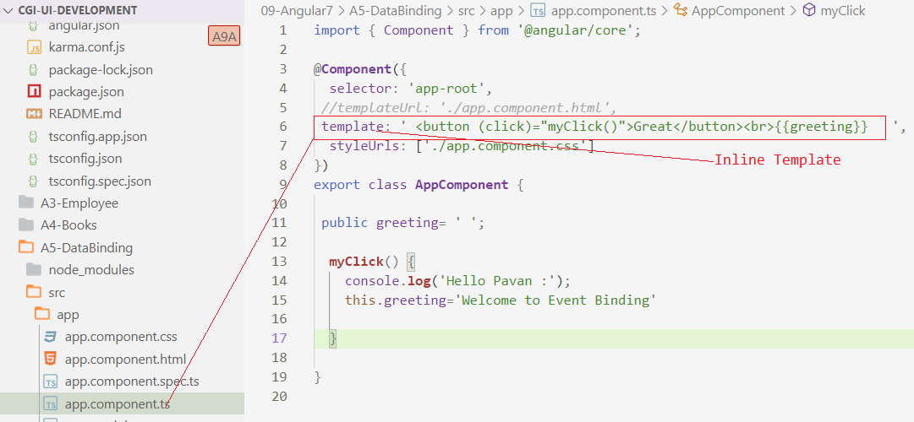
Data binding :
Data binding is a core concept in Angular and allows to define commutation between a component and the DOM
- From the component to the DOM
Interpolation : {{value }} : Adds the value of a property form the component
{{title}}

Property binding
<input type=”email” [value]=”email”;>
template: 'Name : <input [id]="myId" type="text value="Ram"',
public myId="textId";
Event binding :
For the DOM to the component
When a specific DOM event happened(eg : click ,change ,key ups
Call the specified method in the component

@Component({
selector: 'app-root',
//templateUrl: './app.component.html',
template: ' <button (click)="myClick()">Great</button><br>{{greeting}} ',
styleUrls: ['./app.component.css']
})
export class AppComponent {

public greeting= ' ';

myClick() {
console.log('Hello Pavan :');
this.greeting='Welcome to Event Binding'

}

}

Two way data binding
ngModel is Directive :
Part of the Angular “FormsMoudle” and has to imported into your module manually.
- In two-day data binding, automatic synchronization of data happens between the Model and the View
- Change is reflected in both components. Whenever we make changes in the Model, it will be reflected in the view and when we make changes in view, It will be reflect in Model.
- This happens immediately and automatically, ensures that the HTML template and the Typescript code are updated at all times.
- In two-way data binding, property binding and event binding are combined together.
[(ngModel)] = “[property of your component]”
Model - View
[(ngModel)]
View – Model
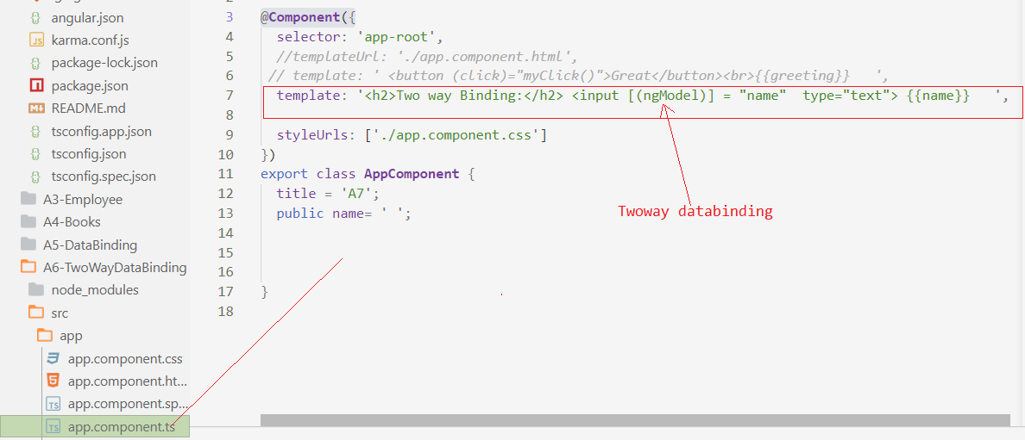
D:\CGI-UI-Development\09-Angular7>
D:\CGI-UI-Development\09-Angular7>

Modules :
Module refers to a place where you can group the components, directives, pipes and service which to the application
When we are developing a website the header , footer, left, center and the right section become part of a module
To define Module, NgMoudle is used
In app.module.ts (it is created by default)

If we Open (app.module.ts)
It has some libraries which are imported and also a declarative which is assigned the appcomponenet
Angular –Cli has used these defualt librabries for the import angular/core , @angular/platform-browser
Imported and saved into variables such as declarations,imports ,providers
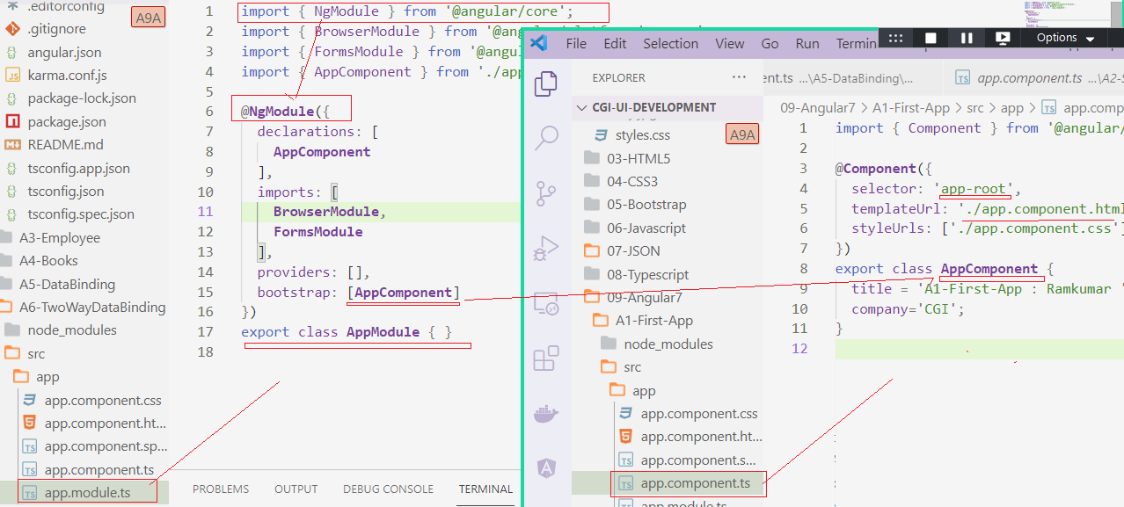

Declarations :
Declarations, the reference to the component is stored.
AppComponent is the default component that is create whenever a new project is initiated
imports

This will have the Module imported
Present, BrowserModule is part of the imports which is imported form @angular/platform-browser

providers
This will have the modules imported
At present BrowserModule is part of the mport which is imported form @angular/platform-browser
Bootstrap:
bootstrap: [AppComponent]
This has reference to the default component created
AppComponent.

Components :
- Every Angular application has at least one component, that is root component (app.component.ts)
- Each Component defines a class that contains application data and logic and is associated with an HTML template that defines a view to be displayed in a target environment
@Component() decorator
- The @Component() decorator identifies the class immediately below it as component and provides the template and related component specific metadata.

Decorators are functions that modify Java script classes. Angular defines a number of decorators that attach specific kinds of metadata to classes. So that the system knows what those classes mean and how they should work.

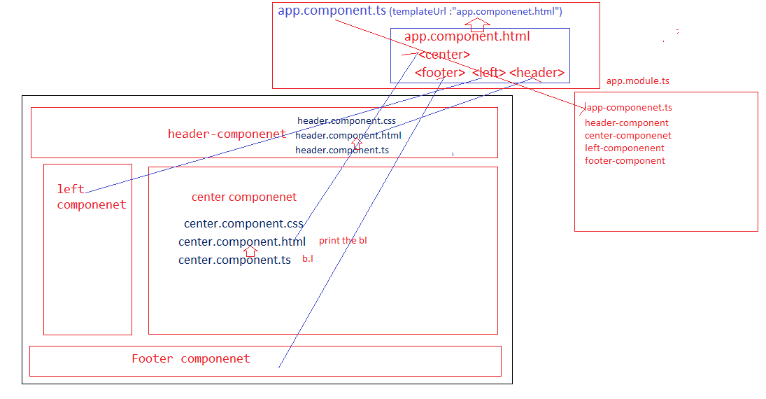
A Component Made up of 3 parts :
- selector: 'app-root',
- templateUrl: './app.component.html',
- styleUrls: ['./app.component.css']

Selector:
Basically, custom html tag that can represent this component
Template URL :
Points to html file that represents view for this component
styleUrls:
which points css files
class: which is nothing but code supports view this is creating typescript data and methods
Create component :
D:\CGI-UI-Development\09-Angular7\A10-Components>ng generate component header

CREATE src/app/header/header.component.html (21 bytes)
CREATE src/app/header/header.component.spec.ts (626 bytes)
CREATE src/app/header/header.component.ts (275 bytes)
CREATE src/app/header/header.component.css (0 bytes)
UPDATE src/app/app.module.ts (396 bytes)

Angular Files and Folders
(.ts) typescript file
(.js) javscript file
(.json) json file

Folders:
Node modules

