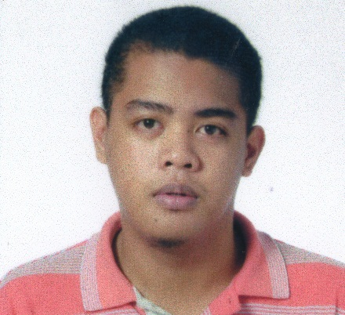**LEO MARAPOC**

Purok Sampaguita

Cogon, Ormoc City

Leyte, Philippines

09482086635

**beboymarapoc@gmail.com**

**PERSONAL INFORMATION**

Birth Date: July 27, 1992

Gender: Male

Status: Single

Nationality: Filipino

Religion: Roman Catholic

**SKILLS**

1. Computer Operations – able to operate Microsoft operation systems.
2. Computer Programming – able to create basic program using Java, Visual Basic, Turbo C
3. Computer Encoding – able to use Microsoft Application (MS Word, MS PowerPoint, MS Excel)
4. Computer System Troubleshooting – able to perform Computer system Maintenance and repair.
5. Digital Image Processing – able to perform basic Photoshop Operation, Macromedia Flash 8, Sony Vegas pro.

**EDUCATION**

Elementary Education : Cogon Central School

Brgy. Cogon, Ormoc City

Secondary Education : Alternative Learning System (ALS)

Ormoc City

College Education : Western Leyte College (WLC)

Degree: Bachelor of Science in Information

Technology (BSIT)

1. Bonifacio St., Ormoc City, Leyte

**AFFILATIONS**

Member - Kabalikat Civicom, Ormoc City Chapter (January 2006 - Present)

Member – Commission on Youth, Mother of the Redeemer Parish (April 2006 - Present)

Member – Dynamic Organization Innovative Computer Enthusiasts (2013 - Present)

**SEMINARS AND TRAINING ATTENDED**

Youth Leadership Training - August 13. 2006

Road Safety Education, Anti-Car napping - October 29, 2009

& other Related Laws Seminar

(Held at Palompon, Leyte)

Radio Communications Courtesy - October 29, 2009

Procedure

(Held at Palompon, Leyte)

2nd Leyte-Samar IT Summit (LESIT) 2013 - September 6, 2013

(Held at Western Leyte College, Ormoc)

Statistics Month seminar - October 27, 2013

(Held at Eastern Visayas State University)

Thesis & Capstone Project for BSCS & BSIT - August 1 – 3, 2014

Student

(Held at Western Leyte College, Ormoc)

**CONTESTS ATTENDED**

3rd Robotics, Web Programming Festival

and Eastern Visayas ICT Expo 2015

(Held at Tacloban City) - Oct.7, 2015

**REFERENCES**

Mr. Joscoro E. Cantero

Instructor, Western Leyte College of Ormoc, Inc.

Telephone: 09219928804

Mr. Francis Rodolfo Quirino Jr.

Instructor, Western Leyte College of Ormoc, Inc.

Telephone: 09435250889

Mrs. Cheryl M. Tarre

Dean, Western Leyte College of Ormoc, Inc.

Telephone: 09399150493