Bella Sheridan
PSP Design Form

Use this form to record whatever you do during the design phase of development. Include notes, class diagrams, flowcharts, formal design notation, pseudocode, or anything else you consider to be part of designing a solution that happens BEFORE you write program source code. Attach additional pages if necessary.

Use examples of decomposition and hierarchy provided in slides for the topic “Handling Software Complexity – Decomposition and Hierarchy”.

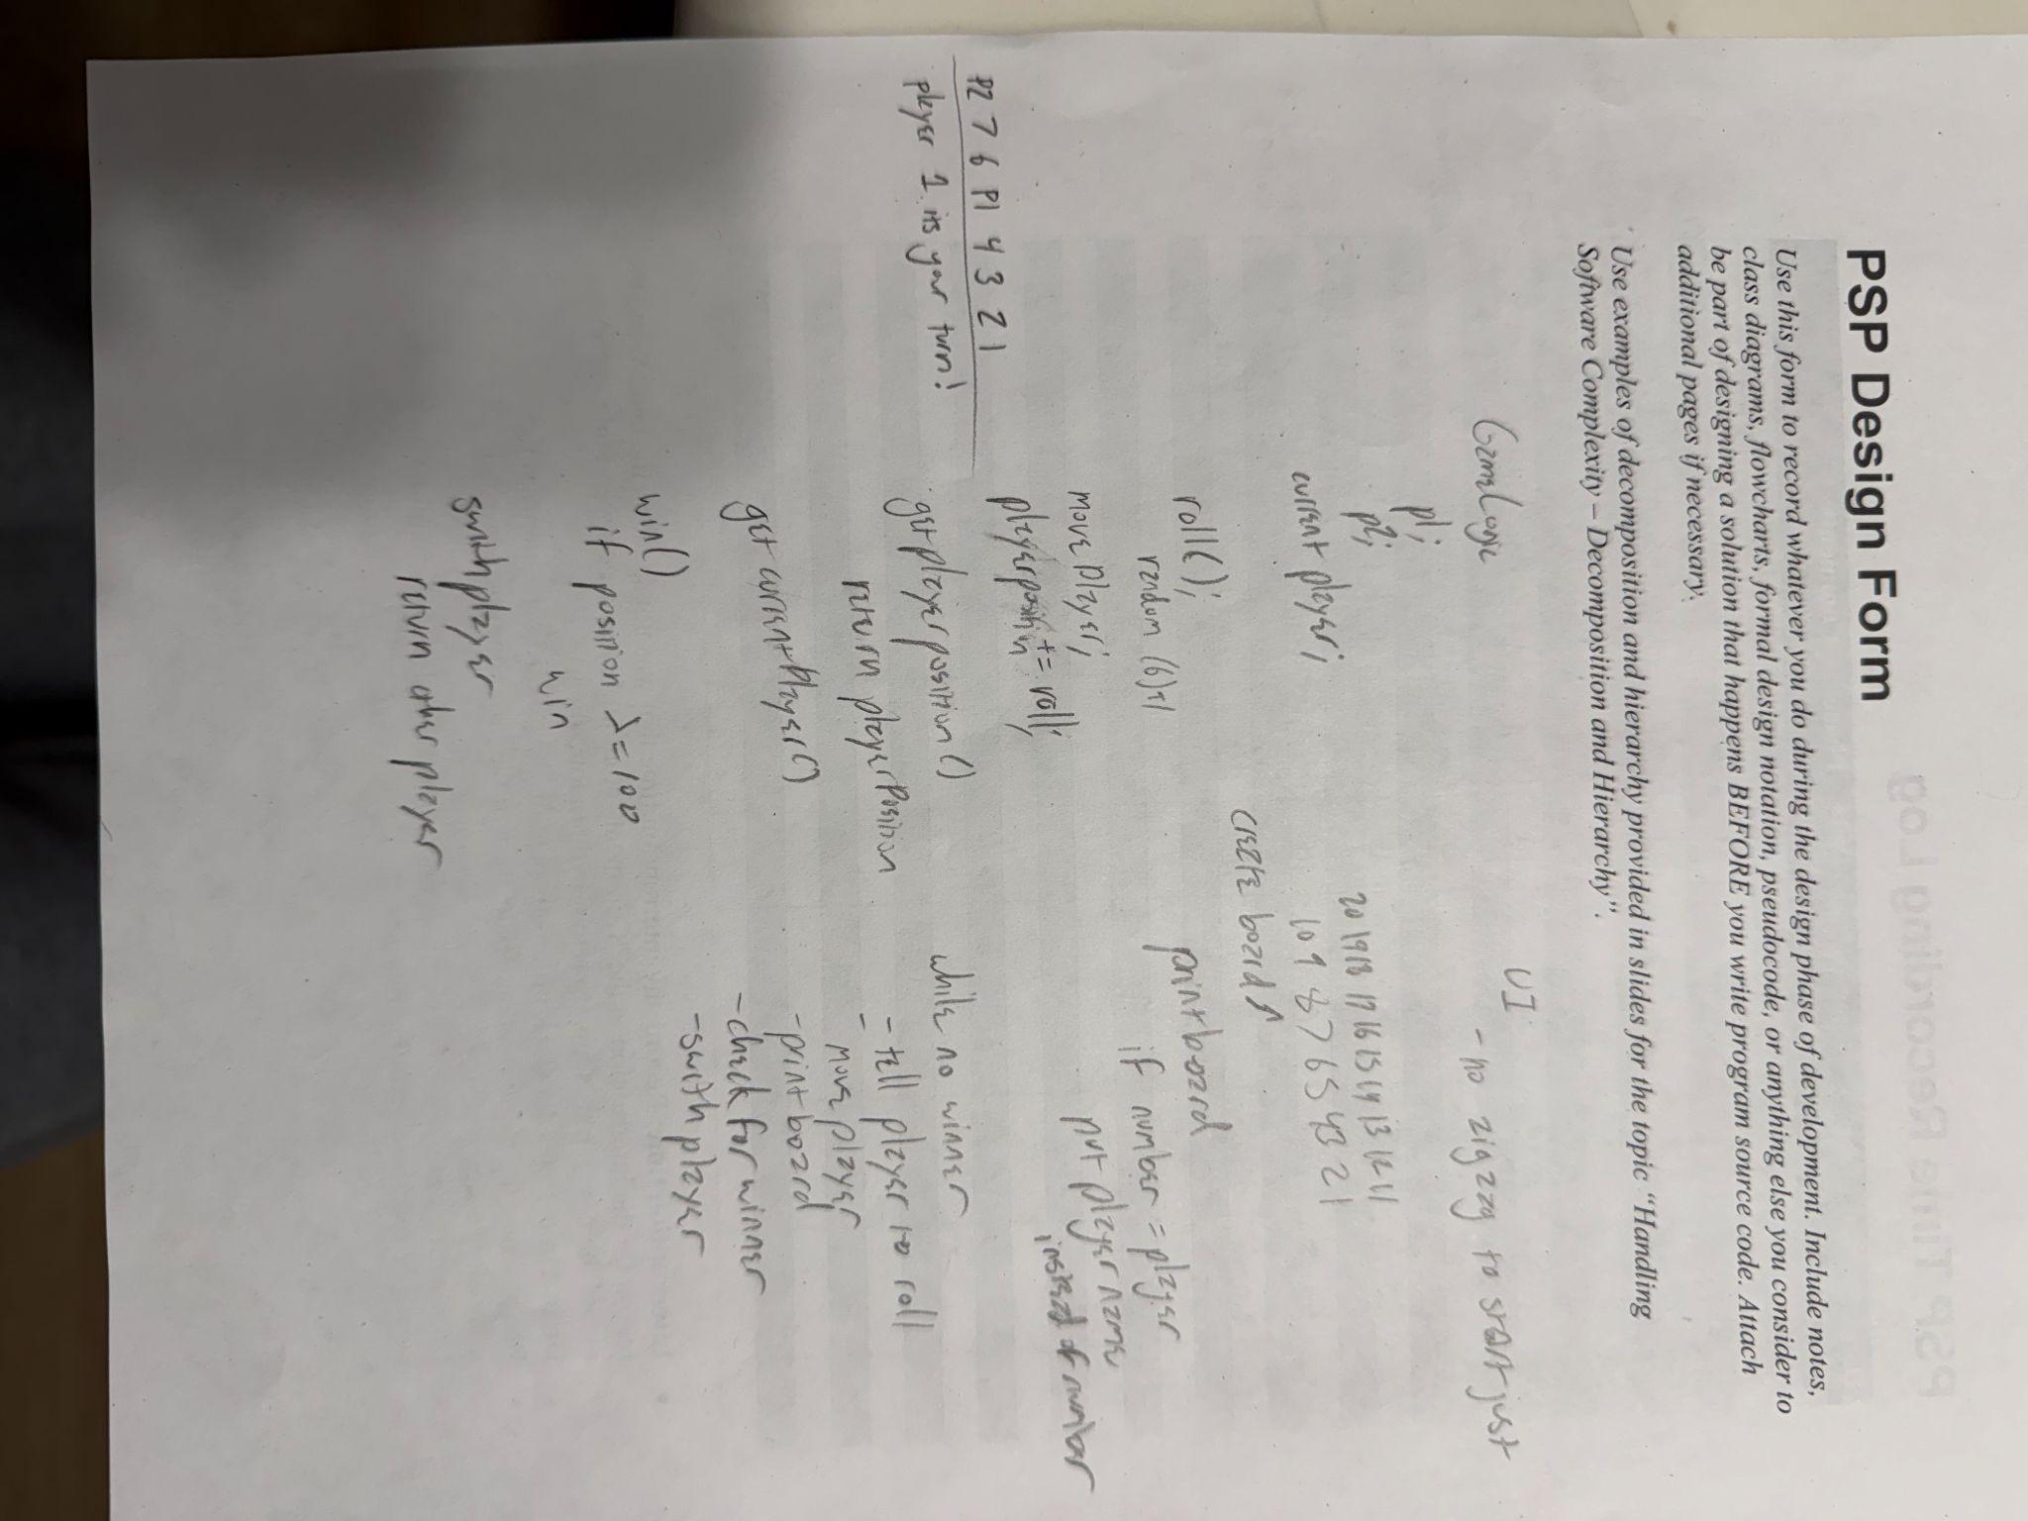

PSP Time Recording Log

Date | Start | Stop | Interruption Time | Delta  Time | Phase | Comments
1/23 | 3:27pm | 3:35pm | 0 | 8 | Plan | Planned how i would start
1/23 | 3:36pm | 4:08pm | 10 | 32 | Design | Did research to refresh memory
1/24 | 10:57a | 11:42a | 18 | 27 | Design | Looked at stackoverflow for ideas
1/24 | 2:12pm | 3:21pm | 10 | 59 | Code | Made files and filled in gameLogic
1/24 | 3:22pm | 3:24pm | 0 | 2 | Compil | Check gameLogic for errors
1/24 | 3:25pm | 3:50pm | 5 | 20 | Code | Fix syntax and method errors
1/24 | 10:57p | 11:17p | 3 | 17 | Code | Look at gamelogic and start ui
1/24 | 11:17p | 11:39p | 2 | 10 | Design | Got confused on board so planning again
1/25 | 5:25pm | 6:16pm | 11 | 40 | Code | Continue making and printing board
1/25 | 6:17am | 6:22pm | 0 | 5 | C/Test | Test board
1/25 | 10:03p | 11:03p | 20 | 35 | Code | Start filling out main method
1/26 | 2:27pm | 2:32pm | 0 | 5 | C/Test | Check for ui bugs
1/26 | 2:32pm | 3:16pm | 12 | 32 | Code | Fix errors and continue on main
1/26 | 3:17pm | 3:27pm | 0 | 10 | C/Test | Test and keep track of ui for errors
1/26 | 3:45pm | 4:00pm | 0 | 15 | Code | Fix roll() error and check
1/26 | 4:05pm | 4:17pm | 0 | 12 | Test | Confirm everything works

- Interruption time: Record any interruption time that was not spent on the task. Write the reason for the interruption in the "Comment" column. If you have several interruptions, record them with plus signs (to remind you to total them).
- Delta Time: Enter the clock time you spent on the task, less the interrupt time.
- Phase: Enter the name or other designation of the programming phase being worked on. Example: Design or Code.
- Comments: Enter any other pertinent comments that might later remind you of any details or specifics regarding this activity.

PSP Defect Recording Log

Serial No. | Date | Defect Type No. | Defect Inject Phase | Defect Removal Phase | Fix Time  (duration) | Fix Ref | Description
001 | 1/24 | 20 | Code | Code | 1 | NA | Used && instead of ||
002 | 1/24 | 80 | Code | Compile | 2 | NA | Didnt have extra return in getPlayerLocation
003 | 1/24 | 100 | Code | Compile | 2 | NA | Created random but forgot to import
004 | 1/25 | 40 | Code | Test | 15 | NA | Called roll twice leading to improper data
005 | 1/25 | 20 | Code | Test | 5 | NA | Made bounds for loop wrong
006 | 1/25 | 40 | Code | Compile | 1 | NA | Used wrong name for row variable
007 | 1/25 | 60 | Code | Compile | 4 | NA | Declared String text outside the loop
008 | 1/25 | 100 | Code | Code | 12 | NA | Improperly spaced squares
009 | 1/26 | 100 | Design | Code | 10 | NA | Printed things in confusing order
010 | 1/26 | 40 | Code | Code | 15 | NA | Was improperly calling the things i needed to use from GameLogic
011 | 1/26 | 100 | Design | Code | 17 | NA | Tried to print zigzag but couldnt figure it out

Instructions
- Serial No.: The unique id you associate with the defect; allows you to reference it later.
- Defect Type No.: The type number of the type—see the PSP Defect Type Standard table below and use your best judgement.
- Defect Inject Phase: Enter the phase (plan, design, code, etc.) when this defect was injected using your best judgment.
- Defect Removal Phase: Enter the phase during which you fixed the defect.
- Fix Time: Enter the amount of time that you took to find and fix the defect.
- Fix Ref: If you or someone else injected this defect while fixing another defect, record the number of the improperly fixed defect. If you cannot identify the defect number, enter an X. If it is not related to any other defect, enter N/A.
- Description: Write a succinct description of the defect that is clear enough to later remind you about the error and help you to remember why you made it.

PSP Defect Type Standard
Type Number | Type Name | Description
10 | Documentation | Comments, messages
20 | Syntax | Spelling, punctuation, typos, instruction formats
30 | Build, Package | Change management, library, version control
40 | Assignment | Declaration, duplicate names, scope, limits
50 | Interface | Procedure calls and references, I/O, user formats
60 | Checking | Error messages, inadequate checks
70 | Data | Structure, content
80 | Function | Logic, loops, recursion, computation, function defects
90 | System | Configuration, timing, memory
100 | Environment | Design, compile, test, or other support system problems

Project Summary

Time in Phase
Phase | Actual time (in minutes) | % of total time
Planning | 8 | 2
Design | 69 | 22
Code | 203 | 65
Test | 32 | 11
Postmortem | 0 | 0
TOTAL | 312 | 100

Defects Injected
Phase | Actual defects (defect count) | % of total defects
Planning | 0 | 0
Design | 2 | 18
Code | 9 | 82
Test | 0 | 0
Postmortem | 0 | 0
TOTAL | 11

Final Summary
Metric | Value
Program Size (Lines of Code—LOC) | 171
Productivity (calculated by LOC/Hour) | 32
Defect Rate (calculated by Defects/KLOC) | 64.3

Reflection Questions
(provide 100-150 word response to each of the following questions)

- In which phase did you spend the most effort? What factors contributed to this distribution of time?
I spent the most effort in the coding phase. This was mostly due to the game UI and figuring out how to create and print the board. I spent a lot of time trying to figure out how to get the board to zig-zag but I struggled a lot and am going to try and attempt it again later. Debugging also added a lot of time to my process as it has been over a semester since ive used java so it took some time to adjust again. It also took me a minute to remember how to get two different files to interact with each other, but I eventually figured it out and now I feel more comfortable with it.

- In which phase did you introduce the greatest number of defects, and what patterns or causes do you notice?

The greatest number of defects were introduced in the coding stage. Most of these errors were logic errors like wrong player movement, switching players, or printing the board wrong. These problems often went unnoticed until I compiled the code or looked at it closer but eventually I caught all of them. Many of them were also syntax or name errors caused by me forgetting what I had called things in my code.

- How useful did you find it to follow a systematic process and track your effort and defects? What insights did this give you about your personal development practices?

I think that the tracking process is good and I understand why it is important and can help us in software development but I definitely find it a little difficult to do. When I am working on something I don’t like having to look away from it to record things it distracts me and makes it more likely for me to pull out my phone honestly. I do think I will get better at it as we go along though, it showed me the types of errors I make most often and helped me realize the areas I need to improve.

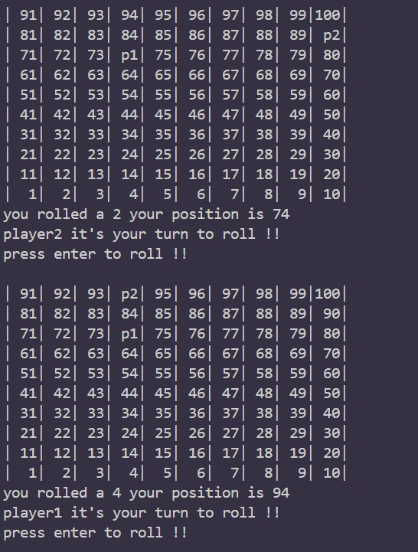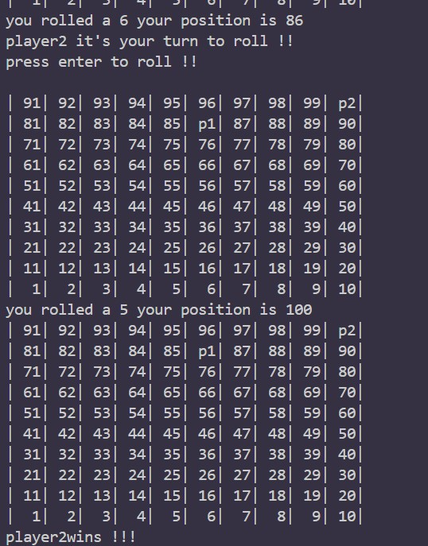

LOC stands for lines of code.
KLOC stands for kilo lines of code (1000 lines)

