Conceptual Design (sketch your high-level design here)

Module Estimates
Module Description | Estimated Size
GameLogic | 3
GameUILogic | 2
PrintBoard | 1
Total Estimated Size: | 6

PSP Design Form

Use this form to record whatever you do during the design phase of development. Include notes, class diagrams, flowcharts, formal design notation, pseudocode, or anything else you consider to be part of designing a solution that happens BEFORE you write program source code. Attach additional pages if necessary.

Use examples of decomposition and hierarchy provided in slides for the topic “Handling Software Complexity – Decomposition and Hierarchy”.

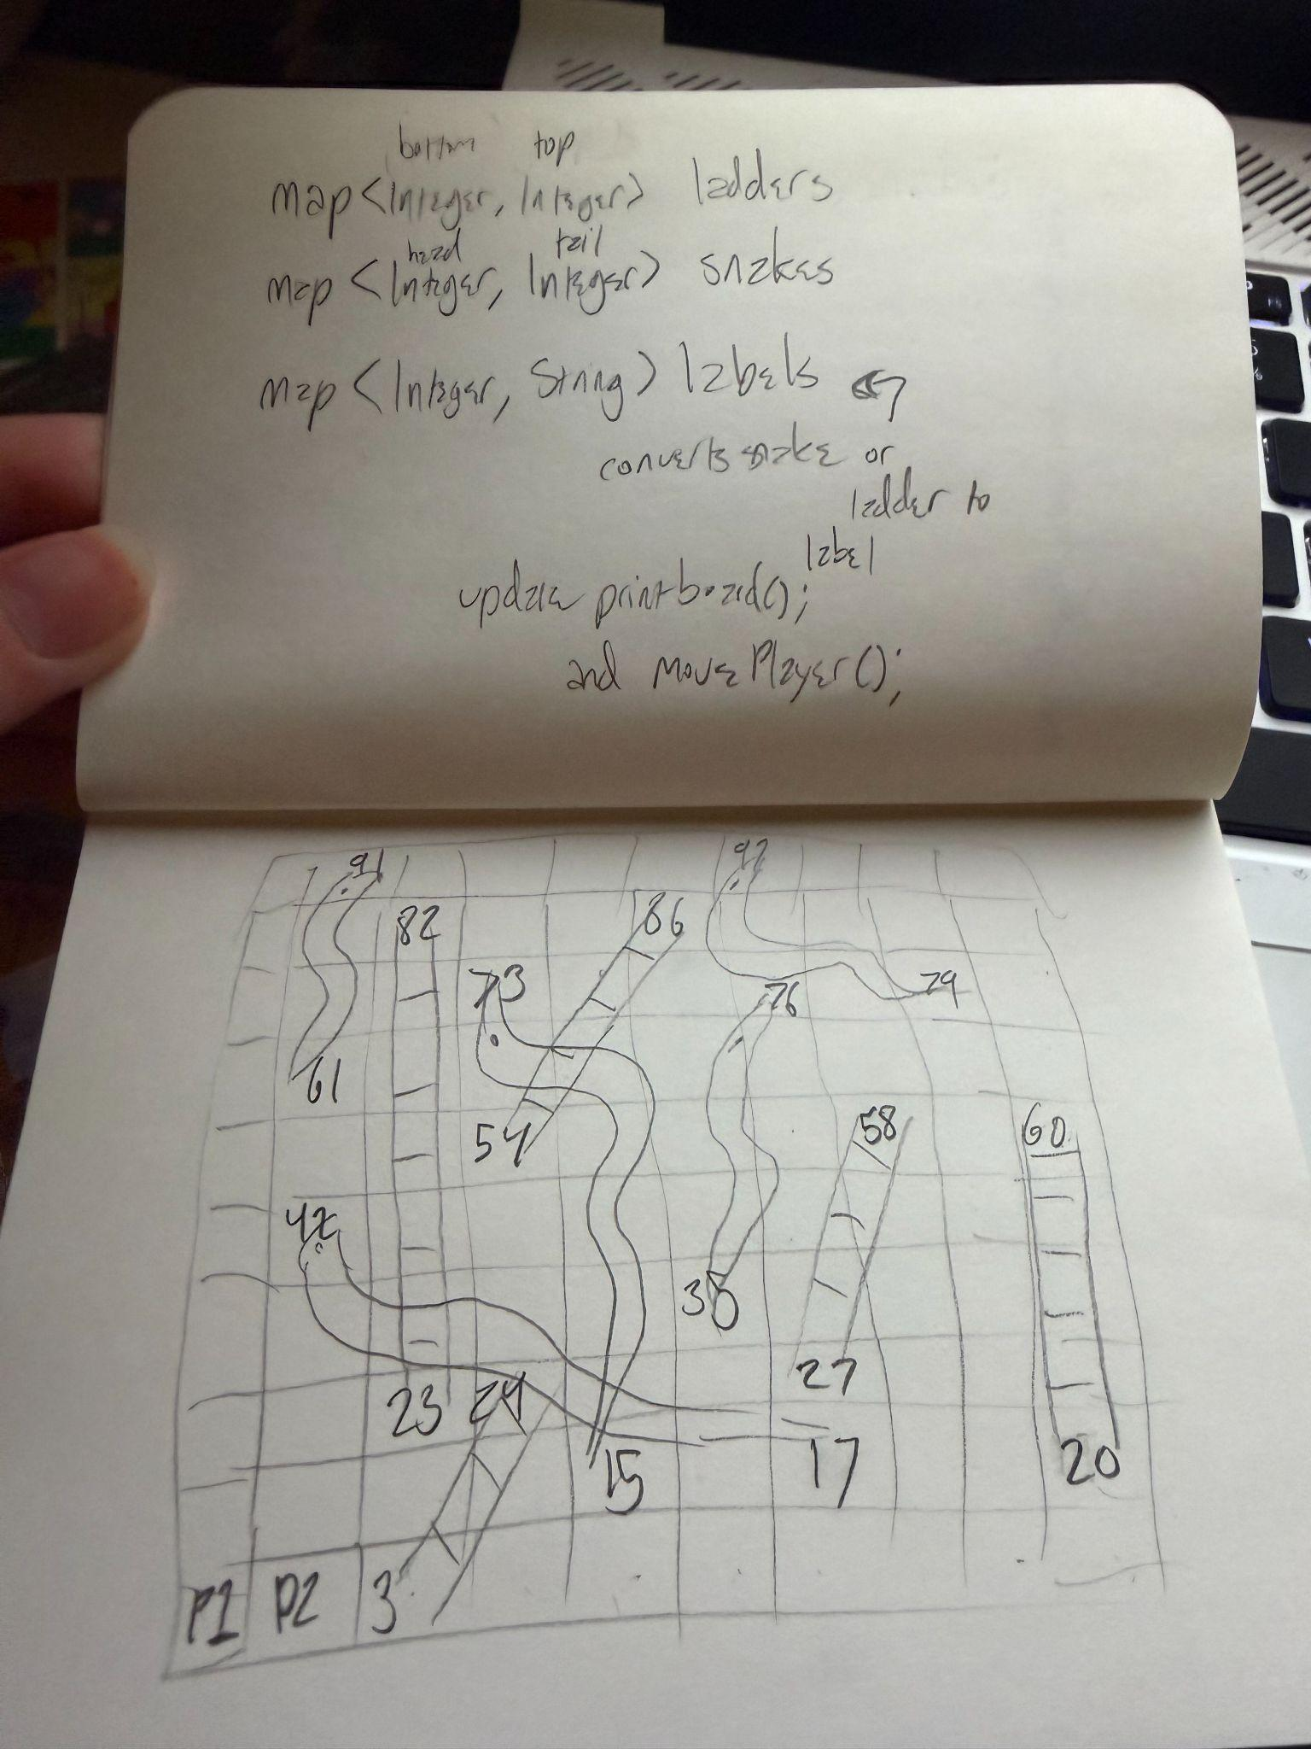

PSP Time Recording Log

Date | Start | Stop | Interruption Time | Delta  Time | Phase | Comments
2/9 | 10:55am | 11:14am | 0 | 19 | Planning | Went over my existing code and decided to use a hashmap for the snakes and ladders and labels for the UI
2/9 | 11:15am | 11:20am | 0 | 5 | Design | Filled out my PSP design form
2/9 | 2:36pm | 3:11pm | 4 | 31 | Code | Did the snakes and ladders game logic
2/9 | 3:15pm | 3:21pm | 0 | 6 | Test | (more looked over than test because the ui wasnt set up)
2/9 | 3:43pm | 4:19pm | 0 | 36 | Code | Created labels map and updated print board
2/9 | 4:36pm | 5:01pm | 5 | 20 | Code | Finished main and printing the labels
2/9 | 5:02pm | 5:11pm | 0 | 9 | Test | Played the game and made sure everything worked correctly
2/9 | 5:12pm | 5:37pm | 9 | 24 | Code | Fixed bugs
2/9 | 5:37pm | 5:44pm | 0 | 7 | Test | Tested to see if bugs were fixed
2/9 | 8:30pm | 8:39pm | 0 | 9 | Postmortem | Made it so player needs exactly 100 to win

- Interruption time: Record any interruption time that was not spent on the task. Write the reason for the interruption in the "Comment" column. If you have several interruptions, record them with plus signs (to remind you to total them).
- Delta Time: Enter the clock time you spent on the task, less the interrupt time.
- Phase: Enter the name or other designation of the programming phase being worked on. Example: Design or Code.
- Comments: Enter any other pertinent comments that might later remind you of any details or specifics regarding this activity.

PSP Defect Recording Log

Serial No. | Date | Defect Type No. | Defect Inject Phase | Defect Removal Phase | Fix Time  (duration) | Fix Ref | Description
01 | 2/9 | 20 | Code | Code | 6 |  | Implemented hashmap wrong
02 | 2/9 | 40 | Code | Code | 12 |  | Called snakes and ladders in ui wrong
03 | 2/9 | 20 | Code | Test/Code | 2 |  | Used i instead of j
04 | 2/9 | 100 | Code | Test/Code | 20 |  | Messed ui spacing up

Instructions
- Serial No.: The unique id you associate with the defect; allows you to reference it later.
- Defect Type No.: The type number of the type—see the PSP Defect Type Standard table below and use your best judgement.
- Defect Inject Phase: Enter the phase (plan, design, code, etc.) when this defect was injected using your best judgment.
- Defect Removal Phase: Enter the phase during which you fixed the defect.
- Fix Time: Enter the amount of time that you took to find and fix the defect.
- Fix Ref: If you or someone else injected this defect while fixing another defect, record the number of the improperly fixed defect. If you cannot identify the defect number, enter an X. If it is not related to any other defect, enter N/A.
- Description: Write a succinct description of the defect that is clear enough to later remind you about the error and help you to remember why you made it.

PSP Defect Type Standard
Type Number | Type Name | Description
10 | Documentation | Comments, messages
20 | Syntax | Spelling, punctuation, typos, instruction formats
30 | Build, Package | Change management, library, version control
40 | Assignment | Declaration, duplicate names, scope, limits
50 | Interface | Procedure calls and references, I/O, user formats
60 | Checking | Error messages, inadequate checks
70 | Data | Structure, content
80 | Function | Logic, loops, recursion, computation, function defects
90 | System | Configuration, timing, memory
100 | Environment | Design, compile, test, or other support system problems

Project Summary
Time in Phase
Phase | Estimated time (in minutes) | Actual time (in minutes) | To Date time | % of total time to Date
Planning | 5 mins | 19 mins | 27 | 70 percent
Design | 15 mins | 5 mins | 74 | 2 percent
Code | 1.5 hours | 104 | 307 | 33 percent
Test | 20 mins | 23 | 55 | 41 percent
Postmortem | 2 mins | 9 | 9 | 100 percent
TOTAL | 2 hours 12 minutes | 2.6 hours | 7.8 hours | 33 percent
Defects Injected
Phase | Estimated Defects | Actual Defects | To Date defects | % of total to Date
Planning | ——————— | 0 | 0 | 0
Design | ——————— | 0 | 2 | 0
Code | ——————— | 4 | 13 | 30 percent
Test | ——————— | 2 | 2 | 100 percent
Postmortem | ——————— | 0 | 0 | 0
TOTAL | ——————— | 4 | 15 | 27 percent

Final Summary
Metric | Estimated | Actual | To Date
Program Size (Lines of Code—LOC) | 40 | 56 | 227
Productivity (calculated by LOC/Hour) | 20/hr | 21 lines an hour | 29 lines an hour
Defect Rate (calculated by Defects/KLOC) | ——————— | 71.4 | 66.1

Reflection Questions
(provide 100-150 word response to each of the following questions)

- How accurate were your time estimates across the different development phases? What factors contributed to any differences between your estimated and actual times?
I was pretty close in my estimates but I sort of switched how my design and planning times ended up turning out. I feel like doing the last assignment helped me calculate how long this one would take me better.

- How close was your estimated program size to the actual size? What might explain any discrepancies, and how could you improve your size estimation in future assignments?
It was actually really close and I think blank spaces and comments make it a bit unpredictable but if I use what i’ve learned in both PSPs im sure I can get close again on the next estimate.

- In which phase did you introduce the highest number of defects? What patterns do you notice about when and why these defects occurred, and what changes could reduce them next time?
Coding always causes the most defects for me and its mostly me just forgetting syntax and how to type random things. I think more practice and experience in java will help me avoid these errors.

- Based on your PSP data, what specific process improvement would you propose to enhance your performance in the next assignment?
Review syntax before I start coding.

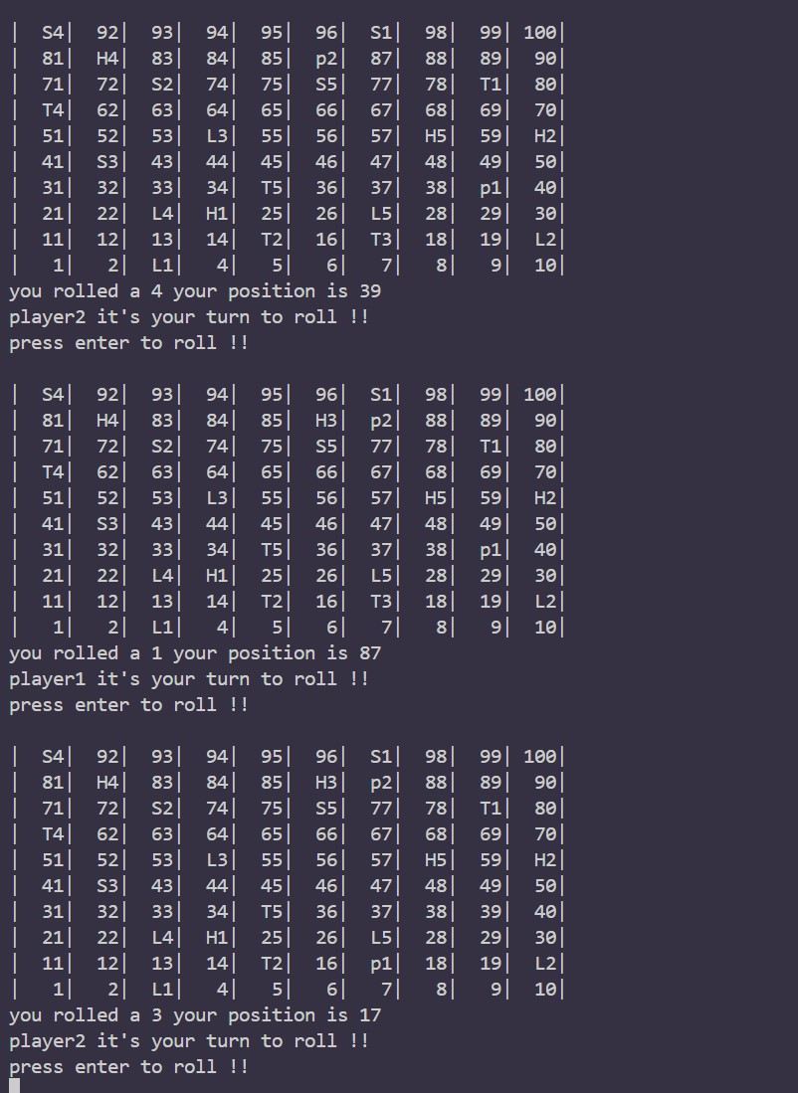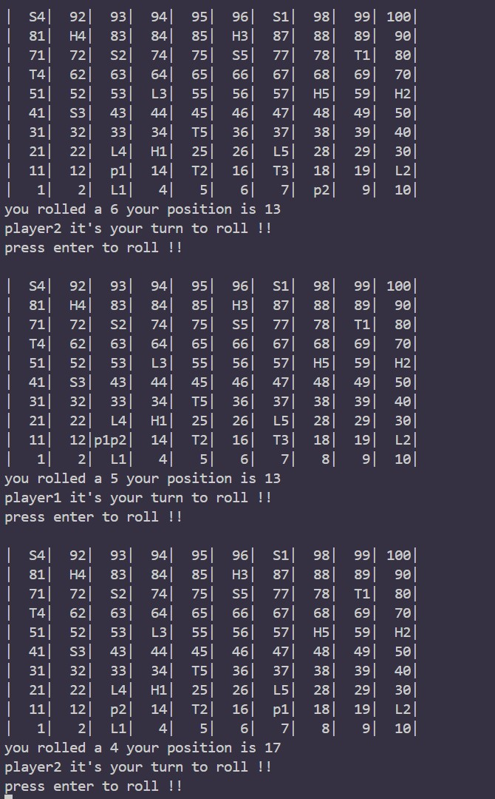

LOC stands for lines of code.
KLOC stands for kilo lines of code (1000 lines)

