ASTANA IT UNIVERSITY

Locker Management System
Project Proposal and Pre-Defence Report
Integrated summary of project rationale, research, requirements, architecture, evaluation, and current status
Team: Murat Bekzat Gizatuly; Amanbek Nazarbek Toleubekuly; Sandybaev Daniyal Gabitovich
Group: SE-2401
Supervisor: Latuta Konstantin Nikolayevich
Stage: Analysis and design
Report date: 24 October 2026

Contents
Executive summary
1. Project proposal
2. Evidence of relevance and survey results
3. Literature review
4. Existing system comparison
5. Technology comparison
6. Requirements specification
7. Architecture and diagram placeholders
8. User scenarios and prototype
9. Verification and evaluation plan
10. Project management and risks
11. Current status, limitations, and next steps
References
Appendix A. Questionnaire overview

Executive Summary
This report consolidates the current analysis and design materials for a proposed web system to manage university lockers, assignments, and repair requests. The project is at the analysis and design stage. Its central design decisions remain provisional because the current process and organisational rules have not yet been fully validated.
The team has prepared a project proposal, an English questionnaire for students and staff, a preliminary analysis of eight form submissions, a literature review, comparisons of three commercial systems and several technology alternatives, initial requirements, architecture drafts, user scenarios, and an evaluation plan. The project tasks are tracked on the YouTrack board: https://nazarbek.youtrack.cloud/agiles/204-1/current.
The survey provides early indications of information gaps around locker identification and repair reporting. The sample is small and uneven. The export does not establish whether the respondent who declined consent was excluded from the subsequent charts; therefore, findings must remain descriptive and provisional. Visual interface mockups, implementation, and measured evaluation results are not yet available.
Immediate priorities are to verify consent filtering and response denominators, document user or client validation, prepare role-based interface mockups, confirm requirements and process rules, align YouTrack deadlines with the submission schedule, and record each member’s contributions in Git.

1. Project Proposal

1.1 Problem statement
The team’s initial project description states that locker allocation is largely handled manually and that a unified digital service for assignments and maintenance is unavailable. This statement has not yet been independently confirmed through a complete process review or an authorised client agreement. The prevalence of allocation delays, locker faults, and user dissatisfaction is also unknown. These statements are therefore treated as hypotheses rather than established institutional facts.
The project will investigate these hypotheses and, if the need is confirmed, design and implement an information system for recording lockers and assignments, managing repair requests, and providing role-appropriate information. The university must approve allocation criteria and the authority of each role before these rules are implemented.

1.2 Aim and objectives
Aim: to design, implement, and evaluate an information system that supports locker, assignment, and repair-request management in an educational institution using requirements confirmed with users and the organisation.
1. Investigate the current process and needs of students, administrators, and technical staff.
2. Define verifiable functional and non-functional requirements and record their evidence sources.
3. Confirm allocation rules, role permissions, and data-handling requirements with an authorised representative.
4. Design the architecture, data model, user scenarios, and interface prototypes.
5. Implement the agreed registry, assignment, and repair workflows.
6. Verify correctness, access control, and usability of the key workflows.
7. Compare the resulting system with a documented baseline using pre-defined measures.

1.3 Users and stakeholders
Role | Proposed responsibilities
Student | View their own locker assignment and, if confirmed, submit and track a repair request.
Administrator | Manage records and assignments and oversee repair requests within approved permissions.
Technician | View assigned repair requests and record work progress and outcomes.
Organisation representative | Confirm current procedures, allocation policy, data constraints, and acceptance conditions.
Supervisor | Review project decisions and deliverables at agreed checkpoints.

1.4 Scope and expected outcomes
Proposed in-scope features are student and locker registries, assignment records, role-based access, repair requests, assignment history, and an administrative summary. Automated allocation is conditional on an approved policy and a defensible method.
Preliminary out-of-scope items are electronic locks and physical access control, biometrics and RFID, payments, a separate mobile application, and integrations with university SIS, ERP, or single sign-on systems. Additions require evidence of need and a scope review.
Expected outcomes:
• Documented description of the current process, user needs, and evidence limitations.
• Approved requirements with acceptance criteria.
• Architecture, data model, diagrams, and key-scenario mockups.
• A working system for the agreed registry, assignment, and repair workflows.
• A reproducible test and evaluation report with conditions, results, and limitations.

1.5 Assumptions and constraints
• A locker has at most one active assignment at a time; enforceability and exceptions require confirmation.
• The proposed application records information and does not verify physical locker condition or unlock a locker.
• GPA, social status, and activity are not approved allocation criteria and are excluded unless necessity and authority are established.
• “Algorithm” refers to deterministic rules unless a validated machine-learning model is separately justified.
• If allocation rules are not approved, the system should support transparent administrative assignment without claiming that an algorithm is fair.

2. Evidence of Relevance and Survey Results

2.1 Research instrument and evidence status
The team prepared an English questionnaire for students and staff. It asks about locker access and allocation, record-keeping, faults and repairs, desired account information, notifications, allocation preferences, and data safeguards. Participation is described as voluntary and anonymous.
The supplied aggregate export contains eight answers to the consent question: seven accepted and one declined. It does not show whether the non-consenting response was removed from all later summaries. Collection dates, recruitment method, distribution channel, and response-sheet configuration were not supplied. These details must be verified before the results are treated as a final research dataset.
The committee’s evidence criterion additionally specifies three to five discussions with user representatives or substantive agreement with an actual client. This survey alone does not demonstrate either requirement. Confirm the required evidence route with the supervisor or committee and document the resulting validation.

2.2 Respondent profile and locker access
Measure | Available responses | Observed result
Role (n=6) | Student 4; Administrator 1; Technician 1 | Two of eight consent-question respondents did not answer this item.
Locker relationship (n=5) | Assigned locker 1; requested but not received 3; unaware that lockers exist 1 | Descriptive only; small and uneven sample.
How users learn availability or assignment (n=4; selections) | Website/system 3; table/list 2; peers 2; email/message 1 | Several channels were selected.
Reported allocation method (n=4) | Application/queue/list 2; administrator 1; self-selected free locker 1 | Does not establish the official process.
Waiting time (n=3) | Same day 1; about one week 2 | Two responses indicated about a week.
Process clarity (n=3) | Ratings: 1, 3, and 4 on a five-point scale | Too few answers for a stable estimate.
Difficulties (n=4; selections) | Could not identify own locker 4; unclear assignment information 2; long wait 1; locker condition 1 | Identification and clarity were selected most often.

2.3 Faults, repair requests, and desired functions
Measure | Available responses | Observed result
Faults (n=3) | Lock failure 1; physical damage 1; locker used by another person 1 | One selection per respondent in the supplied summary.
Repair-process clarity (n=3) | Rating 2: 1; rating 4: 2 | No responses at other scale points.
Desired account information (n=4; selections) | Help contact/instructions 4; assignment status 2; how to report a fault 2; repair status 2; use period 1 | Help instructions were selected by all four respondents.
Notification preference (n=4; selections) | Email 1; messenger 1; SMS 1; no notifications 2 | Counts exceed respondent count, so report as selections.
Useful repair notifications (n=4; selections) | Repair in progress 3; technician assigned 2; more information needed 2; none 1 | No one selected receipt or completion in the supplied counts.
Preferred allocation approach (n=4) | Random draw among equal applicants 3; queue by application time 1 | Not sufficient to establish university policy.
Automated-allocation safeguards (n=4; selections) | Minimum data 4; explanation 2; staff review of disputes 2 | Data minimisation was selected by all four.
Trust in explained automatic allocation (n=4) | Ratings 2, 3, 4, and 5: one each | Responses span the scale; no consensus is demonstrated.

2.4 Staff responses
Staff item | n | Summary
Current record keeping | 2 | Both reported a paper log.
Allocation method | 2 | One reported personal administrator assignment; one reported a queue.
Allocation time | 2 | Both selected “a few hours”.
Errors or disputes | 2 | One selected student disputes; one selected students not knowing their locker.
Repair request channel | 2 | One reported in-person requests; one a form/request system.
Information missing from repair requests | 2 | Both selected a missing problem description.
Approximate scale | 2 | Free-text values were 750 and 740; the export does not clarify which value refers to students or lockers. Verify before reporting.

Free-text suggestions included maintenance alerts, scheduling or curfews, access-control integration, central logging, deletion limits for access logs, and locker durability and ventilation. These are suggestions, not approved requirements. One free-text entry reads “test” and should be verified before use.

2.5 Limitations and implications
The sample is small, uneven by role, and self-selected; results cannot be generalised to all students or staff. Question-level denominators vary. Some counts exceed the number of respondents, indicating multi-select items or an export that needs checking. Report each count with its denominator and do not infer percentages from the total of eight submissions.
The responses point to possible information gaps around locker identification, assignment clarity, and help-seeking instructions. Staff answers suggest that record-keeping and repair requests may use more than one channel. These observations support investigating a central registry and clear request-status information, but they do not establish the scale of the problem.
Respondents favoured a random draw in this small sample. This does not authorise a lottery or automated policy. Any allocation method requires organisational approval and transparent rules. Data minimisation is a preliminary design consideration and must be checked against institutional requirements.
Before final reporting, verify consent-based filtering, collection dates, distribution channel, question types, the “test” entry, and the staff estimates. Complete the required user or client validation separately.

3. Literature Review
The preliminary corpus includes twelve scientific publications from 2021–2026: four on allocation and fairness and eight on parcel-locker or logistics-technology adoption. This is a targeted narrative review, not a systematic review. The search databases, complete search strings, screening criteria, and full-text appraisal record are not yet documented. Many adoption studies concern short-term parcel delivery rather than long-term university locker assignments.
ID and source | Contribution | Transfer limitation
[1] Amanatidis et al. (2023), “Fair division of indivisible goods” | Reviews fairness concepts and algorithms for indivisible resources. | The university must define objectives, constraints, and tie-breaking.
[2] Das (2022), “Local Justice and the Algorithmic Allocation of Scarce Societal Resources” | Highlights institutional and social grounds in scarce-resource allocation. | Does not provide a ready locker-allocation policy.
[3] Liu et al. (2024), “Mixed Fair Division: A Survey” | Surveys models for allocating mixed resources. | Applicability depends on locker differences, preferences, and rules.
[4] Qiu (2022), “Balanced Allocation of Educational Resources Based on Parallel Genetic Algorithm” | Presents a multi-criteria educational resource allocation approach. | Different resource and objective setting; results cannot be transferred without validation.
[5] Tsai and Tiwasing (2021), “Customers’ intention to adopt smart lockers in last-mile delivery service” | Studies consumer adoption factors in parcel delivery. | Delivery and consumer context differ from university assignments.
[6] An et al. (2022), “Consumers’ adoption of parcel locker service” | Examines protection, technology, and perceived privacy. | Parcel-service results do not establish campus requirements.
[7] Encarnación and Amaya (2025), “Determinants of parcel locker adoption…” | Studies usefulness, ease, risk, and location in last-mile delivery. | Urban delivery setting differs from educational operations.
[8] Chen et al. (2024), “Stationary versus mobile parcel lockers…” | Compares locker modes and access distance. | Logistics use case; useful only to inform local research questions.
[9] Tsai, Ngo, and Che (2024), “Last-mile delivery during COVID-19…” | Reviews parcel-locker adoption and consumer experience. | Pandemic delivery context; does not cover campus maintenance directly.
[10] Jang, Hong, and Lee (2024), “Exploring the behavioral adoption…” | Studies adoption of automated parcel lockers. | Does not define long-term assignment or repair workflows.
[11] Cai et al. (2021), “Consumer’s usage of logistics technologies…” | Applies UTAUT and habit to logistics technology use. | Broad logistics scope; adoption factors require local validation.
[12] Arslan (2026), “E-shopper innovativeness and parcel locker adoption…” | Studies trust, social influence, and costs in e-commerce adoption. | Online-shopping context differs from student locker allocation.

3.1 Synthesis
Allocation literature shows that fairness depends on the selected objective, eligibility rules, resource attributes, and treatment of equal cases. A proposed algorithm cannot be called fair without an institutionally approved criterion and an evaluation procedure. If approved, transparent deterministic rules are a more defensible initial option than machine learning given the current evidence.
Parcel-locker adoption studies can inform questions about convenience, trust, information, location, and privacy. Their results do not establish that the university has the same problem or that students will adopt the proposed system. The reviewed corpus contains no direct study of repair-ticket workflows for personal lockers in educational institutions. Add sources on computerised maintenance management, campus facilities, and service-request systems.

3.2 Methodological sources
ISO/IEC/IEEE 29148:2018 on requirements engineering, ISO/IEC 25010:2023 on product quality, ISO 9241-210:2019 on human-centred design, and the OWASP Application Security Verification Standard inform the proposed requirements and evaluation approach. Verify standard versions and access dates before final submission.

4. Existing System Comparison
Three commercial electronic-locker solutions are compared using eight common criteria: education use, central administration, assignment, access, integration, reporting, repair support, and dependence on specialised hardware. The analysis uses official vendor materials, not independent product tests. “Not established” means the reviewed public pages did not confirm a feature; it does not prove the product lacks it.
System | Education and administration | Allocation and access | Integration and reporting | Repair and hardware
Vecos for Schools | Marketed to schools and universities; central remote administration described. | Automated or fixed-term assignment and student choice are described; access by ID or smartphone. | Vendor describes APIs/integrations and real-time occupancy/use information. | Repair-ticket support not established in reviewed pages; offer includes electronic lockers/locks.
GANTNER eLoxx / Education | Education materials for schools, universities, and libraries; central web management. | Specific allocation policy not fully established; RFID and electronic access are central. | Integration depends on product/configuration; usage information is described for some products. | Repair-ticket support not established; described solutions rely on electronic locker equipment.
Keynius | Education is among the stated sectors; cloud portal manages users and lockers with roles. | Fixed and flexible assignments are described; access options include RFID, PIN, QR, and mobile/web. | Open API/integrations claimed; status, history, and reporting described. | Repair-ticket support not established in reviewed material; solution combines software and hardware.
Current university process | Not independently documented. | Allocation and access practices require confirmation. | Records, reporting, and integration status unknown. | Maintenance and repair process require direct evidence.

The reviewed vendors tie software to electronic locker hardware, while the project’s preliminary scope is a software registry and workflow without physical-lock control. The comparison does not establish that a separate system is necessary for this university. Confirm the current process, infrastructure, integration needs, procurement constraints, and client requirements before making that claim.

5. Technology Comparison
Decision | Alternatives | Preliminary assessment
Server platform | FastAPI; Django REST Framework; NestJS | FastAPI is considered for typed schemas and generated REST API documentation. Django offers a mature ORM and admin tools. NestJS shares TypeScript with the client. Confirm team skills and transaction design.
Relational storage | PostgreSQL; MySQL; SQLite | PostgreSQL is preferred provisionally for constraints and transactions. MySQL is a mature alternative. SQLite suits local prototypes but may constrain concurrent writes.
Client updates | WebSocket; Server-Sent Events; polling | WebSocket supports bidirectional events; SSE supports server-to-client streams; polling is simplest but adds requests and delay. Decide only after confirming a real-time requirement.
Allocation method | Manual registry; deterministic rules; machine learning | Manual digital assignment is the baseline. Deterministic rules require approved policy. Machine learning is unsupported by current needs and data.
Client and development stack | React and Vite; FastAPI; SQLAlchemy and Alembic; PostgreSQL; Docker Compose | Proposed working stack. Confirm team skills, dependency versions, compatibility, and deployment constraints before implementation.

No implementation benchmark has been conducted. Final choices should account for team experience, deployment requirements, compatibility, maintenance, and institutional constraints.

6. Requirements Specification
Requirements are preliminary and have not been approved by users or the organisation. “Mandatory” and “Desirable” are proposed priorities. Conditional allocation requirements must not be implemented before policy approval.

6.1 Functional requirements
ID | Priority | Requirement and acceptance summary
FR-01 | Mandatory | Authenticate users; only valid accounts can perform protected operations.
FR-02 | Mandatory | Distinguish Student, Administrator, and Technician; verify permitted and denied actions on the server.
FR-03 | Mandatory | Administrator manages student records; reject duplicate student identifiers.
FR-04 | Mandatory | Administrator manages locker records; enforce unique identifiers and valid states.
FR-05 | Mandatory | Assign an available locker; record the assignment and show it in relevant registries.
FR-06 | Mandatory | Prevent conflicting active assignments; one locker cannot be active for multiple students.
FR-07 | Mandatory | End an assignment, record the end date, and release the locker only if its state permits.
FR-08 | Mandatory | Student sees only their own assignment; requests for another student’s assignment are denied.
FR-09 | Desirable | Retain assignment history with dates and responsible user for authorised administrators.
FR-10 | Desirable | Show summary counts by locker state and match expected values on a control data set.
FR-11 | Desirable | Refresh summary data after a change within an agreed interval.
FR-12 | Conditional | Generate proposals only under approved rules; handle ties as approved and explain each result.
FR-13 | Mandatory | Student submits a fault report for their associated locker and cannot submit on another user’s behalf.
FR-14 | Mandatory | Administrator assigns a repair request to a technician; unauthorised changes are rejected.
FR-15 | Mandatory | Technician records work and outcome, actor, and time; next status follows the approved workflow.
FR-16 | Mandatory | Administrator confirms a result or returns the request with a comment if the process requires it.
FR-17 | Desirable | Student tracks only their own request and sees its current status and next step.

6.2 Non-functional requirements
ID | Priority | Requirement and verification
NFR-01 | Mandatory | Server enforces permissions; integration checks cover roles and operation groups.
NFR-02 | Mandatory | Expose only role-necessary personal data; inspect API schemas and use synthetic demo data.
NFR-03 | Mandatory | Concurrent assignment attempts preserve integrity; at most one conflicting transaction succeeds.
NFR-04 | Desirable | Key flows are understandable; evaluate using agreed scenarios and record observations.
NFR-05 | Desirable | Input errors explain causes and corrections; verify invalid and duplicate values.
NFR-06 | Desirable | Audit agreed significant actions with actor, action, object, and time.
NFR-07 | Conditional mandatory | Approved allocation is explainable and reproducible.
NFR-08 | Mandatory | Collect only necessary data; do not collect GPA, social status, or activity without approved necessity and basis.
NFR-09 | Desirable | Repair transitions are validated and require the appropriate actor and outcome information.

6.3 Open decisions
Confirm who may initiate assignments, whether a student may hold multiple lockers, assignment duration and release rules, required data fields and retention, repair categories and statuses, service targets, authentication and accessibility, notification channels, and whether an approved allocation policy includes tie-breaking, appeals, and human review.

7. Architecture and Diagram Placeholders

7.1 Proposed architecture
The proposed design separates a React web client, a FastAPI server, and a PostgreSQL database. The client calls the API over HTTPS/REST. The server checks authentication and authorisation, applies registry, assignment, allocation, and repair rules, and persists changes through a data-access layer. SQLAlchemy and Alembic are proposed for database access and migrations.
A live event channel and email notifications remain optional. WebSocket, Server-Sent Events, and polling should be compared only if user needs support real-time updates. No external identity service or electronic lock controller is approved in the current scope.

7.2 System context diagram
The context model identifies the Student, Administrator, and Technician as external actors. The proposed system is the system boundary. Email is an optional, unconfirmed external dependency.
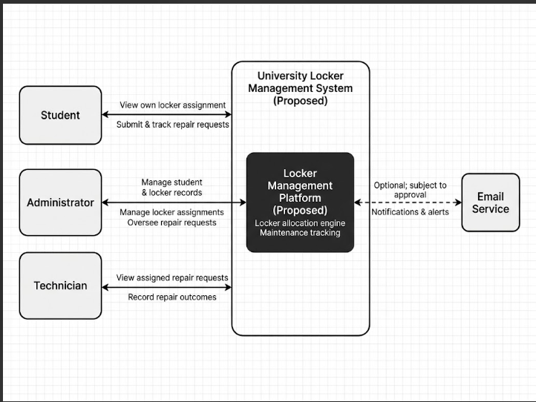

7.3 Use case diagram
The use case model should connect each role only to its authorised actions. Allocation-proposal review is conditional on policy approval. Student actions include viewing an assignment and submitting or tracking a repair request. Technician actions include viewing assigned repairs and recording outcomes. Administrator actions include managing registries, assignments, and repair oversight.
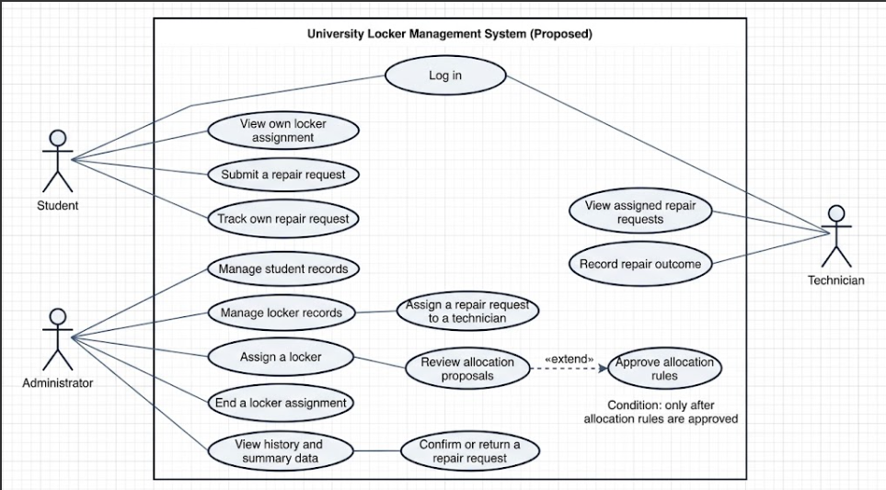

7.4 Component diagram
The component model groups proposed client components and server services. The database is shown separately. Event delivery and the update client are undecided; the allocation component depends on policy approval.
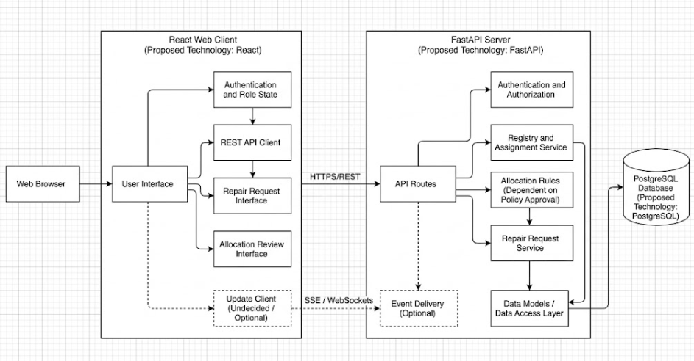

7.5 Preliminary data model
Entity | Purpose | Constraints to confirm
User | Account and role | Authentication method; link to student or staff record.
Student | Minimum data needed for assignment | Fields and allowed identifier set by the organisation.
Locker | Identifier, location, and state | Unique number, location, attributes, lifecycle states.
Assignment | Time-bounded student–locker association | One active assignment per locker; dates and responsible actor.
RepairTicket | Fault report and handling | Categories, statuses, technician, timestamps, resolution.
AllocationRun (optional) | Record of a rules-based allocation run | Include only if reproducibility is required and approved.
AuditEvent | Record of significant actions | Event scope, access, and retention period.

8. User Scenarios and Prototype
Text scenarios are available; visual mockups and an interactive prototype have not yet been supplied. Screen labels, statuses, and business rules must follow approved requirements.

8.1 Administrator assigns a locker
Precondition: the administrator is authenticated, the student exists, and an available locker is recorded. The administrator finds the student, reviews eligibility and current assignment, selects an available locker, confirms the operation, and receives a saved assignment record. The system rejects an unavailable locker or invalid assignment without changing data.

8.2 Student views an assignment and reports a fault
The student opens “My Locker”, views only their own assignment, submits a fault category and description, reviews the request, and receives confirmation and a request status. The student can later track only their own request.

8.3 Technician processes a repair request
The technician opens the assigned queue, records work and outcome, and submits the status update. If the organisation approves administrator confirmation, the administrator closes the request or returns it with a reason.

9. Verification and Evaluation Plan
No application tests or performance measurements have been conducted because the application has not been implemented. The baseline is the organisation’s actual current process; a paper log or spreadsheet must not be assumed until confirmed. Compare equivalent scenarios and data volumes, use synthetic or authorised anonymised data, and record the environment and version.
Measure | Operational definition | Planned evaluation
Scenario success | Share of participants completing an agreed scenario without a critical error. | Set a threshold before testing; document failures.
Assignment time | Elapsed time from scenario start to confirmed assignment. | Compare medians with the measured current process; set target after baseline.
Conflicting assignments | Violations of active-assignment constraints. | Zero conflicts in control and concurrent-request scenarios.
Registry consistency | Match of final states to expected states. | All cases match approved rules.
Interface clarity | Participant rating and observed usability issues. | Agree scale and interpretation before testing.
Update latency | Time from saved change to visible updated state. | Set threshold after choosing mechanism and environment.
Allocation correctness | Match with a reference set generated from approved rules. | Test boundary cases and tie-breaking.
Explainability | Administrator can identify why a proposal was made. | Agree scenario and criterion with the process owner.
Repair lifecycle | Validity of allowed and forbidden ticket transitions. | Test approved transitions, actors, and required outcomes.
Repair processing time | Time from submission to assignment and closure. | Define service target and starting point after process review.

Planned test levels: unit checks for allocation constraints and repair transitions; API/database integration checks; concurrent assignment checks; end-to-end role workflows; negative and boundary scenarios; and user evaluation with agreed participant roles, consent, tasks, and stopping criteria.
For every test, record its identifier, commit or tag, data version, environment, steps, expected and actual behaviour, result, and deviations. Use synthetic data in demonstrations and do not place identifiable response data in the repository.

10. Project Management and Risks

10.1 Team and accountability
Team member | Responsibility currently documented | Contribution evidence status
Murat Bekzat Gizatuly | Backend Developer / Team Lead | Has an individual branch under his name. Will implement the initial half of the FastAPI backend, covering student and locker registries and assignments.
Amanbek Nazarbek Toleubekuly | Backend Developer / DevOps | Has an individual branch under his name. Will implement the frontend and verify the main user workflows.
Sandybaev Daniyal Gabitovich | Frontend Developer / QA | Has an individual branch under his name. Will complete the remaining backend functionality and configure Docker.

10.2 YouTrack board
The project board is https://nazarbek.youtrack.cloud/agiles/204-1/current. The screenshot supplied by the team shows tasks DOA-1 to DOA-9 in the “To Do” column, with assignees, priorities, and due dates between 28 October and 6 November 2026. These dates fall after the stated 24 October submission point; re-prioritise the board. DOA-1 refers to an interview, while the supplied research instrument is a questionnaire. Correct the task to describe the actual method and separately resolve the committee’s requirement for user discussions or client agreement.
Task | Description visible in screenshot | Due date shown
DOA-1 | Conduct an interview about current locker allocation | 28 Oct 2026
DOA-2 | Write functional requirements | 30 Oct 2026
DOA-3 | Define and agree priority rules | 6 Nov 2026
DOA-4 | Create the database ER diagram | 30 Oct 2026
DOA-5 | Set up Git, Docker, and CI | 30 Oct 2026
DOA-6 | Create the initial Backend API structure | 4 Nov 2026
DOA-7 | Prepare UI prototypes for three roles | 2 Nov 2026
DOA-8 | Set up the Frontend project | 4 Nov 2026
DOA-9 | Prepare initial test cases | 6 Nov 2026

10.3 Repository traceability
The reviewed main branch contains one commit dated 22 October 2026, authored by bmurat, covering the initial project documentation. Recent local edits and the report have not yet been committed. The repository must show identifiable contributions from each student, links between YouTrack tasks and commits or merge requests, review evidence, required reviewer access, and a submission tag. A complete application is not required for this pre-defence stage.

10.4 Risk register
Risk | Potential effect | Proposed response
Users or process owner unavailable | Need and requirements remain unverified. | Request access through the supervisor; document limits and avoid unsupported claims.
Allocation rules unapproved | Outcomes may conflict with institutional policy. | Do not implement disputed criteria; record authorised decisions and tie handling.
Excess personal data | Privacy and governance risk. | Collect the minimum data; confirm access, retention, and deletion.
Unclear roles and task ownership | Work and decisions cannot be traced. | Agree responsibilities and assign YouTrack owners and deadlines.
Documentation differs from implementation | Proposed features may be mistaken for delivered features. | Label each item proposed, approved, implemented, or evaluated.
No review evidence | Errors and unresolved decisions may persist. | Record supervisor and peer reviews at checkpoints.

11. Current Status, Limitations, and Next Steps

11.1 Current status
The team has prepared the initial analytical and design package: proposal and scope, questionnaire, preliminary aggregate survey summary, literature and market comparisons, technology alternatives, draft requirements, architecture materials, scenarios, and an evaluation plan. A YouTrack board is available. The application remains unimplemented, consistent with the committee’s statement that a complete application is not required at this stage.

11.2 Known limitations
• Survey participation is limited to eight submissions; consent filtering, denominators, collection dates, and recruitment method need verification.
• The committee’s specified user discussions or substantive client agreement are not evidenced in the available materials.
• Allocation policy, permissions, repair states, notification needs, and data retention remain subject to approval.
• Visual UI mockups and prototype testing are missing.
• There is no application, database, API, automated test suite, or measured evaluation result yet.
• Evaluation thresholds and a measured baseline are pending confirmation of the actual process.
• Current main-branch Git history does not demonstrate contributions from every team member; recent local materials are uncommitted.
• Supervisor feedback has not been verified. An unconfirmed draft must not be submitted as the supervisor’s actual review.

11.3 Next-stage work
1. Verify Google Forms consent routing, response filtering, question types, collection dates, and recruitment method; identify test entries.
2. Analyse the consent-filtered responses and retain per-question denominators and sample limitations.
3. Complete required user or client validation and document the decisions.
4. Confirm allocation rules, roles, privacy requirements, and repair workflow with an authorised representative.
5. Produce and review three role-based UI mockups; add approved context, use-case, and component diagrams in editable and readable formats.
6. Update requirements and acceptance criteria; align YouTrack tasks and deadlines with deliverables.
7. Implement the agreed core workflows, prepare tests, and record results against a measured baseline.
8. Commit and push each student’s identifiable contribution, link tasks to commits or merge requests, and obtain genuine supervisor feedback.

References
[1] Amanatidis, G., Aziz, H., Birmpas, G., Filos-Ratsikas, G., Li, B., Moulin, H., Voudouris, A. A., & Wu, X. (2023). Fair division of indivisible goods: Recent progress and open questions. Artificial Intelligence, 322, 103965. https://doi.org/10.1016/j.artint.2023.103965
[2] Das, S. (2022). Local Justice and the Algorithmic Allocation of Scarce Societal Resources. Proceedings of the AAAI Conference on Artificial Intelligence, 36(11), 12250–12255. https://doi.org/10.1609/aaai.v36i11.21486
[3] Liu, S., Lu, X., Suzuki, M., & Walsh, T. (2024). Mixed Fair Division: A Survey. Proceedings of the AAAI Conference on Artificial Intelligence, 38(20), 22641–22649. https://doi.org/10.1609/aaai.v38i20.30274
[4] Qiu, M. (2022). Balanced Allocation of Educational Resources Based on Parallel Genetic Algorithm. Mathematical Problems in Engineering, 2022, Article 7517267. https://doi.org/10.1155/2022/7517267
[5] Tsai, Y.-T., & Tiwasing, P. (2021). Customers’ intention to adopt smart lockers in last-mile delivery service: A multi-theory perspective. Journal of Retailing and Consumer Services, 61, 102514. https://doi.org/10.1016/j.jretconser.2021.102514
[6] An, H. S., Park, A., Song, J. M., & Chung, C. (2022). Consumers’ adoption of parcel locker service: protection and technology perspectives. Cogent Business & Management, 9(1), 2144096. https://doi.org/10.1080/23311975.2022.2144096
[7] Encarnación, T., & Amaya, J. (2025). Determinants of parcel locker adoption for last-mile deliveries in urban and suburban areas. Transportation Journal, 64(1), e12031. https://doi.org/10.1002/tjo3.12031
[8] Chen, J., Li, R., Ma, J., & An, Q. (2024). Stationary versus mobile parcel lockers: Which self-service technology moves the consumers in the last mile of urban areas? Travel Behaviour and Society, 35, 100742. https://doi.org/10.1016/j.tbs.2024.100742
[9] Tsai, J.-F., Ngo, H. N., & Che, Z.-H. (2024). Last-mile delivery during COVID-19: A systematic review of parcel locker adoption and consumer experience. Acta Psychologica, 249, 104462. https://doi.org/10.1016/j.actpsy.2024.104462
[10] Jang, S., Hong, D., & Lee, C. (2024). Exploring the behavioral adoption of automated parcel locker systems under COVID-19. Transport Policy, 151, 1–11. https://doi.org/10.1016/j.tranpol.2024.03.016
[11] Cai, L., Yuen, K. F., Xie, D., Fang, M., & Wang, X. (2021). Consumer’s usage of logistics technologies: Integration of habit into the unified theory of acceptance and use of technology. Technology in Society, 67, 101789. https://doi.org/10.1016/j.techsoc.2021.101789
[12] Arslan, Y. (2026). E-shopper innovativeness and parcel locker adoption: Mediating roles of social influence and trust, and the moderating impact of transaction costs. Research in Transportation Business & Management, 64, 101550. https://doi.org/10.1016/j.rtbm.2025.101550
[13] ISO/IEC/IEEE 29148:2018. Systems and software engineering — Life cycle processes — Requirements engineering. https://www.iso.org/standard/72089.html
[14] ISO/IEC 25010:2023. Systems and software engineering — Systems and software Quality Requirements and Evaluation (SQuaRE) — Product quality model. https://committee.iso.org/standard/78176.html
[15] ISO 9241-210:2019. Ergonomics of human-system interaction — Human-centred design for interactive systems. https://www.iso.org/standard/77520.html
[16] OWASP. Application Security Verification Standard. https://owasp.org/www-project-application-security-verification-standard/
Commercial system sources:
Vecos, Smart Lockers for Schools: https://www.vecos.com/en/locker-system-schools/
GANTNER, Smart Locker Systems for Educational Institutions: https://www.gantner.com/en/lp/smartlockersystems-education
Keynius education solutions and products: https://keynius.eu/ and https://keynius.eu/products
Technology documentation:
FastAPI: https://fastapi.tiangolo.com/features/
Django REST Framework: https://www.django-rest-framework.org/
NestJS: https://docs.nestjs.com/
PostgreSQL: https://www.postgresql.org/docs/current/ddl-constraints.html
MySQL: https://dev.mysql.com/doc/
SQLite: https://www.sqlite.org/docs.html
MDN Server-Sent Events: https://developer.mozilla.org/en-US/docs/Web/API/Server-sent_events/Using_server-sent_events
MDN WebSocket API: https://developer.mozilla.org/en-US/docs/Web/API/WebSockets_API

Appendix A. Questionnaire Overview
The submitted questionnaire is titled “Survey on getting and maintaining lockers (Locker Management System)”. It describes voluntary and anonymous participation, a four-to-five-minute completion time, aggregated use of answers, and instructions not to provide names, emails, student identifiers, group, GPA, locker number, health information, or personal-status data. The response sheet and live form settings should be checked to confirm these statements are accurate.
Section | Main questions and response areas
Consent | Agreement to participate voluntarily: yes or no. Confirm that a “No” response exits the form and is excluded from analysis.
About you | Optional role: Student, Administrator, or Technician.
Lockers | Relationship to lockers in the academic year: assigned, requested but not received, did not request, unaware, or unsure.
Getting a locker | How users learn about availability/assignment; how lockers are allocated; waiting time; clarity of getting/releasing a locker; difficulties.
Faults and repairs | Types of fault; reporting channel; time to resolution; clarity of process and status.
Desired system | Account information; notification preferences; useful repair notifications; preferred allocation approach; safeguards for automated allocation; trust rating.
Staff survey | Current records; allocation method; approximate student/locker counts; time taken; errors/disputes; repair-request channels; missing request information; most useful system features.
Things to consider | Open response on additional considerations, with a reminder not to include personal identifiers or sensitive personal-status information.

