**Dragonfly in Eclipse (v1.0)**

**Tested on 32-bit Vista and 64-bit Windows 7**

1. Make sure to install Cygwin with GCC compiler version 3.4.4-3 this is not default. This can be configured in the Devel tab of the Cygwin setup.exe program.

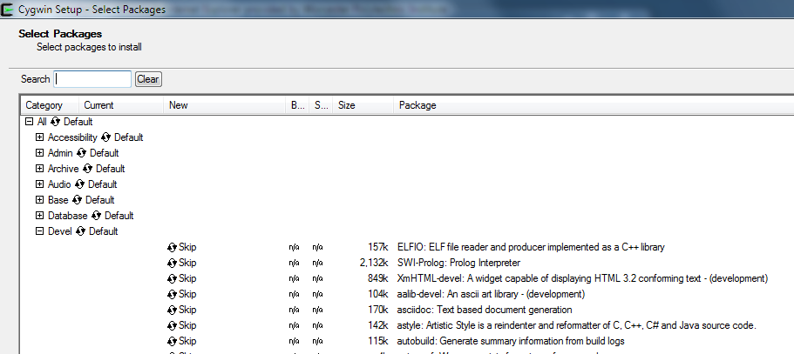

(You might notice the Cygwin installed on FL 222 computers comes with 3.4.4-999. If this is the case you may want to install Cygwin to one of your local folders as you will not be able to update the components on the C: drive.)

1. In Cygwin be sure to install gdb: The GNU Debugger, also found in the Devel tab.
2. Remember to install the linbncurses-devel and libncursesw-devel version 5.7-18 found in the Devel tab.
3. Download project archive and unzip somewhere on your machine.
4. Open up Eclipse in C++ view (<http://www.eclipse.org/downloads/> for a download)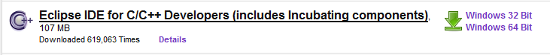
5. Create a new managed makefile project from existing code.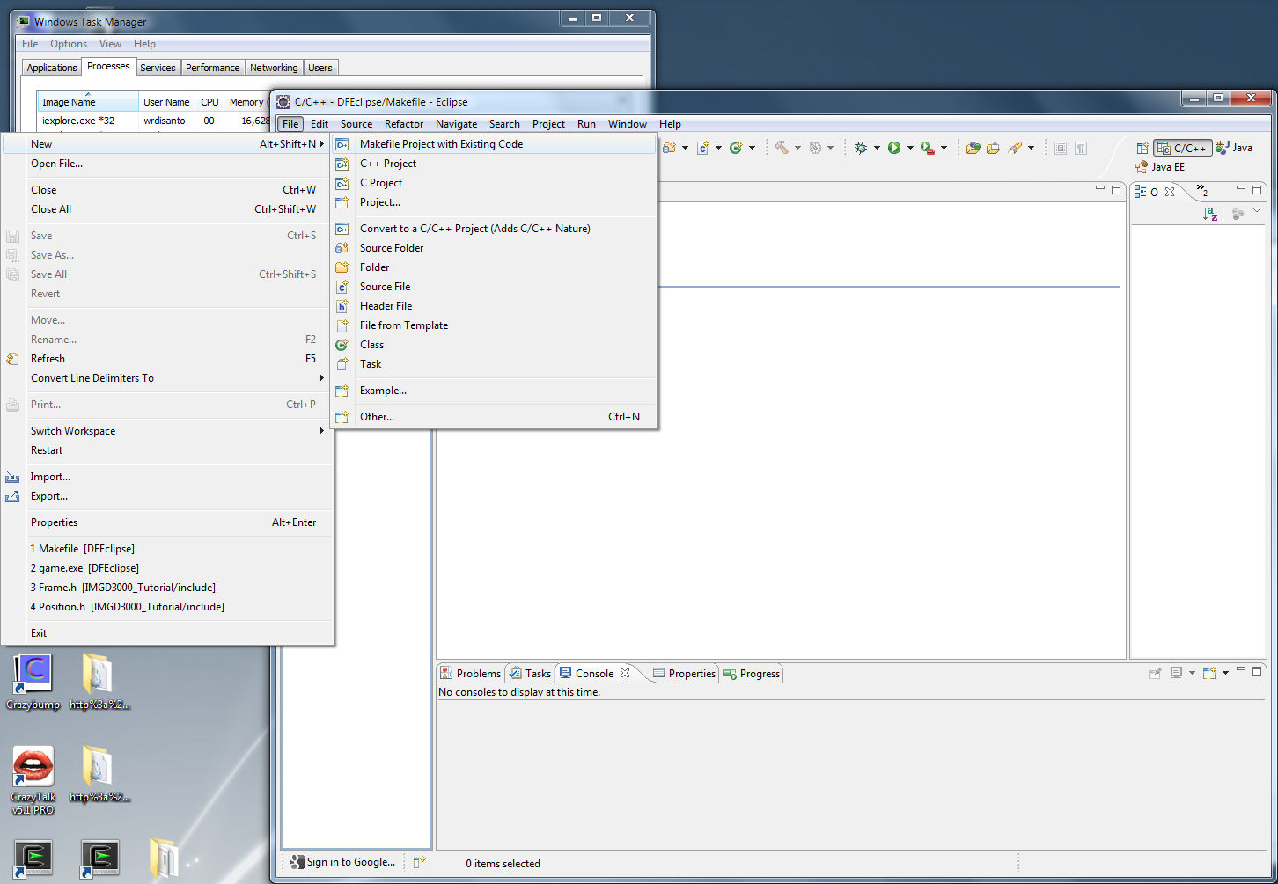
6. In the import existing code module select the Cygwin GCC toolchain from the list, and set the Existing code location to that of the directory of your project. You may also name your project. Click Finish and open the new project in the Project explorer tab found on the left hand side of the Eclipse GUI when in C++ perspective view.

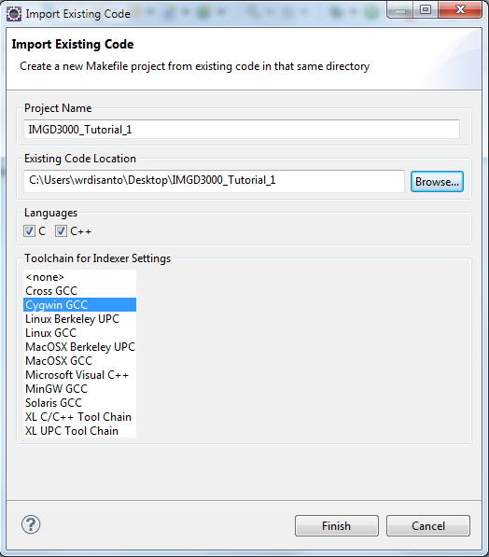

1. Click on the Project drop down menu at the top of the GUI and select Properties. Then navigate to the C/C++ Build – Environment tab and make sure the C:\cygwin\bin; folder path is included in the PATH variable. If not make sure to add it to the front of the list. If you are using your own installation of Cygwin include the path to your local cygwin\bin folder, I used C:\Users\wrdisanto\Documents\bin. Set the CWD and PWD variables to ::${workspace_loc:\IMGD3000_Tutorial_1}.

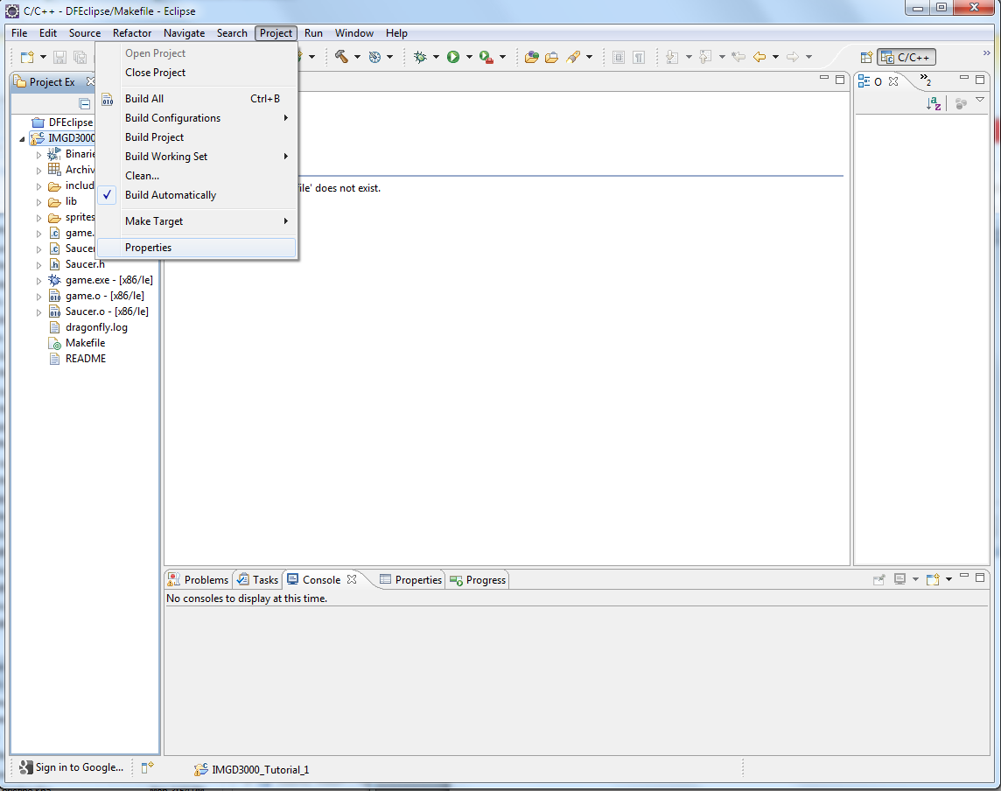

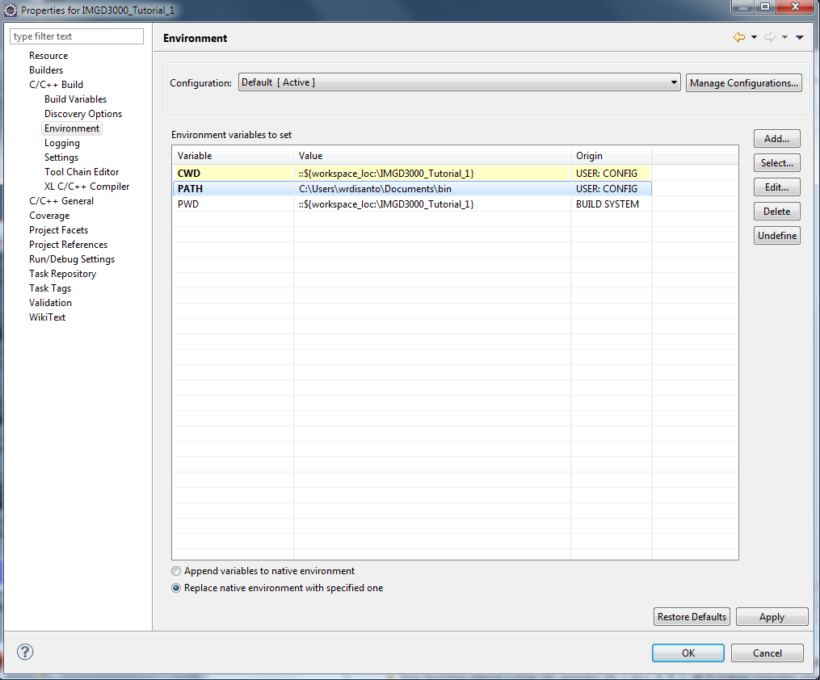

1. Right click the IMGD3000_Tutorial project folder in the Project Explorer and select “make targets” – “create”. This will bring up the “Create Make Target” window. In this window enter the name of your executable. For this project enter the name game.

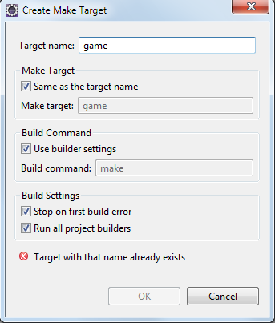

1. Now attempt to build your project, make sure you have make.exe installed in your “cygwin/bin” folder. If not install make in the Devel tab of the setup.exe Cygwin installer. Now right click your project folder and click build project. If the project fails to build because the program “make” could not be run in the provided directory, check that you installed the make executable in the correct folder and that the PATH variable checks this folder for executable as in step 5.
2. Now configure your project to run. Select the “External Tools” – “External Tools Configurations” from the “run” dropdown menu of Eclipse. Select “program” and from the tree on the left and press the “new button” as instructed.

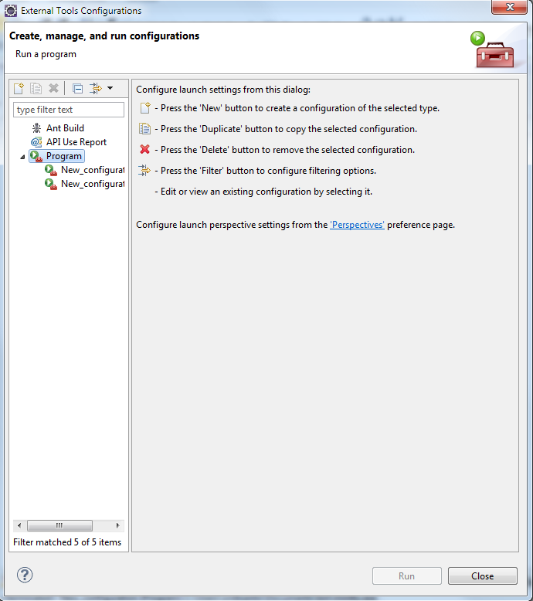

1. Click the “New configuration” in the “program” branch of the tree view. On the main tab in the “Location” text box search for the “mintty.exe” file in your working cygwin bin directory. For example: C:\Users\wrdisanto\Documents\bin\mintty.exe. Then enter the following into the “arguments” text box: ./game
   1. You may need to add an argument, -h always, to the arguments list to hold your mintty terminal open.
2. Check that the program runs by first clicking apply then clicking the Run button at the bottom of the “External Tools Configurations” window. If the program does not run try copying the following dlls into the directory in which your executable can be found: cyggcc_s-1.dll, cygncurses-10.dll, cygwin1.dll *they can be found in the cygwin/bin directory of your working cygwin.

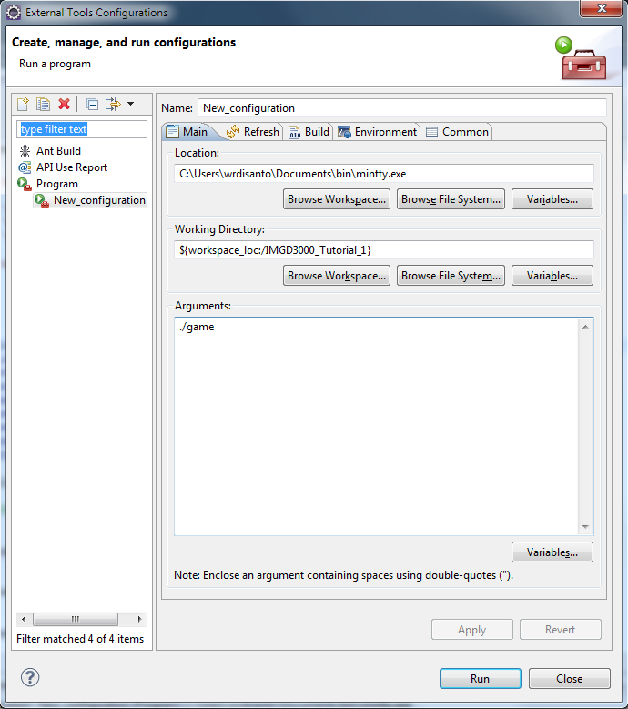

1. Lastly configure the debugger for Cygwin. Under the “Run” dropdown menu select Debug configuration. Click on the debugger tab inside the “Debug Configurations” window.

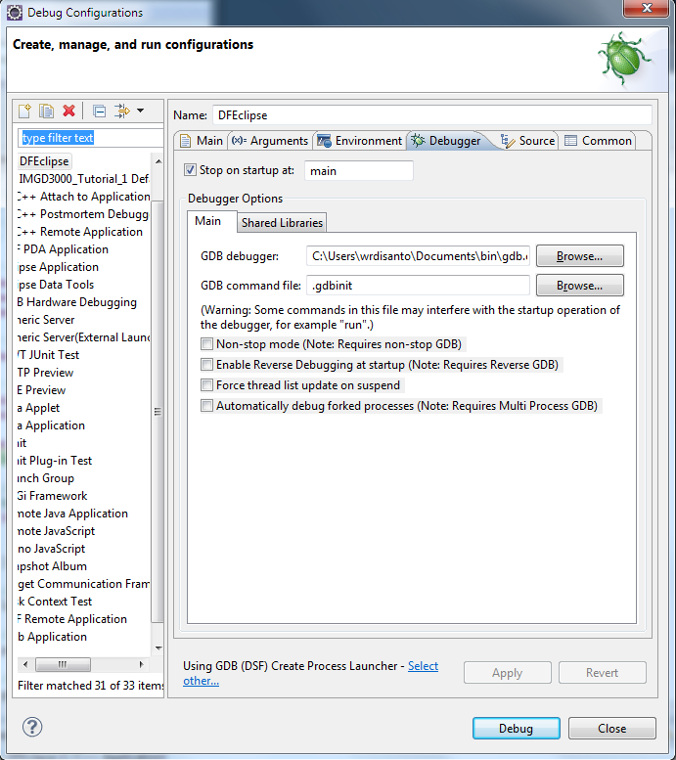

1. If during debugging the correct source file cannot be found you will be prompted to “Edit Source Lookup Path…”. Click this button and navigate to the directory that contains your source files.

