Benjamin Sautermeister & Kyle Bryant

[bsautermeister@wpi.edu](mailto:bsautermeister@wpi.edu) & [kcbryant@wpi.edu](mailto:kcbryant@wpi.edu)

IMGD 3000

Planetary Defense Design

# Updated Schedule

This is the original schedule updated with additional details and completion times.

**Milestone #1: Brainstorming and Refinement:**

- Planned: Oct. 2, Finished: Oct. 2

- Decided on a TD game that would work well with Ben’s Enginex game engine

- Created a Plan document outlining milestones, division of work, and general necessities

- Created a GIT repository for Project 3

Summary of Milestone #1:

Our group brainstormed and drafted ideas for our final project quickly so that the team could begin development as soon as possible. We decided on a tower defense game because of its ease of implementation into an ascii-based game engine and the overall challenge it presented to us as designers. For this part, we got together in the campus center and hashed out ideas on scrap paper, then put the plan document online as a google doc so that we could both edit and change it before submission.

**Milestone #2: Grid System Complete**

- Planned: Oct. 4, Finished: Oct. 4

- Finished quickly so development of base game could continue quickly

- Grid and cursor completed, as well as loading of map files

Summary of Milestone #2:

Benjamin completed most of Milestone #2 before the weekend. This was planned for one of two reasons: We wanted a working base to have our game testable as soon as possible, and Ben was going to be gone for the weekend. We decided that he would finish it up so that Kyle could work on the basic game functionality over the weekend while Ben was in Boston.

**Milestone #3: Basic Game Functionality**

- Planned: Oct. 10, Finished: Oct. 8

- Basic enemies and turrets added to game

- Enemy waves implemented

Summary of Milestone #3:

Kyle and Ben completed a large part of the game functionality before the Alpha week of the project. Kyle spent time over the weekend to implement a base class for enemies as well as creating the spawner and base class for towers. Ben implemented the necessary event classes needed for the game as well as a rudimentary sidebar. Our team created basic art assets as well to flesh out the testing.

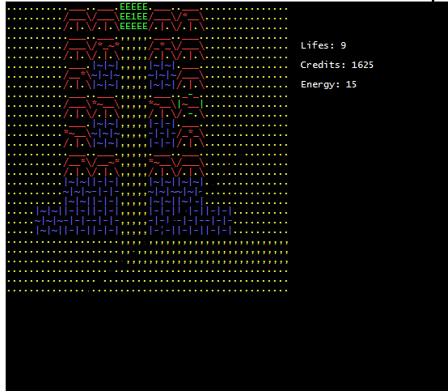

*Screenshot from Milestone #3

**Milestone #4: Game Expansion**

- Planned: Oct. 13, Finished: Oct. 10

- Added multiple enemy and tower types

- Added more sprites

Summary of Milestone #4:

Because of our rapid progress, much of the game expansion was completed for the alpha. Other than small bugs and pesky segmentation faults, our game was in a playable and decent looking state.

**Milestone #5: Menus, Art Assets, and Polish**

- Planned: Oct. 14, Finished: Oct. 12

- Added main menu, controls, and sidebar menu

- Addressed Segmentation fault issues

- Added a win a lose scene

Summary of Milestone #5:

We wanted to get the game in release condition before the week the final was due. Kyle worked to add in artistic assets for the game menu, planet menu, and control menu. Ben worked diligently to find a pesky segmentation fault, as well as implementing a fully functioning sidebar with a beautiful UI.

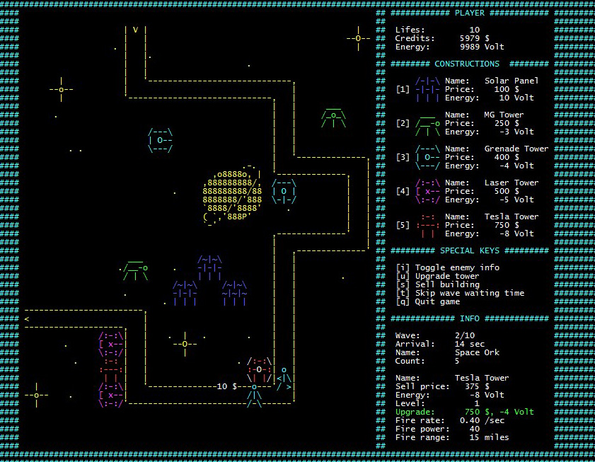

**Milestone #6: Balancing, Debugging and Testing**

- Planned: Oct 15, Finished: Oct 13

- Tested game with another project team

- Balanced game for difficulty scaling

Summary of Milestone #6:

We worked with another team to test out our games and find bugs or balancing issues we may have otherwise overlooked. We used some of their input to update our game and fix some balancing issues.

**Milestone #7: Presentation and Youtube Video**

- Planned: Oct 17, Finished: Oct 13

- Created a short video and uploaded to youtube

- Wrote this design document

- Created game website

- Created other promotional material

Summary of Milestone #7:

Our team worked together to get all of the additional material done for Project 3. Kyle wrote the design document and created the youtube video. Ben created a website for the game, as well as creating a small promo image for Planetary Defense.

Summary of Overall Design

Our team covered ground quickly and efficiently, communication was key in the development of Planetary Defense. Both team members took time to ensure Planetary Defense would live up to the image we had for it from the start. Our game was finished with full functionality that we had originally intended, as well as a few extras we had not originally planned to be a part of Planetary Defense (such as the Planet map) As you will have noticed by looking through the previous checkpoints, our team stayed relatively ahead of the original schedule, and the final product shows our hard work.

# Updated Distribution of Work

Distribution of Work

For collaboration, the control version system GIT is used with on private remote repository hosted on BitBucket. The distribution of work did not change much over the course of the project, however there are some slight variations from the original plan:

**Benjamin**

- Project setup

- Grid system implementation

- Loading of maps

- Virtual cursor navigation

- Level and wave information

- In-game sidebar menu

- General game workflow & Event extensions

- Game website and promo image

- Tesla, Fragmentation, and Laser turrets

- Solar panel

**Kyle**

- Main menu, control menu, and planet menu

- Building and enemy base class

- Machine gun turret

- All enemies

- Wave spawner

- Artistic assets

- Youtube video

- Design document

**Teamwork**

- Brainstorming of game

- Plan document

- Presentation

- Game balancing

- Testing and debugging