It is no news to show another home made tray radiation shield, but this one was thought taking into account some important details. This is the way to get a shield working as it is intended to be. Let's see how to build it, surely some of you may want to make your own.  
  
1.- You need 10 flower pot trays, 20 cm diameter. There's no need for them to be bigger, there will be enough room inside for the sensor. Surely you can get white plastic dishes to avoid the painting, but they use to be thinner than these one. The thicker the more efective shield it will be. Mark three points not too much close to the border, making an equilateral triangle between them. It is better to keep all trays joint together to make the drills, this way you will have a perfect alignment.  
  
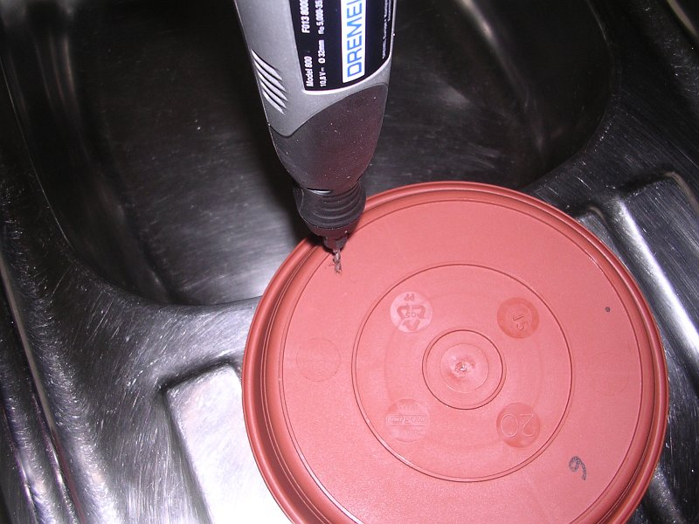  
  
  
2.- You have to make the central cutting on 6 of them. You may want to make a little test to know the cutting extent: trays have to overlap a bit between them, this avoid the horizontal radiation ("A") tho reach the measuring chamber. Looking from below you have to determine the point you reach in direct vision ("B"). A bit far beyont that point you can make the cut ("C"). It is easy to make with a Dremel tool or similar.  
  
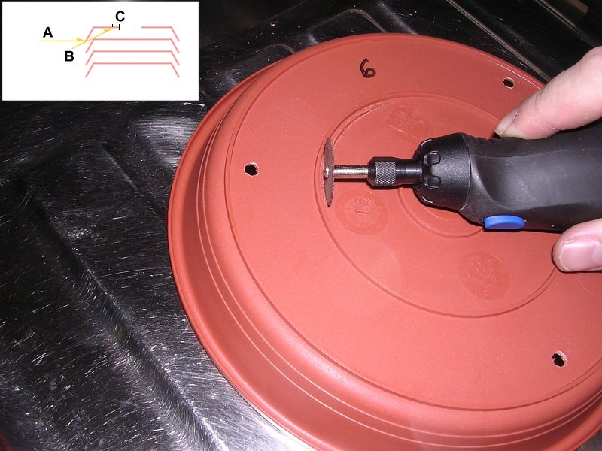  
  
  
3.- Trim with a sharp cutter.  
  
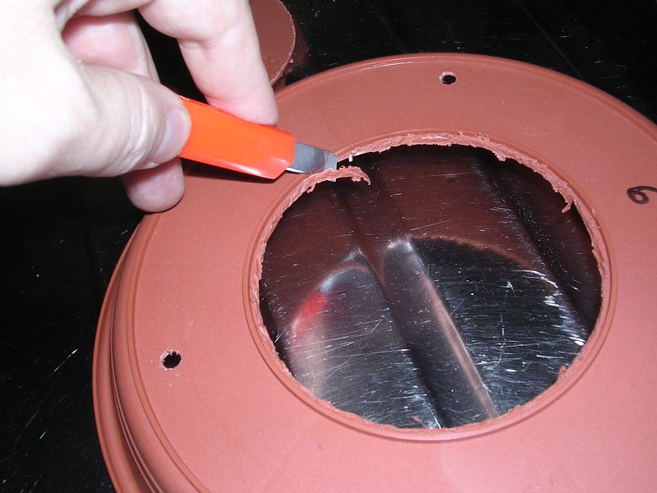  
  
  
4.- This is the finish we want: clean and smooth.  
  
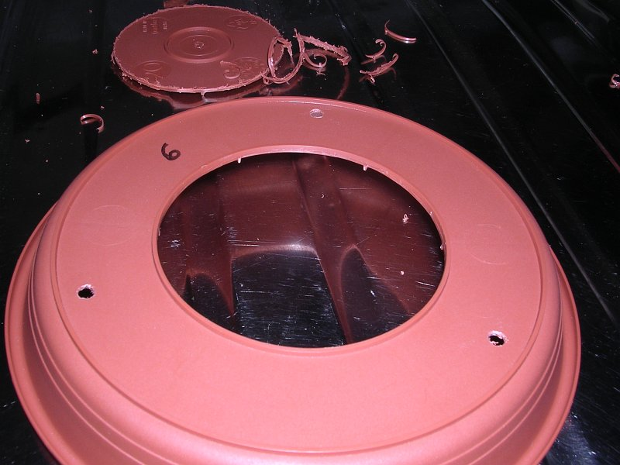  
  
  
5.- Here you have the 10 finished trays. #1 is the lower one, with three threaded rods (30 cm) fitted with some nuts and washes. Tray #7 has a different cut, you will see why later. Trays #9 and #10 have another little rod.  
  
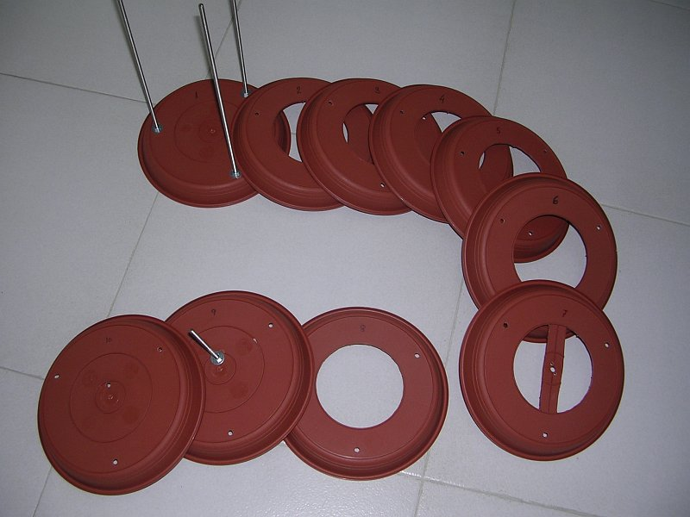  
  
  
6.- From a white painted aluminium tube you have to cut 29 spacers. It is important to make them all of exact length, will avoid later tray misalignments.  
  
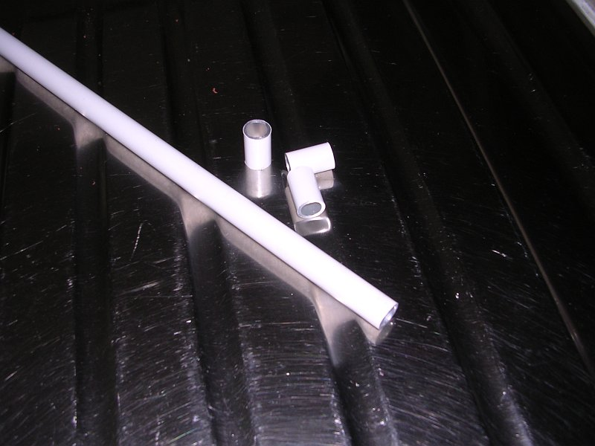  
  
  
7.- Assembling is easy, all you have to do is to put spacer and tray, spacer and try....  
  
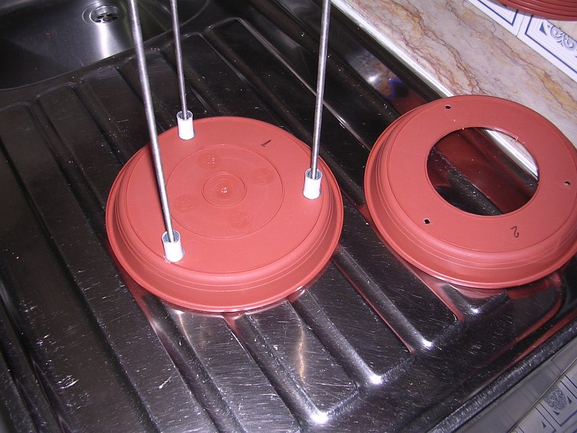  
  
  
8.- Detail of the measuring chamber.  
  
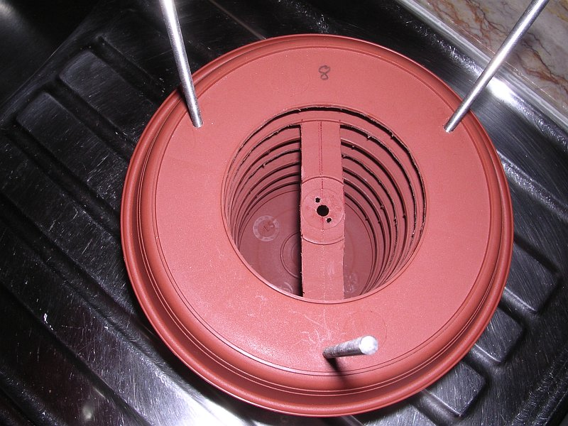  
  
  
9.- Trays #9 and #10 detail. The additional threaded rod allows you to mount a bracket for wall fitting.  
  
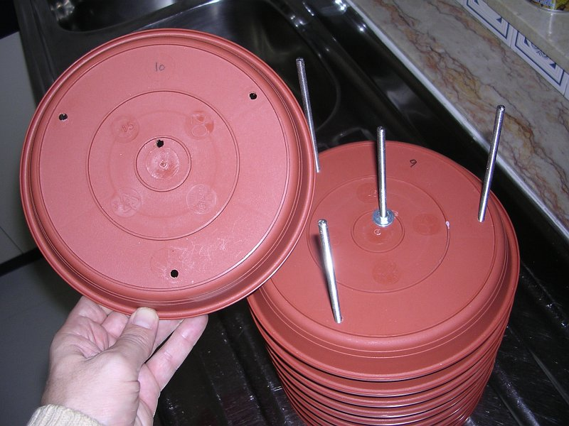  
  
  
10.- Finish the assembly with some more nuts and washes.  
  
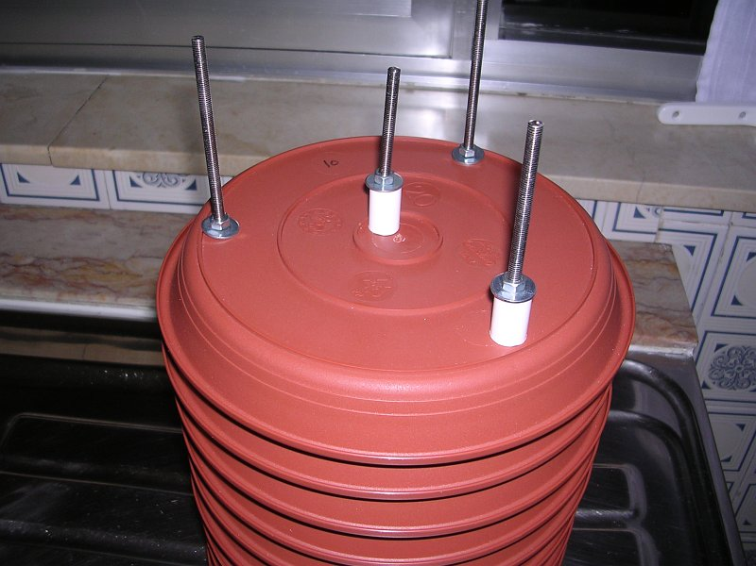  
  
  
11.- Put the shelf bracket into position. Make sure it is long enough to go beyond the trays border. The assembly is strong, it will admit gale winds.  
  
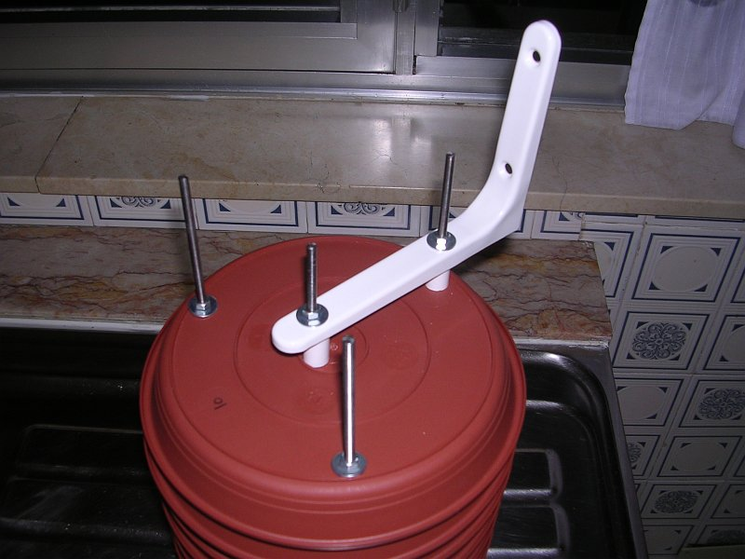  
  
  
12.- Fully assembled radiation shield. All trays aligned, same gap between them. This is not only an aesthetic matter, you intend not to leave any gap or hole to radiation. It is worth to take some time on it.  
  
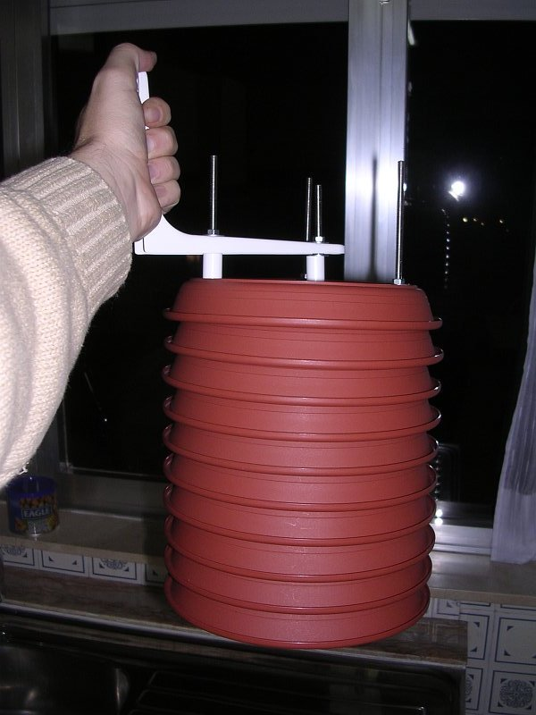  
  
  
13.- Detail of what you see on picture 2 diagram, and the clue for good results: you don't have to see the measuring chamber in any angle, so radiation can't reach it directly. If you take this care you don't have to build a more complicated design.  
  
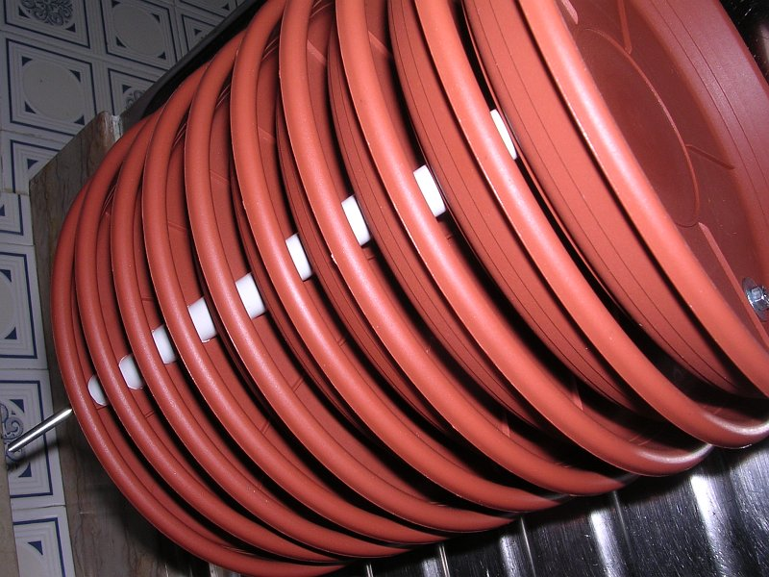  
  
  
14.- Time to disassemble, there's more work to do inside. You have to do the sensor fittings from those pc plates surely you have anywhere. Put them paralell on tray #2.  
  
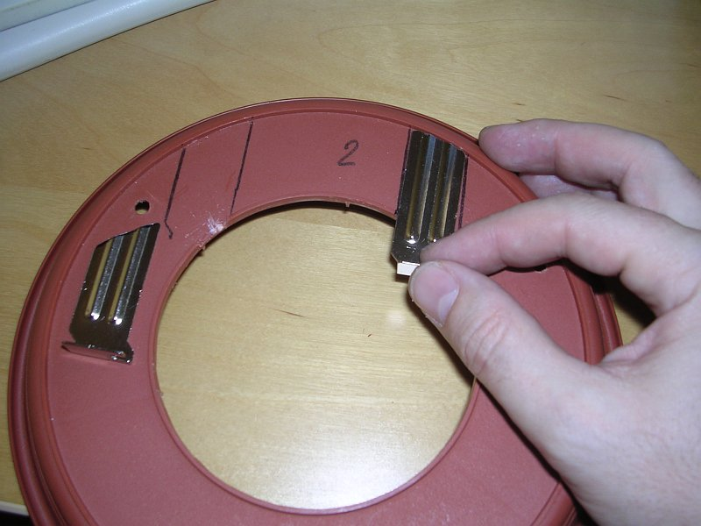  
  
  
15.- A small drill, nut and bolt is enough to fit them in place.  
  
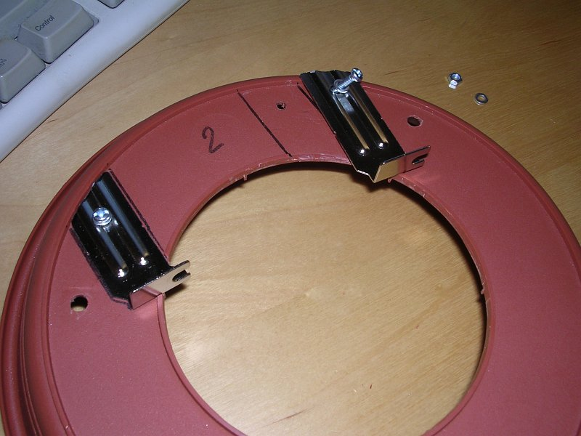  
  
  
16.- Sensor on his final position. This is a WMII sensor but surely you can fit any other in a similar way.  
  
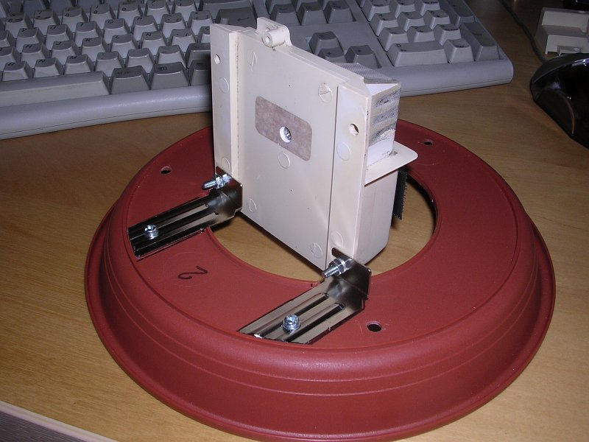  
  
  
17.- Note tha the sensor is horizontally and vertically centered on the measuring chamber, far from direct tray contact.  
  
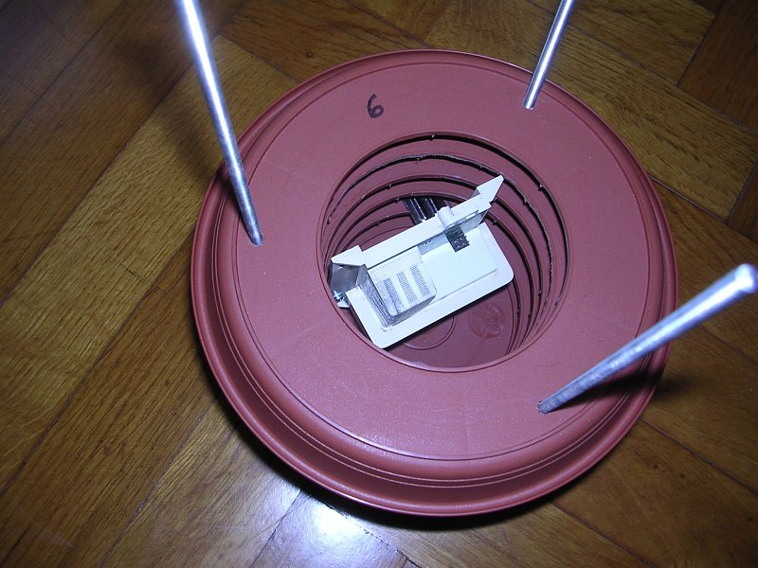  
  
  
18.- Tray #7. The reason why it has a special cut: this is going to be a FARS. All you need is a solar 1 volt motor, a propeller and a 1 volt, 800 mA solar cell. You need to make a central hole for the motor shaft and two small drills for the fitting bolts.  
  
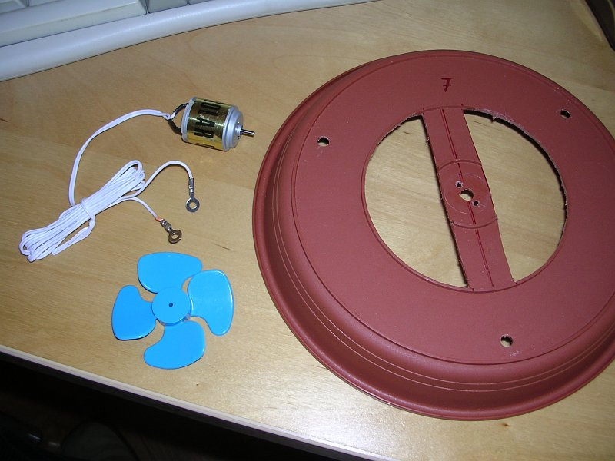  
  
  
19.- The motor fits upside down on top of #7 tray, propeller at the bottom. We want to aspirate, not blow. The motor is directly on the air flow, allowing a small cooling effect on summer. All possible hot parts have to be above the sensor and in the air flow.  
  
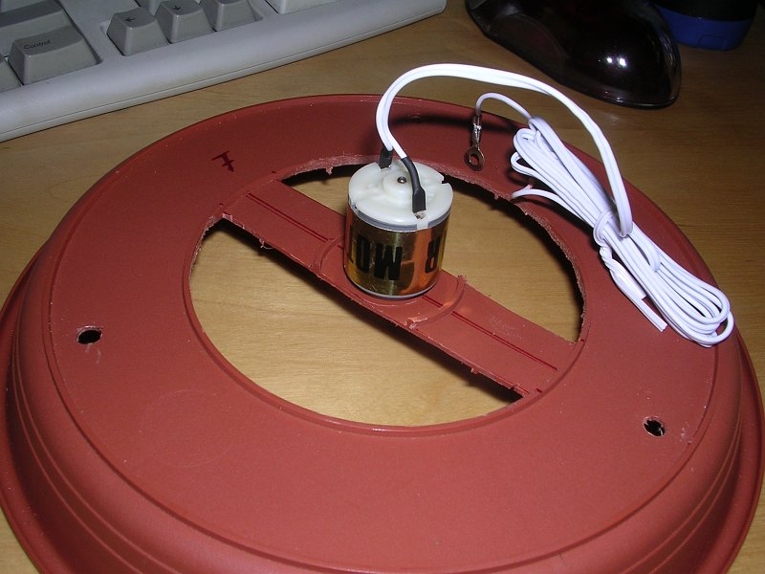  
  
  
20.- Below you can see the small fitting bolts. They have to be very short to avoid damage inside the motor. They thread direcly to motor case.  
  
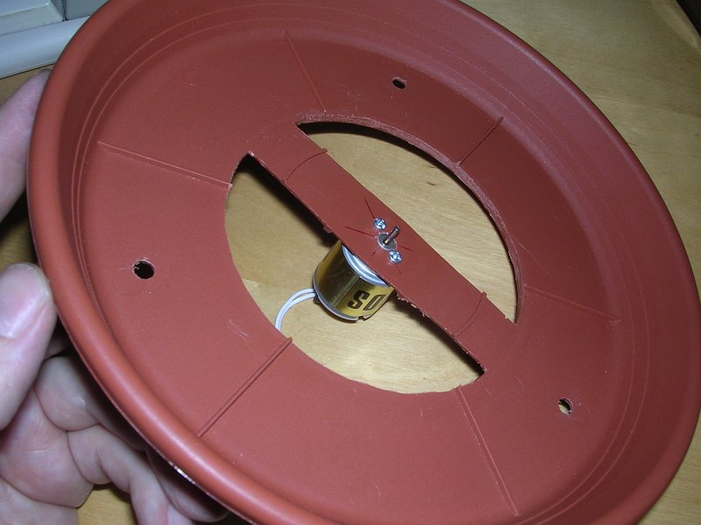  
  
  
21.- Propeller on place. Take care to determine its position and motor polarity. It has to aspire air, not blow it.  
  
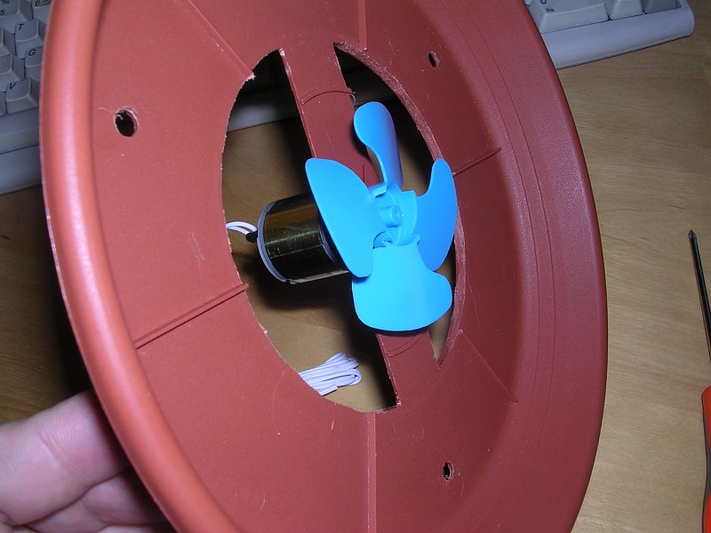  
  
  
22.- Tray #7 in place, Check for enough room between sensor and propeller.  
  
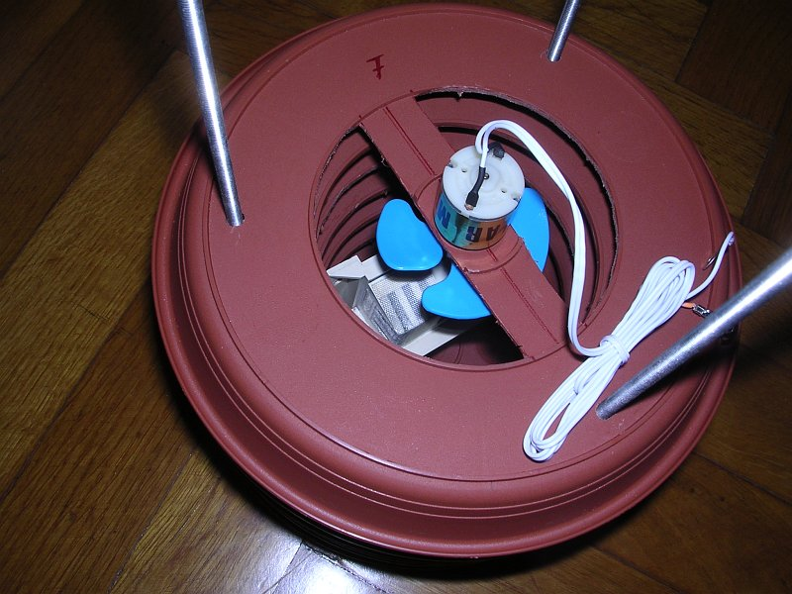  
  
  
23.- A running test. You can see the solar cell at right. Once finished it will fit on top of the radiation shield.  
  
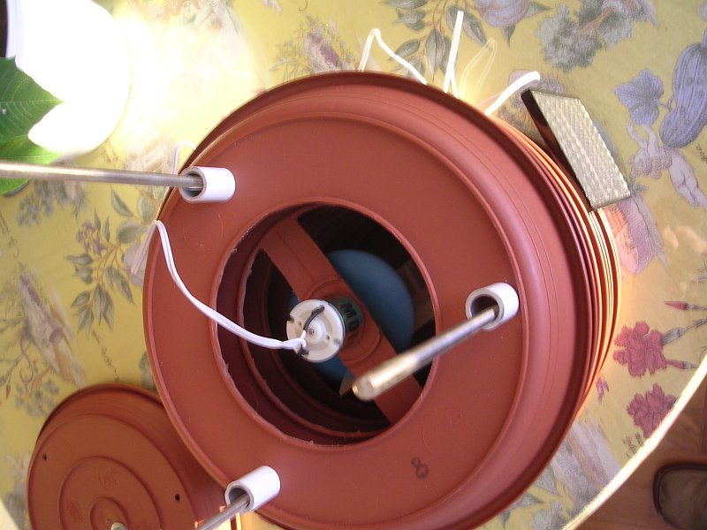  
  
  
24.- Dusk sun which is "fuelling" the test in picture above. You need very little radiation to keep the motor working.  
  
  
  
  
25.- Disassemble again, once you made all checks and fits needed. You need to fill the tray lips, water accumulation on them could distrort humidity readings. Make some down slope to get a better drainage.  
  
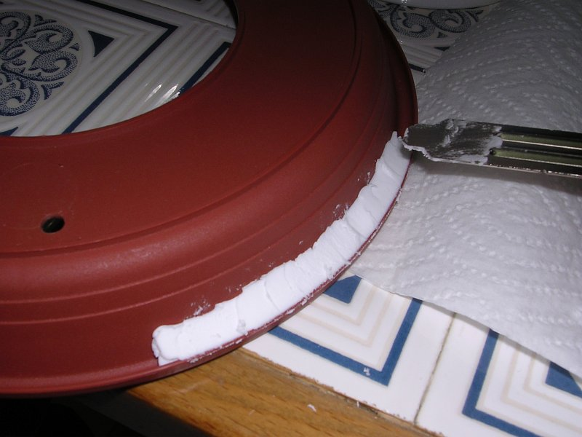  
  
  
26.- Lips once finished. Let the filler dry for a day.  
  
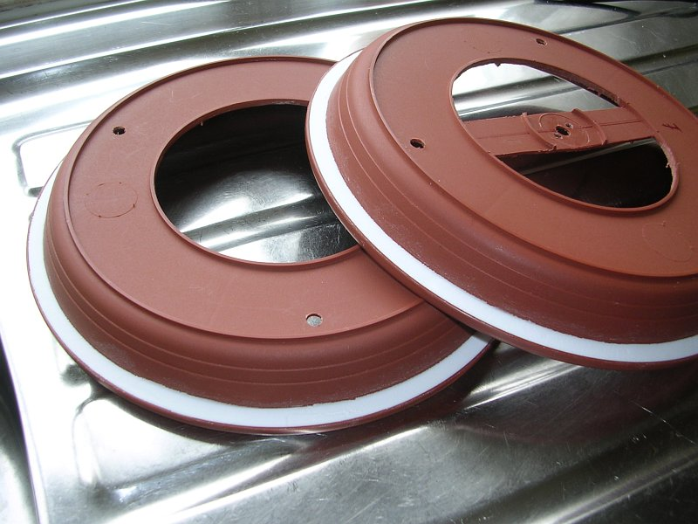  
  
  
27.- Painting job. Take your time to get a good finish. On plastic trays it is recommended to apply a first primer product, then some acryllic paint layers.  
  
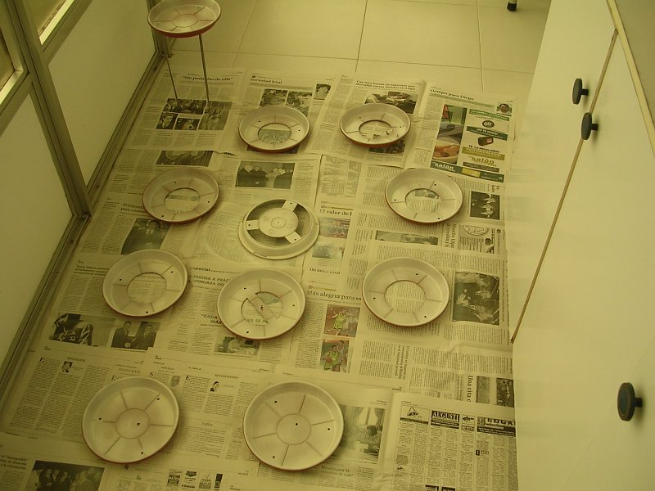  
  
  
28.- The final result: a brilliant white radiation shield, ready to go outside.  
  
