|  |  |
| --- | --- |
| **Architetture dei Sistemi**  **di Elaborazione 02GOLOV** | Delivery date:  Tuesday 22/12 |
| **Laboratory**  **9** | Expected delivery of lab_09.zip must include:   * zipped project folder of the exercise 1 * this lab track completed and converted to pdf format. |

Solve the following problems by starting from the *sample_BUTTON_LED* project (open the file project from the uVision menu). Test the problems using the *LandTiger* emulator.

Remember to check if the emulator is enabled in the menu “Options for Target” after installing the emulator.

|  |  |
| --- | --- |
| Tab “Debug”: load the emulator’s library   | Tab “C/C++”: define SIMULATOR   |

Once you run the debug, if the emulator is correctly installed and added to the debug option, you shall find *LandTiger* under the Peripherals menu.

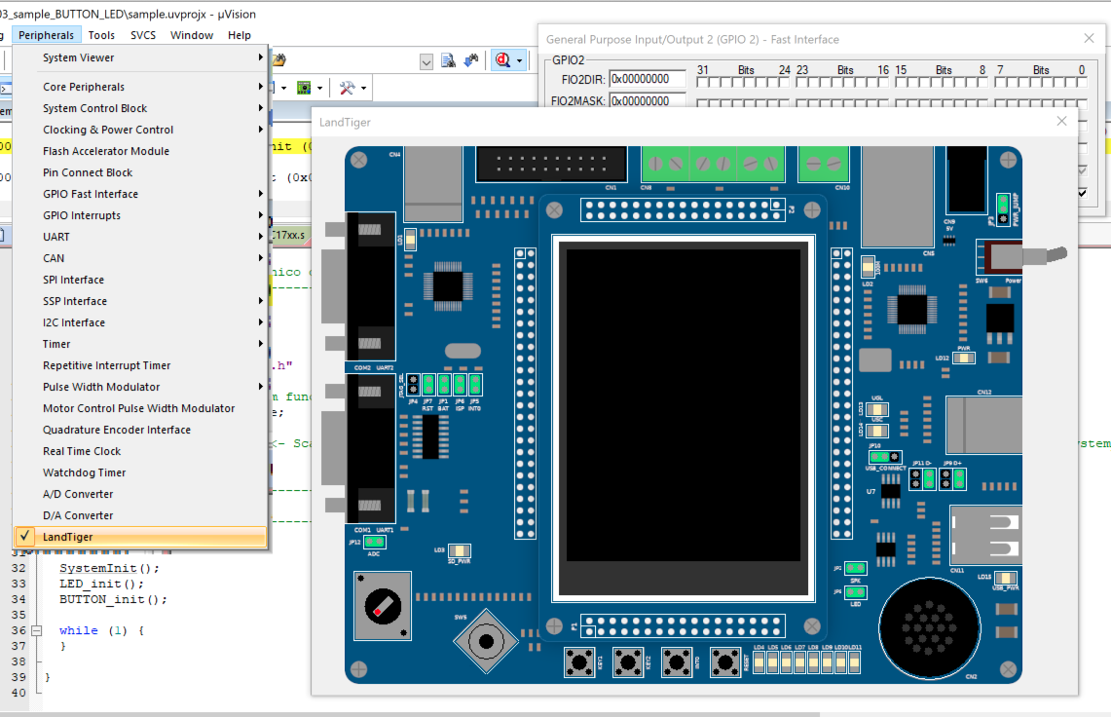

If you right-click on the board, you can access the configuration menu, where you can eventually change some default parameters (tab “Settings”)

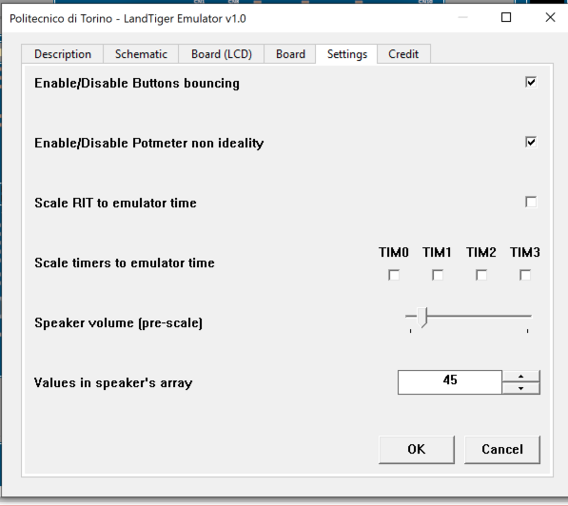

**Exercise 1)** Implement an 8-bit “signed counter” by usingLANDTIGER board; the software permits to use buttons to update a counting value which could be either positive or negative, and the LEDs to show the current value. By first using emulation capabilities, please implement the following functionalities:

* increment a variable every time the button Key1 is pressed,
* decrement when Key2 is pressed (in case, go to negative number)
* reset the count when INT0 is pressed

LEDs are showing the current count in a binary, 2’s complement representation.



**HINT**: It could be useful to use a global variable in order to keep the information about turned ON LEDs. For example, using a variable called “char led_value”, already available in the project.

**Q1:** By adjusting the emulator settings, you can activate a non-ideal behavior of the buttons called "bouncing". Do you notice any different behaviour on the emulator if you enable such a bouncing setting? Please comment.

Abilitando il bouncing, a causa dei rimbalzi nel valore di tensione misurato, il sistema rileva 2, 3 o 4 pressioni del pulsante invece che 1. Introducendo un sistema di temporizzazione che controlla il valore vero dei pulsanti ogni 50 ms si potrebbe risolvere questo problema.

**Q2:** What happens if you act on jumpers JP5 and JP8 with respect to the default configuration?

Se JP5 è disabilitato, il pulsante INT0 viene scollegato dal microcontrollore, pertanto nessun click di quel pulsante verrà registrato.

Se JP8 è disabilitato, i LED vengono scollegati dal microcontrollore. I tasti continuano però a funzionare e ad aggiornare la variabile led_value. Riabilitando JP8, infatti, si vede che i LED assumono il valore corretto, corrispondente alla sequenza di tasti premuta.

Using the emulator, check the schematic and fill the following table.

|  |  |  |
| --- | --- | --- |
| Component | Pull-up resistor name | Pull-up resistor size |
| LEDs | RN3 e RN2 | 470 ohm |
| INT0 | R22 | 10k ohm |
| KEY1 | R25 | 10k ohm |
| KEY2 | R23 | 10k ohm |