**Working with Projects from a SVN repository in Eclipse**

To perform the task shown here you need to have the *Subversive SVN Team Provider* plugin that you can [install from the official Eclipse repository](https://www.eclipse.org/subversive/installation-instructions.php).

The operation you ought to perform for the course are:

* [Check out a project](http://oop.polito.it/svn/OOP2017/docs/CheckoutSvnProject.html#toc_1)
* [Commit your work](http://oop.polito.it/svn/OOP2017/docs/CheckoutSvnProject.html#toc_2)

**Check out a project**

* From the *File* menu select *Import*, the wizard window appears:

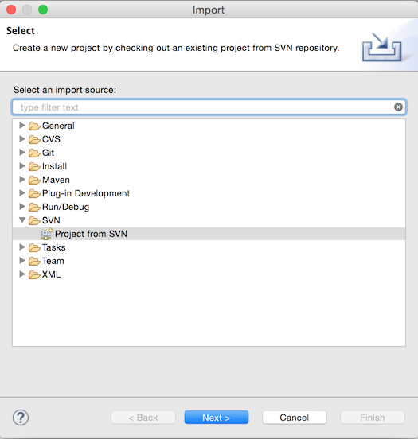

* Select *SVN* and then *Project from SVN*, and, if you are following the procedure for the first time, in the wizard check the *Create a New Repository Location* and then *Next>*.  
  If you alread created a repo location you can select an existing repository and skip the next step.
* The dialog requiring the information about the repository appears:  
  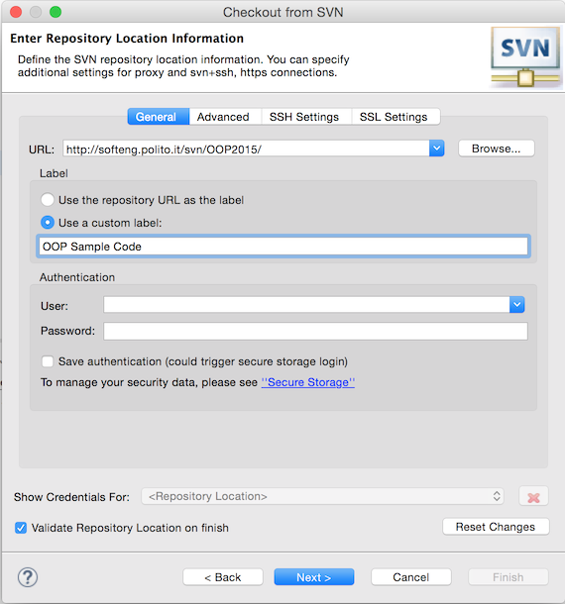

insert the URL of the repository and provide a label.

* + **http://oop.polito.it/svn/OOP2017/** for the code samples presente during lectures
  + **http://oop.polito.it/svn/OOPLabs/s000000** for the personal Lab Assignment repository; in this case:
    - instead of s000000 you should provide your own id
    - the username is your id
    - you should also provide the password you received via email
* Click *Finish* and the resource selection dialog appers:

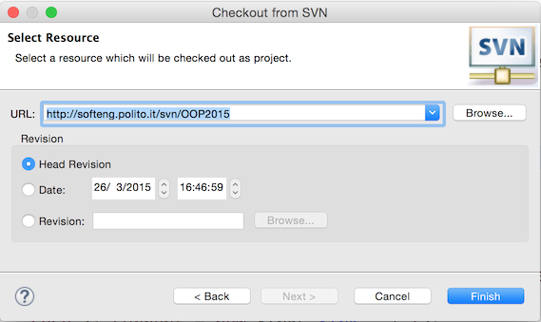

**DO NOT CLICK *FINISH*!!!** that would check out the entire repository which includes several projects, while Eclipse is expecting a single project.

* Click on the *Browse* button, the select resource dialog appears:

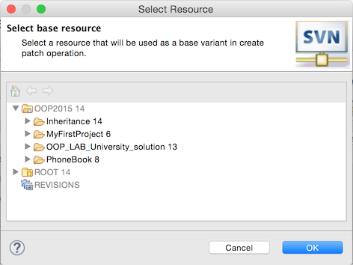

The folders shown there are the Eclipse project you need to import: select one of them and click on *OK*. You are taken back to the previous dialog.

* Now, with a project resource selected you can click on *Finish*, the Check out as dialog appears:

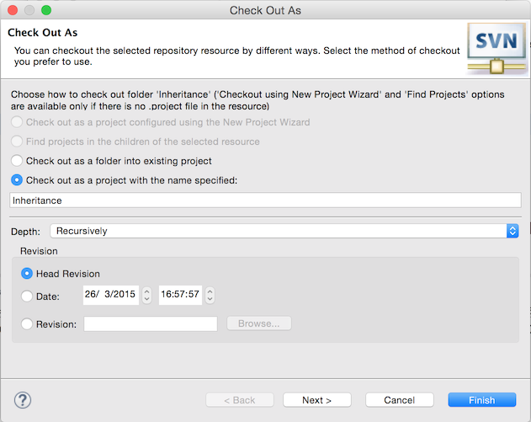

If you wish you can change the name of the project that will be used inside Eclipse (i.e. the folder inside the workspace).

Typically you want to check-out the latest version (the default), if that is not the case you can select a specific version or a date.

* Click on *Finish* to check-out the project into your worksapce.

**Commit Your Work**

To commit your work to the repository (i.e. save a copy of the current status of your project):

* Right click on your project, then select *Team* and then *Commit...*

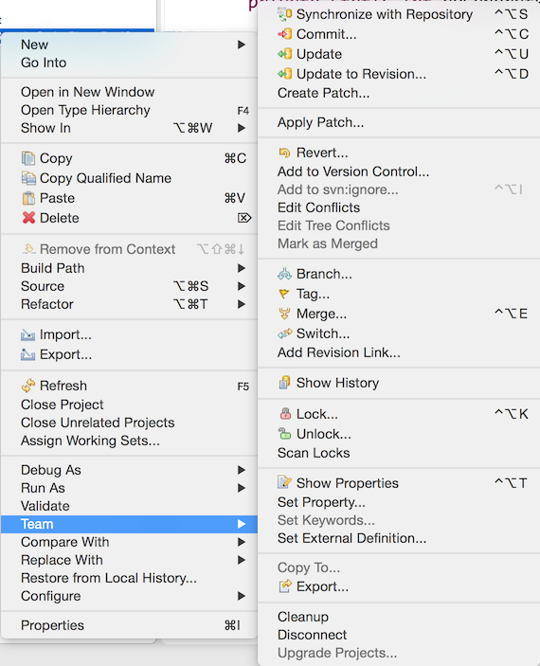

* The commit window opens:

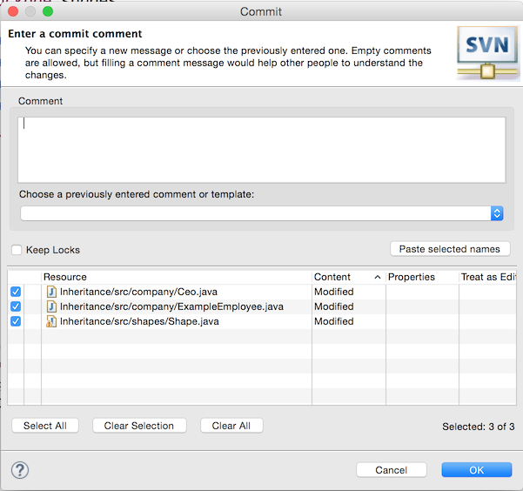

The window reports the resources (files) that changed w.r.t. the version stored on the repository. They could have been: modified, added, or removed.

* Provide a comment (e.g. *Implemented requirement R1*) and click OK.

The project is commited to the repository.

[Creative Commons License](http://creativecommons.org/licenses/by-sa/4.0/)  
This work is licensed under a [Creative Commons Attribution-ShareAlike 4.0 International License](http://creativecommons.org/licenses/by-sa/4.0/).

eAV2D6GvqP