Aegyptus

Egyptian Hieroglyphs, Coptic and Meroitic

󴛸

Aegyptus, version 13.00, March 2020
free strictly for personal, non-commercial use
available under the general ufas licence
Unicode Fonts for Ancient Scripts
George Douros

Aegyptus covers Basic Latin, Coptic, Meroitic, Egyptian Hieroglyphs, quadrats of Gardiner glyphs, the Hieratic alphabet, Egyptian transliteration characters, Punctuation et al. Egyptian Hieroglyphs are encoded in 13000..1342e (Gardiner set of 1071 glyphs) and f3440..f4d3e (extended repertoire of 6399 glyphs). Groups of Gardiner glyphs are available as ligatures (2142 quadrats). The signary is based on Glyph for Windows version 2.0, Gardiner’s Egyptian Grammar, Möller’s Hieratische Paläographie, Unicode proposals et al. See Aegyptus.ods for complete information.

Bibliography

Publications Interuniversitaires de Recherches Égyptologiques Informatisées, ccer, Utrecht - Paris, 2000:
volume I², “Hieroglyphica: Sign List”, Grimal Nicolas, Jochen Hallof, Dirk van der Plas
volume II, “Hieroglyphic Text Processing: Glyph for Windows”, Hans van den Berg, Eric Aubourg
Gardiner, Alan H., “Supplement to the catalogue of the Egyptian hieroglyphic printing type”, 1953
“Catalogue of the Egyptian hieroglyphic printing type”, Oxford University Press, Oxford, 1928
“Egyptian grammar”, 3rd edition, revised, Oxford University Press, London, 1957
Möller, Georg, “Hieratische Paläographie”, Leipzig, 1909-1936, Osnabrück: Otto Zeller, 1909 - 1965
J. Malek, D. Magee and E. Miles, “Objects of Provenance not Known”, Topographical Bibliography, VIII, Griffith Institute, Oxford, 2008
Sylvie Cauville, “Dendara: Le fonds hiéroglyphique au temps de Cléopâtre”, Éditions Cybèle, Paris, 2001
Orientalia Lovaniensia Analecta, Louvain, Belgium, Peeters, 2011-2012:
Dendara XIII, Le pronaos du temple ď Hathor, Façade et colonnes, ola 196,
Dendara XIV, Le pronaos du temple ď Hathor, Parois intérieures, ola 201,
Dendara XV, Le pronaos du temple ď Hathor, Plafond et parois extérieures, ola 213
Michael Everson, “Encoding Egyptian Hieroglyphs in Plane 1 of the UCS”, utc 1999,
“Sources for the encoding of Egyptian Hieroglyphs”, utc 2006
“Preliminary proposal for encoding the Meroitic script in the SMP of the UCS”, utc 2008
“Proposal for encoding the Meroitic Hieroglyphic and the Meroitic Cursive...”, utc 2009
Pandey Anshuman, “Final Proposal to Encode Coptic Epact Numbers in ISO/IEC 10646”, utc 2011
Michel Suignard, “... extended Egyptian Hieroglyphs repertoire”, utc 2016-17 et al.
James P. Allen, “Middle Egyptian: An introduction to the language and culture of hieroglyphs”, cup, 2010
“The Ancient Egyptian Language, An Historical Study”, cup, 2013
A. Erman and H. Grapow, “Wörterbuch der ägyptischen Sprache”, Akademie-Verlag, Berlin, 1971
Raymond O. Faulkner, “A concise dictionary of Middle Egyptian”, Griffith Institute, Ashmolean Museum, 1991
Mark Vygus, “Vygus Egyptian Dictionary”, 2018
Kyriazis Neoklis, “Hieroglyphic Document Editor for gnu-linux”, 2012
Saqqara Technology Ltd., “InScribe 2004 Sign List”, 2004
Bob Richmond, “egpz 1.0 Beta Specification”, 2007
Marwan Kilani, “EgyptianHiero font”, version 3.02
The Unicode Consortium. The Unicode Standard.

Basic characters

! " # $ % & ' ( ) * + , - . / 0 1 2 3 4 5 6 7 8 9 : ; < = > ? @ A B C D E F G H I J K L M N O P Q R S T U V W X Y Z [ \ ] ^ _ ` a b c d e f g h i j k l m n o p q r s t u v w x y z { | } ~ ¤ ¦ § « ¬ ° ¶ • » × ◌͠◌ ‐ ‒ – — ― ‖ ‘ ’ ‚ ‛ “ ” „ ‟ † ‡ • … ′ ″ ‴ ‵ ‶ ‷ ‹ › ⁕ ⁖ ⁘ ⁝ − ∙ ∣ ⋖ ⋗ ⋯ ⋰ ▒ ◌ ☥ ☦ ☨ ⟦ ⟧ ⟨ ⟩ ⟪ ⟫ ⟮ ⟯ ⸨ ⸩ ◌︠ ◌︡ ◌︢ ◌︣ ◌︤ ◌︦ ◌︥ 💻 🖳 (u+1f4bb u+1f5b3)

Meroitic Hieroglyphs (salt)

𐦀 𐦁 𐦂 𐦃 𐦄 𐦅 𐦆 𐦇 𐦈 𐦉 𐦊 𐦋 𐦌 𐦍 𐦎 𐦏 𐦐 𐦑 𐦒 𐦓 𐦔 𐦕 𐦖 𐦗 𐦗 𐦘 𐦘 𐦙 𐦚 𐦛 𐦜 𐦝 𐦞 𐦟

Meroitic Cursive (salt)

𐦠 𐦡 𐦢 𐦣 𐦤 𐦥 𐦦 𐦧 𐦨 𐦩 𐦪 𐦪 𐦫 𐦬 𐦭 𐦮 𐦯 𐦰 𐦰 𐦱 𐦲 𐦳 𐦴 𐦵 𐦶 𐦷 𐦾 𐦿

Meroitic Cursive; numbers

𐦼 𐦽 𐧀 𐧁 𐧂 𐧃 𐧄 𐧅 𐧆 𐧇 𐧈 𐧉 𐧊 𐧋 𐧌 𐧍 𐧎 𐧏 𐧒 𐧓 𐧔 𐧕 𐧖 𐧗 𐧘 𐧙 𐧚 𐧛 𐧜 𐧝 𐧞 𐧟 𐧠 𐧡 𐧢 𐧣 𐧤 𐧥 𐧦 𐧧 𐧨 𐧩 𐧪 𐧫 𐧬 𐧭 𐧮 𐧯 𐧰 𐧱 𐧲 𐧳 𐧴 𐧵 𐧶 𐧷 𐧸 𐧹 𐧺 𐧻 𐧼 𐧽 𐧾 𐧿

Meroitic Cursive; symbols in plane 15

󰦃 󰦄 󰦅 󰦆 󰦇 󰦈 󰦉 󰦊 󰦋 󰦌 󰦍 󰦎 󰦏 󰦐 󰦑 󰦒 󰦔 󰦕 󰦖

Coptic

Ͳ ͳ Ϡ ϡ Ϣ ϣ Ϥ ϥ Ϧ ϧ Ϩ ϩ Ϫ ϫ Ϭ ϭ Ϯ ϯ Ⲁ ⲁ Ⲃ ⲃ Ⲅ ⲅ Ⲇ ⲇ Ⲉ ⲉ Ⲋ ⲋ Ⲍ ⲍ Ⲏ ⲏ Ⲑ ⲑ Ⲓ ⲓ Ⲕ ⲕ Ⲗ ⲗ Ⲙ ⲙ Ⲛ ⲛ Ⲝ ⲝ Ⲟ ⲟ Ⲡ ⲡ Ⲣ ⲣ Ⲥ ⲥ Ⲧ ⲧ Ⲩ ⲩ Ⲫ ⲫ Ⲭ ⲭ Ⲯ ⲯ Ⲱ ⲱ Ⲳ ⲳ Ⲵ ⲵ Ⲷ ⲷ Ⲹ ⲹ Ⲻ ⲻ Ⲽ ⲽ Ⲿ ⲿ Ⳁ ⳁ Ⳃ ⳃ Ⳅ ⳅ Ⳇ ⳇ Ⳉ ⳉ Ⳋ ⳋ Ⳍ ⳍ Ⳏ ⳏ Ⳑ ⳑ Ⳓ ⳓ Ⳕ ⳕ Ⳗ ⳗ Ⳙ ⳙ Ⳛ ⳛ Ⳝ ⳝ Ⳟ ⳟ Ⳡ ⳡ Ⳣ ⳣ ⳤ ⳥ ⳦ ⳧ U+2ce8 ⳩ ⳪ Ⳬ ⳬ Ⳮ ⳮ ◌⳯◌ ◌⳰ ◌⳱ Ⳳ ⳳ ⳹ ⳺ ⳻ ⳼ ⳽ ⳾ ⳿ ◌𐋠 𐋡 𐋢 𐋣 𐋤 𐋥 𐋦 𐋧 𐋨 𐋩 𐋪 𐋫 𐋬 𐋭 𐋮 𐋯 𐋰 𐋱 𐋲 𐋳 𐋴 𐋵 𐋶 𐋷 𐋸 𐋹 𐋺 𐋻

Coptic; OpenType (mark, liga, dlig, aalt, ss01, ss02, ss03)

ϣ̂ϥ̂ϧ̂ϩ̂ϫ̂ϭ̂ϯ̂ⲁ̂ⲃ̂ⲅ̂ⲇ̂ⲉ̂ⲋ̂ⲍ̂ⲏ̂ⲑ̂ⲓ̂ⲕ̂ⲗ̂ⲙ̂ⲛ̂ⲝ̂ⲟ̂ⲡ̂ⲣ̂ⲥ̂ⲧ̂ⲩ̂ⲫ̂ⲭ̂ⲯ̂ⲱ̂
ϣ̄ϥ̄ϧ̄ϩ̄ϫ̄ϭ̄ϯ̄ⲁ̄ⲃ̄ⲅ̄ⲇ̄ⲉ̄ⲋ̄ⲍ̄ⲏ̄ⲑ̄ⲓ̄ⲕ̄ⲗ̄ⲙ̄ⲛ̄ⲝ̄ⲟ̄ⲡ̄ⲣ̄ⲥ̄ⲧ̄ⲩ̄ⲫ̄ⲭ̄ⲯ̄ⲱ̄
ϣ̅ϥ̅ϧ̅ϩ̅ϫ̅ϭ̅ϯ̅ⲁ̅ⲃ̅ⲅ̅ⲇ̅ⲉ̅ⲋ̅ⲍ̅ⲏ̅ⲑ̅ⲓ̅ⲕ̅ⲗ̅ⲙ̅ⲛ̅ⲝ̅ⲟ̅ⲡ̅ⲣ̅ⲥ̅ⲧ̅ⲩ̅ⲫ̅ⲭ̅ⲯ̅ⲱ̅⳨̅
ϣ̇ϥ̇ϧ̇ϩ̇ϫ̇ϭ̇ϯ̇ⲁ̇ⲃ̇ⲅ̇ⲇ̇ⲉ̇ⲋ̇ⲍ̇ⲏ̇ⲑ̇ⲓ̇ⲕ̇ⲗ̇ⲙ̇ⲛ̇ⲝ̇ⲟ̇ⲡ̇ⲣ̇ⲥ̇ⲧ̇ⲩ̇ⲫ̇ⲭ̇ⲯ̇ⲱ̇
ϣ̈ϥ̈ϧ̈ϩ̈ϫ̈ϭ̈ϯ̈ⲁ̈ⲃ̈ⲅ̈ⲇ̈ⲉ̈ⲋ̈ⲍ̈ⲏ̈ⲑ̈ⲓ̈ⲕ̈ⲗ̈ⲙ̈ⲛ̈ⲝ̈ⲟ̈ⲡ̈ⲣ̈ⲥ̈ⲧ̈ⲩ̈ⲫ̈ⲭ̈ⲯ̈ⲱ̈
ϣ̊ϥ̊ϧ̊ϩ̊ϫ̊ϭ̊ϯ̊ⲁ̊ⲃ̊ⲅ̊ⲇ̊ⲉ̊ⲋ̊ⲍ̊ⲏ̊ⲑ̊ⲓ̊ⲕ̊ⲗ̊ⲙ̊ⲛ̊ⲝ̊ⲟ̊ⲡ̊ⲣ̊ⲥ̊ⲧ̊ⲩ̊ⲫ̊ⲭ̊ⲯ̊ⲱ̊
ϣ̑ϥ̑ϧ̑ϩ̑ϫ̑ϭ̑ϯ̑ⲁ̑ⲃ̑ⲅ̑ⲇ̑ⲉ̑ⲋ̑ⲍ̑ⲏ̑ⲑ̑ⲓ̑ⲕ̑ⲗ̑ⲙ̑ⲛ̑ⲝ̑ⲟ̑ⲡ̑ⲣ̑ⲥ̑ⲧ̑ⲩ̑ⲫ̑ⲭ̑ⲯ̑ⲱ̑
ϣ̿ϥ̿ϧ̿ϩ̿ϫ̿ϭ̿ϯ̿ⲁ̿ⲃ̿ⲅ̿ⲇ̿ⲉ̿ⲋ̿ⲍ̿ⲏ̿ⲑ̿ⲓ̿ⲕ̿ⲗ̿ⲙ̿ⲛ̿ⲝ̿ⲟ̿ⲡ̿ⲣ̿ⲥ̿ⲧ̿ⲩ̿ⲫ̿ⲭ̿ⲯ̿ⲱ̿⳨̿
ϣ̿ϥ̿ϧ̿ϩ̿ϫ̿ϭ̿ϯ̿ⲁ̿ⲃ̿ⲅ̿ⲇ̿ⲉ̿ⲋ̿ⲍ̿ⲏ̿ⲑ̿ⲓ̿ⲕ̿ⲗ̿ⲙ̿ⲛ̿ⲝ̿ⲟ̿ⲡ̿ⲣ̿ⲥ̿ⲧ̿ⲩ̿ⲫ̿ⲭ̿ⲯ̿ⲱ̿⳨̿
ϣ⳰ϥ⳰ϧ⳰ϩ⳰ϫ⳰ϭ⳰ϯ⳰ⲁ⳰ⲃ⳰ⲅ⳰ⲇ⳰ⲉ⳰ⲋ⳰ⲍ⳰ⲏ⳰ⲑ⳰ⲓ⳰ⲕ⳰ⲗ⳰ⲙ⳰ⲛ⳰ⲝ⳰ⲟ⳰ⲡ⳰ⲣ⳰ⲥ⳰ⲧ⳰ⲩ⳰ⲫ⳰ⲭ⳰ⲯ⳰ⲱ⳰
ϣ⳱ϥ⳱ϧ⳱ϩ⳱ϫ⳱ϭ⳱ϯ⳱ⲁ⳱ⲃ⳱ⲅ⳱ⲇ⳱ⲉ⳱ⲋ⳱ⲍ⳱ⲏ⳱ⲑ⳱ⲓ⳱ⲕ⳱ⲗ⳱ⲙ⳱ⲛ⳱ⲝ⳱ⲟ⳱ⲡ⳱ⲣ⳱ⲥ⳱ⲧ⳱ⲩ⳱ⲫ⳱ⲭ⳱ⲯ⳱ⲱ⳱
𐋡𐋠 𐋢𐋠 𐋣𐋠 𐋤𐋠 𐋥𐋠 𐋦𐋠 𐋧𐋠 𐋨𐋠 𐋩𐋠 𐋪𐋠 𐋫𐋠 𐋫𐋠 𐋬𐋠 𐋭𐋠 𐋮𐋠 𐋮𐋠 𐋯𐋠 𐋰𐋠 𐋱𐋠 𐋲𐋠 𐋳𐋠 𐋴𐋠 𐋵𐋠 𐋶𐋠 𐋷𐋠 𐋸𐋠 𐋹𐋠 𐋹𐋠 𐋺𐋠 𐋻𐋠 𐋻𐋠 𐋻𐋠 𐋻𐋠
𐋪 𐋩 𐋨 𐋧 𐋦 𐋥 𐋤 𐋣 𐋥 ⳽ 𐋣 𐋨 𐋫 𐋮 𐋱 𐋶 𐋶 𐋶 𐋸 𐋹 𐋻 𐋻 𐋻 ⲡⲟⲥ ⲁ ⲇ ⲕ ⲗ ⲙ ⲝ ⲣ ⲫ 𐅟 𐅱 𐆄 𐆌 𐆍 ⲙ ⲛ

Coptic Numbers

1 | ⲁ̅ | 𐋡 |  | 100 | ⲣ̅ | 𐋳 |  | 10000 | ⲓ̿ | 𐋪𐋠 |  | 1/10 | 𐋪
2 | ⲃ̅ | 𐋢 |  | 200 | ⲥ̅ | 𐋴 |  | 20000 | ⲕ̿ | 𐋫𐋠 𐋫𐋠 |  | 1/9 | 𐋩
3 | ⲅ̅ | 𐋣 |  | 300 | ⲧ̅ | 𐋵 |  | 30000 | ⲗ̿ | 𐋬𐋠 |  | 1/8 | 𐋨
4 | ⲇ̅ | 𐋤 |  | 400 | ⲩ̅ | 𐋶 𐋶 𐋶 𐋶 |  | 40000 | ⲙ̿ | 𐋭𐋠 |  | 1/7 | 𐋧
5 | ⲉ̅ | 𐋥 |  | 500 | ⲫ̅ | 𐋷 |  | 50000 | ⲛ̿ | 𐋮𐋠 𐋮𐋠 |  | 1/6 | 𐋦
6 | ⲋ̅ | 𐋦 |  | 600 | ⲭ̅ | 𐋸 𐋸 |  | 60000 | ⲝ̿ | 𐋯𐋠 |  | 1/5 | 𐋥
7 | ⲍ̅ | 𐋧 |  | 700 | ⲯ̅ | 𐋹 𐋹 |  | 70000 | ⲟ̿ | 𐋰𐋠 |  | 1/4 | 𐋤
8 | ⲏ̅ | 𐋨 𐋨 |  | 800 | ⲱ̅ | 𐋺 |  | 80000 | ⲡ̿ | 𐋱𐋠 |  | 1/3 | 𐋣
9 | ⲑ̅ | 𐋩 |  | 900 | ⳨̅ | ⳨ 𐋻 𐋻 𐋻 𐋻 |  | 90000 | ϥ̿ | 𐋲𐋠 |  | 2/5 | 𐋥
10 | ⲓ̅ | 𐋪 |  | 1000 | ⲁ̿ | 𐋡𐋠 |  | 100000 | ⲣ̿ | 𐋳𐋠 |  | 1/2 | ⳽ ⳽
20 | ⲕ̅ | 𐋫 𐋫 |  | 2000 | ⲃ̿ | 𐋢𐋠 |  | 200000 | ⲥ̿ | 𐋴𐋠 |  | 2/3 | 𐋣
30 | ⲗ̅ | 𐋬 |  | 3000 | ⲅ̿ | 𐋣𐋠 |  | 300000 | ⲧ̿ | 𐋵𐋠
40 | ⲙ̅ | 𐋭 |  | 4000 | ⲇ̿ | 𐋤𐋠 |  | 400000 | ⲩ̿ | 𐋶𐋠
50 | ⲛ̅ | 𐋮 𐋮 |  | 5000 | ⲉ̿ | 𐋥𐋠 |  | 500000 | ⲫ̿ | 𐋷𐋠
60 | ⲝ̅ | 𐋯 |  | 6000 | ⲋ̿ | 𐋦𐋠 |  | 600000 | ⲭ̿ | 𐋸𐋠
70 | ⲟ̅ | 𐋰 |  | 7000 | ⲍ̿ | 𐋧𐋠 |  | 700000 | ⲯ̿ | 𐋹𐋠 𐋹𐋠
80 | ⲡ̅ | 𐋱 𐋱 |  | 8000 | ⲏ̿ | 𐋨𐋠 |  | 800000 | ⲱ̿ | 𐋺𐋠
90 | ϥ̅ | 𐋲 |  | 9000 | ⲑ̿ | 𐋩𐋠 |  | 900000 | ⳨̿ | 𐋻𐋠 𐋻𐋠 𐋻𐋠 𐋻𐋠

A sample of hieroglyphic printing from Gardiner, 1928 p. 13:

image:
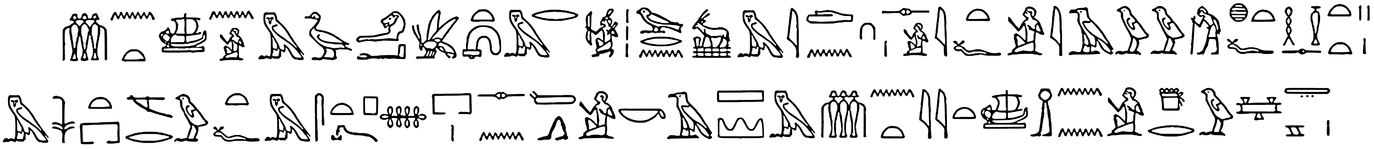

text rendered in Aegyptus-Bold with OpenType support:
𓏃𓈖𓏏𓊝𓈖𓀀𓅓𓅭𓄂𓂝𓆤‌𓏏𓋨𓅓𓂋𓀎𓏪𓅨𓂋𓈖󳶚𓅓𓇋𓂧𓈖𓎆𓊃𓏤𓀀𓇋𓏏𓆑𓀀𓇋𓄿𓅱𓅱𓀗𓐍𓏏𓆑𓎛𓎿𓊃𓏏𓏏𓏮𓏤
𓅓𓇓‌𓏏𓉐𓌻𓂋𓅱‌𓏏𓆑𓅓𓋴𓏏𓊪𓍉𓎂𓉐𓏤𓊃𓈖‌𓏕𓂻𓀀‌𓎡‌𓄿𓈙𓈉𓅓𓏃𓈖𓏏𓇌𓏏𓊝𓏎‌𓈖𓈖𓀀𓇥𓂋𓅱𓈐𓇾𓈇𓏤

the same text with OpenType support turned off:
𓏃𓈖𓏏𓊝𓈖𓀀𓅓𓅭𓄂𓂝𓆤‌𓏏𓋨𓅓𓂋𓀎𓏪𓅨𓂋𓈖󳶚𓅓𓇋𓂧𓈖𓎆𓊃𓏤𓀀𓇋𓏏𓆑𓀀𓇋𓄿𓅱𓅱𓀗𓐍𓏏𓆑𓎛𓎿𓊃𓏏𓏏𓏮𓏤𓅓𓇓‌𓏏𓉐𓌻𓂋𓅱‌𓏏𓆑𓅓𓋴𓏏𓊪𓍉𓎂𓉐𓏤𓊃𓈖‌𓏕𓂻𓀀‌𓎡‌𓄿𓈙𓈉𓅓𓏃𓈖𓏏𓇌𓏏𓊝𓏎‌𓈖𓈖𓀀𓇥𓂋𓅱𓈐𓇾𓈇𓏤

Unicode has 𓉇 instead of Gardiner’s 󳶚; the latter is included in the extended repertoire of Aegyptus.

The Egyptian Alphabet: ascii, Hieratic, Transliteration, Hieroglyphic and Kyriazis’ images

A | A | A | A | 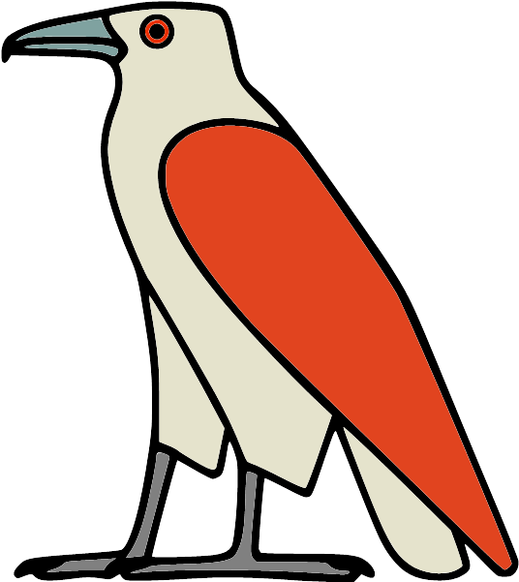 |  | p | p | p | p | 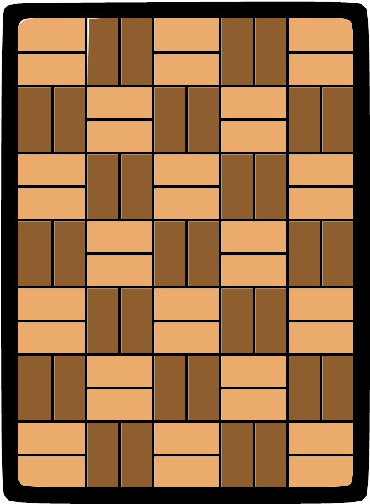 |  | x | x | x | x |  |  | t | t | t | t | 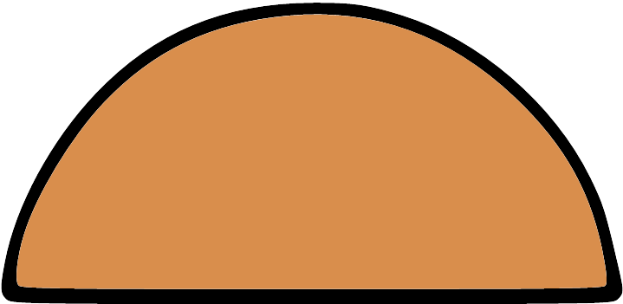
i | i | i | i |  |  | f | f | f | f |  |  | X | X | X | X | 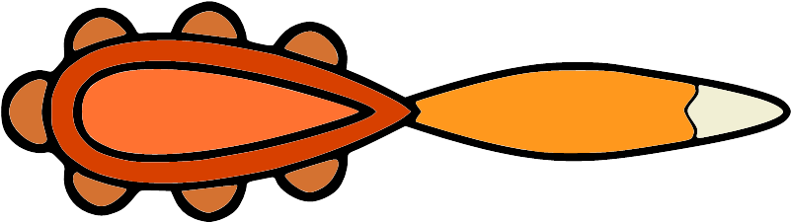 |  | T | T | T | T | 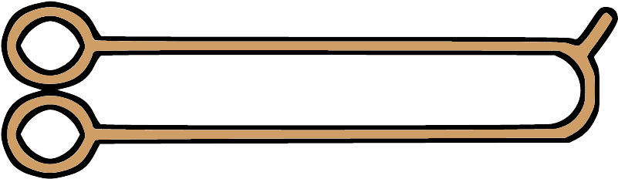
y | y | y | y | 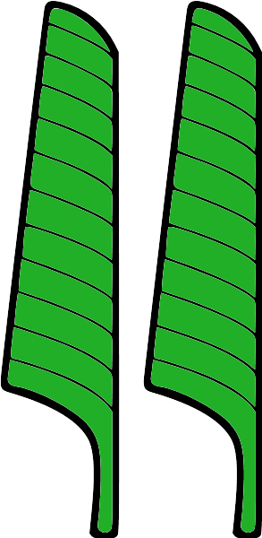 |  | m | m | m | m | 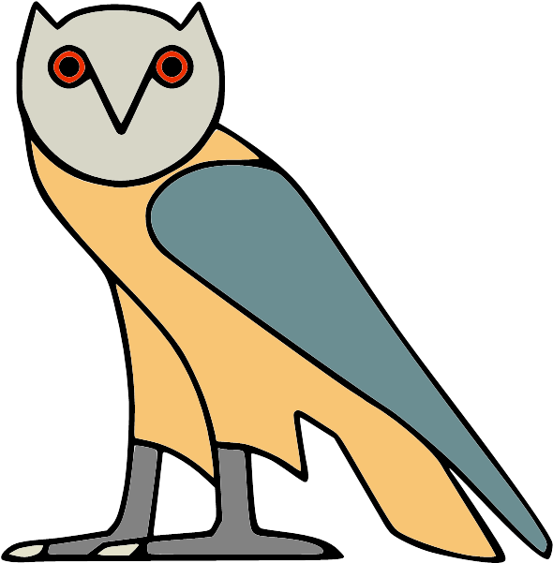 |  | s | s | s | s |  |  | d | d | d | d | 
j | j | j | j |  |  | M | M | M | M |  |  | z | z | z | z |  |  | D | D | D | D | 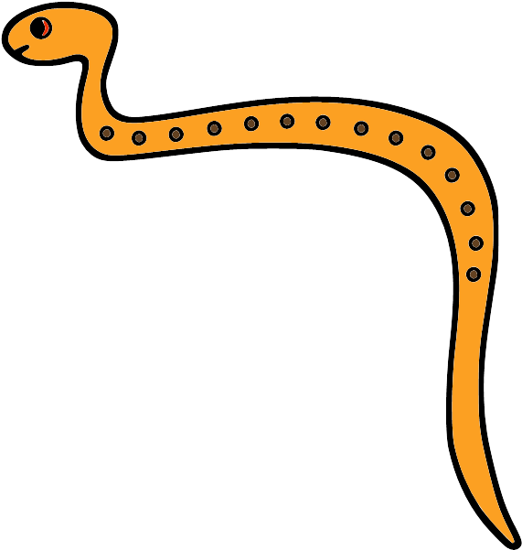
a | a | a | a | 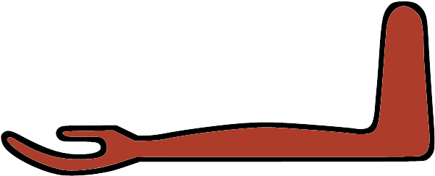 |  | n | n | n | n |  |  | S | S | S | S |  |  | N | N | N | N | 
w | w | w | w |  |  | r | r | r | r |  |  | q | q | q | q | 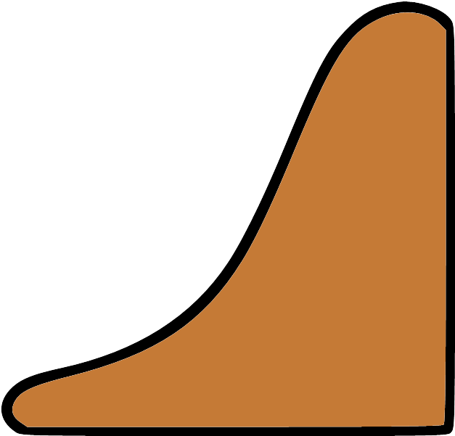 |  | R | R | R | R | 
W | W | W | W |  |  | h | h | h | h | 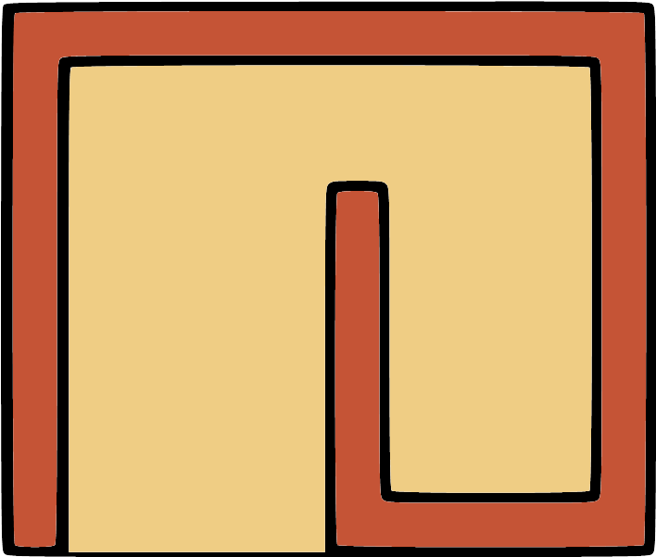 |  | k | k | k | k | 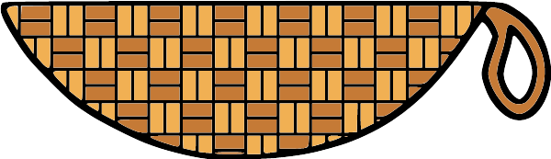 |  | K | K | K | K | 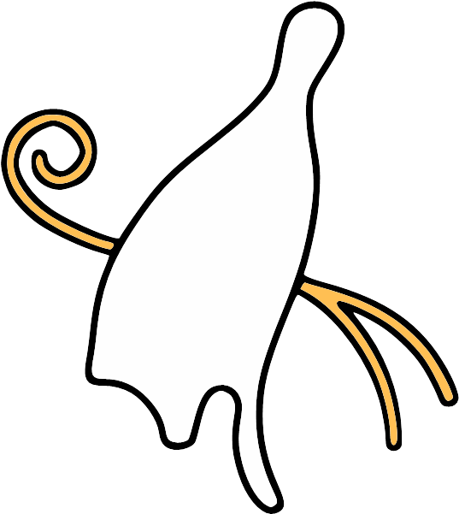
b | b | b | b | 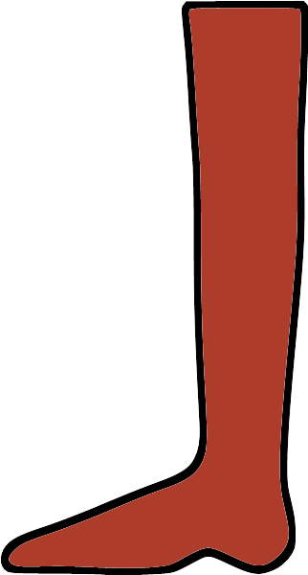 |  | H | H | H | H |  |  | g | g | g | g |  |  | l | l | l | l | 

Hieratic alphabet: ss20
A i y j a w b p f m n r h H x X z s S q k g t T d D W M N R K l →
A i y j a w b p f m n r h H x X z s S q k g t T d D W M N R K l

Transliteration alphabet: ss10
A i y j a w b p f m n r h H x X z s S q k g t T d D W M N R K l →
A i y j a w b p f m n r h H x X z s S q k g t T d D W M N R K l

Hieroglyphic alphabet: ss15
A i y j a w b p f m n r h H x X z s S q k g t T d D W M N R K l →
A i y j a w b p f m n r h H x X z s S q k g t T d D W M N R K l

Dingbats: ornm

1 2 3 4 5 6 7 8 9 → 1 2 3 4 5 6 7 8 9

Quadrats; example:
no ligature, liga=0 default ligature ligature split by a zero width non-joiner u+200c
i10 i9 n35 d54 i10 i9 n35 d54 i10 i9 󲀌 n35 d54

𓆓𓆑𓈖𓂻 𓆓𓆑𓈖𓂻 𓆓𓆑‌𓈖𓂻

Quadrats with variants:

parts, liga=0 | group | aalt |  | parts, liga=0 | group | aalt | aalt=2 |  | parts, liga=0 | group | aalt
𓂂𓏥 | 𓂂𓏥 | 𓂂𓏥 |  | 𓃘𓏥 | 𓃘𓏥 | 𓃘𓏥 |  |  | 𓅬𓏥 | 𓅬𓏥 | 𓅬𓏥
𓂋𓏏𓏥 | 𓂋𓏏𓏥 | 𓂋𓏏𓏥 |  | 𓄂𓏏 | 𓄂𓏏 | 𓄂𓏏 |  |  | 𓅱𓏏 | 𓅱𓏏 | 𓅱𓏏
𓂋𓏤 | 𓂋𓏤 | 𓂋𓏤 |  | 𓅂𓏥 | 𓅂𓏥 | 𓅂𓏥 |  |  | 𓆓𓈒𓏏 | 𓆓𓈒𓏏 | 𓆓𓈒𓏏
𓂓𓂸 | 𓂓𓂸 | 𓂓𓂸 |  | 𓅂𓏏 | 𓅂𓏏 | 𓅂𓏏 |  |  | 𓇓𓏏 | 𓇓𓏏 | 𓇓𓏏
𓂝𓏤 | 𓂝𓏤 | 𓂝𓏤 |  | 𓅓𓂋 | 𓅓𓂋 | 𓅓𓂋 |  |  | 𓎸𓃞 | 𓎸𓃞 | 𓎸𓃞
𓂧𓃀 | 𓂧𓃀 | 𓂧𓃀 |  | 𓅓𓂝 | 𓅓𓂝 | 𓅓𓂝 |  |  | 𓏏𓊾 | 𓏏𓊾 | 𓏏𓊾
𓃒𓏥 | 𓃒𓏥 | 𓃒𓏥 |  | 𓅓𓏏 | 𓅓𓏏 | 𓅓𓏏 | 𓅓𓏏 |  | 𓐍𓏏 | 𓐍𓏏 | 𓐍𓏏
𓃗𓏥 | 𓃗𓏥 | 𓃗𓏥 |  | 𓅨𓂋 | 𓅨𓂋 | 𓅨𓂋 |  |  | 𓐙𓊤 | 𓐙𓊤 | 𓐙𓊤

Quadrats; partial list:
𓀀𓁐𓏥 𓀀𓆑 𓀀𓈖 𓀀𓎡 𓀀𓏥 𓀐𓏥 𓀑𓏥 𓀒𓈙 𓀒𓏏 𓀔𓊪 𓀔𓏥 𓀘𓇯 𓀜𓏥 𓀧𓏥 𓀭𓏥 𓀼𓏏 𓁐𓏥 𓁶𓁶𓁶 𓁶𓂝 𓁶𓆑 𓁶𓊪 𓁶𓊪𓆑 𓁶𓊪𓏭 𓁶𓏏 𓁶𓏤 𓁶𓏤𓂝 𓁶𓏤𓊃 𓁶𓏥 𓁷𓂋 𓁷𓄣 𓁷𓄣𓏏 𓁷𓆑 𓁷𓎡 𓁷𓏏𓄣 𓁷𓏤 𓁷𓏤𓂋 𓁸𓏥 𓁹𓁹 𓁹𓂋 𓁹𓂋𓂋 𓁹𓂋𓏏 𓁹𓆑 𓁹𓈖 𓁹𓈖𓎡 𓁹𓊨 𓁹𓊩 𓁹𓎡 𓁹𓏏 𓁹𓏏𓈖 𓁹𓏏𓏏 𓁹𓏏𓏤 𓁹𓏏𓏥 𓁹𓏏𓏭 𓁹𓏏𓏮 𓁹𓏥 𓁺𓁶𓏤 𓁻𓏥 𓁼𓈓 𓂂𓂁 𓂂𓂂 𓂂𓏥 𓂃𓂃 𓂇𓇳 𓂇𓇳𓏏 𓂇𓏏 𓂇𓏏𓇳 𓂉𓂡 𓂉𓏏 𓂉𓏤 𓂋𓀸 𓂋𓀹 𓂋𓂋 𓂋𓂋𓏏 𓂋𓂝 𓂋𓂞 𓂋𓂞𓏏 𓂋𓂠 𓂋𓂡 𓂋𓂦 𓂋𓂧 𓂋𓂷 𓂋𓂻 𓂋𓄭 𓂋𓅓 𓂋𓅪 𓂋𓅱 𓂋𓆑 𓂋𓆱 𓂋𓇫 𓂋𓇯 𓂋𓈉 𓂋𓈋 𓂋𓈎 𓂋𓈖 𓂋𓈖𓆑 𓂋𓈖𓈖 𓂋𓈖𓊪 𓂜𓎡 𓂜𓎢 𓂜𓏏 𓂜𓏏𓅱 𓂜𓏏𓏏 𓂜𓏏𓏭 𓂜𓏏𓏮 𓂜𓏤 𓂝𓁽 𓂝𓂋 𓂝𓂋𓂋 𓂝𓂋𓆑 𓂝𓂋𓈎 𓂝𓂋𓏏 𓂝𓂝 𓂝𓂡 𓂝𓂺 𓂝𓂻 𓂝𓃀 𓂝𓃭 𓂝𓄏 𓂝𓄚 𓂝𓄡 𓂝𓄯 𓂝𓄹 𓂝𓄹𓏥 𓂝𓅓 𓂝𓅪 𓂝𓅱 𓂝𓆑 𓂝𓆑𓆑 𓂝𓆑𓏏 𓂝𓆓 𓂝𓆱 𓂝𓇤 𓂝𓇧 𓂝𓈎 𓂝𓈖 𓂝𓈖𓈖 𓂝𓈖𓏏 𓂝𓈖𓏥 𓂝𓈗 𓂝𓈙 𓂝𓉐 𓂝𓊃 𓂝𓊄 𓂣𓈎 𓂣𓈖 𓂣𓈖𓈖 𓂣𓍲 𓂣𓏮 𓂣𓏲𓏏 𓂣𓐀 𓂦𓂋 𓂦𓈉 𓂧𓁷 𓂧𓁸 𓂧𓂂 𓂧𓂃 𓂧𓂋 𓂧𓂋𓆑 𓂧𓂑 𓂧𓂑𓄹 𓂧𓂡 𓂧𓂧 𓂧𓂺 𓂧𓂻 𓂧𓃀 𓂧𓃀 𓂧𓄔 𓂧𓄢 𓂧𓄦 𓂧𓄧 𓂧𓄨 𓂧𓄬 𓂧𓅱 𓂧𓆊 𓂧𓆑 𓂧𓆱 𓂧𓇋𓃀 𓂧𓇳 𓂧𓈄 𓂧𓈅 𓂧𓈇 𓂧𓈎 𓂧𓈎𓂋 𓂧𓈒 𓂧𓈒𓏝 𓂧𓈖 𓂧𓈙 𓂧𓈙𓂋 𓂧𓉔 𓂺𓏤𓏛 𓂻𓂋 𓂻𓂻𓂻 𓂻𓅱 𓂻𓅱𓏏 𓂻𓆑 𓂻𓈖 𓂻𓍿 𓂻𓎡 𓂻𓎢 𓂻𓏏 𓂻𓏥 𓃀𓈖 𓃀𓏏 𓃃𓏏 𓃒𓊾 𓃒𓏤 𓃒𓏥 𓃒𓏥 𓃓𓂡 𓃔𓏥 𓃗𓏏 𓃗𓏤 𓃗𓏥 𓃗𓏥 𓃘𓏥 𓃘𓏥 𓃙𓏥 𓃛𓂋 𓃛𓂝 𓃝𓏤 𓃞𓊸 𓃩𓏏 𓃭𓂋 𓃭𓂝 𓃭𓂧 𓃭𓃭 𓃭𓈉 𓃭𓊃 𓃭𓊖 𓃭𓎡 𓃭𓏏𓏤 𓃭𓏤 𓃭𓐝 𓃰𓏥 𓃶𓌆 𓃹𓈖 𓃹𓈖𓈖 𓃹𓈖𓏏 𓃹𓊪 𓃾𓅿𓈀 𓄂𓂝 𓄂𓇳 𓄂𓏏 𓄂𓏏 𓄂𓏏𓏏 𓄂𓏏𓏤 𓄂𓏏𓏭 𓄂𓏲𓏏 𓄇𓄇 𓄋𓊪 𓄋𓊪𓏏 𓄋𓊪𓏴 𓄋𓏏𓏤 𓄋𓏤 𓄏𓂣 𓄏𓏛 𓄏𓏤 𓄑𓂧 𓄑𓈀𓏥 𓄑𓈞 𓄑𓊃 𓄑𓊃𓃔 𓄑𓎺 𓄑𓏛 𓄑𓏤 𓄓𓂋 𓄓𓄏 𓄓𓄹𓏤 𓄓𓊃 𓄓𓊹𓍛𓏨 𓄓𓋨 𓄓𓌎 𓄓𓏏 𓄓𓏏𓏭 𓄓𓏤 𓄓𓏤𓄹 𓄓𓏤𓐢𓈀 𓄔𓄔 𓄔𓈖 𓄔𓏛 𓄔𓏤 𓄖𓂻 𓄖𓄖𓄖 𓄖𓏏 𓄖𓏏𓏭 𓄖𓏛 𓄖𓏭 𓄖𓏮 𓄗𓄹 𓄗𓇼 𓄗𓏤 𓄚𓈖 𓄜𓌕𓏏𓏏 𓄝𓏏 𓄞𓂧 𓄞𓏏𓏭 𓄟𓋴𓈖 𓄡𓂋 𓄡𓂋𓂧 𓄡𓂋𓏏 𓄡𓂝 𓄡𓂧 𓄡𓈎 𓄡𓈐 𓄡𓈖 𓄡𓈖𓈖 𓄡𓊃 𓄡𓊪 𓄡𓎡𓂋 𓄡𓏏 𓄡𓏏𓄹 𓄡𓏏𓏤 𓄡𓏏𓏥 𓄡𓏏𓏭 𓄣𓏏 𓄣𓏤 𓄣𓏤𓆑 𓄣𓏤𓎡 𓄣𓏥 𓄤𓂓 𓄤𓊹 𓄦𓏛 𓄪𓏤 𓄪𓐍 𓄫𓏏 𓄫𓏛 𓄭𓂋 𓄭𓂋𓂻 𓅡𓌆 𓅡𓎡 𓅡𓏏 𓅡𓏤 𓅡𓏥 𓅢𓏤 𓅢𓏥 𓅣𓏤 𓅧𓈎 𓅧𓊃 𓅧𓏏 𓅧𓏤 𓅧𓏲 𓅨𓂋 𓅨𓂋 𓅨𓂋𓂋 𓅨𓂋𓈖 𓅨𓈘 𓅨𓉕 𓅨𓏏 𓅨𓏤 𓅨𓏥 𓅪𓂋 𓅪𓈎 𓅪𓏥 𓅬𓏥 𓅬𓏥 𓅭𓆑 𓅭𓇳 𓅭𓈎 𓅭𓏏 𓅭𓏏𓇳 𓅭𓏏𓏭 𓅭𓏤 𓅭𓏤𓏏 𓅭𓏥 𓅮𓏥 𓅯𓏛 𓅯𓏥 𓅱𓇳 𓅱𓇳𓏤 𓅱𓈅 𓅱𓈎 𓅱𓈟 𓅱𓉔 𓅱𓍢 𓅱𓏏 𓅱𓏏 𓅱𓏏𓏏 𓅱𓏤 𓅱𓏥 𓅱𓏪 𓅱𓏭 𓅱𓐍 𓅷𓏤 𓅹𓈅𓏤 𓅽𓏤 𓅿𓂝 𓆃𓏥 𓆇𓃀 𓆇𓅃𓇼 𓆇𓏏 𓆇𓏤 𓆈𓏥 𓆊𓆊 𓆎𓏏 𓆎𓏏𓊖 𓆐𓎆𓏮 𓆐𓏥 𓆑𓂋 𓆑𓂋𓏏 𓆑𓂓 𓆑𓂝 𓆑𓂡 𓆑𓂧 𓆑𓂧𓏏 𓆑𓃸 𓆑𓄑 𓆑𓄫 𓆑𓄹 𓆑𓄹𓏥 𓆑𓄺 𓆑𓄿 𓆑𓆑 𓆑𓇳 𓆑𓈎 𓆑𓈖 𓆑𓈖𓂋 𓆑𓈖𓂧 𓆑𓈖𓐍 𓆑𓎡 𓆑𓏏 𓆑𓏏𓈖 𓆗𓏩 𓆙𓏤 𓆙𓏥 𓆛𓂡 𓆛𓈖 𓆛𓏤 𓆛𓏥 𓆝𓈘 𓆝𓏤 𓆝𓏥 𓆞𓂋 𓆞𓄿 𓆞𓏏 𓆞𓏏𓐎 𓆟𓂻 𓆟𓆟𓆟 𓆟𓏥 𓆣𓂋 𓆣𓏥 𓆤𓏏 𓆤𓏏𓏯 𓆤𓏥 𓆩𓏏 𓆰𓈖 𓆰𓈖𓈖 𓆰𓉐 𓆰𓏥 𓆱𓆱 𓆱𓉐 𓆱𓏏 𓆱𓏏𓏤 𓆱𓏤 𓆱𓏥 𓆱𓐍𓏏 𓆷𓂝 𓆷𓈇𓏤 𓆷𓏏 𓆷𓏏𓇳 𓆷𓐍𓏏 𓆻𓈅𓏥 𓆻𓈖 𓆻𓏛 𓇇𓋔𓊃 𓇉𓏎𓈖 𓇋𓀟𓈖 𓇋𓅓𓐜𓂞 𓇋𓈖 𓇋𓌳 𓇋𓏠𓈖𓅆 𓇑𓊖𓃀 𓇑𓏏 𓇒𓈖 𓇓𓏏 𓇓𓏏 𓇓𓏏𓌢 𓇘𓏏𓏤 𓇠𓎔 𓇤𓏥 𓇥𓂋 𓇥𓂡 𓇬𓈋 𓇬𓈖 𓇯𓇯 𓇯𓉐 𓇯𓌔 𓇳𓂋 𓇳𓅜 𓇳𓇳 𓇳𓇳𓇳 𓇳𓈇 𓇳𓈒 𓇳𓌡 𓇳𓎟 𓇳𓏏 𓇳𓏤 𓇳𓏤𓎟 𓇳𓏥 𓇳𓐅 𓇴𓏤 𓇶𓅱 𓇶𓏥 𓇷𓈖 𓇷𓏏 𓇸𓏏 𓇹𓂋 𓇹𓂧 𓇹𓇼 𓇹𓈓 𓇹𓏏𓈓 𓇹𓏤 𓇹𓏥 𓇹𓏽 𓇺𓂧 𓇺𓇼 𓇼𓇳 𓇼𓉐 𓇼𓏏𓏤 𓇼𓏤 𓇾𓇾 𓈎𓊹 𓈎𓌳 𓈎𓌴 𓈎𓍿 𓈎𓏏 𓈎𓏒 𓈎𓏖 𓈎𓏛 𓈎𓏲 𓈎𓏴𓂡 𓈎𓐝 𓈏𓏏𓏤 𓈏𓏤𓏏 𓈐𓂋 𓈐𓂻 𓈐𓆑 𓈐𓈐 𓈐𓈐𓈐 𓈐𓏏 𓈐𓏏𓏤 𓈐𓏥 𓈒𓂋 𓈒𓂻 𓈒𓄑 𓈒𓇳 𓈖𓂻 𓈖𓃀 𓈖𓃀𓋴 𓈖𓃫 𓈖𓄓 𓈖𓄓𓊃 𓈖𓄡 𓈖𓄫 𓈖𓄲 𓈖𓄿 𓈖𓅘 𓈖𓅨 𓈖𓅱 𓈖𓆑 𓈖𓆑𓏏 𓈖𓆑𓏭 𓈖𓆓 𓈖𓆞 𓈖𓆱 𓈖𓆱𓐍𓏏 𓈖𓇋 𓈖𓇋𓄿 𓈖𓇋𓅱 𓈖𓇋𓋴 𓈙𓊪𓏏 𓈙𓌳 𓈙𓌳𓂝 𓈙𓍱 𓈙𓍿 𓈙𓎔 𓈙𓎤 𓈙𓏏 𓈙𓏏𓍔 𓈙𓏏𓏤 𓈙𓏒 𓈙𓏤 𓈙𓏤𓈅 𓈙𓏤𓈇 𓈙𓏥 𓈙𓏴 𓈙𓏴𓈅 𓈙𓏴𓈇 𓈙𓐏 𓈚𓃀 𓈜𓇳 𓈞𓂡 𓈞𓃀 𓈞𓄑 𓈞𓈙 𓈞𓈞𓈞 𓈞𓊃 𓈞𓏏 𓈞𓏏𓏤 𓈟𓃀 𓈟𓄑 𓈟𓅓 𓈟𓏏 𓉐𓂋 𓉐𓂋𓂋 𓉐𓂋𓏏 𓉐𓂋𓏏𓇳 𓉐𓅨 𓉐𓆑 𓉐𓇼 𓉐𓈖 𓉐𓉐 𓉐𓉻 𓉐𓏌 𓉐𓏤 𓉐𓏥 𓉔𓂋 𓉔𓂢 𓉔𓂧 𓉔𓂻 𓉔𓈎 𓉔𓈖 𓉔𓈖𓈖 𓉔𓉐 𓉔𓉔 𓉔𓊪 𓉔𓊪𓏲 𓉔𓍿 𓉔𓏏 𓉔𓏏𓇯 𓉔𓏏𓏏 𓉔𓏭 𓉔𓏲 𓉔𓐝 𓉥𓆑 𓉻𓂝 𓉻𓂸 𓉻𓈐 𓉻𓈖𓈖 𓉻𓉐 𓉻𓉐𓉐 𓉻𓉻𓉻 𓉻𓉿 𓉻𓊪𓊪 𓉻𓏏 𓊃𓅱 𓊃𓆑 𓊃𓆑𓈖 𓊃𓆑𓏏 𓊃𓆟 𓊃𓆰 𓊃𓆰𓏤 𓊃𓆷 𓊃𓈖 𓊃𓈖𓂉 𓊃𓈖𓆑 𓊃𓈖𓈖 𓊃𓈖𓈙 𓊃𓈖𓏏 𓊃𓈖𓏕 𓊃𓈖𓏥 𓊃𓈖𓏭 𓊃𓈙 𓊃𓈙𓈖 𓊃𓈙𓈙 𓊃𓉐 𓊃𓉐𓉐 𓊃𓉐𓉐𓀀 𓊃𓊃 𓊃𓊪 𓊃𓊪𓂋 𓊃𓊪𓊗 𓊃𓊪𓏏 𓊃𓊪𓏲 𓊃𓊾 𓊃𓌴 𓊃𓍯 𓊃𓎛 𓊃𓎡 𓊃𓎡𓂋 𓊃𓎡𓈖 𓊃𓎡𓏏 𓊃𓏌𓏊 𓊃𓏏 𓊃𓏏𓁐 𓊃𓏏𓄡 𓊃𓏏𓄹 𓊃𓏏𓈓 𓊃𓏏𓈓 𓊃𓏒𓈖 𓊃𓏠𓈖 𓊃𓏤 𓊃𓏤𓀀 𓊃𓏭 𓊃𓐍 𓊃𓐍𓈖 𓊃𓐍𓎺 𓊃𓐎 𓊋𓏏 𓊌𓏥 𓊏𓂝 𓊏𓊪 𓊑𓏏𓏤 𓊔𓊖 𓊔𓏤 𓊕𓊖 𓊖𓅱 𓊖𓊖 𓊖𓏏𓏤 𓊗𓏥 𓊗𓏭 𓊗𓏮 𓊚𓏏𓈒 𓊛𓏤 𓊛𓏥 𓊠𓂝 𓊡𓏥𓅱 𓊢𓂝𓇳𓏤 𓊤𓆑 𓊨𓁹 𓊩𓁹 𓊪𓂋 𓊪𓂋𓏏 𓊪𓂝 𓊪𓂞 𓊪𓂠 𓊪𓂡 𓊪𓂤 𓊪𓂧 𓊪𓂧𓊃 𓊪𓂧𓏏 𓊪𓄋 𓊪𓄖 𓊪𓄚 𓊪𓄡 𓊪𓄡𓂋 𓊪𓄲 𓊪𓄿 𓊪𓅱 𓊪𓆑 𓊪𓆓 𓊪𓈎 𓊪𓈖 𓊪𓈖𓂝 𓊪𓈘 𓊪𓈙 𓊪𓊃 𓊪𓊷 𓊪𓎼 𓊪𓏏 𓊪𓏏𓆑 𓊪𓏏𓇯 𓊪𓏏𓈈 𓊪𓏏𓈖 𓊪𓏏𓏭 𓊪𓏛 𓊪𓏤 𓊪𓏲 𓊪𓐍 𓊪𓐍𓂧 𓊪𓐑 𓉗𓋔 𓉗𓋞 𓊵𓏏𓊪 𓊵𓏏𓊪𓏏 𓊶𓊪 𓊶𓊪𓏲 𓊸𓃝 𓊸𓃞 𓊸𓅡 𓊸𓅡𓏤 𓊸𓊹 𓊹𓋒 𓊹𓏨 𓊾𓈈 𓋉𓊖 𓋉𓊾 𓋋𓏏 𓋔𓂝 𓋔𓏏 𓋜𓂡 𓋜𓏏 𓋞𓈒𓏥 𓋞𓈓 𓋞𓏥 𓋨𓏛 𓋩𓏛 𓋫𓏏 𓋫𓏏𓏏 𓋬𓂧 𓋭𓄲 𓋭𓄶 𓋭𓊃 𓋭𓊖 𓋭𓏏𓏤 𓋴𓂋 𓋴𓃀𓎡 𓋴𓈖 𓋴𓌢𓈖 𓋴𓌪 𓋴𓏏 𓋴𓏏𓄝 𓋴𓏭 𓋷𓏤 𓋹𓍑𓋴 𓌂𓅃𓋞 𓌂𓈇 𓌅𓏤 𓌆𓍽𓎘 𓌇𓈖 𓌇𓈖𓎡 𓌇𓏌 𓌒𓂻 𓌒𓏏 𓌒𓏏𓏤 𓌒𓏏𓏭 𓌓𓏏 𓌓𓏏𓏤 𓌔𓌔𓌔 𓌔𓏏 𓌔𓏏𓏤 𓌔𓏏𓏭 𓌕𓂡 𓌕𓅨 𓌕𓈖𓏏 𓌕𓏌 𓌕𓏌𓏤 𓌕𓏛 𓌕𓏛𓏥 𓌗𓊌 𓌙𓈊 𓌙𓏭 𓌝𓏤 𓌝𓏥 𓌡𓂝 𓌡𓂝𓏏 𓌡𓂝𓏤 𓏏𓄿𓆇 𓏏𓄿𓏲 𓏏𓅆 𓏏𓅌 𓏏𓅐 𓏏𓅐𓄹 𓏏𓅐𓏤 𓏏𓅑 𓏏𓅜𓐍 𓏏𓅠 𓏏𓅪 𓏏𓅭𓏏𓏤𓏏 𓏏𓅭𓏤𓏏 𓏏𓅭𓏤𓏏𓏏 𓏏𓅱 𓏏𓅱𓏏 𓏏𓆇 𓏏𓆊 𓏏𓆑 𓏏𓆑𓈖 𓏏𓆑𓏭 𓏏𓆛 𓏏𓆜 𓏏𓆠 𓏏𓆰 𓏏𓆱 𓏏𓇋 𓏏𓇠 𓏏𓇢 𓏏𓇨 𓏏𓇯 𓏏𓇳 𓏏𓇼 𓏏𓇽 𓏏𓈅 𓏏𓈅𓈙 𓏏𓈅𓏤 𓏏𓈅𓏥 𓏏𓈇 𓏏𓈇𓏤 𓏏𓈉 𓏏𓈊 𓏏𓈌 𓏏𓈎𓂋 𓏏𓈏 𓏏𓈐 𓏏𓈐𓈓 𓏏𓈒 𓏏𓈒𓏥 𓏏𓈓 𓏏𓈖 𓏏𓈖𓇳 𓏏𓈖𓎡 𓏏𓈖𓏥 𓏏𓈗 𓏏𓈙 𓏏𓈞 𓏏𓉐 𓏏𓉐𓏥 𓏏𓉔 𓏏𓉕 𓏏𓊋 𓏏𓊌 𓏏𓊖 𓏏𓊗 𓏏𓊪 𓏏𓊪𓍉 𓈙𓈉 𓏏𓊵 𓏏𓊹 𓏏𓊾 𓏏𓊾 𓏏𓋨 𓏏𓋩 𓏏𓋭 𓏏𓋷 𓏏𓌎 𓏏𓌏 𓏏𓏐 𓏏𓏐𓏒 𓏏𓏐𓏳 𓏏𓏑 𓏏𓏑𓏒 𓏏𓏑𓏔 𓏏𓏒 𓏏𓏒𓏥 𓏏𓏔 𓏏𓏖 𓏏𓏛 𓏏𓏛𓏥 𓏏𓏝 𓏏𓏤 𓏏𓏤𓆑 𓏏𓏤𓊹 𓏏𓏥 𓏏𓏭 𓏏𓏭𓂡 𓏏𓏭𓅱 𓏏𓏭𓆑 𓏏𓏭𓈉 𓏏𓏭𓈖 𓏏𓏭𓉐 𓏏𓏭𓏛 𓏏𓏮 𓏏𓏯 𓏏𓏱 𓏏𓏲 𓏏𓏲𓎡 𓏏𓏴 𓏏𓏽 𓏏𓐃 𓏏𓐍 𓏏𓐍𓈖 𓏏𓐍𓏛 𓏏𓐎 𓏏𓐚 𓏏𓐡 𓏐𓊹 𓏐𓏊𓈀 𓏐𓏊𓏒 𓏐𓏤 𓏒𓏛 𓏒𓏥 𓏒𓐄 𓏔𓂻 𓏕𓂻 𓏕𓏛 𓏕𓏥 𓏖𓏊 𓏘𓏘 𓏘𓏘𓏘 𓏘𓏘𓏘𓇿𓏥 𓏙𓈖 𓏛𓀀 𓏛𓆑 𓏛𓈓 𓏛𓈖 𓏛𓎡 𓏛𓏏𓏤 𓏛𓏛𓏛 𓏛𓏥 𓏝𓎢 𓏝𓏐𓏊 𓏠𓈖 𓏠𓈖𓆑 𓏠𓈖𓈘 𓏠𓈖𓊒 𓏠𓈖𓏍 𓏠𓈖𓏏 𓏠𓈖𓏛 𓏠𓏍 𓏤𓄑 𓏤𓄹 𓏤𓅨 𓏤𓅱 𓏤𓆑 𓏤𓆱 𓏭𓂢 𓏭𓂻 𓏭𓅪 𓏭𓅱 𓏭𓅱𓏭 𓏭𓆱 𓏭𓐍 𓏮𓏌 𓏮𓏌𓏏 𓏮𓏤 𓏮𓏮 𓏯𓏛 𓏯𓏥 𓏲𓄿 𓏲𓄿𓏭 𓐝𓂡 𓐝𓅎 𓐝𓎼𓎼 𓐝𓐍𓏏 𓐝𓐝𓂝 𓐞𓏤𓆑 𓐟𓏤 𓐠𓏤 𓐡𓂡 𓐣𓍼 𓐥𓏛 𓐩𓏌

