**FORCE CLOSE THE “SPA MANAGEMENT SYSTEM”**

1. On your keyboard. Press and hold the “**Windows Key**” then press “**D**” ( See picture below ) after that release your fingers.

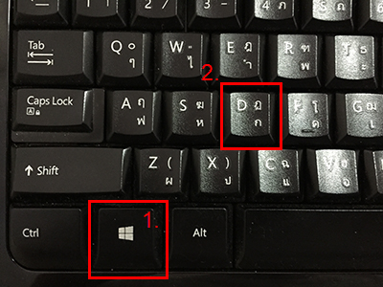

1. The screen will be the desktop screen. ( The screen that have Spa Program Icon )
2. Double Click the file “Force Open” ( see picture below ) then the Spa Management System will be closed.

