Lab: Simple SSD
310551091 林柏均

1. Source Code
https://github.com/b4435242/osdi-nycu2022/tree/main/final

2. Fuse
FUSE is a userspace filesystem framework. It consists of a kernel module (fuse.ko), a userspace library (libfuse.*) and a mount utility (fusermount). Fuse filesystem in which data and metadata are provided by an ordinary userspace process. The filesystem can be accessed normally through the kernel interface. A userspace filesystem mounted by a non-privileged (non-root) user. The filesystem daemon is running with the privileges of the mounting user. A connection between the filesystem daemon and the kernel. The connection exists until either the daemon dies, or the filesystem is umounted. Note that detaching (or lazy umounting) the filesystem does not break the connection, in this case it will exist until the last reference to the filesystem is released.

3. Implementation
The control flow is like specify below:
a. ssd_read -> ssd_do_read -> ftl_read -> nand_read
b. ssd_write -> ssd_do_write -> ftl_write (garbage collection) -> nand_write
As the functions except ftl layer are implemented already, I will only explain the ftl functions and garbage collection.
3.1 ftl_read
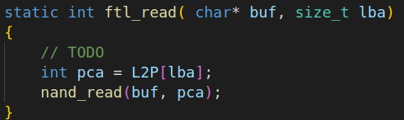
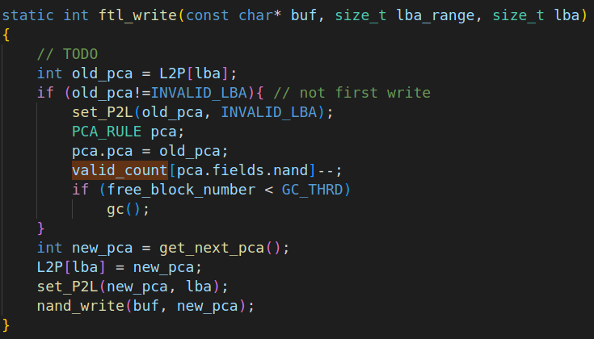

Basically, the function lookups to L2P table to get pca, and parse pca to nand layer to read data.
3.2 ftl_write
To elaborate the functionality of ftl_write, I simply divide the function to 2 parts. The first part is about marking the pca to stale in the case of data overwritten. While, the second part is to map lba to the pca that we just allocate. Furthermore, garbage collection is enabled when free block number is lower than the threshold defined manually.
3.3 garbage collection
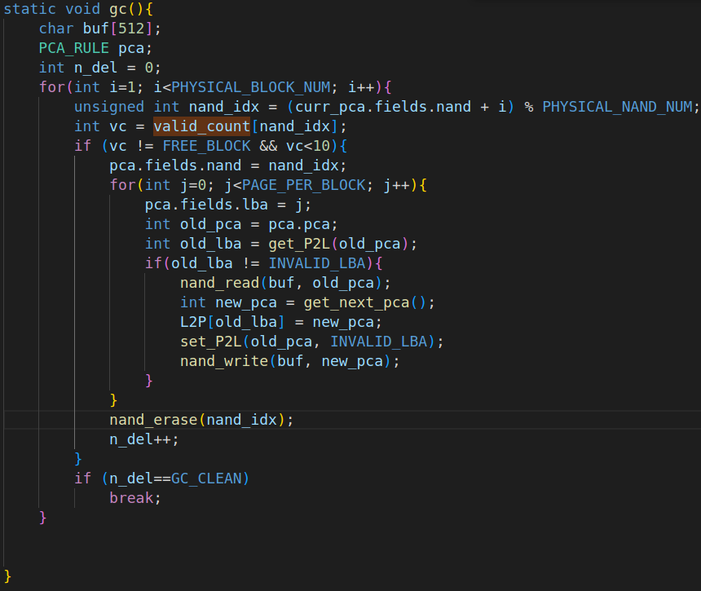

gc loops through all nands to choose the block that does not have full valid pages except free block to erase, and moves the valid page to the new allocated page. When gc erases enough number of nands defined manually or loops through all the nands, it stops and falls back to ftl_write.

4. Analysis
I set GC_threshold=3 at the end to satisfy the purposes of these two test scripts. As you can see below the experiment snapshot about how GC_threshold decides WA.

4.1 GC_threshold = 3
GC is successfully enabled in test2 and disable in test1, which is perfect in the way test script sees.

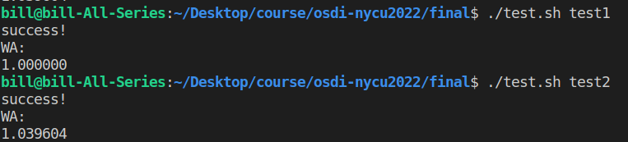
4.2 GC_threshold = 5
GC is both enabled in test2 and test1, which indicates threshold may be too high. Consequently, gc is enable too frequent, and WA gets bigger.
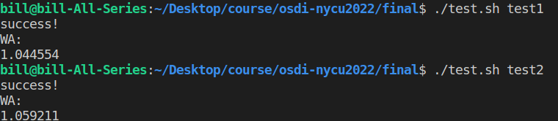
4.3 GC_threshold = 2
GC is both disabled in test2 and test1, which indicates threshold may be too low for these two test scenarios.
