base

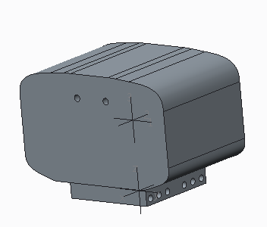

VOLUME = 2.1849068e+05 MM^3

SURFACE AREA = 2.5145747e+04 MM^2

AVERAGE DENSITY = 1.0800000e-03 GRAM / MM^3

MASS = 2.3596993e+02 GRAM

CENTER OF GRAVITY with respect to BASE coordinate frame:

X Y Z 0.0000000e+00 0.0000000e+00 3.1949490e+01 MM

INERTIA with respect to BASE coordinate frame: (GRAM * MM^2)

INERTIA TENSOR:

Ixx Ixy Ixz 4.0791639e+05 0.0000000e+00 0.0000000e+00

Iyx Iyy Iyz 0.0000000e+00 3.5117263e+05 0.0000000e+00

Izx Izy Izz 0.0000000e+00 0.0000000e+00 1.6841967e+05

INERTIA at CENTER OF GRAVITY with respect to BASE coordinate frame: (GRAM * MM^2)

INERTIA TENSOR:

Ixx Ixy Ixz 1.6704539e+05 0.0000000e+00 0.0000000e+00

Iyx Iyy Iyz 0.0000000e+00 1.1030163e+05 0.0000000e+00

Izx Izy Izz 0.0000000e+00 0.0000000e+00 1.6841967e+05

link_l1

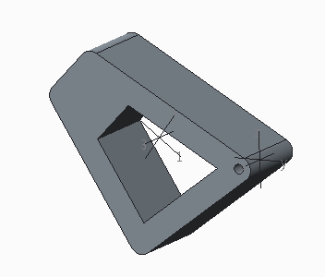

VOLUME = 3.7831703e+04 MM^3

SURFACE AREA = 1.0975693e+04 MM^2

AVERAGE DENSITY = 1.8000000e-03 GRAM / MM^3

MASS = 6.8097065e+01 GRAM

CENTER OF GRAVITY with respect to LINK_L1 coordinate frame:

X Y Z 0.0000000e+00 -3.4278537e+01 4.1852851e+00 MM

INERTIA with respect to LINK_L1 coordinate frame: (GRAM * MM^2)

INERTIA TENSOR:

Ixx Ixy Ixz 1.1760775e+05 0.0000000e+00 0.0000000e+00

Iyx Iyy Iyz 0.0000000e+00 2.1289260e+04 1.6443209e+04

Izx Izy Izz 0.0000000e+00 1.6443209e+04 1.0399076e+05

INERTIA at CENTER OF GRAVITY with respect to LINK_L1 coordinate frame: (GRAM * MM^2)

INERTIA TENSOR:

Ixx Ixy Ixz 3.6399641e+04 0.0000000e+00 0.0000000e+00

Iyx Iyy Iyz 0.0000000e+00 2.0096430e+04 6.6736336e+03

Izx Izy Izz 0.0000000e+00 6.6736336e+03 2.3975480e+04

link_l2

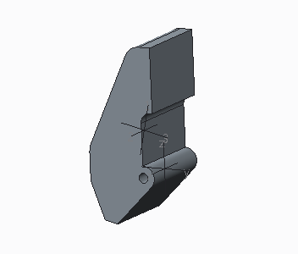

VOLUME = 1.9873208e+04 MM^3

SURFACE AREA = 5.2337967e+03 MM^2

AVERAGE DENSITY = 1.1000000e-03 GRAM / MM^3

MASS = 2.1860528e+01 GRAM

CENTER OF GRAVITY with respect to LINK_L2 coordinate frame:

X Y Z 0.0000000e+00 -6.4256160e+00 1.1257795e+01 MM

INERTIA with respect to LINK_L2 coordinate frame: (GRAM * MM^2)

INERTIA TENSOR:

Ixx Ixy Ixz 8.5626343e+03 0.0000000e+00 0.0000000e+00

Iyx Iyy Iyz 0.0000000e+00 8.2388393e+03 7.5159814e+02

Izx Izy Izz 0.0000000e+00 7.5159814e+02 2.7867480e+03

INERTIA at CENTER OF GRAVITY with respect to LINK_L2 coordinate frame: (GRAM * MM^2)

INERTIA TENSOR:

Ixx Ixy Ixz 4.8894863e+03 0.0000000e+00 0.0000000e+00

Iyx Iyy Iyz 0.0000000e+00 5.4682805e+03 -8.2975468e+02

Izx Izy Izz 0.0000000e+00 -8.2975468e+02 1.8841586e+03

link_r1

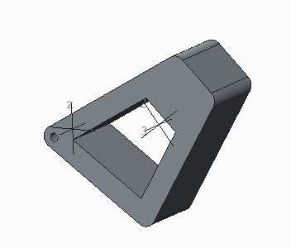

VOLUME = 3.7831703e+04 MM^3

SURFACE AREA = 1.0975693e+04 MM^2

AVERAGE DENSITY = 1.8000000e-03 GRAM / MM^3

MASS = 6.8097065e+01 GRAM

CENTER OF GRAVITY with respect to LINK_R1 coordinate frame:

X Y Z 0.0000000e+00 3.4278537e+01 4.1852851e+00 MM

INERTIA with respect to LINK_R1 coordinate frame: (GRAM * MM^2)

INERTIA TENSOR:

Ixx Ixy Ixz 1.1760775e+05 0.0000000e+00 0.0000000e+00

Iyx Iyy Iyz 0.0000000e+00 2.1289260e+04 -1.6443209e+04

Izx Izy Izz 0.0000000e+00 -1.6443209e+04 1.0399076e+05

INERTIA at CENTER OF GRAVITY with respect to LINK_R1 coordinate frame: (GRAM * MM^2)

INERTIA TENSOR:

Ixx Ixy Ixz 3.6399641e+04 0.0000000e+00 0.0000000e+00

Iyx Iyy Iyz 0.0000000e+00 2.0096430e+04 -6.6736336e+03

Izx Izy Izz 0.0000000e+00 -6.6736336e+03 2.3975480e+04

link_r2

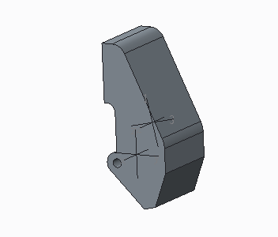

VOLUME = 1.9873208e+04 MM^3

SURFACE AREA = 5.2337967e+03 MM^2

AVERAGE DENSITY = 1.1000000e-03 GRAM / MM^3

MASS = 2.1860528e+01 GRAM

CENTER OF GRAVITY with respect to LINK_R2 coordinate frame:

X Y Z 0.0000000e+00 6.4256160e+00 1.1257795e+01 MM

INERTIA with respect to LINK_R2 coordinate frame: (GRAM * MM^2)

INERTIA TENSOR:

Ixx Ixy Ixz 8.5626343e+03 0.0000000e+00 0.0000000e+00

Iyx Iyy Iyz 0.0000000e+00 8.2388393e+03 -7.5159814e+02

Izx Izy Izz 0.0000000e+00 -7.5159814e+02 2.7867480e+03

INERTIA at CENTER OF GRAVITY with respect to LINK_R2 coordinate frame: (GRAM * MM^2)

INERTIA TENSOR:

Ixx Ixy Ixz 4.8894863e+03 0.0000000e+00 0.0000000e+00

Iyx Iyy Iyz 0.0000000e+00 5.4682805e+03 8.2975468e+02

Izx Izy Izz 0.0000000e+00 8.2975468e+02 1.8841586e+03

|  |  |  |  |
| --- | --- | --- | --- |
|  | x | y | z |
| Base-link_r1 | 0 | 8 | 48 |
| link_r1- link_r2 | 0 | 49.3634 | 28.5 |
| Base-link_l1 | 0 | -8 | 48 |
| link_l1- link_l2 | 0 | -49.3634 | 28.5 |
|  |  |  |  |