A
PROJECT REPORT
ON
Instant Messaging（IM）
For
Partial Fulfillment of Degree
Master of computer application
Submitted
By
(Team Name | Individual Name)
DOIT| Li-Yazi
Wu-Zemin
Li-Wei
Chen-junzhi

PROJECT INDEX

S no. | Particulars | Page no.
1 | About the IM, s/w requirement, SDLC | 1-2
2 | About the modules:-  Login module  Register module  Main interface message module | 3-4
4 | Use case Diagram | 07
5 | DFD of Login Module | 08
6 | DFD of Requirements module | 09
7 | DFD of Payroll module | 10
8 | MVC architecture | 13
9 | Cost estimation | 16-17

TEAM DESCRIPTION & OVERVIEW

CERTIFICATE

ACKNOWLEDGEMENT

PROJECT REPORT
Instant Messaging（IM）
Instant Messaging is the most popular way of communication on Internet at present. Service providers also provide increasingly rich communications services. There is no doubt that Internet has become the real information superhighway. Instant Messaging (IM) is a real-time Messaging system that allows two or more people to communicate in real time via text messages, files, voice and video via the Internet.

Software Requirements
- NetBeans IDE 7.1
- MySQL Workbench 6.3 CE
IM was originally designed as a kind of chat tool, but now it has developed into a comprehensive and multi-purpose tool. For example, people can use it to send any information (including text, picture, video, etc.), which makes it more convenient for people to communicate across the land. In addition, it also designed a variety of emojis to make people chat more humanized; Still have its privacy security protection, also do quite good now, otherwise if cause privacy to divulge to also be a kind of quite big threat to a few people.

SDLC of the Project
This project is a web application and going to be developed using J2EE technology like JDBC similar to all other software projects, this project too has its own software development like cycle. The SDLC of this project will be discussed under the following heads.
This project also connects these two types of databases. The first type is a public database, which provides all the information required by users (it can be understood as network and cloud).
The public database contains two tables, one is to store all the user information; The second is to store the chat message records between all users.
The second is the user database, where a database is created for each user.
The user database also includes two tables. The first table stores the friends' accounts. The second table stores the most recent contact chats.

Software Design
Software design is a solution- “how to approach the creation of a new system”. This important phase is composed of several steps. It provides the understanding and procedural details necessary for implementing the system recommended in the feasibility study.

In software design, there are three distinct types of activities:
- External design
- Architectural design
- Detailed design

External Design
External design of software involves conceiving, planning out and specifying the externally observable characteristics of a software product. These characteristics include user displays, report formats, external data sources, functional requirements , performance requirements and high-level process structure for the product.
External design begins during the analysis phase and continues in the design phase.
Internal Design
Internal design involves conceiving, planning out and specifying the internal structure and processing details of the software product. The goals of internal design are to specify internal structure and processing details, to record design decision and indicate why certain alternatives and trade-offs were chosen, to elaborate the test plan, and to provide a blueprint for implementation, testing, and maintenance activities.
Architectural design
Architectural design concerned with refining the conceptual view of the system, identifying internal processing functions, decomposing high-level functions into sub-functions, and defining internal data streams and data stores, and establishing relationships and interconnections among functions, data streams, and data stores.

The software will be designed according to the various modules required to full fill all the requirements uncovered in our requirements analysis. The whole system can be divided into a number of modules. The following modules can be recognized in our project:
- Login module
- Register module
- Main interface message module

Login module
This module makes sure that all access to the system is proper and authenticated. All the links and navigation paths are available for manipulating any kink of information only after an authorized person enters a valid set of user ID and PASSWORD. So this module serve as an entry point for the system and only the authorized person can access it.
Register module
This module provides the interface to enter the information for the new employee. All the information regarding the profile of an employee is stored. This profile information includes fields like name, password , address and so on.
Main interface message module
This module contains three parts: message, contact and dynamic.

After designing the structures of all the modules and database, the project is developed using MVC (model view condoler) architecture. Implementation of this architecture separates the three parts from each other-data, view and business logic and hence they can we developed separately. The view designed using JSP and the logic is embedded in the controller which is nothing but a servlets. In this [project, we will be using pure java classes to hold the data. These pure java classes will be having only attributes variables representing corresponding data fields with no methods. The over all development is done and executed with the help of a web server like tomcat

Testing
Before the implementation, functioning of the whole projects need to be tested for insuring proper navigation and valid data entry into the forms and corresponding actions accordingly. This is only after a throughout testing process, when the project is ready to be implemented and to be used by the client in the real environment.
After designing and developing, the application is tested for all logical paths and proper working of all operations. The project is also tested for all navigation links provided in all user interfaces. Finally, the project is tested whether all the requirements listed during requirement analysis are being fulfilled or not.
The approach of testing is illustrated in Figure

Debugging | Unit Testing | Integration Testing

Debugging
Debugging is the process of isolating and correcting the causes of known errors. Commonly used debugging methods include:
- Debugging by induction or deduction
- Debugging by backtracking
Debugging by induction or deduction proceeds as follows:
- Listing the possible causes for the observed failure
- Using the available information to eliminate various hypotheses
- Elaborating the remaining hypotheses
- Proving or disproving each hypotheses
- Determining the appropriate corrections
- Verifying the corrections

Debugging by backtracking involves working backward in the source code from the point where the error was observed in an attempt to identify the exact point where the error occurred.

Traditional debugging techniques include:

Snapshot dumps-which are machine –level representations of the partial or total program state at a particular point in the execution sequence. For example, core dump during execution of a C program. The image of the program along with all registers are dumped to a file(core) at the point of execution error.

Trace Facilities—which list changes in selected state components. In its simplest form, a trace will print all changes in data values for all variables and changes control flow. For example, in Visual Basic 4.0 usage of watch pane is a trace facility.

Traditional breakpoint facility—interrupts program execution and transfers control to the programmer’s terminal when execution reaches a specified break instruction in the source code, for example, inserting breakpoints in a Visual Basic program by using stop keyword.

Unit Testing
A program unit is usually small enough that the programmer who developed it can test it in great detail and certainly in greater detail than will be possible when the unit is integrated into an evolving software product. As mentioned in previous sessions, there are four categories of tests that a programmer will typically perform on a program unit:

- Functional tests-specify operating condition, input values and expected results. For example, for a function written for string copy, the source or destination string can be passed as null argument. The function should be able to take care of that situation.
- Performance tests—should be designed to verify response time, execution time, throughput, primary and secondary memory utilization and traffic rates on data channels and communication links. For example, a query executed takes 5 seconds to display results, is a test for response time. Execution time is the time taken by CPU to execute a program. Throughput is the rate at which data gets transferred from one data source to destination. Primary and secondary memory utilization needs to be optimized. Traffic rates on data channels and communication link testing is applicable for networks.
- Stress tests—are designed to overload a system in various ways. The purpose of a stress test is to determine the limitation of the system. For example, during a sort operation, the available memory can be reduced to see whether the program is able to handle the situation.
- Structural tests—are concerned with examining the internal processing logic of a software system. For example, if a function is responsible for tax calculation, the verification of the logic is a structural test.

System Testing
A system is tested for online responses, volume of transactions, stress, recovery from failure, and usability.

System testing involves two kind of activities—Integration testing and acceptance testing.

Integration Testing
Bottom-up integration is the traditional strategy used to integrate the components of a software system into a functioning whole. Bottom-up integration consists of unit testing, followed by subsystem testing, followed by testing of the entire system. Unit testing has the goal of discovering errors in the individual modules of the system. The primary purpose of subsystem testing is to verify operation of the interfaces between modules in the subsystem. System testing is concerned with the decision logic, control flow, recovery procedures, and throughput, capacity and timing characteristics of the entire system.

Disadvantages of bottom-up testing include:

- Necessity to write and debug test harnesses for modules and subsystems
- Level of complexity that result from combining modules and subsystems into larger units.
Top-down integration starts with the main routine and one or two immediate subordinated routines in the system structure. Top-down integration offers several advantages:

- System integration is distributed throughout the implementation phase. Modules are integrated as they are developed
- Top-level interfaces are tested first
- The top-level routines provide a natural test harness for lower-level routines
- Errors are localized to the new modules and interfaces that are being added

Automated tools in integration testing include:
- Module drivers
- Test data generators
- Environment simulators
- Library management facility to allow easy configuration and reconfiguration of system elements

Acceptance Testing
Acceptance testing involves planning and execution of functional tests, performance tests and stress tests in order to demonstrate that the implemented system satisfies its requirements.

Tools of special importance during acceptance testing include:

- Test Coverage Analyzer—records the control paths followed for each test case.
- Timing Analyzer—also called a profiler, reports the time spent in various regions of the source code under different test cases. These regions of the code are areas to concentrate on to improve system performance.
- Coding Standards—static analyzer and standard checkers are used to inspect code for deviations from standards and guidelines.

Implementation and Maintenance
This is the last stage in SDLC. The project is implemented for the client in real environment where it can be used. The project then runs in real environment with all the real process executed by the user. The implementation includes the proper deployment of the project onto the server. After the real execution of the project under the real circumstances by the user, some loop holes many be uncovered. It is also possible that after sometime the user may request some changes of report some problems in the working system. The maintenance of a project means updating the project for the required changes in the implemented system.

COST ESTIMATION
Today, software is the most expensive element of virtually a computer - based systems. So it necessary to estimate cost of project for a developer, because
Large cost estimation error can make the difference between profit and loss. Cost overrun can be disastrous for the developer. Rob Thomsett says “In an age of
Outsourcing and increased competition, the ability to estimate more accurate has
Emerged as a critical survival factor for many IT groups”.
Software cost and effort estimation will never be an exact science. Too many variables- human, technical environment,-can affect the ultimate cost of software and effort applied to develop the software.
For cost estimation of this project (RBRS), I carry out the different tasks in
This project according to the time period gives below. First we estimate the
Cost in working hours.

- Analysis carried out 10 days from 01 May 2008 to 10 May 2008.
- Design carried out 05days from 15 May 2008 to 20 May 2008.
- Coding carried out 15 days from 21 May 2008 to 5 Jun 2008.
- Integration & Testing carried out 20 days from 6 June 2008 to 26 June 2008.
- Report Writing(Documentation of the project) carried out 17 days from
27 June 2008 to 13 July 2008

Given Table shows starting and ending date of each work task and total working days. Table also shows concurrency between two or more work tasks. Code generation, Report Working, and Integration & Testing work tasks have been completed in concurrent manner.

Work Done By | Work task | Starting Date | Ending Date | Duration(day)
李巍 | Analysis | 6 May 19 | 15May 19 | 10
吴泽民 | Design | 15May19 | 16May 19 | 01
李亚子 | Code generation | 16May19 | 23 May 19 | 06
陈俊志 | Report Writing | 23May19 | 24 May 19 | 01
 |  |  |  | Total Day = 18

This software has been developed in 66 days. I work on this project 5 hours a day.
The total hours = 18*5 = 90

Estimated the working cost of manpower is $.10/Hour.
Then the total cost of the project is = 90*10 = 900
So the Estimated Total cost of the Project is nine Hundred, only.

- Login module
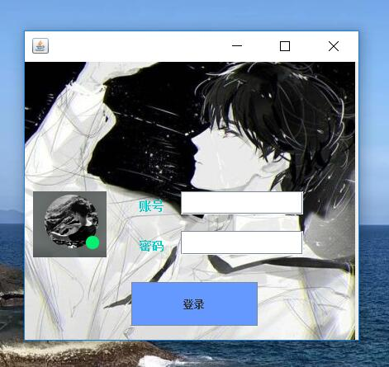

package 测试;
import java.awt.*;
import java.sql.*;
import java.util.logging.Level;
import java.util.logging.Logger;
import javax.swing.ImageIcon;
import javax.swing.JButton;
import javax.swing.JOptionPane;

public class Interface1 extends javax.swing.JFrame {

String ID;
public Interface1() {
initComponents();
setLocation((Toolkit.getDefaultToolkit().getScreenSize().width-200)/2, (Toolkit.getDefaultToolkit().getScreenSize().height-200)/8);
}

@SuppressWarnings("unchecked")
// <editor-fold defaultstate="collapsed" desc="Generated Code">
private void initComponents() {
java.awt.GridBagConstraints gridBagConstraints;

jLabel1 = new javax.swing.JLabel();
jLabel2 = new javax.swing.JLabel();
jLabel3 = new javax.swing.JLabel();
jTextField1 = new javax.swing.JTextField();
jPasswordField1 = new javax.swing.JPasswordField();
jButton1 = new javax.swing.JButton();
jLabel4 = new javax.swing.JLabel();
jLabel5 = new javax.swing.JLabel();

setDefaultCloseOperation(javax.swing.WindowConstants.EXIT_ON_CLOSE);
setBackground(new java.awt.Color(204, 255, 255));
addMouseListener(new java.awt.event.MouseAdapter() {
public void mouseReleased(java.awt.event.MouseEvent evt) {
formMouseReleased(evt);
}
});
getContentPane().setLayout(new java.awt.GridBagLayout());

jLabel1.setIcon(new javax.swing.ImageIcon("C:\\Users\\Lenovo\\Desktop\\p5.png")); // NOI18N
jLabel1.setText("jLabel1");
gridBagConstraints = new java.awt.GridBagConstraints();
gridBagConstraints.gridx = 0;
gridBagConstraints.gridy = 0;
gridBagConstraints.gridheight = 4;
gridBagConstraints.ipadx = -53;
gridBagConstraints.ipady = -7;
gridBagConstraints.anchor = java.awt.GridBagConstraints.NORTHWEST;
gridBagConstraints.insets = new java.awt.Insets(157, 10, 0, 0);
getContentPane().add(jLabel1, gridBagConstraints);

jLabel2.setFont(new java.awt.Font("宋体", 1, 14)); // NOI18N
jLabel2.setForeground(new java.awt.Color(0, 204, 204));
jLabel2.setText("账号");
gridBagConstraints = new java.awt.GridBagConstraints();
gridBagConstraints.gridx = 1;
gridBagConstraints.gridy = 0;
gridBagConstraints.ipadx = 10;
gridBagConstraints.anchor = java.awt.GridBagConstraints.NORTHWEST;
gridBagConstraints.insets = new java.awt.Insets(167, 40, 0, 0);
getContentPane().add(jLabel2, gridBagConstraints);

jLabel3.setFont(new java.awt.Font("宋体", 1, 14)); // NOI18N
jLabel3.setForeground(new java.awt.Color(0, 204, 204));
jLabel3.setText("密码");
gridBagConstraints = new java.awt.GridBagConstraints();
gridBagConstraints.gridx = 1;
gridBagConstraints.gridy = 2;
gridBagConstraints.ipadx = 10;
gridBagConstraints.anchor = java.awt.GridBagConstraints.NORTHWEST;
gridBagConstraints.insets = new java.awt.Insets(30, 40, 0, 0);
getContentPane().add(jLabel3, gridBagConstraints);

jTextField1.setFont(new java.awt.Font("宋体", 2, 14)); // NOI18N
jTextField1.addActionListener(new java.awt.event.ActionListener() {
public void actionPerformed(java.awt.event.ActionEvent evt) {
jTextField1ActionPerformed(evt);
}
});
gridBagConstraints = new java.awt.GridBagConstraints();
gridBagConstraints.gridx = 2;
gridBagConstraints.gridy = 0;
gridBagConstraints.gridwidth = 3;
gridBagConstraints.gridheight = 2;
gridBagConstraints.ipadx = 144;
gridBagConstraints.ipady = 8;
gridBagConstraints.anchor = java.awt.GridBagConstraints.NORTHWEST;
gridBagConstraints.insets = new java.awt.Insets(157, 10, 0, 0);
getContentPane().add(jTextField1, gridBagConstraints);
gridBagConstraints = new java.awt.GridBagConstraints();
gridBagConstraints.gridx = 2;
gridBagConstraints.gridy = 2;
gridBagConstraints.gridwidth = 3;
gridBagConstraints.gridheight = 2;
gridBagConstraints.ipadx = 144;
gridBagConstraints.ipady = 9;
gridBagConstraints.anchor = java.awt.GridBagConstraints.NORTHWEST;
gridBagConstraints.insets = new java.awt.Insets(20, 10, 0, 0);
getContentPane().add(jPasswordField1, gridBagConstraints);

jButton1.setBackground(new java.awt.Color(102, 153, 255));
jButton1.setText("登录");
jButton1.addActionListener(new java.awt.event.ActionListener() {
public void actionPerformed(java.awt.event.ActionEvent evt) {
jButton1ActionPerformed(evt);
}
});
gridBagConstraints = new java.awt.GridBagConstraints();
gridBagConstraints.gridx = 1;
gridBagConstraints.gridy = 4;
gridBagConstraints.gridwidth = 2;
gridBagConstraints.gridheight = 2;
gridBagConstraints.ipadx = 93;
gridBagConstraints.ipady = 27;
gridBagConstraints.anchor = java.awt.GridBagConstraints.NORTHWEST;
gridBagConstraints.insets = new java.awt.Insets(30, 30, 0, 0);
getContentPane().add(jButton1, gridBagConstraints);

jLabel4.setIcon(new javax.swing.ImageIcon("C:\\Users\\Lenovo\\Desktop\\p10.jpg")); // NOI18N
gridBagConstraints = new java.awt.GridBagConstraints();
gridBagConstraints.gridx = 0;
gridBagConstraints.gridy = 0;
gridBagConstraints.gridwidth = 7;
gridBagConstraints.gridheight = 7;
gridBagConstraints.ipady = -63;
gridBagConstraints.anchor = java.awt.GridBagConstraints.NORTHWEST;
gridBagConstraints.insets = new java.awt.Insets(0, 0, 0, 4);
getContentPane().add(jLabel4, gridBagConstraints);

jLabel5.setForeground(new java.awt.Color(102, 102, 255));
jLabel5.setText("注册账号");
jLabel5.addMouseListener(new java.awt.event.MouseAdapter() {
public void mouseClicked(java.awt.event.MouseEvent evt) {
jLabel5MouseClicked(evt);
}
});
gridBagConstraints = new java.awt.GridBagConstraints();
gridBagConstraints.gridx = 5;
gridBagConstraints.gridy = 4;
gridBagConstraints.anchor = java.awt.GridBagConstraints.NORTHWEST;
gridBagConstraints.insets = new java.awt.Insets(63, 0, 0, 0);
getContentPane().add(jLabel5, gridBagConstraints);

pack();
}// </editor-fold>

private void jButton1ActionPerformed(java.awt.event.ActionEvent evt) {
ID=jTextField1.getText();
String code=jPasswordField1.getText();

try {
Class.forName("com.mysql.jdbc.Driver");
Connection con=DriverManager.getConnection("jdbc:mysql://localhost:3306/internet", "root","niit1234");
Statement st=con.createStatement();
String sql="select 账号,登录密码 from usermassege;";
ResultSet rs=st.executeQuery(sql);
int a=0;
while(rs.next())
{
String ID1=rs.getString("账号");
String code1=rs.getString("登录密码");
if(ID.equals(ID1)&&code.equals(code1))
{
dispose();
Maininterface open=new Maininterface(ID);
open.show();
a=1;
}

}
if(a==0){
JOptionPane.showMessageDialog(this, "账号或密码错误！请重新输入");
jTextField1.setText("");
jPasswordField1.setText("");
}
rs.close();
st.close();
con.close();
} catch (SQLException ex) {
Logger.getLogger(Linkdatabase.class.getName()).log(Level.SEVERE, null, ex);
} catch (ClassNotFoundException ex) {
Logger.getLogger(Linkdatabase.class.getName()).log(Level.SEVERE, null, ex);
}

}

private void jTextField1ActionPerformed(java.awt.event.ActionEvent evt) {
// TODO add your handling code here:
}

private void formMouseReleased(java.awt.event.MouseEvent evt) {

}

private void jLabel5MouseClicked(java.awt.event.MouseEvent evt) {

dispose();
interface2 i2=new interface2();
i2.show();// TODO add your handling code here:
}

/**
* @param args the command line arguments
*/
public static void main(String args[]) {
/*
* Set the Nimbus look and feel
*/
//<editor-fold defaultstate="collapsed" desc=" Look and feel setting code (optional) ">
/*
* If Nimbus (introduced in Java SE 6) is not available, stay with the
* default look and feel. For details see
* http://download.oracle.com/javase/tutorial/uiswing/lookandfeel/plaf.html
*/
try {
for (javax.swing.UIManager.LookAndFeelInfo info : javax.swing.UIManager.getInstalledLookAndFeels()) {
if ("Nimbus".equals(info.getName())) {
javax.swing.UIManager.setLookAndFeel(info.getClassName());
break;
}
}
} catch (ClassNotFoundException ex) {
java.util.logging.Logger.getLogger(Interface1.class.getName()).log(java.util.logging.Level.SEVERE, null, ex);
} catch (InstantiationException ex) {
java.util.logging.Logger.getLogger(Interface1.class.getName()).log(java.util.logging.Level.SEVERE, null, ex);
} catch (IllegalAccessException ex) {
java.util.logging.Logger.getLogger(Interface1.class.getName()).log(java.util.logging.Level.SEVERE, null, ex);
} catch (javax.swing.UnsupportedLookAndFeelException ex) {
java.util.logging.Logger.getLogger(Interface1.class.getName()).log(java.util.logging.Level.SEVERE, null, ex);
}
//</editor-fold>

/*
* Create and display the form
*/
java.awt.EventQueue.invokeLater(new Runnable() {

public void run() {
new Interface1().setVisible(true);

}
});
}
Connection con=Linkdatabase.getConnection();
// Variables declaration - do not modify
private javax.swing.JButton jButton1;
private javax.swing.JLabel jLabel1;
private javax.swing.JLabel jLabel2;
private javax.swing.JLabel jLabel3;
private javax.swing.JLabel jLabel4;
private javax.swing.JLabel jLabel5;
private javax.swing.JPasswordField jPasswordField1;
private javax.swing.JTextField jTextField1;
// End of variables declaration
}
- Register module
- 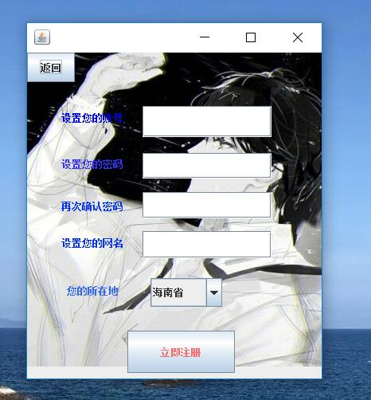

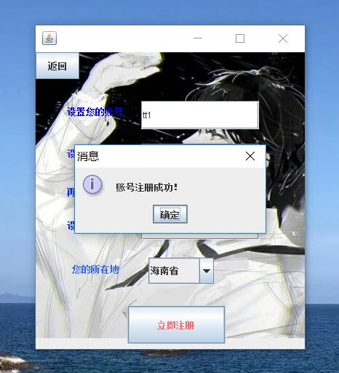
/*
* To change this template, choose Tools | Templates
* and open the template in the editor.
*/
package 测试;

/**
*
* @author Lenovo
*/import java.awt.*;
import java.sql.*;
import java.util.logging.Level;
import java.util.logging.Logger;
import javax.swing.ImageIcon;
import javax.swing.JButton;
import javax.swing.JOptionPane;
public class interface2 extends javax.swing.JFrame {

/**
* Creates new form interface2
*/
public interface2() {
initComponents();
setLocation((Toolkit.getDefaultToolkit().getScreenSize().width-200)/2, (Toolkit.getDefaultToolkit().getScreenSize().height-200)/8);
}

/**
* This method is called from within the constructor to initialize the form.
* WARNING: Do NOT modify this code. The content of this method is always
* regenerated by the Form Editor.
*/
@SuppressWarnings("unchecked")
// <editor-fold defaultstate="collapsed" desc="Generated Code">
private void initComponents() {
java.awt.GridBagConstraints gridBagConstraints;

jLabel1 = new javax.swing.JLabel();
jTextField1 = new javax.swing.JTextField();
jLabel2 = new javax.swing.JLabel();
jTextField2 = new javax.swing.JTextField();
jLabel3 = new javax.swing.JLabel();
jTextField3 = new javax.swing.JTextField();
jButton1 = new javax.swing.JButton();
jComboBox1 = new javax.swing.JComboBox();
jLabel4 = new javax.swing.JLabel();
jTextField4 = new javax.swing.JTextField();
jLabel5 = new javax.swing.JLabel();
jButton2 = new javax.swing.JButton();
jLabel6 = new javax.swing.JLabel();

setDefaultCloseOperation(javax.swing.WindowConstants.EXIT_ON_CLOSE);
getContentPane().setLayout(new java.awt.GridBagLayout());

jLabel1.setForeground(new java.awt.Color(0, 0, 255));
jLabel1.setText("设置您的账号");
gridBagConstraints = new java.awt.GridBagConstraints();
gridBagConstraints.gridx = 0;
gridBagConstraints.gridy = 1;
gridBagConstraints.gridwidth = 2;
gridBagConstraints.anchor = java.awt.GridBagConstraints.NORTHWEST;
gridBagConstraints.insets = new java.awt.Insets(36, 43, 0, 0);
getContentPane().add(jLabel1, gridBagConstraints);
gridBagConstraints = new java.awt.GridBagConstraints();
gridBagConstraints.gridx = 4;
gridBagConstraints.gridy = 1;
gridBagConstraints.gridwidth = 5;
gridBagConstraints.gridheight = 2;
gridBagConstraints.ipadx = 158;
gridBagConstraints.ipady = 19;
gridBagConstraints.anchor = java.awt.GridBagConstraints.NORTHWEST;
gridBagConstraints.insets = new java.awt.Insets(30, 10, 0, 0);
getContentPane().add(jTextField1, gridBagConstraints);

jLabel2.setForeground(new java.awt.Color(51, 51, 255));
jLabel2.setText("设置您的密码");
gridBagConstraints = new java.awt.GridBagConstraints();
gridBagConstraints.gridx = 0;
gridBagConstraints.gridy = 3;
gridBagConstraints.gridwidth = 2;
gridBagConstraints.anchor = java.awt.GridBagConstraints.NORTHWEST;
gridBagConstraints.insets = new java.awt.Insets(25, 43, 0, 0);
getContentPane().add(jLabel2, gridBagConstraints);
gridBagConstraints = new java.awt.GridBagConstraints();
gridBagConstraints.gridx = 4;
gridBagConstraints.gridy = 3;
gridBagConstraints.gridwidth = 5;
gridBagConstraints.gridheight = 2;
gridBagConstraints.ipadx = 158;
gridBagConstraints.ipady = 12;
gridBagConstraints.anchor = java.awt.GridBagConstraints.NORTHWEST;
gridBagConstraints.insets = new java.awt.Insets(20, 10, 0, 0);
getContentPane().add(jTextField2, gridBagConstraints);

jLabel3.setForeground(new java.awt.Color(0, 51, 255));
jLabel3.setText("再次确认密码");
gridBagConstraints = new java.awt.GridBagConstraints();
gridBagConstraints.gridx = 0;
gridBagConstraints.gridy = 5;
gridBagConstraints.gridwidth = 2;
gridBagConstraints.anchor = java.awt.GridBagConstraints.NORTHWEST;
gridBagConstraints.insets = new java.awt.Insets(26, 43, 0, 0);
getContentPane().add(jLabel3, gridBagConstraints);
gridBagConstraints = new java.awt.GridBagConstraints();
gridBagConstraints.gridx = 4;
gridBagConstraints.gridy = 5;
gridBagConstraints.gridwidth = 5;
gridBagConstraints.gridheight = 2;
gridBagConstraints.ipadx = 158;
gridBagConstraints.ipady = 13;
gridBagConstraints.anchor = java.awt.GridBagConstraints.NORTHWEST;
gridBagConstraints.insets = new java.awt.Insets(17, 10, 0, 0);
getContentPane().add(jTextField3, gridBagConstraints);

jButton1.setForeground(new java.awt.Color(255, 102, 102));
jButton1.setText("立即注册");
jButton1.addActionListener(new java.awt.event.ActionListener() {
public void actionPerformed(java.awt.event.ActionEvent evt) {
jButton1ActionPerformed(evt);
}
});
gridBagConstraints = new java.awt.GridBagConstraints();
gridBagConstraints.gridx = 2;
gridBagConstraints.gridy = 10;
gridBagConstraints.gridwidth = 4;
gridBagConstraints.ipadx = 49;
gridBagConstraints.ipady = 27;
gridBagConstraints.anchor = java.awt.GridBagConstraints.NORTHWEST;
gridBagConstraints.insets = new java.awt.Insets(30, 5, 7, 0);
getContentPane().add(jButton1, gridBagConstraints);

jComboBox1.setModel(new javax.swing.DefaultComboBoxModel(new String[] { "海南省", "湖南省", "湖北省", "山西省" }));
gridBagConstraints = new java.awt.GridBagConstraints();
gridBagConstraints.gridx = 4;
gridBagConstraints.gridy = 9;
gridBagConstraints.ipadx = 23;
gridBagConstraints.ipady = 11;
gridBagConstraints.anchor = java.awt.GridBagConstraints.NORTHWEST;
gridBagConstraints.insets = new java.awt.Insets(25, 20, 0, 0);
getContentPane().add(jComboBox1, gridBagConstraints);

jLabel4.setForeground(new java.awt.Color(0, 51, 255));
jLabel4.setText("设置您的网名");
gridBagConstraints = new java.awt.GridBagConstraints();
gridBagConstraints.gridx = 0;
gridBagConstraints.gridy = 7;
gridBagConstraints.gridwidth = 2;
gridBagConstraints.anchor = java.awt.GridBagConstraints.NORTHWEST;
gridBagConstraints.insets = new java.awt.Insets(22, 43, 0, 0);
getContentPane().add(jLabel4, gridBagConstraints);
gridBagConstraints = new java.awt.GridBagConstraints();
gridBagConstraints.gridx = 4;
gridBagConstraints.gridy = 7;
gridBagConstraints.gridwidth = 5;
gridBagConstraints.gridheight = 2;
gridBagConstraints.ipadx = 158;
gridBagConstraints.ipady = 14;
gridBagConstraints.anchor = java.awt.GridBagConstraints.NORTHWEST;
gridBagConstraints.insets = new java.awt.Insets(16, 10, 0, 0);
getContentPane().add(jTextField4, gridBagConstraints);

jLabel5.setForeground(new java.awt.Color(51, 102, 255));
jLabel5.setText("您的所在地");
gridBagConstraints = new java.awt.GridBagConstraints();
gridBagConstraints.gridx = 0;
gridBagConstraints.gridy = 9;
gridBagConstraints.gridwidth = 3;
gridBagConstraints.ipadx = 20;
gridBagConstraints.ipady = 15;
gridBagConstraints.anchor = java.awt.GridBagConstraints.NORTHWEST;
gridBagConstraints.insets = new java.awt.Insets(25, 50, 0, 0);
getContentPane().add(jLabel5, gridBagConstraints);

jButton2.setText("返回");
jButton2.addActionListener(new java.awt.event.ActionListener() {
public void actionPerformed(java.awt.event.ActionEvent evt) {
jButton2ActionPerformed(evt);
}
});
gridBagConstraints = new java.awt.GridBagConstraints();
gridBagConstraints.gridx = 0;
gridBagConstraints.gridy = 0;
gridBagConstraints.ipady = 11;
gridBagConstraints.anchor = java.awt.GridBagConstraints.NORTHWEST;
getContentPane().add(jButton2, gridBagConstraints);

jLabel6.setIcon(new javax.swing.ImageIcon("C:\\Users\\Lenovo\\Desktop\\p10.jpg")); // NOI18N
gridBagConstraints = new java.awt.GridBagConstraints();
gridBagConstraints.gridx = 0;
gridBagConstraints.gridy = 0;
gridBagConstraints.gridwidth = 10;
gridBagConstraints.gridheight = 11;
gridBagConstraints.ipadx = -30;
gridBagConstraints.ipady = -6;
gridBagConstraints.anchor = java.awt.GridBagConstraints.NORTHWEST;
gridBagConstraints.insets = new java.awt.Insets(0, 0, 7, 0);
getContentPane().add(jLabel6, gridBagConstraints);

pack();
}// </editor-fold>

private void jButton2ActionPerformed(java.awt.event.ActionEvent evt) {
dispose();
Interface1 i1=new Interface1();
i1.show();// TODO add your handling code here:
}

private void jButton1ActionPerformed(java.awt.event.ActionEvent evt) {
String ID=jTextField1.getText();
String s1=jTextField2.getText();
String s2=jTextField3.getText();
String name=jTextField4.getText();
try {
Class.forName("com.mysql.jdbc.Driver");
Connection con=DriverManager.getConnection("jdbc:mysql://localhost:3306/internet", "root","niit1234");
Statement st=con.createStatement();
st=con.createStatement();
String sql="select 账号 from usermassege";
ResultSet rs=st.executeQuery(sql);
while(rs.next())
{
String ID1=rs.getString("账号");
String dname="u"+ID;
if(!ID.equals(ID1))
{
if(s1.equals(s2))
{
CallableStatement cs=con.prepareCall("call register(?,?,?,?)");
cs.setString(1, ID);
cs.setString(2,s2 );
cs.setString(3, name);
cs.setString(4, dname);
cs.execute();
cs.close();
JOptionPane.showMessageDialog(this, "账号注册成功！");
new Interface1();
}

}
else
{
JOptionPane.showMessageDialog(this, "该账号已被注册！请再次输入");
jTextField1.setText("");
}

}
JOptionPane.showMessageDialog(this, "两次密码设置不一致！请再次输入");
jTextField2.setText("");
jTextField3.setText("");
rs.close();

st.close();
con.close();
} catch (SQLException ex) {
Logger.getLogger(Linkdatabase.class.getName()).log(Level.SEVERE, null, ex);
} catch (ClassNotFoundException ex) {
Logger.getLogger(Linkdatabase.class.getName()).log(Level.SEVERE, null, ex);
}

}

/**
* @param args the command line arguments
*/
public static void main(String args[]) {
/*
* Set the Nimbus look and feel
*/
//<editor-fold defaultstate="collapsed" desc=" Look and feel setting code (optional) ">
/*
* If Nimbus (introduced in Java SE 6) is not available, stay with the
* default look and feel. For details see
* http://download.oracle.com/javase/tutorial/uiswing/lookandfeel/plaf.html
*/
try {
for (javax.swing.UIManager.LookAndFeelInfo info : javax.swing.UIManager.getInstalledLookAndFeels()) {
if ("Nimbus".equals(info.getName())) {
javax.swing.UIManager.setLookAndFeel(info.getClassName());
break;
}
}
} catch (ClassNotFoundException ex) {
java.util.logging.Logger.getLogger(interface2.class.getName()).log(java.util.logging.Level.SEVERE, null, ex);
} catch (InstantiationException ex) {
java.util.logging.Logger.getLogger(interface2.class.getName()).log(java.util.logging.Level.SEVERE, null, ex);
} catch (IllegalAccessException ex) {
java.util.logging.Logger.getLogger(interface2.class.getName()).log(java.util.logging.Level.SEVERE, null, ex);
} catch (javax.swing.UnsupportedLookAndFeelException ex) {
java.util.logging.Logger.getLogger(interface2.class.getName()).log(java.util.logging.Level.SEVERE, null, ex);
}
//</editor-fold>

/*
* Create and display the form
*/
java.awt.EventQueue.invokeLater(new Runnable() {

public void run() {
new interface2().setVisible(true);
}
});
}
// Variables declaration - do not modify
private javax.swing.JButton jButton1;
private javax.swing.JButton jButton2;
private javax.swing.JComboBox jComboBox1;
private javax.swing.JLabel jLabel1;
private javax.swing.JLabel jLabel2;
private javax.swing.JLabel jLabel3;
private javax.swing.JLabel jLabel4;
private javax.swing.JLabel jLabel5;
private javax.swing.JLabel jLabel6;
private javax.swing.JTextField jTextField1;
private javax.swing.JTextField jTextField2;
private javax.swing.JTextField jTextField3;
private javax.swing.JTextField jTextField4;
// End of variables declaration
}

- Main interface message module
- 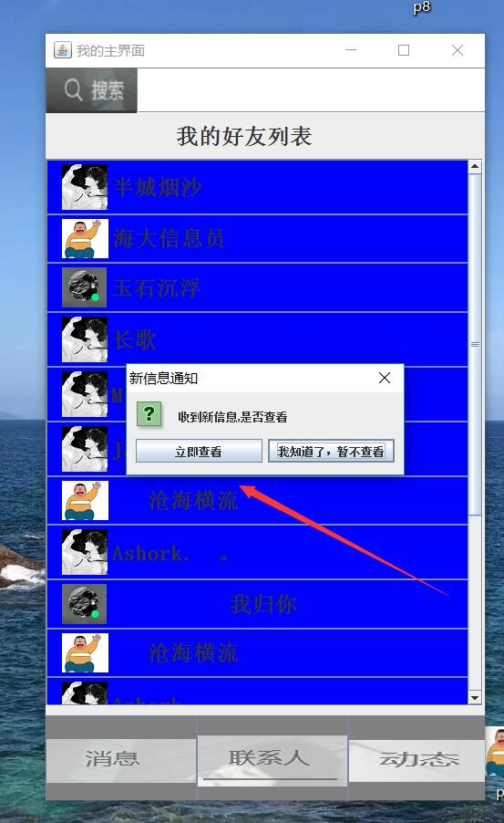
- 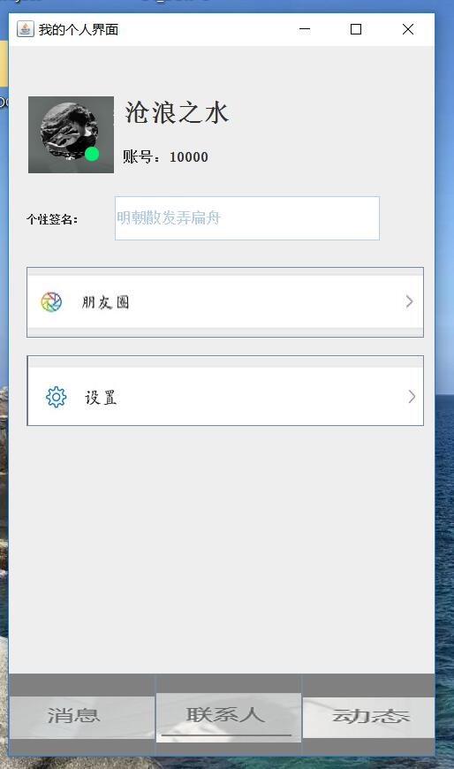
package 测试;
import javax.swing.*;
import java.awt.*;
import java.awt.event.*;
import java.sql.*;
import java.util.logging.Level;
import java.util.logging.Logger;
public class Thirdinter extends JFrame
{
String myid;
Thirdinter(String UID)
{
myid=UID;
setTitle("我的个人界面");
setSize(500, 850);
setDefaultCloseOperation(JFrame.EXIT_ON_CLOSE);
JPanel jp1=new JPanel();
jp1.setLayout(null);
setContentPane(jp1);
String IDD;
String NAME;
String icon;
String s;
/*try {
Class.forName("com.mysql.jdbc.Driver");
Connection con=DriverManager.getConnection("jdbc:mysql://localhost:3306/internet", "root","niit1234");
Statement st=con.createStatement();
String sql="select 账号,网名,头像,电话 from usermassege where 账号=\"10000\";";
ResultSet rs=st.executeQuery(sql);
IDD=rs.getString("账号");
NAME=rs.getString("网名");
icon=rs.getString("头像");
s=rs.getString("电话");

rs.close();
st.close();
con.close();
} catch (SQLException ex) {
Logger.getLogger(Linkdatabase.class.getName()).log(Level.SEVERE, null, ex);
} catch (ClassNotFoundException ex) {
Logger.getLogger(Linkdatabase.class.getName()).log(Level.SEVERE, null, ex);
}
*
*/
JLabel jl1=new JLabel(new ImageIcon("C:\\Users\\Lenovo\\Desktop\\p5.png"));
jl1.setBounds(20,50, 100, 100);
jp1.add(jl1);
JLabel jl2=new JLabel("沧浪之水");
jl2.setBounds(130,50, 200, 50);
jl2.setFont(new Font("宋体",1,28));
jp1.add(jl2);
JLabel jl3=new JLabel("账号：10000");
jl3.setBounds(130,100, 200, 50);
jl3.setFont(new Font("宋体",1,20));
jp1.add(jl3);
JTextField jt1=new JTextField("明朝散发弄扁舟");
jt1.enable(false);
jt1.setFont(new Font("宋体",1,16));
jt1.setBounds(120,170 , 300, 50);
jp1.add(jt1);
JLabel jl4=new JLabel("个性签名：");
jl4.setBounds(20,170, 100, 50);
jl3.setFont(new Font("宋体",1,16));
jp1.add(jl4);

JButton jb4=new JButton(new ImageIcon("C:\\Users\\Lenovo\\Desktop\\p6.jpg"));

jb4.setBounds(20,250, 450, 80);
jb4.setBackground(Color.GRAY);
jp1.add(jb4);
JButton jb5=new JButton(new ImageIcon("C:\\Users\\Lenovo\\Desktop\\p7.jpg"));
jb5.addActionListener(new java.awt.event.ActionListener() {
public void actionPerformed(java.awt.event.ActionEvent evt) {
jb5event(evt);
}
});
jb5.setBounds(20,350, 450, 80);
jb5.setBackground(Color.GRAY);
jp1.add(jb5);

JButton jb1=new JButton(new ImageIcon("C:\\Users\\Lenovo\\Desktop\\p1.png"));
jb1.setFont(new Font("宋体",1,24));
jb1.setBounds(166, 710, 166, 100);
jb1.setBackground(Color.GRAY);
jb1.addActionListener(new java.awt.event.ActionListener() {
public void actionPerformed(java.awt.event.ActionEvent evt) {
jb1event(evt);
}
});
jp1.add(jb1);
JButton jb2=new JButton(new ImageIcon("C:\\Users\\Lenovo\\Desktop\\p2.png"));
jb2.setFont(new Font("宋体",1,24));
jb2.setBounds(0, 710, 166, 100);
jb2.setBackground(Color.GRAY);
jb2.addActionListener(new java.awt.event.ActionListener() {
public void actionPerformed(java.awt.event.ActionEvent evt) {
jb2event(evt);
}
});
jp1.add(jb2);
JButton jb3=new JButton(new ImageIcon("C:\\Users\\Lenovo\\Desktop\\p3.png"));
jb3.setFont(new Font("宋体",1,24));
jb3.setBounds(332, 710, 166, 100);
jb3.setBackground(Color.GRAY);
jp1.add(jb3);
this.setLocation((Toolkit.getDefaultToolkit().getScreenSize().width-200)/2, (Toolkit.getDefaultToolkit().getScreenSize().height-200)/8);
setVisible(true);
}

public void jb1event(ActionEvent e)
{
dispose();
Maininterface m=new Maininterface(myid);
}

public void jb2event(ActionEvent e)
{
dispose();
Minterface m=new Minterface(myid);
}

public void jb5event(ActionEvent e)
{
dispose();
Interface3 i3=new Interface3(myid);
i3.show();
}

public static void main(String args[])
{
new Thirdinter("10000");
}
}
- 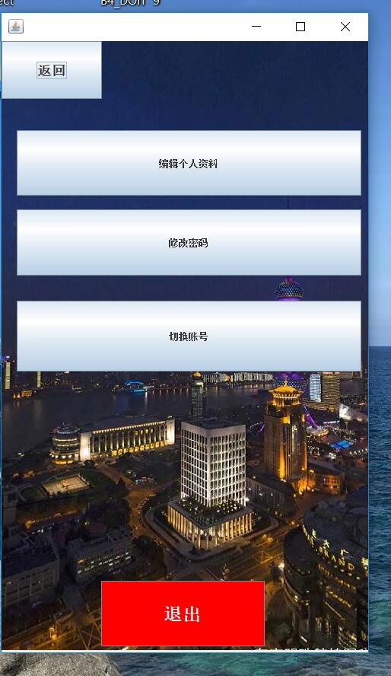
/*
* To change this template, choose Tools | Templates
* and open the template in the editor.
*/
package 测试;

import java.awt.Color;
import java.awt.Font;
import java.awt.Toolkit;
import java.sql.*;
import java.util.logging.Level;
import java.util.logging.Logger;
import javax.swing.ImageIcon;
import javax.swing.JButton;
import javax.swing.JOptionPane;

/**
*
* @author Lenovo
*/
public class Interface3 extends javax.swing.JFrame {

String myid;
public Interface3(String UID) {
myid=UID;
initComponents();
setSize(500,850);
setLocation((Toolkit.getDefaultToolkit().getScreenSize().width-200)/2, (Toolkit.getDefaultToolkit().getScreenSize().height-200)/8);
this.setVisible(true);
}

/**
* This method is called from within the constructor to initialize the form.
* WARNING: Do NOT modify this code. The content of this method is always
* regenerated by the Form Editor.
*/
@SuppressWarnings("unchecked")
// <editor-fold defaultstate="collapsed" desc="Generated Code">
private void initComponents() {

jButton1 = new javax.swing.JButton();
jButton2 = new javax.swing.JButton();
jButton3 = new javax.swing.JButton();
jButton4 = new javax.swing.JButton();
jButton5 = new javax.swing.JButton();
jLabel2 = new javax.swing.JLabel();

setDefaultCloseOperation(javax.swing.WindowConstants.EXIT_ON_CLOSE);
getContentPane().setLayout(null);

jButton1.setFont(new java.awt.Font("宋体", 1, 18)); // NOI18N
jButton1.setText("返回");
jButton1.addActionListener(new java.awt.event.ActionListener() {
public void actionPerformed(java.awt.event.ActionEvent evt) {
jButton1ActionPerformed(evt);
}
});
getContentPane().add(jButton1);
jButton1.setBounds(0, 0, 132, 76);

jButton2.setText("编辑个人资料");
jButton2.addActionListener(new java.awt.event.ActionListener() {
public void actionPerformed(java.awt.event.ActionEvent evt) {
jButton2ActionPerformed(evt);
}
});
getContentPane().add(jButton2);
jButton2.setBounds(20, 117, 453, 86);

jButton3.setText("修改密码");
jButton3.addActionListener(new java.awt.event.ActionListener() {
public void actionPerformed(java.awt.event.ActionEvent evt) {
jButton3ActionPerformed(evt);
}
});
getContentPane().add(jButton3);
jButton3.setBounds(20, 221, 453, 87);

jButton4.setBackground(new java.awt.Color(255, 0, 0));
jButton4.setFont(new java.awt.Font("新宋体", 1, 24)); // NOI18N
jButton4.setForeground(new java.awt.Color(255, 255, 255));
jButton4.setText("退出");
jButton4.addActionListener(new java.awt.event.ActionListener() {
public void actionPerformed(java.awt.event.ActionEvent evt) {
jButton4ActionPerformed(evt);
}
});
getContentPane().add(jButton4);
jButton4.setBounds(131, 709, 215, 86);

jButton5.setText("切换账号");
jButton5.addActionListener(new java.awt.event.ActionListener() {
public void actionPerformed(java.awt.event.ActionEvent evt) {
jButton5ActionPerformed(evt);
}
});
getContentPane().add(jButton5);
jButton5.setBounds(20, 341, 453, 93);

jLabel2.setIcon(new javax.swing.ImageIcon("C:\\Users\\Lenovo\\Desktop\\p11.jpeg")); // NOI18N
getContentPane().add(jLabel2);
jLabel2.setBounds(0, 0, 500, 800);

pack();
}// </editor-fold>

private void jButton1ActionPerformed(java.awt.event.ActionEvent evt) {
dispose();
Thirdinter t1=new Thirdinter(myid);
t1.show();// TODO add your handling code here:
}

private void jButton4ActionPerformed(java.awt.event.ActionEvent evt) {
System.exit(0); // TODO add your handling code here:
}

private void jButton5ActionPerformed(java.awt.event.ActionEvent evt) {
dispose();
Interface1 i1=new Interface1();
i1.show();// TODO add your handling code here:
}

private void jButton2ActionPerformed(java.awt.event.ActionEvent evt) {
dispose();
Interface4 i4=new Interface4(myid);
i4.show();// TODO add your handling code here:
}

private void jButton3ActionPerformed(java.awt.event.ActionEvent evt) {
String code=JOptionPane.showInputDialog(this, "请设置您的新密码");
try {
Class.forName("com.mysql.jdbc.Driver");
Connection con=DriverManager.getConnection("jdbc:mysql://localhost:3306/internet", "root","niit1234");
Statement st=con.createStatement();
String sql= "update usermassege set 登录密码="+code+" where 账号="+myid+";";
st.executeUpdate(sql);

st.close();
con.close();
} catch (SQLException ex) {
Logger.getLogger(Linkdatabase.class.getName()).log(Level.SEVERE, null, ex);
} catch (ClassNotFoundException ex) {
Logger.getLogger(Linkdatabase.class.getName()).log(Level.SEVERE, null, ex);
}
JOptionPane.showMessageDialog(this, "密码修改成功！您下次的登录密码为："+code);

}

/**
* @param args the command line arguments
*/
public static void main(String args[]) {
/*
* Set the Nimbus look and feel
*/
//<editor-fold defaultstate="collapsed" desc=" Look and feel setting code (optional) ">
/*
* If Nimbus (introduced in Java SE 6) is not available, stay with the
* default look and feel. For details see
* http://download.oracle.com/javase/tutorial/uiswing/lookandfeel/plaf.html
*/
try {
for (javax.swing.UIManager.LookAndFeelInfo info : javax.swing.UIManager.getInstalledLookAndFeels()) {
if ("Nimbus".equals(info.getName())) {
javax.swing.UIManager.setLookAndFeel(info.getClassName());
break;
}
}
} catch (ClassNotFoundException ex) {
java.util.logging.Logger.getLogger(Interface3.class.getName()).log(java.util.logging.Level.SEVERE, null, ex);
} catch (InstantiationException ex) {
java.util.logging.Logger.getLogger(Interface3.class.getName()).log(java.util.logging.Level.SEVERE, null, ex);
} catch (IllegalAccessException ex) {
java.util.logging.Logger.getLogger(Interface3.class.getName()).log(java.util.logging.Level.SEVERE, null, ex);
} catch (javax.swing.UnsupportedLookAndFeelException ex) {
java.util.logging.Logger.getLogger(Interface3.class.getName()).log(java.util.logging.Level.SEVERE, null, ex);
}
//</editor-fold>

/*
* Create and display the form
*/
java.awt.EventQueue.invokeLater(new Runnable() {

public void run() {

}
});
}
// Variables declaration - do not modify
private javax.swing.JButton jButton1;
private javax.swing.JButton jButton2;
private javax.swing.JButton jButton3;
private javax.swing.JButton jButton4;
private javax.swing.JButton jButton5;
private javax.swing.JLabel jLabel2;
// End of variables declaration
}
- 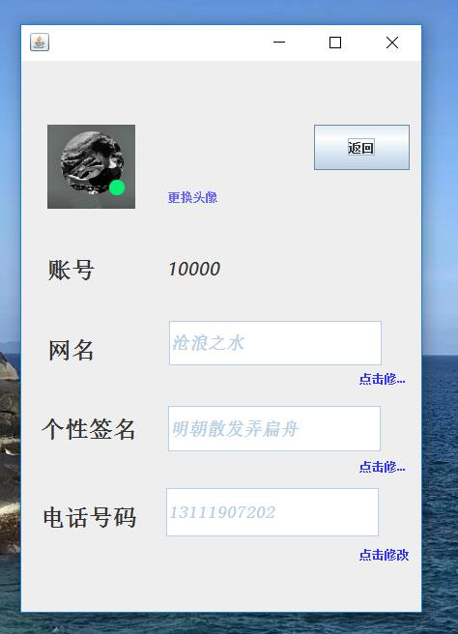
/*
* To change this template, choose Tools | Templates
* and open the template in the editor.
*/
package 测试;

import java.awt.Color;
import java.awt.Font;
import java.sql.*;
import java.util.logging.Level;
import java.util.logging.Logger;
import javax.swing.ImageIcon;
import javax.swing.JButton;
import javax.swing.JFileChooser;
import javax.swing.JOptionPane;
import javax.swing.filechooser.FileNameExtensionFilter;
import javax.swing.filechooser.FileSystemView;

/**
*
* @author Lenovo
*/
public class Interface4 extends javax.swing.JFrame {

String myid;
String icon;
String name;
String s;
String n;
public Interface4(String UID) {
myid=UID;
initComponents();
this.setVisible(true);
}

/**
* This method is called from within the constructor to initialize the form.
* WARNING: Do NOT modify this code. The content of this method is always
* regenerated by the Form Editor.
*/
@SuppressWarnings("unchecked")
// <editor-fold defaultstate="collapsed" desc="Generated Code">
private void initComponents() {

jLabel1 = new javax.swing.JLabel();
jButton1 = new javax.swing.JButton();
jLabel2 = new javax.swing.JLabel();
jLabel3 = new javax.swing.JLabel();
jTextField1 = new javax.swing.JTextField();
jLabel4 = new javax.swing.JLabel();
jLabel5 = new javax.swing.JLabel();
jLabel6 = new javax.swing.JLabel();
jTextField2 = new javax.swing.JTextField();
jLabel7 = new javax.swing.JLabel();
jTextField3 = new javax.swing.JTextField();
jLabel8 = new javax.swing.JLabel();
jLabel9 = new javax.swing.JLabel();
jLabel10 = new javax.swing.JLabel();

setDefaultCloseOperation(javax.swing.WindowConstants.EXIT_ON_CLOSE);
setBackground(new java.awt.Color(153, 153, 153));

jLabel1.setIcon(new javax.swing.ImageIcon("C:\\Users\\Lenovo\\Desktop\\p5.png")); // NOI18N

jButton1.setText("返回");
jButton1.addActionListener(new java.awt.event.ActionListener() {
public void actionPerformed(java.awt.event.ActionEvent evt) {
jButton1ActionPerformed(evt);
}
});

jLabel2.setForeground(new java.awt.Color(102, 102, 255));
jLabel2.setText("更换头像");
jLabel2.addMouseListener(new java.awt.event.MouseAdapter() {
public void mouseClicked(java.awt.event.MouseEvent evt) {
jLabel2MouseClicked(evt);
}
});

jLabel3.setFont(new java.awt.Font("宋体", 1, 24)); // NOI18N
jLabel3.setText("账号");

jTextField1.setFont(new java.awt.Font("宋体", 3, 18)); // NOI18N
jTextField1.setText("沧浪之水");
jTextField1.setEnabled(false);
jTextField1.addActionListener(new java.awt.event.ActionListener() {
public void actionPerformed(java.awt.event.ActionEvent evt) {
jTextField1ActionPerformed(evt);
}
});

jLabel4.setFont(new java.awt.Font("微软雅黑", 2, 18)); // NOI18N
jLabel4.setText("10000");

jLabel5.setFont(new java.awt.Font("宋体", 1, 24)); // NOI18N
jLabel5.setText("网名");

jLabel6.setFont(new java.awt.Font("宋体", 1, 24)); // NOI18N
jLabel6.setText("个性签名");

jTextField2.setFont(new java.awt.Font("宋体", 3, 18)); // NOI18N
jTextField2.setText("明朝散发弄扁舟");
jTextField2.setEnabled(false);
jTextField2.addMouseListener(new java.awt.event.MouseAdapter() {
public void mouseClicked(java.awt.event.MouseEvent evt) {
jTextField2MouseClicked(evt);
}
});
jTextField2.addActionListener(new java.awt.event.ActionListener() {
public void actionPerformed(java.awt.event.ActionEvent evt) {
jTextField2ActionPerformed(evt);
}
});

jLabel7.setFont(new java.awt.Font("宋体", 1, 24)); // NOI18N
jLabel7.setText("电话号码");

jTextField3.setFont(new java.awt.Font("宋体", 3, 18)); // NOI18N
jTextField3.setForeground(new java.awt.Color(0, 204, 204));
jTextField3.setText("13111907202");
jTextField3.setEnabled(false);

jLabel8.setBackground(new java.awt.Color(51, 51, 255));
jLabel8.setForeground(new java.awt.Color(51, 51, 255));
jLabel8.setText("点击修改");
jLabel8.addMouseListener(new java.awt.event.MouseAdapter() {
public void mouseClicked(java.awt.event.MouseEvent evt) {
jLabel8MouseClicked(evt);
}
});

jLabel9.setBackground(new java.awt.Color(51, 51, 255));
jLabel9.setForeground(new java.awt.Color(51, 51, 255));
jLabel9.setText("点击修改");
jLabel9.addMouseListener(new java.awt.event.MouseAdapter() {
public void mouseClicked(java.awt.event.MouseEvent evt) {
jLabel9MouseClicked(evt);
}
});

jLabel10.setBackground(new java.awt.Color(51, 51, 255));
jLabel10.setForeground(new java.awt.Color(51, 51, 255));
jLabel10.setText("点击修改");
jLabel10.addMouseListener(new java.awt.event.MouseAdapter() {
public void mouseClicked(java.awt.event.MouseEvent evt) {
jLabel10MouseClicked(evt);
}
});

javax.swing.GroupLayout layout = new javax.swing.GroupLayout(getContentPane());
getContentPane().setLayout(layout);
layout.setHorizontalGroup(
layout.createParallelGroup(javax.swing.GroupLayout.Alignment.LEADING)
.addGroup(layout.createSequentialGroup()
.addGroup(layout.createParallelGroup(javax.swing.GroupLayout.Alignment.LEADING, false)
.addGroup(layout.createSequentialGroup()
.addGap(27, 27, 27)
.addComponent(jLabel3, javax.swing.GroupLayout.PREFERRED_SIZE, 63, javax.swing.GroupLayout.PREFERRED_SIZE)
.addGap(60, 60, 60)
.addComponent(jLabel4, javax.swing.GroupLayout.PREFERRED_SIZE, 250, javax.swing.GroupLayout.PREFERRED_SIZE))
.addGroup(layout.createSequentialGroup()
.addGap(27, 27, 27)
.addComponent(jLabel5, javax.swing.GroupLayout.PREFERRED_SIZE, 60, javax.swing.GroupLayout.PREFERRED_SIZE)
.addGap(66, 66, 66)
.addComponent(jTextField1, javax.swing.GroupLayout.PREFERRED_SIZE, 220, javax.swing.GroupLayout.PREFERRED_SIZE))
.addGroup(layout.createSequentialGroup()
.addGap(350, 350, 350)
.addComponent(jLabel8, javax.swing.GroupLayout.PREFERRED_SIZE, 50, javax.swing.GroupLayout.PREFERRED_SIZE))
.addGroup(layout.createSequentialGroup()
.addGap(20, 20, 20)
.addComponent(jLabel6)
.addGap(32, 32, 32)
.addComponent(jTextField2, javax.swing.GroupLayout.PREFERRED_SIZE, 220, javax.swing.GroupLayout.PREFERRED_SIZE))
.addGroup(layout.createSequentialGroup()
.addGap(350, 350, 350)
.addComponent(jLabel9, javax.swing.GroupLayout.PREFERRED_SIZE, 50, javax.swing.GroupLayout.PREFERRED_SIZE))
.addGroup(layout.createSequentialGroup()
.addGap(20, 20, 20)
.addComponent(jLabel7, javax.swing.GroupLayout.PREFERRED_SIZE, 110, javax.swing.GroupLayout.PREFERRED_SIZE)
.addGap(20, 20, 20)
.addComponent(jTextField3, javax.swing.GroupLayout.PREFERRED_SIZE, 220, javax.swing.GroupLayout.PREFERRED_SIZE))
.addGroup(layout.createSequentialGroup()
.addGap(350, 350, 350)
.addComponent(jLabel10))
.addGroup(layout.createSequentialGroup()
.addGap(27, 27, 27)
.addComponent(jLabel1, javax.swing.GroupLayout.PREFERRED_SIZE, 91, javax.swing.GroupLayout.PREFERRED_SIZE)
.addGroup(layout.createParallelGroup(javax.swing.GroupLayout.Alignment.LEADING)
.addGroup(layout.createSequentialGroup()
.addGap(34, 34, 34)
.addComponent(jLabel2, javax.swing.GroupLayout.PREFERRED_SIZE, 71, javax.swing.GroupLayout.PREFERRED_SIZE))
.addGroup(javax.swing.GroupLayout.Alignment.TRAILING, layout.createSequentialGroup()
.addPreferredGap(javax.swing.LayoutStyle.ComponentPlacement.RELATED, javax.swing.GroupLayout.DEFAULT_SIZE, Short.MAX_VALUE)
.addComponent(jButton1, javax.swing.GroupLayout.PREFERRED_SIZE, 99, javax.swing.GroupLayout.PREFERRED_SIZE)))))
.addContainerGap(javax.swing.GroupLayout.DEFAULT_SIZE, Short.MAX_VALUE))
);
layout.setVerticalGroup(
layout.createParallelGroup(javax.swing.GroupLayout.Alignment.LEADING)
.addGroup(layout.createSequentialGroup()
.addGap(66, 66, 66)
.addGroup(layout.createParallelGroup(javax.swing.GroupLayout.Alignment.LEADING)
.addGroup(layout.createSequentialGroup()
.addComponent(jButton1, javax.swing.GroupLayout.PREFERRED_SIZE, 47, javax.swing.GroupLayout.PREFERRED_SIZE)
.addGap(15, 15, 15)
.addComponent(jLabel2, javax.swing.GroupLayout.PREFERRED_SIZE, 25, javax.swing.GroupLayout.PREFERRED_SIZE))
.addComponent(jLabel1))
.addGap(47, 47, 47)
.addGroup(layout.createParallelGroup(javax.swing.GroupLayout.Alignment.LEADING)
.addComponent(jLabel3, javax.swing.GroupLayout.PREFERRED_SIZE, 33, javax.swing.GroupLayout.PREFERRED_SIZE)
.addComponent(jLabel4, javax.swing.GroupLayout.PREFERRED_SIZE, 30, javax.swing.GroupLayout.PREFERRED_SIZE))
.addGap(36, 36, 36)
.addGroup(layout.createParallelGroup(javax.swing.GroupLayout.Alignment.LEADING)
.addGroup(layout.createSequentialGroup()
.addGap(15, 15, 15)
.addComponent(jLabel5, javax.swing.GroupLayout.PREFERRED_SIZE, 30, javax.swing.GroupLayout.PREFERRED_SIZE))
.addComponent(jTextField1, javax.swing.GroupLayout.PREFERRED_SIZE, 46, javax.swing.GroupLayout.PREFERRED_SIZE))
.addGap(5, 5, 5)
.addComponent(jLabel8)
.addGap(21, 21, 21)
.addGroup(layout.createParallelGroup(javax.swing.GroupLayout.Alignment.LEADING)
.addGroup(layout.createSequentialGroup()
.addGap(4, 4, 4)
.addComponent(jLabel6, javax.swing.GroupLayout.PREFERRED_SIZE, 40, javax.swing.GroupLayout.PREFERRED_SIZE))
.addComponent(jTextField2, javax.swing.GroupLayout.PREFERRED_SIZE, 47, javax.swing.GroupLayout.PREFERRED_SIZE))
.addGap(7, 7, 7)
.addComponent(jLabel9)
.addGap(15, 15, 15)
.addGroup(layout.createParallelGroup(javax.swing.GroupLayout.Alignment.LEADING)
.addGroup(layout.createSequentialGroup()
.addGap(10, 10, 10)
.addComponent(jLabel7, javax.swing.GroupLayout.PREFERRED_SIZE, 40, javax.swing.GroupLayout.PREFERRED_SIZE))
.addComponent(jTextField3, javax.swing.GroupLayout.PREFERRED_SIZE, 50, javax.swing.GroupLayout.PREFERRED_SIZE))
.addGap(10, 10, 10)
.addComponent(jLabel10)
.addContainerGap(52, Short.MAX_VALUE))
);

pack();
}// </editor-fold>

private void jLabel2MouseClicked(java.awt.event.MouseEvent evt) {
String myicon="";
JFileChooser fileChooser = new JFileChooser("C:\\", FileSystemView.getFileSystemView());
fileChooser.setFileFilter(new FileNameExtensionFilter("Image Files", "jpg", "png", "tif", "gif", "bmp"));
int returnVal = fileChooser.showOpenDialog(this);
if (returnVal == JFileChooser.APPROVE_OPTION) {
String fileName = fileChooser.getSelectedFile().getName();
String extension = fileName.substring(fileName.lastIndexOf("."));
if (extension.equalsIgnoreCase(".jpg") || extension.equalsIgnoreCase(".png")
|| extension.equalsIgnoreCase(".bmp") || extension.equalsIgnoreCase(".tif")
|| extension.equalsIgnoreCase(".gif")) {
myicon=fileChooser.getSelectedFile().getPath();
} else {
JOptionPane.showMessageDialog(this, "Kindly Select Image File Only","Error", JOptionPane.ERROR_MESSAGE);
}
}
try {
Class.forName("com.mysql.jdbc.Driver");
Connection con=DriverManager.getConnection("jdbc:mysql://localhost:3306/internet", "root","niit1234");
Statement st=con.createStatement();
String sql="update usermassege set 头像="+myicon+" where 账号="+myid+";";

st.close();
con.close();
} catch (SQLException ex) {
Logger.getLogger(Linkdatabase.class.getName()).log(Level.SEVERE, null, ex);
} catch (ClassNotFoundException ex) {
Logger.getLogger(Linkdatabase.class.getName()).log(Level.SEVERE, null, ex);
}
JOptionPane.showMessageDialog(this, "头像更换成功!请点击更新");
jLabel1.setIcon(new ImageIcon(myicon));

}

private void jLabel8MouseClicked(java.awt.event.MouseEvent evt) {
jTextField1.enable(true); // TODO add your handling code here:
}

private void jLabel9MouseClicked(java.awt.event.MouseEvent evt) {
jTextField2.enable(true); // TODO add your handling code here:
}

private void jLabel10MouseClicked(java.awt.event.MouseEvent evt) {
jTextField3.enable(true); // TODO add your handling code here:
}

private void jTextField1ActionPerformed(java.awt.event.ActionEvent evt) {
String s=jTextField1.getText();
try {
Class.forName("com.mysql.jdbc.Driver");
Connection con=DriverManager.getConnection("jdbc:mysql://localhost:3306/internet", "root","niit1234");
Statement st=con.createStatement();
String sql="update usermassege set 网名="+s+" where 账号="+myid+";";

st.close();
con.close();
} catch (SQLException ex) {
Logger.getLogger(Linkdatabase.class.getName()).log(Level.SEVERE, null, ex);
} catch (ClassNotFoundException ex) {
Logger.getLogger(Linkdatabase.class.getName()).log(Level.SEVERE, null, ex);
}
JOptionPane.showMessageDialog(this, "网名修改成功!");
jTextField1.enable(false);
}

private void jTextField2MouseClicked(java.awt.event.MouseEvent evt) {

}

private void jButton1ActionPerformed(java.awt.event.ActionEvent evt) {
dispose();
Interface3 open=new Interface3(myid);
open.show();// TODO add your handling code here:
}

private void jTextField2ActionPerformed(java.awt.event.ActionEvent evt) {
String s=jTextField2.getText();
try {
Class.forName("com.mysql.jdbc.Driver");
Connection con=DriverManager.getConnection("jdbc:mysql://localhost:3306/internet", "root","niit1234");
Statement st=con.createStatement();
String sql="update usermassege set 个性签名="+s+" where 账号="+myid+";";

st.close();
con.close();
} catch (SQLException ex) {
Logger.getLogger(Linkdatabase.class.getName()).log(Level.SEVERE, null, ex);
} catch (ClassNotFoundException ex) {
Logger.getLogger(Linkdatabase.class.getName()).log(Level.SEVERE, null, ex);
}
JOptionPane.showMessageDialog(this, "个性签名修改成功!");
jTextField2.enable(false); // TODO add your handling code here: // TODO add your handling code here:
}

/**
* @param args the command line arguments
*/
public static void main(String args[]) {
/*
* Set the Nimbus look and feel
*/
//<editor-fold defaultstate="collapsed" desc=" Look and feel setting code (optional) ">
/*
* If Nimbus (introduced in Java SE 6) is not available, stay with the
* default look and feel. For details see
* http://download.oracle.com/javase/tutorial/uiswing/lookandfeel/plaf.html
*/
try {
for (javax.swing.UIManager.LookAndFeelInfo info : javax.swing.UIManager.getInstalledLookAndFeels()) {
if ("Nimbus".equals(info.getName())) {
javax.swing.UIManager.setLookAndFeel(info.getClassName());
break;
}
}
} catch (ClassNotFoundException ex) {
java.util.logging.Logger.getLogger(Interface4.class.getName()).log(java.util.logging.Level.SEVERE, null, ex);
} catch (InstantiationException ex) {
java.util.logging.Logger.getLogger(Interface4.class.getName()).log(java.util.logging.Level.SEVERE, null, ex);
} catch (IllegalAccessException ex) {
java.util.logging.Logger.getLogger(Interface4.class.getName()).log(java.util.logging.Level.SEVERE, null, ex);
} catch (javax.swing.UnsupportedLookAndFeelException ex) {
java.util.logging.Logger.getLogger(Interface4.class.getName()).log(java.util.logging.Level.SEVERE, null, ex);
}
//</editor-fold>

/*
* Create and display the form
*/
java.awt.EventQueue.invokeLater(new Runnable() {

public void run() {
new Interface4("1000");
}
});
}
// Variables declaration - do not modify
private javax.swing.JButton jButton1;
private javax.swing.JLabel jLabel1;
private javax.swing.JLabel jLabel10;
private javax.swing.JLabel jLabel2;
private javax.swing.JLabel jLabel3;
private javax.swing.JLabel jLabel4;
private javax.swing.JLabel jLabel5;
private javax.swing.JLabel jLabel6;
private javax.swing.JLabel jLabel7;
private javax.swing.JLabel jLabel8;
private javax.swing.JLabel jLabel9;
private javax.swing.JTextField jTextField1;
private javax.swing.JTextField jTextField2;
private javax.swing.JTextField jTextField3;
// End of variables declaration
}

- 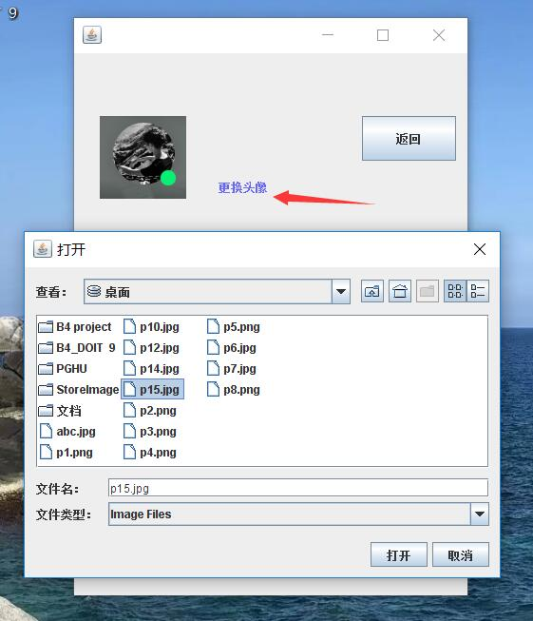
- 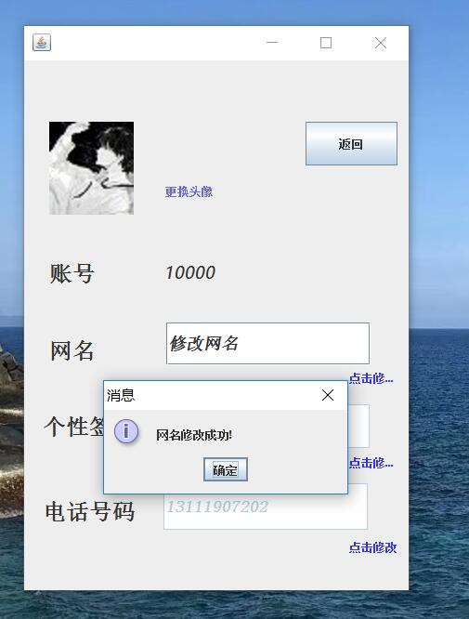
- 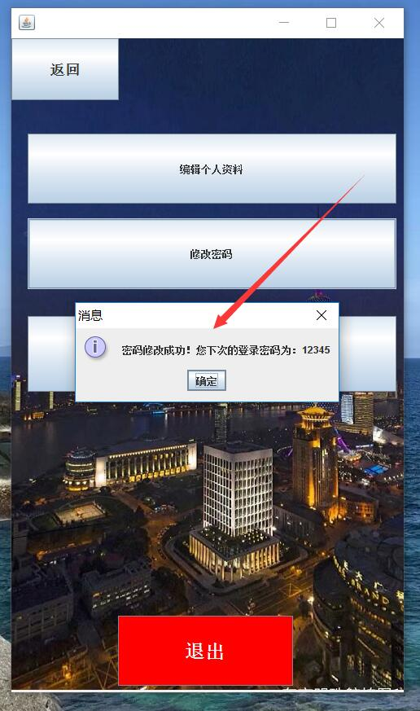
- 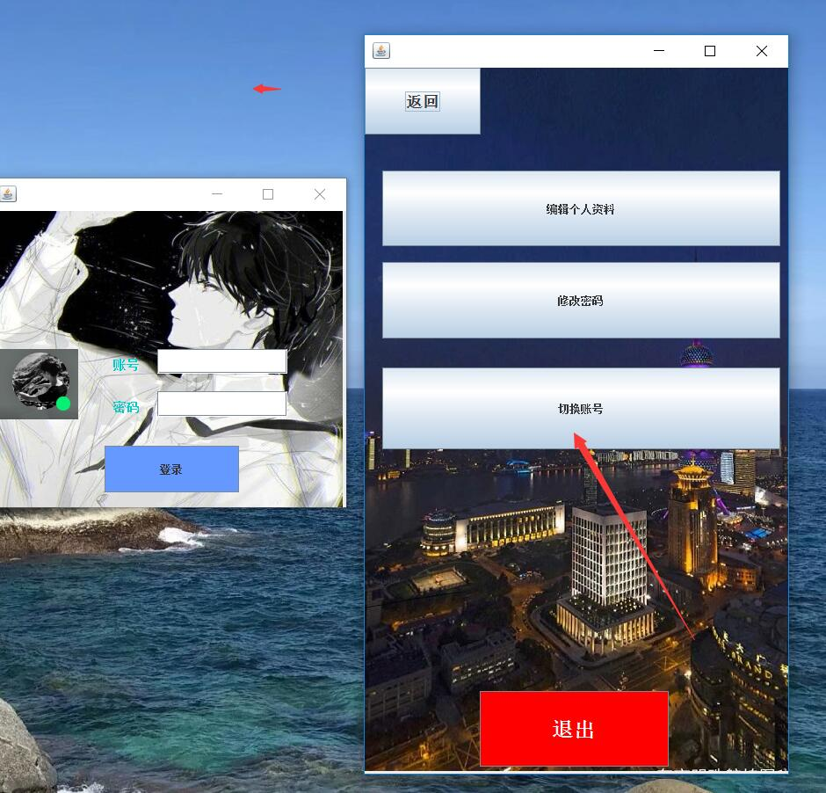

- 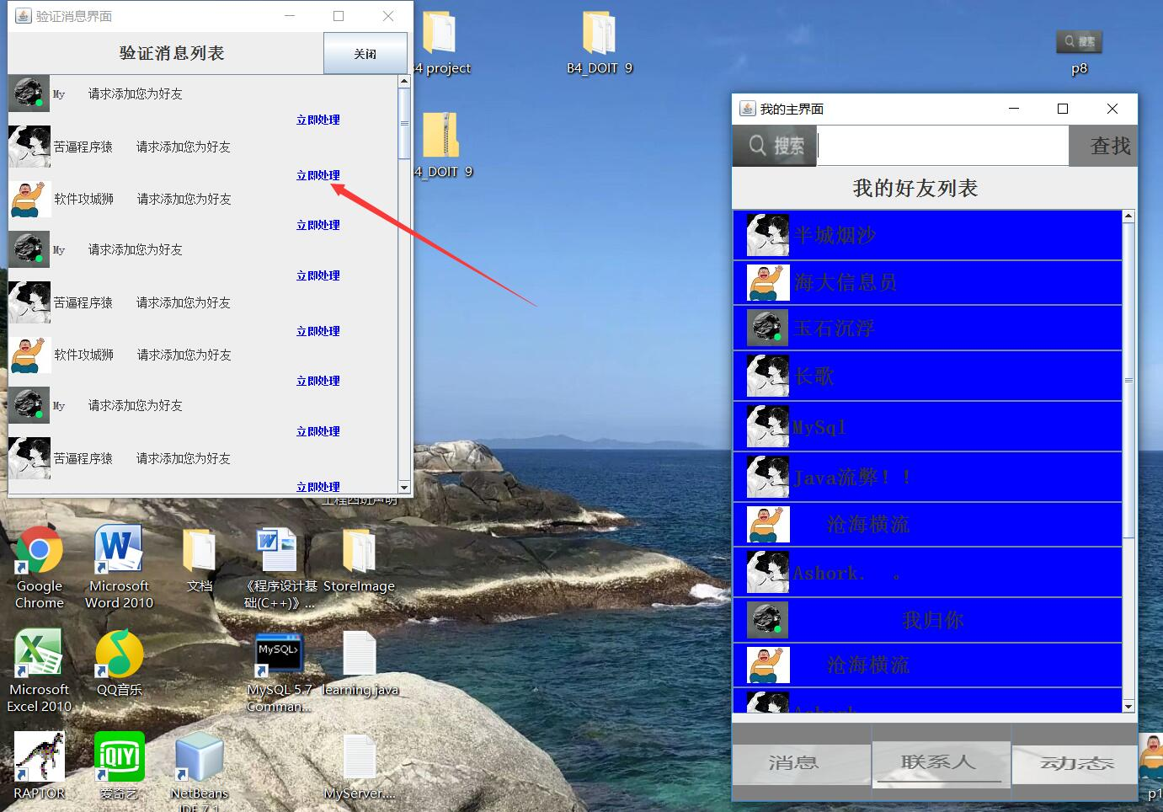
- 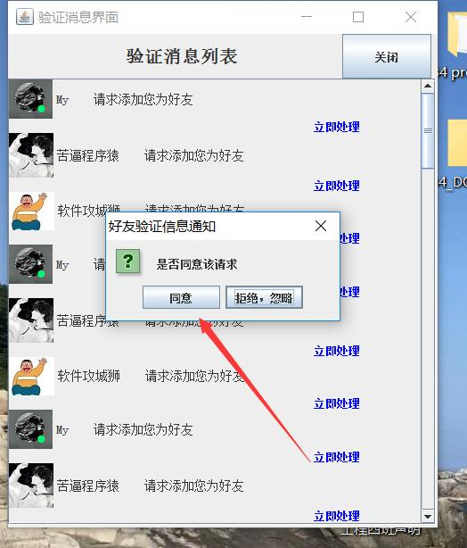
- 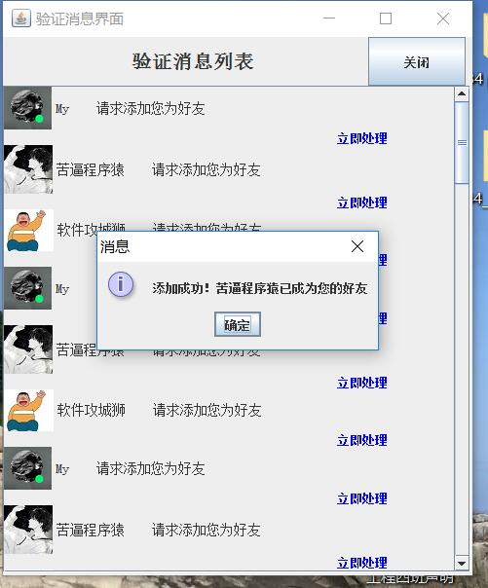
- 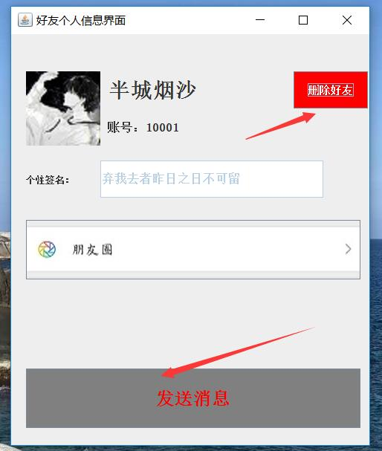
- 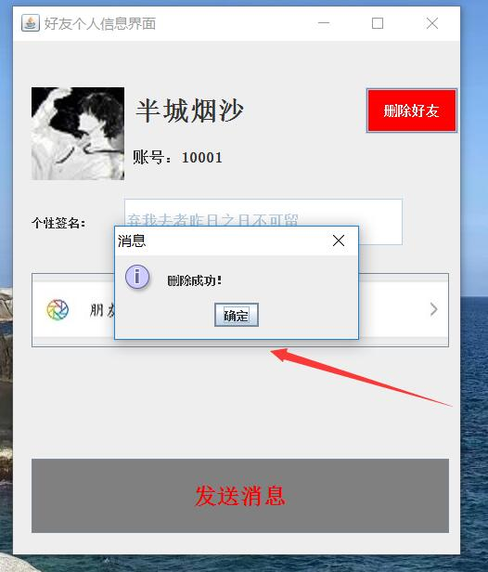
- 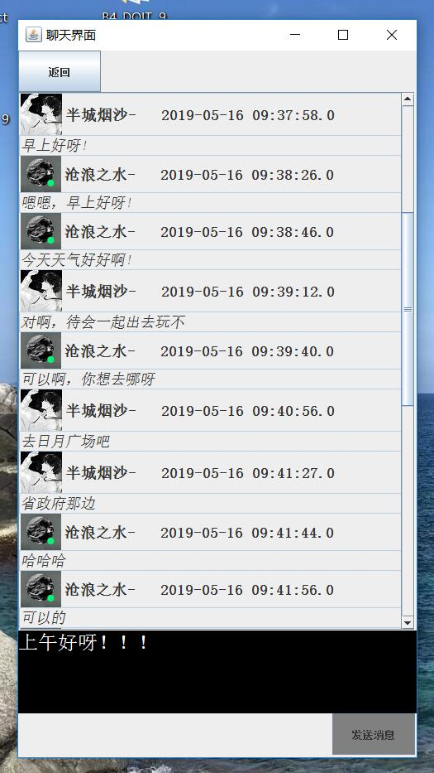

package 测试;
import java.awt.*;
import javax.swing.*;
import java.awt.event.*;
import java.sql.*;
import java.util.logging.*;
public class Chatinterface extends JFrame
{
JPanel jp1=new JPanel();
JPanel jp2=new JPanel();
JTextArea jta1=new JTextArea();
String myid;
String friend;
Chatinterface( String UID,String F)
{
friend=F;
myid=UID;
setTitle("聊天界面");
setSize(500, 900);
setDefaultCloseOperation(JFrame.EXIT_ON_CLOSE);

jp1.setLayout(null);

setContentPane(jp1);
JButton jb1=new JButton("返回");
jb1.setBounds(0, 0, 100, 50);
jb1.addActionListener(new java.awt.event.ActionListener() {
public void actionPerformed(java.awt.event.ActionEvent evt) {
jb1event(evt);
}
});
jp1.add(jb1);
JScrollPane js1=new JScrollPane();

BoxLayout bl1=new BoxLayout(jp2,BoxLayout.Y_AXIS);
jp2.setLayout(bl1);
js1.setViewportView(jp2);
js1.setHorizontalScrollBarPolicy(ScrollPaneConstants.HORIZONTAL_SCROLLBAR_NEVER);
js1.setBounds(0,50, 480, 650);
jp1.add(js1);

jta1.setBounds(0, 700, 500, 100);
jta1.setBackground(Color.BLACK);
jta1.setFont(new Font("宋体",0,24));
jta1.setForeground(Color.white);
jp1.add(jta1);
JButton jb2=new JButton("发送消息");
jb2.setBackground(Color.GRAY);
jb2.setBounds(380, 800, 100, 50);
jb2.addActionListener(new java.awt.event.ActionListener() {
public void actionPerformed(java.awt.event.ActionEvent evt) {
jb2event(evt);
}
});
jp1.add(jb2);

try {
Connection con;
Statement st;

Class.forName("com.mysql.jdbc.Driver");
con=DriverManager.getConnection("jdbc:mysql://localhost:3306/internet", "root","niit1234");
st=con.createStatement();
String sql="select 网名,发送时间,内容,头像 from usermassege join massege on (发送人=账号) order by 发送时间 ;";
ResultSet rs=st.executeQuery(sql);
while(rs.next())
{
String time=rs.getString("发送时间");
String text=rs.getString("内容");
String name=rs.getString("网名");
String icon=rs.getString("头像");
JTextField tjt=new JTextField(text);
tjt.setEditable(false);
tjt.setFont(new Font("宋体",2,18));
JLabel tjl=new JLabel(name+"- "+time,new ImageIcon(icon),JLabel.LEFT);
tjl.setBackground(Color.red);
tjl.setFont(new Font("宋体",1,18));
jp2.add(tjl);
jp2.add(tjt);

}
rs.close();
st.close();
con.close();
} catch (SQLException ex) {
Logger.getLogger(Linkdatabase.class.getName()).log(Level.SEVERE, null, ex);
} catch (ClassNotFoundException ex) {
Logger.getLogger(Linkdatabase.class.getName()).log(Level.SEVERE, null, ex);
}

for(int i=0;i<6;i++)
{

}
this.setLocation((Toolkit.getDefaultToolkit().getScreenSize().width-200)/2, (Toolkit.getDefaultToolkit().getScreenSize().height-200)/8);
setVisible(true);

}

public void jb1event(ActionEvent e)
{
dispose();
Minterface m=new Minterface(myid);
}

public void jb2event(ActionEvent e)
{

String masg=jta1.getText();
jta1.setText("");
JTextField tjt1=new JTextField(masg);
tjt1.setEditable(false);
tjt1.setFont(new Font("宋体",2,18));
JLabel tjl1=new JLabel("沧浪之水 2019/5/16 ",new ImageIcon("C:\\Users\\Lenovo\\Desktop\\p4.png"),JLabel.LEFT);
tjl1.setBackground(Color.red);
tjl1.setFont(new Font("宋体",1,18));

jp2.add(tjl1);
jp2.add(tjt1);
jp2.updateUI();
jp2.validate();
tjl1.scrollRectToVisible(new Rectangle(tjl1.getBounds()));
tjt1.scrollRectToVisible(new Rectangle(tjt1.getBounds()));

}
public static void main(String args[])
{
new Chatinterface("10000","10001");
}
}
- 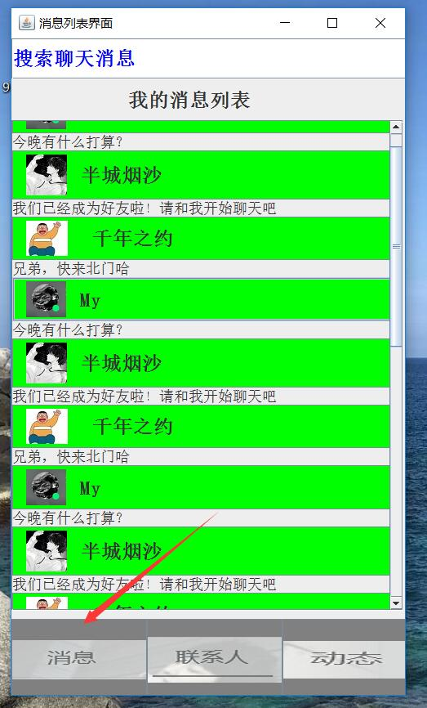
package 测试;
import javax.swing.*;
import java.awt.*;
import java.awt.event.ActionEvent;
import java.sql.*;
import java.util.logging.Level;
import java.util.logging.Logger;
public class Minterface extends JFrame
{
String myid;
String friend;
Minterface(String UID)
{
String name="";
String icon="";
String text="";
myid=UID;

setTitle("消息列表界面");
setSize(500, 850);

setDefaultCloseOperation(JFrame.EXIT_ON_CLOSE);
JPanel jp1=new JPanel();
jp1.setLayout(null);

setContentPane(jp1);
JTextField jt1=new JTextField("搜索聊天消息");
jt1.setForeground(Color.BLUE);
jt1.setFont(new Font("宋体",1,24));
JLabel jl1=new JLabel(" 我的消息列表");
jl1.setFont(new Font("宋体",1,24));
jl1.setBounds(0, 50, 500, 50);
jp1.add(jl1);
JScrollPane js1=new JScrollPane();
JPanel jp2=new JPanel();
BoxLayout bl1=new BoxLayout(jp2,BoxLayout.Y_AXIS);
jp2.setLayout(bl1);
js1.setViewportView(jp2);
js1.setHorizontalScrollBarPolicy(ScrollPaneConstants.HORIZONTAL_SCROLLBAR_NEVER);
jt1.setBounds(0, 0, 500, 50);
js1.setBounds(0,100, 480, 600);
jp1.add(jt1);
jp1.add(js1);

for(int i=0;i<18;i++)
{
if(i%3==0)
{
JButton tjb=new JButton(" My ",new ImageIcon("C:\\Users\\Lenovo\\Desktop\\p4.png"));
tjb.setFont(new Font("宋体",1,24));
tjb.setBackground(Color.GREEN);
tjb.addActionListener(new java.awt.event.ActionListener() {
public void actionPerformed(java.awt.event.ActionEvent evt) {
tjbevent(evt);
}
});
JLabel tjl=new JLabel("今晚有什么打算？");
tjl.setFont(new Font("宋体",0,18));
jp2.add(tjb);
jp2.add(tjl);
}
if(i%3==1)
{
JButton tjb=new JButton(" 半城烟沙 ",new ImageIcon("C:\\Users\\Lenovo\\Desktop\\p12.jpg"));
tjb.setFont(new Font("宋体",1,24));
tjb.setBackground(Color.GREEN);
tjb.addActionListener(new java.awt.event.ActionListener() {
public void actionPerformed(java.awt.event.ActionEvent evt) {
tjbevent(evt);
}
});
JLabel tjl=new JLabel("我们已经成为好友啦！请和我开始聊天吧");
tjl.setFont(new Font("宋体",0,18));
jp2.add(tjb);
jp2.add(tjl);
}
if(i%3==2)
{
JButton tjb=new JButton(" 千年之约 ",new ImageIcon("C:\\Users\\Lenovo\\Desktop\\abc.jpg"));
tjb.setFont(new Font("宋体",1,24));
tjb.setBackground(Color.GREEN);
tjb.addActionListener(new java.awt.event.ActionListener() {
public void actionPerformed(java.awt.event.ActionEvent evt) {
tjbevent(evt);
}
});
JLabel tjl=new JLabel("兄弟，快来北门哈");
tjl.setFont(new Font("宋体",0,18));
jp2.add(tjb);
jp2.add(tjl);
}
}
JButton jb1=new JButton(new ImageIcon("C:\\Users\\Lenovo\\Desktop\\p1.png"));
jb1.setFont(new Font("宋体",1,24));
jb1.setBounds(166, 710, 166, 100);
jb1.setBackground(Color.GRAY);
jb1.addActionListener(new java.awt.event.ActionListener() {
public void actionPerformed(java.awt.event.ActionEvent evt) {
jb1event(evt);
}
});
jp1.add(jb1);
JButton jb2=new JButton(new ImageIcon("C:\\Users\\Lenovo\\Desktop\\p2.png"));
jb2.setFont(new Font("宋体",1,24));
jb2.setBounds(0, 710, 166, 100);
jb2.setBackground(Color.GRAY);

jp1.add(jb2);
JButton jb3=new JButton(new ImageIcon("C:\\Users\\Lenovo\\Desktop\\p3.png"));
jb3.setFont(new Font("宋体",1,24));
jb3.setBounds(332, 710, 166, 100);
jb3.setBackground(Color.GRAY);
jb3.addActionListener(new java.awt.event.ActionListener() {
public void actionPerformed(java.awt.event.ActionEvent evt) {
jb3event(evt);
}
});
jp1.add(jb3);
this.setLocation((Toolkit.getDefaultToolkit().getScreenSize().width-200)/2, (Toolkit.getDefaultToolkit().getScreenSize().height-200)/8);
setVisible(true);

int count=0;
try {
Class.forName("com.mysql.jdbc.Driver");
Connection con=DriverManager.getConnection("jdbc:mysql://localhost:3306/internet", "root","niit1234");
Statement st=con.createStatement();
String sql="select 状态 from massege where 接收人="+myid+" and 消息类型=1;";
ResultSet rs=st.executeQuery(sql);
while(rs.next())
{
int a=rs.getInt("状态");

if(a==0)
count++;

}
rs.close();
st.close();
con.close();
} catch (SQLException ex) {
Logger.getLogger(Linkdatabase.class.getName()).log(Level.SEVERE, null, ex);
} catch (ClassNotFoundException ex) {
Logger.getLogger(Linkdatabase.class.getName()).log(Level.SEVERE, null, ex);
}
if(count!=0)
{
Approve open= new Approve(myid);
open.show();
}
}

public void jb1event(ActionEvent e)
{
hide();
Maininterface m=new Maininterface(myid);
}

public void jb3event(ActionEvent e)
{
dispose();
Thirdinter m=new Thirdinter(myid);
}

public void tjbevent(ActionEvent e)
{
dispose();
Chatinterface m=new Chatinterface(myid,friend);
}

public static void main(String args[])
{
new Minterface("10000");
}
}
- 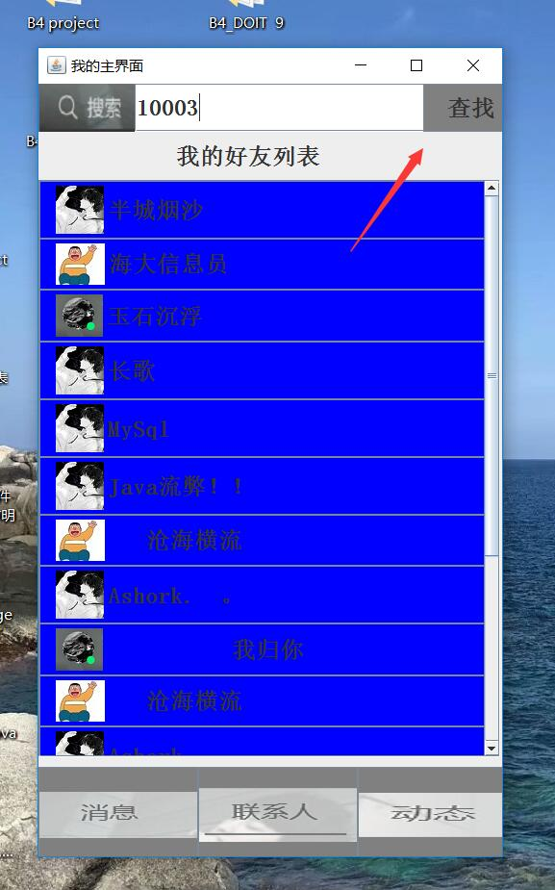
- 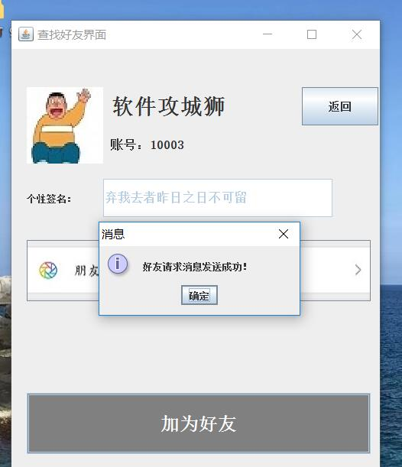
(1)
package 测试;
import javax.swing.*;
import java.awt.*;
import java.awt.event.*;
import java.sql.*;
import java.util.logging.Level;
import java.util.logging.Logger;
public class Add extends JFrame
{
String myid;
String friend;
Add(String UID,String F)
{
friend=F;
myid=UID;
setTitle("查找好友界面");
setSize(500, 600);
setDefaultCloseOperation(JFrame.EXIT_ON_CLOSE);
JPanel jp1=new JPanel();
jp1.setLayout(null);
setContentPane(jp1);
JLabel jl1=new JLabel(new ImageIcon("C:\\Users\\Lenovo\\Desktop\\p14.jpg"));
jl1.setBounds(20,50, 100, 100);
jp1.add(jl1);
JLabel jl2=new JLabel("软件攻城狮");
jl2.setBounds(130,50, 200, 50);
jl2.setFont(new Font("宋体",1,28));
jp1.add(jl2);
JLabel jl3=new JLabel("账号：10003");
jl3.setBounds(130,100, 200, 50);
jl3.setFont(new Font("宋体",1,20));
jp1.add(jl3);
JButton jb8=new JButton("返回");
jb8.addActionListener(new java.awt.event.ActionListener() {
public void actionPerformed(java.awt.event.ActionEvent evt) {
jb8event(evt);
}
});
jb8.setFont(new Font("宋体",1,14));
jb8.setBounds(380, 50, 100, 50);

jp1.add(jb8);
JTextField jt1=new JTextField("弃我去者昨日之日不可留");
jt1.enable(false);
jt1.setFont(new Font("宋体",1,16));
jt1.setBounds(120,170 , 300, 50);
jp1.add(jt1);
JLabel jl4=new JLabel("个性签名：");
jl4.setBounds(20,170, 100, 50);
jl3.setFont(new Font("宋体",1,16));
jp1.add(jl4);

JButton jb4=new JButton(new ImageIcon("C:\\Users\\Lenovo\\Desktop\\p6.jpg"));

jb4.setBounds(20,250, 450, 80);
jb4.setBackground(Color.GRAY);
jp1.add(jb4);
JButton jb5=new JButton("加为好友");
jb5.addActionListener(new java.awt.event.ActionListener() {
public void actionPerformed(java.awt.event.ActionEvent evt) {
jb5event(evt);
}
});
jb5.setFont(new Font("宋体",1,24));
jb5.setForeground(Color.white);
jb5.setBounds(20,450, 450, 80);
jb5.setBackground(Color.GRAY);
jp1.add(jb5);
this.setLocation((Toolkit.getDefaultToolkit().getScreenSize().width-200)/2, (Toolkit.getDefaultToolkit().getScreenSize().height-200)/8);
this.setVisible(true);
}

public void jb5event(ActionEvent e)
{
try {
Class.forName("com.mysql.jdbc.Driver");
Connection con=DriverManager.getConnection("jdbc:mysql://localhost:3306/internet", "root","niit1234");
CallableStatement cs=con.prepareCall("call addfriend(?,?)");
cs.setString(1, myid);
cs.setString(2,friend );

cs.execute();
cs.close();

cs.close();
con.close();
} catch (SQLException ex) {
Logger.getLogger(Linkdatabase.class.getName()).log(Level.SEVERE, null, ex);
} catch (ClassNotFoundException ex) {
Logger.getLogger(Linkdatabase.class.getName()).log(Level.SEVERE, null, ex);
}
JOptionPane.showMessageDialog(this, "好友请求消息发送成功！");
}

public void jb8event(ActionEvent e)
{
new Maininterface("10000");
}

public static void main(String args[])
{
new Add("10000","10003");

}
}

(2) package 测试;
import javax.swing.*;
import java.awt.*;
import java.awt.event.ActionEvent;
import java.sql.*;
import java.util.logging.Level;
import java.util.logging.Logger;
public class Approve extends JFrame
{
String myid;
Approve(String UID)
{
myid=UID;
setTitle("验证消息界面");
setSize(500, 600);

setDefaultCloseOperation(JFrame.EXIT_ON_CLOSE);
JPanel jp1=new JPanel();
jp1.setLayout(null);

setContentPane(jp1);
JLabel jl1=new JLabel(" 验证消息列表");
jl1.setBackground(Color.GRAY);
jl1.setFont(new Font("宋体",1,20));
jl1.setBounds(0, 0, 400, 50);
jp1.add(jl1);
JButton jb=new JButton("关闭");
jb.addActionListener(new java.awt.event.ActionListener() {
public void actionPerformed(java.awt.event.ActionEvent evt) {
jbevent(evt);
}
});
jb.setBounds(375, 0, 100, 50);
jp1.add(jb);
JScrollPane js1=new JScrollPane();
JPanel jp2=new JPanel();
BoxLayout bl1=new BoxLayout(jp2,BoxLayout.Y_AXIS);
jp2.setLayout(bl1);
js1.setViewportView(jp2);
js1.setHorizontalScrollBarPolicy(ScrollPaneConstants.HORIZONTAL_SCROLLBAR_NEVER);

js1.setBounds(0,50, 480, 500);

jp1.add(js1);

try {
Class.forName("com.mysql.jdbc.Driver");
Connection con=DriverManager.getConnection("jdbc:mysql://localhost:3306/internet", "root","niit1234");
Statement st=con.createStatement();
String sql="select 状态 from massege where 接收人="+myid+" and 消息类型=1 order by 发送时间;";
ResultSet rs=st.executeQuery(sql);
while(rs.next())
{
int a=rs.getInt("状态");

if(a==0)
{
for(int i=0;i<10;i++)
{
if(i%3==0)
{
JLabel tjl1=new JLabel("My 请求添加您为好友",new ImageIcon("C:\\Users\\Lenovo\\Desktop\\p4.png"),JLabel.LEFT);

jp2.add(tjl1);
JLabel tjl2=new JLabel(" 立即处理");
tjl1.setFont(new Font("宋体",1,18));
tjl1.setFont(new Font("宋体",0,14));
tjl2.setForeground(Color.BLUE);
jp2.add(tjl2);
tjl2.addMouseListener(new java.awt.event.MouseAdapter() {
public void mouseClicked(java.awt.event.MouseEvent evt) {
tjl2MouseClicked(evt);
}
});
}
if(i%3==1)
{
JLabel tjl1=new JLabel("软件攻城狮 请求添加您为好友",new ImageIcon("C:\\Users\\Lenovo\\Desktop\\abc.jpg"),JLabel.LEFT);
jp2.add(tjl1);
JLabel tjl2=new JLabel(" 立即处理");

jp2.add(tjl2); tjl1.setFont(new Font("宋体",1,18));
tjl1.setFont(new Font("宋体",0,14));
tjl2.setForeground(Color.BLUE);
tjl2.addMouseListener(new java.awt.event.MouseAdapter() {
public void mouseClicked(java.awt.event.MouseEvent evt) {
tjl2MouseClicked(evt);
}
});
}
if(i%3==0)
{
JLabel tjl1=new JLabel("苦逼程序猿 请求添加您为好友",new ImageIcon("C:\\Users\\Lenovo\\Desktop\\p12.jpg"),JLabel.LEFT);
jp2.add(tjl1);
JLabel tjl2=new JLabel(" 立即处理");

tjl1.setFont(new Font("宋体",1,18));
tjl1.setFont(new Font("宋体",0,14));
tjl2.setForeground(Color.BLUE);
jp2.add(tjl2);
tjl2.addMouseListener(new java.awt.event.MouseAdapter() {
public void mouseClicked(java.awt.event.MouseEvent evt) {
tjl2MouseClicked(evt);
}
});
}
}
}

}
rs.close();
st.close();
con.close();
} catch (SQLException ex) {
Logger.getLogger(Linkdatabase.class.getName()).log(Level.SEVERE, null, ex);
} catch (ClassNotFoundException ex) {
Logger.getLogger(Linkdatabase.class.getName()).log(Level.SEVERE, null, ex);
}

this.setVisible(true);
}

public void jbevent(ActionEvent e)
{
dispose();

}

private void tjl2MouseClicked(java.awt.event.MouseEvent evt) {
Object options []={"同意","拒绝，忽略"};
int ch=JOptionPane.showOptionDialog(this, "是否同意该请求", "好友验证信息通知", JOptionPane.OK_CANCEL_OPTION, JOptionPane.QUESTION_MESSAGE, null, options, options[1]);
if(ch==0)
JOptionPane.showMessageDialog(this, "添加成功！苦逼程序猿已成为您的好友");
}

public static void main(String args[])
{
new Approve("10000");
}

}

// Common database definition
create database internet;
use internet;
create table usermassege
(
账号 varchar(15) not null primary key,
登录密码 varchar(15) not null,
网名 char(10),
地区 varchar(10),
性别 char(1),
头像 varchar(100),
电话 char(12)
);
create table massege
(
发送人 varchar(15),
接收人 varchar(15),
内容 tinytext,
消息类型 int,
发送时间 datetime primary key,
状态 int
);
//用户个人数据库定义
create database u10000;
use u10000;
create table myfriend
(
好友账号 varchar(15) primary key
);
create table mt
(
发送人 varchar(15),
接收人 varchar(15),
发送时间 datetime,
消息内容 tinytext
);
//注册账号功能
delimiter $$
create procedure register(in ID varchar(15),in ucode varchar(15),in uname varchar(15) ,in dname varchar(16))
begin
insert into usermassege values (ID,ucode,uname,"海南省海口市","男","C:\\Users\\Lenovo\\Desktop\\p12.jpg","13111907202");
set @s=concat("create database ",dname,";");
prepare stm from @s;
execute stm;
set @t=concat("create table ",dname,".myfriend (好友账号 varchar(15) primary key);");
prepare stm from @t;
execute stm;
set @g=concat("create table ",dname,".mt (发送人 varchar(15),接收人 varchar(15),发送时间 datetime ,消息内容 tinytext);");
prepare stm1 from @g;
execute stm1;
end$$
delimiter ;
call register("10001","12345","半城烟沙","u10001");
call register("10000","12345","沧浪之水","u10000");
call register("10002","12345","Ashock！","u10002");
call register("10003","12345","软件攻城狮","u10003");
call register("10004","12345","My","u10004");
call register("10005","12345"," 不语","u10005");
//发送消息功能
delimiter $$
create procedure setmassege(in sid varchar(15),in rid varchar(15),in tmassege tinytext)
begin
declare thetime1 datetime;
set @thetime1=now();
insert into massege values(sid,rid,tmassege,1,@thetime1,0);
end$$
delimiter ;
call setmassege("10000","100001","到时候北门出发？");
call setmassege("10001","100000","我在北门等你哈");
select * from massege;
drop procedure setmassege;
//添加好友功能
delimiter $$
create procedure addfriend(in sid varchar(15),in rid varchar(15))
begin
declare thetime2 datetime;
set @thetime2=now();
insert into massege values(sid,rid,"",0,@thetime2,0);
end$$
delimiter ;
call addfriend("10001","10002");
select * from massege;
drop procedure addfriend;
//添加好友功能
delimiter $$
create procedure deal(in sid varchar(15),in rid varchar(15),in sd varchar(16),in rd varchar(16))
begin
declare thetime1 datetime;
set @thetime1=now();
set @s1=concat("insert into ",sd,".myfriend ","value(\"",rid,"\");");
set @s2=concat("insert into ",rd,".myfriend ","value(\"",sid,"\");");
prepare stm1 from @s1;
execute stm1;
prepare stm from @s2;
execute stm;
set @g1=concat("insert into ",sd,".mt values(\"",sid,"\",\"",rid,"\",\"",@thetime1,"\",","\"我们已经成为好友啦！请和我开始聊天吧\"",");" );
prepare stm from @g1;
execute stm;
set @g=concat("insert into ",rd,".mt values(\"",sid,"\",\"",rid,"\",\"",@thetime1,"\",","\"我们已经成为好友啦！请和我开始聊天吧\"",");" );
prepare stm1 from @g;
execute stm1;
end$$
delimiter ;
call deal("10000","567","u10000","u567");
select * from u10001.mt;
//删除好友功能
delimiter $$
create procedure dele(in sid varchar(15),in rid varchar(15),in sd varchar(16),in rd varchar(16))
begin
set @s1=concat("delete from ",sd,".myfriend ","where 好友账号=\"",rid,"\";");
set @s2=concat("delete from ",rd,".myfriend ","where 好友账号=\"",sid,"\";");
prepare stm1 from @s1;
execute stm1;
prepare stm2 from @s2;
execute stm2;
end$$
delimiter ;
call dele ("10000","10001","u10000","u10001");
drop procedure dele;
select * from u10000.myfriend;

