FlukeOi!2000 Keyboard Shortcuts
CTRL  ctrl + insert = LEARN, KEY_001  ctrl + delete = RAM, KEY_002  ctrl + home = I/O, KEY_006  ctrl + end = ROM, KEY_007 | 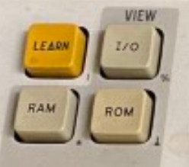

ALT  alt + insert = AUTO, KEY_003  alt + delete = BUS, KEY_004  alt + home = RAM LONG, KEY_008  alt + end = RAM SHORT, KEY_009  alt + page up = ROM, KEY_005  alt + page down = I/O, KEY_010 | 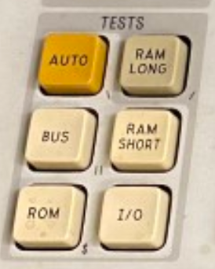

shift + a = A, KEY_022  shift + b = B, KEY_028  shift + c = C, KEY_011  shift + d = D, KEY_016  shift + e = E, KEY_021  shift + f = F, KEY_027  keypad 9= keypad 9, KEY_017  keypad 8= keypad 8, KEY_012  keypad 7 = keypad 7, KEY_029  keypad 6 = keypad 6, KEY_023  keypad 5 = keypad 5, KEY_018  keypad 4 = keypad 4, KEY_013  keypad 3 = keypad 3, KEY_030  keypad 2 = keypad 2, KEY_024  keypad 1 = keypad 1, KEY_019  keypad 0 = keypad 0, KEY_014  keypad return = ENTER/YES, KEY_015  keypad delete = CLEAR, KEY_020  keypad - = PRIOR, KEY_025  keypad + = MORE, KEY_031  keypad * = STS/CTL, KEY_026 | 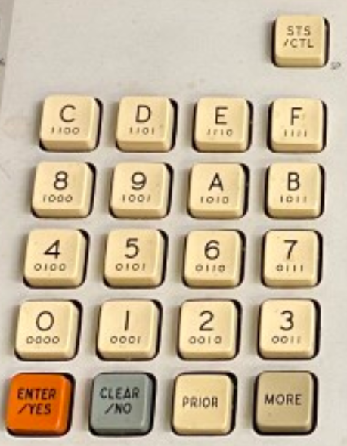

SHIFT  shift + insert = READ, KEY_032  shift + delete = RAMP, KEY_033  shift + home = WRITE, KEY_038  shift + end = WALK, KEY_039  shift + page up = TOGGL ADDR, KEY_034  shift + page down = TOGGL DATA, KEY_040 | 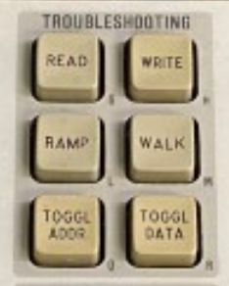

Super/Windows  super + insert = CONT, KEY_035  super + delete = RPEAT, KEY_036  super + home = STOP , KEY_041  super + end = RUN UUT, KEY_042  super + page up = LOOP, KEY_037  super + page down = SETUP , KEY_43 | 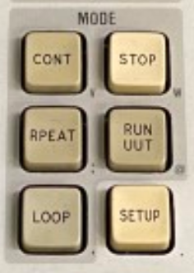

ctrl + qwe, asd, zxc  crtl + q = PROGM, KEY_044  ctrl + w = EXEC, KEY_050  ctrl + e = AUX I/F, KEY_056  ctrl + a = IF, KEY_045  ctrl + s = >, KEY_051  ctrl + d = =, KEY_057  ctrl + z = DISPL, KEY_046  ctrl + x = LABEL, KEY_052  ctrl + c = GOTO, KEY_058 | 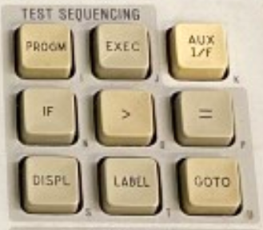

super + qwe, asd, zxc  super + q = AND, KEY_047  super + w = SHIFT LEFT, KEY_053  super + e = INC , KEY_059  super + a = OR, KEY_048  super + s = SHIFT RIGHT, KEY_054  super + d = DECR, KEY_060  super + y = READ PROBE, KEY_059  super + x = REG, KEY_055  super + c = COMPL, KEY_061 | 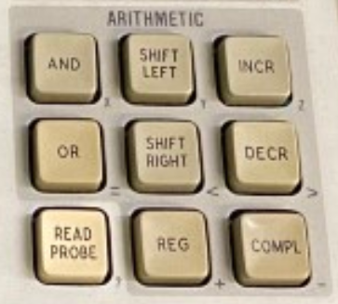

SHIFT  shift + r = READ TAPE, KEY_062  shift + w = WRITE TAPE, KEY_063 | 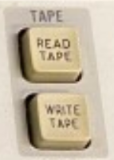

SHIFT  shift + s = SYNC, KEY_064  shift + h = HIGH, KEY_065  shift + l = LOW, KEY_066 | 