CLASS_06: R Functions

Berenice R. Leal

1/23/2020

# Functions

## Level 2 heding

### Level 3 heading

# This is a silly plot  
plot(1:5)

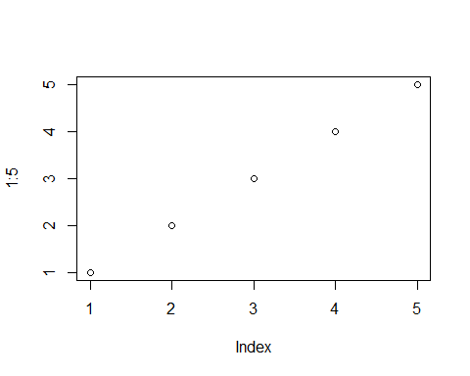

Lets see more about **file import** (i.e. reading files into R). Th main read function in base R is ‘read.table()’